|  | **MINISTRY OF EDUCATION AND TRAINING** |
| --- | --- |

| **FPT UNIVERSITY** |
| --- |
| Capstone Project Document |
| **FPTU Clubs Management System** |

| **CEO Team** | |
| --- | --- |
| **Group Members** | 1. Hoàng Phương Thảo - HE141702  2. Nguyễn Trung Hiếu - HE141706  3. Nguyễn Đình Khuê - HE141599  4. Ninh Công Lực - HE140648  5. Phạm Tiến Đạt - HE141311 |
| **Supervisor** | Lê Thanh Hải |
| **Ext Supervisor** |  |
| **Capstone Project code** | FCMS |

- Hanoi, August 2022 -

**Table of Contents**

**Acknowledgement** **14**

**Definition and Acronyms** **14**

**I. Project Introduction** **16**

**1. Overview** **16**

1.1 Project Information 16

1.2 Project Team 16

a. Supervisor 16

b. Team Members 16

**2. Product Background** **16**

**3. Existing Systems** **19**

**4. Business Opportunity** **19**

**5. Software Product Vision** **19**

**6. Project Scope & Limitations** **20**

6.1 Major Features 20

6.2 Limitations & Exclusions 21

6.2.1 Limitations 21

6.2.2 Exclusions 22

**II. Project Management Plan** **23**

**1. Overview** **23**

1.1 Scope & Estimation 23

1.2 Coding Conventions 28

1.3 Project Objectives 28

1.3.1 Release quality commit 28

1.3.2 Ensure implementation on schedule with allowable resources 29

1.4 Project Risks 29

**2. Management Approach** **30**

2.1 Project Process 30

2.2 Quality Management 31

2.2.1 Execute all processes of testing 31

2.2.2 Follow the process of defect prevention 31

2.3 Training Plan 32

**3. Project Deliverables** **32**

**4. Project Organization** **33**

**5. Responsibility Assignments** **33**

**6. Project Communications** **34**

6.1 Communication Plan 34

6.2 External Interfaces 35

**7. Configuration Management** **36**

7.1 Document Management 36

7.2 Source Code Management 36

7.3 Tools & Infrastructures 36

**III. Software Requirement Specification** **37**

**1. Product Overview** **37**

**2. User Requirements** **37**

2.1 Actors 37

2.2 Use Case Diagram(s) 38

2.2.1. Level 0 – Actors with the system 38

2.2.2. Level 1 – Actor with modules 39

a. Guest 39

b. Guest User 39

c. FCMS User 40

d. Super Admin 41

e. Admin 41

f. Collaborator 48

g. Club Manager 52

2.3 Use Case List 54

2.4 Use Case Specification 57

2.4.1 Sign in with Facebook account 57

2.4.2 Sign in with FCMS account 58

2.4.3 Sign out 59

2.4.4 Reset password 60

2.4.5 Register account 61

2.4.6 View profile 63

2.4.7 Update profile 63

2.4.8 Change password 64

2.4.9 Accept Admin account 65

2.4.10 Reject Admin account 66

2.4.11 Ban Admin account 67

2.4.12 Unban Admin account 68

2.4.13 Send creating Admin account invitation 69

2.4.14 View list Admin account 70

2.4.15 Search Admin account 71

2.4.16 View system notification 72

2.4.17 Create Admin notification 72

2.4.18 View list Admin notification 73

2.4.19 Edit information of IC-PDP’s officer 74

2.4.20 Filter Admin notification 75

2.4.21 View IC-PDP’s introduction 76

2.4.22 View list posts 77

2.4.23 View detail a post 78

2.4.24 Create post 79

2.4.25 Delete posts 80

2.4.26 Edit post 81

2.4.27 View top 5 excellent clubs 82

2.4.28 View list clubs 83

2.4.29 View information of a club 84

2.4.30 Edit club’s information 85

2.4.31 View club’s organization 86

2.4.32 Import file club’s organization 87

2.4.33 Export file club’s organization 88

2.4.34 Create report 89

2.4.35 View list unprocessed reports 90

2.4.36 View list processed reports 91

2.4.37 View list reports of a club 92

2.4.38 View detail a report 92

2.4.39 Review report 93

2.4.40 Create final report semester 95

2.4.41 View list final report semester 95

2.4.42 Create request 96

2.4.43 View list unprocessed requests 98

2.4.44 View list processed requests 98

2.4.45 View list requests of a club 99

2.4.46 View detail a request 100

2.4.47 Review request 101

2.4.48 Create meeting 102

2.4.49 View all meetings 103

2.4.50 View detail information of meeting 104

2.4.51 Delete Club Manager account 105

2.4.52 Set permissions for Collaborator account 106

2.4.53 View Statistic Chart 107

2.4.54 Set banner for Welcome page 108

2.4.55 Other 108

**3. Functional Requirements** **111**

3.1 Screen Flow 111

3.1.1 Guest 111

3.1.2 Guest User & FCMS User 111

3.1.3 Super Admin 111

3.1.4 Admin 112

3.1.5 Collaborator 113

3.1.6 Club Manager Site 114

3.2 Non-Screen Functions 115

3.3 Entity Relationship Diagram 116

**4. Non-Functional Requirements** **117**

4.1 External Interfaces 117

4.1.1 User Interfaces 117

4.1.2 Hardware Interfaces 118

4.1.3 Software Interfaces 118

4.2 Quality Attributes 118

4.2.1 Usability 118

4.2.2 Reliability 118

4.2.3 Performance 118

4.2.4 Maintainability and Extensibility 118

**5. Requirement Appendix** **119**

5.1 Business Rules 119

5.2 Application Messages List 121

**IV. Software Design Description** **125**

**1. System Design** **125**

1.1 System Architecture 125

1.1.1 Diagram 125

1.1.2 System Architecture Explanation 125

1.1.2.1 Overview 125

1.1.2.2 Nginx 126

1.1.2.3 Socket.IO 126

1.1.2.4 Firebase Cloud Messaging 127

1.1.2.5 Cron Job 127

1.1.2.6 Cloudflare 127

1.1.2.7 Vercel 128

1.1.2.8 Amazon S3 128

1.1.2.9 Amazon Elastic Compute Cloud 128

1.1.2.10 PostgreSQL 129

1.1.2.11 ReactJS 129

1.1.2.12 Redux 129

1.1.2.13 React Router 129

1.1.2.14 React Hook Form 130

1.1.2.15 NodeJS 130

1.1.2.16 Graph API 130

1.1.2.17 Gmail Service 131

1.2 Architecture Layers Design 132

1.2.1 Frontend 132

1.2.2 Backend 133

**2. Database Design** **135**

2.1 Operational Database Design 136

2.2 Table descriptions 136

2.2.1 Table ‘user’ 136

2.2.2 Table ‘club’ 137

2.2.3 Table ‘social_media’ 137

2.2.4 Table ‘social_media_type’ 138

2.2.5 Table ‘icpdp_member’ 138

2.2.6 Table ‘icpdp_role’ 138

2.2.7 Table ‘club_mentor’ 138

2.2.8 Table ‘club_event’ 138

2.2.9 Table ‘club_photos’ 139

2.2.10 Table ‘club_type’ 139

2.2.11 Table ‘club_excellent’ 139

2.2.12 Table ‘role’ 139

2.2.13 Table ‘request’ 139

2.2.14 Table ‘request_type’ 140

2.2.15 Table ‘likes’ 140

2.2.16 Table ‘post’ 140

2.2.17 Table ‘meeting’ 141

2.2.18 Table ‘participant’ 141

2.2.19 Table ‘user_feature’ 142

2.2.20 Table ‘feature’ 142

2.2.21 Table ‘notification’ 142

2.2.22 Table ‘receiver_notification’ 142

2.2.23 Table ‘token_device’ 143

2.2.24 Table ‘report_semester’ 143

2.2.25 Table ‘report’ 143

2.2.26 Table ‘report_type’ 144

2.2.27 Table ‘evaluation_criteria’ 144

2.2.28 Table ‘report_evaluation_criteria’ 144

2.2.29 Table ‘icpdp_background’ 144

2.2.30 Table ‘icpdp_video’ 144

2.2.31 Table ‘icpdp_introduction’ 145

2.2.32 Table ‘icpdp_image’ 145

2.2.33 Table ‘individual_excellent’ 145

2.2.34 Table ‘invitation’ 145

2.2.35 Table ‘token’ 145

**3. Detailed Design** **146**

3.1 Register Account 146

3.1.1 Class Diagram 146

3.1.2 Sequence Diagram 146

3.2 Sign in 147

3.2.1 Class Diagram 148

3.2.2 Sequence Diagram 148

3.3 View List Users By Role 150

3.3.1 Class Diagram 150

3.3.2 Sequence Diagram 150

3.4 Delete Users 150

3.4.1 Class Diagram 151

3.4.2 Sequence Diagram 151

3.5 Update profile 152

3.5.1 Class Diagram 153

3.5.2 Sequence Diagram 153

3.6 View Statistic Chart User 155

3.6.1 Class Diagram 155

3.6.2 Sequence Diagram 155

3.7 Set Permission For Collaborator 156

3.7.1 Class Diagram 156

3.7.2 Sequence Diagram 156

3.8 Invite Register Account 156

3.8.1 Class Diagram 157

3.8.2 Sequence Diagram 157

3.9 Reset Password 157

3.9.1 Class Diagram 158

3.9.2 Sequence Diagram 158

3.10 View List Excellent Clubs 159

3.10.1 Class Diagram 159

3.10.2 Sequence Diagram 159

3.11 Add Excellent Clubs 159

3.11.1 Class Diagram 160

3.11.2 Sequence Diagram 160

3.12 Add Excellent Individuals 160

3.12.1 Class Diagram 161

3.12.2 Sequence Diagram 161

3.13 Update Excellent Individual’s Information 162

3.13.1 Class Diagram 162

3.13.2 Sequence Diagram 162

3.14 View All Meetings 162

3.14.1 Class Diagram 163

3.14.2 Sequence Diagram 163

3.15 Create Meeting 163

3.15.1 Class Diagram 164

3.15.2 Sequence Diagram 164

3.16 Accept/Reject Meeting 165

3.16.1 Class Diagram 165

3.16.2 Sequence Diagram 165

3.17 Create Admin Notification 166

3.17.1 Class Diagram 167

3.17.2 Sequence Diagram 167

3.18 Create Post 168

3.18.1 Class Diagram 168

3.18.2 Sequence Diagram 168

3.19 Update Post 169

3.19.1 Class Diagram 169

3.19.2 Sequence Diagram 170

3.19 Like Post 170

3.19.1 Class Diagram 171

3.19.2 Sequence Diagram 171

3.20 Create Report 171

3.20.1 Class Diagram 172

3.20.2 Sequence Diagram 172

3.21 Review Report 172

3.21.1 Class Diagram 173

3.21.2 Sequence Diagram 173

3.22 View List Reports 174

3.22.1 Class Diagram 175

3.22.2 Sequence Diagram 175

3.23 Create Final Report Semester 176

3.23.1 Class Diagram 176

3.23.2 Sequence Diagram 176

3.24 Create Request 176

3.24.1 Class Diagram 177

3.24.2 Sequence Diagram 177

3.25 Review Request 178

3.25.1 Class Diagram 178

3.25.2 Sequence Diagram 178

3.26 View List Club’s Organization 179

3.26.1 Class Diagram 179

3.26.2 Sequence Diagram 179

3.27 View List Clubs 179

3.27.1 Class Diagram 180

3.27.2 Sequence Diagram 180

3.28 Other 180

**V. Software Testing Documentation** **182**

**1. Scope of Testing** **182**

1.1 Stages of testing 182

1.2 Type of testing 183

1.3 Range of testing 183

**2. Test Strategy** **183**

2.1 Test model 183

2.2 Test stage 184

2.3 Deliverables 185

2.4 Testing Types 185

2.4.1 Unit test 185

2.4.2 API testing 185

2.4.3 UI testing 185

2.4.4 Performance testing 186

2.4.5 Regression testing 186

2.4.6 Acceptance testing 186

2.4.7 Load testing 186

2.5 Test Levels 186

2.6 Supporting Tools 187

2.6.1 FCMS Front-end and Project testing 187

2.6.6.1 Chrome DevTools 187

2.6.6.2 Redux Devtools 187

2.6.6.3 Jira 187

2.6.6.4 Microsoft Excel 187

2.6.6.5 Postman 188

2.6.2 FCMS API testing 188

2.6.6.6 Mocha 188

2.6.6.7 Chaijs 188

**3. Test Plan** **189**

3.1 Human Resources 189

3.2 Test Environment 189

3.3 Test Milestones 190

**4. Test Cases** **191**

4.1 Automation test with API testing and Unit testing 191

4.2 System testing 195

4.3 Acceptance test 196

4.4 Defect Log 200

**5. Test Reports** **201**

5.1 Automation test case report 201

5.2 Automation test report 203

5.3 System test case report 203

5.4 System test report 212

**VI. Release Package & User Guides** **213**

**1. Installation Guides** **213**

1.1 Environment for development 213

1.1.1 Setup development environment 213

1.2 Environment for deployment 215

1.2.1 Create server Elastic Compute Cloud (EC2) 215

1.2.2 Set up to run sever Elastic Compute Cloud 219

1.2.3 Setup environment auto run PM2 222

1.2.4 Create Storage S3 to save data image, file, video 223

1.2.5 Configure PostgreSQL 227

1.2.6 Install nginx 231

1.2.7 Set up deploy Frontend with Vercel 231

1.2.8 CloudFlare 234

1.2.9 Setup Firebase Cloud Messaging 238

1.2.10 Setup SendGmail 242

**2. User Manual** **247**

2.1 Form register account 247

2.2.1 Admin 247

2.2.2 Collaborator 248

2.2.3 Club Manager 249

2.2 User logs in 250

2.3 User view/edit profile 252

2.4 User interface homepage 254

2.5 Super Admin 260

2.6. Admin 263

2.6.1 “Quản lý thông báo” screen 263

2.6.2 “Quản lý bài đăng” screen 265

2.6.3 “Quản lý CLB” screen 281

2.6.4 “Quản lý báo cáo” screen 285

2.6.6 “Quản lý yêu cầu” screen 293

2.6.7 “Quản lý lịch họp” screen 297

2.6.8 “Quản lý tài khoản” screen 300

2.6.9 “Biểu đồ thống kê” screen 305

2.7. Collaborator 308

2.8. Club Manager 308

2.8.1 “Quản lý CLB” screen 309

2.8.2 “Quản lý báo cáo” screen 316

2.8.3 “Quản lý yêu cầu” screen 320

2.8.4 “Quản lý lịch họp” screen 322

# Acknowledgement

FCMS Project is reaching its final stage. Looking back to the very beginning, it has been a long journey for each member of the project and the team as a whole. We started at the zero point when we decided to do FCMS. Fortunately, we have received tremendous support from many people during our journey. Therefore, we would like to let them know that we are very grateful.

First of all, we wish to offer our deepest gratitude to our team’s supervisor - Mr. Le Thanh Hai, without him, we won't be able to achieve the results we have now. Besides technological advice, he is also an excellent motivation for us not to give up and always yearn to achieve more for the project.

Secondly, we would like to thank our Product Owner - Ms. Nguyen Nhat Ha, and all members of IC-PDP department. They have always been dedicated to providing and supporting requirements and business for us. Their enthusiasm and cooperation are one of the important factors determining the success of our project.

We would also like to thank all of our teachers at FPT University. They have shown us great support this semester when we do our Capstone Project. Also, thanks to their lessons, we, the clueless students, can become the ones we want to be and do what we want to do.

Moreover, we also want to show our gratitude to our friends and families, who always give us a helping hand during this challenging period.

Last but not least, we want to say thanks to the great source of knowledge, the internet, to the people we do not know but still share with us precious knowledge, which helps us a lot in this project. We are very thankful for that.

FCMS Project, CEO Team

Hanoi, August 20th, 2022

# Definition and Acronyms

| **Acronym** | **Definition** |
| --- | --- |
| FPTU | FPT University |
| FCM | FPTU Clubs Management |
| FCMS | FPTU Clubs Management System |
| IC | International Cooperation |
| PDP | Personal Development Program |
| IC-PDP | International Cooperation and Personal Development Program |
| BR | Business Rule |
| N/A | Not Available |
| URL | Uniform Resource Locator |
| HTTP | Hypertext Transfer Protocol |
| ERD | Entity Relationship Diagram |
| GUI | Graphical User Interface |
| PM | Project Manager |
| BA | Business Analyst |
| SDD | Software Design Description |
| SPMP | Software Project Management Plan |
| SRS | Software Requirement Specification |
| UAT | User Acceptance Test |
| UC | Use Case |
| API | Application Program Interface |
| AWS | Amazon Web Services |
| UML | Unified Modelling Language |
| WBS | Work Breakdown Structure |
| EC2 | Amazon Elastic Compute Cloud |
| S3 | Amazon Simple Storage Service |
| MSG | Message |

# I. Project Introduction

## 1. Overview

### 1.1 Project Information

* Project name: FPTU Clubs Management System
* Project code: FCMS
* Group name: CEO Team
* Software type: Website application

### 1.2 Project Team

#### *a. Supervisor*

| **Full Name** | **Title** | **Email** | **Mobile** |
| --- | --- | --- | --- |
| Le Thanh Hai | Lecturer | hailt10@fe.edu.vn | 0849483072 |

*Table 1. Supervisor’s information*

#### *b. Team Members*

| **Full Name** | **Role** | **Email** | **Mobile** |
| --- | --- | --- | --- |
| Hoang Phuong Thao | Leader | thaohphe141702@fpt.edu.vn | 0343025732 |
| Nguyen Trung Hieu | Member | hieunthe141706@fpt.edu.vn | 0982581684 |
| Nguyen Dinh Khue | Member | khuendhe141599@fpt.edu.vn | 0969133718 |
| Ninh Cong Luc | Member | lucnche140648@fpt.edu.vn | 0835254416 |
| Pham Tien Dat | Member | datpthe141311@fpt.edu.vn | 0865353983 |

*Table 2. Team member’s information*

## 2. Product Background

FPT University is a university that always aims to build a model of a new generation university, attaching training to the real-life and human needs of the country, contributing to bringing Vietnamese education forward on par with other countries in the world.

IC-PDP Department is the International Cooperation and Personal Development Program, a unique and exclusive department of FPT University that was born to serve the purpose of training and fostering the necessary skills of young people in the 21st century along with providing opportunities for students to challenge themselves in new environments, and go beyond their comfort zone to discover their own limits.

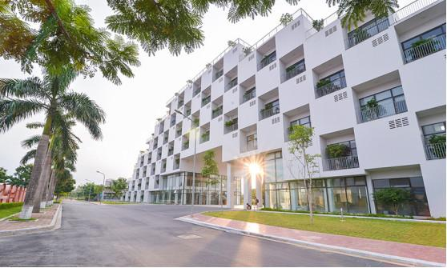

*Figure 1. FPT University Hanoi.*

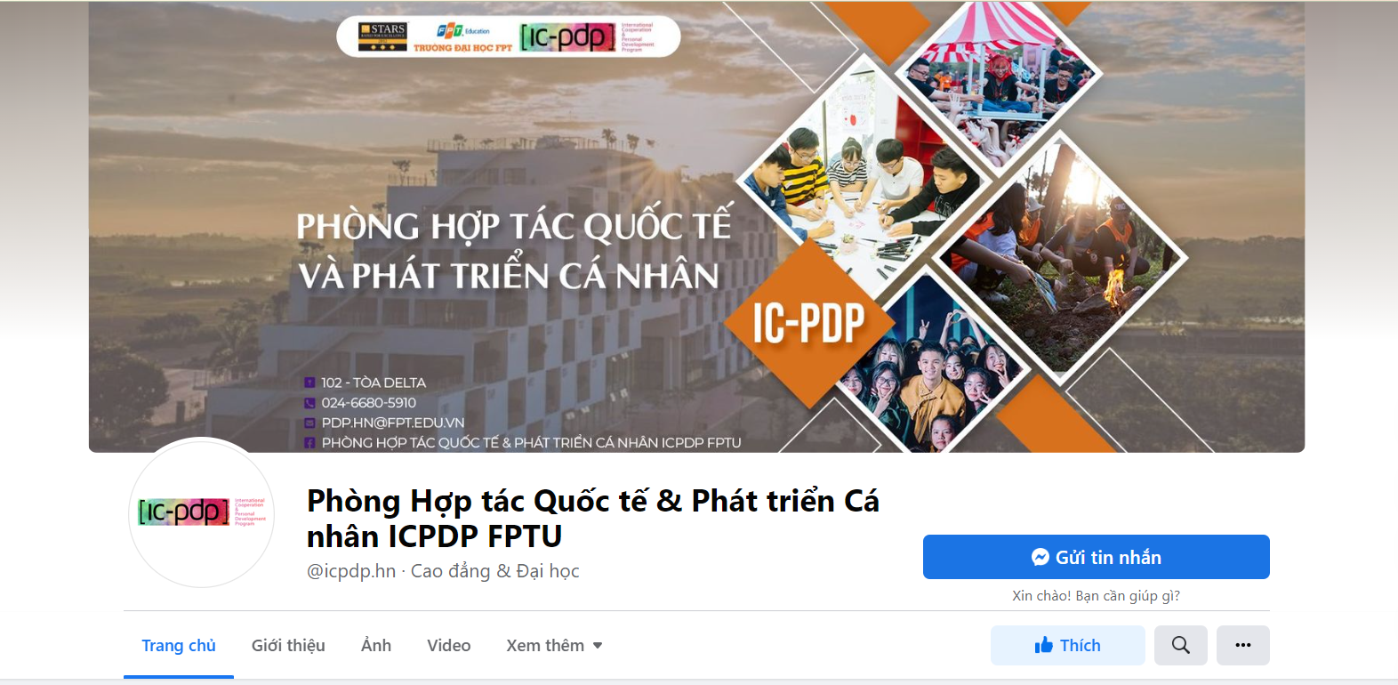

*Figure 2. Fanpage of IC-PDP on Facebook.*

One of the significant management areas of IC-PDP is club management. Through our research, currently, IC-PDP is managing the club through groups on Facebook and sending and exchanging requests and reports via Google Form, Google Sheets, and Mail. According to discussions with the staff of IC-PDP, the current management has many inconveniences and difficulties. With report aggregation, they are currently aggregating reports of 43 clubs manually by copying and pasting each report file into a single common report file. Such a way of working not only wastes their time and effort but sometimes also lacks information about the clubs. In addition, because the exchanges and requests are often made via Facebook in the form of texting, it is difficult for them to review the history, which sometimes could lead to a lack of or missing information.

Difficulties and inconveniences in management make IC-PDP staff wish to have a dedicated management system to reduce manual operations, avoid loss of information, save time, and have a more professional workspace.

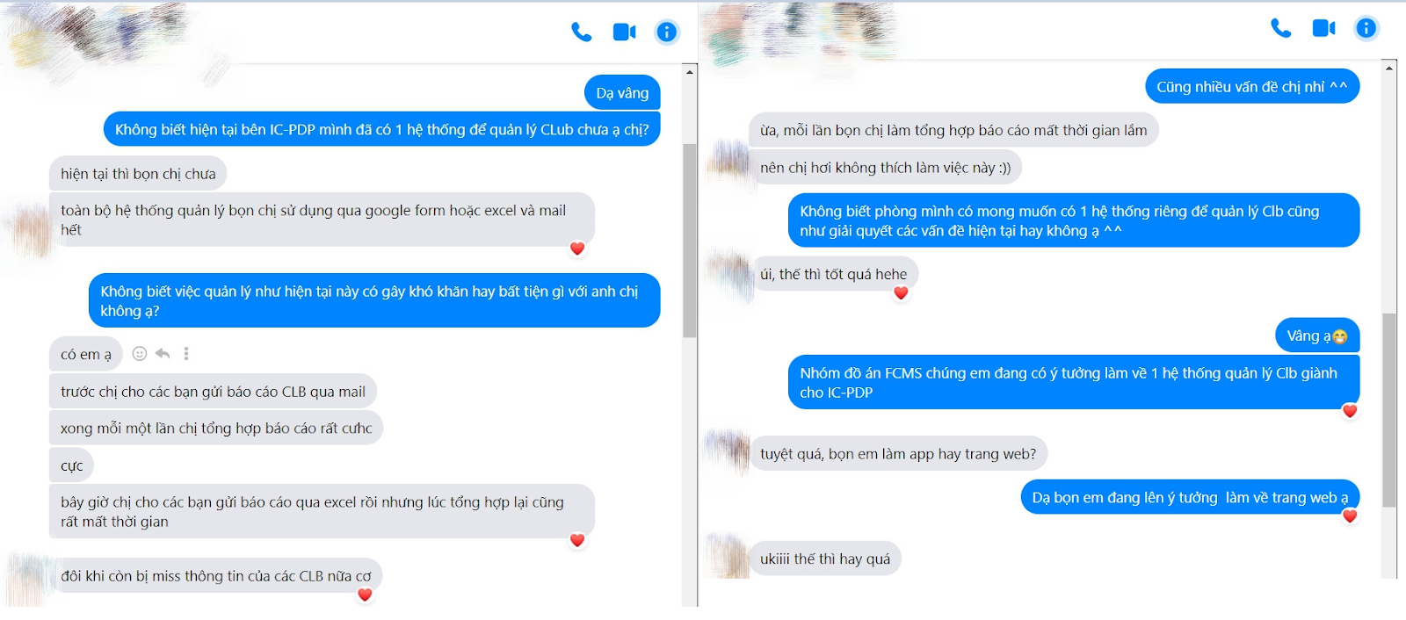

*Figure 3. The discussion about IC-PDP's current difficulties in club management with Ms. Nhat Ha - Manager of IC-PDP Division's Clubs Division.*

*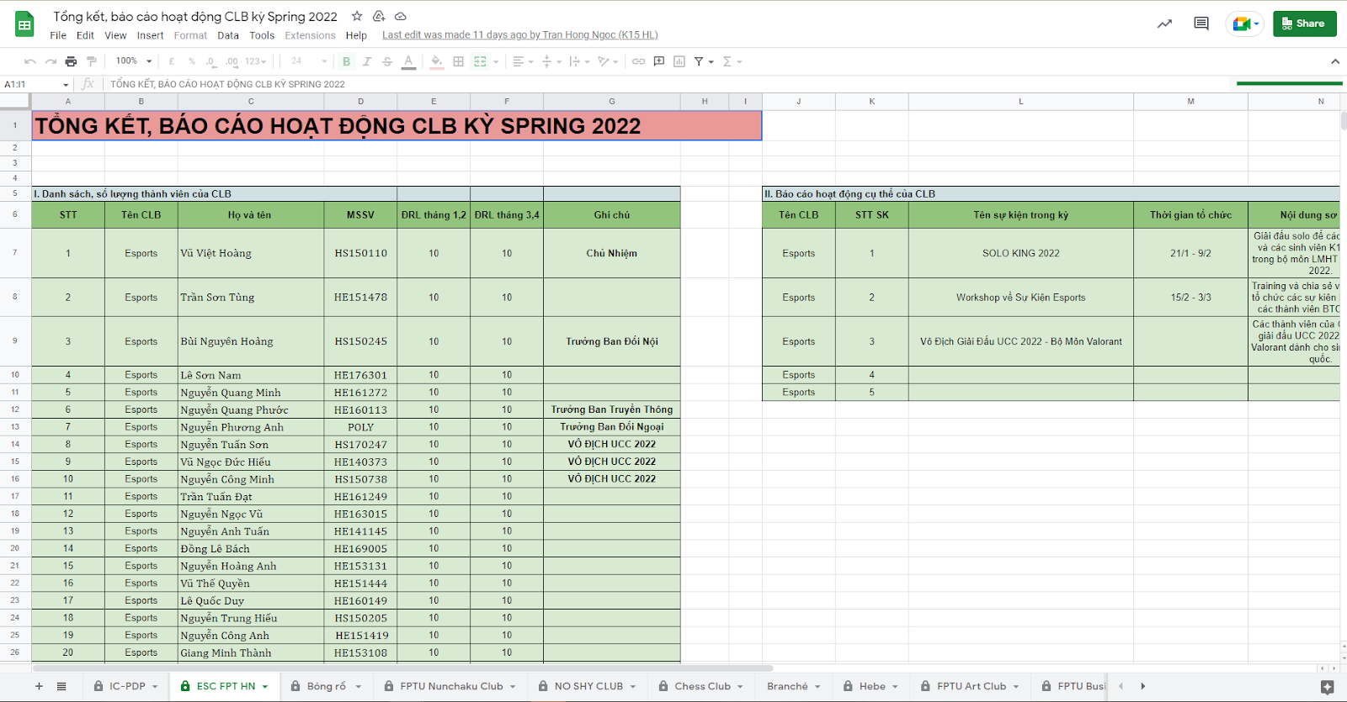Figure 4. Report on the end-of-term activities of a club managed by IC-PDP.*

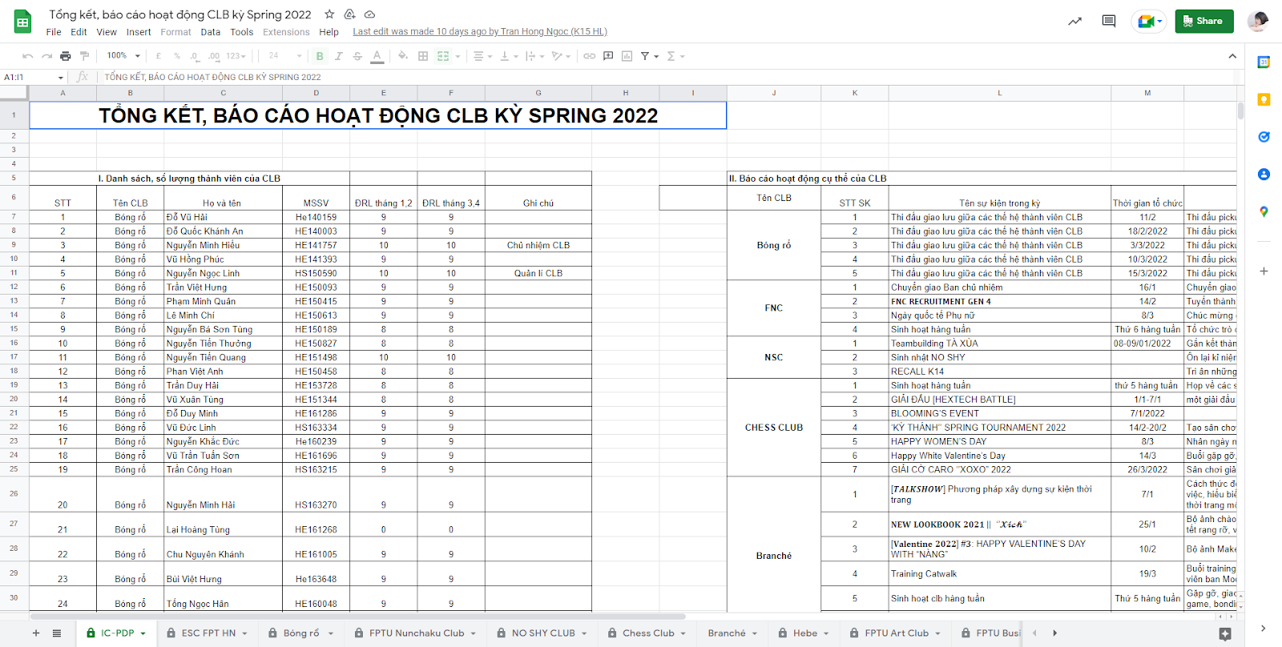

*Figure 5. IC-PDP summarises reports of 43 clubs into a standard file (file “IC-PDP”) by copying and pasting manually.*

Our system will solve those problems of IC-PDP’s members. We will create a professional management space connecting IC-PDP and clubs with a friendly, easy-to-use interface.

## 3. Existing Systems

According to our team's research, currently, FPT Education has no dedicated system to manage clubs. Our customer - IC-PDP department currently only uses Facebook groups, chat groups, Gmail, and Google Drive to manage the clubs.

## 4. Business Opportunity

Our system was developed from favorable factors in the external environment to help the IC-PDP department achieve its purpose of effective management by including important attributes of business opportunities.

Attractiveness: Currently, IC-PDP does not have or has not used any system to manage clubs. That means that our system is unique, there is no competition, and it is suitable for current usage needs.

Timing: With the rapid development in the quality of the training environment, and the massive surge in the number of FPT students leading to the rise of clubs both in quantity and quality, management will become easier if there is a management support system.

Stability - Products and services-oriented: IC-PDP and clubs all receive added value. From saving time and effort in contacting, maintaining, and managing work, this will be a necessary and suitable platform and system for users.

## 5. Software Product Vision

Our system will provide a centralized and professional working environment and solve the remaining problems and difficulties in the management stage of the IC-PDP department such as summarising reports and resolving club requests, tracking club activities, etc... We also provide features such as meeting management so that users can easily create and track meeting schedules and manage notifications to send important notices to the clubs. Not only that, but we also have a news website so that IC-PDP can promote themselves and the clubs, and also a place for people to find out more information related to IC- PDP and clubs easily.

## 6. Project Scope & Limitations

### 6.1 Major Features

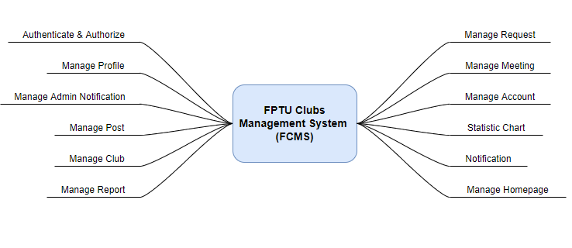

*Figure 6. Major features*

| **ID** | **Feature & Description** |
| --- | --- |
| FE-01 | Authenticate & Authorise: Users must have an authentication account to access other features on the system. Different roles have access to other features. This feature supports users to register an account, sign in/sign out of an account, reset the password, change the password and filter user access based on permission. |
| FE-02 | Manage Profile: This feature set includes personal profile management that provides for viewing, updating the user's profile, and updating the user's avatar. |
| FE-03 | Manage Admin Notification: This feature set includes features to create and update a notification. When the Admin publicizes the notification, the user who has access will receive a notification in the system, an email about this notification, and receive a notification on the user’s device. |
| FE-04 | Manage Post: This feature set includes features to view the posts list and create, update, and delete posts. When the admin published posts, all users can view this. |
| FE-05 | Manage Club: Club Managers can update/edit their club’s information. All users can view this information. Admin can update the list of 5 excellent clubs of the semester and view the history of excellent clubs of previous semesters. |
| FE-06 | Manage Report: Club Manager can create a report that includes downloading the report template, filling form report, and uploading the attached file. The user who has access can view all list reports, view detail reports, search reports by any keyword, and filter reports by creator/report type/create date/reviewer/priority. After receiving the report, the Admin/Collaborator will review the report and give a response to the Club Manager. If the report type is “Báo cáo theo sự kiện”, Admin/Collaborator can evaluate according to the criteria. |
| FE-07 | Manage Request: Club Manager can create a request that includes filling the form request, and uploading the attached file. The user who has access can view all list requests, view detail requests, search requests by any keyword, and filter requests by creator/report type/create date/reviewer. After receiving the request, the Admin/Collaborator will review the request and give a response to the Club Manager. |
| FE-08 | Manage Meeting: This feature set includes features to view the schedule of all meetings of everyone, create a meeting, cancel a meeting, set participants, is accepted/declined by the participant, and view the detailed description of the meeting that can only by the participant. |
| FE-09 | Manage Account: Admin can view list accounts, list banned accounts, create account invitations, set permission for Collaborators, accept/decline accounts, and ban or remove accounts. |
| FE-10 | Statistic Chart: This feature set includes features to view a Statistical chart of the number of users, a Statistical chart of the number of reports and requests, and The chart compares the activity level between the clubs of the same type, Statistics of web visits (Google Analysis). |
| FE-11 | Notification: Users can view the list of notifications of other features and campaign notifications. |
| FE-12 | Manage Homepage: This feature set includes features to view/update IC-PDP’s information, view/update slider, view/update IC-PDP’s members, view/update excellent individuals in the semester, and view the history of excellent individuals of previous periods semesters. |

*Table 3. List of major features.*

### 6.2 Limitations & Exclusions

Due to time constraints and current customer needs, we have 3 limitations and 1 exclusion which are mentioned below, although we are aware that they are quite useful and necessary features.

#### *6.2.1 Limitations*

| **ID** | **Feature & Description** |
| --- | --- |
| LI-01 | The system only supports web applications and does not support Mobile versions. |
| LI-02 | The system shall be used only for IC-PDP department in FPTU Hoa Lac. |
| LI-03 | The system only supports the Vietnamese language. |

*Table 6.2.1 Limitations*

#### *6.2.2 Exclusions*

| **ID** | **Feature & Description** |
| --- | --- |
| EX-01 | The system focuses on the main subjects of Admin - IC-PDP and club management, so there are not many features for other objects such as guests and students. |

*Table 4. Exclusions*

# II. Project Management Plan

## 1. Overview

### 1.1 Scope & Estimation

| **#** | **WBS Item** | **Complexity** | **Est.Effort (Man-days)** |
| --- | --- | --- | --- |
|
| ***1.*** | ***Authenticate & Authorise*** |  | **19.0** |
| 1.1 | Register Account | Medium | 9.0 |
| 1.2 | Sign in Account | Medium | 4.0 |
| 1.3 | Sign out Account | Simple | 1.0 |
| 1.4 | Reset Password | Medium | 3.0 |
| 1.5 | Change Password | Simple | 2.0 |
| ***2.*** | ***Manage Profile*** |  | **6.0** |
| 2.1 | View Profile | Simple | 2.0 |
| 2.2 | Update Profile | Medium | 4.0 |
| ***3.*** | ***Manage Admin Notification*** |  | **11.5** |
| 3.1 | View List Admin Notifications | Simple | 1.5 |
| 3.2 | Create Admin Notification | Medium | 2.0 |
| 3.3 | Filter Admin Notifications | High | 3.0 |
| 3.4 | Search Admin Notifications By Any Keyword | High | 3.0 |
| 3.5 | Send Notification To All Users Automatically | Medium | 2.0 |
| ***4.*** | ***Manage Post*** |  | **29.0** |
| 4.1 | View List Posts | Simple | 2.0 |
| 4.2 | View Detail A Post | Simple | 2.0 |
| 4.3 | Create Post | Medium | 3.0 |
| 4.4 | Edit Post | Medium | 3.0 |
| 4.5 | Delete Post | Simple | 1.0 |
| 4.6 | Search Posts By Any Keyword | High | 4.0 |
| 4.7 | Filter Posts | High | 4.0 |
| 4.8 | Like Post | Medium | 2.0 |
| 4.9 | Share Post | High | 4.0 |
| 4.11 | Send Notification To Creator Of Post When Post is Liked/Shared/Commented Automatically | Medium | 4.0 |
| ***5.*** | ***Manage Club*** |  | **38.0** |
| 5.1 | View List Clubs | Simple | 2.0 |
| 5.2 | View Club’s Information | Simple | 2.0 |
| 5.3 | View Club’s Organization | Simple | 3.0 |
| 5.4 | Search Clubs By Any Keyword | High | 4.0 |
| 5.5 | Update Club’s Information | High | 11.0 |
| 5.6 | Update Club’s Organization | Medium | 2.5 |
| 5.7 | Export File Club’Organization | Simple | 2.0 |
| 5.8 | Import File Club’Organization | Medium | 3.0 |
| 5.9 | View List History Excellent Clubs | Simple | 2.0 |
| 5.10 | Add Excellent Clubs | Medium | 4.0 |
| 5.11 | Update Excellent Clubs In The Semester | Medium | 2.5 |
| ***6.*** | ***Manage Report*** |  | **48.0** |
| 6.1 | View List Unprocessed Reports Of All Clubs | Simple | 2.0 |
| 6.2 | View List Processed Reports Of All Clubs | Simple | 2.0 |
| 6.3 | View List Report Of A Club | Simple | 2.0 |
| 6.4 | View Detail Report | Simple | 2.0 |
| 6.5 | View Online/Download Attached File Report | Medium | 3.0 |
| 6.6 | Review Report | Medium | 3.0 |
| 6.7 | Create Report | High | 4.5 |
| 6.8 | Filter Reports | High | 4.0 |
| 6.9 | Search Reports By Any Keyword | High | 4.0 |
| 6.10 | View List History Final Report Semester | Medium | 3.0 |
| 6.11 | Generate Report Semester Automatically | Medium | 5.5 |
| 6.12 | Delete Report Automatically Yearly | Medium | 5.0 |
| 6.13 | Send Notification To Remind 1 Day Before Deleting Reports Automatically | Medium | 4.0 |
| 6.14 | Send Notification To Remind Review Report Overdue 3-5 Days Automatically | Medium | 4.0 |
| ***7.*** | ***Manage Request*** |  | **39.5** |
| 7.1 | View List Unprocessed Requests Of All Clubs | Simple | 2.0 |
| 7.2 | View List Being Processed Requests Of All Clubs | Simple | 2.0 |
| 7.3 | View List Approved Requests Of All Clubs | Simple | 2.0 |
| 7.4 | View List Requests Of A Club | Simple | 2.0 |
| 7.5 | View Detail Request | Simple | 2.0 |
| 7.6 | View Online/Download Attached File Request | Medium | 4.0 |
| 7.8 | Review Request | Simple | 2.0 |
| 7.9 | Create Request | High | 4.0 |
| 7.10 | Filter Requests | High | 4.0 |
| 7.11 | Search Requests By Any Keyword | High | 4.0 |
| 7.12 | Delete Requests Automatically Yearly | Medium | 3.5 |
| 7.13 | Send Notification To Remind 1 Day Before Deleting Requests Automatically | Medium | 4.0 |
| 7.14 | Send Notification To Remind Review Requests Overdue 3-5 Days Automatically | Medium | 4.0 |
| ***8.*** | ***Manage Meeting*** |  | **28.0** |
| 8.1 | View All Meeting In Calendar | High | 6.0 |
| 8.2 | Filter Meetings | High | 4.0 |
| 8.3 | View Detail Meeting | Medium | 3.0 |
| 8.4 | Accept/Reject Meeting | Medium | 3.0 |
| 8.5 | Create A Meeting | Medium | 3.0 |
| 8.6 | Close A Meeting | Simple | 2.0 |
| 8.7 | View Number Of Participant Accept/Reject Meeting | Medium | 3.0 |
| 8.8 | Send Notification To Remind Join Meeting 1 Hour Before Meeting Started Automatically | Medium | 4.0 |
| ***9.*** | ***Manage Account*** |  | **55.5** |
| 9.1 | Accept/Reject Collaborator Account | Simple | 2.0 |
| 9.2 | View List Collaborator Account | Simple | 2.0 |
| 9.3 | View List Banned Collaborator Account | Simple | 2.0 |
| 9.4 | Ban Collaborator Account | Simple | 2.0 |
| 9.5 | Unban Collaborator Account | Simple | 2.0 |
| 9.6 | Send Invitation To Create Collaborator Account | Medium | 3.0 |
| 9.7 | Set Permission For Collaborator Account | High | 4.0 |
| 9.8 | Accept/Reject Club Manager Account | Simple | 3.0 |
| 9.10 | View List Club Manager Account | Simple | 2.0 |
| 9.11 | View List Banned Club Manager Account | Simple | 2.0 |
| 9.12 | Delete Club Manager Account | Simple | 3.0 |
| 9.13 | Ban Club Manager Account | Simple | 2.0 |
| 9.14 | Unban Club Manager Account | Simple | 2.0 |
| 9.15 | Send Invitation To Create Club Manager Account | Medium | 3.0 |
| 9.16 | Accept/Reject Admin Account | Simple | 2.0 |
| 9.17 | View List Admin Account | Simple | 2.0 |
| 9.18 | View List Banned Admin Account | Simple | 2.0 |
| 9.19 | Ban Admin Account | Simple | 2.0 |
| 9.20 | Unban Admin Account | Simple | 2.0 |
| 9.21 | Send Invitation To Create Admin Account | Medium | 3.0 |
| 9.22 | Search Account By Any Keyword | Medium | 4.0 |
| 9.23 | Send Notification To Notify Invitation To Create Account Not Response Automatically | High | 4.5 |
| ***10*** | ***Statistic Chart*** |  | **16.0** |
| 10.1 | Statistical Chart Of The Number Of Users | High | 4.0 |
| 10.2 | Statistical Chart Of The Number Of Reports And Requests | High | 5.0 |
| 10.3 | View Chart Compares The Activity Level Between The Clubs Of The Same Type | High | 4.0 |
| 10.4 | Statistics Of Web Visits (Google Analysis) | Medium | 3.0 |
| ***11*** | ***Notification*** |  | **21.0** |
| 11.1 | View List All Notifications | High | 9.0 |
| 11.2 | View List Read Notifications | High | 9.0 |
| 11.3 | Mark All Notifications As Read | Medium | 3.0 |
| ***12*** | ***Manage Homepage*** |  | **28.5** |
| 12.1 | View Banner | Simple | 2.0 |
| 12.2 | Update Banner | Medium | 3.0 |
| 12.3 | View IC-PDP’s Introduction | Simple | 2.0 |
| 12.4 | Update IC-PDP’s Introduction | Medium | 3.0 |
| 12.5 | View IC-PDP’s Member | Simple | 2.0 |
| 12.6 | Update IC-PDP’s Member | Medium | 3.0 |
| 12.7 | View 5 Excellent Individuals | Simple | 2.0 |
| 12.8 | Add 5 Excellent Individuals | Medium | 4.0 |
| 12.9 | Edit Excellent Individual’s Information | Medium | 3.0 |
| 12.10 | Add List Link Youtube | Simple | 2.0 |
| 12.11 | Add Image About IC-PDP | Simple | 2.5 |

| ***Total Estimated Effort (man-days)*** | ***340.0*** |
| --- | --- |

*Table 3. Scope and Estimation*

### 1.2 Coding Conventions

We strictly follow Airbnb JavaScript Style Guide.

Please refer to **JavaScript Style Guide - Airbnb.pdf** file or the official website at https://github.com/airbnb/javascript

### 1.3 Project Objectives

Objective:

* All team members will follow the task assigned.
* All team members learn new knowledge and new technology.

#### *1.3.1 Release quality commit*

| **#** | **Testing Stage** | **Test Coverage** | **No. of Defects** | **% of Defect** | **Notes** |
| --- | --- | --- | --- | --- | --- |
| 1 | Reviewing | 100% | 15 | 10% |  |
| 2 | Unit Test | 100% | 50 | 33.33% | Written and implemented by software developers to ensure that a part of an application (called a "unit") follows its design and functions as expected. |
| 3 | Integration Test | 100% | 30 | 20% | Individual software modules are combined and tested as a group. |
| 4 | System Test | 100% | 40 | 26.67% | Taken across the entire system, testing not only the design but also the behavior and even the raw expectations of the customer. |
| 5 | Acceptance Test | 100% | 15 | 10% | System users perform tests in accordance with what will happen in real-life scenarios. |

*Table 4. Defect distribution*

#### *1.3.2 Ensure implementation on schedule with allowable resources*

● Milestone Timeliness: 100%

● Allocated Effort: 345 man-days

### 1.4 Project Risks

| **#** | **Name** | **Impact** | **Possibility** | **Prevention** | **Correction** |
| --- | --- | --- | --- | --- | --- |
| R1 | **Internet interruptions** | High | High | All developers have to set up the isolated development environment and have an offline copy of the documentation. Using various online communication tools and creating face-to-face meetings at any possible time. | Always make sure that there are alternative ways to connect to the internet, such as: using VPN or 3G. |
| R2 | **Illness or absence of team members** | High | Medium | Members have to notify the team about the absence period and the plan of how to keep up with the work process. | Ensure that the absence of a member won’t affect others and always have plans to deal with this problem. |
| R3 | **Business problem** | High | Medium | Most of the business will be provided by the customer. In addition, the team will also develop some more ideas based on reality and possibility. | Make sure the business logic of any ideas is carefully analyzed. |
| R4 | **Requirement changed** | High | High | Requirement can be changed, added or removed by customer regularly. | All members discuss carefully at the start of each sprint to define the scope and requirements.  Make sure that resource allocations are changed correctly to accommodate the new requirements. |
| R5 | **Miscommunication** | High | Low | Everything has to be documented. Any team member has to attempt to express his/her opinion clearly and carefully. | Make sure any miscommunication has to be resolved. |
| R6 | **New technology** | Medium | Medium | Choosing technology based on member’s qualifications. All team members must nurture by self-study. | When someone chooses a new technology, he/she has to explain to all team members about the decision. |

*Table 5. Project risks*

## 2. Management Approach

### 2.1 Project Process

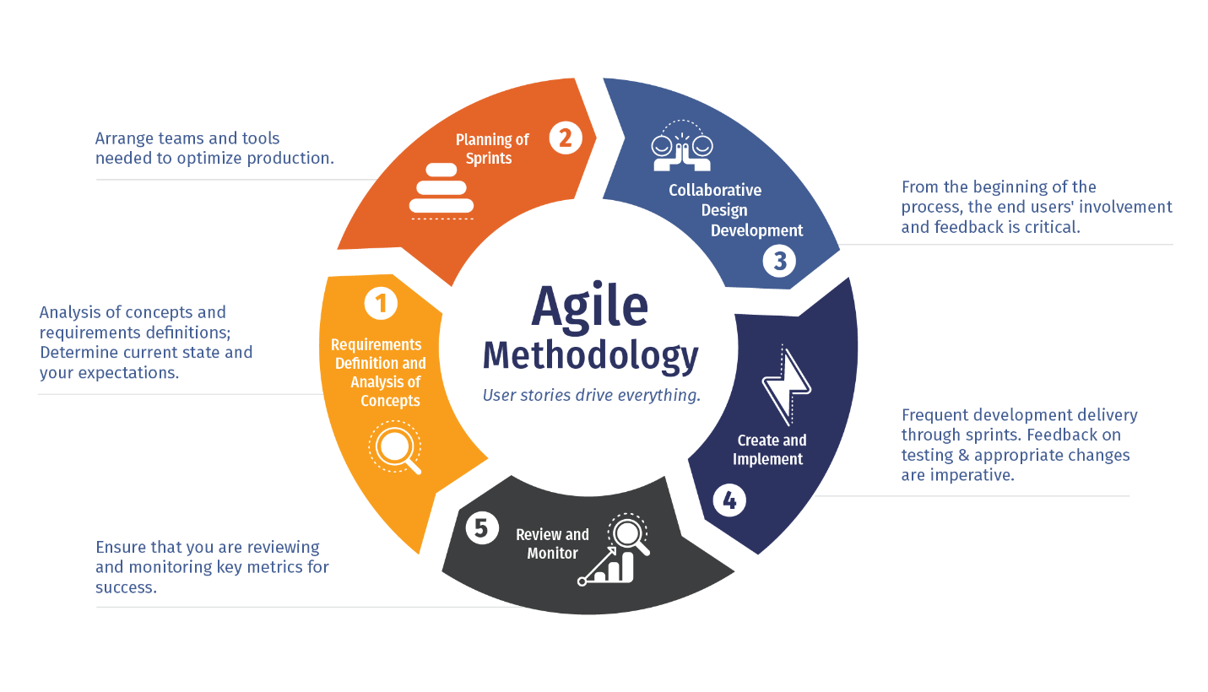

*Figure 7. Agile model*

FCMS has real users (IC-PDP, Club Managers). To update and release new functions, needs a fast and flexible process. Therefore, we use the Agile model, a set of iterative and incremental development methods in which requirements and solutions are developed through collaborative collaboration between self-managed teams. management and cross-functional groups. It is developed in a number of small stages and through iterative cycles until the entire product development process is complete. We chose this process model because the scope of this project is large and the key requirements are clearly defined, but we expect to add more details over time. The duration of each sprint is two weeks.

It has these advantages:

● Can easily change the scope of the project.

● Reduces the risk of building the product by increments.

● Optimizes the team’s efficiency and efficacy.

● Testing and debugging during smaller sprints are easier.

● The built-in functions are quick, clear, and easy to manage.

### 2.2 Quality Management

#### *2.2.1 Execute all processes of testing*

| **Testing Method** | **Target** |
| --- | --- |
| Review | The person responsible must be honest and unbiased to any member. If something goes wrong, this person must notify the person responsible for the defect.  Errors should be signed on bug tracking software with details such as priority.  The person responsible for found defects must act accordingly. |
| Unit Test | Isolate each part of the program and show that the individual parts are correct. |
| Integration Test | Performed to evaluate the conformity of a system or component to specific functional requirements. |
| System Test | Implement a complete system integration to assess the suitability of the system to its specific requirements. |
| Acceptance Test | Confident that the product developed meets functional and non-functional requirements. |

*Table 6. Level of testing*

#### *2.2.2 Follow the process of defect prevention*

| **Defect Type** | **Note** | **Action** |
| --- | --- | --- |
| CRITICAL | Errors that lead to complete failure, e.g. Can't load software. | Must repair immediately in the next construction step. |
| MINOR | The bug crashes the system but some features are still usable. | Must be fixed at any stage of construction, but must include detachments. |
| MAJOR | Cause problems but keep the software running. | Must correct the error after the split or the next split. |
| TRIVIAL | The errors are not related to the data or the operation of the software, but to the interface of the program. | Repairs may or may not be required. |

*Table 7. Process of defect prevention*

### 2.3 Training Plan

| **Training Area** | **Participants** | **Duration** | **When** | **Waiver Criteria** |
| --- | --- | --- | --- | --- |
| NodeJS | Backend team | 2 days | Sprint 0 | Mandatory |
| ReactJS | Frontend team | 2 days | Sprint 0 | Mandatory |
| AWS | All members | 1 week | Sprint 0 | Mandatory |
| Figma | Frontend team | 1 week | Sprint 0 | Mandatory |
| Git, Github | All members | 1 day | Sprint 0 | Mandatory |

*Table 8. Training plan*

## 3. Project Deliverables

| **#** | **Deliverable** | **Due Date** | **Notes** |
| --- | --- | --- | --- |
| 1 | Report 1: Project Introduction | 16/05/2022 |  |
| 2 | Report 2: Project Plan | 16/05/2022 | CP Topic Review & Group Division |
| 3 | Report 3: Software Requirement (SRS) | 23/05/2022 | Project Plan Review |
| 4 | Report 4: Software Design (SDD) | 30/05/2022 | Project & SRS Review, Project Review |
| 5 | Code Iteration 1 Plan & Demo | 27/06/2022 |  |
| 6 | Code Iteration 2 Plan & Demo | 11/07/2022 |  |
| 7 | Code Iteration 3 Plan & Demo | 25/07/2022 |  |
| 8 | Report 5: Software Test Document (STD) | 15/08/2022 | System Test Plan & Guide, Final Package Product Demo |
| 9 | Report 6: Software User Guides | 15/08/2022 | Team Weekly Meeting: Project & Software Package Review, Practice for Presentation of Capstone Project |
| 10 | Report 7: Final Project Report | 20/08/2022 | Includes all the final project documents (completed Reports No. 1-6, both soft copy & hard copy), Software Product, and thesis presentation slide |

*Table 9. Project deliverables*

## 4. Project Organization

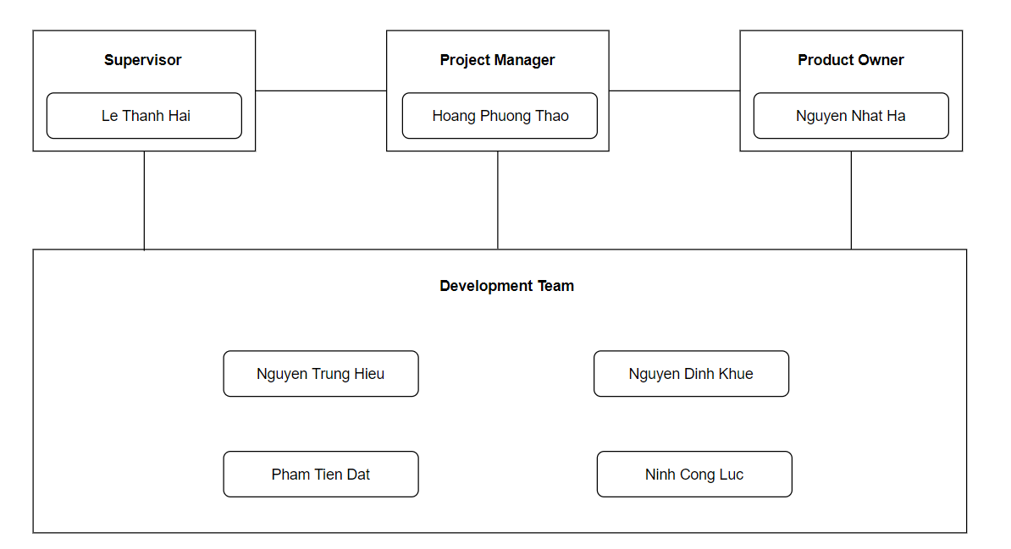

*Figure 8. Project Organization.*

| **Member** | **Roles** |
| --- | --- |
| Le Thanh Hai | Supervisor |
| Nguyen Nhat Ha | Product Owner (IC-PDP) |
| Hoang Phuong Thao | PM, BA, Tester |
| Nguyen Trung Hieu | Designer, Test Leader |
| Ninh Cong Luc | Backend Developer, Frontend Developer, Tester |
| Nguyen Dinh Khue | Backend Developer, DevOps, Tester |
| Pham Tien Dat | Frontend Developer, DevOps |

*Table 9. Member and Roles*

## 5. Responsibility Assignments

| **Responsibility** | **ThaoHPHE141702** | **HieuNT HE141706** | **LucNC HE140648** | **KhueND HE141599** | **DatPT HE141311** |
| --- | --- | --- | --- | --- | --- |
| Project Planning | D | I | I | I | I |
| Project Tracking | D | I | I | I | I |
| Prepare Project Introduction Document | D | R | R | R | R |
| Prepare SRS Document | D | S, R | S, R | S, R | S, R |
| Prepare SDD Document | D, R | I | D | D | D |
| Code Backend | S | I | D, R | D, R | I |
| Code Frontend | S | S | D | S | D, R |
| Deployment | I | I | D | D | D |
| Prepare Test Document and Report | R | D | S | S | I |
| Prepare User Guides | R | D | S | S | S |
| Prepare Final Report (all document and presentation slide) | D, R | S, R | R | R | R |

*Table 10. Responsibility assignments*

***Note:***

| D | Do |
| --- | --- |
| R | Review |
| S | Support |
| I | Informed |

## 

## 6. Project Communications

### 6.1 Communication Plan

| **Communication Item** | **Participants** | **Purpose** | **When Frequency** | **Type, Tool, Method(s)** |
| --- | --- | --- | --- | --- |
| Weekly Meeting with Supervisor | -Supervisor  -Team members | - The supervisor checks progress and reviews the quality of the product.  - Give new/updated features of the project | Every Wednesday from 16h - 17h30 | Google Meet(Online), AL204R(Offline) |
| Meeting with Product Owner | - Team members  - Product Owner  - Head and Staff of IC-PDP | - Ask about Requirements.  - Suggest Features.  - Show what is accomplished during the sprint.  - Take a demo of new/updated features.  - Give new/updated features of the project. | One time each 2-week | Google Meet(Online), DEL102L(Offline) |
| Weekly Meeting | Team members | - Review tasks  - Check the progress of tasks in the sprint.  - Support for hard problems | Every Saturday from 20h - 23h30 (Online) or  from 14h-17h30 (Offline) | Google Meet(Online), Library(Offline) |
| Daily Meeting | Team members | - Report Task  - Raise problems | Every day from 20h - 20h15 | Google Meet(Online) |
| Additional Meeting | Team members | Solving Issues | Anytime when team has problems | Google Meet(Online), Library(Offline) |

*Table 11. Communication plan*

### 6.2 External Interfaces

| **No** | **Contact Person**  **(name, position)** | **Contact address**  **(email, telephone)** | **Responsibility** |
| --- | --- | --- | --- |
| 1 | Bui Van Phu  (Manager of IC) | phubv@fpt.edu.vn | - Evaluate the completeness and usability of the features  - Give requirements for new/updated features |
| 2 | Nguyen Nhat Ha  (Officer of PDP - Manager of all clubs) | hann@fpt.edu.vn  0348914258 | - Evaluate the completeness and usability of the features  - Give requirements for new/updated features |
| 3 | Tran Hong Ngoc  (Collaborator of IC-PDP) |  | - Give comments and suggestions when experiencing the system |
| 4 | Pham Thuy Linh (President of FPTU Taekwondo Club) |  |
| 5 | Dao Thi Dieu Vi (President of Psychology Club) |  |
| 6 | Do Kieu Duc An (President of NoShy Club) |  |
| 7 | Cao Sy Long Vu (President of Vovinam Club) |  |
| 8 | Do Dinh Son (FU Street Workout Club) |  |
| 9 | Le Thi Ngoc Anh (Leader of Color Team) |  |
| 10 | Tran Khac Bang (President of FU Photography Club) |  |
| 11 | Nguyen Huong Huyen (President of FPTU English Club) |  |
| 12 | Tran Hong Ngoc  (President of iGo Club) |  |

*Table 12. Stake holder’s information and their responsibility*

## 7. Configuration Management

### 7.1 Document Management

Microsoft Office 365 is used to edit documents with OneDrive as storage. All team members can edit the document at the same time and the history is automatically saved. Thus, members can easily track document changes.

### 7.2 Source Code Management

Git is used to manage the source code of the project. Github is a remote repository for changing source code and it's easy to connect to AWS.

### 7.3 Tools & Infrastructures

| **Category** | **Tools / Infrastructure** |
| --- | --- |
| **Technology** | NodeJS (Backend), ReactJS(Frontend) |
| **External Service** | AWS S3, Cloudflare, Firebase Cloud Messaging, Gmail Service, Graph API |
| **Database** | DBeaver |
| **IDEs/Editors** | Visual Studio Code |
| **Deployment server** | EC2 (Backend), Vercel (Frontend) |
| **Version Control** | GitHub (Source Codes), Google Drive and Confluence (Documents) |
| **CI/CD** | GitHub |
| **Project management** | Jira (Schedule, Tasks, Defects, Manage Bugs) |
| **Testing Tools** | Jira, Chrome dev tools, Redux dev tools, Microsoft Excel, Postman, Mocha |
| **Other Tools** | Figma, Photoshop, Notion |
| **Documentation** | Microsoft Office, Google Docs/Sheets/Slides |
| **Diagramming** | Draw.io |
| **Communication** | Google Meet, Messenger |

*Table 13. Tools and infrastructures*

# III. Software Requirement Specification

## 1. Product Overview

FCMS is a website that helps solve club management issues of the IC-PDP department such as managing club information issues, reviewing reports, and club requests, and assessing the level Whether the club's activity level is positive or negative, thereby giving strategies and directions to manage the club system of FPT University. At the same time, FCMS also supports Club Managers in storing and providing their club's information, performing report submission tasks, and sending requests to the IC-PDP department. FCMS is also considered a place where the IC-PDP department can promote its image and that of the clubs to everyone through the FCMS homepage.

## 2. User Requirements

### 2.1 Actors

| **#** | **Actor** | **Description** |
| --- | --- | --- |
| 1 | Super Admin | Super Admin is the person who is responsible for managing the Admin account. |
| 2 | Admin | Admin is the official staff of the IC-PDP department who has the highest permission level and is responsible for managing the system. |
| 3 | Collaborator | Collaborator is the intern of the IC-PDP department who can do the actions that the Admin set permission for. |
| 4 | Club Manager | Club Manager is the manager of a club of FPTU. |
| 5 | Guest User | The person who signs in to the system by Facebook. |
| 6 | FCMS User | FCMS User is the person who has an FCMS account. That means FCMS User can be one of Super Admin, Admin, Collaborator, Club Manager. |
| 7 | Guest | Guest is the person who does not sign in to the system. |

*Table 14. Actors of FCMS*

### 2.2 Use Case Diagram(s)

#### *2.2.1. Level 0 – Actors with the system*

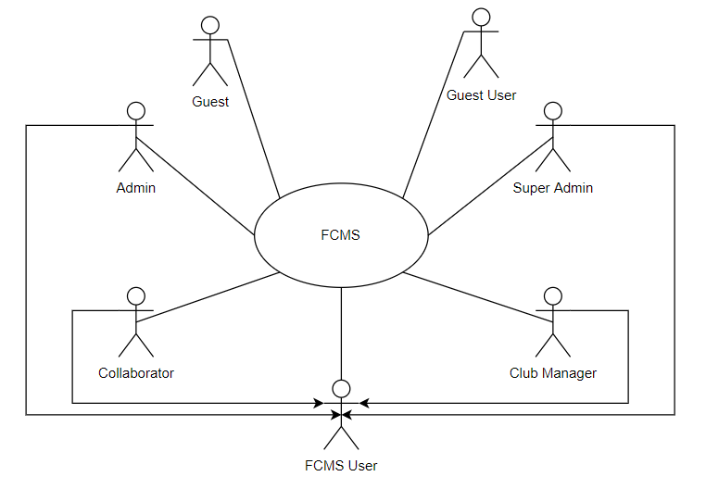

*Figure 9. Actors with the FCMS system*

#### *2.2.2. Level 1 – Actor with modules*

##### **a. Guest**

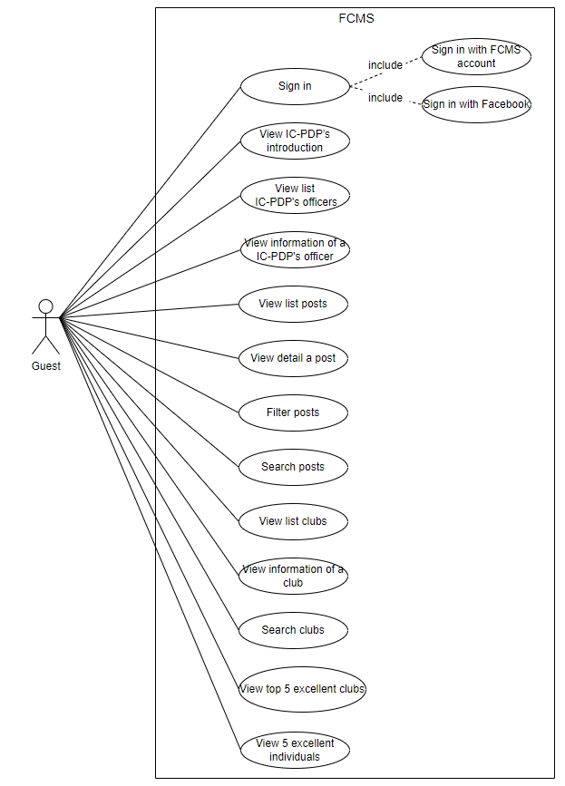

*Figure 10. Guest use cases*

##### **b. Guest User**

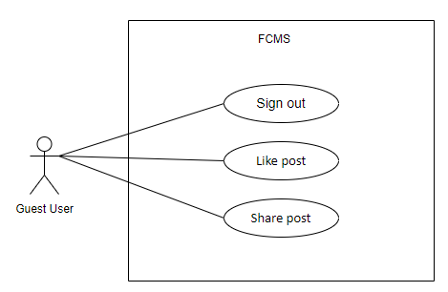

*Figure 11. Guest User use cases*

##### **c. FCMS User**

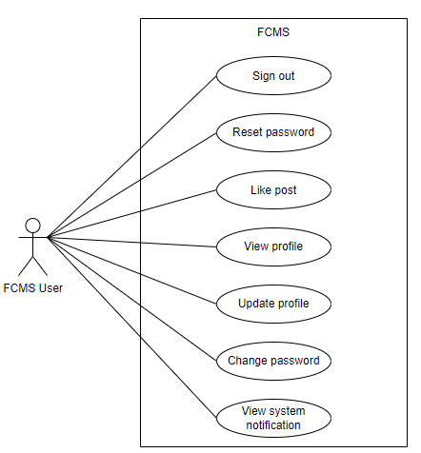

*Figure 12. FCMS User use cases*

##### **d. Super Admin**

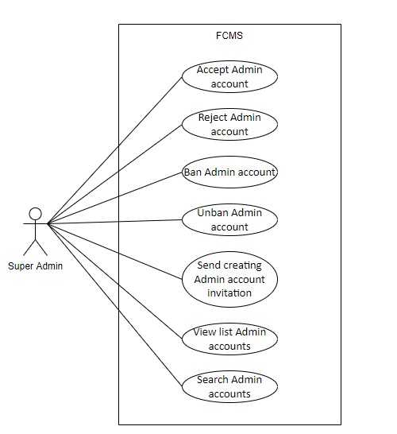

*Figure 13. Super Admin use cases*

##### **e. Admin**

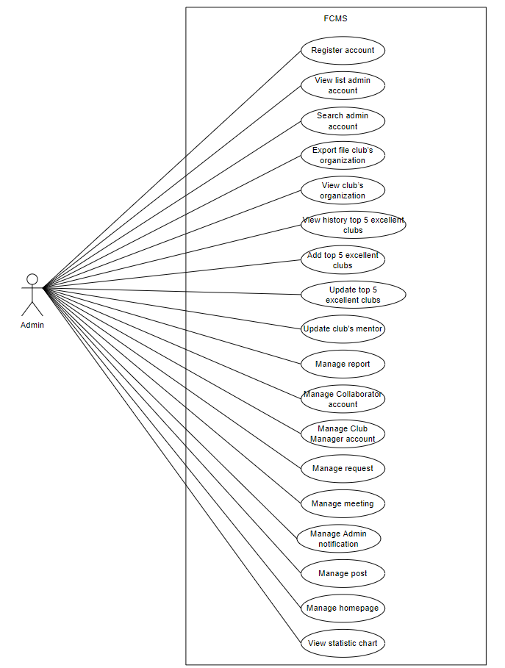

*Figure 14. Admin use cases*

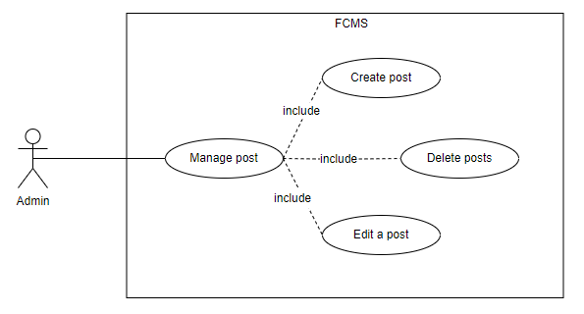

*Figure 15. Admin with ‘Manage post’ use cases*

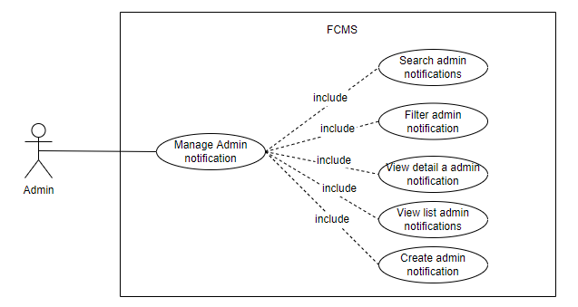

*Figure 16. Admin with ‘Manage Admin notification’ use cases*

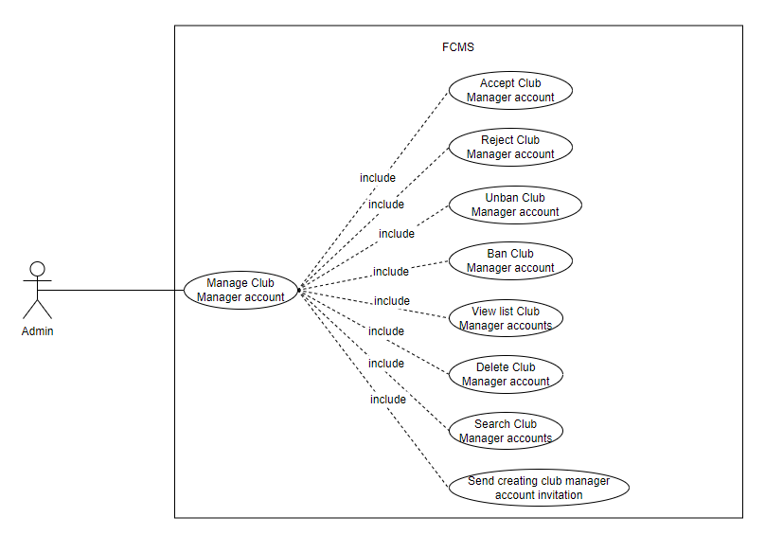

*Figure 17. Admin with ‘Manage Club Manager account’ use cases*

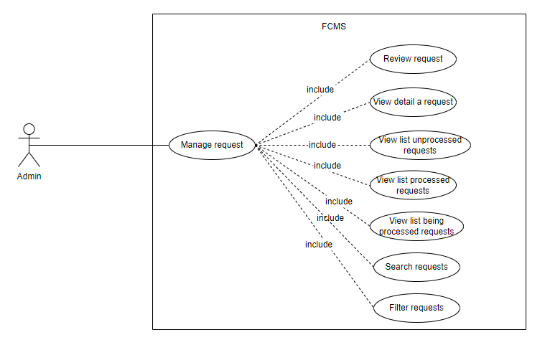

*Figure 18. Admin with ‘Manage request’ use cases*

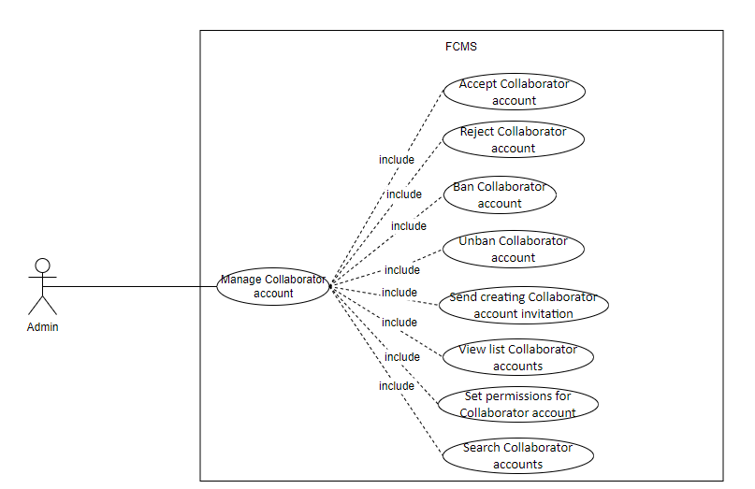

*Figure 19. Admin with ‘Manage Collaborator account’ use cases*

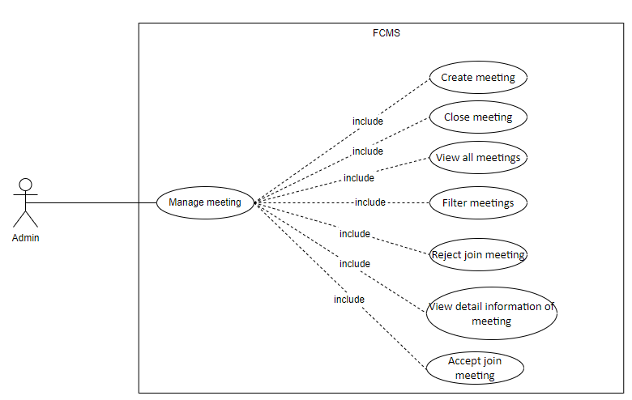

*Figure 20. Admin with ‘Manage meeting’ use cases*

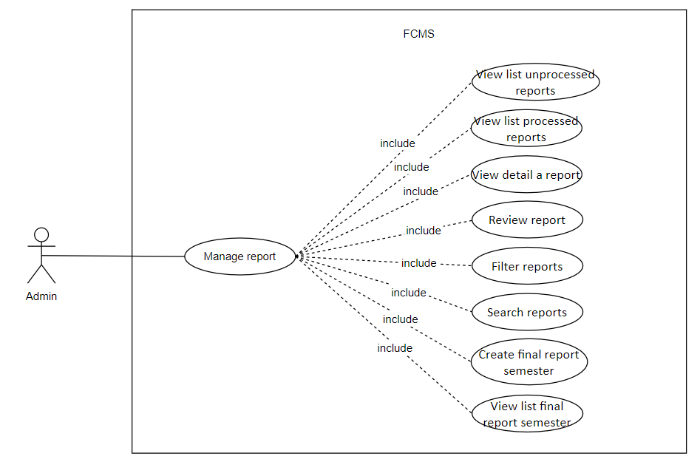

*Figure 21. Admin with ‘Manage report’ use cases*

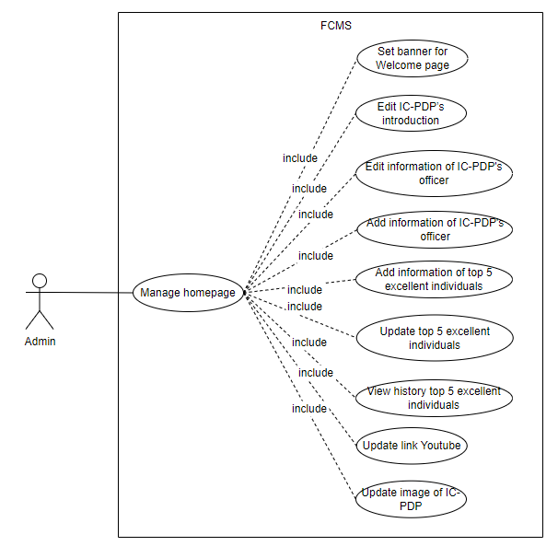

*Figure 22. Admin with ‘Manage homepage’ use case*

##### **f. Collaborator**

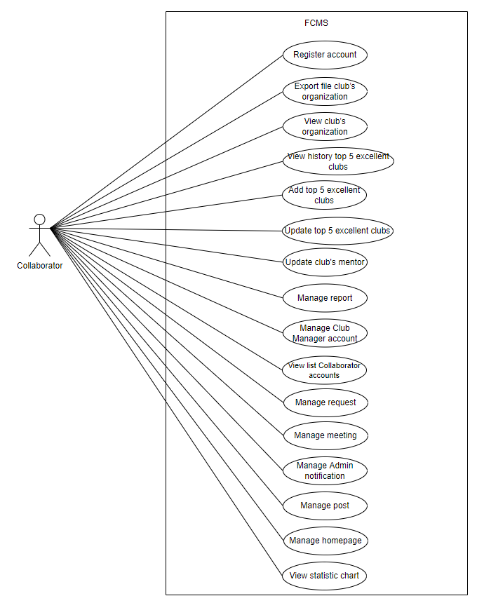

*Figure 23. Collaborator use cases*

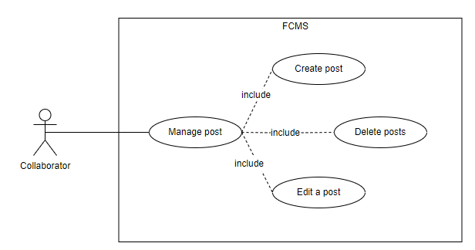

*Figure 24. Collaborator with ‘Manage post’ use cases*

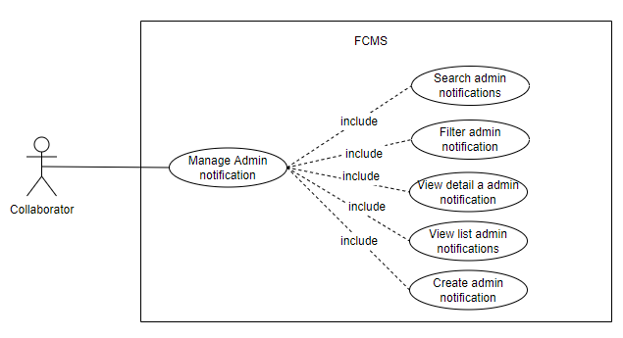

*Figure 25. Collaborator with ‘Manage Admin notification’ use cases*

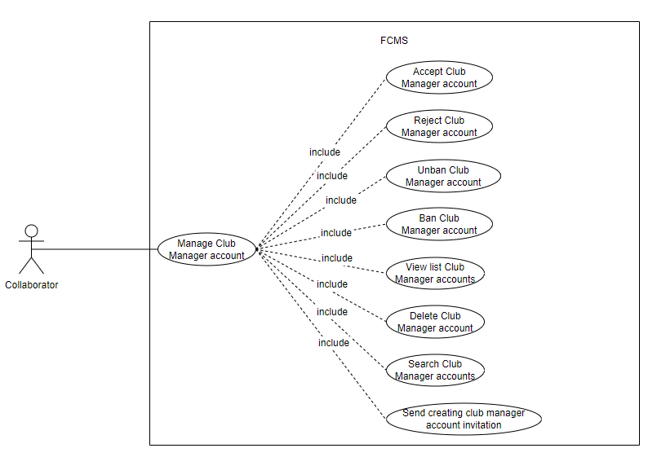

*Figure 26. Collaborator with ‘Manage Club Manager account’ use cases*

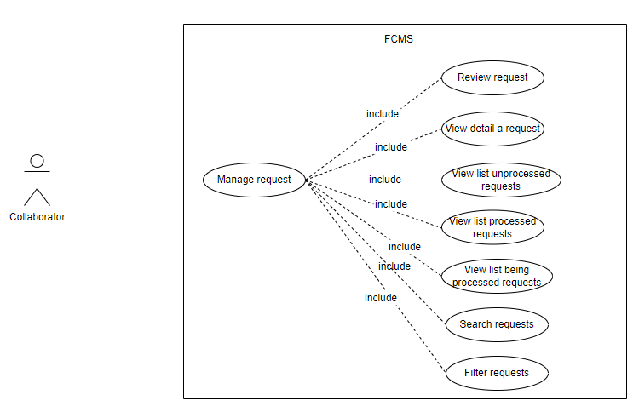

*Figure 27. Collaborator with ‘Manage request’ use cases*

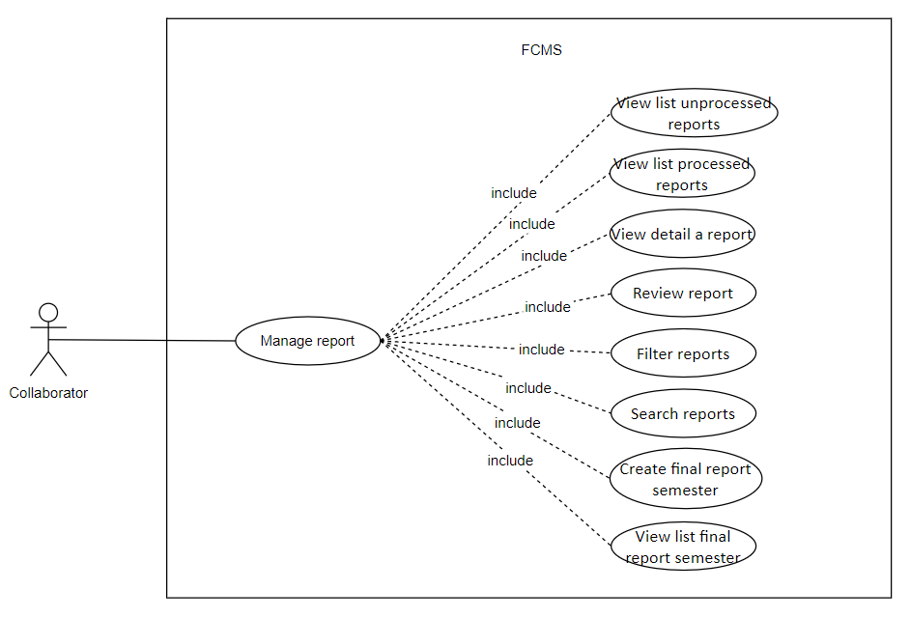

*Figure 28. Collaborator with ‘Manage report’ use cases*

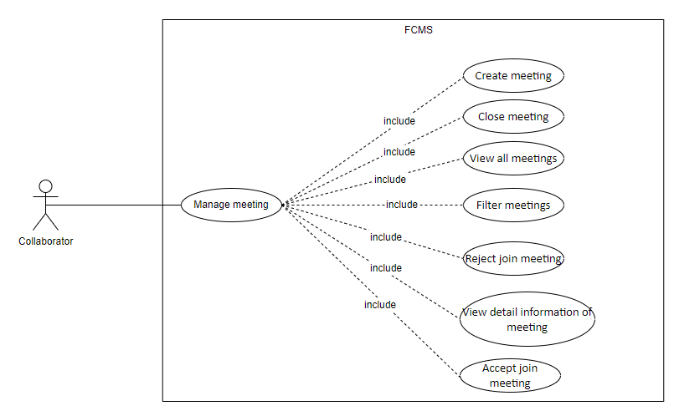

*Figure 29. Collaborator with ‘Manage meeting’ use cases*

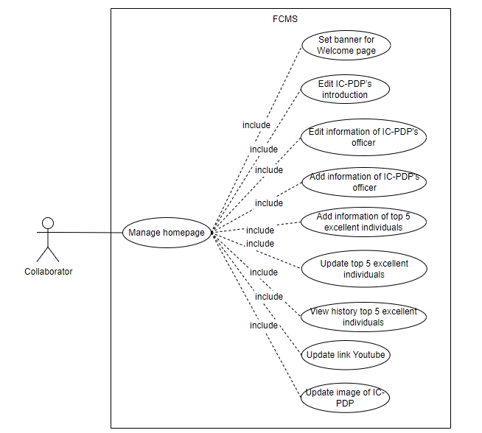

*Figure 30. Collaborator with ‘Manage homepage’ use cases*

##### **g. Club Manager**

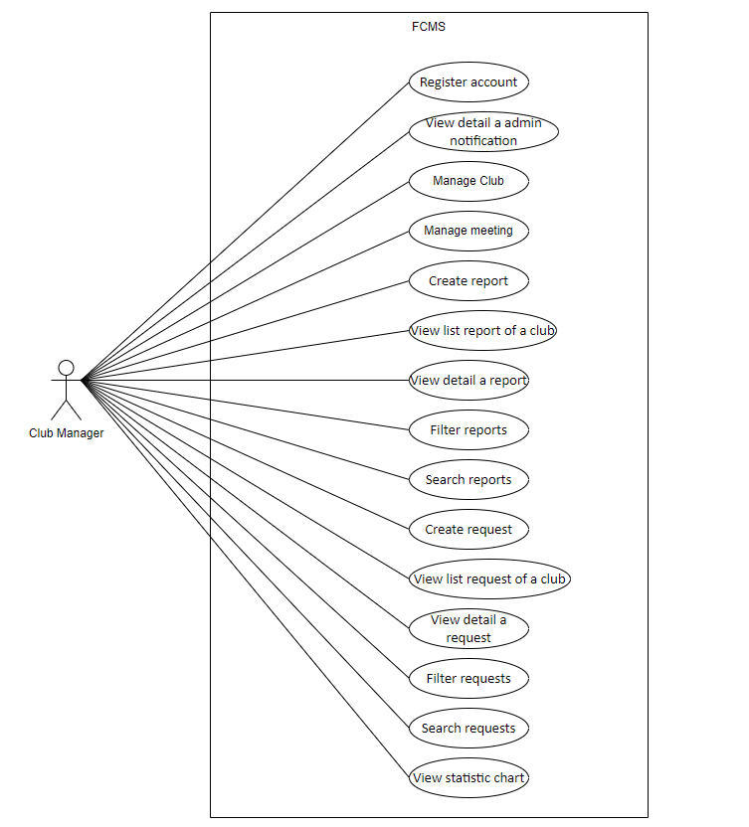

*Figure 31. Club Manager use cases*

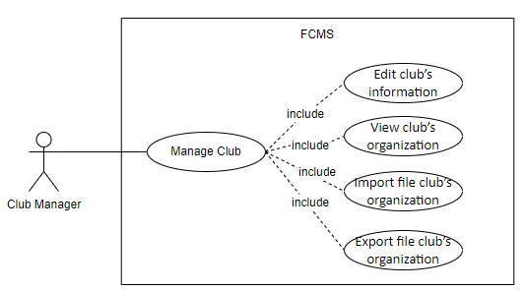

*Figure 32. Club Manager with ‘Manage club’ use cases*

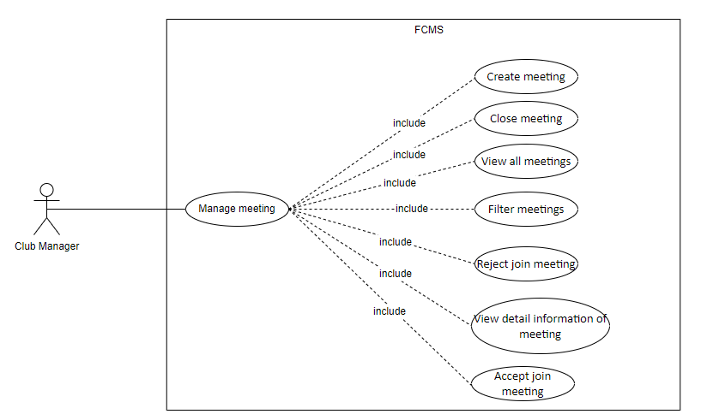

*Figure 33. Club Manager with ‘Manage meeting’ use cases*

### 

### 2.3 Use Case List

| **ID** | **Primary Actor** | **Name** |
| --- | --- | --- |
| UC-1 | Guest | Sign in with Facebook account |
| UC-2 | Guest | Sign in with FCMS account |
| UC-3 | Guest User, FCMS User | Sign out |
| UC-4 | FCMS User | Reset password |
| UC-5 | Admin, Collaborator, Club Manager | Register account |
| UC-6 | FCMS User | View profile |
| UC-7 | FCMS User | Update profile |
| UC-8 | FCMS User | Change password |
| UC-9 | Super Admin | Accept admin account |
| UC-10 | Super Admin | Reject admin account |
| UC-11 | Super Admin | Ban admin account |
| UC-12 | Super Admin | Unban admin account |
| UC-13 | Super Admin | Send creating admin account invitation |
| UC-14 | Super Admin, Admin | View list admin accounts |
| UC-15 | Super Admin, Admin | Search admin accounts |
| UC-16 | FCMS User | View system notification |
| UC-17 | Admin, Collaborator | Create admin notification |
| UC-18 | Admin, Collaborator | View list admin notifications |
| UC-19 | Admin, Collaborator, Club Manager | View detail a admin notification |
| UC-20 | Admin, Collaborator | Edit information of IC-PDP’s officer |
| UC-21 | Admin, Collaborator | Filter admin notifications |
| UC-22 | Admin, Collaborator | Search admin notifications |
| UC-23 | Guest | View IC-PDP’s introduction |
| UC-24 | Guest | View list posts |
| UC-25 | Guest | View detail a post |
| UC-26 | Guest User, FCMS User | Like post |
| UC-27 | Guest User | Share post |
| UC-28 | Guest | View list IC-PDP’s officers |
| UC-29 | Admin, Collaborator | Update information of top 5 excellent individuals |
| UC-30 | Admin, Collaborator | View history top 5 excellent individuals |
| UC-31 | Guest | View 5 excellent individuals |
| UC-32 | Admin, Collaborator | Create post |
| UC-33 | Admin, Collaborator | Delete posts |
| UC-34 | Admin, Collaborator | Edit a post |
| UC-35 | Guest | Filter posts |
| UC-36 | Guest | Search posts |
| UC-37 | Guest | View top 5 excellent clubs |
| UC-38 | Guest | View list clubs |
| UC-39 | Guest | View information of a club |
| UC-40 | Club Manager | Edit club’s information |
| UC-41 | Admin, Collaborator, Club Manager | View club’s organization |
| UC-42 | Club Manager | Import file club’s organization |
| UC-43 | Admin, Collaborator, Club Manager | Export file club’s organization |
| UC-44 | Guest | Search clubs |
| UC-45 | Club Manager | Create report |
| UC-46 | Admin, Collaborator | View list unprocessed reports |
| UC-47 | Admin, Collaborator | View list processed reports |
| UC-48 | Club Manager | View list report of a club |
| UC-49 | Admin, Collaborator, Club Manager | View detail a report |
| UC-50 | Admin, Collaborator | Review report |
| UC-51 | Admin, Collaborator, Club Manager | Filter reports |
| UC-52 | Admin, Collaborator, Club Manager | Search reports |
| UC-53 | Admin, Collaborator | Create final report semester |
| UC-54 | Admin, Collaborator | View list final report semester |
| UC-55 | Club Manager | Create request |
| UC-56 | Admin, Collaborator | View list unprocessed requests |
| UC-57 | Admin, Collaborator | View list processed requests |
| UC-58 | Club Manager | View list requests of a club |
| UC-59 | Admin, Collaborator, Club Manager | View detail a request |
| UC-60 | Admin, Collaborator | Review request |
| UC-61 | Admin, Collaborator, Club Manager | Filter requests |
| UC-62 | Admin, Collaborator, Club Manager | Search requests |
| UC-63 | Admin, Collaborator, Club Manager | Create meeting |
| UC-64 | Admin, Collaborator, Club Manager | Close meeting |
| UC-65 | Admin, Collaborator, Club Manager | View all meetings |
| UC-66 | Admin, Collaborator, Club Manager | Filter meetings |
| UC-67 | Admin, Collaborator, Club Manager | View detail information of meeting |
| UC-68 | Admin, Collaborator, Club Manager | Accept join meeting |
| UC-69 | Admin, Collaborator, Club Manager | Reject join meeting |
| UC-70 | Admin, Collaborator | Accept Club Manager account |
| UC-71 | Admin, Collaborator | Reject Club Manager account |
| UC-72 | Admin, Collaborator | Ban Club Manager account |
| UC-73 | Admin, Collaborator | Unban Club Manager account |
| UC-74 | Admin, Collaborator | Send creating Club Manager account invitation |
| UC-75 | Admin, Collaborator | View list Club Manager accounts |
| UC-76 | Admin, Collaborator | Delete Club Manager account |
| UC-77 | Admin, Collaborator | Search Club Manager accounts |
| UC-78 | Admin | Accept Collaborator account |
| UC-79 | Admin | Reject Collaborator account |
| UC-80 | Admin | Ban Collaborator account |
| UC-81 | Admin | Unban Collaborator account |
| UC-82 | Admin | Send creating Collaborator account invitation |
| UC-83 | Admin, Collaborator | View list Collaborator accounts |
| UC-84 | Admin | Set permissions for Collaborator account |
| UC-85 | Admin, Collaborator | Search Collaborator accounts |
| UC-86 | Admin, Collaborator, Club Manager | View statistic chart |
| UC-87 | Admin, Collaborator | Set banner for Welcome page |
| UC-88 | Admin, Collaborator | Edit IC-PDP’s introduction |
| UC-89 | Admin, Collaborator | Update top 5 excellent clubs |
| UC-90 | Admin, Collaborator | View history top 5 excellent clubs |
| UC-91 | Admin, Collaborator | View list being processed requests |
| UC-92 | Admin, Collaborator | Update link Youtube |
| UC-93 | Admin, Collaborator | Update image of IC-PDP |
| UC-94 | Admin, Collaborator | Add information of IC-PDP’s officer |
| UC-95 | Admin, Collaborator | Add top 5 excellent clubs |
| UC-96 | Admin, Collaborator | Add information of top 5 excellent individuals |
| UC-97 | Admin, Collaborator | Update club’s mentor |

*Table 15. List of use cases*

### 2.4 Use Case Specification

#### *2.4.1 Sign in with Facebook account*

| **Use Case ID** | **UC-1** | | |
| --- | --- | --- | --- |
| **Use Case Name** | **Sign in with Facebook account** | | |
| **Create By:** | **ThaoHP** | **Create Date:** | **05/06/2022** |
| **Primary Actor:** | **Guest** | **Secondary Actors:** | **N/A** |
| **Description:** | Guest sign in the system by Facebook. | | |
| **Trigger:** | N/A | | |
| **Preconditions:** | **PRE-1.1.** Guest has Facebook account. | | |
| **Post-Condition:** | **POST-1.1.** Guest is signed into FCMS successfully.  **POST-1.2.** The system displays the home page. | | |
| **Normal Flow:** | 1. Guest visits website.  2. System displays Welcome page.  3. Guest clicks “Đăng nhập” in the top right corner.  4. System displays the sign in form as a popup.  5. Guest clicks “Đăng nhập bằng Facebook” button to log in with Facebook account.  6. Browser displays Facebook sign in form.  7. Guest enters username and password of Facebook account.  8. Facebook verifies credentials and closes the popup.  9. System directs to home page. | | |
| **Alternative Flow:** | 1.1 Guest has already signed in to Facebook account (Step 6)  1. Browser displays Facebook confirm the signed form.  2. Guest clicks to confirm Facebook account. | | |
| **Exceptions** | **1-E1**. Cannot communicate with API server:  1. FCMS displays the error message MSG-01. | | |
| **Priority:** | High | | |
| **Frequency of Use:** | High | | |
| **Business Rules:** | **BR-1, BR-2** | | |
| **Other Information:** | N/A | | |
| **Assumptions:** | N/A | | |

*Table 16. Sign in with Facebook account use case specification*

#### *2.4.2 Sign in with FCMS account*

| **Use Case ID** | **UC-2** | | |
| --- | --- | --- | --- |
| **Use Case Name** | **Sign in with FCMS account** | | |
| **Create By:** | **ThaoHP** | **Create Date:** | **05/06/2022** |
| **Primary Actor:** | **Guest** | **Secondary Actors:** | **N/A** |
| **Description:** | Guest sign in system by FCMS account. | | |
| **Trigger:** | N/A | | |
| **Preconditions:** | **PRE-2.1.** Guest has FCMS account.  **PRE-2.2.** The guest’s account is activated. | | |
| **Post-Condition:** | **POST-2.1.** Guest is signed into FCMS successfully.  **POST-2.2.** The system displays the home page. | | |
| **Normal Flow:** | 1. Guest visits website.  2. System displays Welcome page.  3. Guest clicks “Đăng nhập” in the top right corner.  4. System displays the sign in form as a popup.  5. User enters username and password in the sign in form.  6. User press “Đăng nhập” button.  7. The system checks the input information which the user entered.  8. System directs to home page. | | |
| **Alternative Flow:** | N/A | | |
| **Exceptions** | **2-E1**. Cannot communicate with API server:  FCMS displays error message MSG-01.  **2-E2.** The account is inactivated:  FCMS displays error message MSG-03.  **2-E3.** Username/Password is not correct:  FCMS displays error message MSG-02.  **2-E4.** Username is empty:  FCMS displays error message MSG-04.  **2-E5.** Password is empty:  FCMS displays error message MSG-04. | | |
| **Priority:** | High | | |
| **Frequency of Use:** | High | | |
| **Business Rules:** | **BR-01, BR-03, BR-04** | | |
| **Other Information:** | N/A | | |
| **Assumptions:** | N/A | | |

*Table 17. Sign in with FCMS account use case specification*

#### *2.4.3 Sign out*

| **Use Case ID** | **UC-3** | | |
| --- | --- | --- | --- |
| **Use Case Name** | **Sign out** | | |
| **Create By:** | **ThaoHP** | **Create Date:** | **05/06/2022** |
| **Primary Actor:** | **Guest User, FMCS User** | **Secondary Actors:** | **N/A** |
| **Description:** | User wants to sign out system. | | |
| **Trigger:** | N/A | | |
| **Preconditions:** | **PRE-3.1.** User account is activated.  **PRE-3.2.** User signed in account. | | |
| **Post-Condition:** | **POST-3.1.** User sign out successfully | | |
| **Normal Flow:** | 1. User clicks on the avatar icon on the top right of the navigation bar.  2. User clicks on the “Đăng xuất” button.  3. The system logs guest out of FCMS and then displays the Welcome page. | | |
| **Alternative Flow:** | N/A | | |
| **Exceptions** | N/A | | |
| **Priority:** | High | | |
| **Frequency of Use:** | High | | |
| **Business Rules:** | N/A | | |
| **Other Information:** | N/A | | |
| **Assumptions:** | N/A | | |

*Table 18. Sign out use case specification*

#### *2.4.4 Reset password*

| **Use Case ID** | **UC-4** | | |
| --- | --- | --- | --- |
| **Use Case Name** | **Reset password** | | |
| **Create By:** | **ThaoHP** | **Create Date:** | **05/06/2022** |
| **Primary Actor:** | **FCMS User** | **Secondary Actors:** | **N/A** |
| **Description:** | Reset user’s password. | | |
| **Trigger:** | The user forgot password and wants to reset it. | | |
| **Preconditions:** | **PRE-4.1.** User has FCMS account.  **PRE-4.2.** The user’s account is activated.  **PRE-4.3**. User is in the sign in form. | | |
| **Post-Condition:** | **POST-4.1.** System reset user’s password. | | |
| **Normal Flow:** | 1. The user clicks on “Quên mật khẩu”.  2. System directs to Reset password page.  3. The user enters his/her email in “Nhập email” box.  4. The user clicks on the “Gửi về email” button.  5. The system checks the email that the user entered.  6. The system resets the user password and sends a new password to the email that user inputted.  7. The user receives a new password from the inputted email.  8. The user uses the new password that the system sent to log in.  9. System displays message MSG-06. | | |
| **Alternative Flow:** | N/A | | |
| **Exceptions** | **4-E1**. Cannot communicate with API server:  FCMS displays error message MSG-01.  **4-E2**. Email inputed when change password is invalid:  FCMS displays error message MSG-05. | | |
| **Priority:** | High | | |
| **Frequency of Use:** | Medium | | |
| **Business Rules:** | **BR-01, BR-05, BR-06, BR-07** | | |
| **Other Information:** | N/A | | |
| **Assumptions:** | N/A | | |

*Table 19. Reset password use case specification*

#### *2.4.5 Register account*

| **Use Case ID** | **UC-5** | | |
| --- | --- | --- | --- |
| **Use Case Name** | **Register account** | | |
| **Create By:** | **ThaoHP** | **Create Date:** | **05/06/2022** |
| **Primary Actor:** | **Admin, Collaborator, Club Manager** | **Secondary Actors:** | **N/A** |
| **Description:** | Register an account to use the services of the FCMS system. | | |
| **Trigger:** | N/A | | |
| **Preconditions:** | **PRE-5.1.** User received the invitation to create an account by email. | | |
| **Post-Condition:** | **POST-5.1.** User registers successfully. | | |
| **Normal Flow:** | 1. User accesses to his/her email.  2. User opens mail sent by FCMS and then clicks on the “Đăng ký ngay” button in this mail.  3. Brower directs to the registration page of FCMS.  4. User enters the required information in the registration form.  5. The system checks the information that the user entered.  6. User clicks on the “Đăng ký” button.  7. The system checks the valid information which the User entered.  8. The system show message MSG-07.  9. The system directs to the Welcome page. | | |
| **Alternative Flow:** | N/A | | |
| **Exceptions** | **5-E1**. Cannot communicate with API server:  FCMS displays error message MSG-01.  **5-E2.** First name is empty:  The system displays message MSG-08.  **5-E3.** First name is invalid:  The system displays message MSG-09.  **5-E4.** Last name is empty:  The system displays message MSG-10.  **5-E5.** Last name is invalid:  The system displays message MSG-11.  **5-E6.** Username is empty:  The system displays message MSG-12.  **5-E7.** Username is invalid:  The system displays message MSG-13.  **5-E8.** Password is empty:  The system displays message MSG-14.  **5-E9.** Password is invalid:  The system displays message MSG-15.  **5-E10.** Confirmed password is empty:  The system displays message MSG-16.  **5-E11.** The confirmed password does not match with the password:  The system displays message MSG-17.  **5-E12.** Avatar is empty:  The system displays message MSG-18.  **5-E13.** Club Code is empty:  The system displays message MSG-19.  **5-E14.** Club Name is empty:  The system displays message MSG-20.  **5-E15.** Birthdate is after current date:  FCMS displays error message MSG-21.  **5-E16.** Phone numer is invalid:  The system displays message MSG-22.  **5-E17.** Email is used to register account:  The system displays message MSG-23.  **5-E18.** Email is used to register account:  The system displays message MSG-23.  **5-E19.** Image file size is over 2MB:  The system displays message MSG-75. | | |
| **Priority:** | High | | |
| **Frequency of Use:** | Medium | | |
| **Business Rules:** | **BR-01, BR-03, BR-04, BR-08, BR-09, BR-10, BR-11, BR-12, BR-13, BR-14, BR-15, BR-16, BR-17, BR-18, BR-19, BR-20, BR-21, BR-63** | | |
| **Other Information:** | N/A | | |
| **Assumptions:** | N/A | | |

*Table 20. Register account use case specification*

#### *2.4.6 View profile*

| **Use Case ID** | **UC-6** | | |
| --- | --- | --- | --- |
| **Use Case Name** | **View profile** | | |
| **Create By:** | **ThaoHP** | **Create Date:** | **05/06/2022** |
| **Primary Actor:** | **FCMS User** | **Secondary Actors:** | **N/A** |
| **Description:** | View user’s own profile. | | |
| **Trigger:** | User want to view user’s own profile. | | |
| **Preconditions:** | **PRE-6.1.** User account is activated.  **PRE-6.2.** User is signed into FCMS. | | |
| **Post-Condition:** | N/A | | |
| **Normal Flow:** | 1. The user clicks on the avatar icon on the top right of the navigation bar.  2. The user clicks on the “Hồ sơ” button.  3. System displays user’s profile. | | |
| **Alternative Flow:** | 1.1 User is in the tab “Thay đổi mật khẩu”  1. User clicks on the “Thông tin” tab. | | |
| **Exceptions** | **6-E1**. Cannot communicate with API server:  FCMS displays error message MSG-01. | | |
| **Priority** | Medium | | |
| **Frequency of Use:** | Medium | | |
| **Business Rules:** | **BR-1** | | |
| **Other Information:** | N/A | | |
| **Assumptions:** | N/A | | |

*Table 21. View profile use case specification*

#### *2.4.7 Update profile*

| **Use Case ID** | **UC-7** | | |
| --- | --- | --- | --- |
| **Use Case Name** | **Update profile** | | |
| **Create By:** | **ThaoHP** | **Create Date:** | **05/06/2022** |
| **Primary Actor:** | **FCMS User** | **Secondary Actors:** | **N/A** |
| **Description:** | User can update his/her profile after sign in. | | |
| **Trigger:** | N/A | | |
| **Preconditions:** | **PRE-7.1.** User account is activated.  **PRE-7.2.** User is signed into FCMS.  **PRE-7.3.** User is in viewing her/his profile. | | |
| **Post-Condition:** | **POST-7.1.** User updates profile successfully. | | |
| **Normal Flow:** | 1. The user clicks on the edit icon to edit the user’s information. Username, Email, and Club Name are the fields that can not be edited.  2. The system display form user’s information to update the profile.  3. The user enters the information that wants to update.  4. The user clicks on the “Lưu thông tin” button.  5. The system checks the valid information which the user entered.  6. The system updates new information which the user entered.  7. The system displays message MSG-24. | | |
| **Alternative Flow:** | N/A | | |
| **Exceptions** | **7-E1**. Cannot communicate with API server:  FCMS displays error message MSG-01.  **7-E3.** First name is empty:  The system displays message MSG-08.  **7-E4.** First name is invalid:  The system displays message MSG-09.  **7-E5.** Last name is empty:  The system displays message MSG-10.  **7-E6.** Last name is invalid:  The system displays message MSG-11.  **7-E7.** Avatar is empty:  The system displays message MSG-18.  **7-E8.** Birthdate is after current date:  FCMS displays error message MSG-21.  **7-E9.** Phone numer is invalid:  The system displays message MSG-22.  **7-E10.** Image file size is over 2MB:  The system displays message MSG-75. | | |
| **Priority** | High | | |
| **Frequency of Use:** | High | | |
| **Business Rules:** | **BR-01, BR-08, BR-09, BR-10, BR-11, BR-16, BR-19, BR-20, BR-63** | | |
| **Other Information:** | N/A | | |
| **Assumptions:** | N/A | | |

*Table 22. Update profile use case specification*

#### *2.4.8 Change password*

| **Use Case ID** | **UC-8** | | |
| --- | --- | --- | --- |
| **Use Case Name** | **Change password** | | |
| **Create By:** | **ThaoHP** | **Create Date:** | **05/06/2022** |
| **Primary Actor:** | **FCMS User** | **Secondary Actors:** | **N/A** |
| **Description:** | User change password. | | |
| **Trigger:** | User wants to change current password to a new password. | | |
| **Preconditions:** | **PRE-8.1.** User account is activated.  **PRE-8.2.** User is signed into FCMS. | | |
| **Post-Condition:** | **POST-8.1.** The user can log in with the new password. | | |
| **Normal Flow:** | 1. The user clicks on the avatar icon on the top right of the navigation bar.  2. The user clicks on the “Hồ sơ” button.  3. The user clicks on the “Thay đổi mật khẩu” tab.  4. The user enters the current password, the new password, and re-enters the new password.  5. The user clicks on the “Xác nhận” button.  6. The system checks valid passwords which users entered.  7. The system displays the message MSG-25. | | |
| **Alternative Flow:** | N/A | | |
| **Exceptions** | **8-E1**. Cannot communicate with API server:  FCMS displays the error message MSG-01.  **8-E2.** Password is empty:  The system displays message MSG-14.  **8-E3.** Password is invalid:  The system displays message MSG-15.  **8-E4.** Confirmed password is empty:  The system displays message MSG-16.  **8-E5.** The confirmed password does not match with the password:  The system displays message MSG-17. | | |
| **Priority:** | High | | |
| **Frequency of Use:** | Medium | | |
| **Business Rules:** | **BR-01, BR-04, BR-13, BR-14, BR-15** | | |
| **Other Information:** | N/A | | |
| **Assumptions:** | N/A | | |

*Table 23. Change password use case specification*

#### *2.4.9 Accept Admin account*

| **Use Case ID** | **UC-9** | | |
| --- | --- | --- | --- |
| **Use Case Name** | **Accept Admin account** | | |
| **Create By:** | **ThaoHP** | **Create Date:** | **05/06/2022** |
| **Primary Actor:** | **Super Admin** | **Secondary Actors:** | **N/A** |
| **Description:** | Accept Admin account. | | |
| **Trigger:** | Super Admin wants to accept admin account. | | |
| **Preconditions:** | **PRE-9.1**. Super Admin account is activated.  **PRE-9.2.** Super Admin is signed into FCMS.  **PRE-9.3.** Super Admin is on the Management page. | | |
| **Post-Condition:** | **POST-9.1**. Admin account is activated.  **POST-9.2**. User can sign in FCMS by admin account. | | |
| **Normal Flow:** | 1. Super Admin clicks on “Duyệt tài khoản” tab.  2. Super Admin clicks on the accept icon to accept the admin account.  3. System activates the admin account.  4. The system displays the message MSG-26.  5. The activated admin account is moved to the list admin account. | | |
| **Alternative Flow:** | N/A | | |
| **Exceptions** | **9-E1**. Cannot communicate with API server:  FCMS displays error message MSG-01.  **9-E2.** The list of admin accounts is empty:  Display the text "Hiện chưa có dữ liệu" on the screen. | | |
| **Priority** | High | | |
| **Frequency of Use:** | High | | |
| **Business Rules:** | **BR-01, BR-25** | | |
| **Other Information:** | N/A | | |
| **Assumptions:** | N/A | | |

*Table 24. Accept Admin account use case specification*

#### *2.4.10 Reject Admin account*

| **Use Case ID** | **UC-10** | | |
| --- | --- | --- | --- |
| **Use Case Name** | **Reject Admin account** | | |
| **Create By:** | **ThaoHP** | **Create Date:** | **05/06/2022** |
| **Primary Actor:** | **Super Admin** | **Secondary Actors:** | **N/A** |
| **Description:** | Reject Admin account. | | |
| **Trigger:** | Super Admin wants to reject admin account. | | |
| **Preconditions:** | **PRE-10.1**. Super Admin account is activated.  **PRE-10.2.** Super Admin is signed into FCMS.  **PRE-10.3.** Super Admin is on the Management page. | | |
| **Post-Condition:** | **POST-10.1**. The account is inactivated. | | |
| **Normal Flow:** | 1. Super Admin clicks on “Duyệt tài khoản” tab.  2. Super Admin clicks on the reject icon to reject the admin account.  3. The system displays the message MSG-34.  4. System removes the account from the list of accounts to review. | | |
| **Alternative Flow:** | N/A | | |
| **Exceptions** | **10-E1**. Cannot communicate with API server:  FCMS displays error message MSG-01.  **10-E2.** The list of accounts is empty:  Display the text "Hiện chưa có dữ liệu" on the screen. | | |
| **Priority** | High | | |
| **Frequency of Use:** | High | | |
| **Business Rules:** | **BR-01, BR-25** | | |
| **Other Information:** | N/A | | |
| **Assumptions:** | N/A | | |

*Table 25. Reject Admin account use case specification*

#### *2.4.11 Ban Admin account*

| **Use Case ID** | **UC-11** | | |
| --- | --- | --- | --- |
| **Use Case Name** | **Ban Admin account** | | |
| **Create By:** | **ThaoHP** | **Create Date:** | **05/06/2022** |
| **Primary Actor:** | **Super Admin** | **Secondary Actors:** | **N/A** |
| **Description:** | Ban Admin account. | | |
| **Trigger:** | Super Admin wants to ban admin account. | | |
| **Preconditions:** | **PRE-11.1**. Super Admin account is activated.  **PRE-11.2.** Super Admin is signed into FCMS.  **PRE-11.3.** Super Admin is on the Management page. | | |
| **Post-Condition:** | **POST-11.1.** The admin account is deactivated.  **POST-11.2.** The user cannot sign in by a banned account. | | |
| **Normal Flow:** | 1. Super Admin clicks on the “Danh sách tài khoản” tab.  2. Super Admin clicks on the ban icon in column “Hành động” that is in the same row as each account to ban the admin account.  3. The system displays the message MSG-28 to confirm.  4. Super Admin clicks on the “Xác nhận” button to confirm or the “Hủy” button to cancel the action ban.  5. System deactivates the admin account.  6. System display the message MSG-29.  7. The deactivated admin account is moved to the list of banned admin accounts. | | |
| **Alternative Flow:** | 1. Super Admin can click checkboxes in the first column and then click the icon ban at the top of the table to ban multiple accounts. | | |
| **Exceptions** | **11-E1**. Cannot communicate with API server:  FCMS displays error message MSG-01.  **11-E2**. The list of accounts is empty:  Display the text "Hiện chưa có dữ liệu" on the screen. | | |
| **Priority** | Medium | | |
| **Frequency of Use:** | Medium | | |
| **Business Rules:** | **BR-01, BR-26** | | |
| **Other Information:** | N/A | | |
| **Assumptions:** | N/A | | |

*Table 26. Ban Admin account use case specification*

#### *2.4.12 Unban Admin account*

| **Use Case ID** | **UC-12** | | |
| --- | --- | --- | --- |
| **Use Case Name** | **Unban Admin account** | | |
| **Create By:** | **ThaoHP** | **Create Date:** | **05/06/2022** |
| **Primary Actor:** | **Super Admin** | **Secondary Actors:** | **N/A** |
| **Description:** | Unban Admin account. | | |
| **Trigger:** | Super Admin wants to unban admin account. | | |
| **Preconditions:** | **PRE-12.1**. Super Admin account is activated.  **PRE-12.2.** Super Admin is signed into FCMS.  **PRE-12.3.** Super Admin is on the Management page. | | |
| **Post-Condition:** | **POST-12.1.** Admin accounts are activated again.  **POST-12.2**. User can log in FCMS by admin account. | | |
| **Normal Flow:** | 1. Super Admin clicks on the “Danh sách tài khoản bị cấm” tab.  2. Super Admin clicks on the unban icon in column “Hành động” that is in the same row as each account to unban the admin account.  3. The system displays the message MSG-30 to confirm.  4. Super Admin clicks on the “Xác nhận” button to confirm or the “Từ chối” button to cancel the action unban.  5. The system activates the admin account.  6. System display the message MSG-31.  7. The activated admin account is moved to the list of admin accounts. | | |
| **Alternative Flow:** | 1. Super Admin can click checkboxes in the first column and then click the icon unban at the top of the table to unban multiple accounts. | | |
| **Exceptions** | **12-E1**. Cannot communicate with API server:  FCMS displays the error message MSG-01.  **12-E2**. The list of accounts is empty:  Display the text "Hiện chưa có dữ liệu" on the screen. | | |
| **Priority** | High | | |
| **Frequency of Use:** | High | | |
| **Business Rules:** | **BR-01, BR-27** | | |
| **Other Information:** | N/A | | |
| **Assumptions:** | N/A | | |

*Table 27. Unban Admin account use case specification*

#### *2.4.13 Send creating Admin account invitation*

| **Use Case ID** | **UC-13** | | |
| --- | --- | --- | --- |
| **Use Case Name** | **Send creating Admin account invitation** | | |
| **Create By:** | **ThaoHP** | **Create Date:** | **05/06/2022** |
| **Primary Actor:** | **Super Admin** | **Secondary Actors:** | **N/A** |
| **Description:** | Send Creating Admin Account Invitation. | | |
| **Trigger:** | Super Admin wants to invite admin to create account. | | |
| **Preconditions:** | **PRE-13.1**. Super Admin account is activated.  **PRE-13.2.** Super Admin is signed into FCMS.  **PRE-13.3.** Super Admin is on the Management page. | | |
| **Post-Condition:** | **POST-13.1.** User receives an email that invites create an account. | | |
| **Normal Flow:** | 1. Super Admin clicks on the “Gửi lời mời tạo tài khoản” tab.  2. Super Admin enters the emails that want to invite to create accounts in the field “Nhập email” then press Enter.  3. Super Admin clicks on the “Gửi lời mời” button.  4. System displays message MSG-32.  5. System sends admin account invitations to all emails filled. | | |
| **Alternative Flow:** | N/A | | |
| **Exceptions** | **13-E1**. Cannot communicate with API server:  FCMS displays the error message MSG-01.  **13-E2**. Email is empty:  FCMS displays error message MSG-33.  **13-E3**. Email does not exist or does not respond after 7 days:  FCMS sends a notification to Super Admin. | | |
| **Priority** | High | | |
| **Frequency of Use:** | High | | |
| **Business Rules:** | **BR-01, BR-05** | | |
| **Other Information:** | N/A | | |
| **Assumptions:** | N/A | | |

*Table 28. Send creating Admin account invitation use case specification*

#### *2.4.14 View list Admin account*

| **Use Case ID** | **UC-14** | | |
| --- | --- | --- | --- |
| **Use Case Name** | **View list Admin account** | | |
| **Create By:** | **ThaoHP** | **Create Date:** | **05/06/2022** |
| **Primary Actor:** | **Super Admin, Admin** | **Secondary Actors:** | **N/A** |
| **Description:** | View List Admin Account. | | |
| **Trigger:** | User wants to view list admin account. | | |
| **Preconditions:** | **PRE-14.1**. User account is activated.  **PRE-14.2.** User is signed into FCMS.  **PRE-14.3.** User is on the Management page. | | |
| **Post-Condition:** | **POST-14.1.** System displays list admin account. | | |
| **Normal Flow:** | 1.1. If the user is Super Admin, clicks on “Danh sách tài khoản” tab.  1.2. If user is Admin, clicks on “Quản lý tài khoản” tab.  1.2.1 Admin clicks on “Danh sách tài khoản” tab.  1.2.2 Admin clicks on “Admin” tab.  2. The system displays the list of admin accounts. | | |
| **Alternative Flow:** | N/A | | |
| **Exceptions** | **14-E1**. Cannot communicate with API server:  FCMS displays error message MSG-01.  **14-E2**. The list of accounts is empty:  Display the text "Hiện chưa dữ liệu" on the screen. | | |
| **Priority** | High | | |
| **Frequency of Use:** | High | | |
| **Business Rules:** | **BR-01** | | |
| **Other Information:** | N/A | | |
| **Assumptions:** | N/A | | |

*Table 29. View list Admin account use case specification*

#### *2.4.15 Search Admin account*

| **Use Case ID** | **UC-15** | | |
| --- | --- | --- | --- |
| **Use Case Name** | **Search Admin Account** | | |
| **Create By:** | **ThaoHP** | **Create Date:** | **05/06/2022** |
| **Primary Actor:** | **Super Admin, Admin** | **Secondary Actors:** | **Admin** |
| **Description:** | Search Admin Account. | | |
| **Trigger:** | User wants to search any admin account. | | |
| **Preconditions:** | **PRE-15.1**. User’s account is activated.  **PRE-15.2.** User is signed into FCMS.  **PRE-15.3.** User is on the Management page.  **PRE-15.4**. User is in the viewing list admin account. | | |
| **Post-Condition:** | **POST-15.1**. The system displays list admin accounts matched by keyword search. | | |
| **Normal Flow:** | 1. User enters a keyword in field search at the top of the table.  2. System displays the list of admin accounts searched. | | |
| **Alternative Flow:** | N/A | | |
| **Exceptions** | **15-E1**. Cannot communicate with API server:  FCMS displays error message MSG-01.  **15-E2**. The list of accounts is empty:  Display the text "Hiện chưa có dữ liệu" on the screen. | | |
| **Priority** | High | | |
| **Frequency of Use:** | High | | |
| **Business Rules:** | **BR-01** | | |
| **Other Information:** | N/A | | |
| **Assumptions:** | N/A | | |

*Table 30. Search Admin account use case specification*

#### *2.4.16 View system notification*

| **Use Case ID** | **UC-16** | | |
| --- | --- | --- | --- |
| **Use Case Name** | **View system notification** | | |
| **Create By:** | **ThaoHP** | **Create Date:** | **05/06/2022** |
| **Primary Actor:** | **FCMS User** | **Secondary Actors:** | **N/A** |
| **Description:** | View system notification. | | |
| **Trigger:** | N/A | | |
| **Preconditions:** | **PRE-16.1**. User account is activated.  **PRE-16.2.** User is signed into FCMS. | | |
| **Post-Condition:** | **N/A** | | |
| **Normal Flow:** | 1. User clicks on the notification icon on the top right of the navigation bar.  2. System shows list notification.  3. User can view list of all notifications or only list unread notifications.  4. If user clicks on a notification, it changes the status from unread to read and shows detail. | | |
| **Alternative Flow:** | N/A | | |
| **Exceptions** | **16-E1**. Cannot communicate with API server:  FCMS displays error message MSG-01.  **16-E1**. The list of notifications is empty:  Display the text "Hiện chưa có dữ liệu" on the screen. | | |
| **Priority** | High | | |
| **Frequency of Use:** | High | | |
| **Business Rules:** | **BR-01** | | |
| **Other Information:** | N/A | | |
| **Assumptions:** | N/A | | |

*Table 31. View system notification use case specification*

#### *2.4.17 Create Admin notification*

| **Use Case ID** | **UC-17** | | |
| --- | --- | --- | --- |
| **Use Case Name** | **Create Admin notification** | | |
| **Create By:** | **ThaoHP** | **Create Date:** | **06/06/2022** |
| **Primary Actor:** | **Admin, Collaborator** | **Secondary Actors:** | **N/A** |
| **Description:** | User creates a notification. | | |
| **Trigger:** | N/A | | |
| **Preconditions:** | **PRE-17.1**. User account is activated.  **PRE-17.2.** User is signed into FCMS.  **PRE-17.3.** Collaborator is granted access by admin to manage admin notifications.  **PRE-17.4.** User is on the Management page. | | |
| **Post-Condition:** | **POST-17.1.** System sends the notification to users. | | |
| **Normal Flow:** | 1. User clicks on “Quản lý thông báo” tab.  2. User clicks on “Tạo thông báo” tab.  3. User enters the title and content of the notification.  4. User clicks on the “Đăng thông báo” button.  5. The system checks the valid information which the user entered.  6. The system displays the message MSG-34.  7. The system sends the notification to another user in their FCMS account, email, and receiver’s device. | | |
| **Alternative Flow:** | N/A | | |
| **Exceptions** | **17-E1**. Cannot communicate with API server:  FCMS displays error message MSG-01.  **17-E2**. Title is empty:  FCMS displays error message MSG-35.  **17-E3**. Title is invalid:  FCMS displays error message MSG-36.  **17-E4**. Content is empty:  FCMS displays error message MSG-37.  **17-E5**. Content is invalid:  FCMS displays error message MSG-38.  **17-E6.** Collaborator is not granted access by admin to manage admin notifications:  FCMS displays error message MSG-39. | | |
| **Priority** | High | | |
| **Frequency of Use:** | High | | |
| **Business Rules:** | **BR-01, BR-28, BR-29, BR-30, BR-31, BR-32** | | |
| **Other Information:** | N/A | | |
| **Assumptions:** | N/A | | |

*Table 32. Create system notification use case specification*

#### *2.4.18 View list Admin notification*

| **Use Case ID** | **UC-18** | | |
| --- | --- | --- | --- |
| **Use Case Name** | **View list Admin notification** | | |
| **Create By:** | **ThaoHP** | **Create Date:** | **06/06/2022** |
| **Primary Actor:** | **Admin, Collaborator** | **Secondary Actors:** | **N/A** |
| **Description:** | View list admin notification. | | |
| **Trigger:** | N/A | | |
| **Preconditions:** | **PRE-18.1**. User account is activated.  **PRE-18.2.** User is signed into FCMS.  **PRE-18.3.** Collaborator is granted access by admin to manage admin notifications.  **PRE-18.4.** User is on the Management page. | | |
| **Post-Condition:** | N/A | | |
| **Normal Flow:** | 1. User clicks on “Quản lý thông báo” tab.  2. User clicks on “Danh sách thông báo” tab.  3. The system displays the list of admin notifications. | | |
| **Alternative Flow:** | N/A | | |
| **Exceptions** | **18-E1**. Cannot communicate with API server:  FCMS displays error message MSG-01.  **18-E2**. The list of admin notifications is empty:  Display the text "Hiện chưa có dữ liệu" on the screen.  **18-E3.** Collaborator is not granted access by admin to manage admin notifications:  FCMS displays error message MSG-39. | | |
| **Priority** | High | | |
| **Frequency of Use:** | High | | |
| **Business Rules:** | **BR-01, BR-32** | | |
| **Other Information:** | N/A | | |
| **Assumptions:** | N/A | | |

*Table 33. View list Admin notification use case specification*

#### *2.4.19 Edit information of IC-PDP’s officer*

| **Use Case ID** | **UC-20** | | |
| --- | --- | --- | --- |
| **Use Case Name** | **Edit information of IC-PDP’s officer** | | |
| **Create By:** | **ThaoHP** | **Create Date:** | **06/06/2022** |
| **Primary Actor:** | **Admin, Collaborator** | **Secondary Actors:** | **N/A** |
| **Description:** | Edit information of IC-PDP’ officer. | | |
| **Trigger:** | N/A | | |
| **Preconditions:** | **PRE-20.1**. User account is activated.  **PRE-20.2.** User is signed into FCMS.  **PRE-20.3.** Collaborator is granted access by admin to manage post.  **PRE-20.4.** User is on the Management page.  **PRE-20.5.** User is in the viewing list IC-PDP’s officers. | | |
| **Post-Condition:** | **POST-20.1.** Information of IC-PDP’ officer is updated. | | |
| **Normal Flow:** | 1. User clicks on icon edit on the top right of card of an officer.  2. The system displays the form edit information of officer.  3. User enters information that wants to edit.  4. The system checks the valid information which the user entered.  5. The system update information of officer.  6. The system displays message MSG-24. | | |
| **Alternative Flow:** | N/A | | |
| **Exceptions** | **20-E1**. Cannot communicate with API server:  FCMS displays error message MSG-01.  **20-E2.** Collaborator is not granted access by admin to manage admin notifications.  FCMS displays error message MSG-39.  **20-E3**. Full name is empty:  FCMS displays error message MSG-40.  **20-E4**. Full name is invalid:  FCMS displays error message MSG-41.  **20-E5**. Email is empty:  FCMS displays error message MSG-42.  **20-E6**. Email is invalid:  FCMS displays error message MSG-33.  **20-E7**. Image file size is over 2MB:  FCMS displays error message MSG-75. | | |
| **Priority** | High | | |
| **Frequency of Use:** | High | | |
| **Business Rules:** | **BR-01, BR-05, BR-06, BR-32, BR-33, BR-34, BR-63** | | |
| **Other Information:** | N/A | | |
| **Assumptions:** | N/A | | |

*Table 34. Edit information of IC-PDP’s officer use case specification*

#### *2.4.20 Filter Admin notification*

| **Use Case ID** | **UC-21** | | |
| --- | --- | --- | --- |
| **Use Case Name** | **Filter admin notification** | | |
| **Create By:** | **ThaoHP** | **Create Date:** | **06/06/2022** |
| **Primary Actor:** | **Admin, Collaborator** | **Secondary Actors:** | **N/A** |
| **Description:** | Filter admin notification. | | |
| **Trigger:** | N/A | | |
| **Preconditions:** | **PRE-21.1**. User account is activated.  **PRE-21.2.** User is signed into FCMS.  **PRE-21.3.** Collaborator is granted access by admin to manage admin notifications.  **PRE-21.4.** User is on the Management page.  **PRE-21.5.** User in viewing list admin notification. | | |
| **Post-Condition:** | N/A | | |
| **Normal Flow:** | 1. User clicks on the filter icon at the top of the table.  2. System show dropdown includes: “Người gửi” (filter by the creator), “Khoảng thời gian” (filter by date range), and “Xóa tất cả” (clear all).  3. User click to choose type filter (user can choose multiple types). If user chooses “Khoảng thời gian” (filter by date range), the user needs to select the start date and end date for the range.  4. System displays the list of admin notifications filtered. If the user chooses “Xóa tất cả” (clear all), the system will clear all data filtered and display the initial list of admin notification. | | |
| **Alternative Flow:** | N/A | | |
| **Exceptions** | **21-E1**. Cannot communicate with API server:  FCMS displays error message MSG-01.  **21-E2**. The list of admin notifications is empty:  Display the text "Hiện chưa có dữ liệu" on the screen.  **21-E3**. The start date is after the end date:  FCMS displays error message MSG-43.  **21-E4.** Collaborator is not granted access by admin to manage admin notifications.  FCMS displays error message MSG-39. | | |
| **Priority** | High | | |
| **Frequency of Use:** | High | | |
| **Business Rules:** | **BR-01, BR-32, BR-35** | | |
| **Other Information:** | N/A | | |
| **Assumptions:** | N/A | | |

*Table 35. Filter Admin notification use case specification*

#### *2.4.21 View IC-PDP’s introduction*

| **Use Case ID** | **UC-23** | | |
| --- | --- | --- | --- |
| **Use Case Name** | **View IC-PDP’s introduction** | | |
| **Create By:** | **ThaoHP** | **Create Date:** | **06/06/2022** |
| **Primary Actor:** | **Guest** | **Secondary Actors:** | **N/A** |
| **Description:** | View IC-PDP’s introduction. | | |
| **Trigger:** | N/A | | |
| **Preconditions:** | **PRE-23.1**. Guest is on the Welcome page. | | |
| **Post-Condition:** | N/A | | |
| **Normal Flow:** | 1. Guest clicks on “Giới thiệu” tab in the navigation then chooses “Thông tin chung” tab.  2. System directs to IC-PDP’s introduction page. | | |
| **Alternative Flow:** | 1. In brief IC-PDP’s introduction part on the Welcome page, the guest clicks “Xem thêm” button. | | |
| **Exceptions** | **23-E1**. Cannot communicate with API server:  FCMS displays error message MSG-01. | | |
| **Priority** | High | | |
| **Frequency of Use:** | High | | |
| **Business Rules:** | **BR-01** | | |
| **Other Information:** | N/A | | |
| **Assumptions:** | N/A | | |

*Table 36. View IC-PDP’s introduction use case specification*

#### *2.4.22 View list posts*

| **Use Case ID** | **UC-24** | | |
| --- | --- | --- | --- |
| **Use Case Name** | **View list posts** | | |
| **Create By:** | **ThaoHP** | **Create Date:** | **06/06/2022** |
| **Primary Actor:** | **Guest** | **Secondary Actors:** | **N/A** |
| **Description:** | View list posts. | | |
| **Trigger:** | N/A | | |
| **Preconditions:** | **PRE-24.1**. Guest is on the Welcome page. | | |
| **Post-Condition:** | N/A | | |
| **Normal Flow:** | 1. Guest clicks on “Hợp tác quốc tế” or “Phát triển cá nhân” tab in the navigation.  2. System displays list posts. | | |
| **Alternative Flow:** | 1. In brief “Hợp tác quốc tế” or “Phát triển cá nhân” part in the Welcome page, guest clicks “Xem thêm” button.  1.2. System displays list posts.  2. If the user is admin or Collaborator (Collaborator is granted access by admin to manage post):  2.1 User is on the Management page.  2.1 User clicks on “Quản lý bài đăng” tab.  2.2 User clicks on “Danh sách bài đăng” tab.  2.3 User clicks on “Hợp tác quốc tế” or “Phát triển cá nhân” tab.  2.4 System displays list posts. | | |
| **Exceptions** | **24-E1**. Cannot communicate with API server:  FCMS displays error message MSG-01.  **24-E2**. The list of posts is empty:  Display the text "Hiện chưa có dữ liệu" on the screen.  **25-E3.** Collaborator is not granted access by admin to manage posts:  FCMS displays error message MSG-39. | | |
| **Priority** | High | | |
| **Frequency of Use:** | High | | |
| **Business Rules:** | **BR-01, BR-32** | | |
| **Other Information:** | N/A | | |
| **Assumptions:** | N/A | | |

*Table 37. View list posts use case specification*

#### *2.4.23 View detail a post*

| **Use Case ID** | **UC-25** | | |
| --- | --- | --- | --- |
| **Use Case Name** | **View detail a post** | | |
| **Create By:** | **ThaoHP** | **Create Date:** | **06/06/2022** |
| **Primary Actor:** | **Guest** | **Secondary Actors:** | **N/A** |
| **Description:** | View detail a post. | | |
| **Trigger:** | N/A | | |
| **Preconditions:** | **PRE-25.1**. Guest is on the Welcome page.  **PRE-25.2.** Guest is in viewing list posts. | | |
| **Post-Condition:** | N/A | | |
| **Normal Flow:** | 1. Guest clicks on a post to view detail.  2. System displays the detail of post. | | |
| **Alternative Flow:** | N/A | | |
| **Exceptions** | **25-E1**. Cannot communicate with API server:  FCMS displays error message MSG-01.  **25-E2**. The list of posts is empty:  Display the text "Hiện chưa có dữ liệu" on the screen.  **25-E3.** Collaborator is not granted access by admin to manage post:  FCMS displays error message MSG-39. | | |
| **Priority** | High | | |
| **Frequency of Use:** | High | | |
| **Business Rules:** | **BR-01, BR-32** | | |
| **Other Information:** | N/A | | |
| **Assumptions:** | N/A | | |

*Table 38. View detail a post use case specification*

#### *2.4.24 Create post*

| **Use Case ID** | **UC-32** | | |
| --- | --- | --- | --- |
| **Use Case Name** | **Create post** | | |
| **Create By:** | **ThaoHP** | **Create Date:** | **06/06/2022** |
| **Primary Actor:** | **Admin, Collaborator** | **Secondary Actors:** | **N/A** |
| **Description:** | Create a post. | | |
| **Trigger:** | N/A | | |
| **Preconditions:** | **PRE-32.1**. User account is activated.  **PRE-32.2.** User is signed into FCMS.  **PRE-32.3.** Collaborator is granted access by admin to manage posts.  **PRE-32.4.** User is on the Management page. | | |
| **Post-Condition:** | **POST-32.1.** System creates a new post. | | |
| **Normal Flow:** | 1. User clicks on the “Quản lý bài đăng” tab.  2. User clicks on the “Thêm bài đăng” tab.  3. User enters title, selects the type of post in the drop down, selects post has form register or not, and enters the content of post.  4. User clicks on the “Đăng bài” button.  5. The system checks the valid information which the Admin entered.  6. The system displays message MSG-44.  7. The system creates the post that the user created.  8. System add post created to list posts. | | |
| **Alternative Flow:** | N/A | | |
| **Exceptions** | **32-E1**. Cannot communicate with API server:  FCMS displays error message MSG-01.  **32-E2**. Title is empty:  FCMS displays error message MSG-35.  **32-E3**. Title is invalid:  FCMS displays error message MSG-36.  **32-E4**. Content is empty:  FCMS displays error message MSG-37.  **32-E5**. Content is invalid:  FCMS displays error message MSG-38.  **32-E6.** Collaborator is not granted access by admin to manage post:  FCMS displays error message MSG-39.  **32-E7.** Image file size is over 2MB:  FCMS displays error message MSG-75. | | |
| **Priority** | High | | |
| **Frequency of Use:** | High | | |
| **Business Rules:** | **BR-01, BR-28, BR-29, BR-30, BR-31, BR-32, BR-63** | | |
| **Other Information:** | N/A | | |
| **Assumptions:** | N/A | | |

*Table 39. Create post use case specification*

#### *2.4.25 Delete posts*

| **Use Case ID** | **UC-33** | | |
| --- | --- | --- | --- |
| **Use Case Name** | **Delete posts** | | |
| **Create By:** | **ThaoHP** | **Create Date:** | **06/06/2022** |
| **Primary Actor:** | **Admin, Collaborator** | **Secondary Actors:** | **N/A** |
| **Description:** | Delete posts. | | |
| **Trigger:** | N/A | | |
| **Preconditions:** | **PRE-33.1**. User account is activated.  **PRE-33.2.** User is signed into FCMS.  **PRE-33.3.** Collaborator is granted access by admin to manage post.  **PRE-33.4.** User is on the Management page.  **PRE-33.5.** User is in viewing list posts. | | |
| **Post-Condition:** | **POST-33.1**. System deletes posts. | | |
| **Normal Flow:** | 1. User clicks on the checkbox above the posts that user wants to delete.  2. User clicks on icon delete in the top right of list posts.  3. System displays message MSG-019 to confirm.  4. User clicks on the “Xác nhận” button to confirm or the “Hủy” button to cancel action delete.  5. System deletes posts if user confirms to delete. | | |
| **Alternative Flow:** | N/A | | |
| **Exceptions** | **33-E1**. Cannot communicate with API server:  FCMS displays error message MSG-01.  **33-E2**. The list of posts is empty:  Display the text "Hiện chưa có dữ liệu" on the screen.  **33-E3.** Collaborator is not granted access by admin to manage post:  FCMS displays error message MSG-39. | | |
| **Priority** | High | | |
| **Frequency of Use:** | High | | |
| **Business Rules:** | **BR-01, BR-32** | | |
| **Other Information:** | N/A | | |
| **Assumptions:** | N/A | | |

*Table 40. Delete post use case specification*

#### *2.4.26 Edit post*

| **Use Case ID** | **UC-34** | | |
| --- | --- | --- | --- |
| **Use Case Name** | **Edit post** | | |
| **Create By:** | **ThaoHP** | **Create Date:** | **06/06/2022** |
| **Primary Actor:** | **Admin, Collaborator** | **Secondary Actors:** | **N/A** |
| **Description:** | Edit post. | | |
| **Trigger:** | N/A | | |
| **Preconditions:** | **PRE-34.1**. User account is activated.  **PRE-34.2.** User is signed into FCMS.  **PRE-34.3.** Collaborator is granted access by admin to manage post.  **PRE-34.4.** User is on the Management page.  **PRE-34.5.** User is in viewing detail a post. | | |
| **Post-Condition:** | **POST-34.1**. System edits post. | | |
| **Normal Flow:** | 1. User clicks on the edit icon to edit information of post: title, type, has form register or not, content.  2. User clicks on the “Xác nhận” button.  3. The system checks the valid information which the Admin entered.  4. The system update post which the Admin entered.  5. The system displays message MSG-45. | | |
| **Alternative Flow:** | N/A | | |
| **Exceptions** | **34-E1**. Cannot communicate with API server:  FCMS displays error message MSG-01.  **34-E2**. The list of posts is empty:  Display the text "Hiện chưa có dữ liệu" on the screen.  **32-E3**. Title is empty:  FCMS displays error message MSG-35.  **32-E4**. Title is invalid:  FCMS displays error message MSG-36.  **32-E5**. Content is empty:  FCMS displays error message MSG-37.  **32-E6**. Content is invalid:  FCMS displays error message MSG-38.  **34-E7.** Collaborator is not granted access by admin to manage posts:  FCMS displays error message MSG-39.  **32-E8.** Image file size is over 2MB:  FCMS displays error message MSG-75. | | |
| **Priority** | High | | |
| **Frequency of Use:** | High | | |
| **Business Rules:** | **BR-01, BR-28, BR-29, BR-30, BR-31, BR-32, BR-63** | | |
| **Other Information:** | N/A | | |
| **Assumptions:** | N/A | | |

*Table 41. Edit post use case specification*

#### *2.4.27 View top 5 excellent clubs*

| **Use Case ID** | **UC-37** | | |
| --- | --- | --- | --- |
| **Use Case Name** | **View top 5 excellent clubs** | | |
| **Create By:** | **ThaoHP** | **Create Date:** | **06/06/2022** |
| **Primary Actor:** | **Guest** | **Secondary Actors:** | **N/A** |
| **Description:** | View top 5 excellent clubs in the semester. | | |
| **Trigger:** | N/A | | |
| **Preconditions:** | **PRE-37.1**. Guest is on the Welcome page. | | |
| **Post-Condition:** | N/A | | |
| **Normal Flow:** | 1. Guest visit “Hệ thống câu lạc bộ” part.  2. System shows logo of top 5 excellent clubs in the semester.  3. Guest can click on the logo to view the club’s information. | | |
| **Alternative Flow:** | N/A | | |
| **Exceptions** | **37-E1**. Cannot communicate with API server:  FCMS displays error message MSG-01. | | |
| **Priority** | High | | |
| **Frequency of Use:** | High | | |
| **Business Rules:** | **BR-01** | | |
| **Other Information:** | N/A | | |
| **Assumptions:** | N/A | | |

*Table 42. View top 5 excellent clubs use case specification*

#### *2.4.28 View list clubs*

| **Use Case ID** | **UC-38** | | |
| --- | --- | --- | --- |
| **Use Case Name** | **View list clubs** | | |
| **Create By:** | **ThaoHP** | **Create Date:** | **06/06/2022** |
| **Primary Actor:** | **Guest** | **Secondary Actors:** | **N/A** |
| **Description:** | View list clubs | | |
| **Trigger:** | N/A | | |
| **Preconditions:** | **PRE-38.1**. Guest is on the Welcome page. | | |
| **Post-Condition:** | N/A | | |
| **Normal Flow:** | 1. Guest clicks on “Hệ thống CLB” tab in the navigation.  2. System displays list clubs. | | |
| **Alternative Flow:** | 1. Guest visit “Hệ thống câu lạc bộ” part.  1.2 Guest clicks on “Xem thêm” button.  1.3 System displays list clubs.  2. If the user is admin or Collaborator (Collaborator is granted access by admin to manage clubs):  2.1 User clicks on “Quản lý câu lạc bộ” tab.  2.2 User clicks on “Danh sách câu lạc bộ” tab.  2.3 System displays list clubs. | | |
| **Exceptions** | **38-E1**. Cannot communicate with API server:  FCMS displays error message MSG-01.  **38-E2**. The list of clubs is empty:  Display the text "Hiện chưa có dữ liệu" on the screen.  **38-E3.** Collaborator is not granted access by admin to manage clubs.  FCMS displays error message MSG-39. | | |
| **Priority** | High | | |
| **Frequency of Use:** | High | | |
| **Business Rules:** | **BR-01, BR-32** | | |
| **Other Information:** | N/A | | |
| **Assumptions:** | N/A | | |

*Table 43. View list clubs use case specification*

#### *2.4.29 View information of a club*

| **Use Case ID** | **UC-39** | | |
| --- | --- | --- | --- |
| **Use Case Name** | **View information of a club** | | |
| **Create By:** | **ThaoHP** | **Create Date:** | **06/06/2022** |
| **Primary Actor:** | **Guest** | **Secondary Actors:** | **N/A** |
| **Description:** | View information of a club | | |
| **Trigger:** | N/A | | |
| **Preconditions:** | **PRE-39.1**. Guest is on the Welcome page.  **PRE-39.2.** Gues in viewing list clubs. | | |
| **Post-Condition:** | N/A | | |
| **Normal Flow:** | 1. Guest in viewing list clubs.  2. Guest clicks on a club to view information.  3. System displays club’s information. | | |
| **Alternative Flow:** | 1. If the user is admin or Collaborator (Collaborator is granted access by admin to manage clubs) (step 1):  1.1 User clicks on “Quản lý câu lạc bộ” tab.  1.2 User clicks on “Danh sách câu lạc bộ” tab. | | |
| **Exceptions** | **39-E1**. Cannot communicate with API server:  FCMS displays error message MSG-01.  **39-E2**. The list of clubs is empty:  Display the text "Hiện chưa có dữ liệu" on the screen.  **39-E3.** Collaborator is not granted access by admin to manage clubs:  FCMS displays error message MSG-39. | | |
| **Priority** | High | | |
| **Frequency of Use:** | High | | |
| **Business Rules:** | **BR-01, BR-32** | | |
| **Other Information:** | N/A | | |
| **Assumptions:** | N/A | | |

*Table 44. View information of a club use case specification*

#### *2.4.30 Edit club’s information*

| **Use Case ID** | **UC-40** | | |
| --- | --- | --- | --- |
| **Use Case Name** | **Edit club’s information** | | |
| **Create By:** | **ThaoHP** | **Create Date:** | **06/06/2022** |
| **Primary Actor:** | **Club Manager** | **Secondary Actors:** | **N/A** |
| **Description:** | Edit club’s information | | |
| **Trigger:** | N/A | | |
| **Preconditions:** | **PRE-40.1**. Club Manager account is activated.  **PRE-40.2.** Club Manager is signed into FCMS.  **PRE-40.3.** Club Manager is on the Management page. | | |
| **Post-Condition:** | N/A | | |
| **Normal Flow:** | 1. Club Manager clicks on “Quản lý câu lạc bộ” tab.  2. Club Manager clicks on “Thông tin CLB” tab.  3. System display club’s information.  4. Club Manager clicks on any information that wants to edit. That includes Background, Logo, Description, Introduction, Album, and Best event.  5. Club Manager clicks on “Cập nhật” button.  6. System update club’s information.  7. The system displays message MSG-24. | | |
| **Alternative Flow:** | N/A | | |
| **Exceptions** | **40-E1**. Cannot communicate with API server:  FCMS displays error message MSG-01.  **40-E2**. Description is invalid:  FCMS displays error message MSG-46.  **40-E3**. The founding date is after the current date:  FCMS displays error message MSG-47.  **40-E4**. Image of best event is empty:  FCMS displays error message MSG-48.  **40-E5**. Name of best event is empty:  FCMS displays error message MSG-49.  **40-E6**. Description of best event is empty:  FCMS displays error message MSG-50.  **40-E7.** Image file size is over 2MB:  FCMS displays error message MSG-75. | | |
| **Priority** | High | | |
| **Frequency of Use:** | High | | |
| **Business Rules:** | **BR-01, BR-36, BR-37, BR-38, BR-39, BR-40, BR-63** | | |
| **Other Information:** | N/A | | |
| **Assumptions:** | N/A | | |

*Table 45. Edit club’s information use case specification*

#### *2.4.31 View club’s organization*

| **Use Case ID** | **UC-41** | | |
| --- | --- | --- | --- |
| **Use Case Name** | **View club’s organization** | | |
| **Create By:** | **ThaoHP** | **Create Date:** | **06/06/2022** |
| **Primary Actor:** | **Admin, Collaborator, Club Manager** | **Secondary Actors:** | **N/A** |
| **Description:** | View club’s organization | | |
| **Trigger:** | N/A | | |
| **Preconditions:** | **PRE-41.1**. User account is activated.  **PRE-41.2.** User is signed into FCMS.  **PRE-41.3.** Collaborator is granted access by admin to manage clubs.  **PRE-41.4.**User is on the Management page. | | |
| **Post-Condition:** | N/A | | |
| **Normal Flow:** | 1. User clicks on “Quản lý câu lạc bộ” tab.  2 User clicks on “Danh sách câu lạc bộ” tab.  3. System displays the list of clubs.  4. User clicks on a club.  5. System display the club’s information.  6. User click “Danh sách thành viên” tab.  7. System display the club’s organization. | | |
| **Alternative Flow:** | 1. If the user is Club Manager (after step 1):  1. User clicks on “Danh sách thành viên” tab. | | |
| **Exceptions** | **41-E1**. Cannot communicate with API server:  FCMS displays error message MSG-01.  **41-E2**. The list of clubs is empty:  Display the text "Hiện chưa có dữ liệu" on the screen.  **41-E3.** Collaborator is not granted access by admin to manage clubs:  FCMS displays error message MSG-39.  **41-E4.** File club’s organization is never ever uploaded before:  Display the text "Hiện chưa có dữ liệu" on the screen. | | |
| **Priority** | High | | |
| **Frequency of Use:** | High | | |
| **Business Rules:** | **BR-01, BR-32** | | |
| **Other Information:** | N/A | | |
| **Assumptions:** | N/A | | |

*Table 46. View club’s organization use case specification*

#### *2.4.32 Import file club’s organization*

| **Use Case ID** | **UC-42** | | |
| --- | --- | --- | --- |
| **Use Case Name** | **Import file club’s information** | | |
| **Create By:** | **ThaoHP** | **Create Date:** | **06/06/2022** |
| **Primary Actor:** | **Club Manager** | **Secondary Actors:** | **N/A** |
| **Description:** | Club Manager import file club’s information | | |
| **Trigger:** | N/A | | |
| **Preconditions:** | **PRE-42.1**. Club Manager account is activated.  **PRE-42.2.** Club Manager is signed into FCMS.  **PRE-42.3.**User is on the Management page.  **PRE-42.4.** Club Manager is in viewing club’s organization. | | |
| **Post-Condition:** | N/A | | |
| **Normal Flow:** | 1. Club Manager clicks on “Tải file mẫu” to download the file organization template.  2. Club Manager clicks on “Nhập file” button.  3. System display Choose file box.  4. Club Manager upload file club’s organization.  5. System display content of file club’s organization to table. | | |
| **Alternative Flow:** | N/A | | |
| **Exceptions** | **42-E1**. Cannot communicate with API server:  FCMS displays error message MSG-01.  **42-E2.** File is match template:  FCMS displays error message MSG-51.  **42-E3.** File club’s organization is never ever uploaded before:  Display the text "Hiện chưa có dữ liệu" on the screen.  **42-E4.** File size is over 5MB:  FCMS displays error message MSG-76. | | |
| **Priority** | High | | |
| **Frequency of Use:** | High | | |
| **Business Rules:** | **BR-01, BR-41, BR-64** | | |
| **Other Information:** | N/A | | |
| **Assumptions:** | N/A | | |

*Table 47. Import file club’s organization use case specification*

#### *2.4.33 Export file club’s organization*

| **Use Case ID** | **UC-43** | | |
| --- | --- | --- | --- |
| **Use Case Name** | **User exports file club’s information** | | |
| **Create By:** | **ThaoHP** | **Create Date:** | **06/06/2022** |
| **Primary Actor:** | **Admin, Collaborator, Club Manager** | **Secondary Actors:** | **N/A** |
| **Description:** | User exports file club’s information | | |
| **Trigger:** | N/A | | |
| **Preconditions:** | **PRE-43.1**. User account is activated.  **PRE-43.2.** User is signed into FCMS.  **PRE-43.3.** Collaborator is granted access by admin to manage clubs.  **PRE-43.4.**User is on the Management page.  **PRE-43.5.** User is in viewing club’s organization. | | |
| **Post-Condition:** | N/A | | |
| **Normal Flow:** | 1. User clicks on “Xuất file” button.  2. Brower downloads file club’s organization. | | |
| **Alternative Flow:** | N/A | | |
| **Exceptions** | **43-E1**. Cannot communicate with API server:  FCMS displays error message MSG-01.  **43-E2.** Collaborator is not granted access by admin to manage clubs:  FCMS displays error message MSG-39.  **43-E3.** File club’s organization is never ever uploaded before:  Display the text "Hiện chưa có dữ liệu" on the screen. | | |
| **Priority** | High | | |
| **Frequency of Use:** | High | | |
| **Business Rules:** | **BR-01, BR-32** | | |
| **Other Information:** | N/A | | |
| **Assumptions:** | N/A | | |

*Table 48. Export file club’s organization use case specification*

#### *2.4.34 Create report*

| **Use Case ID** | **UC-45** | | |
| --- | --- | --- | --- |
| **Use Case Name** | **Create report** | | |
| **Create By:** | **ThaoHP** | **Create Date:** | **06/06/2022** |
| **Primary Actor:** | **Club Manager** | **Secondary Actors:** | **N/A** |
| **Description:** | Create Report | | |
| **Trigger:** | Club Manager wants to send a report to Admin | | |
| **Preconditions:** | **PRE-45.1**. Club Manager account is activated.  **PRE-45.2.** Club Manager is signed into FCMS.  **PRE-45.3.** Club Manager is on the Management page. | | |
| **Post-Condition:** | **POST-45.1.** System creates a new report.  **POST-45.2.** System sends a notification to admin | | |
| **Normal Flow:** | 1. Club Manager clicks on “Quản lý báo cáo” tab.  2. Club Manager clicks on “Tạo báo cáo” tab.  3. Club Manager clicks on “Click here” inline “Mẫu báo cáo” to download the template file report.  4. Club Manager enters title, selects type of report in the drop-down, enters purpose of the report, and uploads attached file.  5. Club Manager clicks on the “Gửi báo cáo” button.  6. The system checks the valid information which the Club Manager entered.  7. The system displays message MSG-52.  8. The system sends a notification to admin to notify them that a report was sent. | | |
| **Alternative Flow:** | N/A | | |
| **Exceptions** | **45-E1**. Cannot communicate with API server:  FCMS displays error message MSG-01.  **45-E2**. Title is empty:  The system displays error message MSG-35.  **45-E3**. Title is invalid:  The system displays error message MSG-36.  **45-E4**. Purpose is empty:  The system displays error message MSG-53.  **45-E5**. Purpose is invalid:  The system displays error message MSG-54.  **45-E6**. Type of report is not selected:  The system displays error message MSG-55.  **45-E7**. File report is empty:  The system displays error message MSG-56.  **45-E8**. File report does not match template:  The system displays error message MSG-51.  **45-E9**. Create report that has type “Báo cáo cuối kỳ” in invalid time:  The system displays error message MSG-57.  **45-E10**. Image file size is over 2MB:  The system displays error message MSG-75.  **45-E11**. File size is over 5MB:  The system displays error message MSG-76. | | |
| **Priority** | High | | |
| **Frequency of Use:** | High | | |
| **Business Rules:** | **BR-01, BR-28, BR-29, BR-41, BR-42, BR-43, BR-44, BR-45, BR-46, BR-63, BR-64** | | |
| **Other Information:** | N/A | | |
| **Assumptions:** | N/A | | |

*Table 49. Create report use case specification*

#### *2.4.35 View list unprocessed reports*

| **Use Case ID** | **UC-46** | | |
| --- | --- | --- | --- |
| **Use Case Name** | **View list unprocessed reports** | | |
| **Create By:** | **ThaoHP** | **Create Date:** | **06/06/2022** |
| **Primary Actor:** | **Admin, Collaborator** | **Secondary Actors:** | **N/A** |
| **Description:** | View list unprocessed reports. | | |
| **Trigger:** | N/A | | |
| **Preconditions:** | **PRE-46.1**. User account is activated.  **PRE-46.2.** User is signed into FCMS.  **PRE-46.3.** Collaborator is granted access by admin to manage reports.  **PRE-46.4.** User is on the Management page. | | |
| **Post-Condition:** | N/A | | |
| **Normal Flow:** | 1. User clicks on “Quản lý báo cáo” tab.  2. User clicks on “Danh sách báo cáo” tab.  3. System displays list unprocessed reports. | | |
| **Alternative Flow:** | 1. If user is in viewing list processed reports (after step 2).  User clicks “Báo cáo chưa xử lý” tab. | | |
| **Exceptions** | **46-E1**. Cannot communicate with API server:  FCMS displays error message MSG-01.  **46-E2.** Collaborator is not granted access by admin to manage reports:  FCMS displays error message MSG-39.  **46-E3.** The list of reports is empty:  Display the text "Hiện chưa có dữ liệu" on the screen. | | |
| **Priority** | High | | |
| **Frequency of Use:** | High | | |
| **Business Rules:** | **BR-01, BR-32** | | |
| **Other Information:** | N/A | | |
| **Assumptions:** | N/A | | |

*Table 50. View list unprocessed reports use case specification*

#### *2.4.36 View list processed reports*

| **Use Case ID** | **UC-47** | | |
| --- | --- | --- | --- |
| **Use Case Name** | **View list processed reports** | | |
| **Create By:** | **ThaoHP** | **Create Date:** | **06/06/2022** |
| **Primary Actor:** | **Admin, Collaborator** | **Secondary Actors:** | **N/A** |
| **Description:** | View list processed reports. | | |
| **Trigger:** | N/A | | |
| **Preconditions:** | **PRE-47.1**. User account is activated.  **PRE-47.2.** User is signed into FCMS.  **PRE-47.3.** Collaborator is granted access by admin to manage reports.  **PRE-47.4.** User is on the Management page. | | |
| **Post-Condition:** | N/A | | |
| **Normal Flow:** | 1. User clicks on “Quản lý báo cáo” tab.  2. User clicks on “Danh sách báo cáo” tab.  3. User clicks on “Báo cáo đã xử lý” tab.  4. System displays list processed reports. | | |
| **Alternative Flow:** | N/A | | |
| **Exceptions** | **47-E1**. Cannot communicate with API server:  FCMS displays error message MSG-01.  **47-E2.** Collaborator is not granted access by admin to manage reports:  FCMS displays error message MSG-39.  **47-E3.** The list of reports is empty:  Display the text "Hiện chưa có dữ liệu" on the screen. | | |
| **Priority** | High | | |
| **Frequency of Use:** | High | | |
| **Business Rules:** | **BR-01, BR-32** | | |
| **Other Information:** | N/A | | |
| **Assumptions:** | N/A | | |

*Table 51. View list processed reports use case specification*

#### *2.4.37 View list reports of a club*

| **Use Case ID** | **UC-48** | | |
| --- | --- | --- | --- |
| **Use Case Name** | **Views list reports of a club** | | |
| **Create By:** | **ThaoHP** | **Create Date:** | **06/06/2022** |
| **Primary Actor:** | **Club Manager** | **Secondary Actors:** | **N/A** |
| **Description:** | Club Manager views list reports of own club | | |
| **Trigger:** | N/A | | |
| **Preconditions:** | **PRE-48.1**. Club Manager account is activated.  **PRE-48.2.** Club Manager is signed into FCMS.  **PRE-48.3.** Club Manager is on the Management page. | | |
| **Post-Condition:** | N/A | | |
| **Normal Flow:** | 1. Club Manager clicks on “Quản lý báo cáo” tab.  2. Club Manager clicks on “Danh sách báo cáo” tab.  4. System displays list reports. | | |
| **Alternative Flow:** | N/A | | |
| **Exceptions** | **48-E1**. Cannot communicate with API server:  FCMS displays error message MSG-01.  **48-E2.** The list of reports is empty:  Display the text "Hiện chưa có dữ liệu" on the screen. | | |
| **Priority** | High | | |
| **Frequency of Use:** | High | | |
| **Business Rules:** | **BR-01** | | |
| **Other Information:** | N/A | | |
| **Assumptions:** | N/A | | |

*Table 52. View list reports of a club use case specification*

#### *2.4.38 View detail a report*

| **Use Case ID** | **UC-49** | | |
| --- | --- | --- | --- |
| **Use Case Name** | **View detail a report** | | |
| **Create By:** | **ThaoHP** | **Create Date:** | **06/06/2022** |
| **Primary Actor:** | **Admin, Collaborator, Club Manager** | **Secondary Actors:** | **N/A** |
| **Description:** | User views detail a report. | | |
| **Trigger:** | N/A | | |
| **Preconditions:** | **PRE-49.1**. User account is activated.  **PRE-49.2.** User is signed into FCMS.  **PRE-49.3.** Collaborator is granted access by admin to manage reports.  **PRE-49.4.** User is on the Management page.  **PRE-49.5.** User is in viewing list reports. | | |
| **Post-Condition:** | N/A | | |
| **Normal Flow:** | 1. User clicks on the view icon in column “Hành động” that is in the same row as each report to view detail of a report.  2. The system displays detail of the report.  3. User clicks on the file attached to download or clicks on view icon besides file name to view online. | | |
| **Alternative Flow:** | N/A | | |
| **Exceptions** | **49-E1**. Cannot communicate with API server:  FCMS displays error message MSG-01.  **49-E2.** Collaborator is not granted access by admin to manage reports:  FCMS displays error message MSG-39.  **49-E3.** The list of reports is empty:  Display the text "Hiện chưa có dữ liệu" on the screen. | | |
| **Priority** | High | | |
| **Frequency of Use:** | High | | |
| **Business Rules:** | **BR-01, BR-32** | | |
| **Other Information:** | N/A | | |
| **Assumptions:** | N/A | | |

*Table 53. View detail a report use case specification*

#### *2.4.39 Review report*

| **Use Case ID** | **UC-50** | | |
| --- | --- | --- | --- |
| **Use Case Name** | **Review report** | | |
| **Create By:** | **ThaoHP** | **Create Date:** | **06/06/2022** |
| **Primary Actor:** | **Admin, Collaborator** | **Secondary Actors:** | **N/A** |
| **Description:** | User reviews a report. | | |
| **Trigger:** | N/A | | |
| **Preconditions:** | **PRE-50.1**. User account is activated.  **PRE-50.2.** User is signed into FCMS.  **PRE-50.3.** Collaborator is granted access by admin to manage reports.  **PRE-50.4.** User is on the Management page.  **PRE-50.5.** User is in viewing list of unprocessed reports. | | |
| **Post-Condition:** | **POST-50.1** System updates report’s information.  **POST-50.2** System send a notification to Club Manager (creator). | | |
| **Normal Flow:** | 1. User clicks on the view icon in column “Hành động” that is in the same row as each report to view detail of a report that he/she wants to review.  2. The system displays detail of the report.  3. In “Mức độ” user can choose “Important” to avoid the report will be automatically deleted by the system after 1 year, if not, it defaults “None”. User can download file report by clicking on file attached and view only file report by clicking on view icon beside file attached. User can fill reply box if he/she wants to reply.  4. User clicks on “Chấp nhận” button if wants to accept the report. User clicks “Từ chối” button if wants to reject report.  5. If report type is “Báo cáo sự kiện” after user clicks “Chấp nhận”:  5.1 system displays a popup with criteria to evaluate the event.  5.2 User vote for each criterion.  5.3 User clicks “Gửi” button to submit evaluation. If user clicks on “Hủy” button, system will back the review report page (Cannot complete action submit review).  6. The system displays message MSG-58 to notify that sends a response for the report successfully.  7. System update result of reviewing report and send a notification to Club Manager (creator). | | |
| **Alternative Flow:** | N/A | | |
| **Exceptions** | **50-E1**. Cannot communicate with API server:  FCMS displays error message MSG-01.  **50-E2.** Collaborator is not granted access by admin to manage reports:  FCMS displays error message MSG-39.  **50-E3.** The list of reports is empty:  Display the text "Hiện chưa có dữ liệu" on the screen. | | |
| **Priority** | High | | |
| **Frequency of Use:** | High | | |
| **Business Rules:** | **BR-01, BR-32, BR-47, BR-49** | | |
| **Other Information:** | N/A | | |
| **Assumptions:** | N/A | | |

*Table 54. Review report use case specification*

#### *2.4.40 Create final report semester*

| **Use Case ID** | **UC-53** | | |
| --- | --- | --- | --- |
| **Use Case Name** | **Create final report semester** | | |
| **Create By:** | **ThaoHP** | **Create Date:** | **06/06/2022** |
| **Primary Actor:** | **Admin, Collaborator** | **Secondary Actors:** | **N/A** |
| **Description:** | Create final report semester. | | |
| **Trigger:** | N/A | | |
| **Preconditions:** | **PRE-53.1**. User account is activated.  **PRE-53.2.** User is signed into FCMS.  **PRE-53.3.** Collaborator is granted access by admin to manage reports.  **PRE-53.4.** User is on the Management page. | | |
| **Post-Condition:** | **POST-53.1** System set start date and end date for creating final report semester. | | |
| **Normal Flow:** | 1. User clicks on “Quản lý báo cáo” tab.  2. User clicks on “Quản lý báo cáo QA” tab.  3. User selects date for Start Date and End Date.  4. User clicks on “Xác nhận” button.  5. System set start date and end date for creating final report semester and send a notification to Club Manager.  6. If final report of current semester is created before:  6.1 System display message confirm MSG-77.  6.2 If user clicks “Đồng ý” button, system removes old file and create a new file. If user clicks “Hủy” button, system cancels action. | | |
| **Alternative Flow:** | N/A | | |
| **Exceptions** | **53-E1**. Cannot communicate with API server:  FCMS displays error message MSG-01.  **53-E2.** Collaborator is not granted access by admin to manage reports:  FCMS displays error message MSG-39.  **53-E3**. The start date is after the end date:  FCMS displays error message MSG-43. | | |
| **Priority** | High | | |
| **Frequency of Use:** | High | | |
| **Business Rules:** | **BR-01, BR-32, BR-35** | | |
| **Other Information:** | N/A | | |
| **Assumptions:** | N/A | | |

*Table 55. Create report semester use case specification*

#### *2.4.41 View list final report semester*

| **Use Case ID** | **UC-54** | | |
| --- | --- | --- | --- |
| **Use Case Name** | **View list final report semester** | | |
| **Create By:** | **ThaoHP** | **Create Date:** | **06/06/2022** |
| **Primary Actor:** | **Admin, Collaborator** | **Secondary Actors:** | **N/A** |
| **Description:** | View list final report semester. | | |
| **Trigger:** | N/A | | |
| **Preconditions:** | **PRE-54.1**. User account is activated.  **PRE-54.2.** User is signed into FCMS.  **PRE-54.3.** Collaborator is granted access by admin to manage reports.  **PRE-54.4.** User is on the Management page. | | |
| **Post-Condition:** | **N/A** | | |
| **Normal Flow:** | 1. User clicks on “Quản lý báo cáo” tab.  2. User clicks on “Quản lý báo cáo QA” tab.  3. System displays list final report semester. The final report of the current semester is displayed in “Báo cáo kỳ này”. The final reports of previous semesters are displayed in “Lịch sử báo cáo”. | | |
| **Alternative Flow:** | N/A | | |
| **Exceptions** | **54-E1**. Cannot communicate with API server:  FCMS displays error message MSG-01.  **54-E2.** Collaborator is not granted access by admin to manage reports:  FCMS displays error message MSG-39.  **54-E3.** The list of reports is empty:  Display the text "Hiện chưa có dữ liệu" on the screen. | | |
| **Priority** | High | | |
| **Frequency of Use:** | High | | |
| **Business Rules:** | **BR-01, BR-32** | | |
| **Other Information:** | N/A | | |
| **Assumptions:** | N/A | | |

*Table 56. View list final report semester use case specification*

#### *2.4.42 Create request*

| **Use Case ID** | **UC-55** | | |
| --- | --- | --- | --- |
| **Use Case Name** | **Create request** | | |
| **Create By:** | **ThaoHP** | **Create Date:** | **06/06/2022** |
| **Primary Actor:** | **Club Manager** | **Secondary Actors:** | **N/A** |
| **Description:** | Create Request. | | |
| **Trigger:** | Club Manager wants to send a request to Admin. | | |
| **Preconditions:** | **PRE-55.1**. Club Manager account is activated.  **PRE-55.2.** Club Manager is signed into FCMS.  **PRE-55.3.** Club Manager is on the Management page. | | |
| **Post-Condition:** | **POST-55.1.** System creates a new request.  **POST-55.2.** System sends a notification to admin | | |
| **Normal Flow:** | 1. Club Manager clicks on “Quản lý yêu cầu” tab.  2. Club Manager clicks on “Tạo yêu cầu” tab.  3. Club Manager enters title, selects the type of request in the drop-down, enters purpose of the request, and uploads the attached file.  4. Club Manager clicks on the “Gửi yêu cầu” button.  5. The system checks the valid information which the Club Manager entered.  6. The system displays message MSG-59.  7. The system sends a notification to admin to notify them that a request was sent. | | |
| **Alternative Flow:** | N/A | | |
| **Exceptions** | **55-E1**. Cannot communicate with API server:  FCMS displays error message MSG-01.  **55-E2**. Title is empty:  The system displays error message MSG-35.  **55-E3**. Title is invalid:  The system displays error message MSG-36.  **55-E4**. Purpose is empty:  The system displays error message MSG-53.  **55-E5**. Purpose is invalid:  The system displays error message MSG-54.  **55-E6**. Type of request is not selected:  The system displays error message MSG-55.  **55-E7**. Image file size is over 2MB:  The system displays error message MSG-75.  **55-E8**. File size is over 5MB:  The system displays error message MSG-76. | | |
| **Priority** | High | | |
| **Frequency of Use:** | High | | |
| **Business Rules:** | **BR-01, BR-28, BR-29, BR-42, BR-43, BR-48, BR-63, BR-64** | | |
| **Other Information:** | N/A | | |
| **Assumptions:** | N/A | | |

*Table 57. Create request use case specification*

#### *2.4.43 View list unprocessed requests*

| **Use Case ID** | **UC-56** | | |
| --- | --- | --- | --- |
| **Use Case Name** | **View list unprocessed requests** | | |
| **Create By:** | **ThaoHP** | **Create Date:** | **06/06/2022** |
| **Primary Actor:** | **Admin, Collaborator** | **Secondary Actors:** | **N/A** |
| **Description:** | View list unprocessed requests. | | |
| **Trigger:** | N/A | | |
| **Preconditions:** | **PRE-56.1**. User account is activated.  **PRE-56.2.** User is signed into FCMS.  **PRE-56.3.** Collaborator is granted access by admin to manage requests.  **PRE-56.4.** User is on the Management page. | | |
| **Post-Condition:** | N/A | | |
| **Normal Flow:** | 1. User clicks on “Quản lý yêu cầu” tab.  2. User clicks on “Danh sách yêu cầu” tab.  3. System displays list unprocessed requests. | | |
| **Alternative Flow:** | 1. If user is in viewing list of processed requests or list of being processed requests (after step 2).  User clicks “Yêu cầu chưa xử lý” tab. | | |
| **Exceptions** | **56-E1**. Cannot communicate with API server:  FCMS displays error message MSG-01.  **56-E2.** Collaborator is not granted access by admin to manage requests:  FCMS displays error message MSG-39.  **56-E3.** The list of requests is empty:  Display the text "Hiện chưa có dữ liệu" on the screen. | | |
| **Priority** | High | | |
| **Frequency of Use:** | High | | |
| **Business Rules:** | **BR-01, BR-32** | | |
| **Other Information:** | N/A | | |
| **Assumptions:** | N/A | | |

*Table 58. View list unprocessed requests use case specification*

#### *2.4.44 View list processed requests*

| **Use Case ID** | **UC-57** | | |
| --- | --- | --- | --- |
| **Use Case Name** | **View list processed requests** | | |
| **Create By:** | **ThaoHP** | **Create Date:** | **06/06/2022** |
| **Primary Actor:** | **Admin, Collaborator** | **Secondary Actors:** | **N/A** |
| **Description:** | View list processed requests. | | |
| **Trigger:** | N/A | | |
| **Preconditions:** | **PRE-57.1**. User account is activated.  **PRE-57.2.** User is signed into FCMS.  **PRE-57.3.** Collaborator is granted access by admin to manage reports.  **PRE-57.4.** User is on the Management page. | | |
| **Post-Condition:** | N/A | | |
| **Normal Flow:** | 1. User clicks on “Quản lý yêu cầu” tab.  2. User clicks on “Danh sách yêu cầu” tab.  3. User clicks on “Yêu cầu đã xử lý” tab.  4. System displays list of processed requests. | | |
| **Alternative Flow:** | N/A | | |
| **Exceptions** | **57-E1**. Cannot communicate with API server:  FCMS displays error message MSG-01.  **57-E2.** Collaborator is not granted access by admin to manage requests:  FCMS displays error message MSG-39.  **57-E3.** The list of requests is empty:  Display the text "Hiện chưa có dữ liệu" on the screen. | | |
| **Priority** | High | | |
| **Frequency of Use:** | High | | |
| **Business Rules:** | **BR-01, BR-32** | | |
| **Other Information:** | N/A | | |
| **Assumptions:** | N/A | | |

*Table 59. View list processed requests use case specification*

#### *2.4.45 View list requests of a club*

| **Use Case ID** | **UC-58** | | |
| --- | --- | --- | --- |
| **Use Case Name** | **Views list requests of a club** | | |
| **Create By:** | **ThaoHP** | **Create Date:** | **06/06/2022** |
| **Primary Actor:** | **Club Manager** | **Secondary Actors:** | **N/A** |
| **Description:** | Club Manager views list requests of own club. | | |
| **Trigger:** | N/A | | |
| **Preconditions:** | **PRE-58.1**. Club Manager account is activated.  **PRE-58.2.** Club Manager is signed into FCMS.  **PRE-58.3.** Club Manager is on the Management page. | | |
| **Post-Condition:** | N/A | | |
| **Normal Flow:** | 1. Club Manager clicks on “Quản lý yêu cầu” tab.  2. Club Manager clicks on “Danh sách yêu cầu” tab.  4. System displays list requests. | | |
| **Alternative Flow:** | N/A | | |
| **Exceptions** | **58-E1**. Cannot communicate with API server:  FCMS displays error message MSG-01.  **58-E3.** The list of requests is empty:  Display the text "Hiện chưa có dữ liệu" on the screen. | | |
| **Priority** | High | | |
| **Frequency of Use:** | High | | |
| **Business Rules:** | **BR-01** | | |
| **Other Information:** | N/A | | |
| **Assumptions:** | N/A | | |

*Table 60. View list requests of a club use case specification*

#### *2.4.46 View detail a request*

| **Use Case ID** | **UC-59** | | |
| --- | --- | --- | --- |
| **Use Case Name** | **View detail a request** | | |
| **Create By:** | **ThaoHP** | **Create Date:** | **06/06/2022** |
| **Primary Actor:** | **Admin, Collaborator, Club Manager** | **Secondary Actors:** | **N/A** |
| **Description:** | User views detail a request. | | |
| **Trigger:** | N/A | | |
| **Preconditions:** | **PRE-59.1**. User account is activated.  **PRE-59.2.** User is signed into FCMS.  **PRE-59.3.** Collaborator is granted access by admin to manage requests.  **PRE-59.4.** User is on the Management page.  **PRE-59.5.** User is in viewing list requests. | | |
| **Post-Condition:** | N/A | | |
| **Normal Flow:** | 1. User clicks on the view icon in column “Hành động” that is in the same row as each request to view detail of a request.  2. The system displays detail of the request.  3. User clicks on file attached to download or clicks on view icon besides file name to view online. | | |
| **Alternative Flow:** | N/A | | |
| **Exceptions** | **59-E1**. Cannot communicate with API server:  FCMS displays error message MSG-01.  **59-E2.** Collaborator is not granted access by admin to manage requests:  FCMS displays error message MSG-39.  **59-E3.** The list of requests is empty:  Display the text "Hiện chưa có dữ liệu" on the screen. | | |
| **Priority** | High | | |
| **Frequency of Use:** | High | | |
| **Business Rules:** | **BR-01, BR-32** | | |
| **Other Information:** | N/A | | |
| **Assumptions:** | N/A | | |

*Table 61. View detail a request use case specification*

#### *2.4.47 Review request*

| **Use Case ID** | **UC-60** | | |
| --- | --- | --- | --- |
| **Use Case Name** | **Review request** | | |
| **Create By:** | **ThaoHP** | **Create Date:** | **06/06/2022** |
| **Primary Actor:** | **Admin, Collaborator** | **Secondary Actors:** | **N/A** |
| **Description:** | User reviews a request. | | |
| **Trigger:** | N/A | | |
| **Preconditions:** | **PRE-60.1**. User account is activated.  **PRE-60.2.** User is signed into FCMS.  **PRE-60.3.** Collaborator is granted access by admin to manage requests.  **PRE-60.4.** User is on the Management page.  **PRE-60.5.** User is in viewing list of unprocessed requests. | | |
| **Post-Condition:** | **POST-60.1** System updates request’s information.  **POST-60.2** System sends a notification to Club Manager (creator). | | |
| **Normal Flow:** | 1. User clicks on the view icon in column “Hành động” that is in the same row as each request to view detail of a request that he/she wants to review.  2. The system displays detail of the request .  3. User sets status for request: Approved/Rejected/Opening. User can download file request by clicking on file attached and view only file request by clicking on view icon beside file attached. User can fill reply box if he/she wants to reply.  4. User clicks on “Duyệt” button.  5. The system displays message MSG-60.  6. System update result of reviewing request and send a notification to Club Manager (creator). | | |
| **Alternative Flow:** | N/A | | |
| **Exceptions** | **60-E1**. Cannot communicate with API server:  FCMS displays error message MSG-01.  **60-E2.** Collaborator is not granted access by admin to manage requests:  FCMS displays error message MSG-39.  **60-E3.** The list of requests is empty:  Display the text "Hiện chưa có dữ liệu" on the screen. | | |
| **Priority** | High | | |
| **Frequency of Use:** | High | | |
| **Business Rules:** | **BR-01, BR-32, BR-50, BR-51** | | |
| **Other Information:** | N/A | | |
| **Assumptions:** | N/A | | |

*Table 62. Review request use case specification*

#### *2.4.48 Create meeting*

| **Use Case ID** | **UC-63** | | |
| --- | --- | --- | --- |
| **Use Case Name** | **Create meeting** | | |
| **Create By:** | **ThaoHP** | **Create Date:** | **07/06/2022** |
| **Primary Actor:** | **Admin, Collaborator, Club Manager** | **Secondary Actors:** | **N/A** |
| **Description:** | Create meeting. | | |
| **Trigger:** | N/A | | |
| **Preconditions:** | **PRE-63.1**. User account is activated.  **PRE-63.2.** User is signed into FCMS.  **PRE-63.3.** Collaborator is granted access by admin to manage meeting.  **PRE-63.4.** User is on the Management page. | | |
| **Post-Condition:** | **POST-63.1.** System creates a new meeting. | | |
| **Normal Flow:** | 1. User clicks on the “Quản lý cuộc họp” tab.  2. User clicks on the “Tạo cuộc họp” tab.  3. User enters title, selects participants, selects start time and end time, selects type of meeting, content. If meeting is online, user fills “Link” box. If meeting if offline, user fills “Địa điểm” box.  4. User clicks on the “Tạo cuộc họp” button.  5. The system checks the valid information which the user entered.  6. The system creates the meeting that the user created.  7. The system displays message MSG-61.  8. System add meeting created to meeting calendar. | | |
| **Alternative Flow:** | N/A | | |
| **Exceptions** | **63-E1**. Cannot communicate with API server:  FCMS displays error message MSG-01.  **63-E2.** Title is empty:  The system displays message MSG-35.  **63-E3.** Title is invalid:  The system displays message MSG-36.  **63-E4.** The start time is after the end time:  The system displays message MSG-62.  **63-E5.** Link is empty:  The system displays message MSG-63.  **63-E6.** Link is invalid:  The system displays message MSG-64.  **63-E7.** Location is empty:  The system displays message MSG-65.  **63-E8.** Location is invalid:  The system displays message MSG-66.  **63-E9.** Content is empty:  The system displays message MSG-37.  **63-E10.** Content is invalid:  The system displays message MSG-38.  **63-E11.** Collaborator is not granted access by admin to manage meeting:  FCMS displays error message MSG-39. | | |
| **Priority** | High | | |
| **Frequency of Use:** | High | | |
| **Business Rules:** | **BR-01, BR-28, BR-29, BR-30, BR-31, BR-39, BR-52, BR-53, BR-54, BR-55, BR-56** | | |
| **Other Information:** | N/A | | |
| **Assumptions:** | N/A | | |

*Table 63. Create meeting use case specification*

#### *2.4.49 View all meetings*

| **Use Case ID** | **UC-65** | | |
| --- | --- | --- | --- |
| **Use Case Name** | **View all meetings** | | |
| **Create By:** | **ThaoHP** | **Create Date:** | **07/06/2022** |
| **Primary Actor:** | **Admin, Collaborator, Club Manager** | **Secondary Actors:** | **N/A** |
| **Description:** | View all meetings | | |
| **Trigger:** | N/A | | |
| **Preconditions:** | **PRE-65.1**. User account is activated.  **PRE-65.2.** User is signed into FCMS.  **PRE-65.3.** Collaborator is granted access by admin to manage meeting.  **PRE-65.4.** User is on the Management page. | | |
| **Post-Condition:** | **N/A** | | |
| **Normal Flow:** | 1. User clicks on the “Quản lý cuộc họp” tab.  2. User clicks on the “Xem lịch họp” tab.  3. System dispaly calendar meeting. | | |
| **Alternative Flow:** | N/A | | |
| **Exceptions** | **65-E1**. Cannot communicate with API server:  FCMS displays error message MSG-01.  **65-E2.** Collaborator is not granted access by admin to manage meeting:  FCMS displays error message MSG-39. | | |
| **Priority** | High | | |
| **Frequency of Use:** | High | | |
| **Business Rules:** | **BR-01, BR-32** | | |
| **Other Information:** | N/A | | |
| **Assumptions:** | N/A | | |

*Table 64. View all meetings use case specification*

#### *2.4.50 View detail information of meeting*

| **Use Case ID** | **UC-67** | | |
| --- | --- | --- | --- |
| **Use Case Name** | **View detail information of meeting** | | |
| **Create By:** | **ThaoHP** | **Create Date:** | **07/06/2022** |
| **Primary Actor:** | **Admin, Collaborator, Club Manager** | **Secondary Actors:** | **N/A** |
| **Description:** | View detail information of meeting. | | |
| **Trigger:** | N/A | | |
| **Preconditions:** | **PRE-67.1**. User account is activated.  **PRE-67.2.** User is signed into FCMS.  **PRE-67.3.** Collaborator is granted access by admin to manage meeting.  **PRE-67.4.** User is on the Management page.  **PRE-67.5.** User in viewing Calendar meeting. | | |
| **Post-Condition:** | **N/A** | | |
| **Normal Flow:** | 1. User click on a meeting that wants to view detail.  2. System display a box contains information of meeting. | | |
| **Alternative Flow:** | N/A | | |
| **Exceptions** | **67-E1**. Cannot communicate with API server:  FCMS displays error message MSG-01.  **67-E2.** Collaborator is not granted access by admin to manage meeting:  FCMS displays error message MSG-39. | | |
| **Priority** | High | | |
| **Frequency of Use:** | High | | |
| **Business Rules:** | **BR-01, BR-32, BR-57** | | |
| **Other Information:** | N/A | | |
| **Assumptions:** | N/A | | |

*Table 65. View detail information of meeting use case specification*

#### *2.4.51 Delete Club Manager account*

| **Use Case ID** | **UC-76** | | |
| --- | --- | --- | --- |
| **Use Case Name** | **Delete Club Manager account** | | |
| **Create By:** | **ThaoHP** | **Create Date:** | **07/06/2022** |
| **Primary Actor:** | **Admin, Collaborator** | **Secondary Actors:** | **N/A** |
| **Description:** | Delete Club Manager Account. | | |
| **Trigger:** | User wants to delete Club Manager account. | | |
| **Preconditions:** | **PRE-76.1**. User account is activated.  **PRE-76.2.** User is signed into FCMS.  **PRE-76.3.** Collaborator is granted access by admin to manage account.  **PRE-76.4.** User is on the Management page. | | |
| **Post-Condition:** | **POST-76.1.** System deletes Club Manager account. | | |
| **Normal Flow:** | 1. User clicks on“Quản lý tài khoản” tab.  2. User clicks on the “Danh sách tài khoản” tab.  3. User clicks on the “Câu lạc bộ” tab.  4. User clicks on the delete icon in column “Hành động” (Action column) that is in the same row as each account to delete the Club Manager account.  5. System displays message MSG-67 to confirm.  6. Admin clicks on the “Xác nhận” button to confirm or the “Hủy” button to cancel action delete.  7. System deletes Club Manager accounts if Admin confirms to delete.  8. System displays message MSG-68. | | |
| **Alternative Flow:** | 1. Admin can click checkboxes in the first column and then click the icon delete at the top of the table to delete multiple accounts. | | |
| **Exceptions** | **76-E1**. Cannot communicate with API server:  FCMS displays error message MSG-01.  **76-E2.** The list of accounts is empty:  Display the text "Hiện chưa có dữ liệu" on the screen.  **76-E3.** Collaborator is not granted access by admin to manage account:  FCMS displays error message MSG-39. | | |
| **Priority** | High | | |
| **Frequency of Use:** | High | | |
| **Business Rules:** | **BR-01, BR-32** | | |
| **Other Information:** | N/A | | |
| **Assumptions:** | N/A | | |

*Table 66. Delete club account use case specification*

#### *2.4.52 Set permissions for Collaborator account*

| **Use Case ID** | **UC-84** | | |
| --- | --- | --- | --- |
| **Use Case Name** | **Set permissions for Collaborator account** | | |
| **Create By:** | **ThaoHP** | **Create Date:** | **07/06/2022** |
| **Primary Actor:** | **Admin** | **Secondary Actors:** | **N/A** |
| **Description:** | Set permissions for Collaborator account. | | |
| **Trigger:** | N/A | | |
| **Preconditions:** | **PRE-84.1**. Admin account is activated.  **PRE-84.2.** Admin is signed into FCMS.  **PRE-84.3.** Admin is on the Management page. | | |
| **Post-Condition:** | **POST-84.1.** System grants access to Collaborator. | | |
| **Normal Flow:** | 1. Admin clicks on “Quản lý tài khoản” tab.  2. Admin clicks on “Quản lý quyền nhân viên” tab.  3. Admin clicks on checkboxes in the first column to choose Collaborator accounts that want to set permissions and then clicks on check boxes corresponding to the permissions.  4. Admin clicks on the “Xác nhận” button to confirm.  5. System updated permissions for Collaborator accounts.  6. System displays message MSG-69.  7. Collaborator accounts can access permissions. | | |
| **Alternative Flow:** | N/A | | |
| **Exceptions** | **84-E1**. Cannot communicate with API server:  FCMS displays error message MSG-01.  **84-E2.** The list of accounts is empty:  Display the text "Hiện chưa có dữ liệu" on the screen. | | |
| **Priority** | High | | |
| **Frequency of Use:** | High | | |
| **Business Rules:** | **BR-01, BR-32, BR-58** | | |
| **Other Information:** | N/A | | |
| **Assumptions:** | N/A | | |

*Table 67. Set permission for Collaborator account use case specification*

#### *2.4.53 View Statistic Chart*

| **Use Case ID** | **UC-86** | | |
| --- | --- | --- | --- |
| **Use Case Name** | **View Statistic Chart** | | |
| **Create By:** | **ThaoHP** | **Create Date:** | **07/06/2022** |
| **Primary Actor:** | **Admin, Staff, Club Manager** | **Secondary Actors:** | **N/A** |
| **Description:** | View Statistic Chart. | | |
| **Trigger:** | N/A | | |
| **Preconditions:** | **PRE-86.1**. User account is activated.  **PRE-86.2.** User is signed into FCMS.  **PRE-86.3.** User is on the Management page. | | |
| **Post-Condition:** | N/A | | |
| **Normal Flow:** | 1. User clicks on the “Biểu đồ thống kê” tab.  2. User selects one tab: “Người dùng”, “Báo cáo-Yêu cầu”, “Mức độ hoạt động”, “Lượt truy cập”.  3. The system displays statistic chart. | | |
| **Alternative Flow:** | N/A | | |
| **Exceptions** | **86-E1**. Cannot communicate with API server:  FCMS displays error message MSG-01. | | |
| **Priority** | High | | |
| **Frequency of Use:** | High | | |
| **Business Rules:** | **BR-01** | | |
| **Other Information:** | N/A | | |
| **Assumptions:** | N/A | | |

*Table 68. View statistic chart use case specification*

#### *2.4.54 Set banner for Welcome page*

| **Use Case ID** | **UC-87** | | |
| --- | --- | --- | --- |
| **Use Case Name** | **Set banner for Welcome page** | | |
| **Create By:** | **ThaoHP** | **Create Date:** | **07/06/2022** |
| **Primary Actor:** | **Admin, Collaborator** | **Secondary Actors:** | **N/A** |
| **Description:** | Set banner for Welcome page. | | |
| **Trigger:** | N/A | | |
| **Preconditions:** | **PRE-87.1**. User account is activated.  **PRE-87.2.** User is signed into FCMS.  **PRE-87.3.** Collaborator is granted access by admin to manage posts.  **PRE-87.4.** User is on the Management page. | | |
| **Post-Condition:** | **POST-87.1** System changes banner for Welcome page. | | |
| **Normal Flow:** | 1. User clicks on the “Quản lý bài đăng” tab.  2. User clicks on “Cài đặt trang chủ” tab.  3. User upload 3 images for banner in Welcome page.  4. System display message MSG-70  4. System changes banner for Welcome page. | | |
| **Alternative Flow:** | N/A | | |
| **Exceptions** | **87-E1**. Cannot communicate with API server:  FCMS displays error message MSG-01.  **87-E2.** Collaborator is not granted access by admin to manage posts:  FCMS displays error message MSG-39.  **87-E3.** Image file size is over 2MB  FCMS displays error message MSG-63. | | |
| **Priority** | High | | |
| **Frequency of Use:** | High | | |
| **Business Rules:** | **BR-01, BR-32** | | |
| **Other Information:** | N/A | | |
| **Assumptions:** | N/A | | |

*Table 69. Set banner for Welcome page use case specification*

#### *2.4.55 Other*

Some of the following use cases will be similarly implemented:

| **STT** | **ID** | **Primary Actor** | **Name** |
| --- | --- | --- | --- |
| 1 | UC-19 | Admin, Collaborator, Club Manager | View detail a admin notification |
| 2 | UC-22 | Admin, Collaborator | Search admin notifications |
| 3 | UC-26 | User | Like post |
| 4 | UC-27 | User | Share post |
| 5 | UC-28 | Guest | View list IC-PDP’s officers |
| 6 | UC-29 | Admin, Collaborator | Update top top 5 excellent individuals |
| 7 | UC-30 | Admin, Collaborator | View history top 5 excellent individuals |
| 8 | UC-31 | Guest | View 5 excellent individuals |
| 9 | UC-35 | Guest | Filter posts |
| 10 | UC-36 | Guest | Search posts |
| 11 | UC-44 | Guest | Search clubs |
| 12 | UC-51 | Admin, Collaborator, Club Manager | Filter reports |
| 13 | UC-52 | Admin, Collaborator, Club Manager | Search reports |
| 14 | UC-61 | Admin, Collaborator, Club Manager | Filter requests |
| 15 | UC-62 | Admin, Collaborator, Club Manager | Search requests |
| 16 | UC-64 | Admin, Collaborator, Club Manager | Close meeting |
| 17 | UC-66 | Admin, Collaborator, Club Manager | Filter meetings |
| 18 | UC-68 | Admin, Collaborator, Club Manager | Accept join meeting |
| 19 | UC-69 | Admin, Collaborator, Club Manager | Reject join meeting |
| 20 | UC-70 | Admin, Collaborator | Accept Club Manager account |
| 21 | UC-71 | Admin, Collaborator | Reject Club Manager account |
| 22 | UC-72 | Admin, Collaborator | Ban Club Manager account |
| 23 | UC-73 | Admin, Collaborator | Unban Club Manager account |
| 24 | UC-74 | Admin, Collaborator | Send creating Club Manager account invitation |
| 25 | UC-75 | Admin, Collaborator | View list Club Manager accounts |
| 26 | UC-77 | Admin, Collaborator | Search Club Manager accounts |
| 27 | UC-78 | Admin | Accept Collaborator account |
| 28 | UC-79 | Admin | Reject Collaborator account |
| 29 | UC-80 | Admin | Ban Collaborator account |
| 30 | UC-81 | Admin | Unban Collaborator account |
| 31 | UC-82 | Admin | Send creating Collaborator account invitation |
| 32 | UC-83 | Admin, Collaborator | View list Collaborator accounts |
| 33 | UC-85 | Admin, Collaborator | Search Collaborator accounts |
| 34 | UC-88 | Admin, Collaborator | Edit IC-PDP’s introduction |
| 35 | UC-89 | Admin, Collaborator | Update top 5 excellent clubs |
| 36 | UC-90 | Admin, Collaborator | View history top 5 excellent clubs |
| 37 | UC-91 | Admin, Collaborator | View list being processed requests |
| 38 | UC-92 | Admin, Collaborator | Update link Youtube |
| 39 | UC-93 | Admin, Collaborator | Update image of IC-PDP |
| 40 | UC-94 | Admin, Collaborator | Add information of IC-PDP’s officer |
| 41 | UC-95 | Admin, Collaborator | Add top 5 excellent clubs |
| 42 | UC-96 | Admin, Collaborator | Add information of top 5 excellent individuals |
| 43 | UC-97 | Admin, Collaborator | Update club’s mentor |

*Table 70. Remaining use cases list*

## 3. Functional Requirements

### 3.1 Screen Flow

#### *3.1.1 Guest*

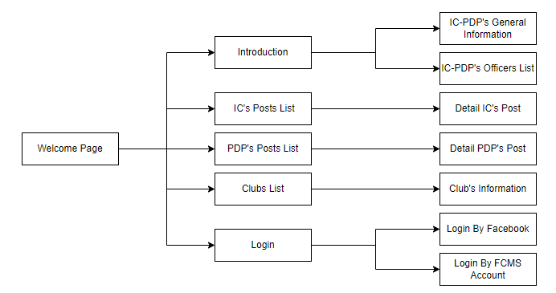

*Figure 34. Screen flow of Guest actor*

All users have a Welcome Page like Guest, so in the below flows we will not redraw the screen of the Welcome page.

#### *3.1.2 Guest User & FCMS User*

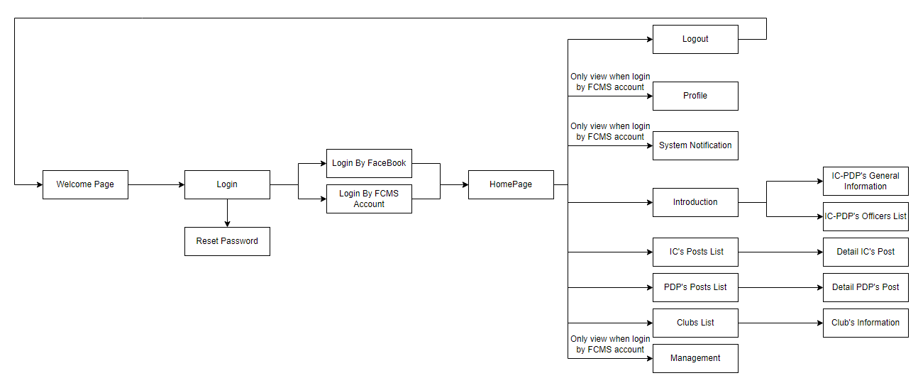

*Figure 35. Screen flow of Guest User actor and FCMS User actor*

All FCMS Users have a Home Page like Guest User, so in the below flows we will not redraw the screen of the Home page.

#### *3.1.3 Super Admin*

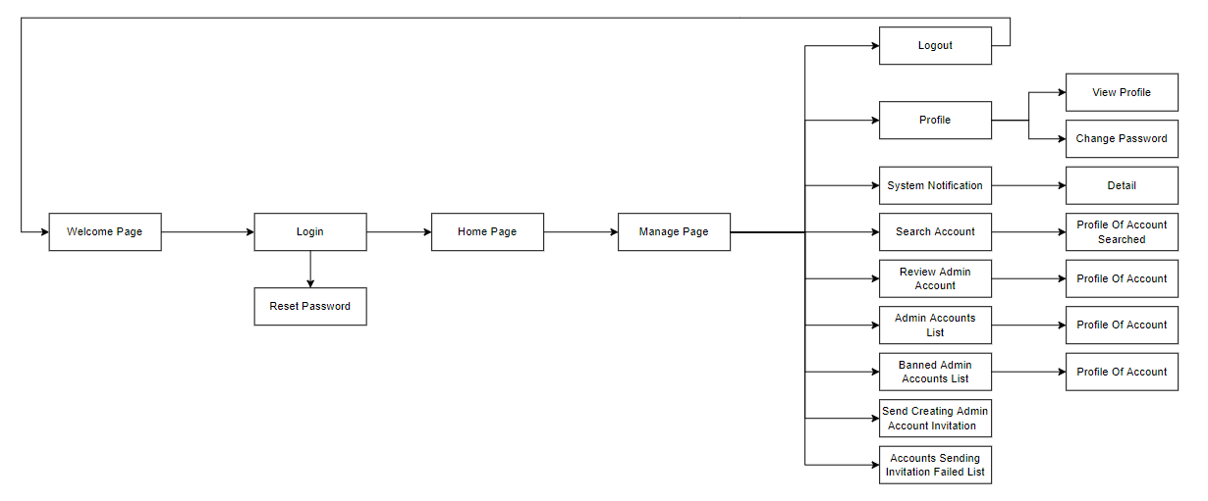

*Figure 36. Screen flow of Super Admin actor*

#### *3.1.4 Admin*

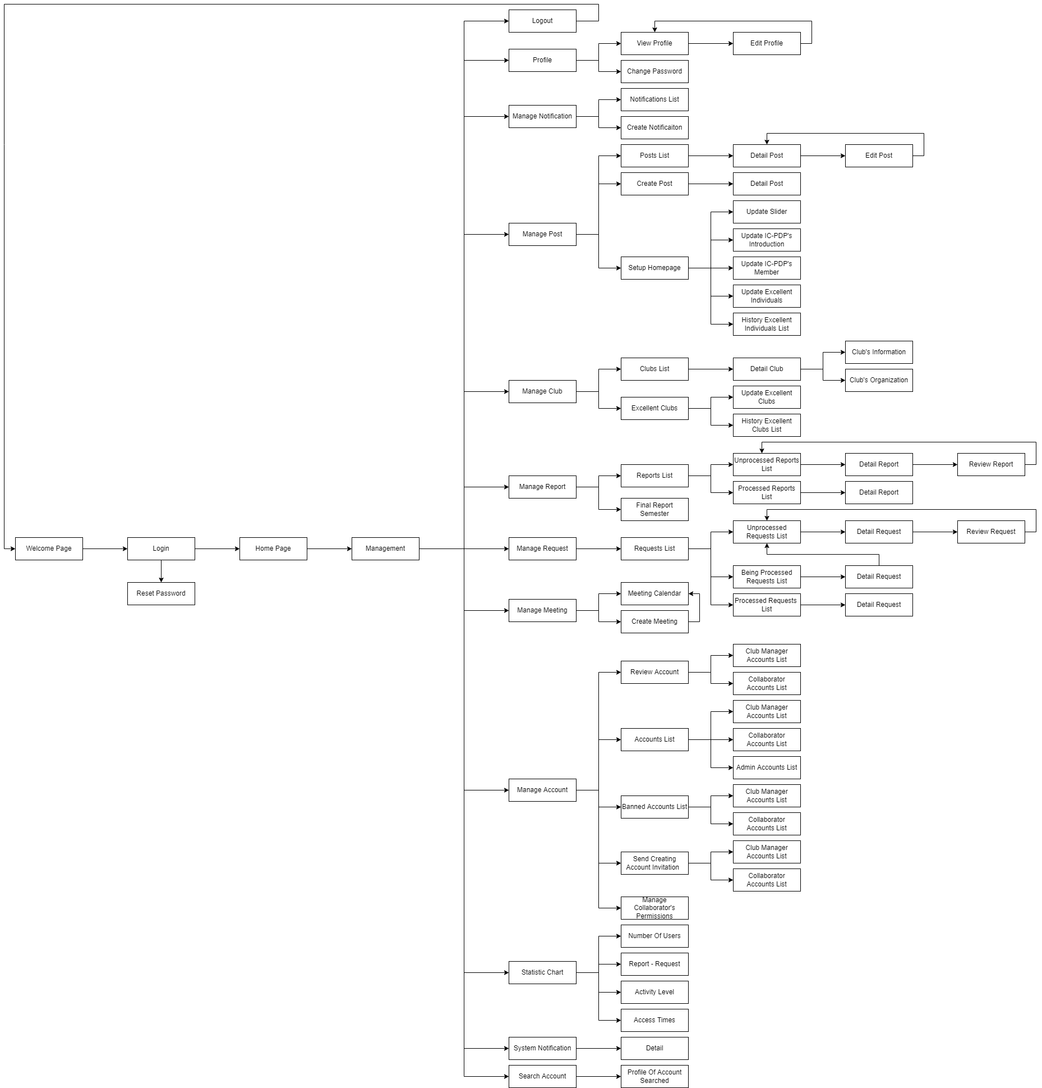

*Figure 37. Screen flow of Admin actor*

#### *3.1.5 Collaborator*

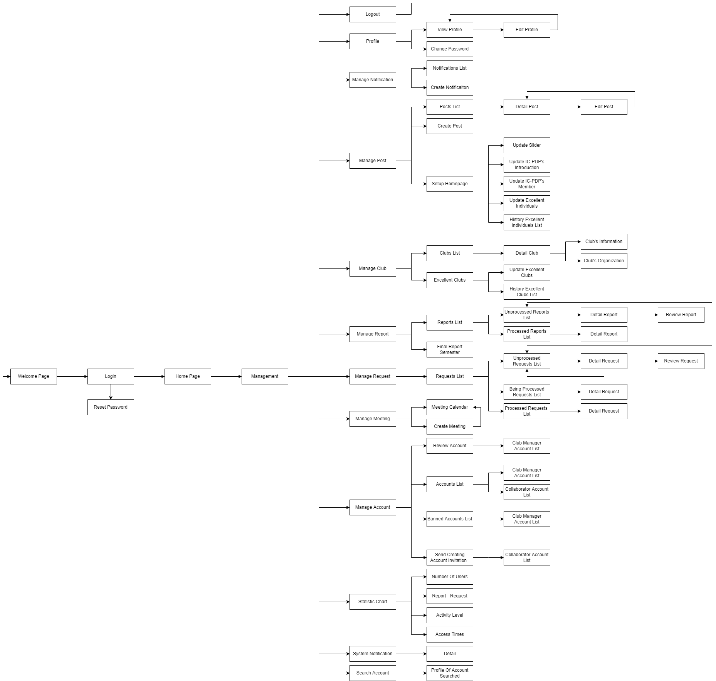

*Figure 38. Screen flow of Collaborator actor*

#### *3.1.6 Club Manager Site*

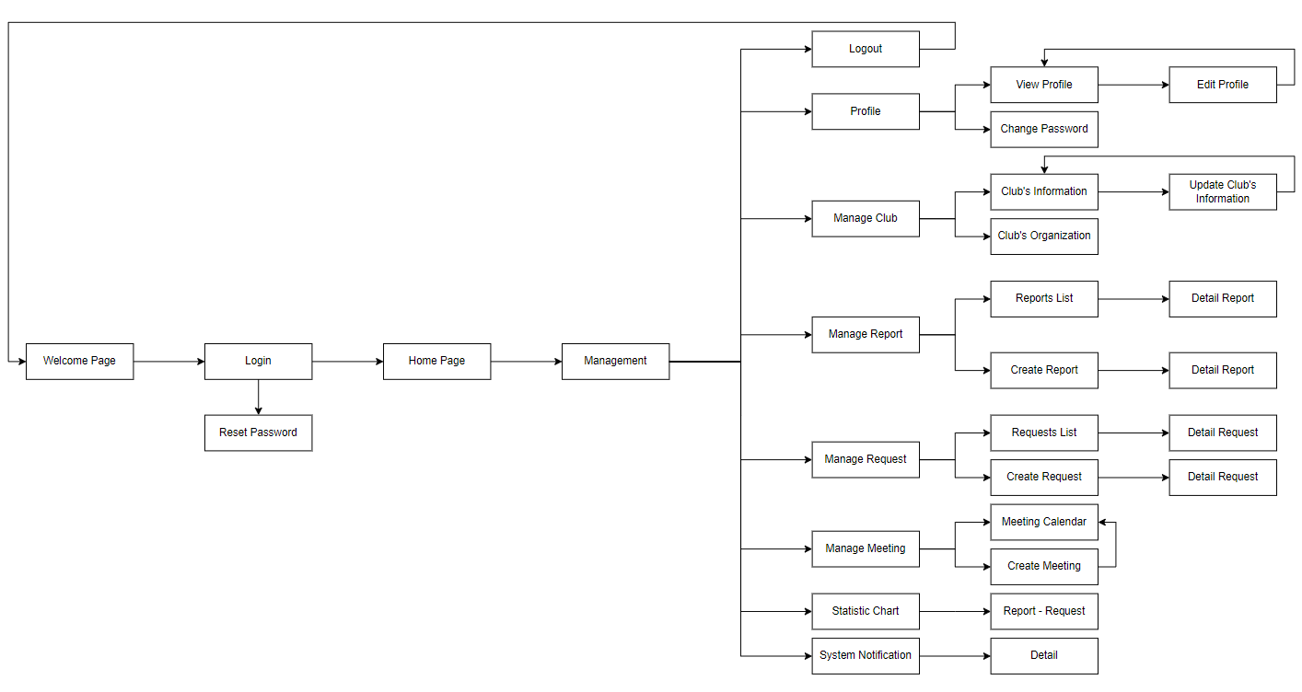

*Figure 39. Screen flow of Club Manager actor*

### 3.2 Non-Screen Functions

| **#** | **Feature** | **Description** |
| --- | --- | --- |
| 1 | Cron job automatically sends a notification when an invited user creates an account without a response. | Run the cron job after 7 days from the date of sending the invitation to create an account to check which email has been sent without a response (register for an account), then send a notification to the admin of unresponsive emails. |
| 2 | Cron job automatically sends a notification when a report approval is overdue. | Run the cron job after 3 and 5 days from the date of sending the report to check which reports are still in OPENING state, then send a notification to the admin to remind the admin to approve the report. |
| 3 | Cron job automatically sends a notification when a request approval is overdue. | Run the cron job after 3 and 5 days from the date of sending request to check which requests are still in OPENING/PENDING state, then send a notification to admin to remind admin to approve request. |
| 4 | Cron job automatically sends a notification to notify removing reports per year and removes reports after 1 day since sending them. | Run cron job every year to notify and remove reports that are not rated as important. |
| 5 | Cron job automatically sends a notification to notify removing requests per year and removes requests after 1 day since send notify. | Run cron job every year to notify and remove requests. |
| 6 | Cron job automatically removes notifications read yearly. | Run cron job every year to remove notifications. |
| 7 | Cron job automatically sends a notification to remind users that a meeting will start in 1 hour. | Run cron job to remind a meeting will start in 1 hour. |

*Table 71. Cron job list*

### 3.3 Entity Relationship Diagram

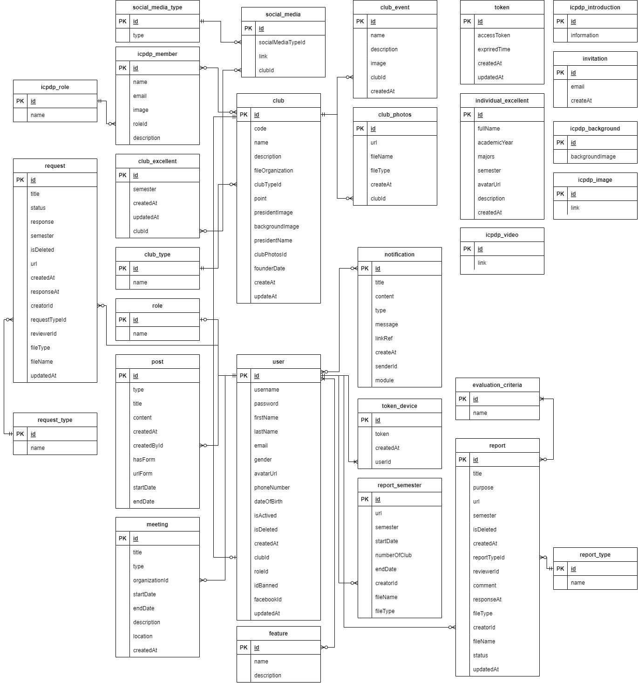

*Figure 40. Entity Relationship Diagram*

**Entities List**

| **#** | **Entity** | **Description** |
| --- | --- | --- |
| 1 | Club | General term describing club. |
| 2 | Club Event | General term describing event of a club. |
| 3 | Club Excellent | General term describing excellent club. |
| 4 | Club Mentor | General term describing mentor of a club. |
| 5 | Club Photos | General term describing photo of a club. |
| 6 | Club Type | General term describing type of a club. |
| 7 | Evaluation Criteria | General term describing evaluation criteria. |
| 8 | Feature | General term describing feature. |
| 9 | IC-PDP Introduction | General term describing introduction of IC-PDP. |
| 10 | IC-PDP Background | General term describing background of IC-PDP. |
| 11 | IC-PDP Image | General term describing image of IC-PDP. |
| 12 | IC-PDP Member | General term describing member of IC-PDP. |
| 13 | IC-PDP Role | General term describing role of IC-PDP. |
| 14 | IC-PDP Video | General term describing video of IC-PDP. |
| 15 | Individual Excellent | General term describing excellent individual. |
| 16 | Invitation | General term describing invitation to register account. |
| 17 | Likes | General term describing likes of post. |
| 18 | Meeting | General term describing meeting. |
| 19 | Notification | General term describing notification. |
| 20 | Post | General term describing post. |
| 21 | Report | General term describing report. |
| 22 | Report Semester | General term describing report semester. |
| 23 | Report Type | General term describing type of report. |
| 24 | Request | General term describing request. |
| 25 | Request Type | General term describing type of a request. |
| 26 | Role | General term describing user’s role. |
| 27 | Social Media | General term describing social media. |
| 28 | Social Media Type | General term describing type of social media. |
| 29 | Token | General term describing authentication of user sign in. |
| 30 | Token Device | General term describing user’s device code. |
| 31 | User | General term describing user. |

*Table 72. Entities list*

## 4. Non-Functional Requirements

### 4.1 External Interfaces

#### *4.1.1 User Interfaces*

* UI-1: Website enhance SEO and performance by using semantic HTML tags, remove unnecessary javascript code.
* UI-2: Display fallback content while fetching data from api (using loading text, skeleton effects).
* UI-3: The user must be alerted to any system failures.
* UI-4: Prevent XSS attack when fetching HTML content from API by using sanitize library.
* UI-5: Easy to use for user and customer. Purpose of feature is clear, user easy to navigate around the website.
* UI-6: All required data fields must be marked *.
* UI-7: The system supports Vietnamese only but can extend to support English in the future with i18n library setup in code.
* UI-8: Font size, colors, theme between pages is consistent.
* UI-9: Security is concerned with using environment variables instead of hard code sensitive data.
* UI-10: UI is responsive for guest pages and some pages of admin site.
* UI-11: All pages must use a steady visible subject matter. Pop-ups showing notifications, mistake messages, or warnings must use the identical subject.

#### *4.1.2 Hardware Interfaces*

* All server-side elements should execute on server-class computers.
* All client-side components must execute on workstation-class and personal-class computers.

#### *4.1.3 Software Interfaces*

* The interface should be ready to connect with info to store XML schema outlined exploitation XSD and data streams.
* Source and destination formats for data must embrace XML and should conjointly include: protractible Stylesheet Language Transformation (XSLT), JavaScript Object Notation (JSON), Comma Separated price (CSV), and yank normal Code for data Interchange (ASCII).

### 4.2 Quality Attributes

#### *4.2.1 Usability*

* The interface ought to be tasteful and uncomplicated.
* For items that are not text, including photos and maps, alt attributes are available.
* Links, buttons, and checkboxes are all easily clickable; for instance, selecting a checkbox can be done by clicking the text as well as the checkbox itself.
* Users may see their typing in the search field because it is wide enough.
* Not just the homepage, but every page, has search functionality.
* Links can be quickly identified. They seem to be clickable. Non-link items don't appear clickable; for instance, underlining text is avoided.

#### *4.2.2 Reliability*

* Prior to releasing and/or deployment, the software system should go through feature testing, load testing, and regression testing.

#### *4.2.3 Performance*

* Web front-end leverages ReactJS, which employs a number of deft strategies to reduce the quantity of expensive DOM actions necessary to refresh the UI.
* In order to provide a more fluid user experience akin to a desktop program, the web front-end is a Single Page Application.
* Adding indexes to PostgreSQL, which makes query incurring filtering and sorting run much faster.

#### *4.2.4 Maintainability and Extensibility*

* Using Mocha and Chai, we created automated tests, including unit tests and integration tests.
* To ensure that every piece of code follows the same, consistent convention, use ESLint.
* Strictly adhere to the coding convention to make the source code easier to read and the website easier to maintain.
* Create a website using an object-oriented programming paradigm to improve maintainability and extensibility.

## 5. Requirement Appendix

### 5.1 Business Rules

| **#** | **ID** | **Business Rule Definition** |
| --- | --- | --- |
| 1 | BR-01 | Device must be connected to the internet and server. |
| 2 | BR-02 | Guest User must have Facebook account. |
| 3 | BR-03 | The username must not be empty. |
| 4 | BR-04 | The password must not be empty. |
| 5 | BR-05 | The email must not be empty. |
| 6 | BR-06 | The email must be valid. |
| 7 | BR-07 | The inactivated account cannot reset password. |
| 8 | BR-08 | First name must not be empty. |
| 9 | BR-09 | First name cannot be more than 30 characters. |
| 10 | BR-10 | Last name must not be empty. |
| 11 | BR-11 | Last name cannot be more than 30 characters. |
| 12 | BR-12 | Username must contain from 3 to 30 characters, written immediately, without accents. |
| 13 | BR-13 | Password must be between 6 and 32 characters, including uppercase, lowercase, numbers and special characters. |
| 14 | BR-14 | Confirmed password must not be empty. |
| 15 | BR-15 | The confirmed password must match with the password. |
| 16 | BR-16 | Avatar must not be empty. |
| 17 | BR-17 | Club Code must not be empty. |
| 18 | BR-18 | Club Name must not be empty. |
| 19 | BR-19 | Birthdate must be before the current date. |
| 20 | BR-20 | Phone numbers have a number of characters from 9 to 11. |
| 21 | BR-21 | Email must never ever be used to register account. |
| 22 | BR-22 | Username cannot be updated. |
| 23 | BR-23 | Email cannot be updated. |
| 24 | BR-24 | Club Name cannot be updated. |
| 25 | BR-25 | Only Super Admin can review Admin account. |
| 26 | BR-26 | Only Super Admin can ban Admin account. |
| 27 | BR-27 | Only Super Admin can unban Admin account. |
| 28 | BR-28 | Title cannot be more than 50 characters. |
| 29 | BR-29 | Title must not be empty. |
| 30 | BR-30 | Content cannot be more than 250 characters. |
| 31 | BR-31 | Content must not be empty. |
| 32 | BR-32 | Collaborator can only access management when the admin grants him/her access. |
| 33 | BR-33 | Full name must not be empty. |
| 34 | BR-34 | Full name cannot be more than 50 characters. |
| 35 | BR-35 | The start date must be before the end date. |
| 36 | BR-36 | Description cannot be more than 250 characters. |
| 37 | BR-37 | The founding date must be before the current date. |
| 38 | BR-38 | Image of the best event must not be empty. |
| 39 | BR-39 | Name of the best event must not be empty. |
| 40 | BR-40 | Description of the best event must not be empty. |
| 41 | BR-41 | File must match file template. |
| 42 | BR-42 | Purpose cannot be more than 250 characters. |
| 43 | BR-43 | Purpose must not be empty. |
| 44 | BR-44 | Type of report must be selected. |
| 45 | BR-45 | File report must not be empty. |
| 46 | BR-46 | Create report that has type “Báo cáo cuối kỳ” must be in the valid time. |
| 47 | BR-47 | If the report type is “Báo cáo sự kiện”, Admin must evaluate event quality after approval. |
| 48 | BR-48 | Type of request must be selected. |
| 49 | BR-49 | Cannot edit the processed report. |
| 50 | BR-50 | Cannot edit the processed request. |
| 51 | BR-51 | Request has 4 statuses: OPENING, PENDING, APPROVED, REJECTED. |
| 52 | BR-52 | Link cannot be more than 100 characters. |
| 53 | BR-53 | Link must not be empty. |
| 54 | BR-54 | Location cannot be more than 100 characters. |
| 55 | BR-55 | Location must not be empty. |
| 56 | BR-56 | The start time must be before the end time. |
| 57 | BR-57 | Only participants of the meeting can view detail of the meeting. |
| 58 | BR-58 | Only Admin can set permission for Collaborator. |
| 59 | BR-59 | Academy year must not be empty. |
| 60 | BR-60 | Majors must not be empty. |
| 61 | BR-61 | Year must not be empty. |
| 62 | BR-62 | The year must have 4 characters, which is a number. |
| 63 | BR-63 | Image file size is limited to 2MB. |
| 64 | BR-64 | File size is limited to 5MB. |

*Table 73. Business Rules list*

### 5.2 Application Messages List

| **#** | **Code** | **Type** | **Context** | **Content** |
| --- | --- | --- | --- | --- |
| 1 | MSG-01 | Notification | Cannot connect to the server | *Không thể kết nối đến máy chủ.* |
| 2 | MSG-02 | Notification | The account is inactivated | *Tài khoản của bạn chưa được kích hoạt.* |
| 3 | MSG-03 | Notification | Username/Password is not correct | *Tên đăng nhập hoặc mật khẩu không đúng.* |
| 4 | MSG-04 | Notification | Required field is empty | *Vui lòng điền vào trường này.* |
| 5 | MSG-05 | Notification | The inputted email when change password is invalid | *Có lỗi xảy ra khi thay đổi mật khẩu.* |
| 6 | MSG-06 | Notification | Reset password successfully | *Kiểm tra mail để nhận mật khẩu mới.* |
| 7 | MSG-07 | Notification | Register successfully | *Tạo tài khoản thành công.* |
| 8 | MSG-08 | Notification | First name is empty | *Trường họ là bắt buộc* |
| 9 | MSG-09 | Notification | First name is invalid | *Họ không thể quá 30 kí tự.* |
| 10 | MSG-10 | Notification | Last name is empty | *Trường tên là bắt buộc.* |
| 11 | MSG-11 | Notification | Last name is invalid | *Tên không thể quá 30 kí tự.* |
| 12 | MSG-12 | Notification | Username is empty | *Trường tên đăng nhập là bắt buộc.* |
| 13 | MSG-13 | Notification | Username is invalid | *Tên đăng nhập phải chứa từ 3 đến 30 ký tự, viết liền, không dấu.* |
| 14 | MSG-14 | Notification | Password is empty | *Trường mật khẩu là bắt buộc.* |
| 15 | MSG-15 | Notification | Password is invalid | *Mật khẩu phải là từ 6 đến 32 ký tự, bao gồm chữ hoa, chữ thường, số và ký tự đặc biệt.* |
| 16 | MSG-16 | Notification | Confirmed password is empty | *Trường nhập lại mật khẩu là bắt buộc.* |
| 17 | MSG-17 | Notification | The confirmed password does not match with the password | *Mật khẩu và nhập lại mật khẩu phải giống nhau.* |
| 18 | MSG-18 | Notification | Avatar is empty | *Trường ảnh đại diện là bắt buộc.* |
| 19 | MSG-19 | Notification | Club Code is empty | *Mã câu lạc bộ là bắt buộc.* |
| 20 | MSG-20 | Notification | Club Name is empty | *Tên câu lạc bộ là bắt buộc.* |
| 21 | MSG-21 | Notification | Birthdate is after the current date | *Ngày sinh không thể lớn hơn ngày hiện tại.* |
| 22 | MSG-22 | Notification | Phone numer is invalid | *Số điện thoại có số ký tự từ 9 đến 11* |
| 23 | MSG-23 | Notification | Email is used to register account | *Email này đã được sử dụng.* |
| 24 | MSG-24 | Notification | Update profile successfully | *Cập nhật thông tin thành công.* |
| 25 | MSG-25 | Notification | Change password successfully | *Đổi mật khẩu thành công.* |
| 26 | MSG-26 | Notification | Accept account successfully | *Duyệt tài khoản thành công.* |
| 27 | MSG-27 | Notification | Reject account successfully | *Từ chối duyệt tài khoản thành công.* |
| 28 | MSG-28 | Confirmation | Confirm ban Admin account | *Bạn thật sự muốn cấm tài khoản này?* |
| 29 | MSG-29 | Notification | Ban account successfully | *Cấm tài khoản thành công.* |
| 30 | MSG-30 | Confirmation | Confirm unban Admin account | *Bạn thật sự muốn bỏ cấm tài khoản này?* |
| 31 | MSG-31 | Notification | Unban account successfully | *Bỏ cấm tài khoản thành công.* |
| 32 | MSG-32 | Notification | Send creating account invitation successfully | *Gửi lời mời tạo tài khoản thành công.* |
| 33 | MSG-33 | Notification | The email is invalid | *Email không hợp lệ.* |
| 34 | MSG-34 | Notification | Send notification successfully | *Gửi thông báo thành công.* |
| 35 | MSG-35 | Notification | Title is empty | *Tiêu đề là bắt buộc.* |
| 36 | MSG-36 | Notification | Title is invalid | *Tiêu đề không thể quá 50 ký tự.* |
| 37 | MSG-37 | Notification | Content is empty | *Nội dung là bắt buộc.* |
| 38 | MSG-38 | Notification | Content is invalid | *Nội dung không thể quá 250 ký tự.* |
| 39 | MSG-39 | Notification | Collaborator is not granted access by admin | *Bạn không có quyền truy cập.* |
| 40 | MSG-40 | Notification | Full name is empty | *Họ và tên là bắt buộc.* |
| 41 | MSG-41 | Notification | Full name is invalid | *Họ và tên không thể quá 50 ký tự.* |
| 42 | MSG-42 | Notification | Email is empty | *Email là bắt buộc.* |
| 43 | MSG-43 | Notification | The start date is after the end date | *Ngày bắt đầu không thể sau ngày kết thúc.* |
| 44 | MSG-44 | Notification | Create post successfully | *Tạo bài đăng thành công.* |
| 45 | MSG-45 | Notification | Update post successfully | *Cập nhật bài đăng thành công.* |
| 46 | MSG-46 | Notification | Description is invalid | *Mô tả không thể quá 250 ký tự.* |
| 47 | MSG-47 | Notification | The founding date is after the current date | *Ngày thành lập không thể sau ngày hiện tại.* |
| 48 | MSG-48 | Notification | Image of best event is empty | *Ảnh của sự kiện nổi bật là bắt buộc.* |
| 49 | MSG-49 | Notification | Name of best event is empty | *Tên của sự kiện nổi bật là bắt buộc.* |
| 50 | MSG-50 | Notification | Description of best event is empty | *Mô tả của sự kiện nổi bật là bắt buộc.* |
| 51 | MSG-51 | Notification | File is not matched template | *File không hợp lệ.* |
| 52 | MSG-52 | Notification | Send report successfully | *Gửi báo cáo thành công.* |
| 53 | MSG-53 | Notification | Purpose is empty | *Mục đích là bắt buộc.* |
| 54 | MSG-54 | Notification | Purpose is invalid | *Mục đích không thể quá 250 ký tự.* |
| 55 | MSG-55 | Notification | Type of report is not selected | *Loại báo cáo là bắt buộc.* |
| 56 | MSG-56 | Notification | File report is empty | *File báo cáo là bắt buộc.* |
| 57 | MSG-57 | Notification | Create report that has type “Báo cáo cuối kỳ” in invalid time | *Chưa đến hạn nộp báo cáo cuối kỳ.* |
| 58 | MSG-58 | Notification | Send response for the report successfully | *Gửi phản hồi cho báo cáo thành công.* |
| 59 | MSG-59 | Notification | Send request successfully | *Gửi yêu cầu thành công.* |
| 60 | MSG-60 | Notification | Send response for request successfully | *Gửi phản hồi cho yêu cầu thành công.* |
| 61 | MSG-61 | Notification | Create meeting successfully | *Tạo cuộc họp thành công.* |
| 62 | MSG-62 | Notification | The start time is after the end time | *Thời gian bắt đầu phải trước thời gian kết thúc.* |
| 63 | MSG-63 | Notification | Link is empty | *Link là bắt buộc.* |
| 64 | MSG-64 | Notification | Link is invalid | *Link không thể quá 100 ký tự.* |
| 65 | MSG-65 | Notification | Location is empty | *Địa điểm là bắt buộc.* |
| 66 | MSG-66 | Notification | Location is invalid | *Địa điểm thể quá 100 ký tự.* |
| 67 | MSG-67 | Confirmation | Confirm to delete club manager account | *Bạn thật sự muốn xóa câu lạc bộ này và những thông tin liên quan đến nó? Nếu không muốn xóa những thông tin liên quan hãy chọn Cấm tài khoản.* |
| 68 | MSG-68 | Notification | Delete Club Manager Account successfully | *Xóa tài khoản thành công.* |
| 69 | MSG-69 | Notification | Set permission for Collaborator successfully | *Cấp quyền cho Cộng tác viên thành công.* |
| 70 | MSG-70 | Notification | Update banner successfully | *Cập nhật banner thành công.* |
| 71 | MSG-71 | Notification | Academy year is empty | *Khóa là bắt buộc.* |
| 72 | MSG-72 | Notification | Majors is empty | *Chuyên ngành là bắt buộc.* |
| 73 | MSG-73 | Notification | Year is empty | *Năm là bắt buộc.* |
| 74 | MSG-74 | Notification | Year is invalid | *Năm phải có 4 ký tự, là số.* |
| 75 | MSG-75 | Notification | Image file size is over 2MB | *Dung lượng hình ảnh giới hạn là 2MB.* |
| 76 | MSG-76 | Notification | File size is over 5MB | *Dung lượng file giới hạn là 5MB.* |
| 77 | MSG-77 | Confirmation | Confirm to remove current file final report semester and create a new file final report semester | *Nếu Xác nhận, toàn bộ data của file hiện tại sẽ bị xóa. Bạn chắc chắn muốn tạo file mới?* |

*Table 74. Messages list*

# IV. Software Design Description

## 1. System Design

### 1.1 System Architecture

#### *1.1.1 Diagram*

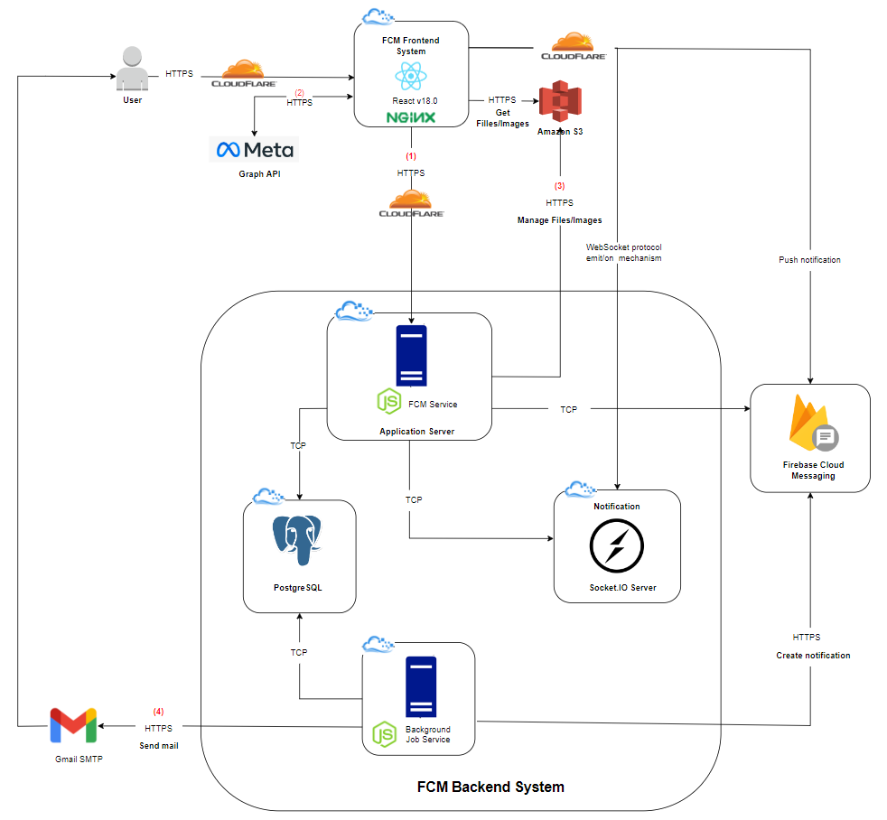

*Figure 41. System Architecture Diagram*

#### *1.1.2 System Architecture Explanation*

##### **1.1.2.1 Overview**

Currently, on the backend we are deploying a Web server on Amazon EC2 and on the frontend we deploy on Vercel. And the [icpdp.net](http://icpdp.net) domain management is being purchased and managed on Cloud Flare.

Details about the technology and why we use it will be detailed below.

##### **1.1.2.2 Nginx**



*Figure 42. Nginx*

* **NGINX** is open source software for web serving, reverse proxying, caching, load balancing, media streaming, and more. It started out as a web server designed for maximum performance and stability.  
  In addition to its HTTP server capabilities, NGINX can also function as a proxy server for email (IMAP, POP3, and SMTP) and a reverse proxy and load balancer for HTTP, TCP, and UDP servers.
* We are using it as a reverse proxy to direct the request to the desired server.

##### **1.1.2.3 Socket.IO**



*Figure 43. Socket.IO*

* [**Socket.IO**](http://socket.io) is a library that enables low-latency, bidirectional and event-based communication between a client and a server. It is built on top of the WebSocket protocol and provides additional guarantees like a fallback to HTTP long-polling or automatic reconnection.
* We useit for real-time application, giving users immediate access to information while using the application.

##### **1.1.2.4 Firebase Cloud Messaging**



*Figure 44. Firebase Cloud Messaging*

* **Firebase Cloud Messaging**, formerly known as Google Cloud Messaging, is a cross-platform cloud solution for messages and notifications for Android, iOS, and web applications
* We use it for the purpose of sending notifications outside the app, users can receive it when not using the website app.

##### **1.1.2.5 Cron Job**



*Figure 45. Cron job*

* The Cron command-line utility is a job scheduler on Unix-like operating systems. Users who set up and maintain software environments use Cron to schedule jobs, also known as Cron jobs, to run periodically at fixed times, dates, or intervals.
* We use Cron job to schedule appointments for sending reminder notifications, and deleting data periodically.

##### **1.1.2.6 Cloudflare**



*Figure 46. Cloudflare*

* **Cloudflare** is one of the biggest networks operating on the Internet. People use Cloudflare services for the purposes of increasing the security and performance of their websites and services.  
  In addition to the normal DNS function, when using Cloudflare you can also use CDN, firewall to limit DDoS + Spam, SSL, Forward Domain and many other functions.
* We use **Cloudflare** as an intermediary DNS between user, browser and server communication. Manage subdomains and analysis websites.

##### **1.1.2.7 Vercel**



*Figure 47. Vercel*

* **Vercel** is a platform for frontend frameworks and static sites, built to integrate with your headless content, commerce, or database.
* We use **Vercel** to deploy for the client-side.

##### **1.1.2.8 Amazon S3**



*Figure 48. Amazon S3*

* **Amazon Simple Storage Service (Amazon S3)** is a scalable, high-speed, web-based cloud storage service.
* We use **S3** to store data in the form of images and files.

##### **1.1.2.9 Amazon Elastic Compute Cloud**



*Figure 49. Amazon Elastic Compute Cloud*

* **Amazon Elastic Compute Cloud (Amazon EC2)** is a web service that provides secure and scalable computing power in the cloud. The service is designed to make it easier for developers to use cloud computing on a web scale.
* We use the **EC2** to deploy the server side.

##### **1.1.2.10 PostgreSQL**



*Figure 50. PostgreSQL*

* **PostgreSQL** is a powerful, open source object-relational database system.
* We use it to store all project operational data.

##### **1.1.2.11 ReactJS**



*Figure 51. ReactJS*

* **ReactJS** is an open-source JavaScript library providing a view for data rendered as HTML. React promises programmers a model in which subcomponents cannot directly affect enclosing components ("data flows down"); efficient updating of the HTML document when data changes.
* We use **ReactJS** to completely build website view and interaction instead of plain HTML/JavaScript. ReactJS helps the code cleaner and reusable.

##### **1.1.2.12 Redux**



*Figure 52. Redux*

* **Redux** is a predictable state container for JavaScript apps. Redux evolves the ideas of Flux which is the application architecture that Facebook uses for building client-side web applications. It complements React's composable view components by utilizing a unidirectional data flow.
* We use **Redux** to take advantages of better separation of concerns, and less time debugging.

##### **1.1.2.13 React Router**



*Figure 53. React Router*

* **React Router** is a complete routing library for React. React Router keeps UI in sync with the URL. It has a simple API with powerful features like lazy code loading, dynamic route matching, and location transition handling built right in. Make the URL your first thought, not an after-thought.

##### **1.1.2.14 React Hook Form**



*Figure 54. React Hook Form*

* **React hook form** is a performant, flexible and extensible forms with easy-to-use validation.
* You have the ability to isolate component re-renders which leads to better performance on your page or app

##### **1.1.2.15 NodeJS**



*Figure 55. NodeJS*

* **NodeJS** is an open-source, cross-platform runtime environment for developing server-side Web applications.
* We use NodeJS and many of its modules to develop FCM API Service, FCM Background Job Service, and FCM Socket.IO server.

##### **1.1.2.16 Graph API**



*Figure 56. Meta for Developers*

* The **Graph API** is the primary method by which applications read and write to Facebook’s social network graph. All of our SDKs and products interact with the Graph API in some way, and our other APIs are an extension of the Graph API.
* We use **Graph API** to get user information data when users log in with Facebook.

##### **1.1.2.17 Gmail Service**



*Figure 57. Gmail*

* **Gmail** is an email service developed by Google, one of the two most popular email clients in the world... In which, users can create a completely free account and use it as a transport tool. / receive personal-to-personal, personal and file-to-file e-mail, even business-to-business.
* We use a combination of Gmail service and Nodemailer module for sending emails.

### 1.2 Architecture Layers Design

#### *1.2.1 Frontend*

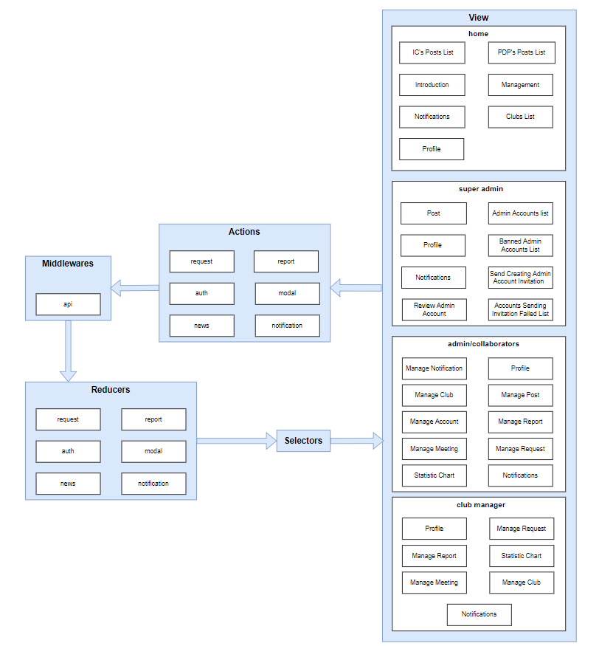

*Figure 58. FCMS - Layer Design*

| **No** | **Directory/File** | **Description** | **Convention** |
| --- | --- | --- | --- |
|  | index.tsx | Entry point for the application. Everything in the app gets triggered through this file. |  |
|  | routes/ | Define application routings |  |
|  | side-effects/ | Define api, model and effects. Effects help transform raw data from api to clean data for front-end. |  |
|  | base/components/ | Define common reusable components |  |
|  | base/const | Define common const (regex, url, etc,..) |  |
|  | base/axios | Define custom axios, when calling api, api response go through axios interceptor | A noun. |
|  | base/helper | Define common helper methods | Every component should be started with type. |
|  | base/context | Define custom theme context |  |
|  | app/helpers | This folder contains these helper functions. |  |
|  | base/hooks | Define reusable custom hooks |  |
|  | base/layout | Define common layout |  |
| 1. a | base/assets | Define static assets: images |  |
| 1. a | app/selectors/ | This folder contains these selectors what used for computing derived data. |  |
|  | app/shared/ | This folder contains the declarations of status codes, shared constants. |  |
|  | app/store | This folder contains Redux store. |  |
|  | app/rootSaga | Entry pointer for other redux sagas |  |
|  | app/hooks | Predefined useAppDispatch, useAppSelector for typescript |  |
|  | .env | Environment variables for local development |  |
|  | .prettierrc | Keep the same coding styles between different editors and IDEs. |  |
| 1. . | .gitignore | File that define common formatting for prettier |  |
|  | tsconfig.json | specifies the root files and the compiler options required to compile the project |  |
|  | package.json | Metadata about the application: the list of dependencies, npm run script. |  |

*Table 75. Directory/File description*

#### *1.2.2 Backend*

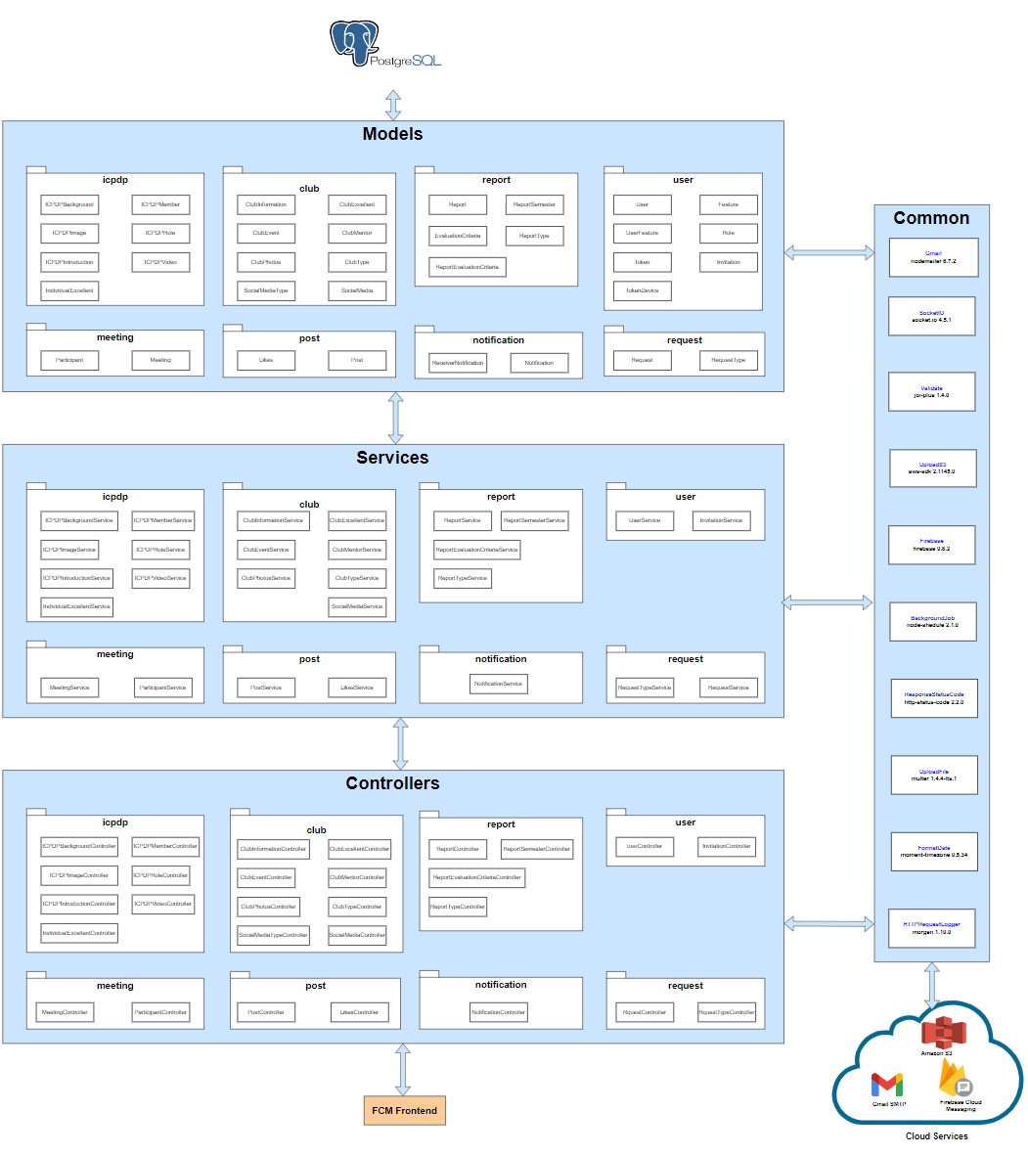

*Figure 59. FCMS - API Layer Design*

| **No** | **Directory/File** | **Description** | **Convention** |
| --- | --- | --- | --- |
|  | app.ts | Entry point for the application. Everything in the app gets triggered through this file. |  |
|  | src/ | It is the place where all the logic code in the system is stored. |  |
|  | src/api | Here stored as a module, in modules stored in layers such as route, controller, service, repository.  Example: user.route.ts, user.controller.ts, user.service.ts, user.repository,ts. |  |
|  | src/commons | Store data used in multiple locations in the project. Like variables or common functions. |  |
|  | src/configs | Contain configuration files such as database configuration and email configuration |  |
|  | src/external-services | Contain configuration files that use external services |  |
|  | src/messages | Contains message files according to each module returned to the client |  |
|  | src/views | Contain .hbs files for displaying email interface |  |
|  | src/unit-test | Organise test file for testing |  |
|  | .editorconfig | Serves to increase code consistency, when coding on multiple devices or different IDE. |  |
|  | .env | Contain all the environment variables |  |
|  | .eslintrc.json | Define standards and rules for writing code |  |
|  | .gitignore | Specifics intentionally untracked files that Git should ignore |  |
| 14 | .pretierrc | Support code formatting to make the code clearer and easier to read |  |
| 15 | .tsconfig.json | Specifies the root files and the compiler options required to compile the project. |  |

*Table 76. API Directory/File description*

## 2. Database Design

### 2.1 Operational Database Design

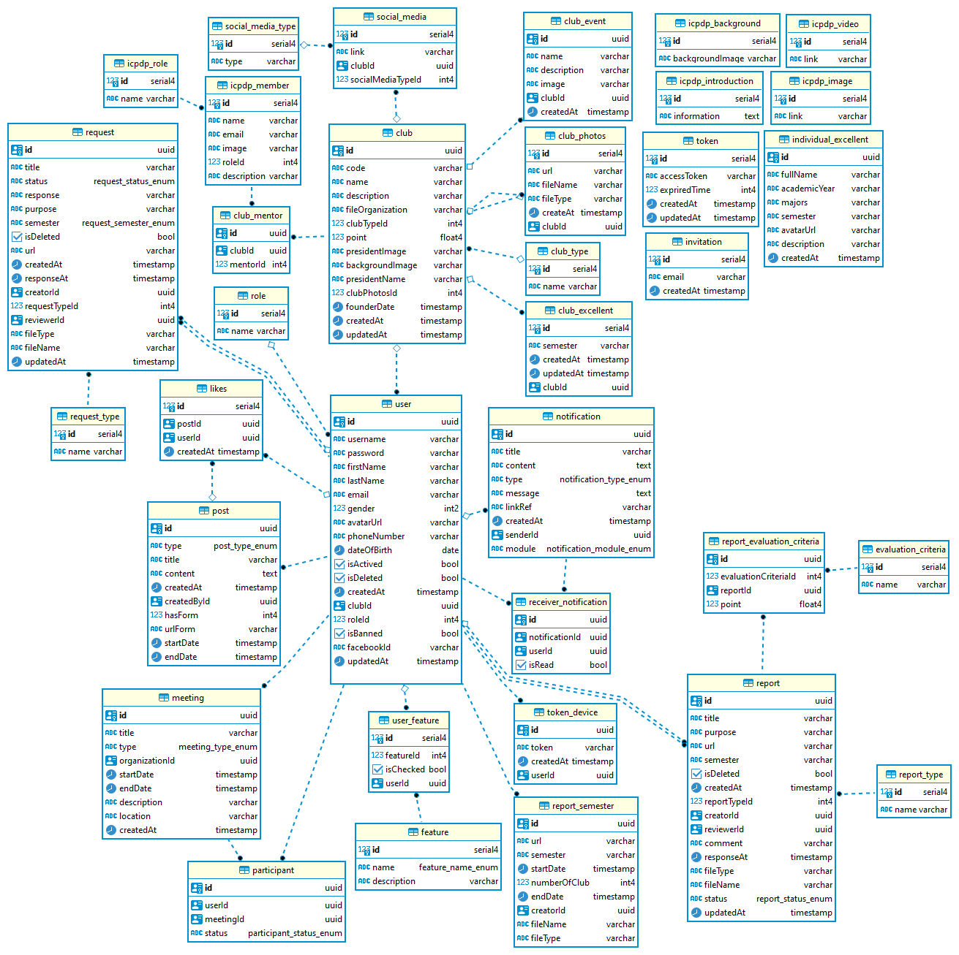

*Figure 60. FCMS - Operational Database Design*

### 2.2 Table descriptions

#### *2.2.1 Table ‘user’*

| **#** | **Field name** | **Type** | **Unique** | **Not Null** | **PK/FK** | **Note** |
| --- | --- | --- | --- | --- | --- | --- |
| 1 | id | uuid | x | x | PK |  |
| 2 | username | varchar |  | x |  |  |
| 3 | password | varchar |  | x |  |  |
| 4 | firstName | varchar |  | x |  |  |
| 5 | lastName | varchar |  | x |  |  |
| 7 | email | varchar |  | x |  |  |
| 8 | gender | int2 |  | x |  | default is ‘0’ |
| 9 | avatarUrl | varchar |  |  |  |  |
| 10 | phoneNumber | varchar |  |  |  |  |
| 11 | dateOfBirth | date |  |  |  |  |
| 12 | isActived | bool |  |  |  | default is ‘false’ |
| 13 | isDeleted | bool |  |  |  | default is ‘false’ |
| 14 | createdAt | timestamp |  |  |  |  |
| 15 | clubId | uuid |  |  | FK | FK to club(id) |
| 16 | roleId | int4 |  |  | FK | FK to role(id) |
| 17 | isBanned | bool |  |  |  | default is ‘false’ |
| 18 | facebookId | varchar |  |  |  |  |
| 19 | updatedAt | timestamp |  |  |  |  |

*Table 77. Table ‘user’*

#### *2.2.2 Table ‘club’*

| **#** | **Field name** | **Type** | **Unique** | **Not Null** | **PK/FK** | **Note** |
| --- | --- | --- | --- | --- | --- | --- |
| 1 | id | uuid | x | x | PK |  |
| 2 | code | varchar | x | x |  |  |
| 3 | name | varchar | x | x |  |  |
| 4 | description | varchar |  |  |  |  |
| 5 | fileOrganization | varchar |  |  |  |  |
| 7 | clubTypeId | int4 |  | x | FK | FK to club_type(id) |
| 8 | point | float4 |  |  |  |  |
| 9 | presidentImage | varchar |  |  |  |  |
| 10 | backgroundImage | varchar |  |  |  |  |
| 11 | presidentName | varchar |  |  |  |  |
| 12 | clubPhotosId | int4 |  |  | FK | FK to club_photos(id) |
| 13 | founderDate | timestamp |  |  |  |  |
| 14 | createdAt | timestamp |  |  |  |  |
| 15 | updateAt | timestamp |  |  |  |  |

*Table 78. Table ‘club’*

#### *2.2.3 Table ‘social_media’*

| **#** | **Field name** | **Type** | **Unique** | **Not Null** | **PK/FK** | **Note** |
| --- | --- | --- | --- | --- | --- | --- |
| 1 | id | serial4 | x | x | PK |  |
| 2 | link | varchar |  |  |  |  |
| 3 | clubId | uuid |  | x | FK | FK to club(id) |
| 4 | socialMediaTypeId | int4 |  | x | FK | FK to social_media_type(id) |

*Table 79. Table ‘social_media’*

#### *2.2.4 Table ‘social_media_type’*

| **#** | **Field name** | **Type** | **Unique** | **Not Null** | **PK/FK** | **Note** |
| --- | --- | --- | --- | --- | --- | --- |
| 1 | id | serial4 | x | x | PK |  |
| 2 | type | varchar | x | x |  |  |

*Table 80. Table ‘social_media_type’*

#### *2.2.5 Table ‘icpdp_member’*

| **#** | **Field name** | **Type** | **Unique** | **Not Null** | **PK/FK** | **Note** |
| --- | --- | --- | --- | --- | --- | --- |
| 1 | id | serial4 | x | x | PK |  |
| 2 | name | varchar |  | x |  |  |
| 3 | email | varchar |  | x |  |  |
| 4 | image | varchar |  |  |  |  |
| 5 | roleId | int4 |  | x | FK | FK to icpdp_role(id) |
| 6 | description | varchar |  |  |  |  |

*Table 81. Table ‘icpdp_member’*

#### *2.2.6 Table ‘icpdp_role’*

| **#** | **Field name** | **Type** | **Unique** | **Not Null** | **PK/FK** | **Note** |
| --- | --- | --- | --- | --- | --- | --- |
| 1 | id | serial4 | x | x | PK |  |
| 2 | name | varchar | x | x |  |  |

*Table 82. Table ‘icpdp_role’*

#### *2.2.7 Table ‘club_mentor’*

| **#** | **Field name** | **Type** | **Unique** | **Not Null** | **PK/FK** | **Note** |
| --- | --- | --- | --- | --- | --- | --- |
| 1 | id | uuid | x | x | PK |  |
| 2 | clubId | uuid |  | x | FK | FK to club(id) |
| 3 | mentorId | int4 |  | x | FK | FK to mentor(id) |

*Table 83. Table ‘club_mentor’*

#### *2.2.8 Table ‘club_event’*

| **#** | **Field name** | **Type** | **Unique** | **Not Null** | **PK/FK** | **Note** |
| --- | --- | --- | --- | --- | --- | --- |
| 1 | id | uuid | x | x | PK |  |
| 2 | name | varchar |  | x |  |  |
| 3 | description | varchar |  |  |  |  |
| 4 | image | varchar |  |  |  |  |
| 5 | clubId | uuid |  |  | FK | FK to club(id) |
| 6 | createdAt | timestamp |  |  |  |  |

*Table 84. Table ‘club_event’*

#### *2.2.9 Table ‘club_photos’*

| **#** | **Field name** | **Type** | **Unique** | **Not Null** | **PK/FK** | **Note** |
| --- | --- | --- | --- | --- | --- | --- |
| 1 | id | serial4 | x | x | PK |  |
| 2 | url | varchar |  | x |  |  |
| 3 | fileName | varchar |  | x |  |  |
| 4 | fileType | varchar |  | x |  |  |
| 5 | clubId | uuid |  | x | FK | FK to club(id) |
| 6 | createdAt | timestamp |  |  |  |  |

*Table 85. Table ‘club_photos’*

#### *2.2.10 Table ‘club_type’*

| **#** | **Field name** | **Type** | **Unique** | **Not Null** | **PK/FK** | **Note** |
| --- | --- | --- | --- | --- | --- | --- |
| 1 | id | serial4 | x | x | PK |  |
| 2 | name | varchar | x | x |  |  |

*Table 86. Table ‘club_type’*

#### *2.2.11 Table ‘club_excellent’*

| **#** | **Field name** | **Type** | **Unique** | **Not Null** | **PK/FK** | **Note** |
| --- | --- | --- | --- | --- | --- | --- |
| 1 | id | serial4 | x | x | PK |  |
| 2 | semester | varchar |  | x |  |  |
| 3 | createdAt | timestamp |  |  |  |  |
| 4 | updatedAt | timestamp |  |  |  |  |
| 5 | clubId | uuid |  | x | FK | FK to club_excellent(id) |

*Table 87. Table ‘club_excellent’*

#### *2.2.12 Table ‘role’*

| **#** | **Field name** | **Type** | **Unique** | **Not Null** | **PK/FK** | **Note** |
| --- | --- | --- | --- | --- | --- | --- |
| 1 | id | serial4 | x | x | PK |  |
| 2 | name | varchar | x | x |  |  |

*Table 88. Table ‘role’*

#### *2.2.13 Table ‘request’*

| **#** | **Field name** | **Type** | **Unique** | **Not Null** | **PK/FK** | **Note** |
| --- | --- | --- | --- | --- | --- | --- |
| 1 | id | uuid | x | x | PK |  |
| 2 | title | varchar |  | x |  |  |
| 3 | status | request_status_enum |  | x |  |  |
| 4 | response | varchar |  |  |  |  |
| 5 | purpose | varchar |  | x |  |  |
| 7 | semester | request_semester_enum |  |  |  |  |
| 8 | isDeleted | bool |  |  |  |  |
| 9 | url | varchar |  |  |  |  |
| 10 | createdAt | timestamp |  |  |  |  |
| 11 | responseAt | timestamp |  |  |  |  |
| 12 | creatorId | uuid |  | x | FK | FK to user(id) |
| 13 | requestTypeId | int4 |  |  | FK | FK to request_type(id) |
| 14 | reviewerId | uuid |  |  | FK | FK to user(id) |
| 15 | fileType | varchar |  |  |  |  |
| 16 | fileName | varchar |  |  |  |  |
| 17 | updatedAt | timestamp |  |  |  |  |

*Table 89. Table ‘request’*

#### *2.2.14 Table ‘request_type’*

| **#** | **Field name** | **Type** | **Unique** | **Not Null** | **PK/FK** | **Note** |
| --- | --- | --- | --- | --- | --- | --- |
| 1 | id | serial4 | x | x | PK |  |
| 2 | name | varchar | x | x |  |  |

*Table 90. Table ‘request_type’*

#### *2.2.15 Table ‘likes’*

| **#** | **Field name** | **Type** | **Unique** | **Not Null** | **PK/FK** | **Note** |
| --- | --- | --- | --- | --- | --- | --- |
| 1 | id | serial4 | x | x | PK |  |
| 2 | postId | uuid |  | x | FK | FK to post(id) |
| 3 | userId | uuid |  | x | FK | FK to user(id) |
| 4 | createdAt | timestamp |  |  |  |  |

*Table 91. Table ‘likes’*

#### *2.2.16 Table ‘post’*

| **#** | **Field name** | **Type** | **Unique** | **Not Null** | **PK/FK** | **Note** |
| --- | --- | --- | --- | --- | --- | --- |
| 1 | id | uuid | x | x | PK |  |
| 2 | type | post_type_enum |  | x |  |  |
| 3 | title | varchar |  | x |  |  |
| 4 | content | text |  | x |  |  |
| 5 | createdAt | timestamp |  |  |  |  |
| 6 | createdById | uuid |  |  | FK | FK to post(id) |
| 7 | hasForm | int4 |  |  |  |  |
| 8 | urlForm | varchar |  |  |  |  |
| 9 | startDate | timestamp |  |  |  |  |
| 10 | endDate | timestamp |  |  |  |  |

*Table 92. Table ‘post’*

#### *2.2.17 Table ‘meeting’*

| **#** | **Field name** | **Type** | **Unique** | **Not Null** | **PK/FK** | **Note** |
| --- | --- | --- | --- | --- | --- | --- |
| 1 | id | uuid | x | x | PK |  |
| 2 | type | meeting_type_enum |  | x |  |  |
| 3 | title | varchar |  | x |  |  |
| 4 | organizationId | uuid |  |  | FK | FK to user(id) |
| 5 | description | varchar |  |  |  |  |
| 6 | location | varchar |  |  |  |  |
| 9 | startDate | timestamp |  |  |  |  |
| 10 | endDate | timestamp |  |  |  |  |
|  | createdAt | timestamp |  |  |  |  |

*Table 93. Table ‘meeting’*

#### *2.2.18 Table ‘participant’*

| **#** | **Field name** | **Type** | **Unique** | **Not Null** | **PK/FK** | **Note** |
| --- | --- | --- | --- | --- | --- | --- |
| 1 | id | uuid | x | x | PK |  |
| 2 | userId | uuid |  | x | FK | FK to user(id) |
| 3 | meetingId | uuid |  | x | FK | FK to meeting(id) |
| 4 | status | participant_status_enum |  |  |  |  |

*Table 94. Table ‘participant’*

#### *2.2.19 Table ‘user_feature’*

| **#** | **Field name** | **Type** | **Unique** | **Not Null** | **PK/FK** | **Note** |
| --- | --- | --- | --- | --- | --- | --- |
| 1 | id | serial4 | x | x | PK |  |
| 2 | featureId | int4 |  | x | FK | FK to feature(id) |
| 3 | isChecked | bool |  |  |  |  |
| 4 | userId | uuid |  | x | FK | FK to user(id) |

*Table 95. Table ‘user_feature’*

#### *2.2.20 Table ‘feature’*

| **#** | **Field name** | **Type** | **Unique** | **Not Null** | **PK/FK** | **Note** |
| --- | --- | --- | --- | --- | --- | --- |
| 1 | id | serial4 | x | x | PK |  |
| 2 | name | feature_name_enum | x | x |  |  |
| 3 | description | varchar |  |  |  |  |

*Table 96. Table ‘feature’*

#### *2.2.21 Table ‘notification’*

| **#** | **Field name** | **Type** | **Unique** | **Not Null** | **PK/FK** | **Note** |
| --- | --- | --- | --- | --- | --- | --- |
| 1 | id | uuid | x | x | PK |  |
| 2 | content | text |  |  |  |  |
| 3 | title | varchar |  | x |  |  |
| 4 | type | notification_type_enum |  | x |  |  |
| 5 | message | text |  |  |  |  |
| 6 | linkRef | varchar |  |  |  |  |
| 7 | senderId | uuid |  |  | FK | FK to user(id) |
| 8 | module | notification_module_enum |  |  |  |  |
| 9 | createdAt | timestamp |  |  |  |  |

*Table 97. Table ‘notification’*

#### *2.2.22 Table ‘receiver_notification’*

| **#** | **Field name** | **Type** | **Unique** | **Not Null** | **PK/FK** | **Note** |
| --- | --- | --- | --- | --- | --- | --- |
| 1 | id | uuid | x | x | PK |  |
| 2 | notificationId | uuid |  | x | FK | FK to notification(id) |
| 3 | isRead | bool |  |  |  |  |
| 4 | userId | uuid |  | x | FK | FK to user(id) |

*Table 98. Table ‘receiver_notification’*

#### *2.2.23 Table ‘token_device’*

| **#** | **Field name** | **Type** | **Unique** | **Not Null** | **PK/FK** | **Note** |
| --- | --- | --- | --- | --- | --- | --- |
| 1 | id | uuid | x | x | PK |  |
| 2 | token | varchar |  | x |  |  |
| 3 | createdAt | timestamp |  |  |  |  |
| 4 | userId | uuid |  | x | FK | FK to user(id) |

*Table 99. Table ‘token_device’*

#### *2.2.24 Table ‘report_semester’*

| **#** | **Field name** | **Type** | **Unique** | **Not Null** | **PK/FK** | **Note** |
| --- | --- | --- | --- | --- | --- | --- |
| 1 | id | uuid | x | x | PK |  |
| 2 | url | varchar |  | x |  |  |
| 3 | semester | varchar |  | x |  |  |
| 4 | startDate | timestamp |  | x |  |  |
| 5 | endDate | timestamp |  | x |  |  |
| 6 | numberOfClub | int4 |  |  |  |  |
| 7 | creatorId | uuid |  | x | FK | FK to user(id) |
| 8 | fileName | varchar |  |  |  |  |
| 9 | fileType | varchar |  |  |  |  |

*Table 100. Table ‘report_semester’*

#### *2.2.25 Table ‘report’*

| **#** | **Field name** | **Type** | **Unique** | **Not Null** | **PK/FK** | **Note** |
| --- | --- | --- | --- | --- | --- | --- |
| 1 | id | uuid | x | x | PK |  |
| 2 | title | varchar |  | x |  |  |
| 3 | purpose | varchar |  | x |  |  |
| 4 | url | varchar |  |  |  |  |
| 5 | semester | varchar |  | x |  |  |
| 7 | isDeleted | bool |  |  |  |  |
| 8 | createdAt | timestamp |  |  |  |  |
| 9 | reportTypeId | int4 |  | x | FK | FK to report_type(id) |
| 10 | creatorId | uuid |  | x | FK | FK to user(id) |
| 11 | responseAt | timestamp |  |  |  |  |
| 12 | reviewerId | uuid |  |  | FK | FK to user(id) |
| 13 | comment | varchar |  |  |  |  |
| 14 | fileType | varchar |  |  |  |  |
| 15 | fileName | varchar |  |  |  |  |
| 16 | status | report_status_enum |  |  |  |  |
| 17 | updatedAt | timestamp |  |  |  |  |

*Table 101. Table ‘report’*

#### *2.2.26 Table ‘report_type’*

| **#** | **Field name** | **Type** | **Unique** | **Not Null** | **PK/FK** | **Note** |
| --- | --- | --- | --- | --- | --- | --- |
| 1 | id | serial4 | x | x | PK |  |
| 2 | name | varchar | x | x |  |  |

*Table 102. Table ‘report_type’*

#### *2.2.27 Table ‘evaluation_criteria’*

| **#** | **Field name** | **Type** | **Unique** | **Not Null** | **PK/FK** | **Note** |
| --- | --- | --- | --- | --- | --- | --- |
| 1 | id | serial4 | x | x | PK |  |
| 2 | name | varchar | x | x |  |  |

*Table 103. Table ‘evaludation_criteria’*

#### *2.2.28 Table ‘report_evaluation_criteria’*

| **#** | **Field name** | **Type** | **Unique** | **Not Null** | **PK/FK** | **Note** |
| --- | --- | --- | --- | --- | --- | --- |
| 1 | id | uuid | x | x | PK |  |
| 2 | evaluationCriteriaId | int4 |  | x | FK | FK to evaluation_criteria(id) |
| 3 | reportId | uuid |  | x | FK | FK to report(id) |
| 4 | point | float4 |  |  |  |  |

*Table 104. Table ‘report_evaluation_criteria’*

#### *2.2.29 Table ‘icpdp_background’*

| **#** | **Field name** | **Type** | **Unique** | **Not Null** | **PK/FK** | **Note** |
| --- | --- | --- | --- | --- | --- | --- |
| 1 | id | serial4 | x | x | PK |  |
| 2 | backgroundImage | varchar |  |  |  |  |

*Table 105. Table ‘icpdp_background’*

#### *2.2.30 Table ‘icpdp_video’*

| **#** | **Field name** | **Type** | **Unique** | **Not Null** | **PK/FK** | **Note** |
| --- | --- | --- | --- | --- | --- | --- |
| 1 | id | serial4 | x | x | PK |  |
| 2 | link | varchar |  |  |  |  |

*Table 106. Table ‘icpdp_video’*

#### *2.2.31 Table ‘icpdp_introduction’*

| **#** | **Field name** | **Type** | **Unique** | **Not Null** | **PK/FK** | **Note** |
| --- | --- | --- | --- | --- | --- | --- |
| 1 | id | serial4 | x | x | PK |  |
| 2 | information | text |  |  |  |  |

*Table 107. Table ‘icpdp_introduction’*

#### *2.2.32 Table ‘icpdp_image’*

| **#** | **Field name** | **Type** | **Unique** | **Not Null** | **PK/FK** | **Note** |
| --- | --- | --- | --- | --- | --- | --- |
| 1 | id | serial4 | x | x | PK |  |
| 2 | link | varchar |  |  |  |  |

*Table 108. Table ‘icpdp_image’*

#### *2.2.33 Table ‘individual_excellent’*

| **#** | **Field name** | **Type** | **Unique** | **Not Null** | **PK/FK** | **Note** |
| --- | --- | --- | --- | --- | --- | --- |
| 1 | id | uuid | x | x | PK |  |
| 2 | fullName | varchar |  | x |  |  |
| 3 | academicYear | varchar |  | x |  |  |
| 4 | majors | varchar |  | x |  |  |
| 5 | semester | varchar |  | x |  |  |
| 6 | avatarUrl | varchar |  |  |  |  |
| 7 | description | varchar |  |  |  |  |
| 8 | createdAt | timestamp |  |  |  |  |

*Table 109. Table ‘individual_excellent’*

#### *2.2.34 Table ‘invitation’*

| **#** | **Field name** | **Type** | **Unique** | **Not Null** | **PK/FK** | **Note** |
| --- | --- | --- | --- | --- | --- | --- |
| 1 | id | serial4 | x | x | PK |  |
| 2 | email | varchar |  | x |  |  |
| 3 | createdAt | timestamp |  |  |  |  |

*Table 110. Table ‘invitation’*

#### *2.2.35 Table ‘token’*

| **#** | **Field name** | **Type** | **Unique** | **Not Null** | **PK/FK** | **Note** |
| --- | --- | --- | --- | --- | --- | --- |
| 1 | id | serial4 | x | x | PK |  |
| 2 | accessToken | varchar |  |  |  |  |
| 3 | expriedTime | int4 |  |  |  |  |
| 4 | createdAt | timestamp |  |  |  |  |
| 5 | updatedAt | timestamp |  |  |  |  |

*Table 111. Table ‘token’*

## 3. Detailed Design

### 3.1 Register Account

#### *3.1.1 Class Diagram*

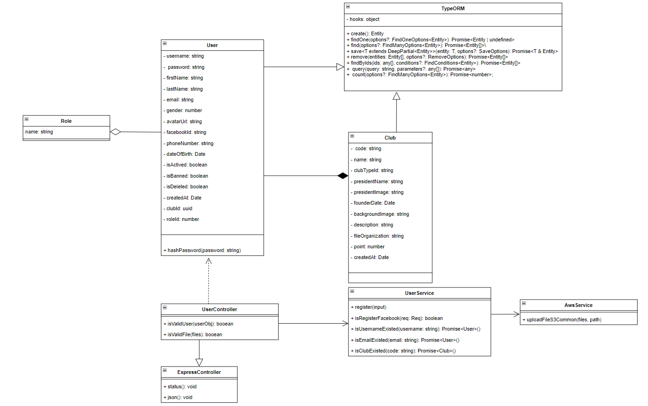

*Figure 61. Class Diagram of feature Register Account*

#### *3.1.2 Sequence Diagram*

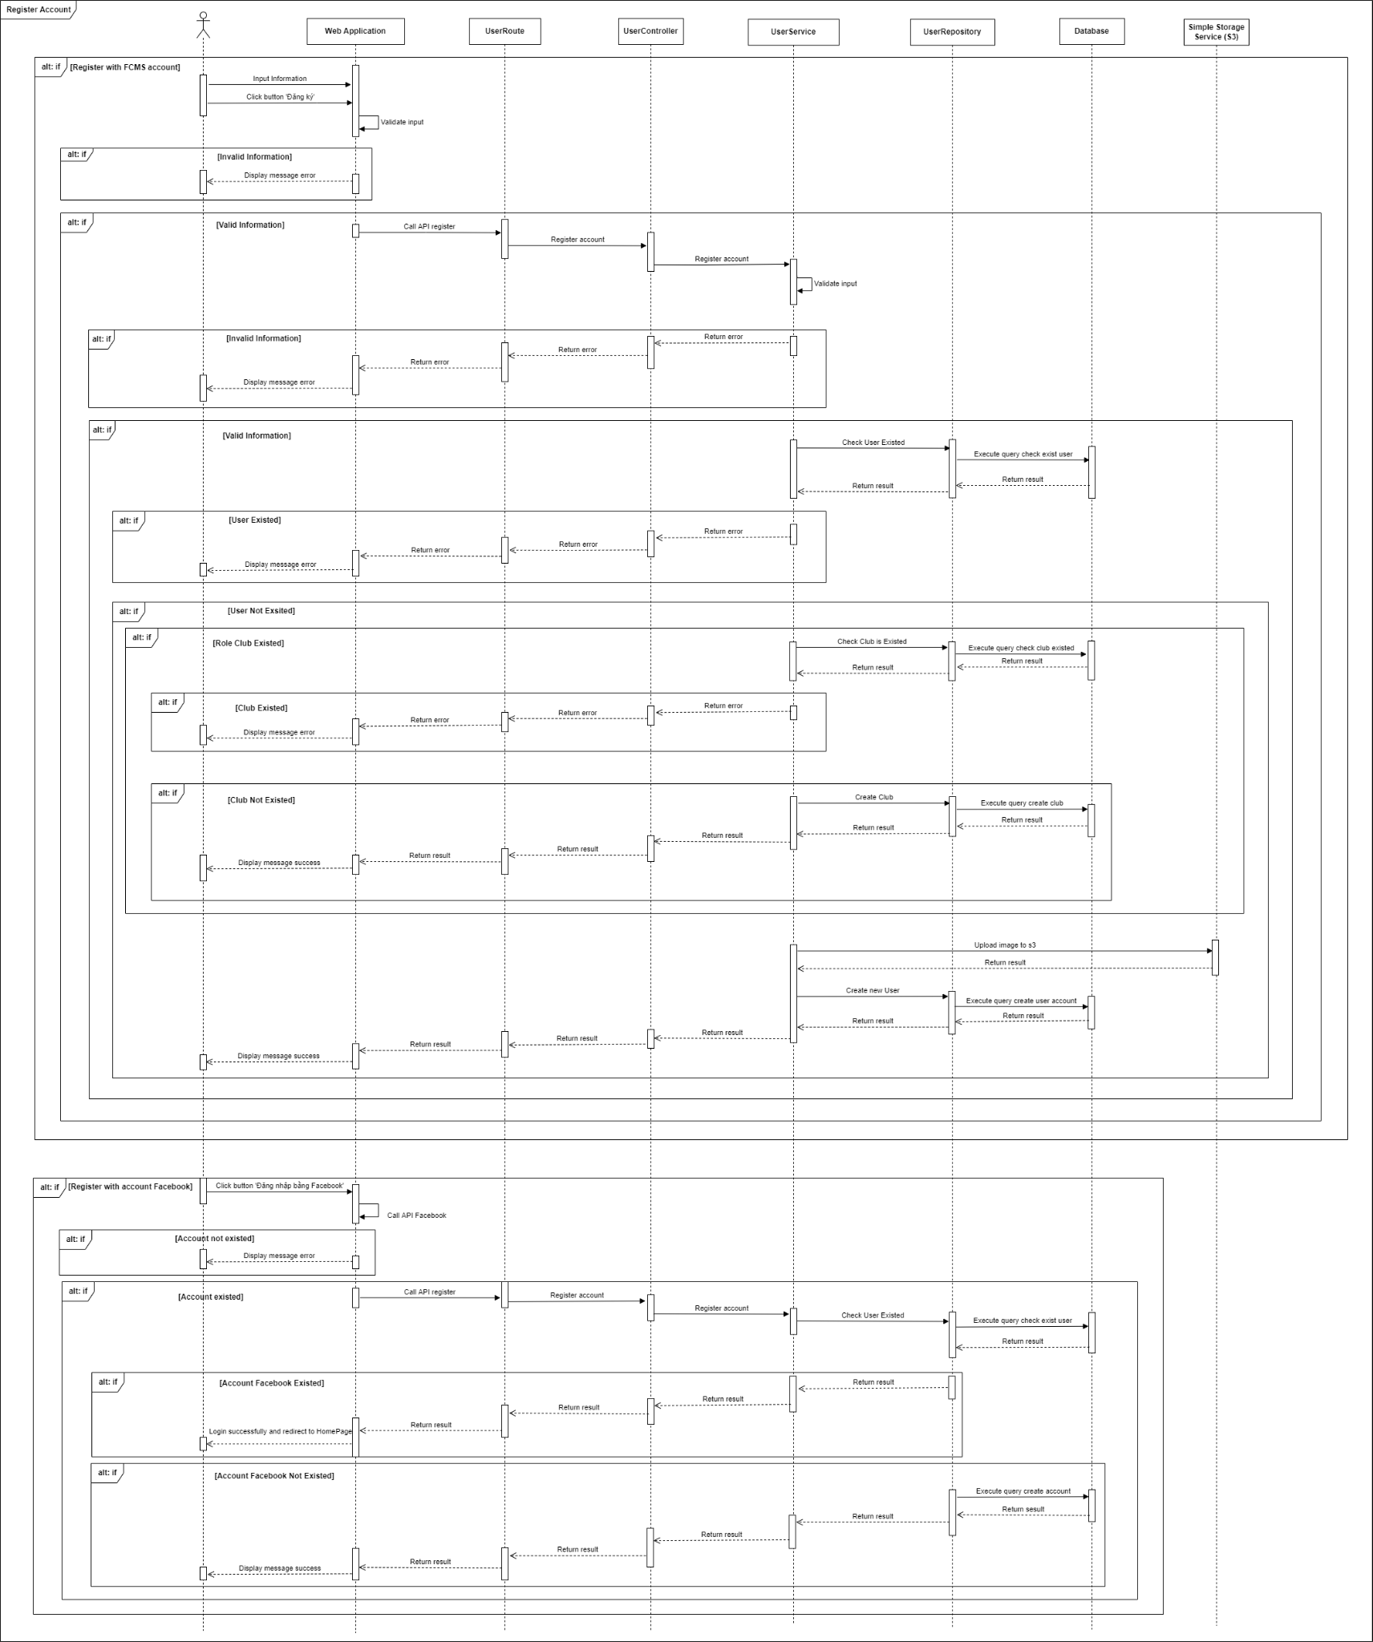

*Figure 62. Sequence Diagram of feature Register Account*

### 3.2 Sign in

#### *3.2.1 Class Diagram*

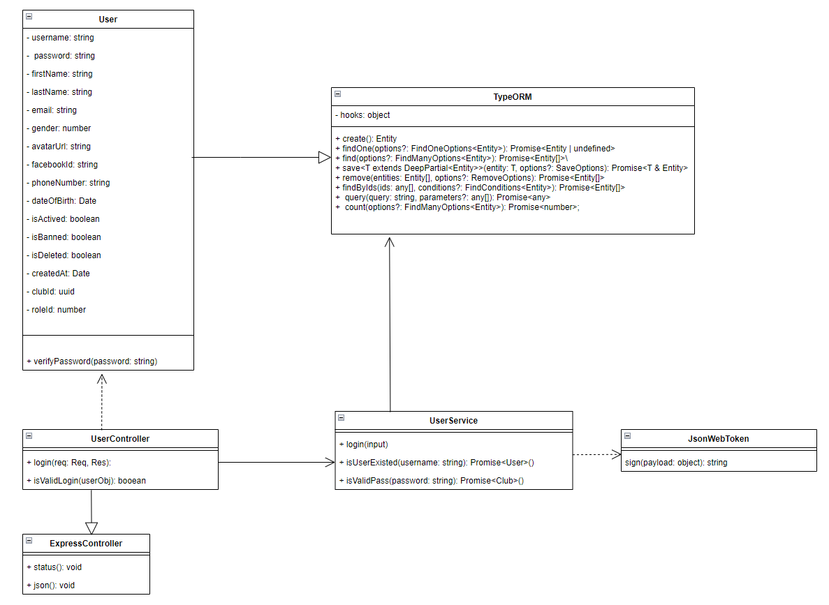

*Figure 63. Class Diagram of feature Sign in*

#### *3.2.2 Sequence Diagram*

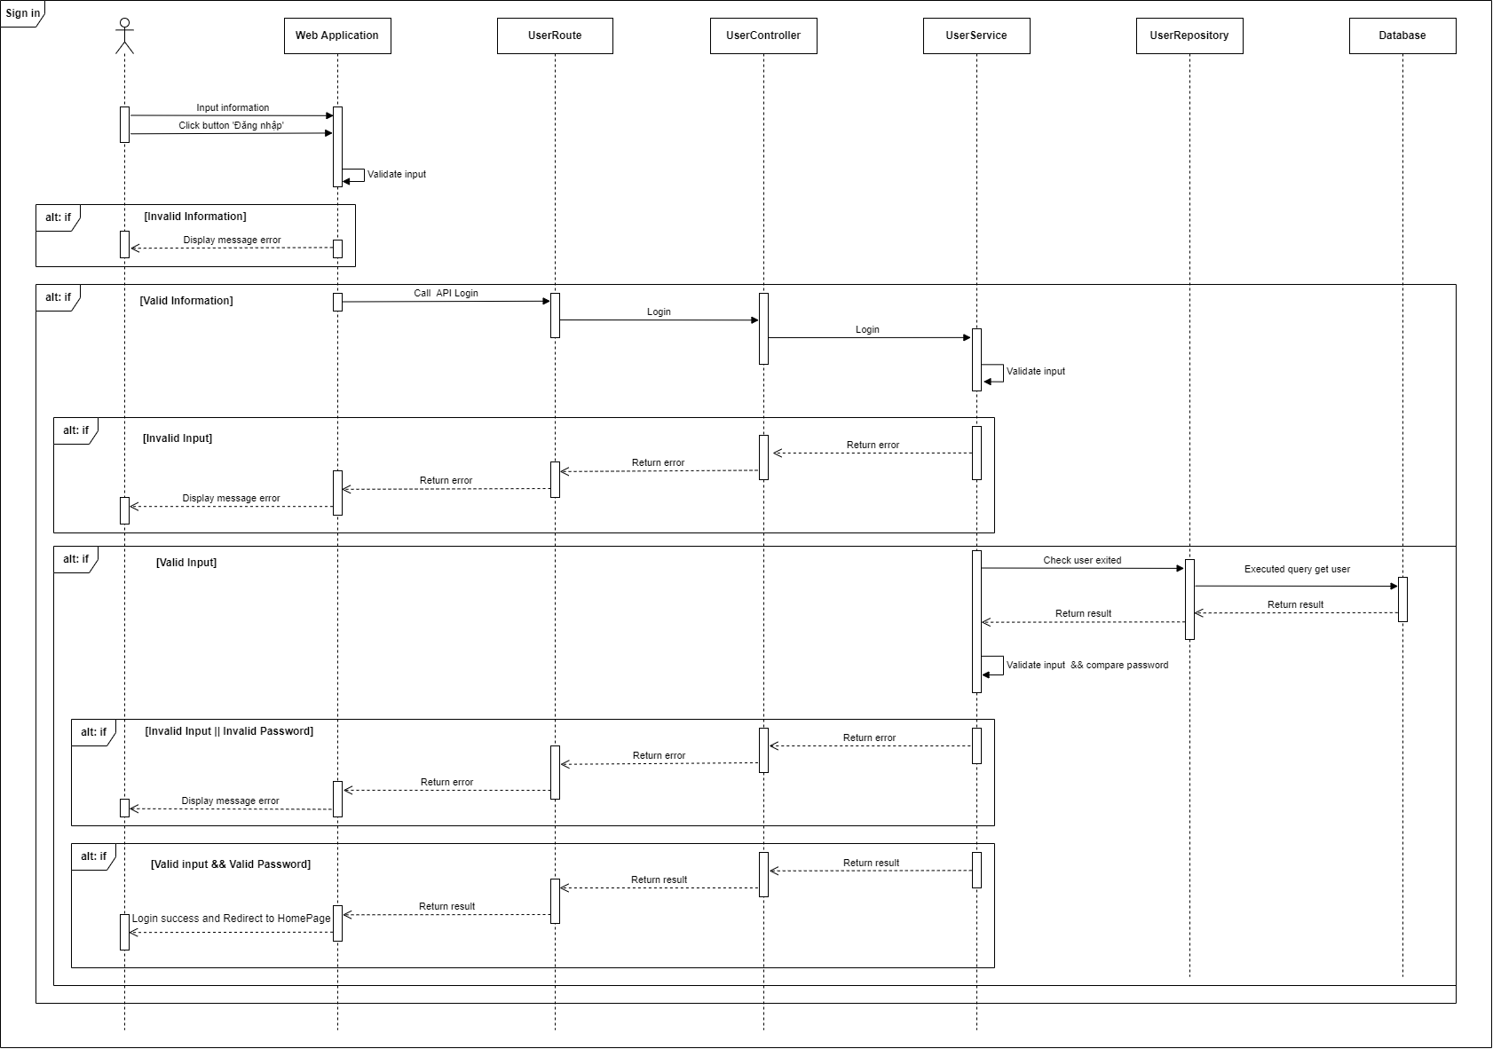

*Figure 64. Sequence Diagram of feature Sign in*

### 3.3 View List Users By Role

#### *3.3.1 Class Diagram*

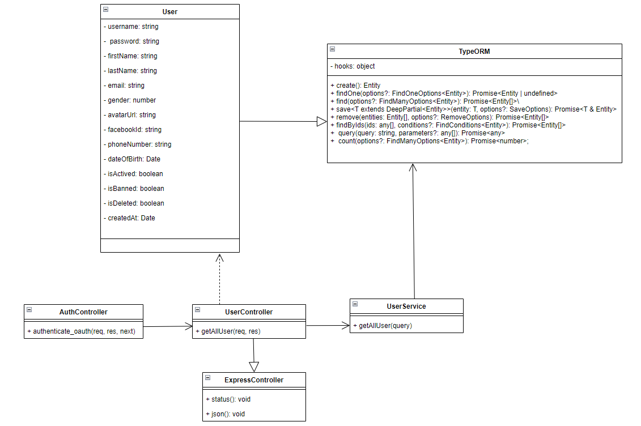

*Figure 65. Class Diagram of feature View List Users By Role*

#### *3.3.2 Sequence Diagram*

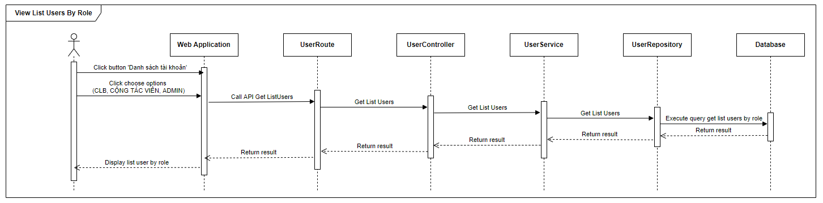

*Figure 66. Sequence Diagram of feature View List Users By Role*

### 3.4 Delete Users

#### *3.4.1 Class Diagram*

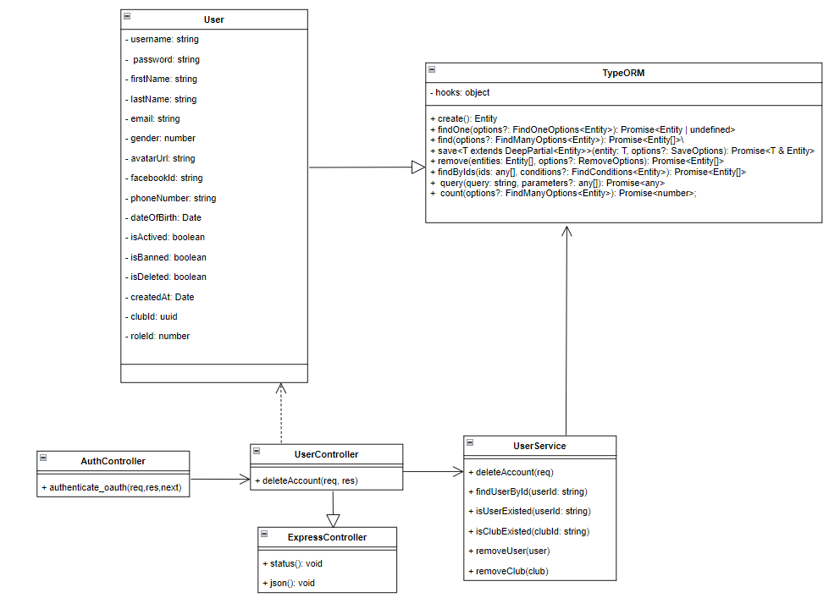

*Figure 67. Class Diagram of feature Delete Users*

#### *3.4.2 Sequence Diagram*

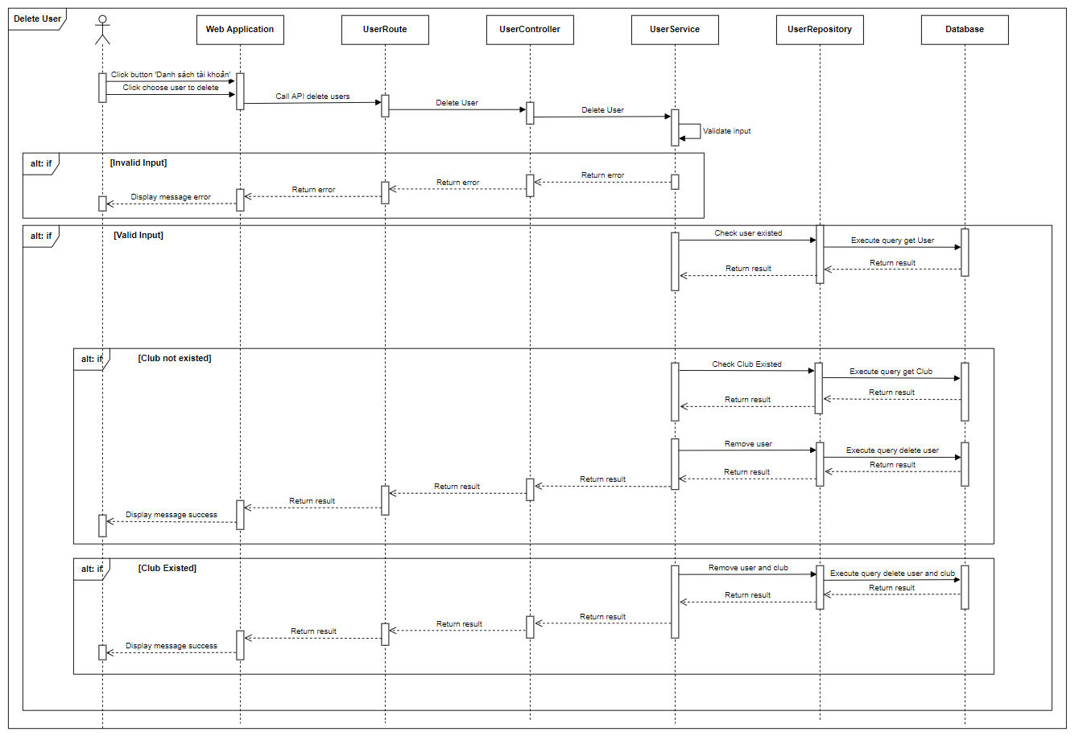

*Figure 68. Sequence Diagram of feature Delete Users*

### 3.5 Update profile

#### *3.5.1 Class Diagram*

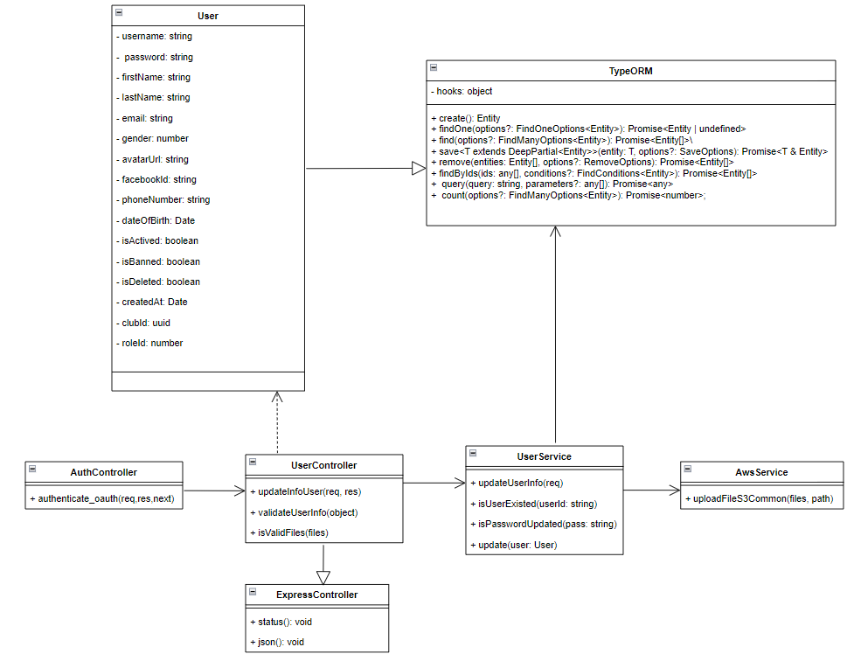

*Figure 69. Class Diagram of feature Update profile*

#### *3.5.2 Sequence Diagram*

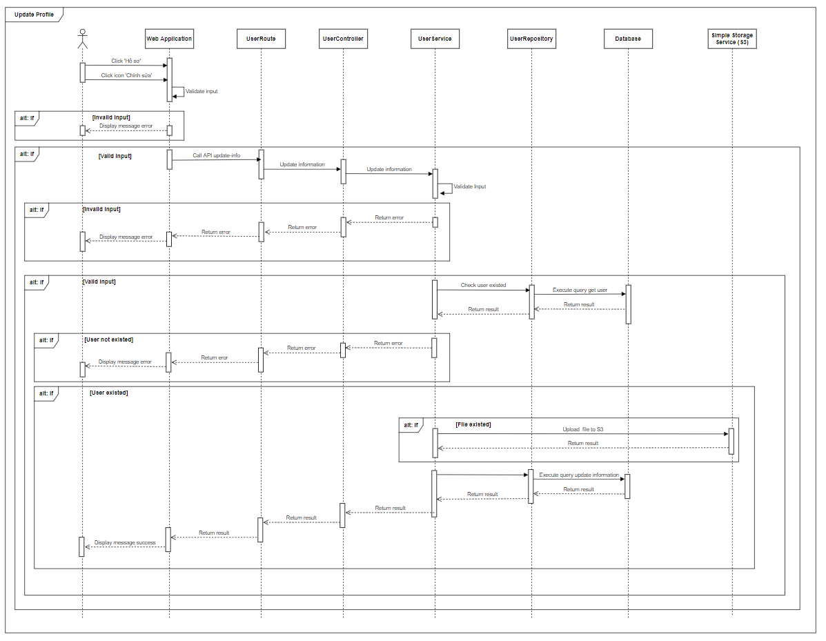

*Figure 70. Sequence Diagram of feature Update profile*

### 3.6 View Statistic Chart User

#### *3.6.1 Class Diagram*

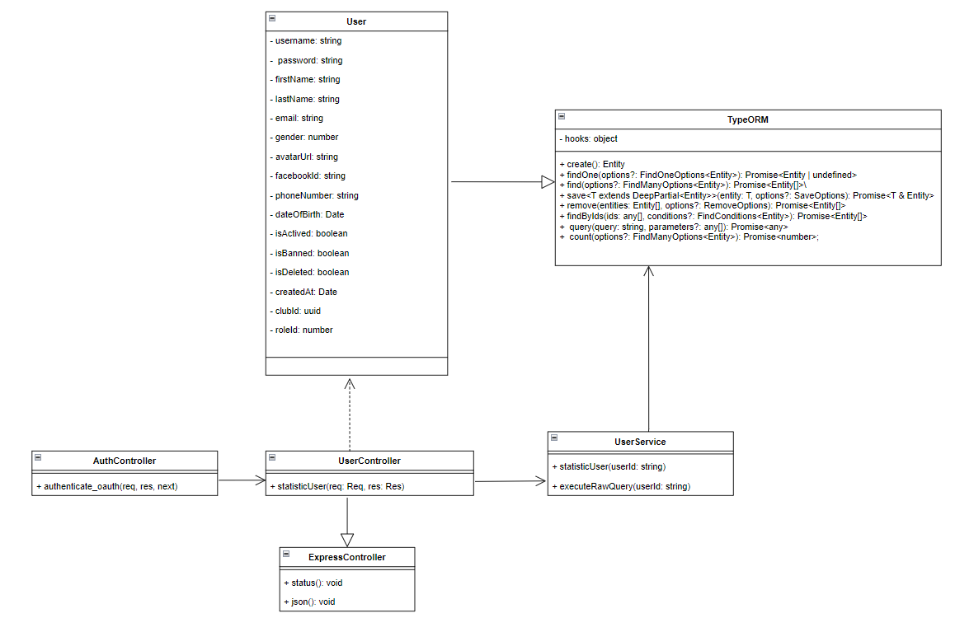

*Figure 71. Class Diagram of feature View Statistic Chart User*

#### *3.6.2 Sequence Diagram*

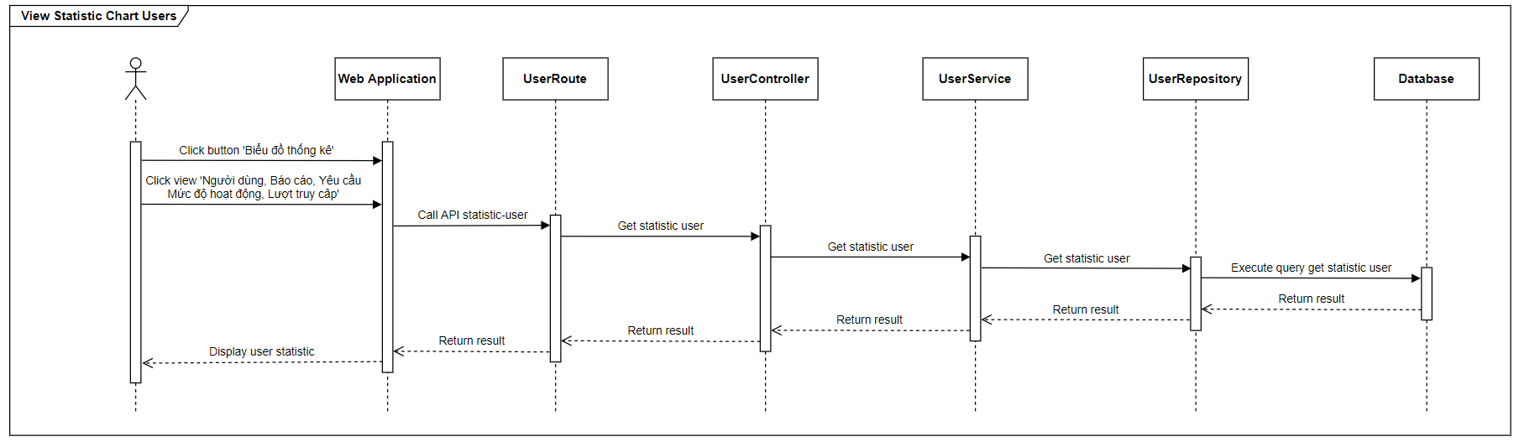

*Figure 72. Sequence Diagram of feature View Statistic Chart User*

### 3.7 Set Permission For Collaborator

#### *3.7.1 Class Diagram*

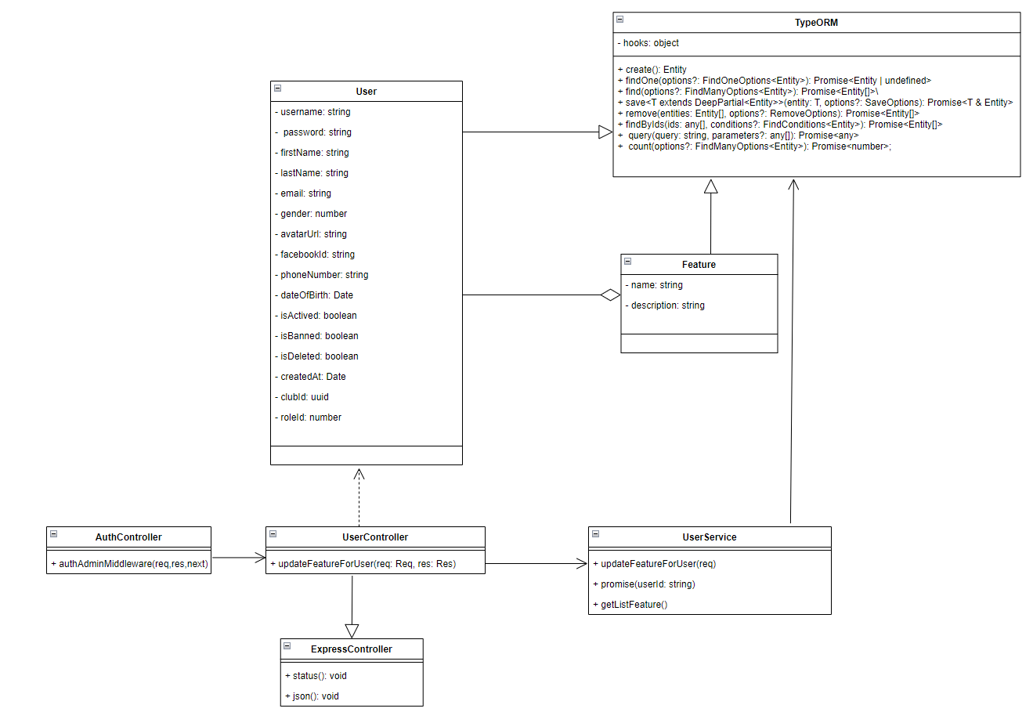

*Figure 73. Class Diagram of feature Set Permission For Collaborator*

#### *3.7.2 Sequence Diagram*

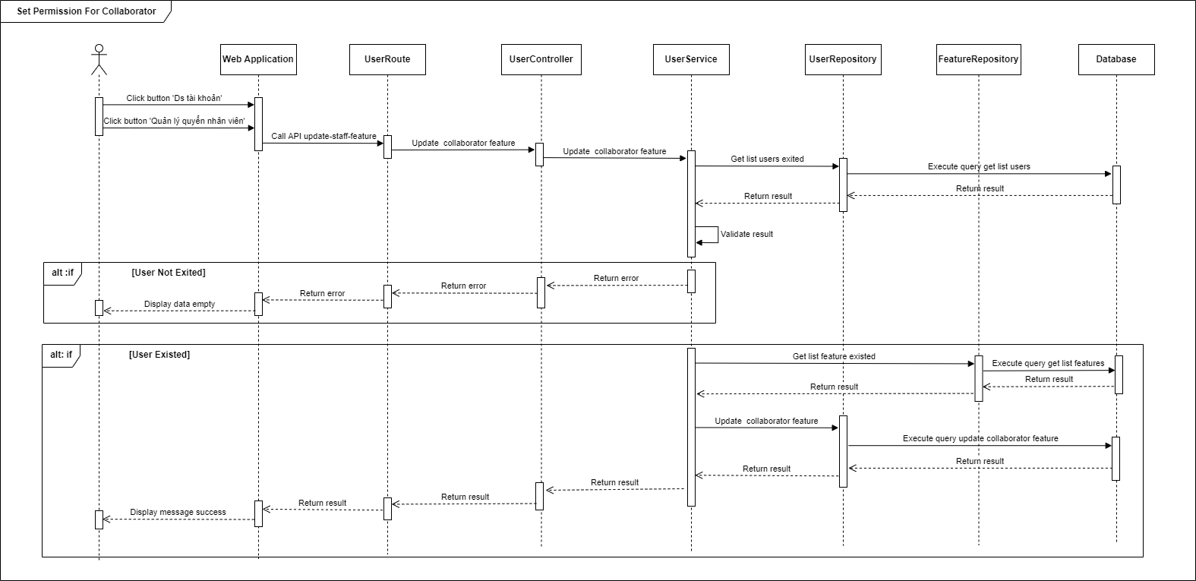

*Figure 74. Sequence Diagram of feature Set Permission For Collaborator*

### 3.8 Invite Register Account

#### *3.8.1 Class Diagram*

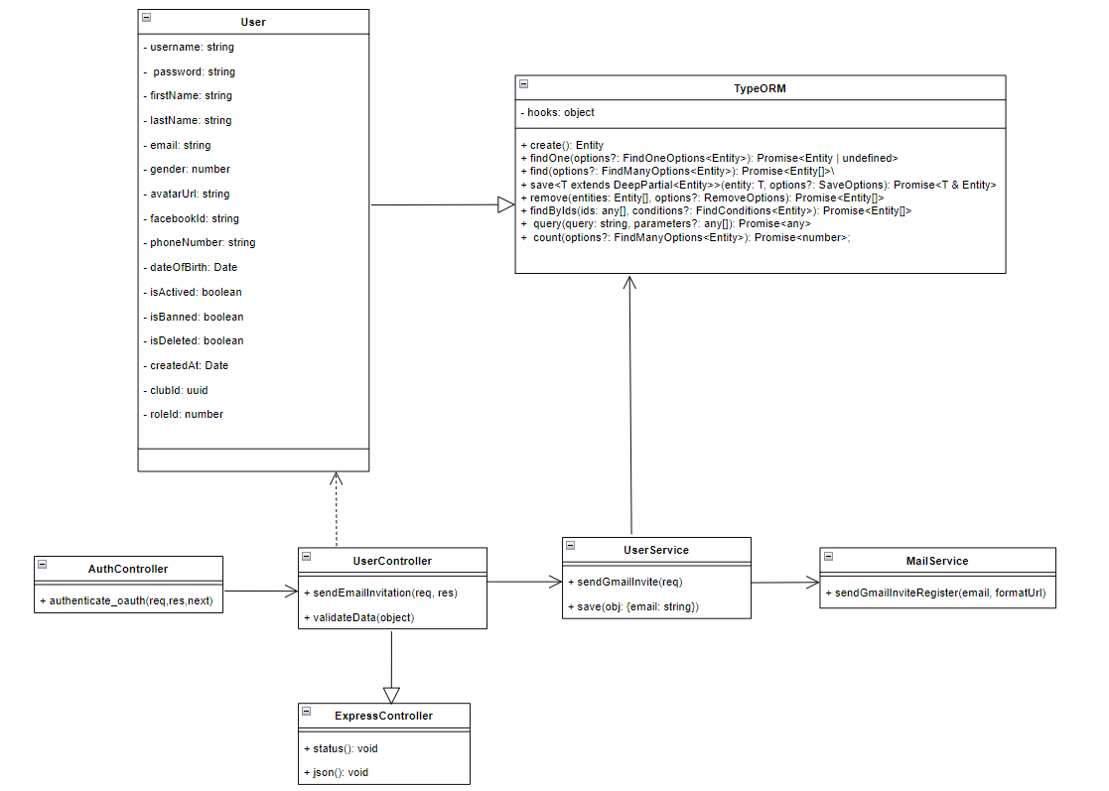

*Figure 75. Class Diagram of feature Invite Register Account*

#### *3.8.2 Sequence Diagram*

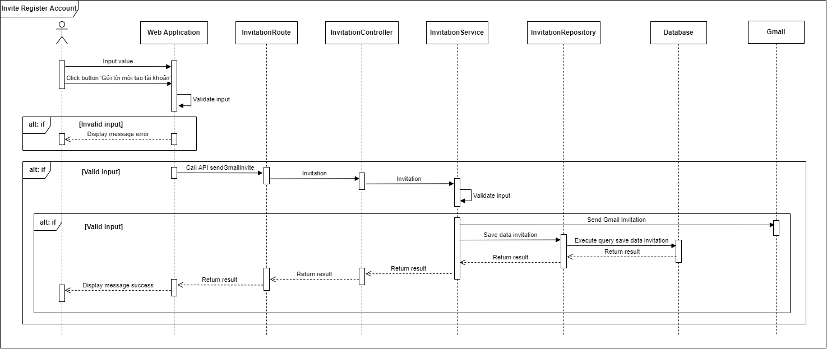

*Figure 76. Sequence Diagram of feature Invite Register Account*

### 3.9 Reset Password

#### *3.9.1 Class Diagram*

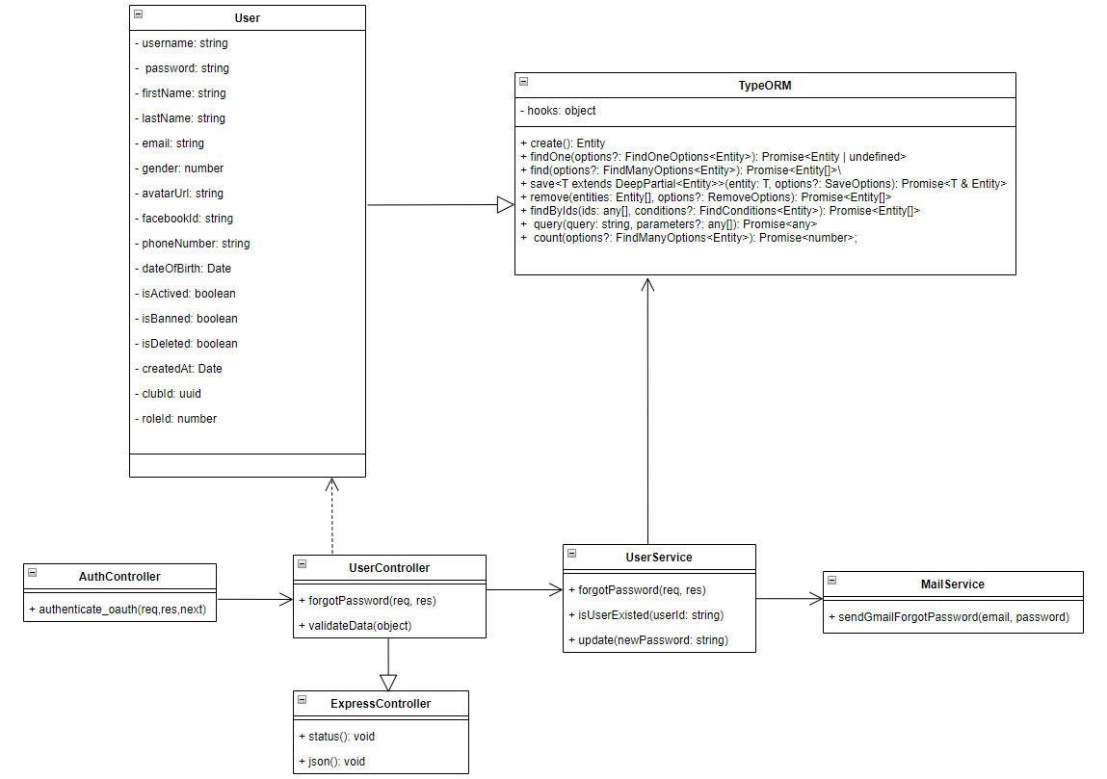

*Figure 77. Class Diagram of feature Reset Password*

#### *3.9.2 Sequence Diagram*

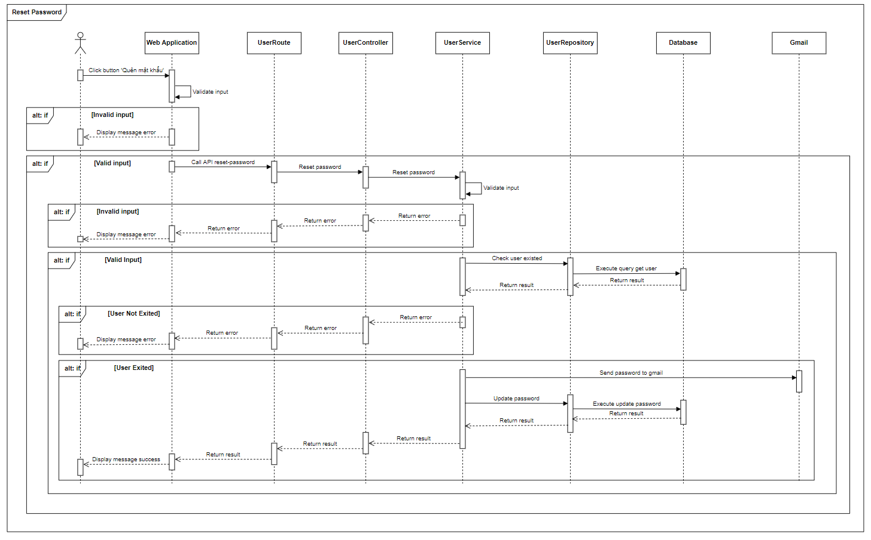

*Figure 78. Sequence Diagram of feature Reset Password*

### 3.10 View List Excellent Clubs

#### *3.10.1 Class Diagram*

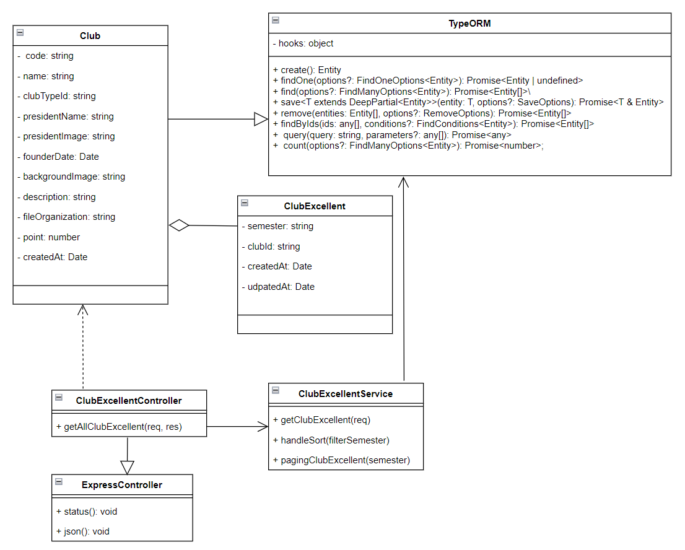

*Figure 79. Class Diagram of feature View List Excellent Clubs*

#### *3.10.2 Sequence Diagram*

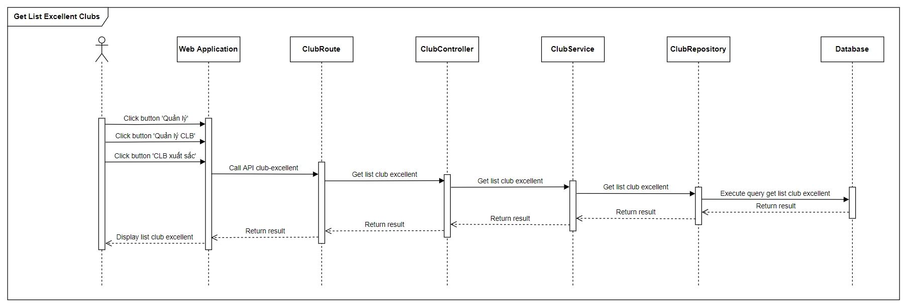

*Figure 80. Sequence Diagram of feature View List Excellent Clubs*

### 3.11 Add Excellent Clubs

#### *3.11.1 Class Diagram*

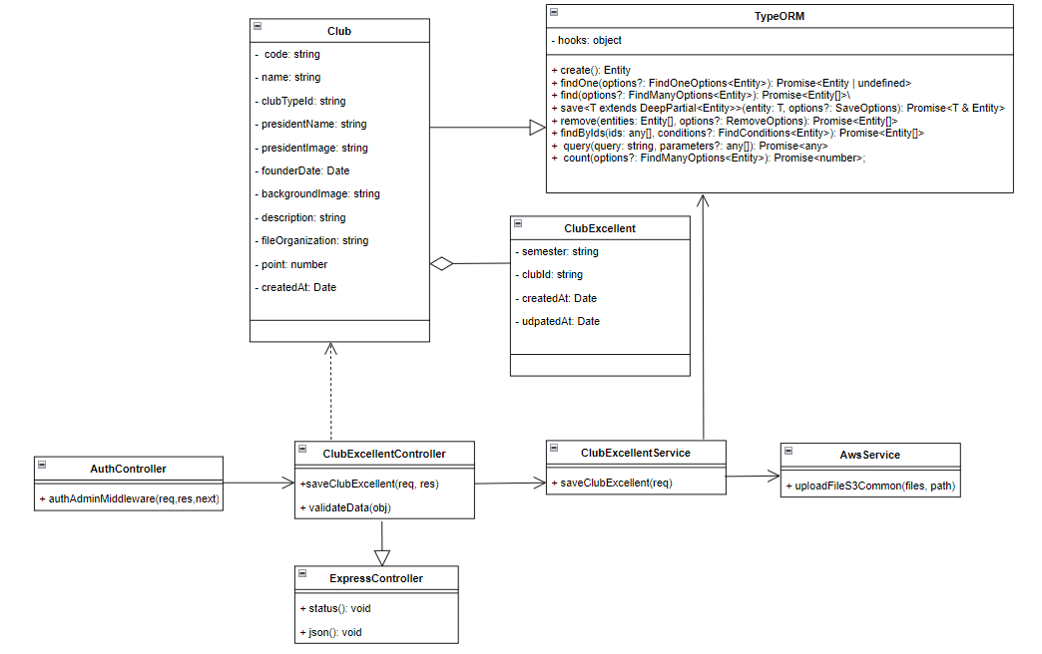

*Figure 81. Class Diagram of feature Add Excellent CLubs*

#### *3.11.2 Sequence Diagram*

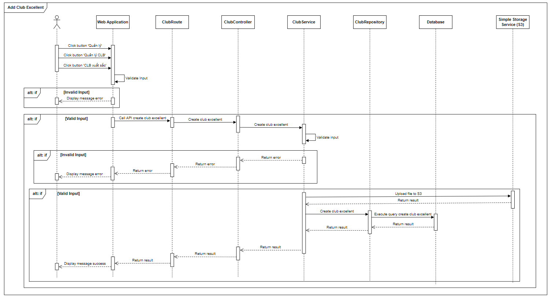

*Figure 82. Sequence Diagram of feature Add Excellent CLubs*

### 3.12 Add Excellent Individuals

#### *3.12.1 Class Diagram*

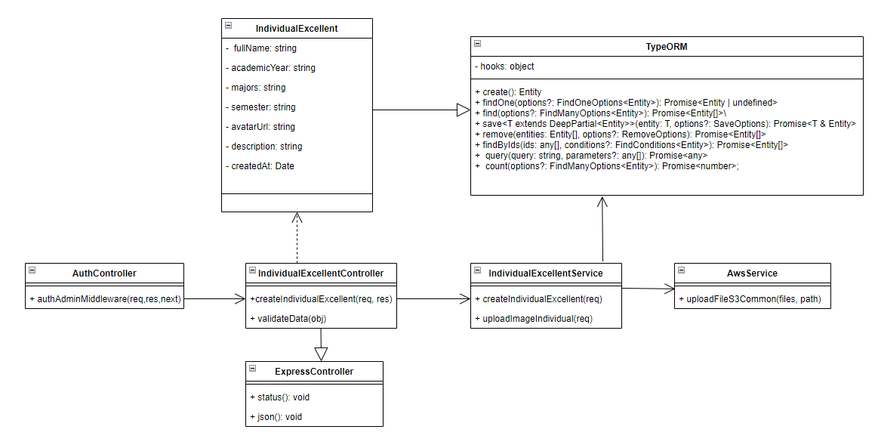

*Figure 83. Class Diagram of feature Add Excellent Individuals*

#### *3.12.2 Sequence Diagram*

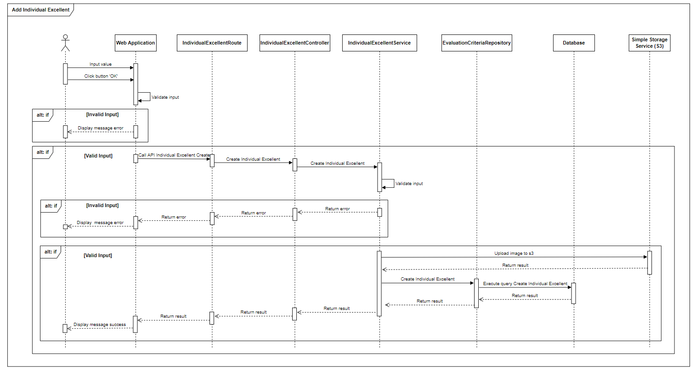

*Figure 84. Sequence Diagram of feature Add Excellent Individuals*

### 3.13 Update Excellent Individual’s Information

#### *3.13.1 Class Diagram*

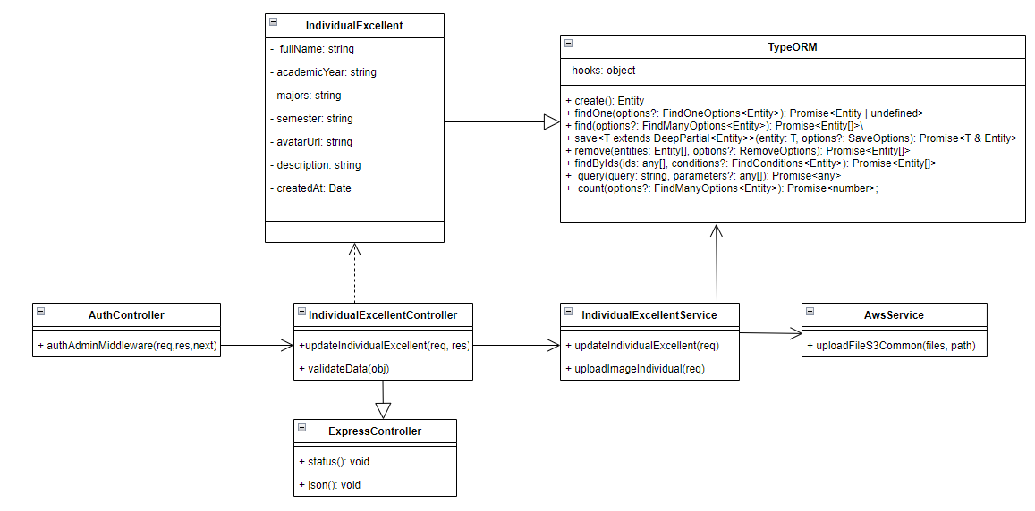

*Figure 85. Class Diagram of feature Update Excellent Individual’s Information*

#### *3.13.2 Sequence Diagram*

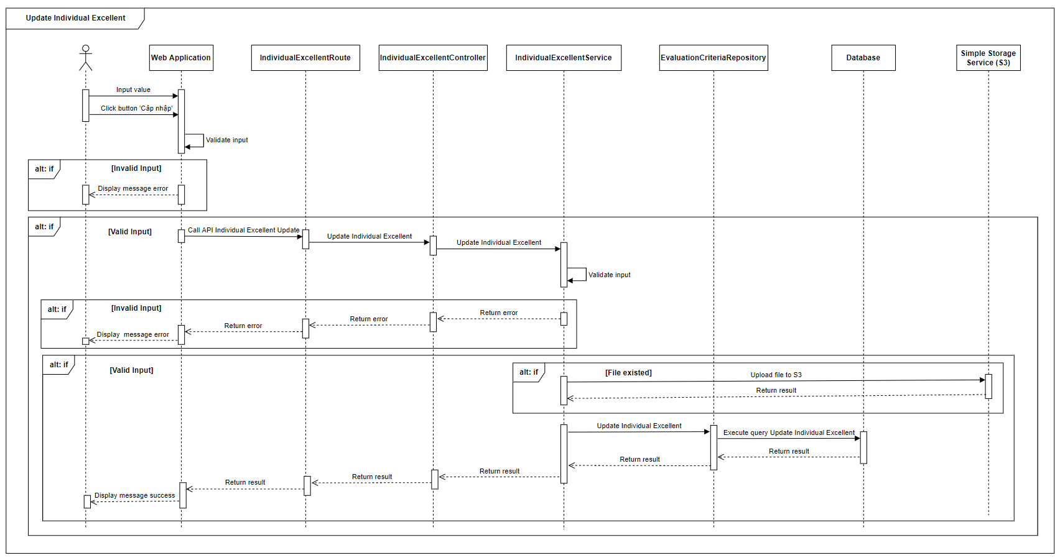

*Figure 86. Sequence Diagram of feature Update Excellent Individual’s Information*

### 3.14 View All Meetings

#### *3.14.1 Class Diagram*

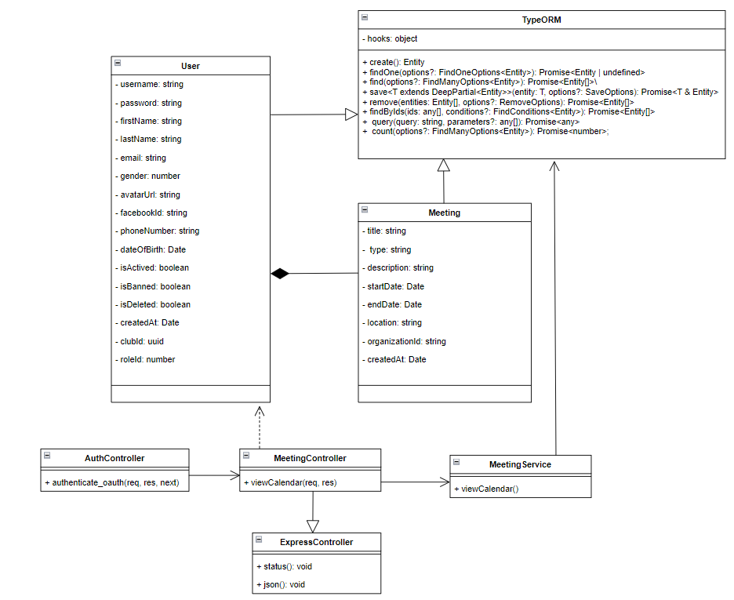

*Figure 87. Class Diagram of feature View All Meetings*

#### *3.14.2 Sequence Diagram*

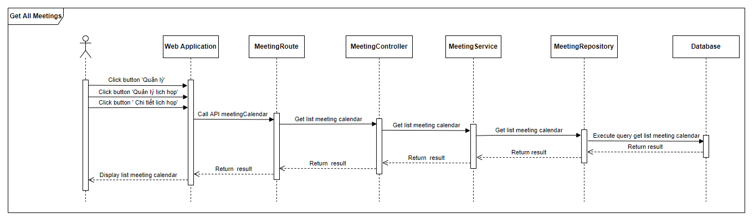

*Figure 88. Sequence Diagram of feature View All Meetings*

### 3.15 Create Meeting

#### *3.15.1 Class Diagram*

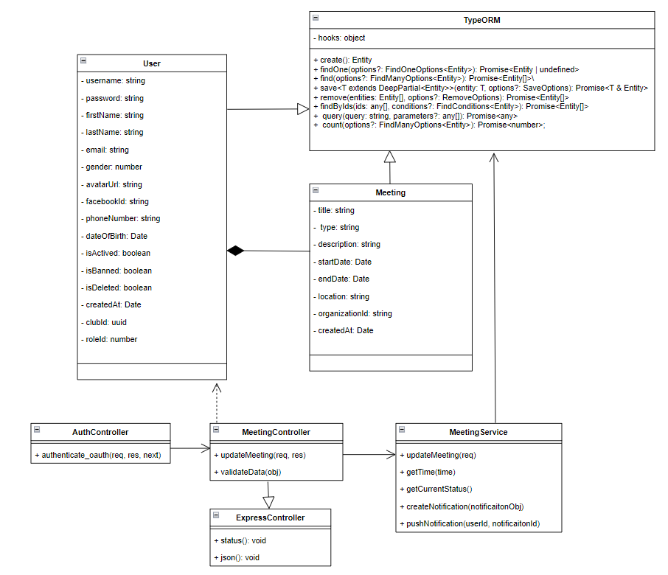

*Figure 89. Class Diagram of feature Create Meeting*

#### *3.15.2 Sequence Diagram*

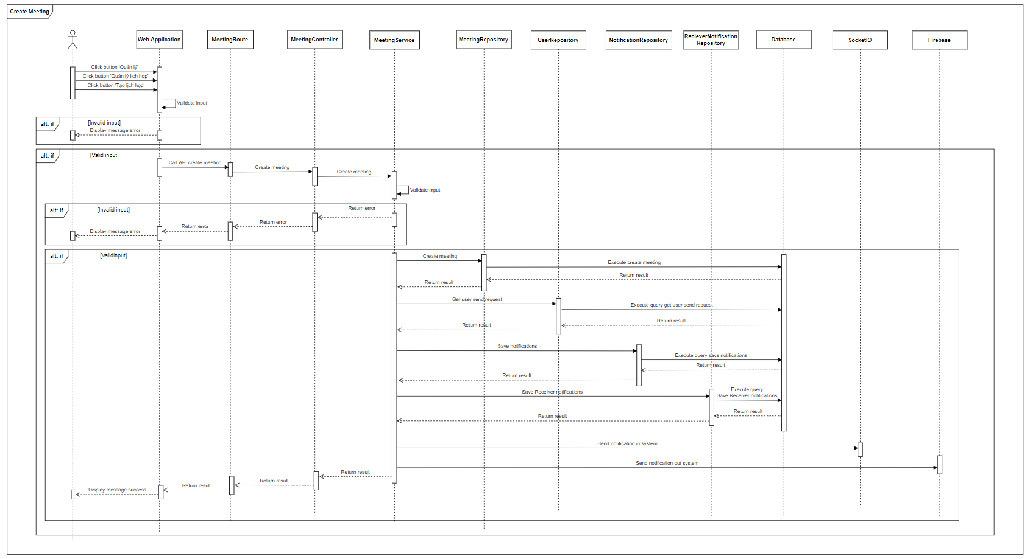

*Figure 90. Sequence Diagram of feature Create Meeting*

### 3.16 Accept/Reject Meeting

#### *3.16.1 Class Diagram*

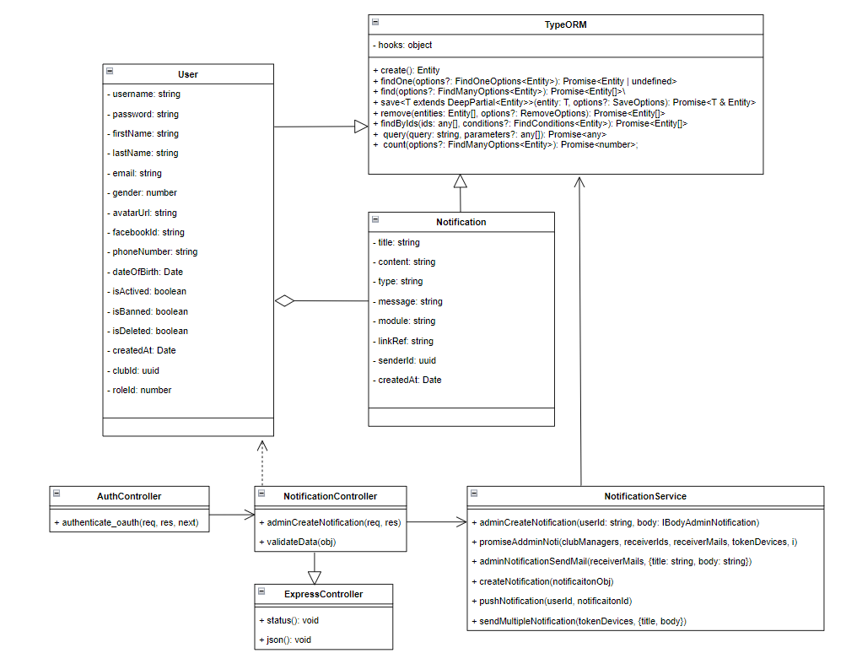

*Figure 91. Class Diagram of feature Accept/Reject Meeting*

#### *3.16.2 Sequence Diagram*

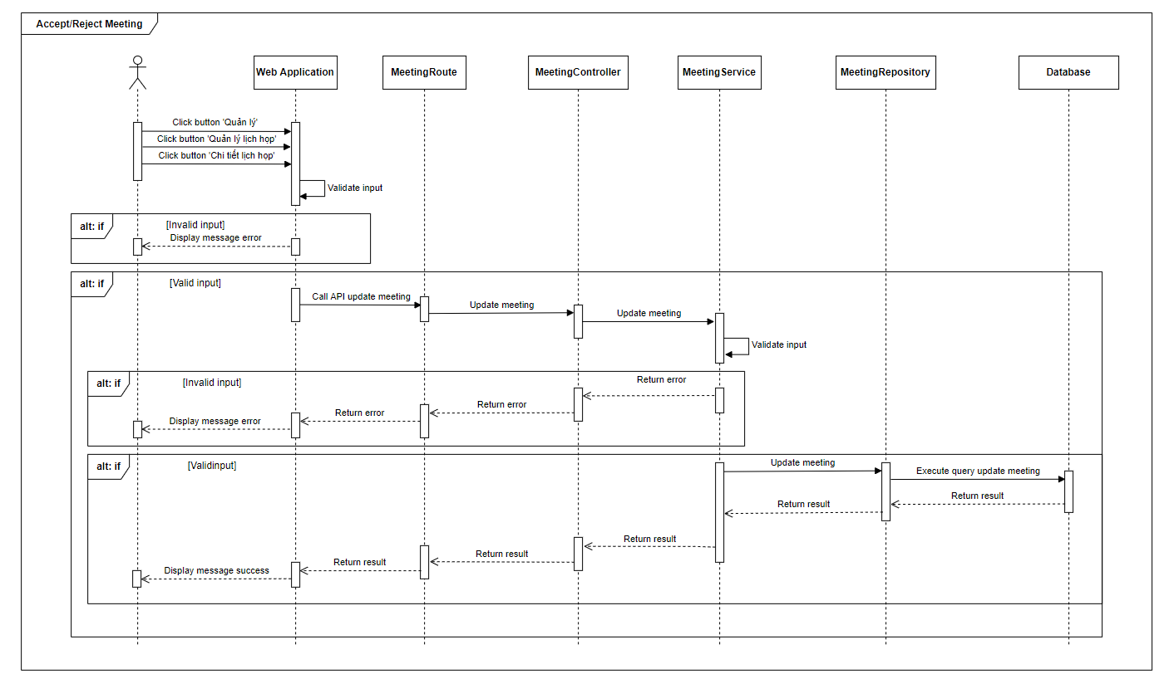

*Figure 92. Sequence Diagram of feature Accept/Reject Meeting*

### 3.17 Create Admin Notification

#### *3.17.1 Class Diagram*

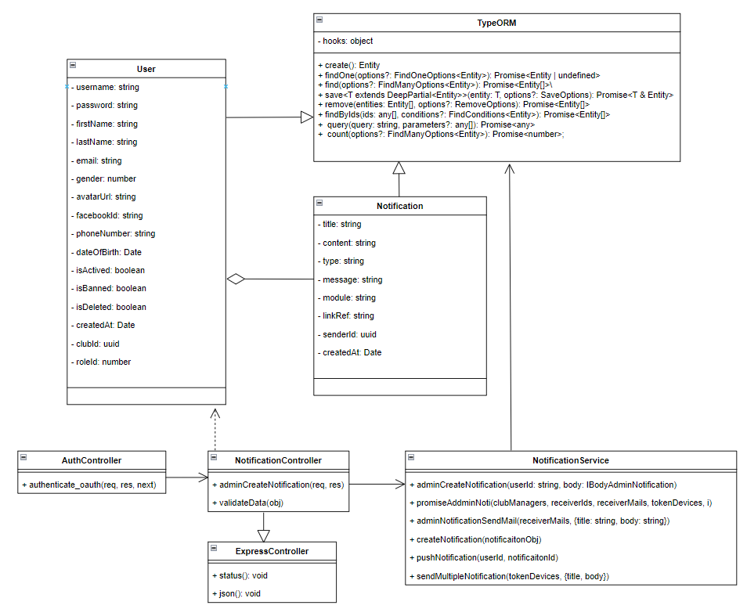

*Figure 93. Class Diagram of feature Create Admin Notification*

#### *3.17.2 Sequence Diagram*

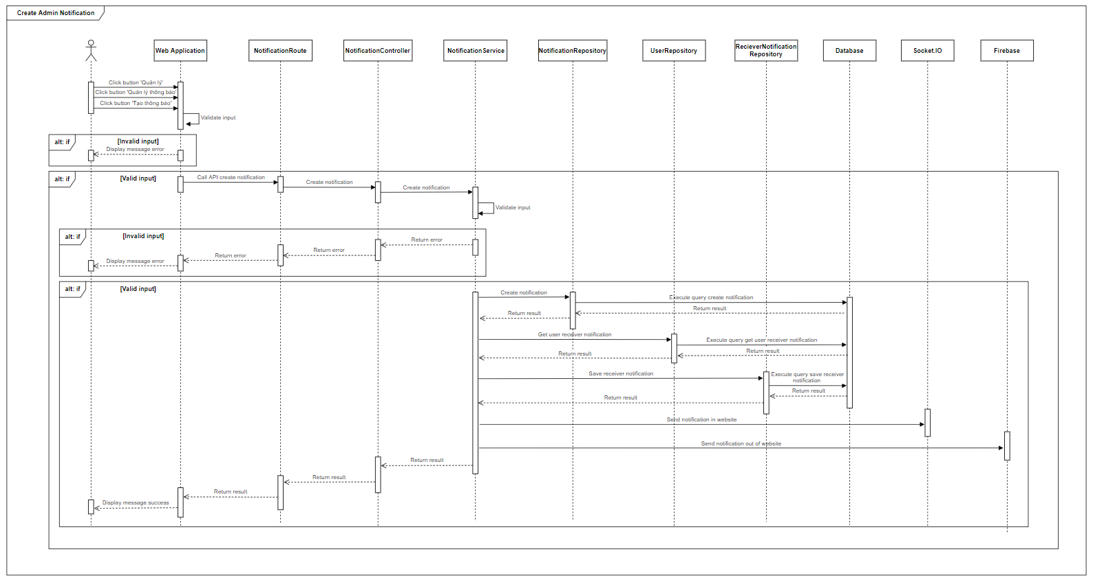

*Figure 94. Sequence Diagram of feature Create Admin Notification*

### 3.18 Create Post

#### *3.18.1 Class Diagram*

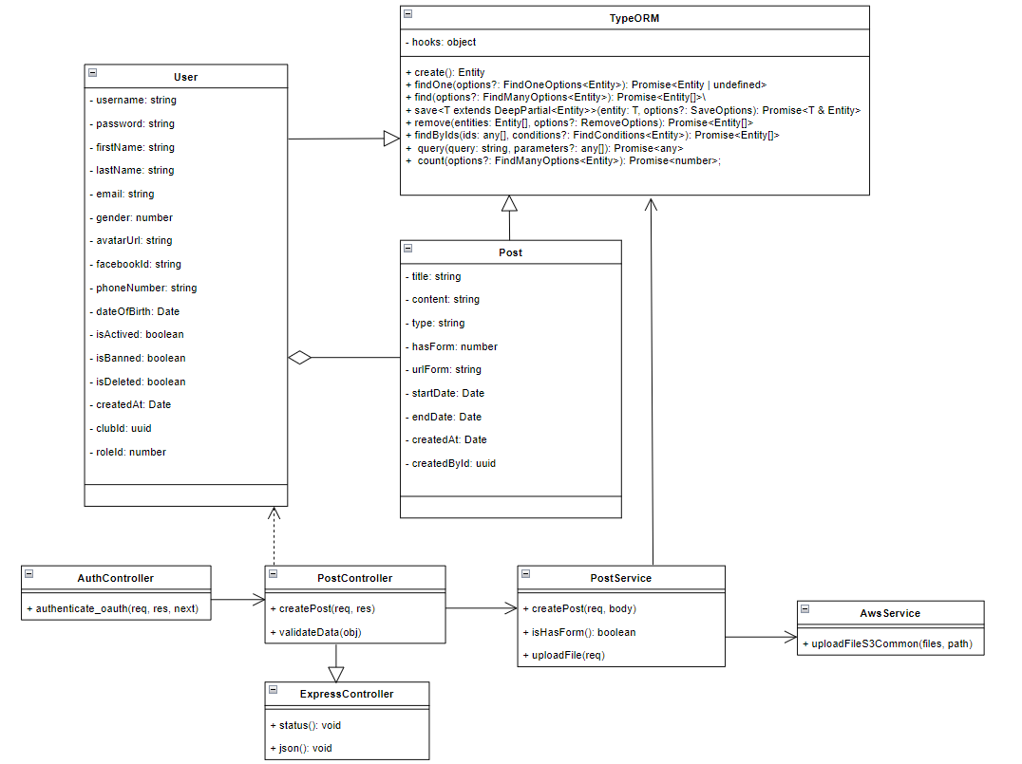

*Figure 95. Class Diagram of feature Create Post*

#### *3.18.2 Sequence Diagram*

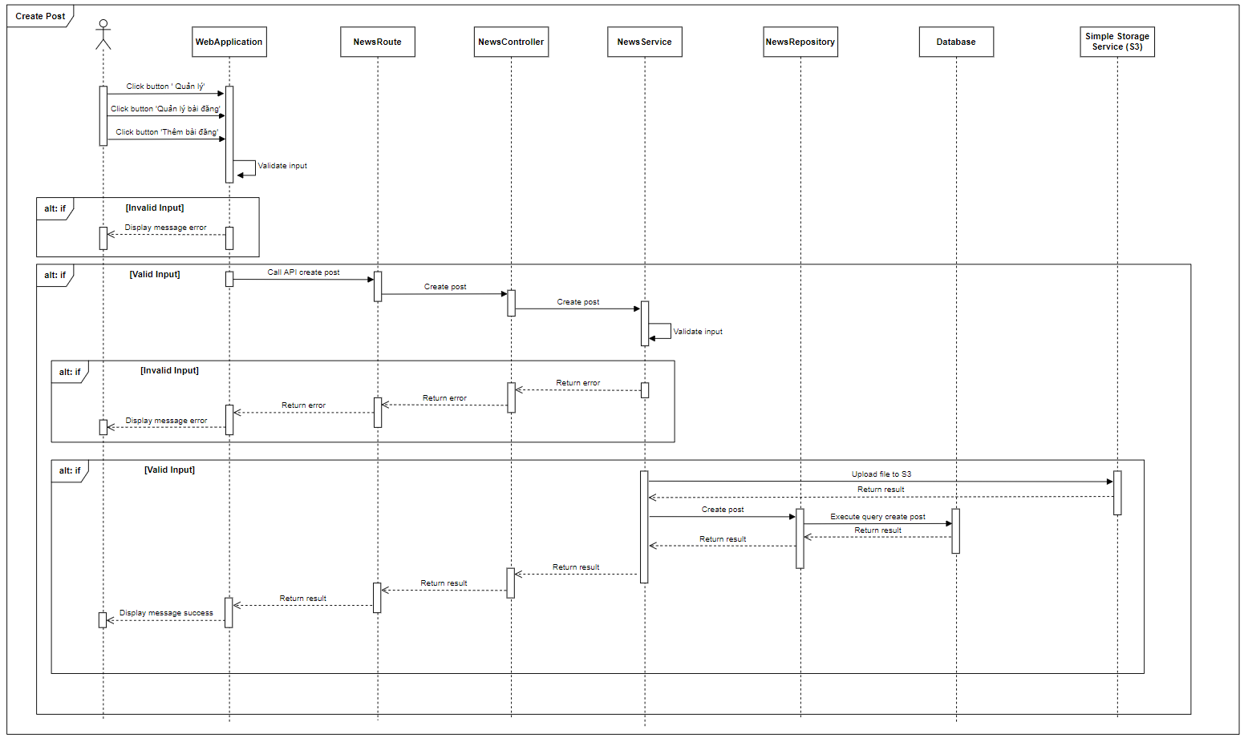

*Figure 96. Sequence Diagram of feature Create Post*

### 3.19 Update Post

#### *3.19.1 Class Diagram*

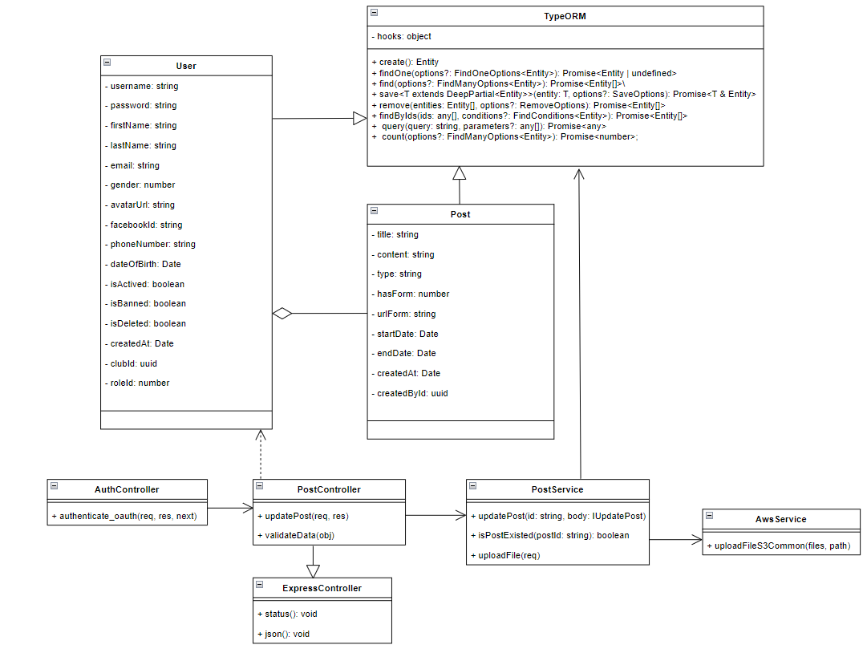

*Figure 97. Class Diagram of feature Update Post*

#### *3.19.2 Sequence Diagram*

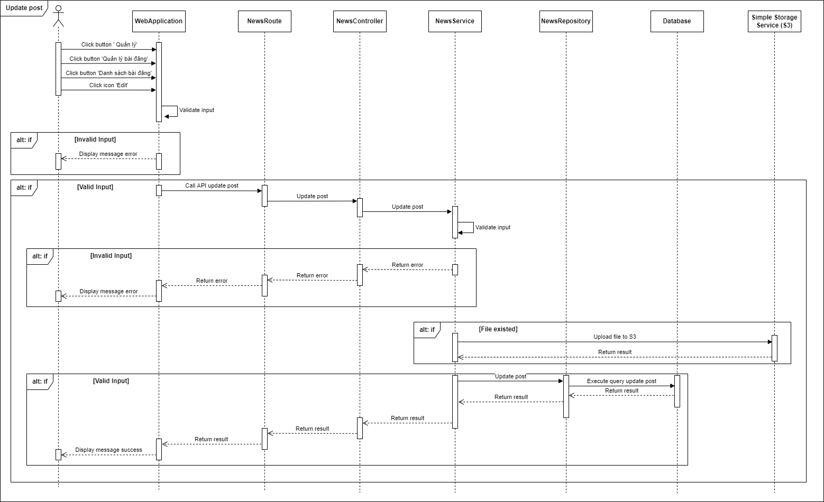

*Figure 98. Sequence Diagram of feature Update Post*

### 3.19 Like Post

#### *3.19.1 Class Diagram*

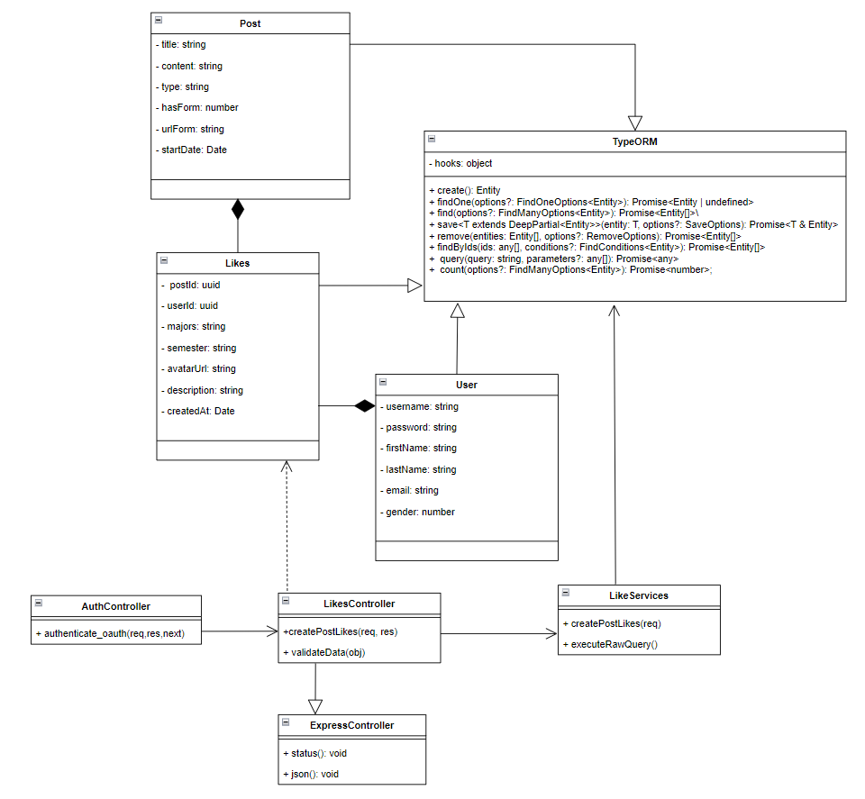

*Figure 99. Class Diagram of feature Like Post*

#### *3.19.2 Sequence Diagram*

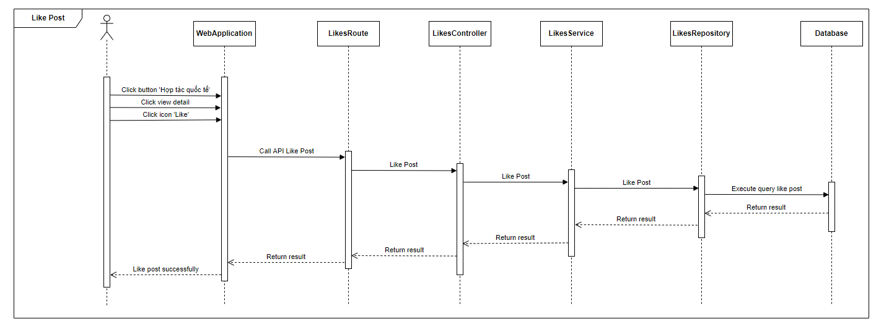

*Figure 100. Sequence Diagram of feature Like Post*

### 3.20 Create Report

#### *3.20.1 Class Diagram*

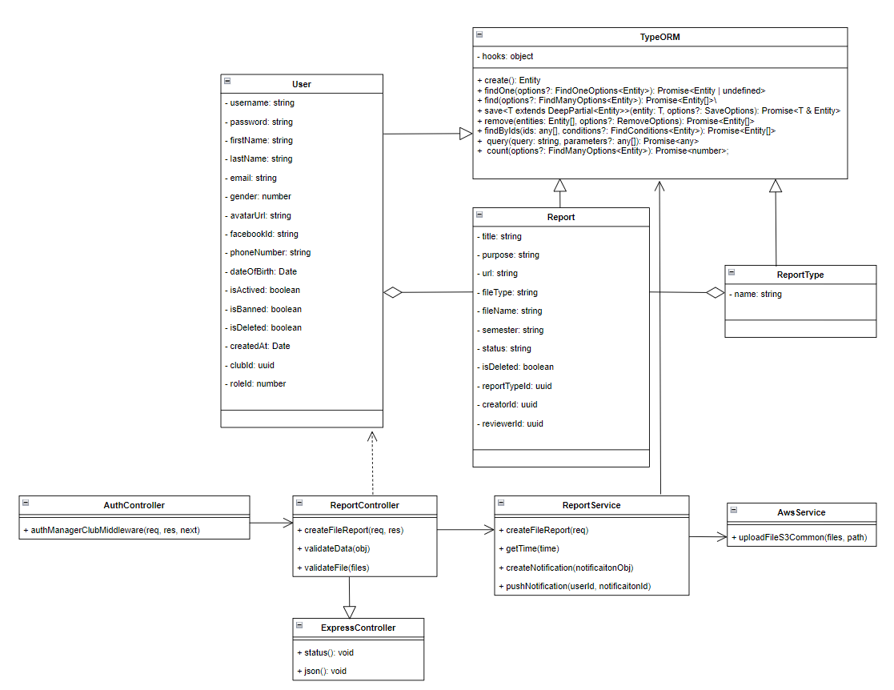

*Figure 101. Class Diagram of feature Create Report*

#### *3.20.2 Sequence Diagram*

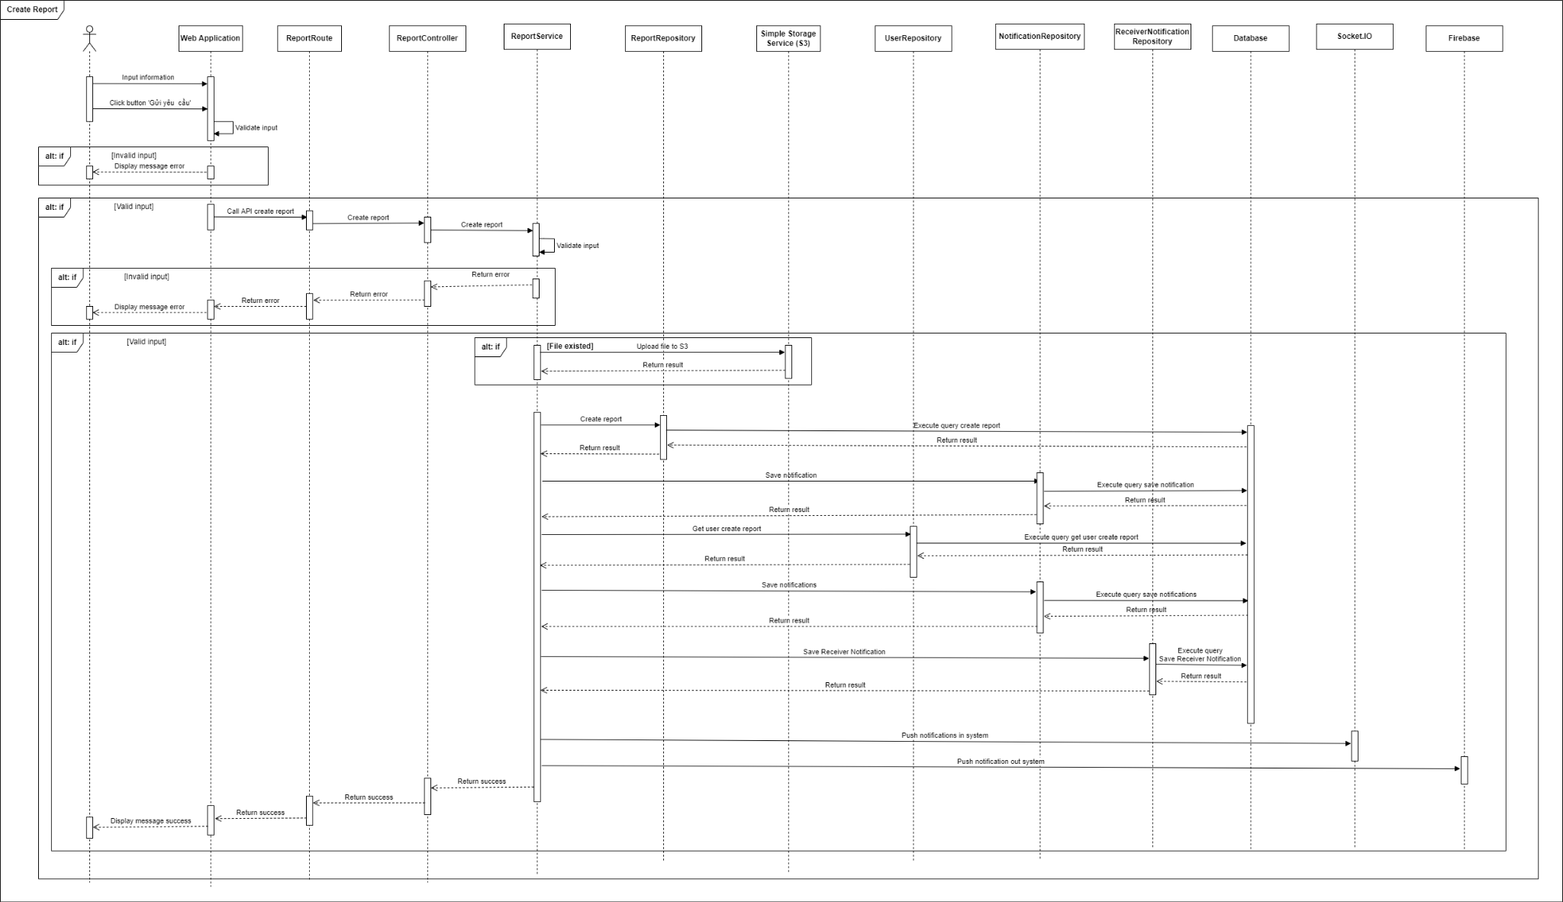

*Figure 102. Sequence Diagram of feature Create Report*

### 3.21 Review Report

#### *3.21.1 Class Diagram*

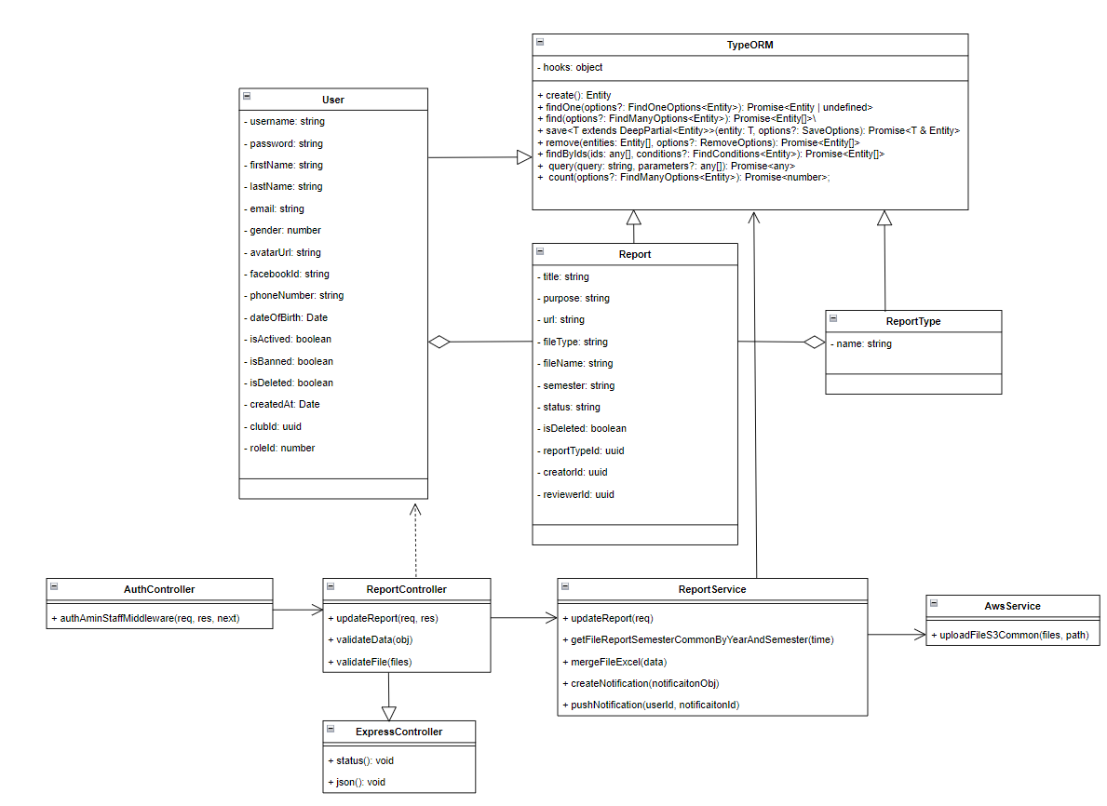

*Figure 103. Class Diagram of feature Review Report*

#### *3.21.2 Sequence Diagram*

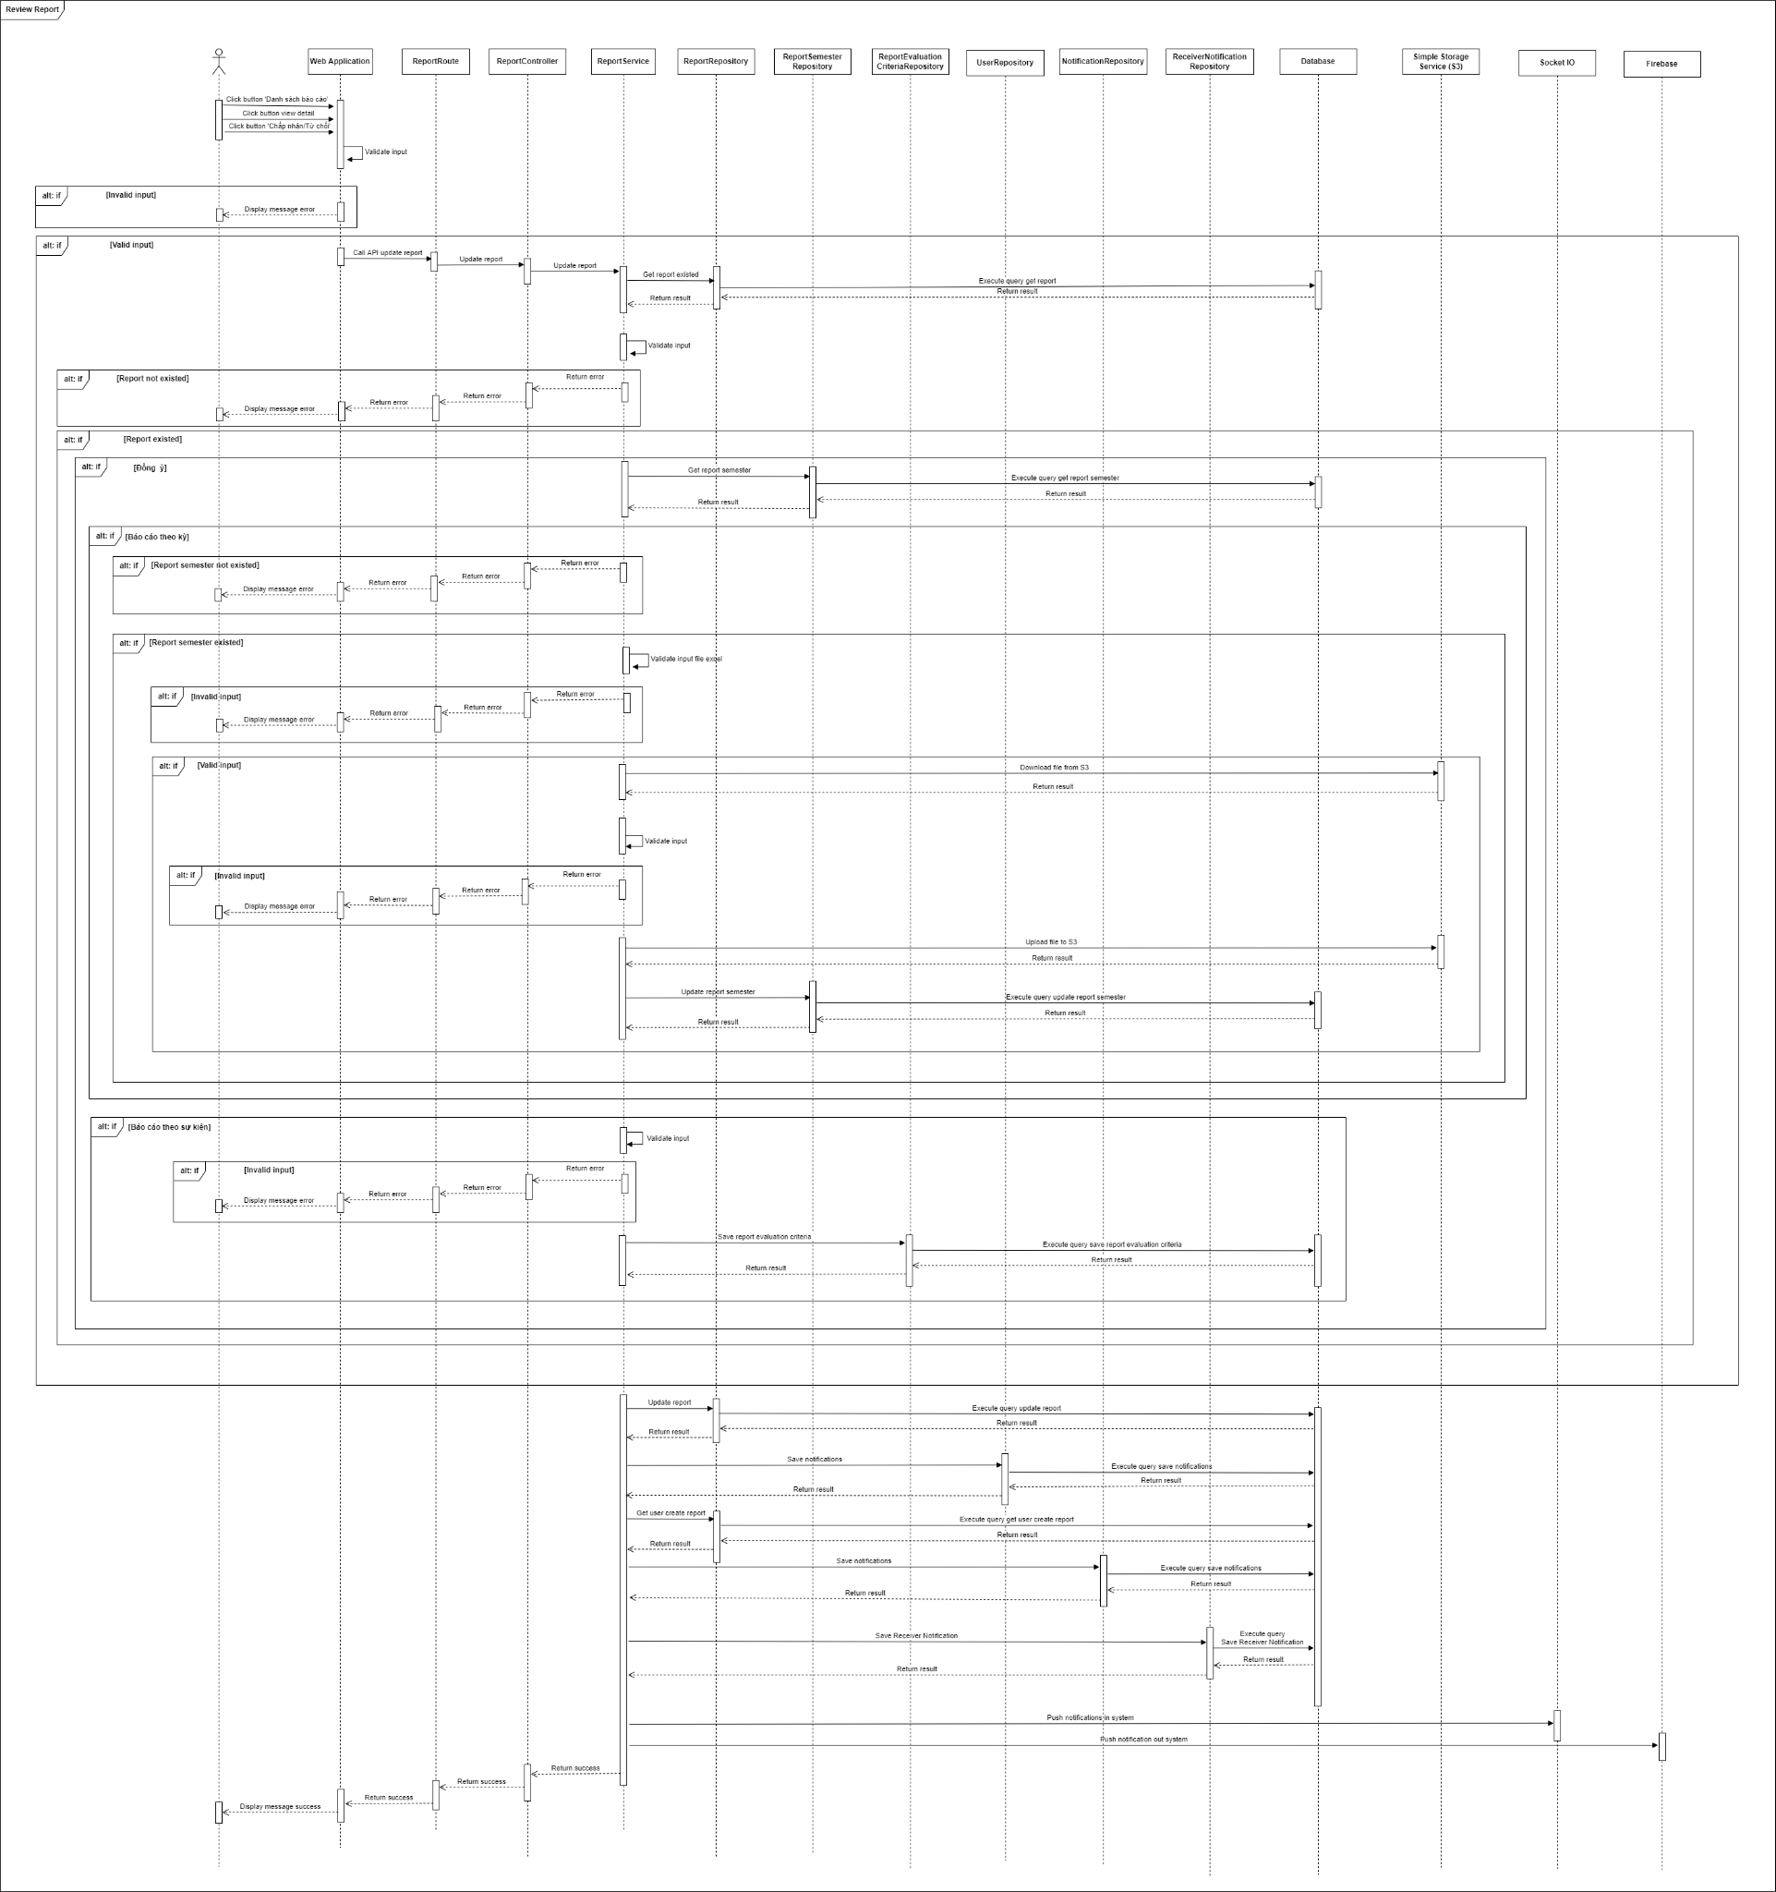

*Figure 104. Sequence Diagram of feature Review Report*

### 3.22 View List Reports

#### *3.22.1 Class Diagram*

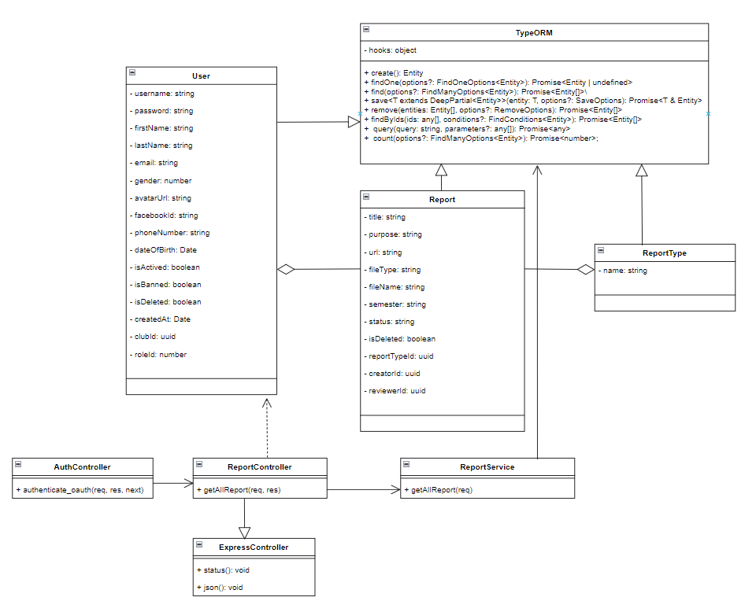

*Figure 105. Class Diagram of feature View List Reports*

#### *3.22.2 Sequence Diagram*

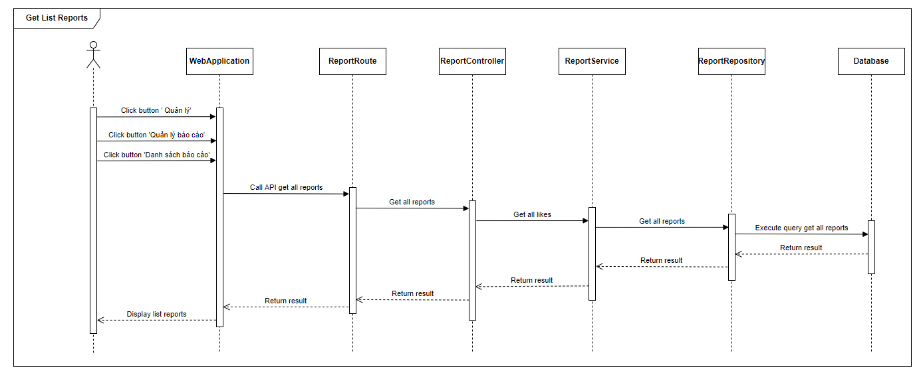

*Figure 106. Sequence Diagram of feature View List Reports*

### 3.23 Create Final Report Semester

#### *3.23.1 Class Diagram*

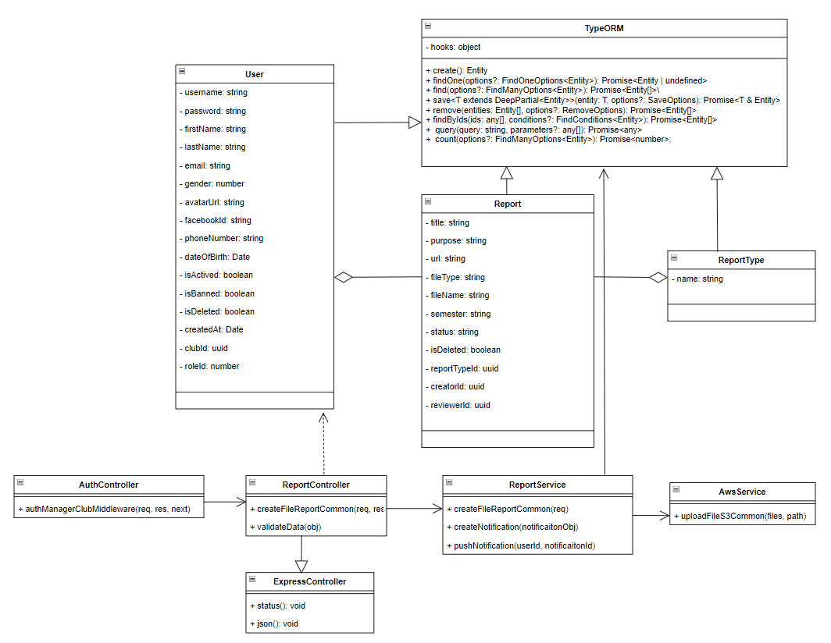

*Figure 107. Class Diagram of feature Create Final Report Semester*

#### *3.23.2 Sequence Diagram*

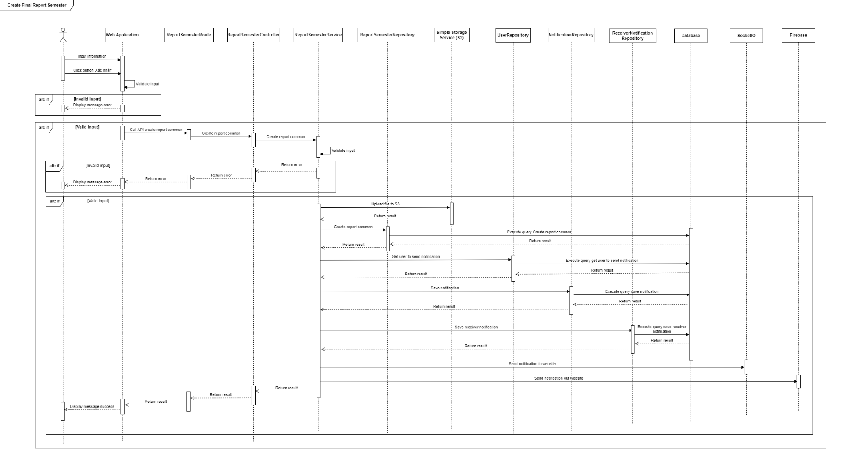

*Figure 108. Sequence Diagram of feature Create Final Report Semester*

### 3.24 Create Request

#### *3.24.1 Class Diagram*

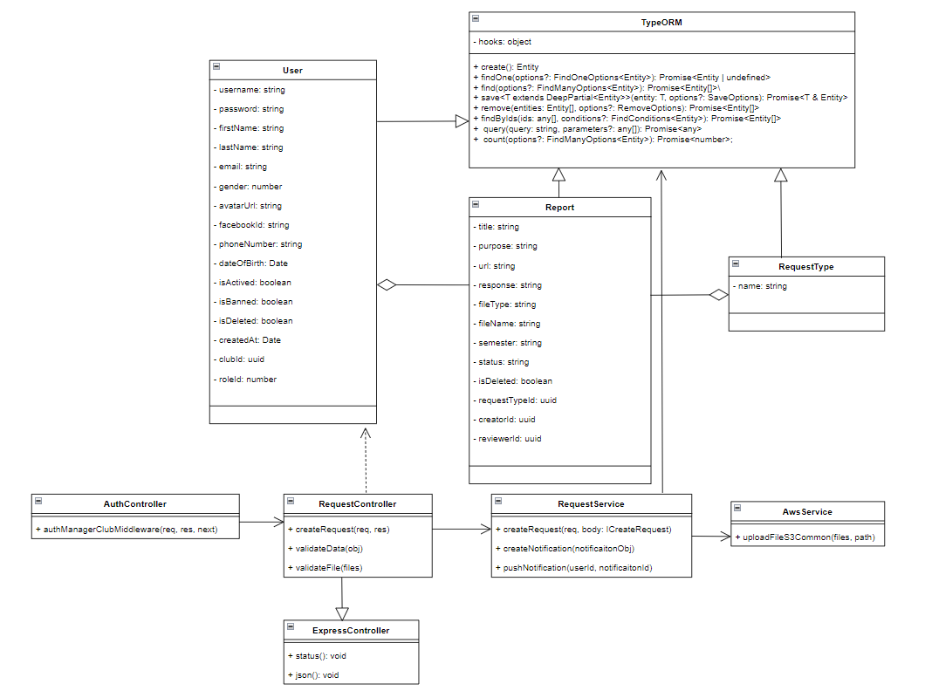

*Figure 109. Class Diagram of feature Create Request*

#### *3.24.2 Sequence Diagram*

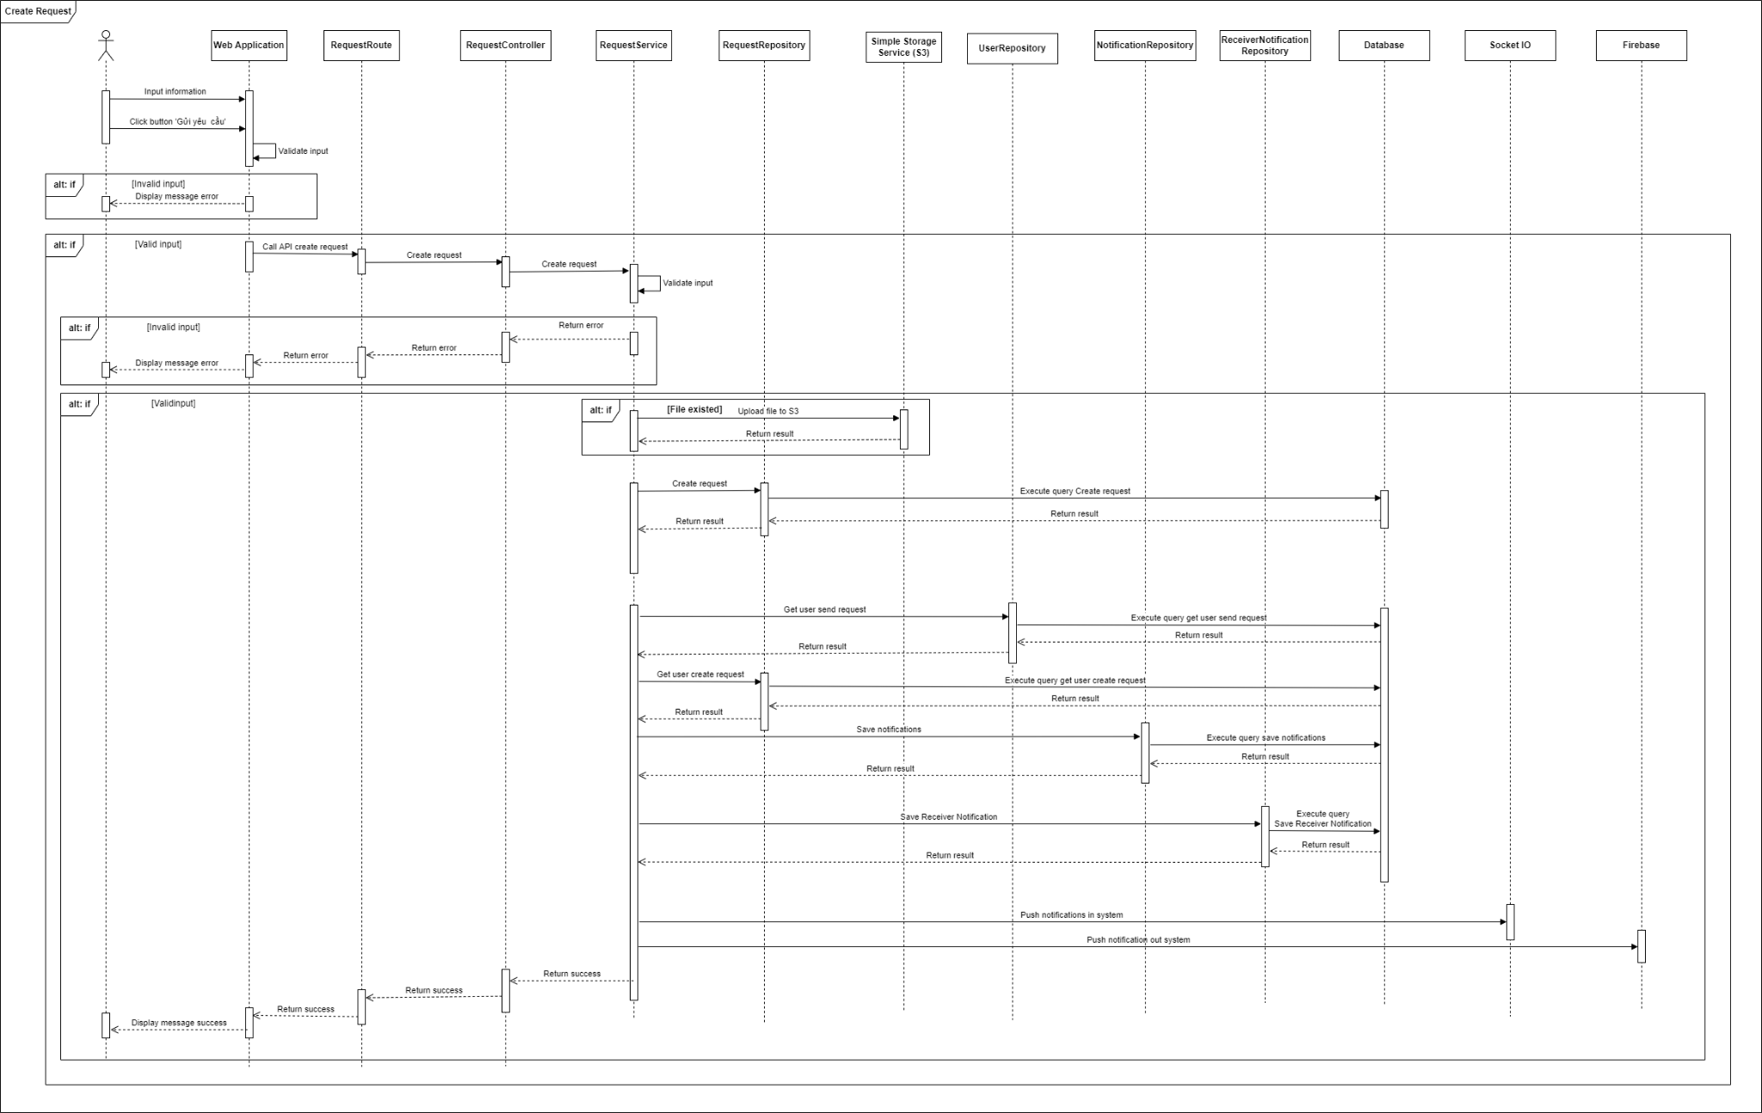

*Figure 110. Sequence Diagram of feature Create Request*

### 3.25 Review Request

#### *3.25.1 Class Diagram*

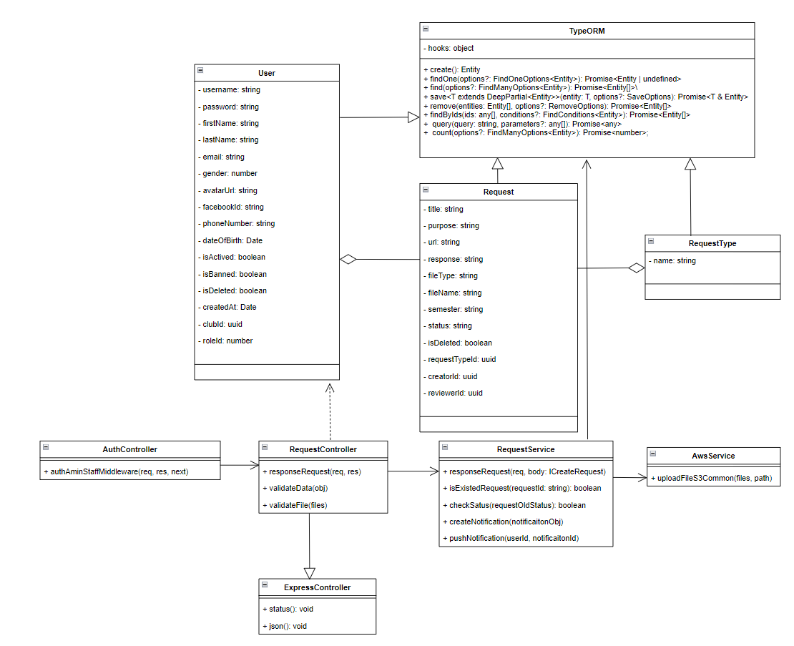

*Figure 111. Class Diagram of feature Review Request*

#### *3.25.2 Sequence Diagram*

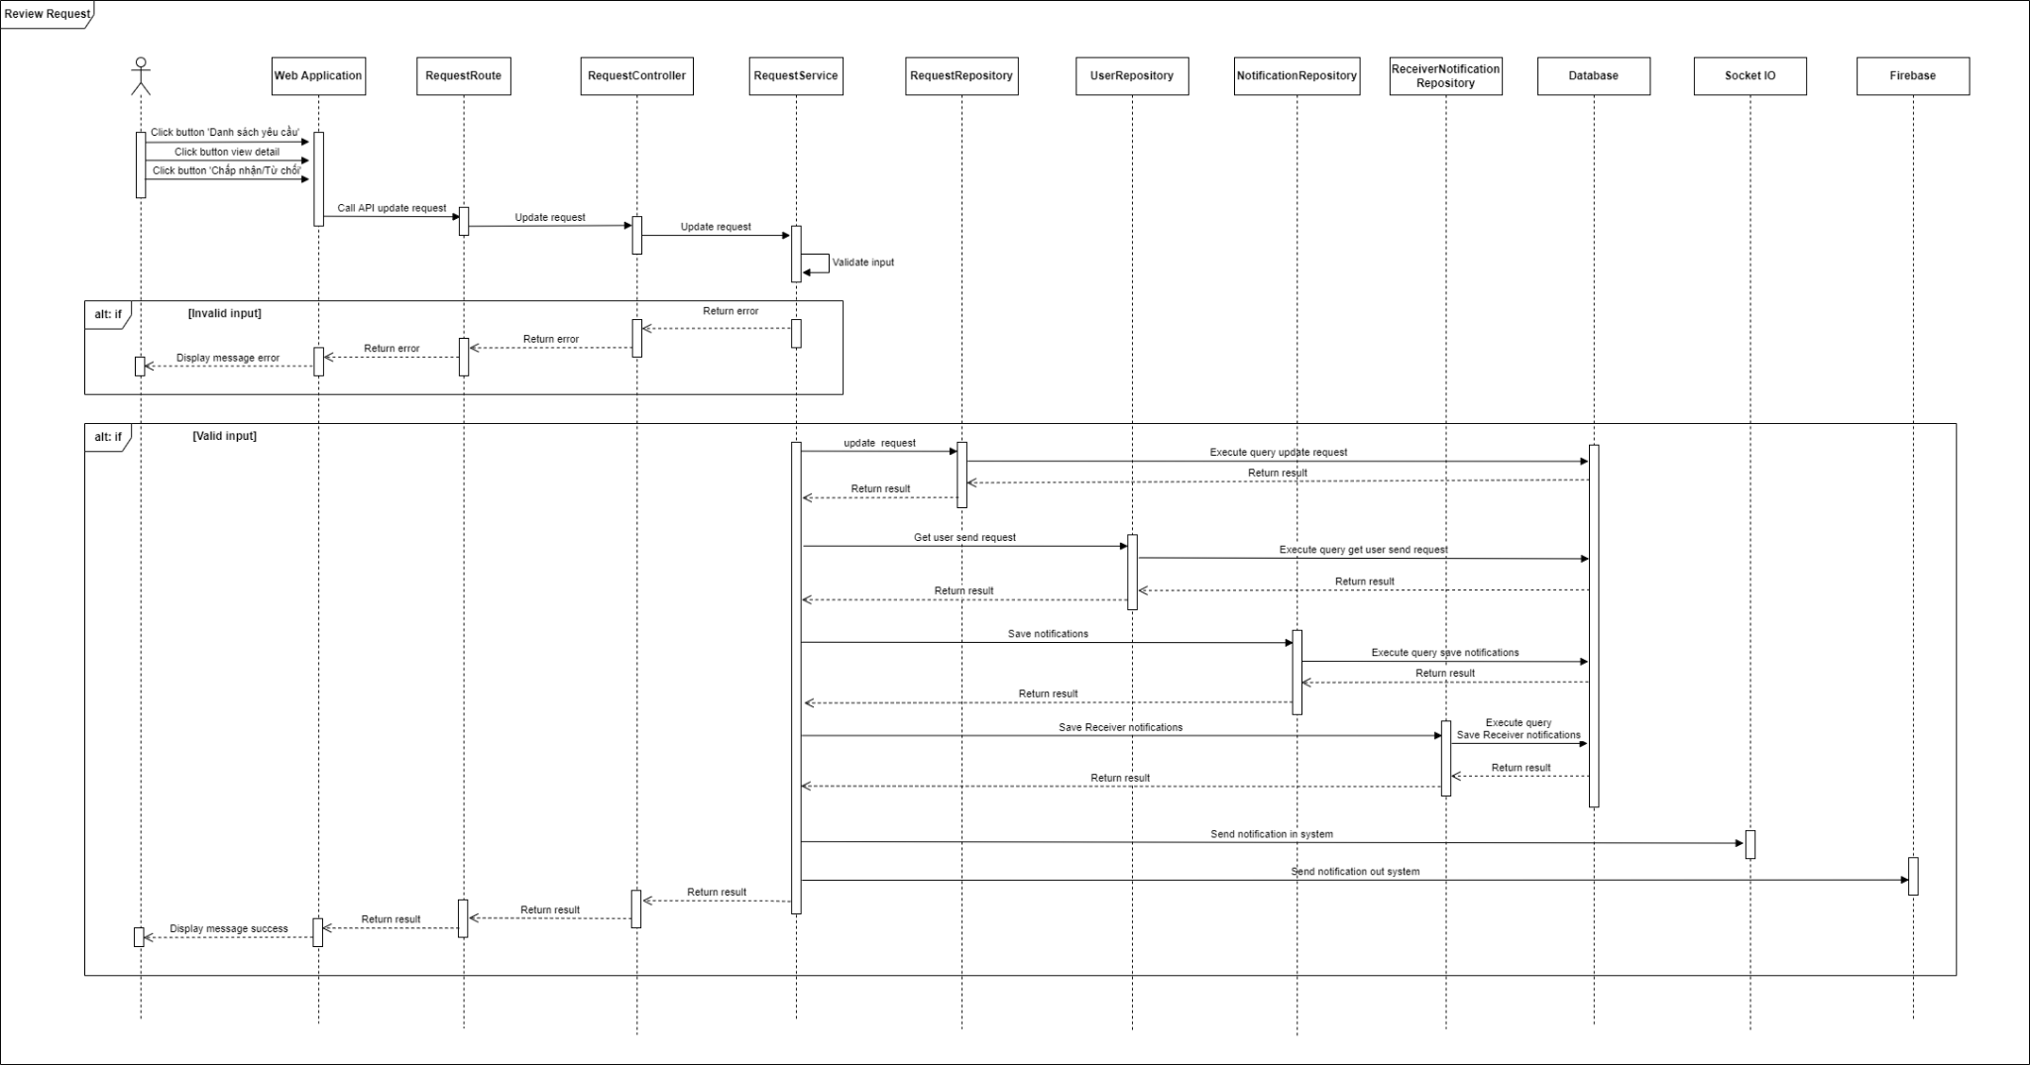

*Figure 112. Sequence Diagram of feature Review Request*

### 3.26 View List Club’s Organization

#### *3.26.1 Class Diagram*

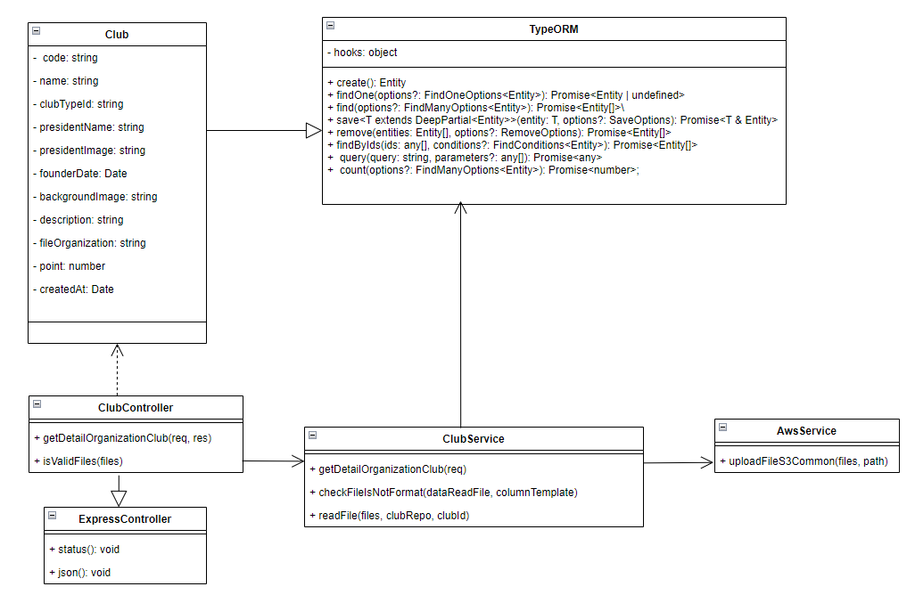

*Figure 113. Class Diagram of feature View List Club’s Organization*

#### *3.26.2 Sequence Diagram*

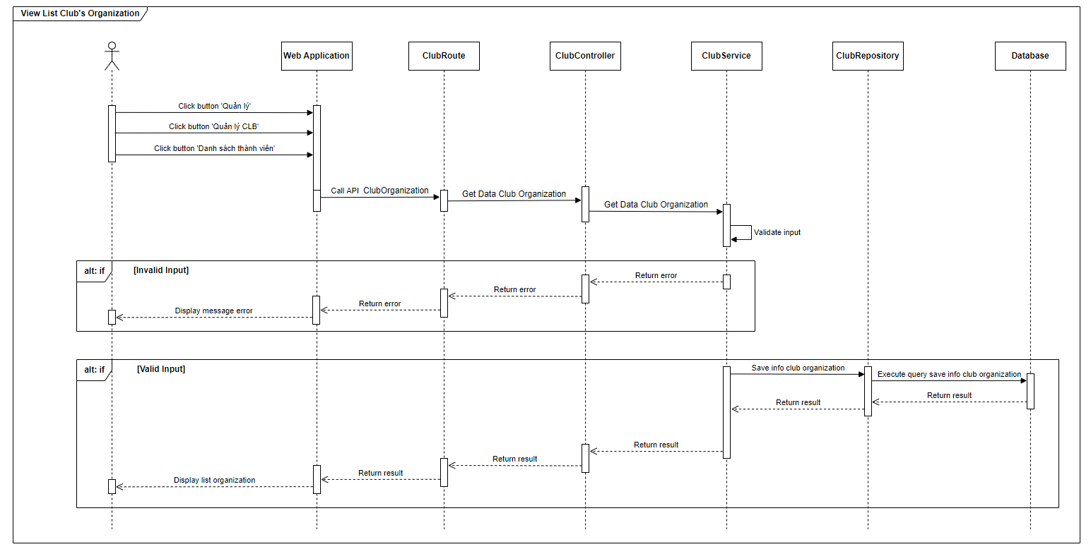

*Figure 114. Sequence Diagram of feature View List Club’s Organization*

### 3.27 View List Clubs

#### *3.27.1 Class Diagram*

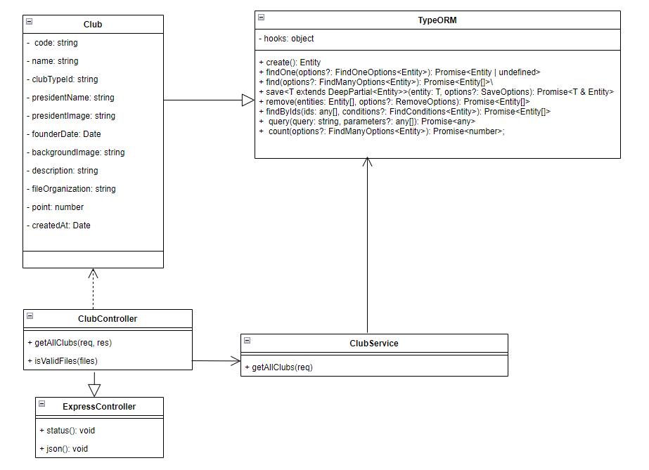

*Figure 115. Class Diagram of feature View List Clubs*

#### *3.27.2 Sequence Diagram*

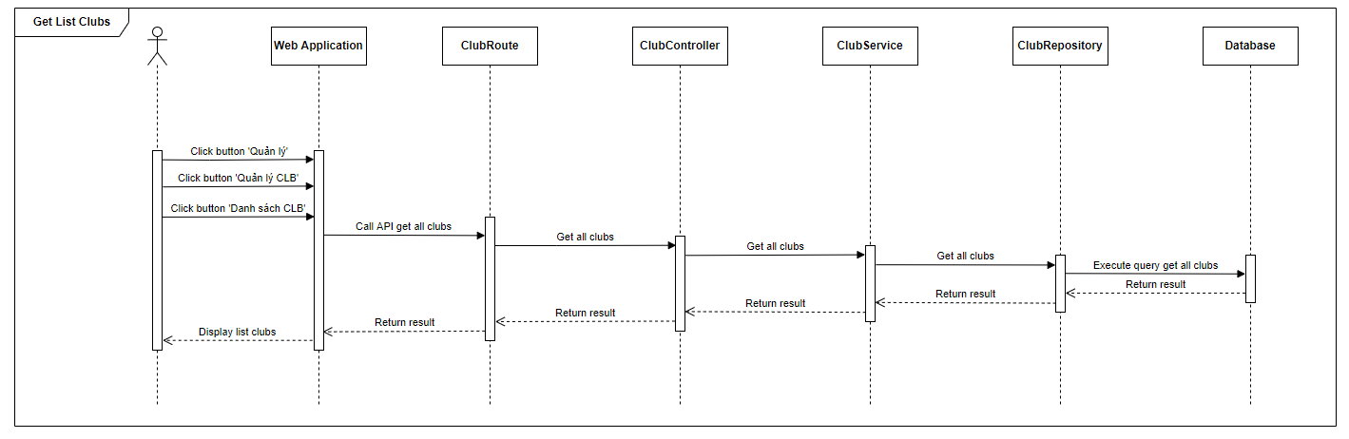

*Figure 116. Sequence Diagram of feature View List Clubs*

### 3.28 Other

The following features are implemented similarly.

| **STT** | **Feature** |
| --- | --- |
| 1 | Sign out Account |
| 2 | Change Password |
| 3 | View Profile |
| 4 | View List Admin Notifications |
| 5 | Filter Admin Notifications |
| 6 | Search Admin Notifications By Any Keyword |
| 7 | Send Notification To All Users Automatically |
| 8 | View List Posts |
| 9 | View Detail A Post |
| 10 | Delete Post |
| 11 | Search Posts By Any Keyword |
| 12 | Filter Posts |
| 13 | Share Post |
| 14 | Send Notification To Creator Of Post When Post is Liked/Shared/Commented Automatically |
| 15 | View Club’s Information |
| 16 | Search Clubs By Any Keyword |
| 17 | Update Club’s Information |
| 18 | Update Club’s Organization |
| 19 | Export File Club’Organization |
| 20 | Import File Club’Organization |
| 21 | Update Excellent Clubs |
| 22 | View Detail Report |
| 23 | View Online/Download Attached File Report |
| 24 | Filter Reports |
| 25 | Search Reports By Any Keyword |
| 26 | View List History Final Report Semester |
| 27 | Delete Report Automatically Yearly |
| 28 | Send Notification To Remind 1 Day Before Deleting Reports Automatically |
| 29 | Send Notification To Remind Review Report Overdue 3-5 Days Automatically |
| 30 | View List Unprocessed Requests Of All Clubs |
| 31 | View List Being Processed Requests Of All Clubs |
| 32 | View List Approved Requests Of All Clubs |
| 33 | View List Requests Of A Club |
| 34 | View Detail Request |
| 35 | View Online/Download Attached File Request |
| 36 | Filter Requests |
| 37 | Search Requests By Any Keyword |
| 38 | Delete Requests Automatically Yearly |
| 39 | Send Notification To Remind 1 Day Before Deleting Requests Automatically |
| 40 | Send Notification To Remind Review Requests Overdue 3-5 Days Automatically |
| 41 | Filter Meetings |
| 42 | View Detail Meeting |
| 43 | Close A Meeting |
| 44 | View Number Of Participant Accept/Reject Meeting |
| 45 | Send Notification To Remind Join Meeting 1 Hour Before Meeting Started Automatically |
| 46 | Accept/Reject Collaborator Account |
| 47 | View List Banned Collaborator Account |
| 48 | Ban Collaborator Account |
| 49 | Unban Collaborator Account |
| 50 | Accept/Reject Club Manager Account |
| 51 | View List Banned Club Manager Account |
| 52 | Ban Club Manager Account |
| 53 | Unban Club Manager Account |
| 54 | Accept/Reject Admin Account |
| 55 | View List Banned Admin Account |
| 56 | Ban Admin Account |
| 57 | Unban Admin Account |
| 58 | Search Account By Any Keyword |
| 59 | Send Notification To Notify Invitation To Create Account Not Response Automatically |
| 60 | Statistical Chart Of The Number Of Reports And Requests |
| 61 | View Chart Compares The Activity Level Between The Clubs Of The Same Type |
| 62 | Statistics Of Web Visits (Google Analysis) |
| 63 | View List All Notifications |
| 64 | View List Read Notifications |
| 65 | Mark All Notifications As Read |
| 66 | View Banner |
| 67 | Update Banner |
| 68 | View IC-PDP’s Introduction |
| 69 | Update IC-PDP’s Introduction |
| 70 | View IC-PDP’s Member |
| 71 | Update IC-PDP’s Member |
| 72 | View 5 Excellent Individuals |
| 73 | Add List Link Youtube |
| 74 | Add Image About IC-PDP |

*Table 112. Remaining features list*

# V. Software Testing Documentation

## 1. Scope of Testing

### 1.1 Stages of testing

There are 4 phases in the Testing Process: Unit testing, Integration testing, System testing and Acceptance testing.

| **ID** | **Test Stages** | **Description** |
| --- | --- | --- |
| **1** | **Unit testing** | The main aim of this endeavor is to determine whether the application functions as designed. In this phase, a unit can refer to a function, individual program or even a procedure, and a [White-box Testing](http://stackoverflow.com/questions/402161/black-box-vs-white-box-testing) method is usually used to get the job done. |
| **2** | **Integration testing** | Integration testing allows individuals the opportunity to combine all of the units within a program and test them as a group. This testing level is designed to find interface defects between the modules/functions. This is particularly beneficial because it determines how efficiently the units are running together. |
| **3** | **System testing** | System testing is the first level in which the complete application is tested as a whole. The goal at this level is to evaluate whether the system has complied with all of the outlined requirements and to see that it meets Quality Standards. |
| **4** | **Acceptance testing** | Acceptance testing (or User Acceptance Testing), is conducted to determine whether the system is ready for release. During this phase, the tester and some alpha test users will test the system to find out whether the application meets their business’ needs. |

*Table 113. Stages of testing*

### 1.2 Type of testing

The test team has to test the following type on Google Chrome

* GUI test
* Function test
* Performance test
* Regression test
* Acceptance test include alpha test
* Unit test
* Load test

### 1.3 Range of testing

Team performs all functions defined in the SRS based on the approved version.

## 2. Test Strategy

### 2.1 Test model

Overall, FCMS project uses the V-Model in software testing.In this, based on customer’s demand, each phase of SDLC in FCMS system must complete before the next phase starts. It follows a sequential design process similar to the waterfall model. Testing of the device is planned in parallel with a corresponding stage of development. Besides, we chose using V-Model by advantage (pros)

* Easy to Understand.
* Testing Methods like planning, test designing happens well before coding.
* This saves a lot of time. Hence a higher chance of success over the waterfall model.
* Avoids the downward flow of the defects.
* Works well for small plans where requirements are easily understood.

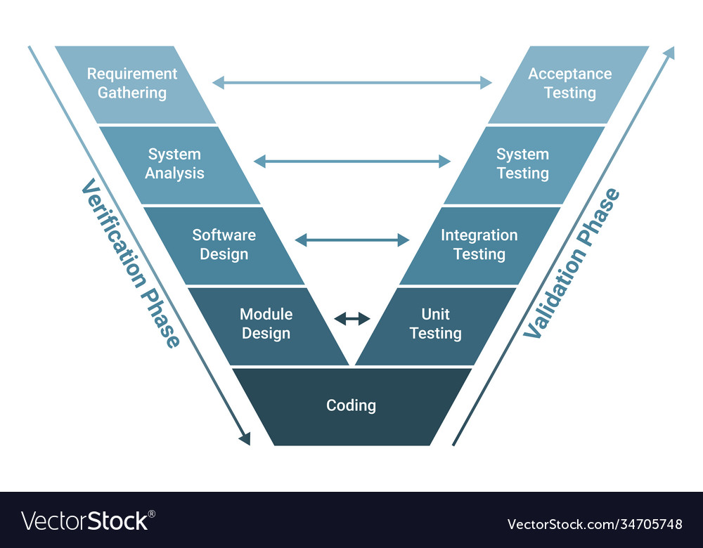

*Figure 117. V-Model*

### 2.2 Test stage

Table below are the stages in which common tests are executed:

| **Type of test** | **Stage of test** | | | |
| --- | --- | --- | --- | --- |
| **Unit test** | **Integration test** | **System test** | **Acceptance test** |
| Unit Tests | x | x | x |  |
| API Tests | x | x |  |  |
| UI Tests |  |  |  | x |
| Regression Tests | x | x | x | x |
| Performance Tests |  |  | x | x |
| Acceptance Tests |  |  | x |  |
| Load Tests |  |  | x | x |

*Table 114. Test stage*

### 2.3 Deliverables

Table below is the Deliverables for FCMS Project:

| **Deliverables** | **Responsibilities** | **Complete date** |
| --- | --- | --- |
| Test Plan | Tester | 18/05/2022 |
| Test Cases | Tester | 16/06/2022 |
| Test case review | Tester + PM | 31/06/2022 |
| Defect report | All members | 21/08/2022 |
| Final test Summary report | PM | 21/08/2022 |

*Table 115. Test stage deliverable*

### 2.4 Testing Types

Testing FCMS Project will be carried out in each release package as defined in the project plan and will depend on internal delivery by development side. Critical tests will be defined as any new or modified tests for the FCMS system. That means each mature feature will be tested continuously and iteratively to ensure the problem is prevented from failure. The Project Manager will decide which closed defects the test team cannot determine.

Each type of FCMS Project Testing will be designated to cover a level of project, from each feature, API function, FCMS API sub-system level and FCMS Project level with Unit testing combined with Database testing, API testing, System testing and Acceptance testing. On the other hand, FCMS will use several testing types to prevent defects from code modifications and latent bugs.

#### *2.4.1 Unit test*

* + Testing all individual implemented methods, functions of model class or library class.
  + Unit test also includes database testing to verify constraint, transaction, default value, data types, data format, and check null and junk characters which are mentioned in database design and software requirements.
  + Test case will have to cover all logic branches that function or method could execute with different data input. Another alternative logic branch should be covered if not, that logic branch should be detected at API testing level.
  + Implemented function’s error message and database error message will be included in this test.

#### *2.4.2 API testing*

* + Involves testing APIs directly to determine if they meet expectations for functionality, reliability, performance, and security. API testing will test all of the individual implemented API of FCMS API.
  + Testing will mock all possible datasets and call a corresponding API with a separate testing database by using Chaijs, SuperTest and Mocha.
  + Test case will verify constraint of data which be mentioned in Business Rules.
  + Basically, almost all API test cases are executed as automation tests. After that all API with standard sample datasets will be saved and confirmation tests will be executed by using Postman with the developer's local database.

#### *2.4.3 UI testing*

* + User Interface testing verifies a user’s interaction with the software. The goal of GUI testing is to ensure that the GUI provides the user with appropriate access and navigation through the functions of the target-of-test. In addition, GUI testing ensures that the objects within the GUI function as expected and conform to requirements
  + The GUI test will be performed fully on all screens.
  + This test targets to cover the verification of the overall look and feel of the FCMS system including initial position, font, text size, color, focus, initial button, tab order, label, screen sizes and sentences width.
  + Check all the GUI elements for size, position, width, length and acceptance of characters or numbers. For instance, it must be able to provide inputs to the input fields.
* Check if Error Messages are displayed correctly.
* Check if Font used in the application is readable.
* Check if the alignment of the text is proper.
* Check if the Color of the font and warning messages is aesthetically pleasing.
* Check if images have good clarity.
* Check if images are properly aligned.
* Check the positioning of GUI elements for different screen resolutions.

#### *2.4.4 Performance testing*

* + The testing is to confirm to cover for response time for FCMS System with different network conditions with the throttling tool of Google Chrome.

#### *2.4.5 Regression testing*

* + The testing is to confirm that the bug was removed including the extent of the impact, when developers fix bugs, developers and testers will confirm with each other what the impacts of fix bug modification are, after that all impact units or functions will be retested by developers then testers after that.

#### *2.4.6 Acceptance testing*

* + This test type will be executed by a tester with designed test cases, acceptance test is a test type conducted to determine if the requirements of a specification or contract are met.
  + It also includes alpha testing, alpha testing takes place at a close relation user’s site and is a free test to detect bugs and strange behavior. By that, development team will improve UX and UI of system.

#### *2.4.7 Load testing*

* + The testing is executed by developers to estimate a web server performance in order to find if the server can serve sufficiently high workload by using Google dev tool.

### 2.5 Test Levels

There are 4 phases in the Testing Process: Unit testing, Integration testing, System testing and Acceptance testing.

| **ID** | **Test Stages** | **Description** |
| --- | --- | --- |
| **1** | **Unit testing** | The main aim of this endeavor is to determine whether the application functions as designed. In this phase, a unit can refer to a function, individual program or even a procedure, and a [White-box Testing](http://stackoverflow.com/questions/402161/black-box-vs-white-box-testing) method is usually used to get the job done. |
| **2** | **Integration testing** | Integration testing allows individuals the opportunity to combine all of the units within a program and test them as a group. This testing level is designed to find interface defects between the modules/functions. This is particularly beneficial because it determines how efficiently the units are running together. |
| **3** | **System testing** | System testing is the first level in which the complete application is tested as a whole. The goal at this level is to evaluate whether the system has complied with all of the outlined requirements and to see that it meets Quality Standards. |
| **4** | **Acceptance testing** | Acceptance testing (or User Acceptance Testing), is conducted to determine whether the system is ready for release. During this phase, the tester and some alpha test users will test the system to find out whether the application meets their business’ needs. |

*Table 116. Test Levels*

### 2.6 Supporting Tools

#### *2.6.1 FCMS Front-end and Project testing*

##### **2.6.6.1 Chrome DevTools**

* **Chrome DevTools:** Chrome DevTools is a set of web developer tools built directly into the Google Chrome browser
* We use to view logs, inspect elements.



*Figure 118. Chrome Developer Tools*

##### **2.6.6.2 Redux Devtools**

* **Redux DevTools:** Redux DevTools is a development time package that provides power-ups for your Redux development workflow.
* We use to view Redux state tree.

##### **2.6.6.3 Jira**

* **Jira:** Jira Software is part of a family of products designed to help teams of all types manage work.
* We use to manage bugs: Show all bugs and life cycle of process to resolve bugs.



*Figure 119. Atlassian Jira*

##### **2.6.6.4 Microsoft Excel**

* **Microsoft Excel:** Excel is a spreadsheet program from Microsoft and a component of its Office product group for business applications
* We use to manage test cases



*Figure 120. Microsoft Excel*

##### **2.6.6.5 Postman**

* **Postman:** postman is an API platform for building and using APIs.
* We use to manage the list of all APIs and manually test APIs’ result



*Figure 121. Postman*

#### *2.6.2 FCMS API testing*

##### **2.6.6.6 Mocha**

* **Mocha :** Mocha is a feature-rich JavaScript test framework running on Node.js and in the browser, making asynchronous testing simple and fun.
* A feature-rich JavaScript test framework running on Node.js and in the browser, used to make asynchronous testing simple.



*Figure 122. MochaJS*

##### **2.6.6.7 Chaijs**

* **Chaijs :** Chai is a BDD / TDD assertion library for nodes, to help assertion result in a test.



*Figure 123. ChaiJS*

* **Chai as Promised :** Chai as Promised extends Chai with a fluent language for asserting facts about promises, to assert result with Promises.
* **faker.js :** a library which generates massive amounts of fake data in Node.js and the browser.
* **SuperTest :** ASuper-agent driven library for testing node.js HTTP servers using a fluent API, used to make a test from high-level abstraction to the low-level API.
* **timekeeper :** a test helper library which helps to make Node.js testing of time-dependent code.
* **rewire :** An Easy monkey-patching for Node.js unit tests
* **istanbul :** to observe code coverage

## 3. Test Plan

### 3.1 Human Resources

| **ID** | **Resources** | **Responsibilities** |
| --- | --- | --- |
| 1 | Project Manager | * Responsible for Project Schedules and overall success of the project. * Review Test-case and report. |
| 2 | Tester | * Performing the actual system testing. * Manage test resources and assign test tasks. * Create a Test Plan. * Create Test Cases. * Create a Test Report. * Execute Test. * Test Log report. |
| 3 | Developer | * Create unit tests and integration test scripts. * Fix bugs. |

*Table 117. Human resources*

### 3.2 Test Environment

| **Type of testing** | **Software** | **Hardware** |
| --- | --- | --- |
| System test and Acceptance test | * Microsoft Office Excel 2020. * Microsoft Office Word 2020 * Version 104.0.5112.81 (Official Build) (64-bit) | Personal computer for developing with the minimum configuration:   * Windows 10 Professional 64-bit, Service Pack 1 * Intel® Core™ i5 * Installed memory (RAM): 16.00GB |
| Unit test and API testing | * Chaijs v3.5.0 * Chai as promised v5.3.0 * Fakerjs v3.1.0 * Mocha v9.2.2 * rewire v2.5.1 * SuperTest v1.2.0 * timekeeper v1.0.19 * istanbul v0.4.4 * Postman v9.15.7 | Personal computer for run testing with minimum configuration   * Ubuntu 14.04 64-bit * Intel® Core™ i5 * Installed memory (RAM): 16.00GB |

*Table 118. Test environment*

### 3.3 Test Milestones

Table below is the Test Milestones for FCMS Project:

| **Test Milestones** | **Start Date** | **End Date** |
| --- | --- | --- |
| ***Authentication and Report, Request related features*** | 09/05/2022 | 21/08/2022 |
| Unit Testing and API Testing | 09/05/2022 | 21/08/2022 |
| User Interface Testing | 09/05/2022 | 20/08/2022 |
| System Testing | 09/05/2022 | 20/08/2022 |
| Performance Tests | 07/06/2022 | 20/08/2022 |
| Regression Tests | 09/05/2022 | 20/08/2022 |
| ***Manage Club, Post, Meeting related features and optimization*** | 06/06/2022 | 21/08/2022 |
| Unit Testing and API Testing | 06/06/2022 | 20/08/2022 |
| User Interface Testing | 06/06/2022 | 20/08/2022 |
| System Testing | 09/05/2022 | 19/08/2022 |
| Performance Tests | 06/07/2022 | 21/08/2022 |
| Regression Tests | 14/05/2022 | 21/08/2022 |
| Acceptance testing | 06/07/2022 | 21/08/2022 |

*Table 119. Test milestones*

## 4. Test Cases

### 4.1 Automation test with API testing and Unit testing

Unit testing and API testing will be done by the developers and approved by the development team leader.

The FUM development team embrace this feature to gain the following advantages:

* Reduce the level of bugs in production code.
* Save development time.
* Automation tests can be run as frequently as required.
* Make it easier to change and refactor code by improving the design of code especially with Test-Driven Development.
* Can easily form a document from the tests.
* Easier to maintain than [GUI tests](https://en.wikipedia.org/wiki/Graphical_user_interface_testing) which are difficult to maintain with the short release cycles and frequent changes and with a complex system
* Reduce cost of resource to corresponding GUI testing

Automation testing framework:

* For API testing and Unit testing, we use Mocha testing framework combined with Chai assertion library and Sinon for test spying and mocking.
* All testing frameworks and libraries will be installed to FCMS APIs project automatically by using npm package manager:

$ npm install

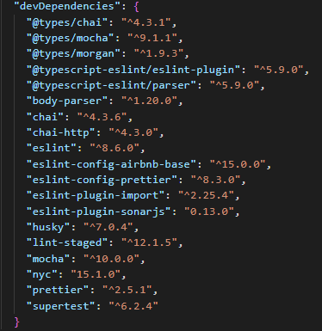

*Figure 124. Declare testing frameworks and libraries to project dependencies in* ***package.json*** *file*

* Automation tests use a separate environment which is similar to the production environment and includes: database, Google application id, image storage bucket, Redis instance, Socket.io, etc.

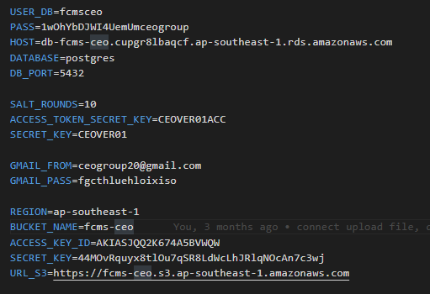

*Figure 125. Test environment configuration file (.env.test)*

* All automation test scripts will be created manually and saved to the testdirectory of FCMS API. Unit tests are stored in **models**, **libs** and **middlewares** folder, API tests will be storage in **features** folder

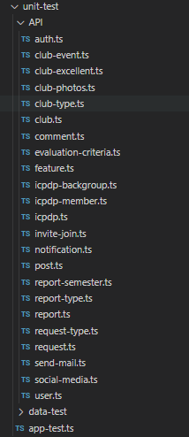

*Figure 126. Test directory structure*

* Unit tests focus on individual functions in class and will be created simply as below

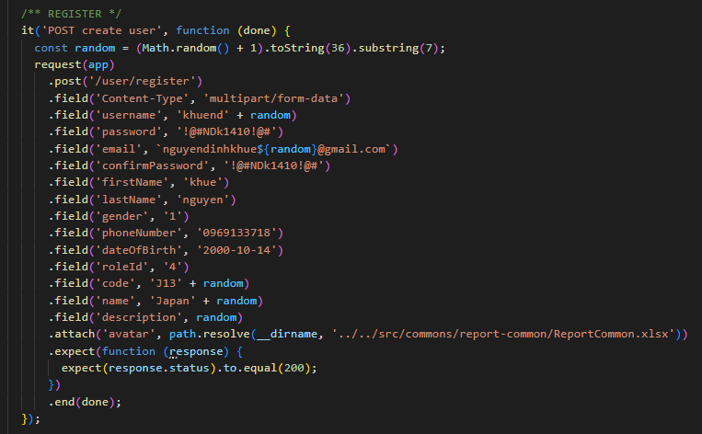

*Figure 127. Unit test case sample  
This factory function is used to create an Account admin.  
Test case will check if the factory of the Account model is valid or not.*

* API tests focus on individual API and use SuperTest to test these API based on the business rule.

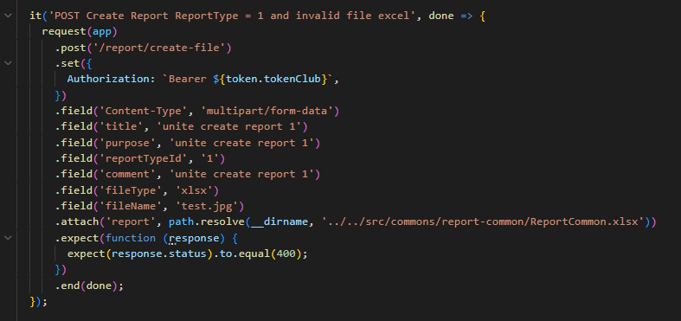

*Figure 128. API test case sample  
Test behavior of HTTP method which used to create a report with valid user token*

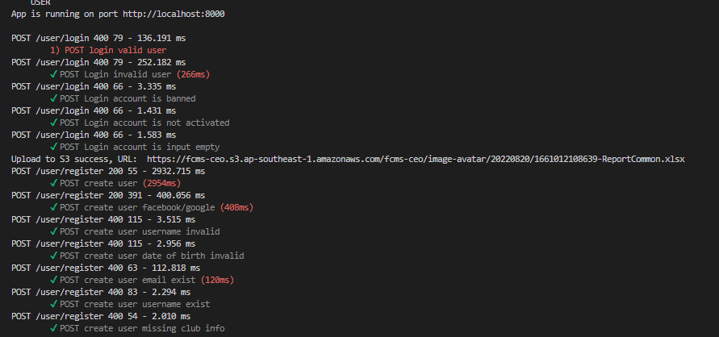

*Figure 129. Sample API test report*

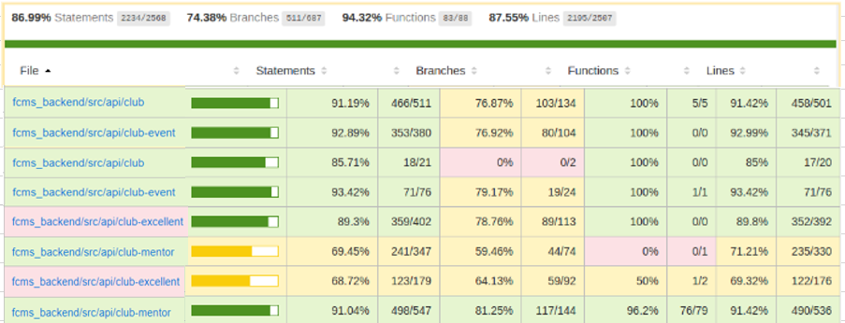

*Figure 130. Static http test coverage report*

### 4.2 System testing

Detailed Test cases will be described in the TestCase_Final.xlsxfile.

As a standard definition, FCMS Project defines that a test case is:

* A set of test data and test programs (test scripts) and their expected results. A test case validates one or more system requirements and generates a pass or fail
* A good test case should follow two basic aspects, the Contents and the Style. Test cases for functional testing are derived from the target of test's use cases Test cases should be developed for each use case scenario. The use case scenarios are identified by describing the paths through the use case that traverse the basic flow and alternate flows start to finish through the use case.
* By using good automation test and using, FCMS Project System testing will not focus on common logic of system like length of text but focus on behavior of website and aims to validate that all software module dependencies are functionally correct and that data integrity is maintained between separate modules for the entire solution
* On the other hand by using token-based authentication, we prevented [Cross-Site Scripting XSS so that security testing in system testing will focus on implementation of the security matrix which is mentioned in **Error! Reference source not found.**](http://en.wikipedia.org/wiki/Cross-site_scripting).

### 4.3 Acceptance test

Acceptance Testing is a level of the software testing process where a system is tested for acceptability. The purpose of this test is to evaluate the system’s compliance with the business requirements and assess whether it is acceptable for delivery. Our project will simultaneously use a checklist to replace Acceptance testing and some examples of Acceptance testing.

The content of the Checklist is shown in the table below

| **ID** | **Checklists** | **Yes** | **No** |
| --- | --- | --- | --- |
| **General** | | | |
| CL-001 | Text on all pages for spelling and grammatical errors. | √ |  |
| CL-002 | Functionality of buttons available on all pages. | √ |  |
| CL-003 | All mandatory fields are validated. | √ |  |
| CL-004 | Validation error messages are displayed properly below the field. | √ |  |
| CL-005 | All error messages are displayed in red color. | √ |  |
| CL-006 | All inactive items are gray out | √ |  |
| CL-007 | Delete functionality for any record on page is asked for confirmation. | √ |  |
| CL-008 | All numeric values are formatted properly. | √ |  |
| CL-009 | Application crash or unavailable pages are redirected to the error page. | √ |  |
| **GUI and Usability** | | | |
| CL-010 | Screens are designed following project standards. | √ |  |
| CL-011 | The screen is well organized and easy to use. | √ |  |
| CL-012 | All fields on the page (e.g. text box, radio options, dropdown lists) should be aligned properly. | √ |  |
| CL-013 | Information is arranged symmetrically with adequate spacing between components. | √ |  |
| CL-014 | The most important fields are located where they are easy to see. | √ |  |
| CL-015 | Information is presented in the order that the user needs it. | √ |  |
| CL-016 | The screen is designed to fit the requirements for international use. | √ |  |
| CL-017 | The text is easy to translate. Don't use slang, acronyms, and abbreviations. | √ |  |
| CL-018 | Icons and images are designed for impression and copyright. | √ |  |
| CL-019 | Font size, style and color for headline, description test, labels, infield data, and grid information standard as specified in SRS. | √ |  |
| CL-020 | Page Text must be standing by language locale. | √ |  |
| CL-021 | Numeric values must be standing by language locale. | √ |  |
| CL-022 | The static text is clear, concise, and meaningful. | √ |  |
| CL-023 | Buttons follow the project standards for size and position (e.g., Negative button is the correct size and to the right of the Positive button). | √ |  |
| CL-024 | Graphical objects are used appropriately and according to the guidelines specified in Graphical User Interface Design. | √ |  |
| CL-025 | A list view is used to allow a collection of items that are on a single hierarchical level. | √ |  |
| CL-026 | A tree view is used to allow a collection of items to be displayed and manipulated within varying hierarchical levels. | √ |  |
| CL-027 | Pop-up menus are provided for the user to access information about an object's properties or perform specific tasks on the object. | √ |  |
| CL-028 | Command buttons are used to trigger application processes. | √ |  |
| CL-029 | Toggle buttons are used to show independent on/off choices. Can change status for different answers. | √ |  |
| CL-030 | System display notification message when meet trouble, error. | √ |  |
| **Database** | | | |
| CL-031 | Correct data is getting saved in the database upon successful page submission. | √ |  |
| CL-032 | Values columns are not accepting null values. | √ |  |
| CL-033 | Data should be stored in single or multiple tables based on design. | √ |  |
| CL-034 | Input data is not truncated. Field length shown to the user on page and in database schema should be the same. | √ |  |
| CL-035 | Input numeric fields with minimum, maximum, and float values. | √ |  |
| CL-036 | Input numeric fields with negative values (for both acceptance and non-acceptance). | √ |  |
| CL-037 | Drop down lists are saved correctly in the database. | √ |  |
| CL-038 | Database fields are designed with correct data type and data length. | √ |  |
| CL-039 | All table constraints like Primary key, Foreign key etc. are implemented correctly. | √ |  |
| CL-040 | Stored procedures and triggers with sample input data. | √ |  |
| CL-041 | Input field leading and trailing spaces are truncated before committing data to the database. | √ |  |
| CL-042 | Null values are not allowed for Primary key columns. | √ |  |
| **Performance** | | | |
| CL-043 | Real time connection | √ |  |
| CL-044 | Page load time is within acceptable range. | √ |  |
| CL-045 | Page load on slow connections. | √ |  |
| CL-046 | Response time for any action under light, normal, moderate and heavy load conditions. | √ |  |
| CL-047 | Performance of database stored procedures and triggers. | √ |  |
| CL-048 | Database query execution time. | √ |  |
| CL-049 | Load testing of applications. | √ |  |
| CL-050 | Stress testing of application. | √ |  |
| **Security** | | | |
| CL-051 | Test cookie allowed (disabled or allowed to be edited) | √ |  |
| CL-052 | Test the form giving away security information if the source is viewed | √ |  |
| CL-053 | Test password security and password policy enforcement. | √ |  |
| CL-054 | Check application logout functionality. | √ |  |
| CL-055 | Cookie information should be stored in encrypted format only. | √ |  |

*Table 120. Checklist table*

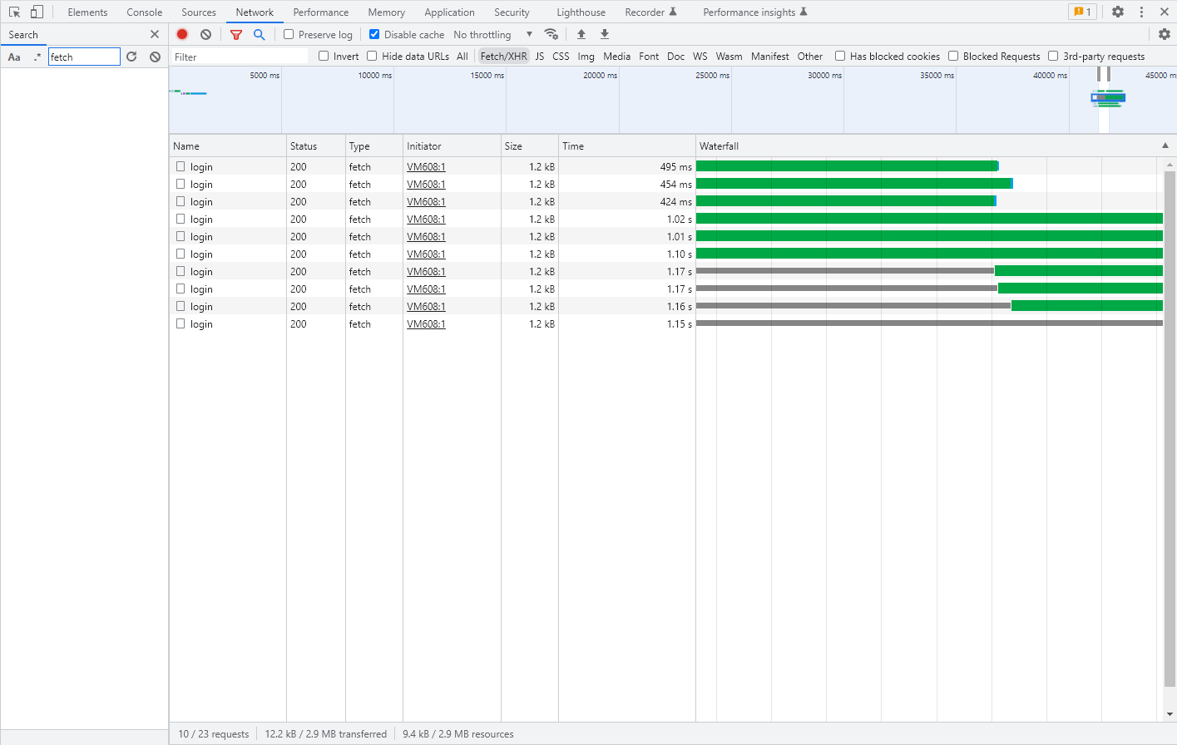

*Figure 131. Performance when 10 users log into the system at the same time*

*Faster time request: 241ms/ Lowest time request: 993ms / Total time: 924ms*

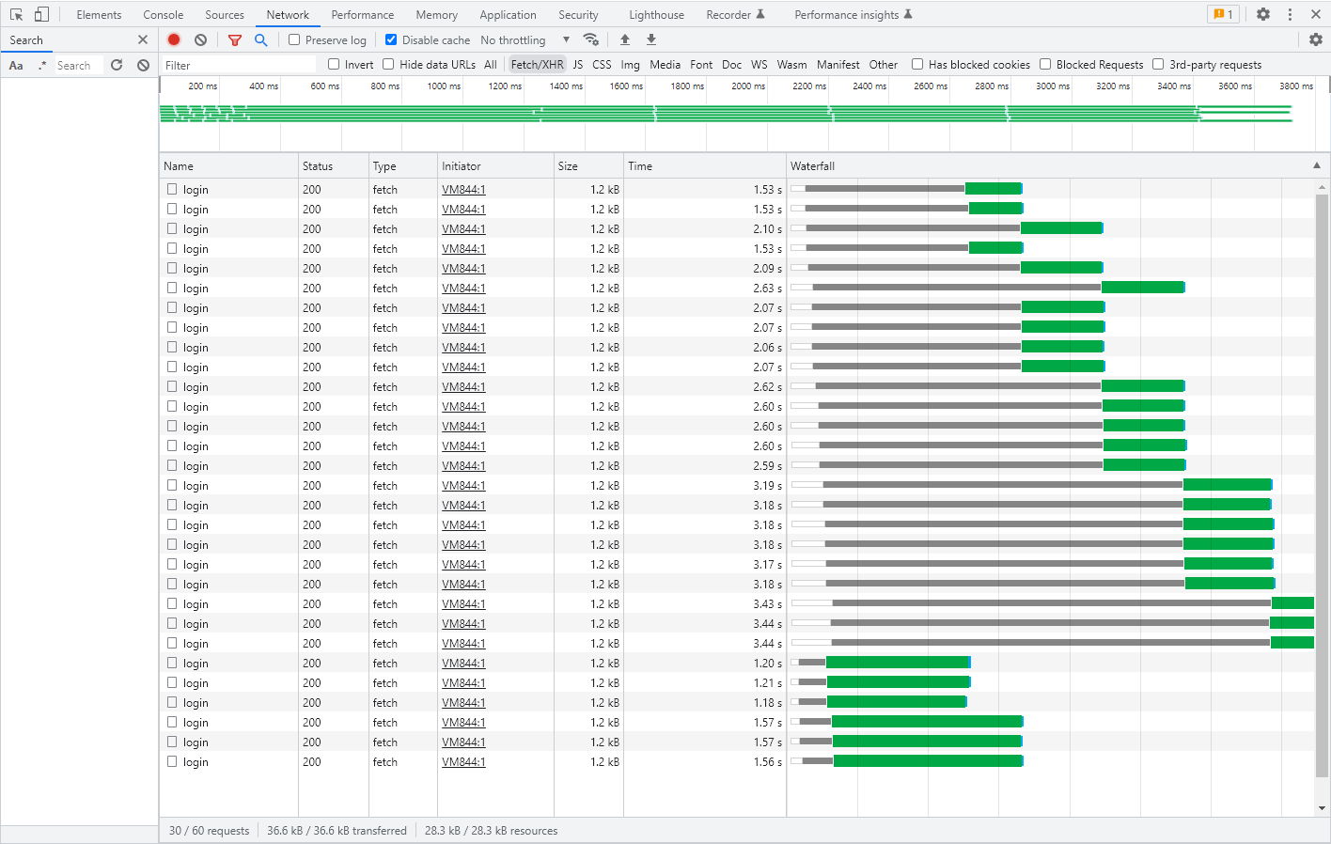

*Figure 132. Performance when 30 users log into the system at the same time*

*Faster time request: 366ms/ Lowest time request: 2.95s / Total time: 1.02ms*

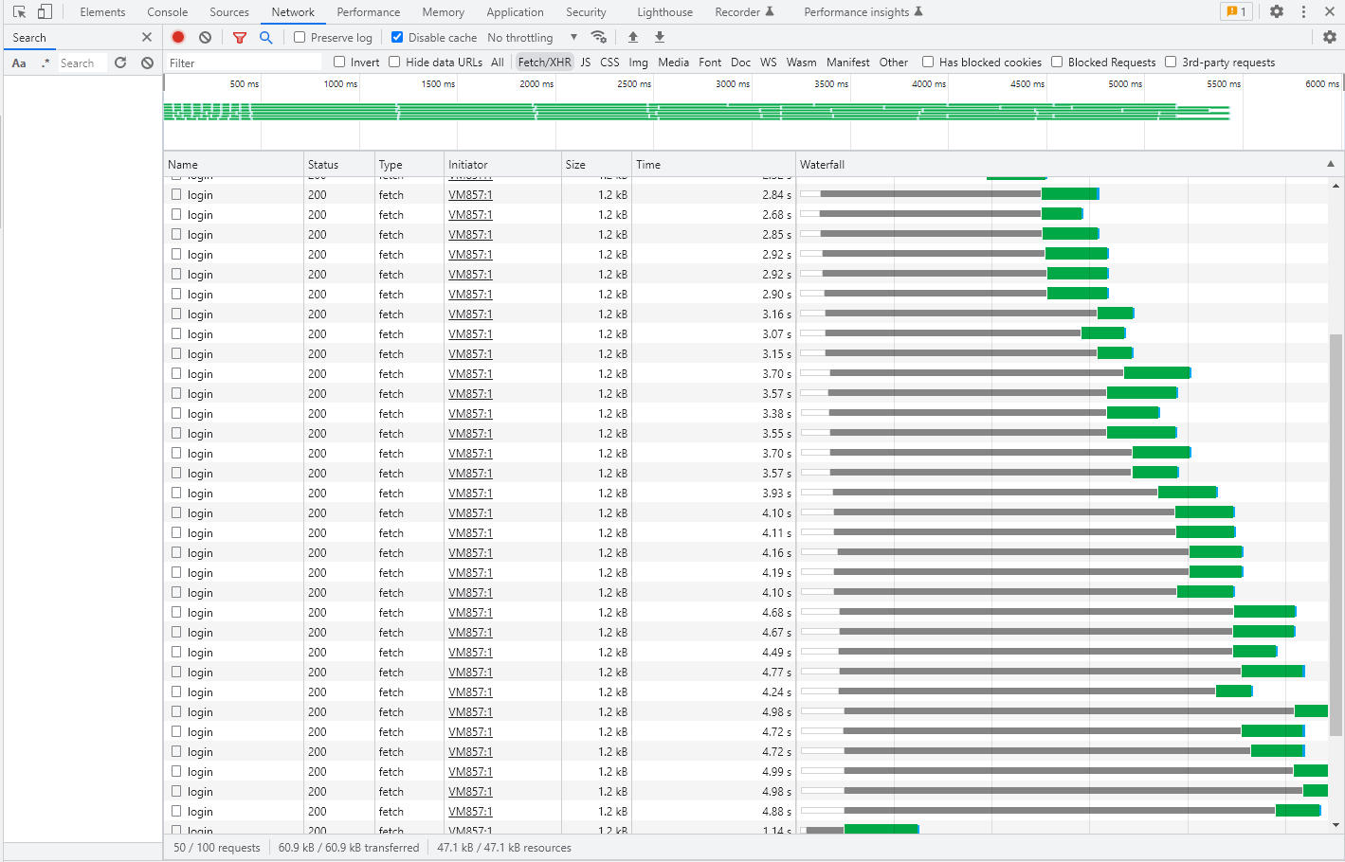

*Figure 133. Performance when 50 users log into the system at the same time*

*Faster time request: 577ms/ Lowest time request: 4.8s / Total time: 2.3s*

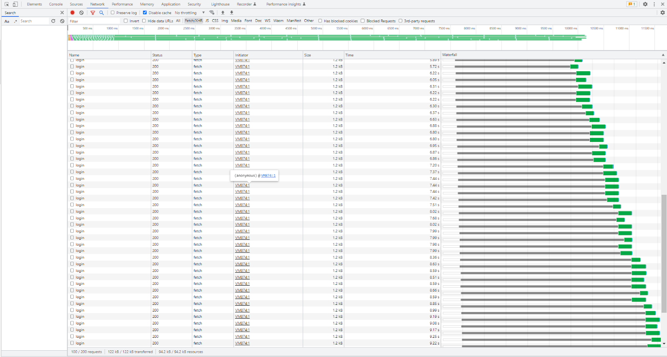

*Figure 134. Performance when 100 users log into the system at the same time*

*Faster time request: 1.01s/ Lowest time request: 9.25s / Total time: 4.2s*

### 4.4 Defect Log

FCMS project used <https://www.atlassian.com/software/jira> to manage tasks and defects.

Every member of the FCMS project created an account in Jira Software to take part in activities: control bugs, fix bugs, re-test bugs and close bugs. Bug will be logged by tester or developer in development progress.

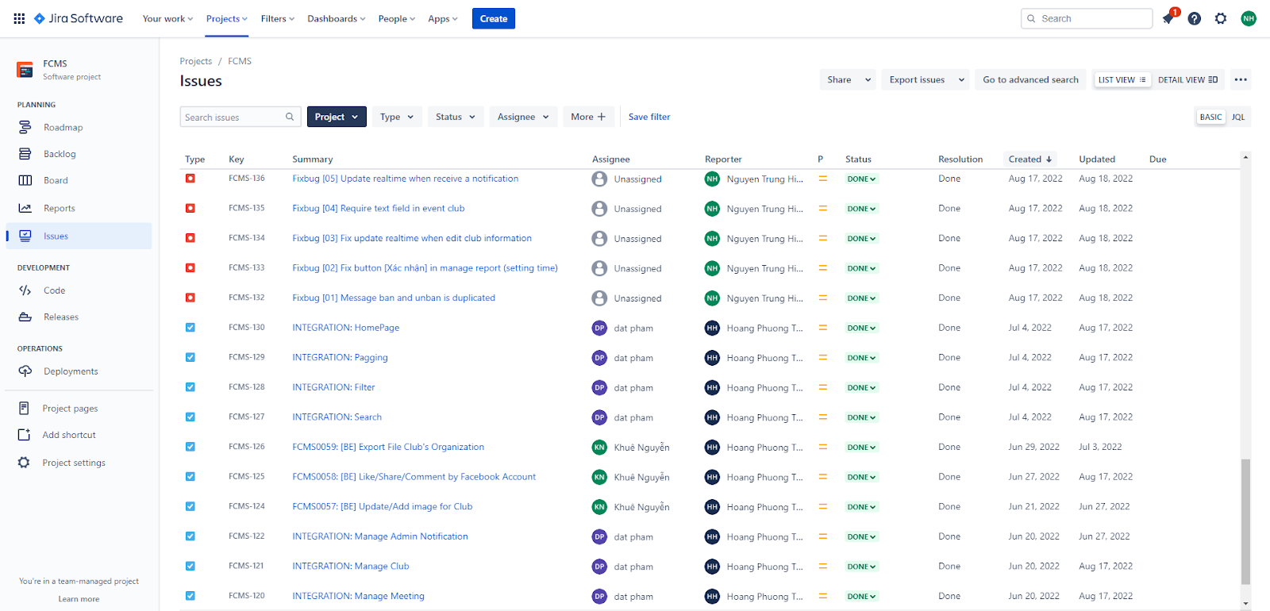

*Figure 135. Control task and bug with Jira Software*

## 5. Test Reports

### 5.1 Automation test case report

The contents of the Automation Test Case Report are shown in the table below:

| **Client** | **Test Case** | **Pass** | **Fail** | **Not available** | **Number of Test Case** |
| --- | --- | --- | --- | --- | --- |
| User | Authentication | 11 | 0 | 0 | 11 |
| View feed | 15 | 0 | 0 | 15 |
| Update information | 22 | 0 | 0 | 22 |
| FCMS-Form Create Account Admin | 24 | 0 | 0 | 24 |
| FCMS-Form To Create Account Club Manager | 25 | 0 | 0 | 25 |
| FCMS-Form To Create Account Collaborator | 24 | 0 | 0 | 24 |
| Club Manager | CM Manage Club | 24 | 0 | 0 | 24 |
| CM Manage Report | 18 | 0 | 0 | 18 |
| CM Manage Request | 18 | 0 | 0 | 18 |
| CM Manage Meeting | 19 | 0 | 0 | 19 |
| Collaborator | Check Authentication | 3 | 0 | 0 | 3 |
| Collaborator Manage Notification | 30 | 0 | 0 | 30 |
| Collaborator Manage Post | 138 | 0 | 0 | 138 |
| Collaborator Manage Club | 23 | 0 | 0 | 23 |
| Collaborator Manage Request | 105 | 0 | 0 | 105 |
| Collaborator Manage Report | 84 | 0 | 0 | 84 |
| Collaborator Manage Manage Meeting | 19 | 0 | 0 | 19 |
| Collaborator Manage Account | 43 | 0 | 0 | 43 |
| Admin | Admin Manage Notification | 30 | 0 | 0 | 30 |
| Admin Manage Posts | 138 | 0 | 0 | 138 |
| Admin Manage Club | 23 | 0 | 0 | 23 |
| Admin Manage Request | 105 | 0 | 0 | 105 |
| Admin Manage Report | 84 | 0 | 0 | 84 |
| Admin Manage Manage Meeting | 19 | 0 | 0 | 19 |
| Admin Manage Account | 43 | 0 | 0 | 43 |
| Super Admin | Check Authentication | 7 | 0 | 0 | 7 |
| Sent Invitation Admin | 11 | 0 | 0 | 11 |
| Manage Account | 28 | 0 | 0 | 28 |
| UI | UI | 12 | 0 | 0 | 12 |
| Total of Test Case | | 1145 | 0 | 0 | 1145 |

*Table 121. Automation test case report*

### 5.2 Automation test report

Automation tests are an integral part of the development process. So, there are 2 phases as 2 phases of Iterative and Incremental Software Process Model.

| **Test case** | **Result** | | **Final** |
| --- | --- | --- | --- |
| Pass | Fail |
| API Test - SuperAdmin | 26 | 0 | 26 |
| API Test - Admin | 180 | 0 | 180 |
| API Test - Collaborator | 184 | 0 | 184 |
| API Test - Club Manager | 127 | 0 | 127 |
| API Test - Guest User | 63 | 0 | 63 |
| Total all test case | 580 | 0 | 580 |

*Table 122. Automation test report*

| **Test report** | **Coverage** | | | |
| --- | --- | --- | --- | --- |
| Statements | Branches | Functions | Lines |
| **Percentage** | 86.99% | 74.38% | 94.32% | 87.55% |

*Table 123. Automation test coverage report*

### 5.3 System test case report

The contents of the System Test Case Report are shown in the table below:

| **Client** | **Test Case** | **Pass** | **Fail** | **Not available** | **Number of Test Case** |
| --- | --- | --- | --- | --- | --- |
| User | Authentication | 11 | 0 | 0 | 11 |
| View feed | 15 | 0 | 0 | 15 |
| Update information | 22 | 0 | 0 | 22 |
| FCMS-Form Create Account Admin | 24 | 0 | 0 | 24 |
| FCMS-Form To Create Account Club Manager | 25 | 0 | 0 | 25 |
| FCMS-Form To Create Account Collaborator | 24 | 0 | 0 | 24 |
| Club Manager | CM Manage Club | 24 | 0 | 0 | 24 |
| CM Manage Report | 18 | 0 | 0 | 18 |
| CM Manage Request | 18 | 0 | 0 | 18 |
| CM Manage Meeting | 19 | 0 | 0 | 19 |
| Collaborator | Check Authentication | 3 | 0 | 0 | 3 |
| Collaborator Manage Notification | 30 | 0 | 0 | 30 |
| Collaborator Manage Post | 138 | 0 | 0 | 138 |
| Collaborator Manage Club | 23 | 0 | 0 | 23 |
| Collaborator Manage Request | 105 | 0 | 0 | 105 |
| Collaborator Manage Report | 84 | 0 | 0 | 84 |
| Collaborator Manage Manage Meeting | 19 | 0 | 0 | 19 |
| Collaborator Manage Account | 43 | 0 | 0 | 43 |
| Admin | Admin Manage Notification | 30 | 0 | 0 | 30 |
| Admin Manage Posts | 138 | 0 | 0 | 138 |
| Admin Manage Club | 23 | 0 | 0 | 23 |
| Admin Manage Request | 105 | 0 | 0 | 105 |
| Admin Manage Report | 84 | 0 | 0 | 84 |
| Admin Manage Manage Meeting | 19 | 0 | 0 | 19 |
| Admin Manage Account | 43 | 0 | 0 | 43 |
| Super Admin | Check Authentication | 7 | 0 | 0 | 7 |
| Sent Invitation Admin | 11 | 0 | 0 | 11 |
| Manage Account | 28 | 0 | 0 | 28 |
| UI | UI | 12 | 0 | 0 | 12 |
| Total of Test Case | | 1145 | 0 | 0 | 1145 |

*Table 124. System test case report*

* ***Test case list:***

| **ID** | **Test description** | **Test Case Procedure** | **Expected Output** | **Result on** | **Test date** |
| --- | --- | --- | --- | --- | --- |
| [Manage Notification -1] | Admin view all notification posted | 1. Click on drop down menu at the left navigation bar of the page  2. Click button [List notification] on the left navigation bar of the page  3. View list notification | 1. Show dropdown menu  2. Show all notification max 10 post in each page | Pass | 21/06/2022 |
| [Manage Notification -2] | Admin view all notification posted - Using URL | 1. Click on drop down menu at the left navigation bar of the page  2. Click button [List notification] on the left navigation bar of the page  3. View list notification  4. Copy URL and paste to a new tab on the same browser. | 1. Show dropdown menu  2. Show all notification max 10 post in each page  3. Show the same result as output 2. | Pass | 21/06/2022 |
| [Manage Notification -3] | Admin navigates through paging | 1. Click on drop down menu at the left navigation bar of the page  2. Click button [List notification] on the left navigation bar of the page  3. View list notification  4. Click button [Next] page | 1. Show a drop down list containing options to choose  2. Show all notification max 10 notification in each page | Pass | 21/06/2022 |
| [Manage Notification -4] | Admin navigates through paging | 1. Click on drop down menu at the left navigation bar of the page  2. Click button [List notification] on the left navigation bar of the page  3. View list notification  4. Click button [Previous] page | 1. Show a drop down list containing options to choose  2. Show all notification max 10 notification in each page | Pass | 21/06/2022 |
| [Manage Notification -5] | Admin search post | 1. Click on drop down menu at the left navigation bar of the page  2. Click button [List notification] on the left navigation bar of the page  3. View list notification  4. Navigate to search field  5. Fill in text field "" | 1. Show a drop down list containing options to choose  2. Show all notification max 10 post in each page  3. Target to item is search | Pass | 21/06/2022 |
| [Manage Notification -6] | Admin search post | 1. Click on drop down menu at the left navigation bar of the page  2. Click button [List notification] on the left navigation bar of the page  3. View list notification  4. Navigate to search field  5. Fill in text field "Thông báo" | 1. Show a drop down list containing options to choose  2. Show all notification max 10 post in each page  3. Target to item is search | Pass | 21/6/2022 |
| [Manage Notification -7] | Admin filter notification | 1. Click on drop down menu at the left navigation bar of the page  2. Click button [List notification] on the left navigation bar of the page  3. View list notification  4. Navigate to filter icon  5. Select "Người gửi" | 1. Show a drop down list containing options to choose  2. Show all notification max 10 post in each page  3. Show option filter | Pass | 21/06/2022 |
| [Manage Notification -8] | Admin filter notification | 1. Click on drop down menu at the left navigation bar of the page  2. Click button [List notification] on the left navigation bar of the page  3. View list notification  4. Navigate to filter icon  5. Select "Người gửi"  6. Select "iGo" | 1. Show a drop down list containing options to choose  2. Show all notification max 10 post in each page  3. Show option filter  4. Show dropdown list "Người gửi" | Pass | 21/06/2022 |
| [Manage Notification -9] | Admin filter notification | 1. Click on drop down menu at the left navigation bar of the page  2. Click button [List notification] on the left navigation bar of the page  3. View list notification  4. Navigate to filter icon  5. Select "Người gửi"  6. Select "iGo"  7. Click button "X" | 1. Show a drop down list containing options to choose  2. Show all notification max 10 post in each page  3. Show option filter  4. Show dropdown list "Người gửi"  5. Close dropdown list "Người gửi" | Pass | 21/06/2022 |
| [Manage Notification -10] | Admin filter notification | 1. Click on drop down menu at the left navigation bar of the page  2. Click button [List notification] on the left navigation bar of the page  3. View list notification  4. Navigate to filter icon  5. Select "Khoảng thời gian" | 1. Show a drop down list containing options to choose  2. Show all notification max 10 post in each page  3. Show option filter  4. Show setting start date and end date | Pass | 21/06/2022 |
| [Manage Notification -11] | Admin filter notification | 1. Click on drop down menu at the left navigation bar of the page  2. Click button [List notification] on the left navigation bar of the page  3. View list notification  4. Navigate to filter icon  5. Select "Khoảng thời gian"  6. Set start date "01/08/2022" | 1. Show a drop down list containing options to choose  2. Show all notification max 10 post in each page  3. Show option filter  4. Show setting start date and end date | Pass | 22/06/2022 |
| [Manage Notification -12] | Admin filter notification | 1. Click on drop down menu at the left navigation bar of the page  2. Click button [List notification] on the left navigation bar of the page  3. View list notification  4. Navigate to filter icon  5. Select "Khoảng thời gian"  6. Set start date > current date | 1. Show a drop down list containing options to choose  2. Show all notification max 10 post in each page  3. Show option filter  4. Show setting start date and end date  5. Show message "Ngày nhập không thể lớn hơn ngày hiện tại" | Pass | 22/06/2022 |
| [Manage Notification -13] | Admin filter notification | 1. Click on drop down menu at the left navigation bar of the page  2. Click button [List notification] on the left navigation bar of the page  3. View list notification  4. Navigate to filter icon  5. Select "Khoảng thời gian"  6. Set end date > current date | 1. Show a drop down list containing options to choose  2. Show all notification max 10 post in each page  3. Show option filter  4. Show setting start date and end date  5. Show message "Ngày nhập không thể lớn hơn ngày hiện tại" | Pass | 22/06/2022 |
| [Manage Notification -14] | Admin filter notification | 1. Click on drop down menu at the left navigation bar of the page  2. Click button [List notification] on the left navigation bar of the page  3. View list notification  4. Navigate to filter icon  5. Select "Khoảng thời gian"  6. Set end date "02/08/2022" | 1. Show a drop down list containing options to choose  2. Show all notification max 10 post in each page  3. Show option filter  4. Show setting start date and end date  5. Show message "Ngày nhập không thể lớn hơn ngày hiện tại" | Pass | 22/06/2022 |
| [Manage Notification -15] | Admin filter notification | 1. Click on drop down menu at the left navigation bar of the page  2. Click button [List notification] on the left navigation bar of the page  3. View list notification  4. Navigate to filter icon  5. Select "Khoảng thời gian"  6. Click button "X" | 1. Show a drop down list containing options to choose  2. Show all notification max 10 post in each page  3. Show option filter  4. Show dropdown list "Khoảng thời gian"  5. Close dropdown list "Khoảng thời gian" | Pass | 22/06/2022 |
| [Manage Notification -16] | Admin filter notification | 1. Click on drop down menu at the left navigation bar of the page  2. Click button [List notification] on the left navigation bar of the page  3. View list notification  4. Navigate to filter icon  5. Select "Khoảng thời gian"  6. Enter start date "abc" | 1. Show a drop down list containing options to choose  2. Show all notification max 10 post in each page  3. Show option filter  4. Show setting start date and end date  5. Nothing to do | Pass | 22/06/2022 |
| [Manage Notification -17] | Admin filter notification | 1. Click on drop down menu at the left navigation bar of the page  2. Click button [List notification] on the left navigation bar of the page  3. View list notification  4. Navigate to filter icon  5. Select "Khoảng thời gian"  6. Enter end date "abc" | 1. Show a drop down list containing options to choose  2. Show all notification max 10 post in each page  3. Show option filter  4. Show setting start date and end date  5. Nothing to do | Pass | 23/06/2022 |
| [Manage Notification -18] | Admin filter notification | 1. Click on drop down menu at the left navigation bar of the page  2. Click button [List notification] on the left navigation bar of the page  3. View list notification  4. Navigate to filter icon  5. Select "Khoảng thời gian"  6. Enter start date < 1900s | 1. Show a drop down list containing options to choose  2. Show all notification max 10 post in each page  3. Show option filter  4. Show setting start date and end date  5. Show message "Khoảng thời gian quá lâu" | Pass | 23/06/2022 |
| [Manage Notification -19] | Admin filter notification | 1. Click on drop down menu at the left navigation bar of the page  2. Click button [List notification] on the left navigation bar of the page  3. View list notification  4. Navigate to filter icon  5. Select "Khoảng thời gian"  6. Enter end date < 1900s | 1. Show a drop down list containing options to choose  2. Show all notification max 10 post in each page  3. Show option filter  4. Show setting start date and end date  5. Show message "Khoảng thời gian quá lâu" | Pass | 23/06/2022 |
| [Manage Notification -20] | Admin filter notification | 1. Click on drop down menu at the left navigation bar of the page  2. Click button [List notification] on the left navigation bar of the page  3. View list notification  4. Navigate to filter icon  5. Select "Người gửi"  5. Select "Khoảng thời gian"  6. Select "Xóa tất cả" | 1. Show a drop down list containing options to choose  2. Show all notification max 10 post in each page  3. Show option filter  4. Show dropdown list "Người gửi"  5. Show setting start date and end date  6. Close dropdown list "Người gửi"  7. Close setting date | Pass | 23/06/2022 |
| [Manage Notification -21] | Admin post a notification | 1. Click on drop down menu at the left navigation bar of the page  2. Click button [Tạo thông báo] on the left navigation bar of the page | 1. Show a drop down list containing options to choose  2. Show text editor to custom post | Pass | 23/06/2022 |
| [Manage Notification -22] | Admin post a notification | 1. Click on drop down menu at the left navigation bar of the page  2. Click button [Tạo thông báo] on the left navigation bar of the page  3. Click button post notification | 1. Show a drop down list containing options to choose  2. Show text editor to custom post  3. Show message "Please fill out this field" | Pass | 23/06/2022 |
| [Manage Notification -23] | Admin post a notification | 1. Click on drop down menu at the left navigation bar of the page  2. Click button [Tạo thông báo] on the left navigation bar of the page  3. Fill in title text field ""  4. Click button post notification | 1. Show a drop down list containing options to choose  2. Show text editor to custom post  3. Show message "Please fill out this field" | Pass | 23/06/2022 |
| [Manage Notification -24] | Admin post a notification | 1. Click on drop down menu at the left navigation bar of the page  2. Click button [Tạo thông báo] on the left navigation bar of the page  3. Fill in title and content text field ""  4. Click button post notification | 1. Show a drop down list containing options to choose  2. Show text editor to custom post  3. Show message "Create successfully" | Pass | 23/06/2022 |
| [Manage Notification -25] | Admin post a notification | 1. Click on drop down menu at the left navigation bar of the page  2. Click button [Tạo thông báo] on the left navigation bar of the page  3. Fill in title > 50 characters  4. Click button post notification | 1. Show a drop down list containing options to choose  2. Show text editor to custom post  3. Show message "Title notification should not exceed 50 characters" | Pass | 23/06/2022 |
| [Manage Notification -26] | Admin post a notification | 1. Click on drop down menu at the left navigation bar of the page  2. Click button [Tạo thông báo] on the left navigation bar of the page  3. Fill in content > 100 characters  4. Click button post notification | 1. Show a drop down list containing options to choose  2. Show text editor to custom post  3. Show message "Content notification should not exceed 50 characters" | Pass | 23/06/2022 |
| [Manage Notification -27] | Admin post a notification | 1. Click on drop down menu at the left navigation bar of the page  2. Click button [Tạo thông báo] on the left navigation bar of the page  3. Fill in content < 3 characters  4. Click button post notification | 1. Show a drop down list containing options to choose  2. Show text editor to custom post  3. Show message "Create successfully" | Pass | 23/06/2022 |
| [Manage Notification -28] | Admin post a notification | 1. Click on drop down menu at the left navigation bar of the page  2. Click button [Tạo thông báo] on the left navigation bar of the page  3. Fill in title < 3 characters  4. Click button post notification | 1. Show a drop down list containing options to choose  2. Show text editor to custom post  3. Show message "Create successfully" | Pass | 23/06/2022 |
| [Manage Notification -29] | Admin post a notification - Using URL | 1. Click on drop down menu at the left navigation bar of the page  2. Click button [Tạo thông báo] on the left navigation bar of the page  3. View Screen Tạo thông báo  4. Copy URL and paste to a new tab on the same browser. | 1. Show a drop down list containing options to choose  2. Show text editor to custom post  3. Show the same result as output 2 | Pass | 23/06/2022 |
| [Manage Notification -30] | Admin post a notification | 1. Click on drop down menu at the left navigation bar of the page  2. Click button [Tạo thông báo] on the left navigation bar of the page  3. Fill in content text field ""  4. Click button "Đăng thông báo" | 1. Show a drop down list containing options to choose  2. Show text editor to custom post  3. Show message "Please fill out this field" | Pass | 23/06/2022 |

*Table 125. Test cases list*

For more details about all test suites, please look at file “**FCMS_TestCase.xlsx”**

### 5.4 System test report

We execute a test with 2 stages with 2 phases of process model, to finish the project. With 2nd stage, we test with 2 small task:

* The first one: re-test stage 1 and implemented function of stage 2
* The last one: test all test case and re-test to confirm bug

The contents of the Test Report are shown in the table below

| **Test Case** | | **Stage 1** | | **Stage 2-1** | | **Stage 2-2** | | **Final** |
| --- | --- | --- | --- | --- | --- | --- | --- | --- |
| Pass | Fail | Pass | Fail | Pass | Fail |
| Client | User | 100 | 21 | 116 | 5 | 121 | 0 | 121 |
| Super Admin | 34 | 12 | 44 | 2 | 46 | 0 | 46 |
| Admin | 400 | 42 | 437 | 5 | 442 | 0 | 442 |
| Collaborator | 403 | 42 | 440 | 5 | 445 | 0 | 445 |
| Club Manager | 65 | 14 | 75 | 4 | 79 | 0 | 79 |
| GUI Test Case | | 10 | 2 | 12 | 0 | 12 | 0 | 12 |
| **Total all Test Case** | | **1012** | **133** | **1124** | **21** | **1145** | **0** | **1145** |

*Table 126. System test report*

# VI. Release Package & User Guides

## 1. Installation Guides

### 1.1 Environment for development

#### *1.1.1 Setup development environment*

**Link to download:** <https://code.visualstudio.com/download>

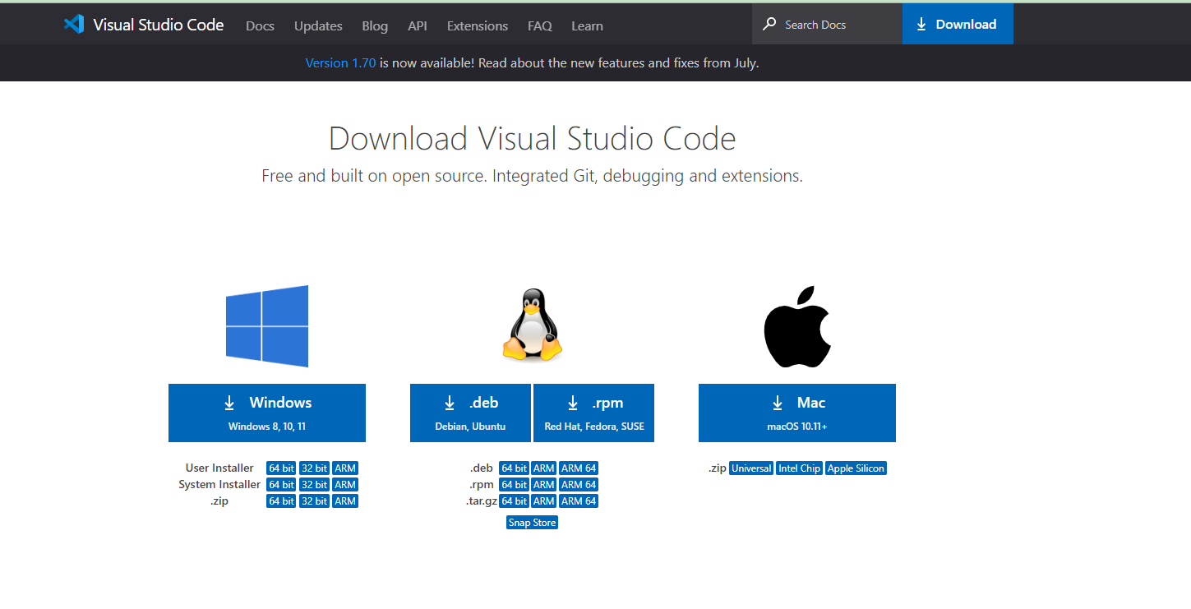

*Figure 136. Download Visual Studio Code*

* **Search and Open visual studio**

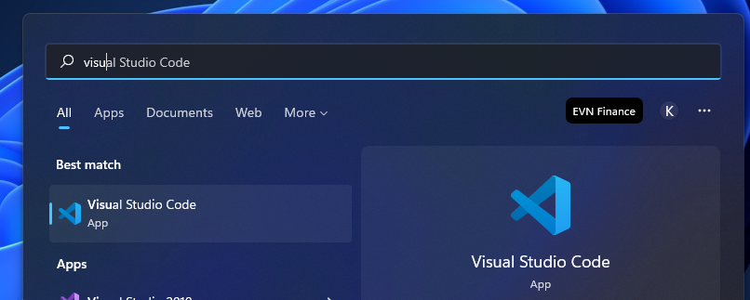

*Figure 137. Visual Studio Code*

* **Install extension**

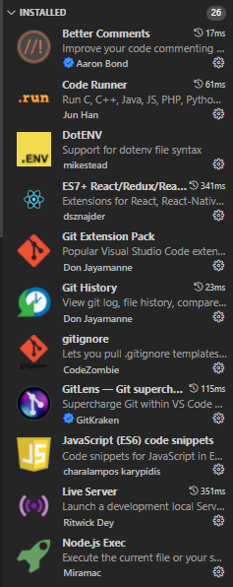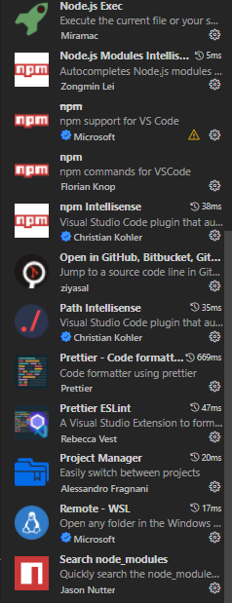

*Figure 138. Necessary extensions used in the project*

* **Start with Visual Studio Code**

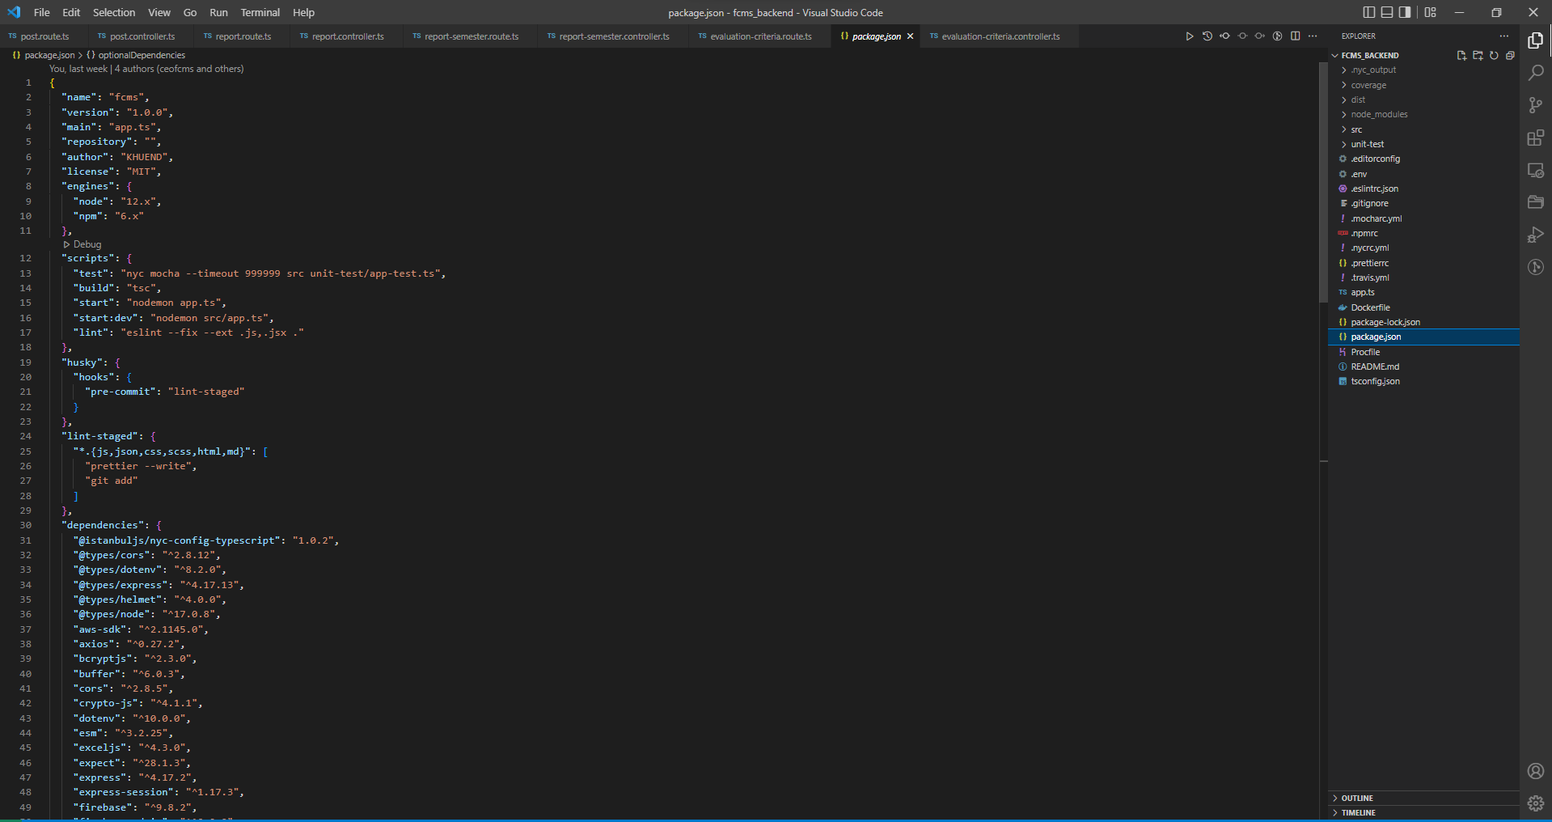

*Figure 139. Coding in Visual Studio Code*

### 1.2 Environment for deployment

#### *1.2.1 Create server Elastic Compute Cloud (EC2)*

* **Login to Amazon Web Services (AWS)**

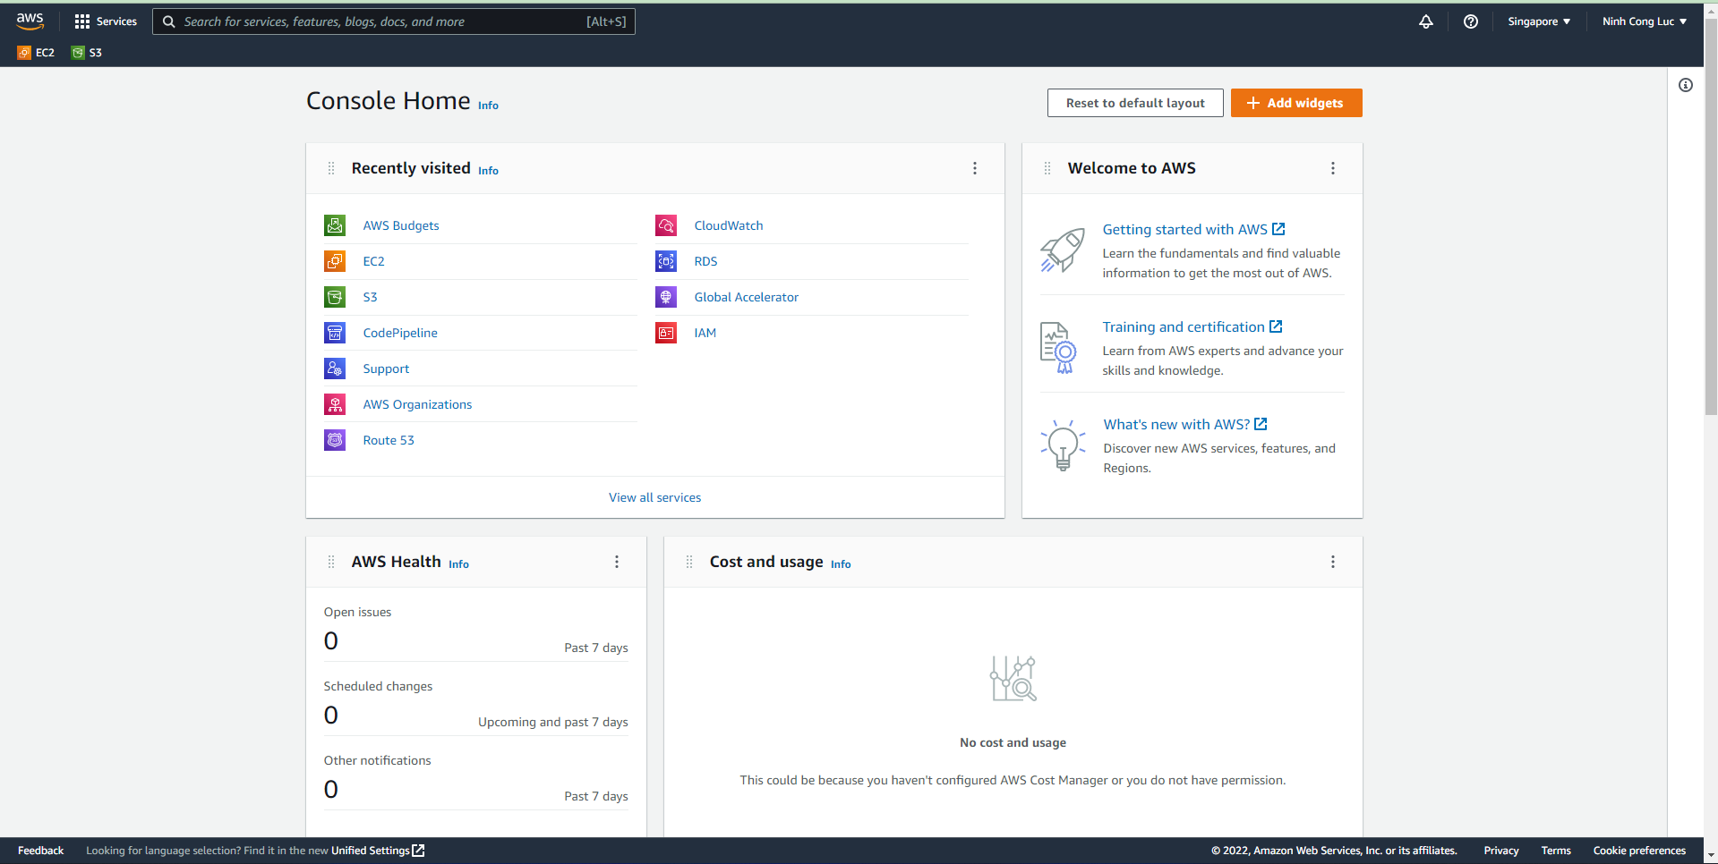

*Figure 140. Console Home of Amazon Web Servies*

* **Create instance on Amazon Web Service (EC2)**

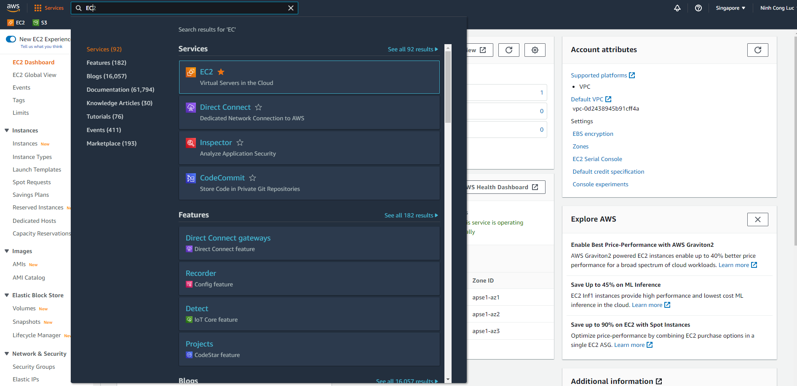

*Figure 141. EC2 of Amazon Web Servies*

* **Click launch instance**

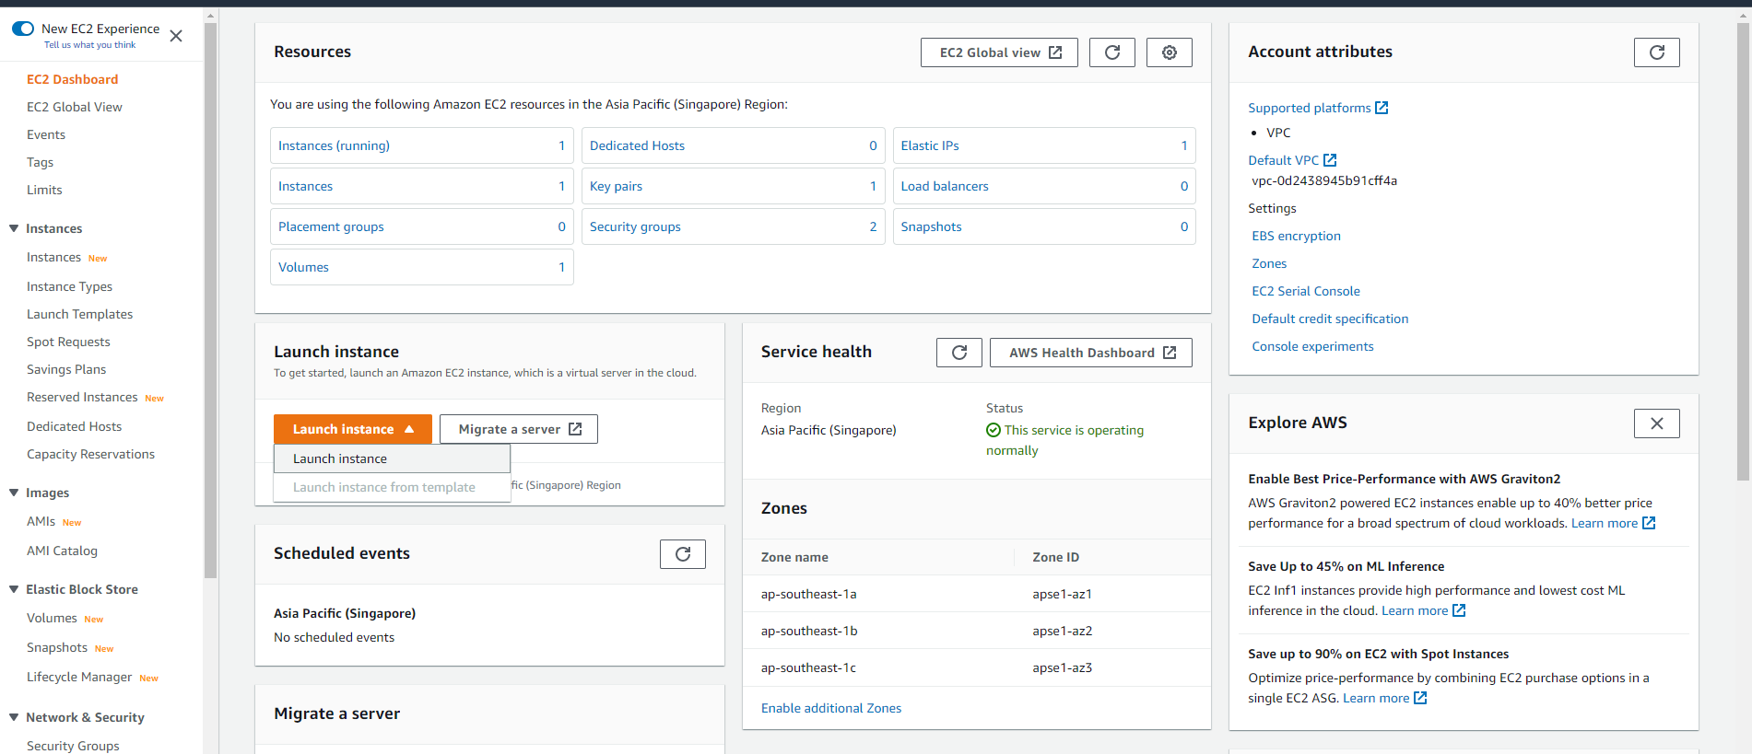

*Figure 142. EC2 Dashboard*

* **Input information and create**

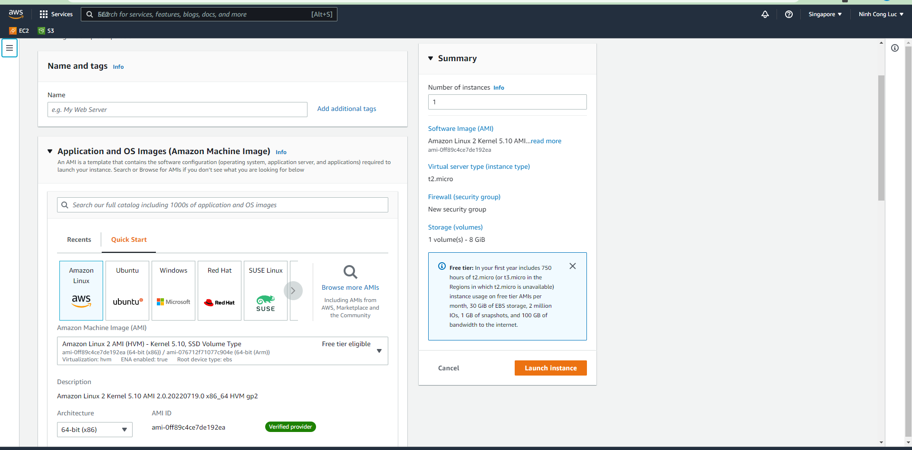

*Figure 143. EC2 Dashboard*

* **Create new instance on Amazon web service (AWS)**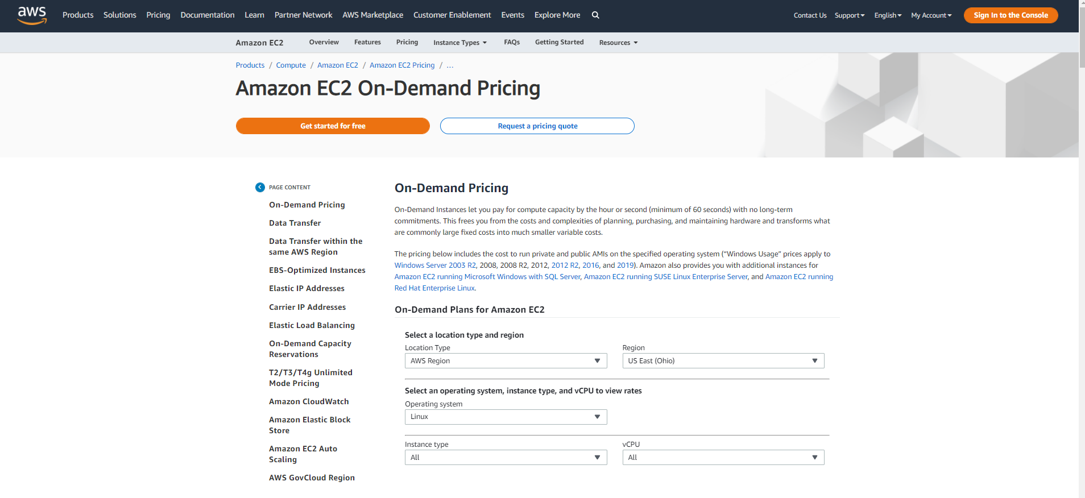

*Figure 144. EC2 On-Demand Pricing*

* **Choose a suitable Instance, in this project we will create t3-medium:**

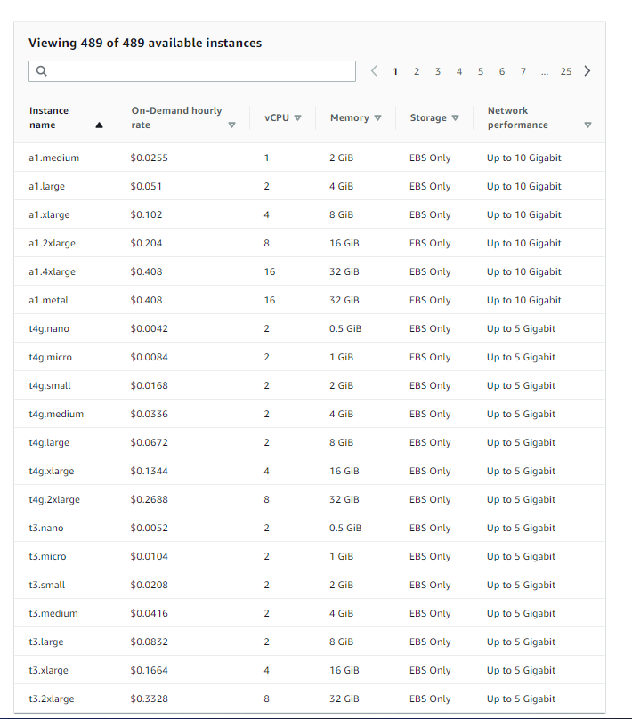

*Figure 145. Setup AWS T3*

* **Create instance successfully -> Click instance -> Choose instance created successfully**

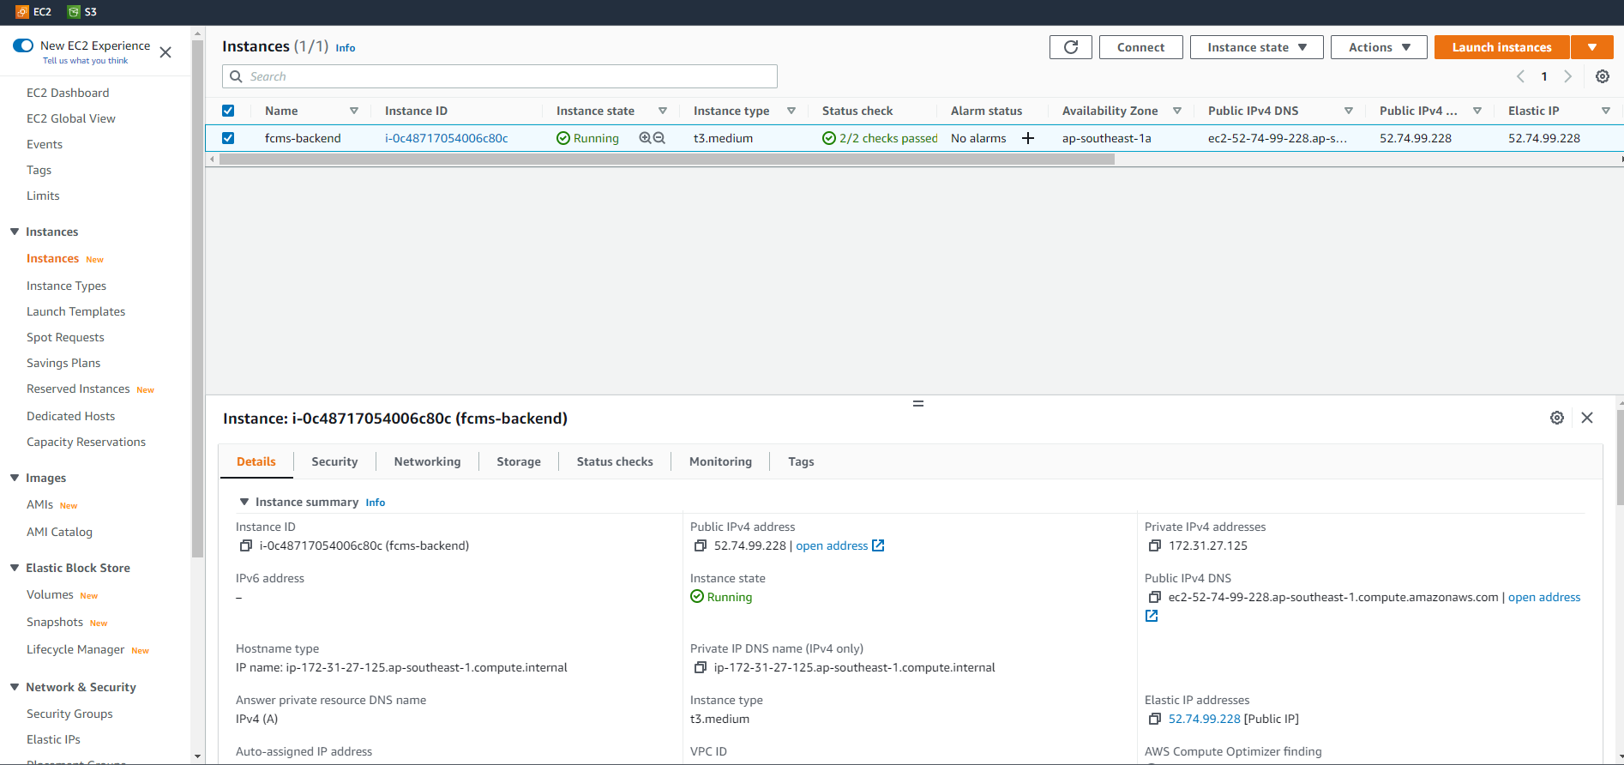

*Figure 146. EC2 Instances*

#### *1.2.2 Set up to run sever Elastic Compute Cloud*

* **Download XShell:** <https://www.netsarang.com/en/xshell-download/>

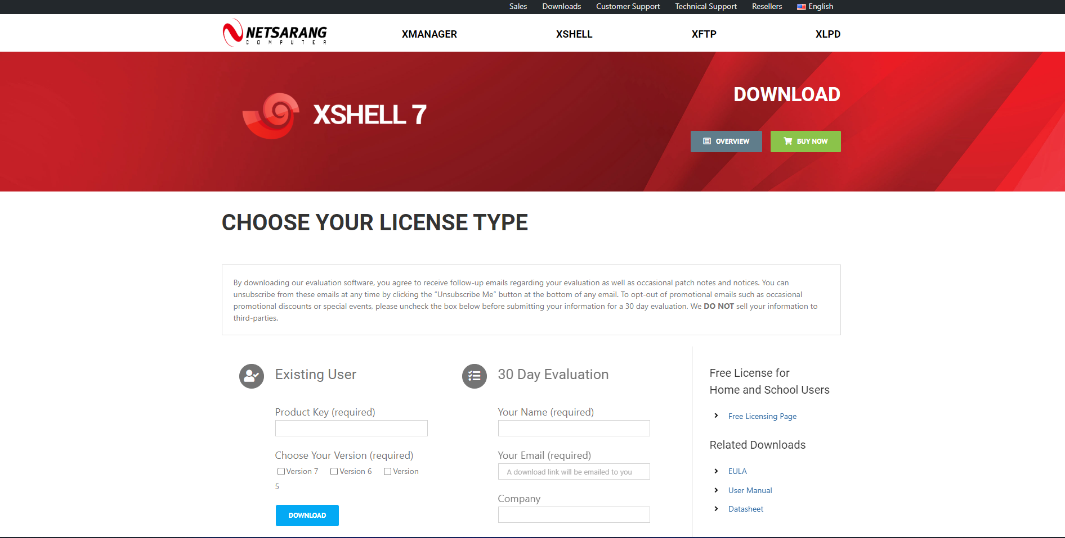

*Figure 147. XShell 7*

* ***Install successfully -> Open XShell:***

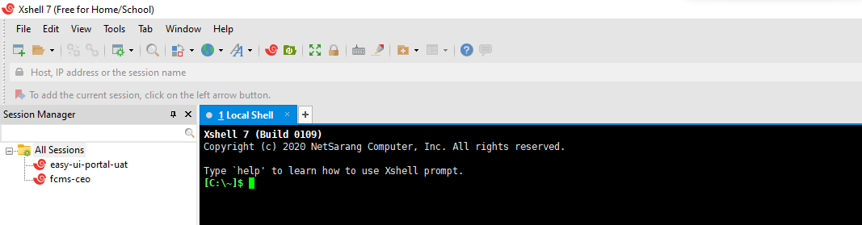

*Figure 148. Setup XShell*

* **Click “New” :**
  + **Get information create instance on AWS and then Input information IP on EC2 into XShell to connect server**

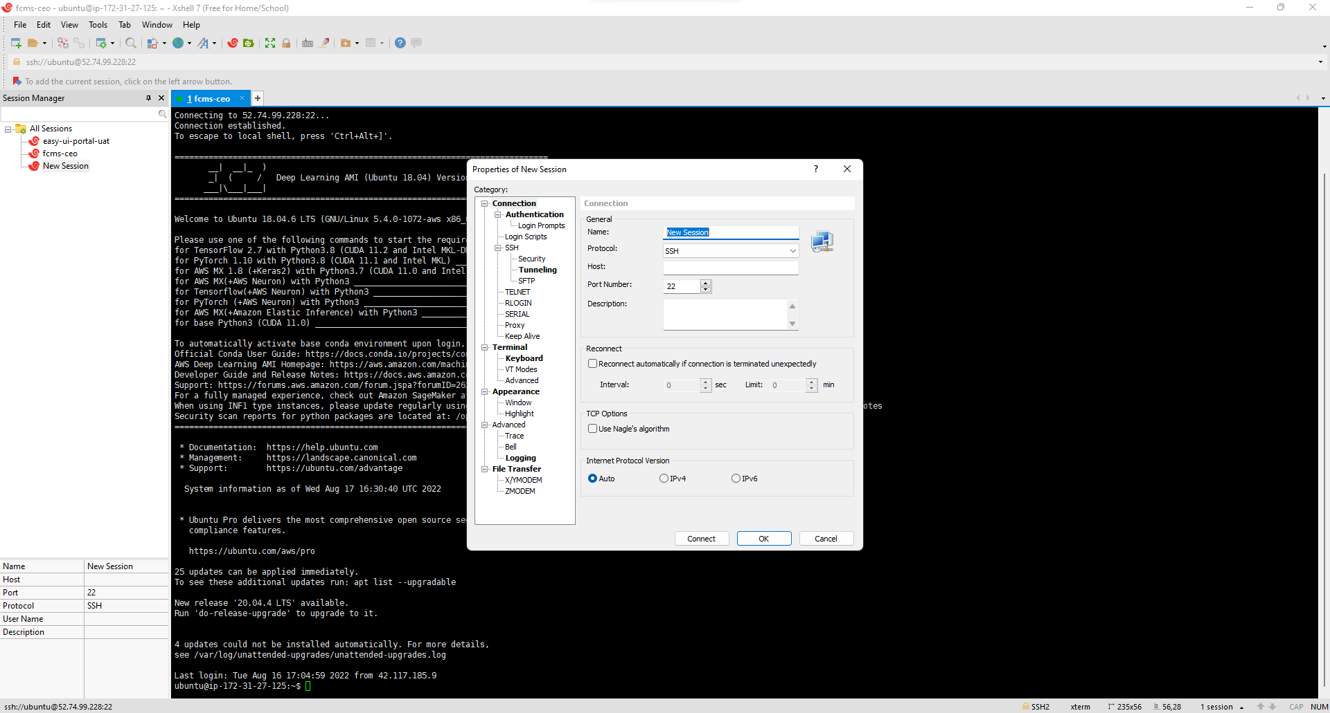

*Figure 149. Setup to connect server*

* **Connect successfully with server on EC2 (Aws)**

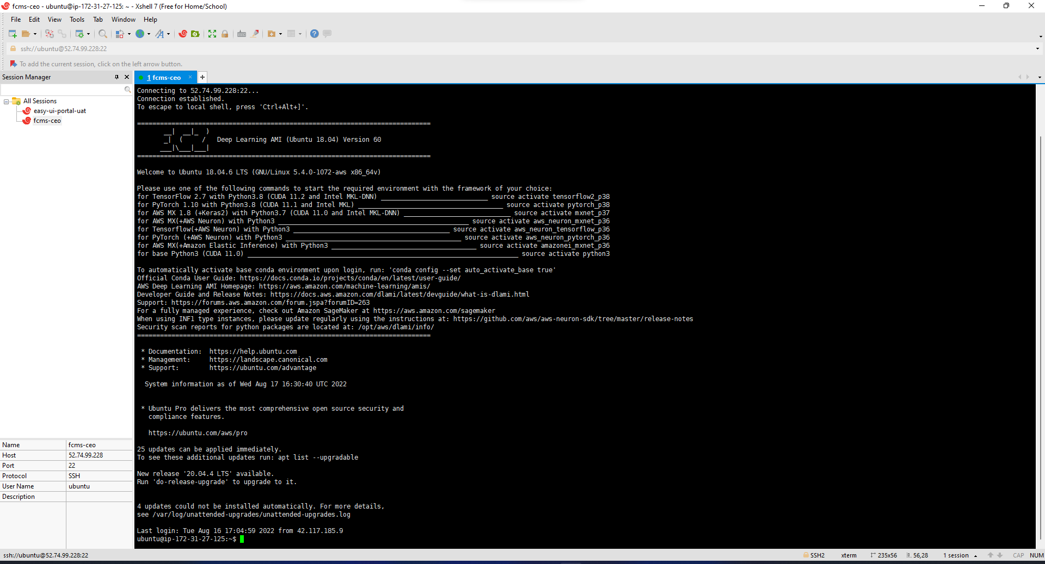

*Figure 150. Connect server EC2 successfully*

* **Install environment same install in local machine on ubuntu server**
* **Add ssh key on environment ubuntu:** 
  + **Generate ssh key: cat ~/.ssh/id_rsa.pub**

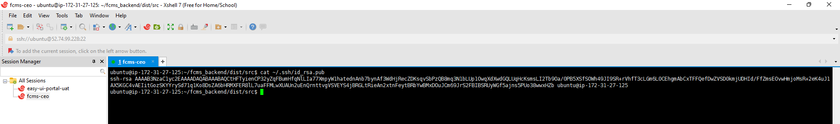

*Figure 151. Generate SSH Key*

* **Add ssh key to git:**

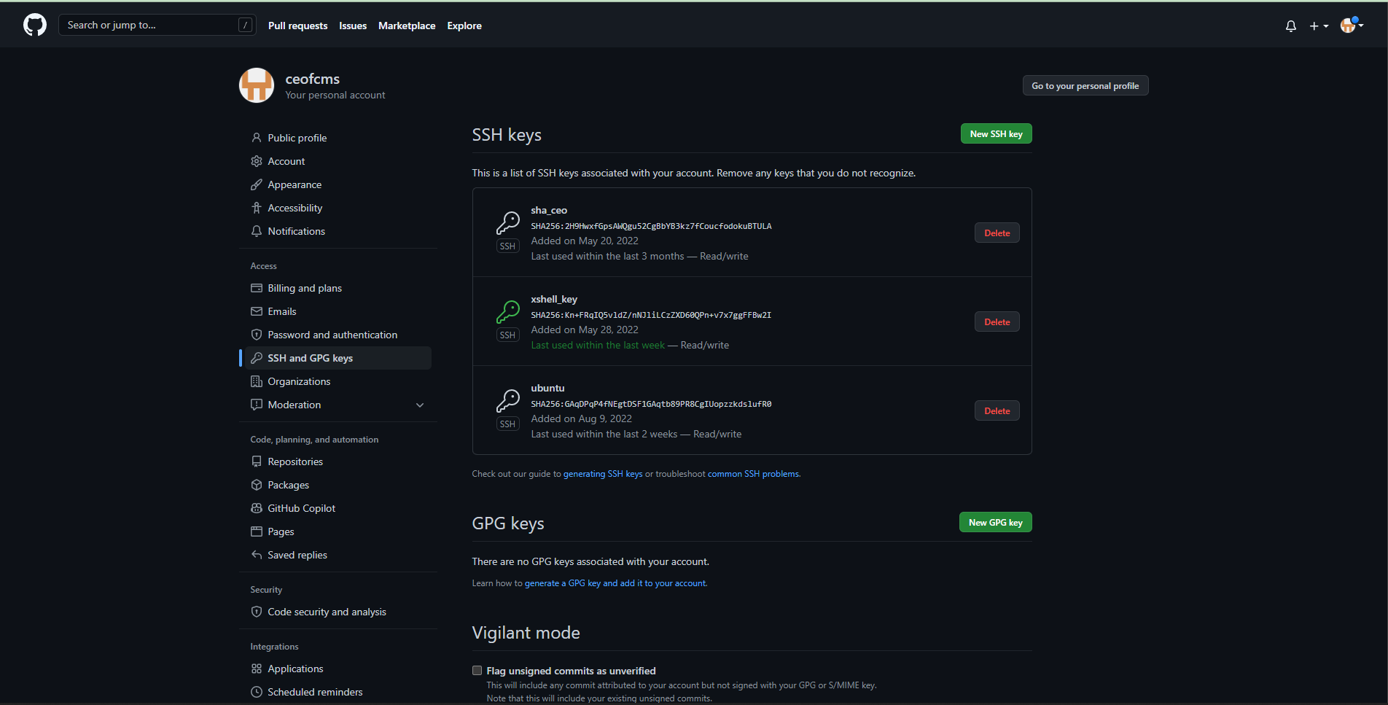

*Figure 152. Add SSH Key to git*

* **Git clone source code from repository github or git lab**
  + **Link github:** https://github.com/

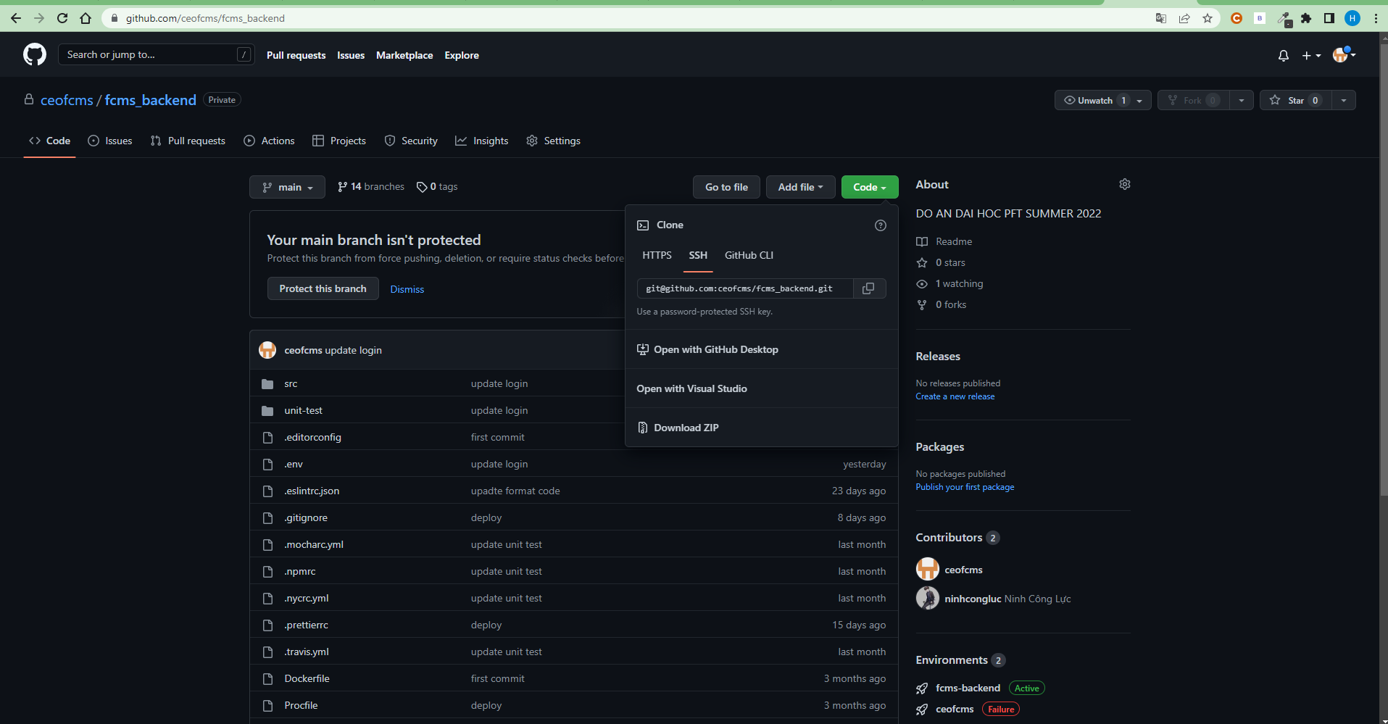

*Figure 153. Github*

#### *1.2.3 Setup environment auto run PM2*

**Link:** [**https://pm2.keymetrics.io/docs/usage/quick-start/**](https://pm2.keymetrics.io/docs/usage/quick-start/)

* **Install environment:**

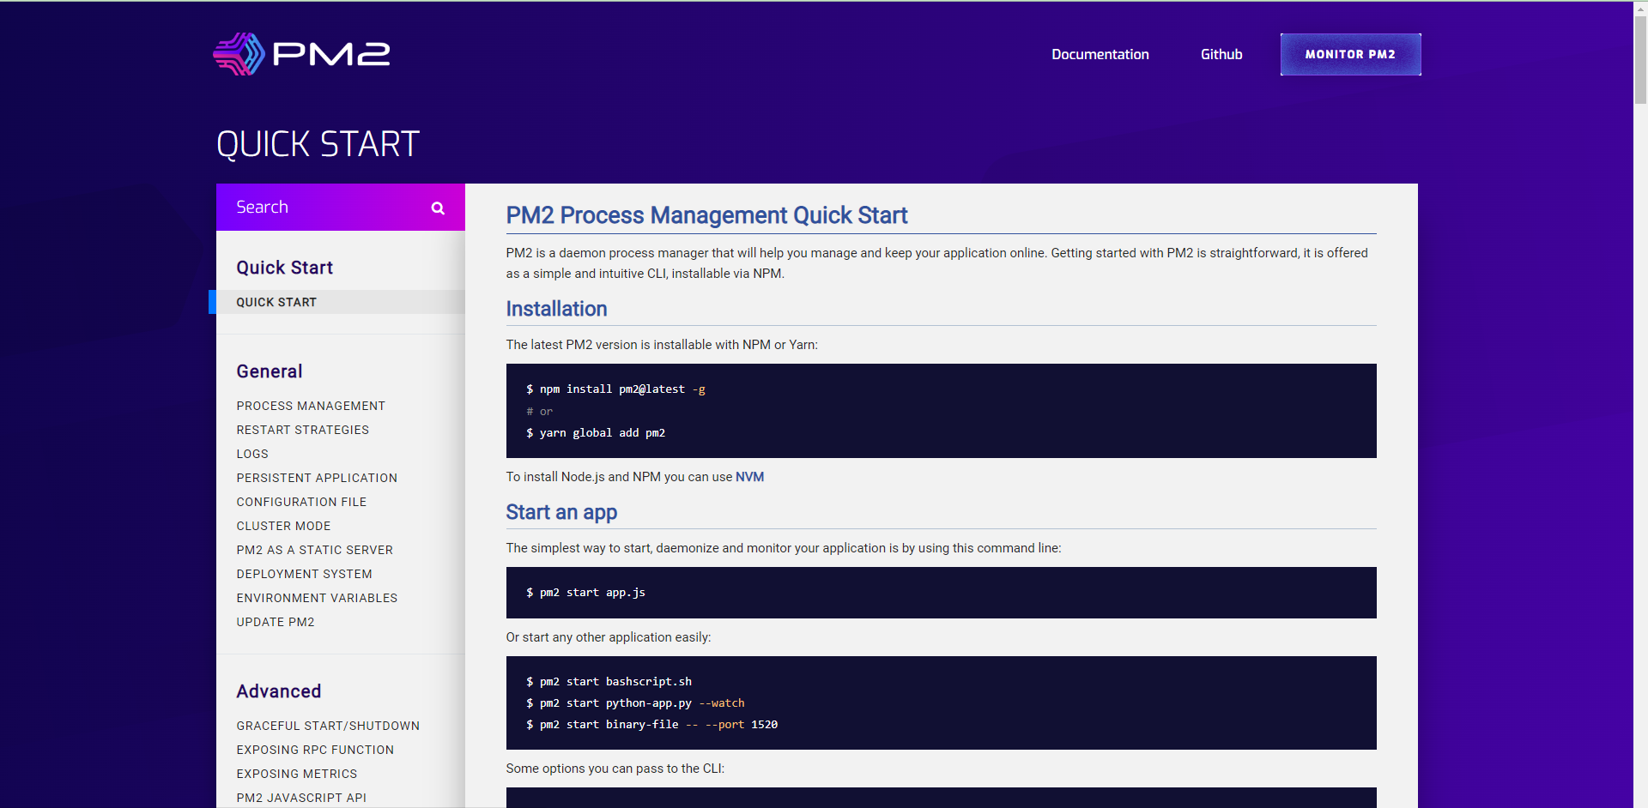

*Figure 154. PM2*

* **Depoyment configuration**
  + Create file: ecosystem.config.js
  + Syntax edit file config: Sudo vim ecosystem.config.js

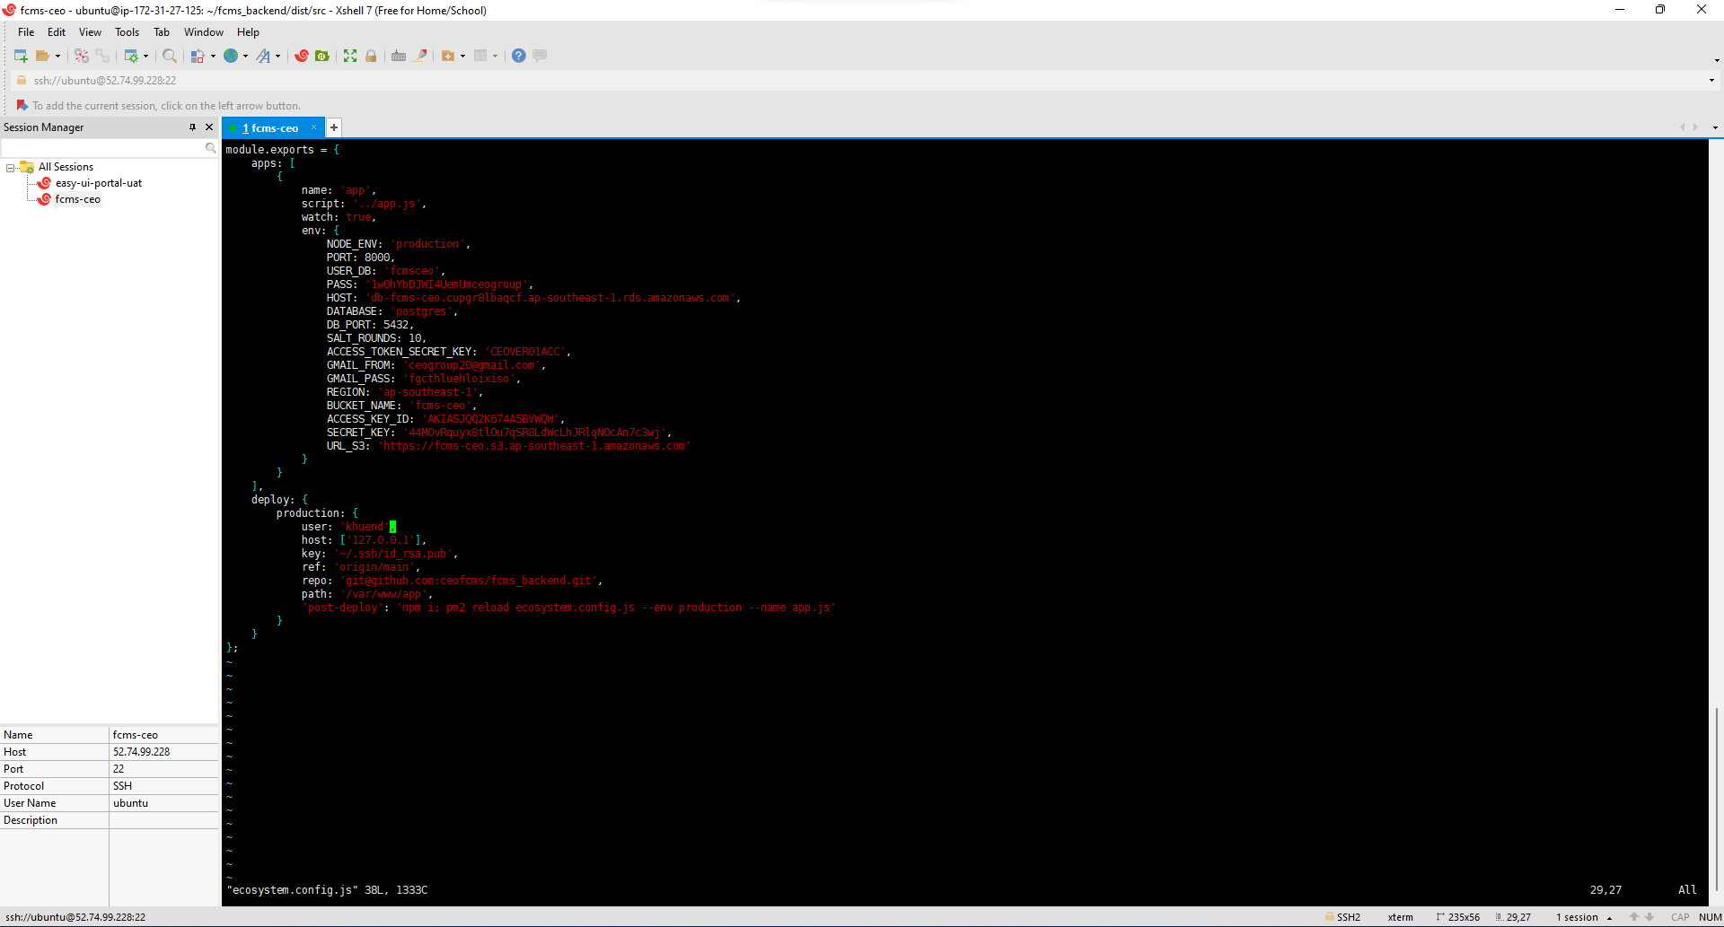

*Figure 155. Config PM2*

* **Run tests in development environment**
  + Syntax run: pm2 start ecosystem.config.js --env production

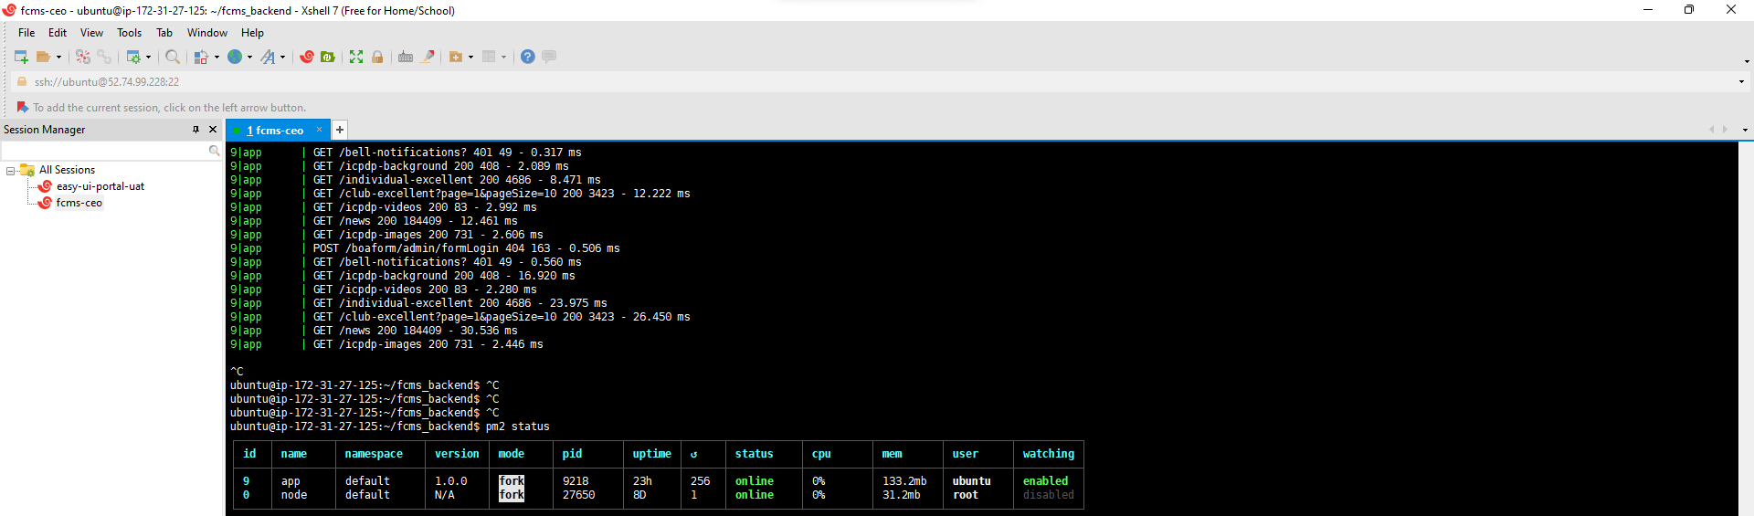

*Figure 156. Run tests in development environment*

#### *1.2.4 Create Storage S3 to save data image, file, video*

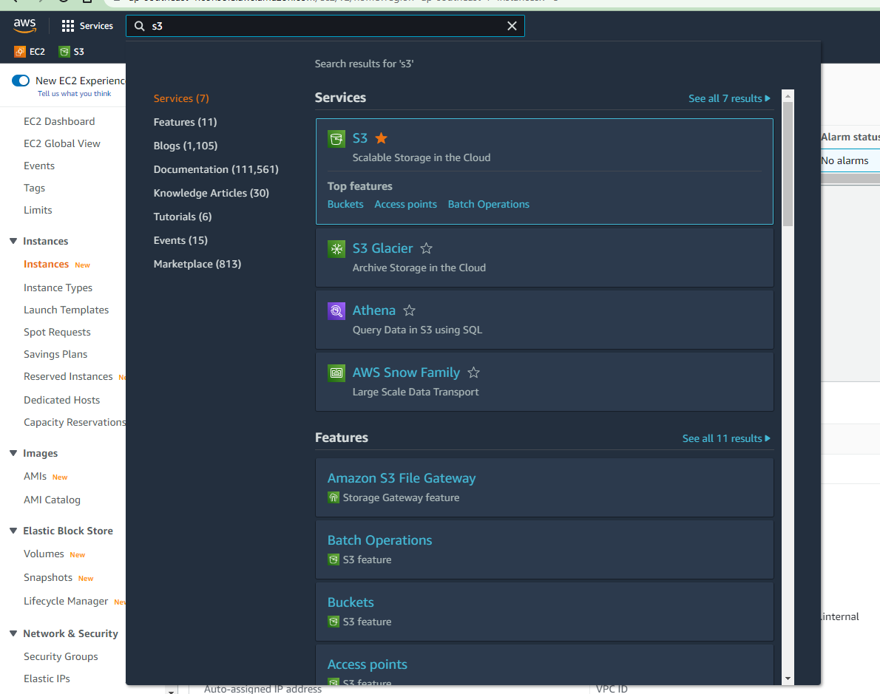

*Figure 157. S3 in AWS*

* **Click ‘Create bucket’:**

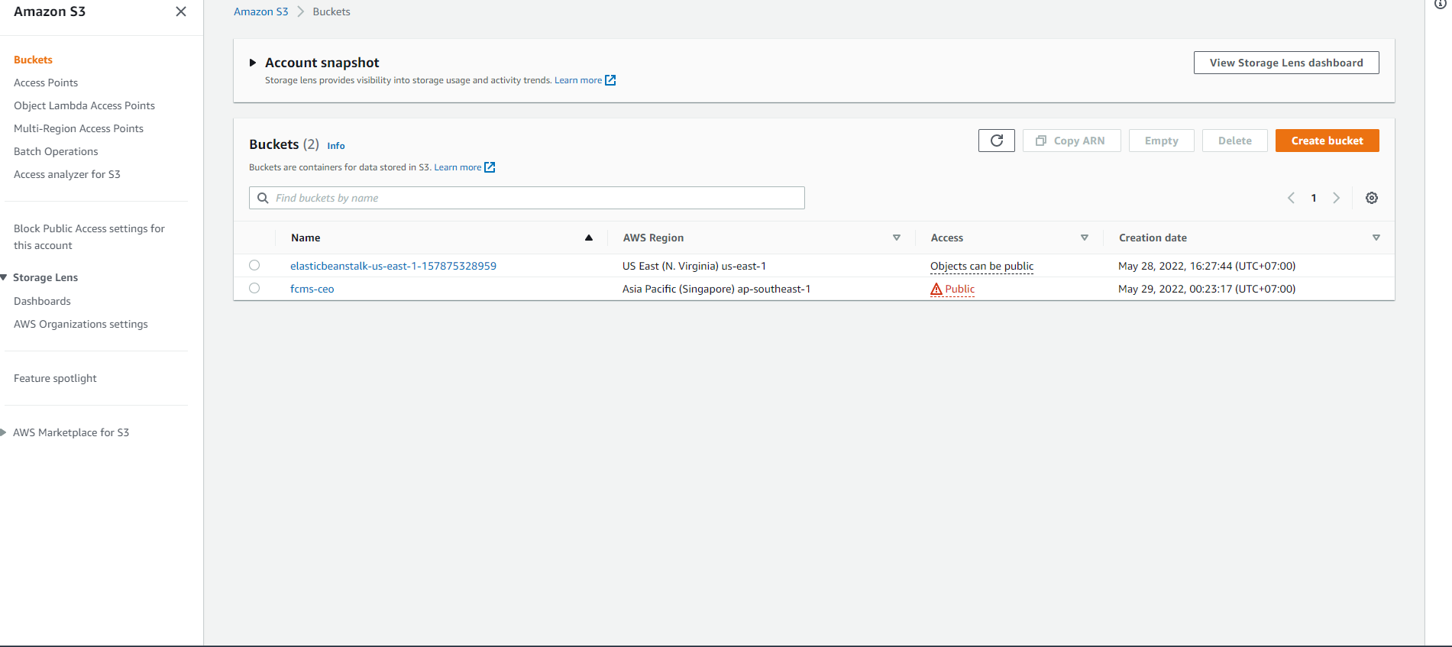

*Figure 158. Create bucket*

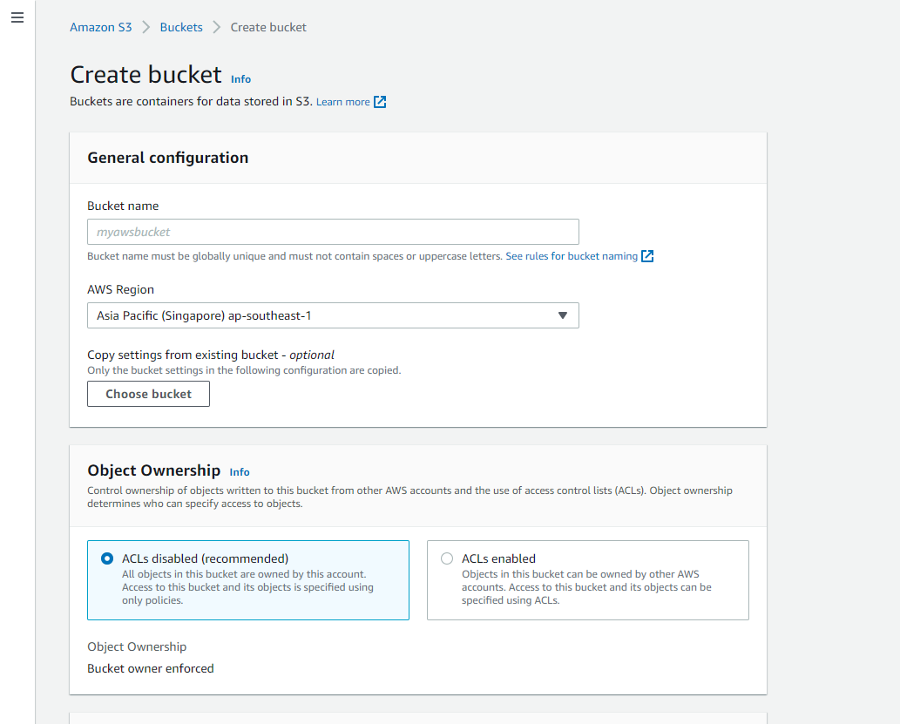

*Figure 159. Create bucket*

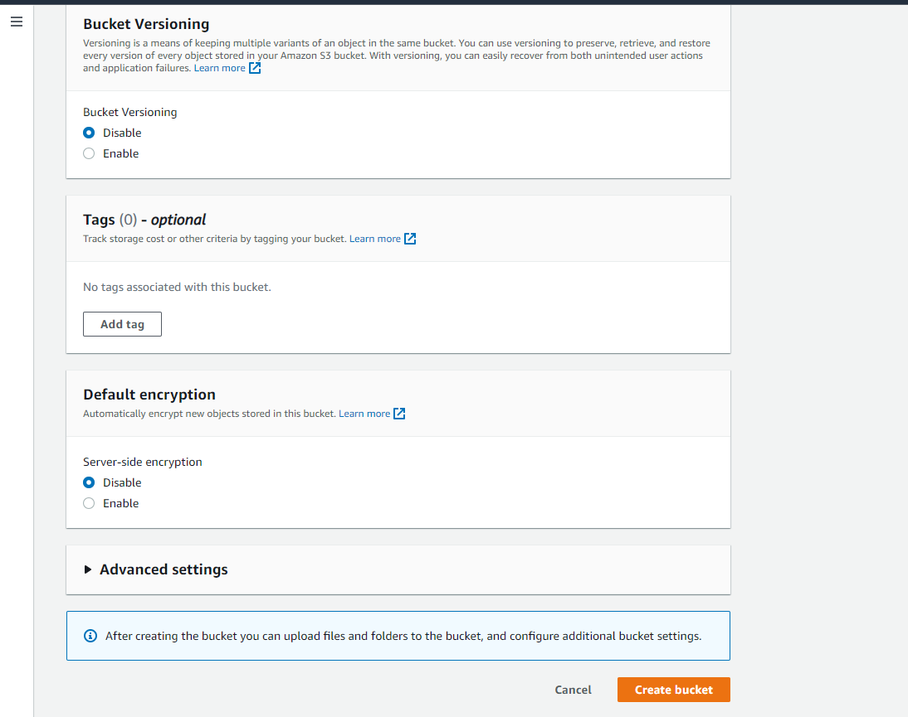

*Figure 160. Create bucket*

* **Create bucket successfully:**

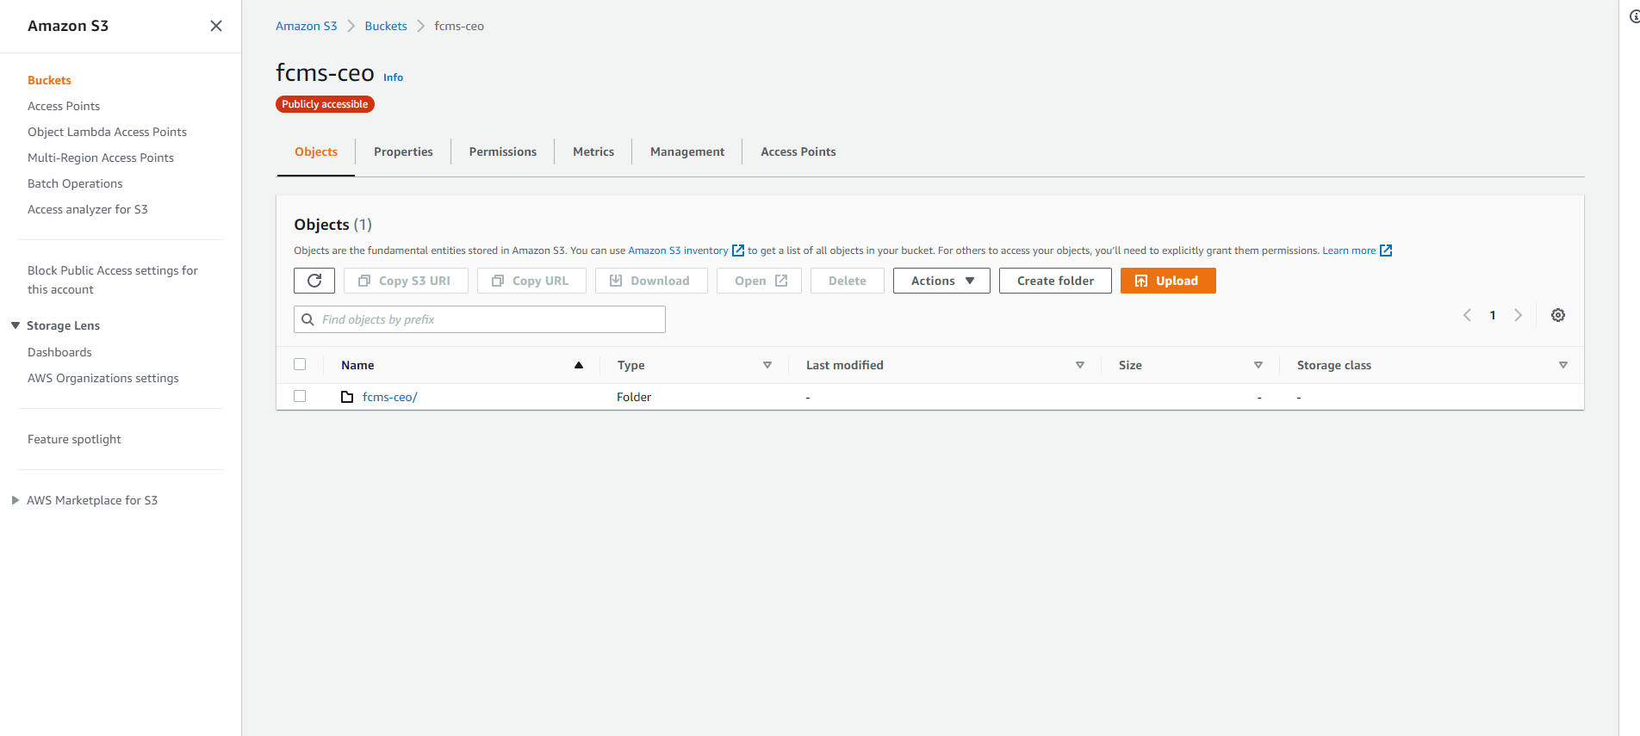

*Figure 161. Create bucket successfully*

* **Click ‘Create bucket’ -> Download file key connect S3 to save file:**

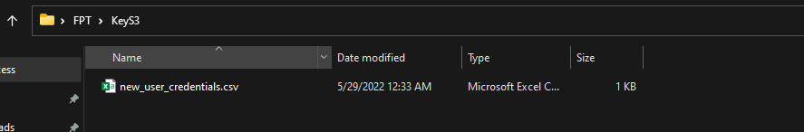

*Figure 162. Download file key connect S3*

* **Code demo connect to s3:**
  + upload file

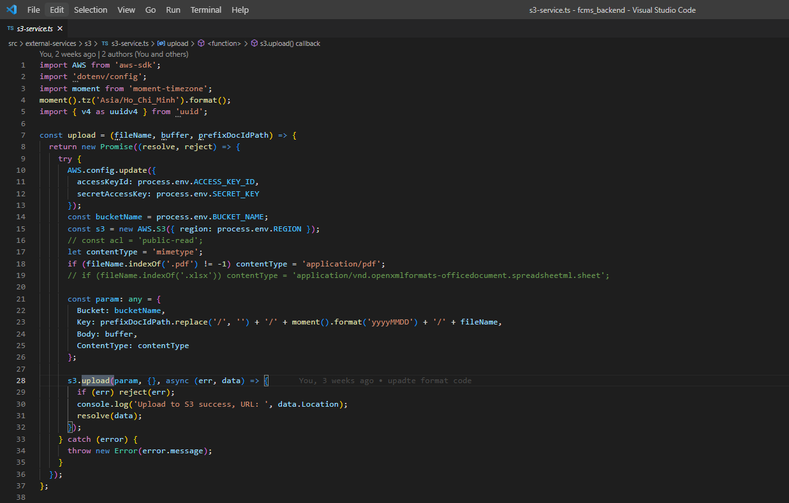

*Figure 163. Upload file to S3*

* + download file

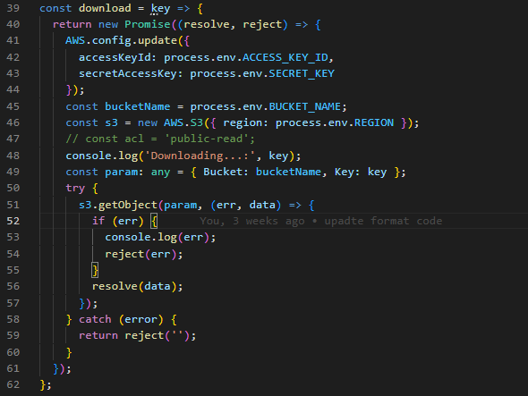

*Figure 164. Download file from S3*

#### *1.2.5 Configure PostgreSQL*

**Link:** [**https://dbeaver.io/download/**](https://dbeaver.io/download/)

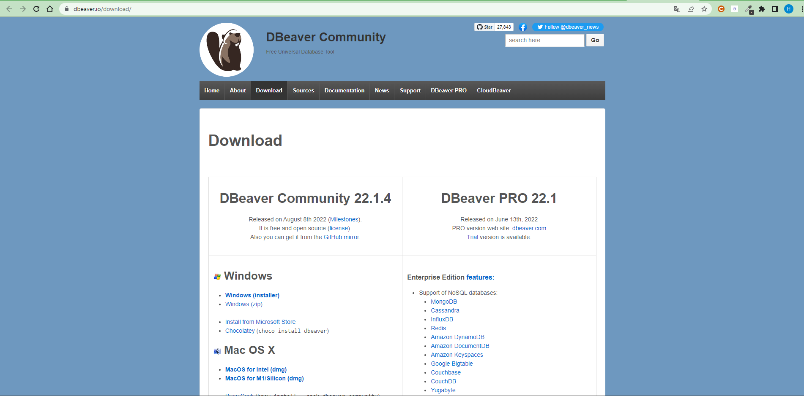

*Figure 165. DBeaver*

* **Install successfully -> Open DBeaver**

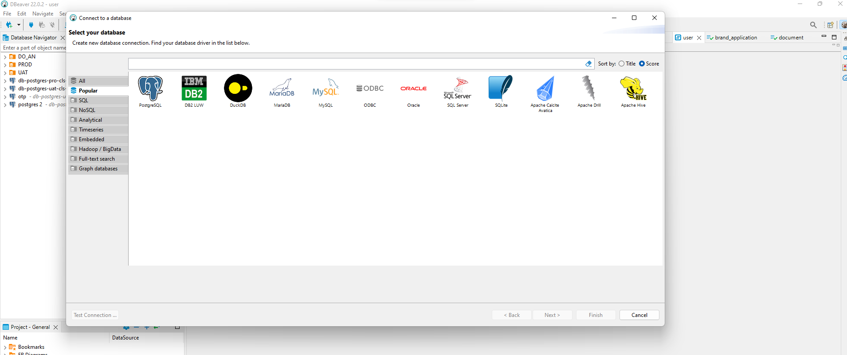

*Figure 166. Install DBeaver successfully*

* **Create database RDS on AWS:**

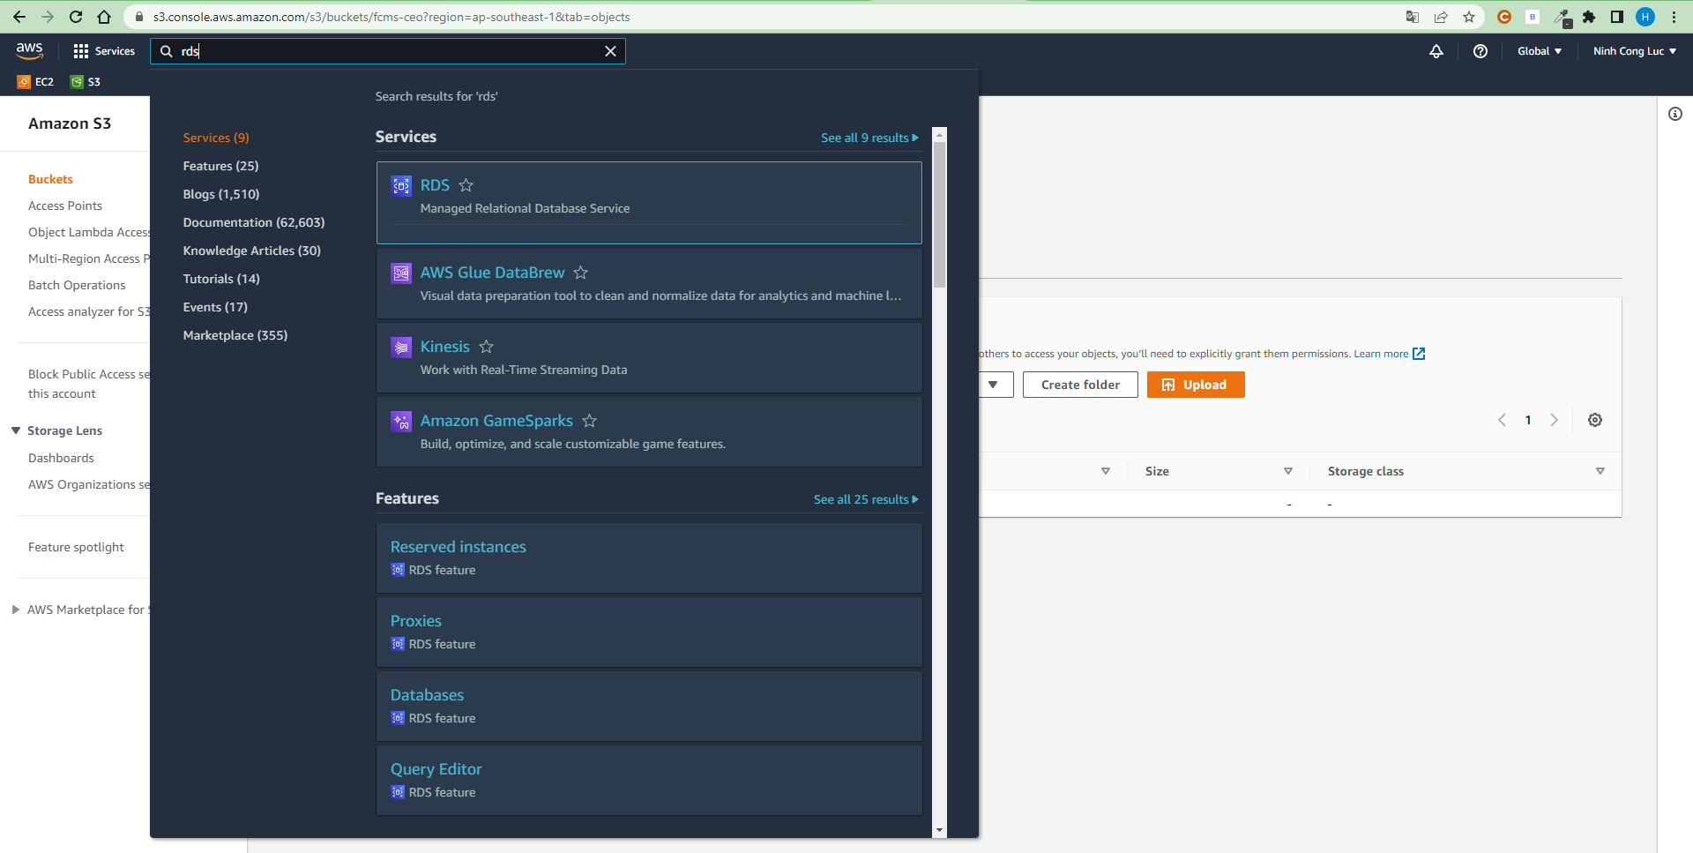

*Figure 167. RDS on AWS*

* **Click ‘Create database’:**

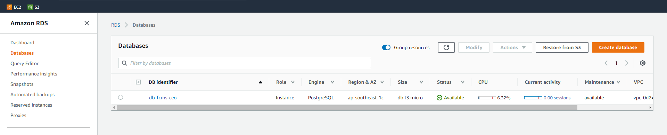

*Figure 168. Create database RDS on AWS*

* **Choose database PostgreSQL:**

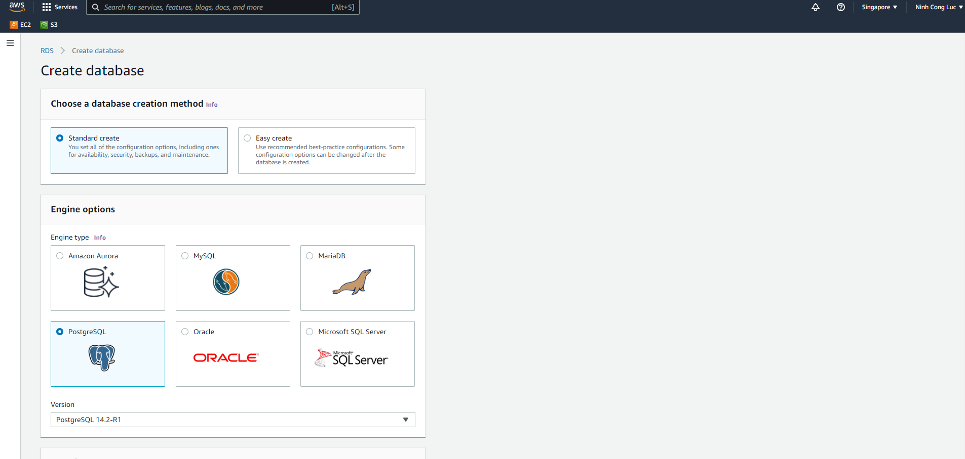

*Figure 169. PostgresSQL*

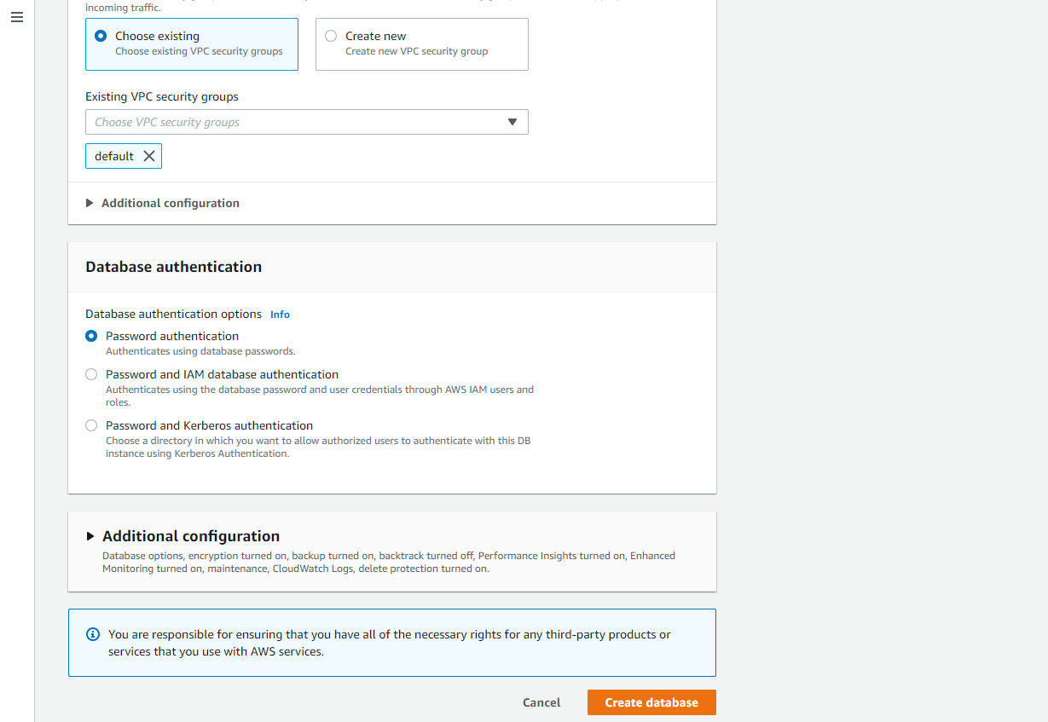

*Figure 170. Setup PostgresSQL in AWS*

* **Click Create database to create database RDS successfully:**

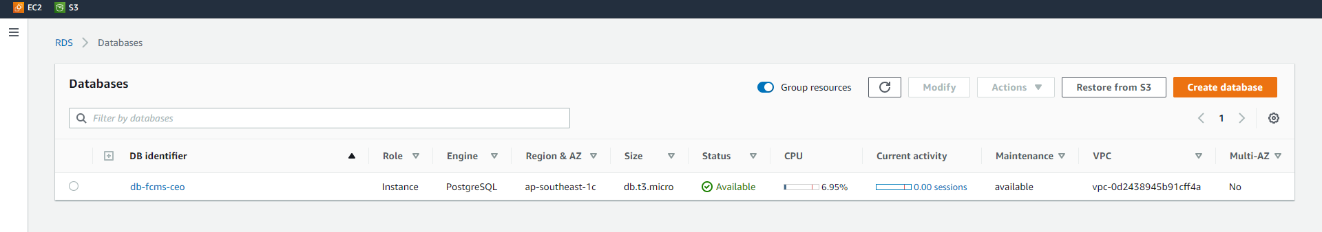

*Figure 171. Setup PostgresSQL in AWS successfully*

* **Connect database RDS:**
  + Input information RDS to connect:

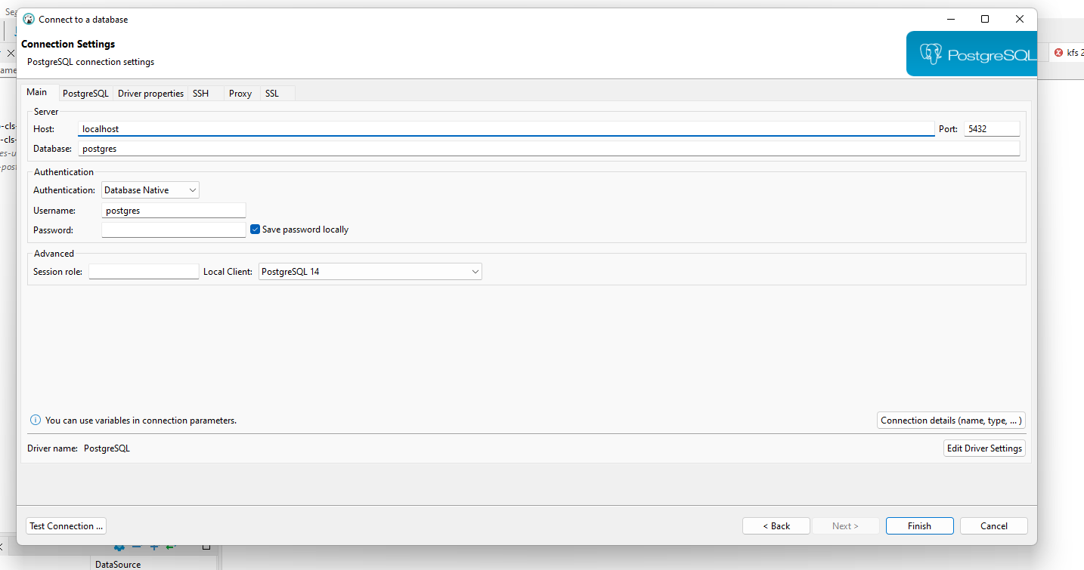

*Figure 172. Connection settings RDS*

#### *1.2.6 Install nginx*

$ sudo apt-get -y install nginx

* Create configuration file for FCMS Frontend

$ sudo vim /etc/nginx/sites-enabled/default

* Add following configurations

server {

listen 80 default_server;

listen [::]:80 default_server;

root /var/www/html;

index index.html index.htm index.nginx-debian.html;

server_name api.icpdp.net;

location / {

proxy_pass http://localhost:8000; #whatever port your app runs on

proxy_http_version 1.1;

proxy_set_header Upgrade $http_upgrade;

proxy_set_header Connection 'upgrade';

proxy_set_header Host $host;

proxy_cache_bypass $http_upgrade;

}

listen [::]:443 ssl ipv6only=on; # managed by Certbot

listen 443 ssl; # managed by Certbot

ssl_certificate /etc/letsencrypt/live/api.icpdp.net/fullchain.pem; # managed by Certbot

ssl_certificate_key /etc/letsencrypt/live/api.icpdp.net/privkey.pem; # managed by Certbot

include /etc/letsencrypt/options-ssl-nginx.conf; # managed by Certbot

ssl_dhparam /etc/letsencrypt/ssl-dhparams.pem; # managed by Certbot

}

* Reload nginx to apply change

$ sudo nginx –s reload

***Link video:*** [*https://www.youtube.com/watch?v=oykl1Ih9pMg*](https://www.youtube.com/watch?v=oykl1Ih9pMg)

#### *1.2.7 Set up deploy Frontend with Vercel*

* To be able to deploy your frontend application to vercel or prepare a frontend repo. We use Github to manage source code.
* Go to the official page of Vercel: <https://vercel.com/>
* Go to <https://vercel.com/signup> to sign up account

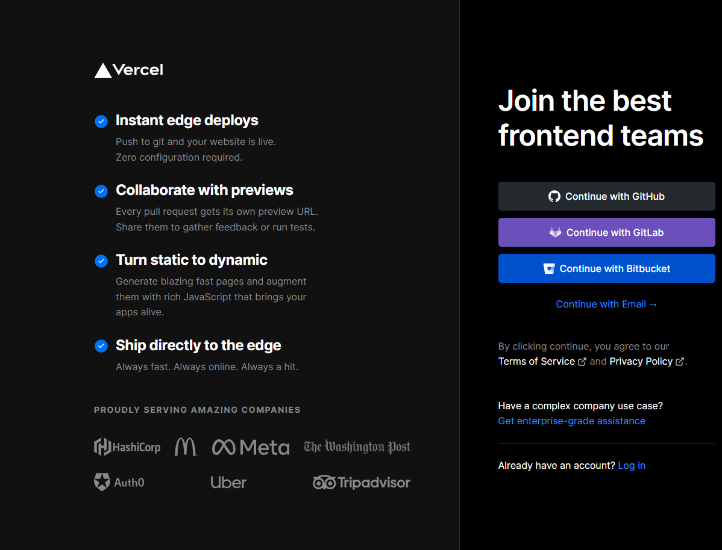

*Figure 173. Vercel sign up page*

* Once the success, the dashboard show look like this:

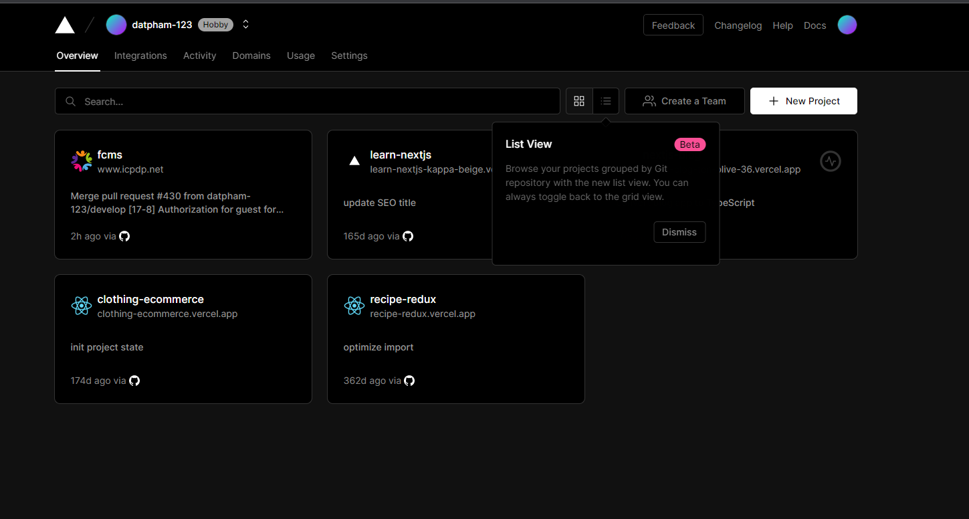

*Figure 174. After login success*

* The first step would be to visit your dashboard and click "New Project":

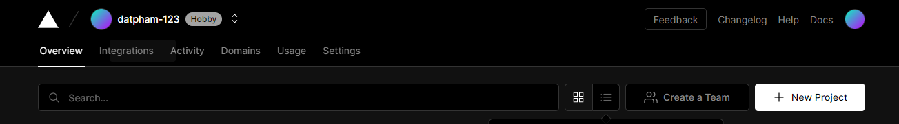

*Figure 175. Button New Project located in the right corner*

* Then choose your github repository:

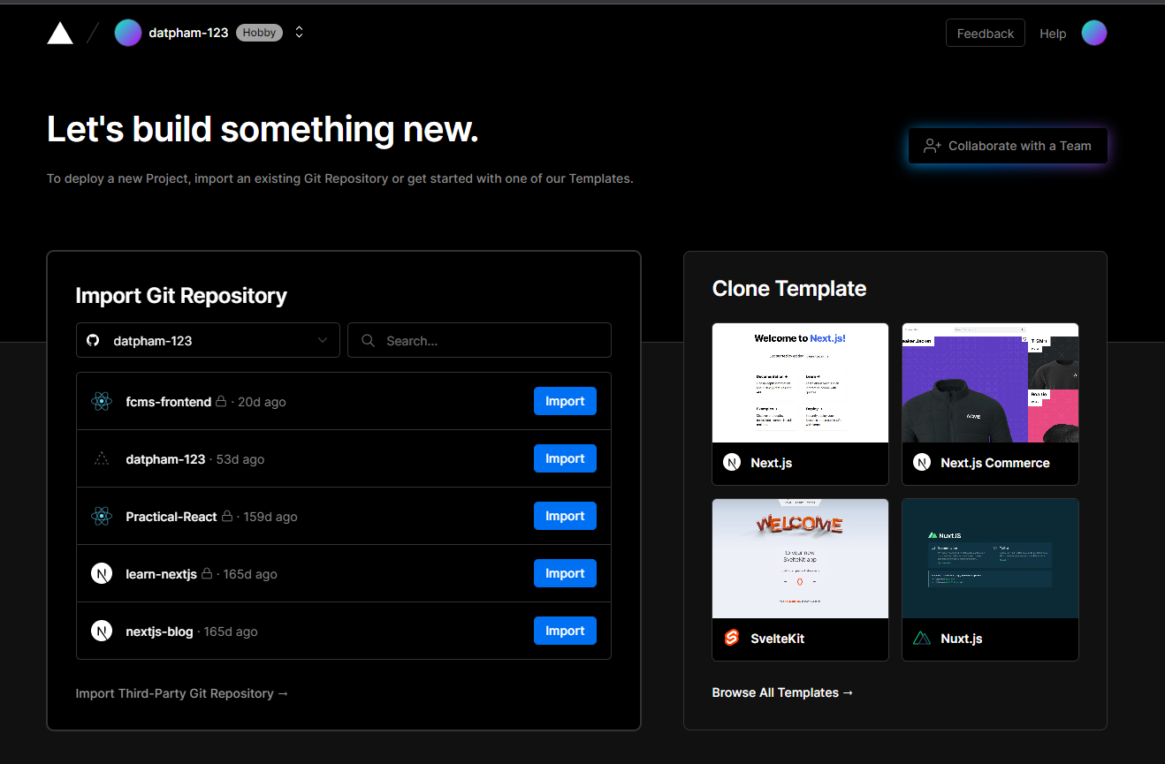

*Figure 176. Screen display after click “New Project”*

* Import your repository and will appear: (Vercel automatic detects your framework)

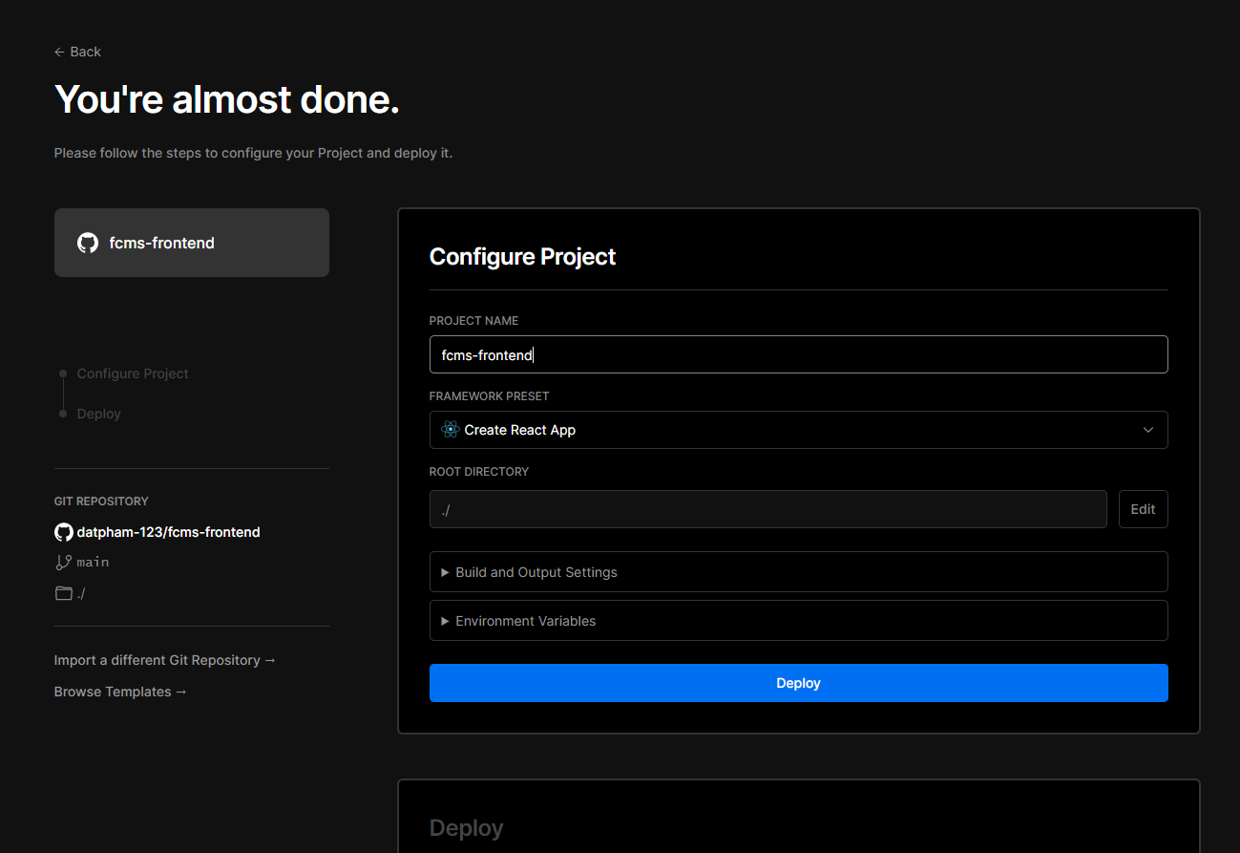

*Figure 177. Screen display after click “Import”*

* And the final result is:

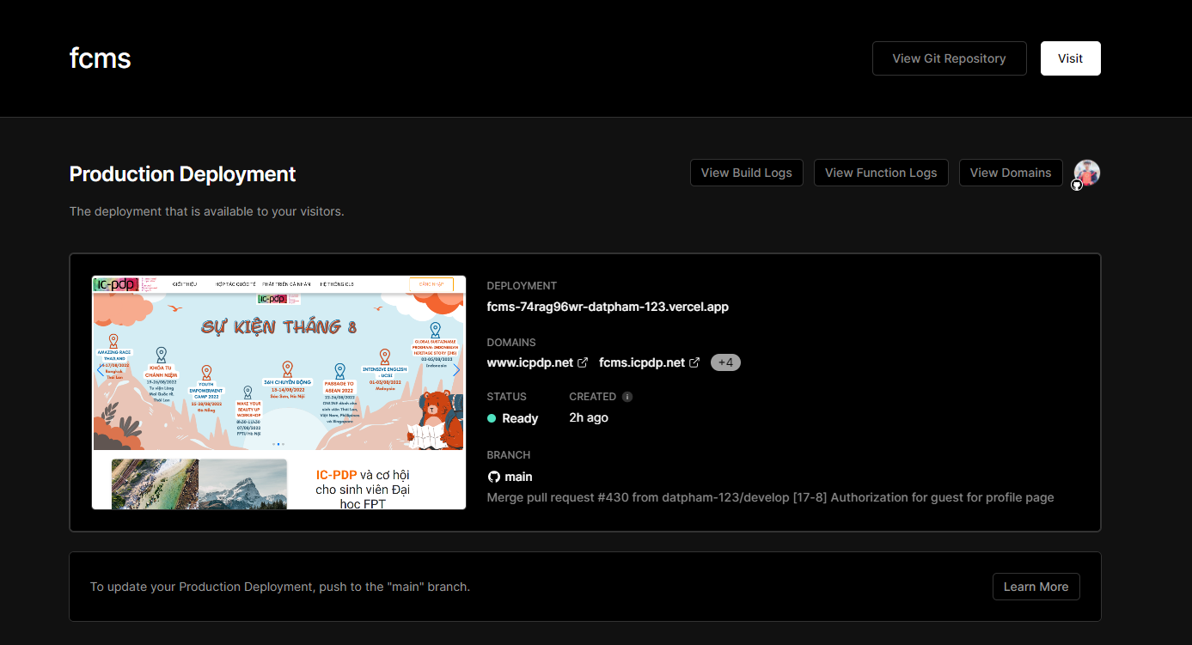

*Figure 178. Screen display result after deploy success*

#### *1.2.8 CloudFlare*

* **Register account at CloudFlare**
  + Go to <https://dash.cloudflare.com/sign-up> and fill private your information

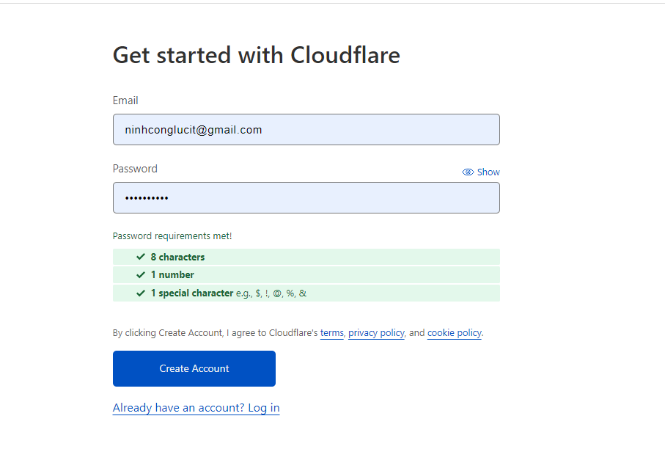

*Figure 179. Create CloudFlare screen*

* ***Configurations***
  + Login to your CloudFlare account
  + Go to Domain Registration -> Click Register Domains and input domain you want to buy

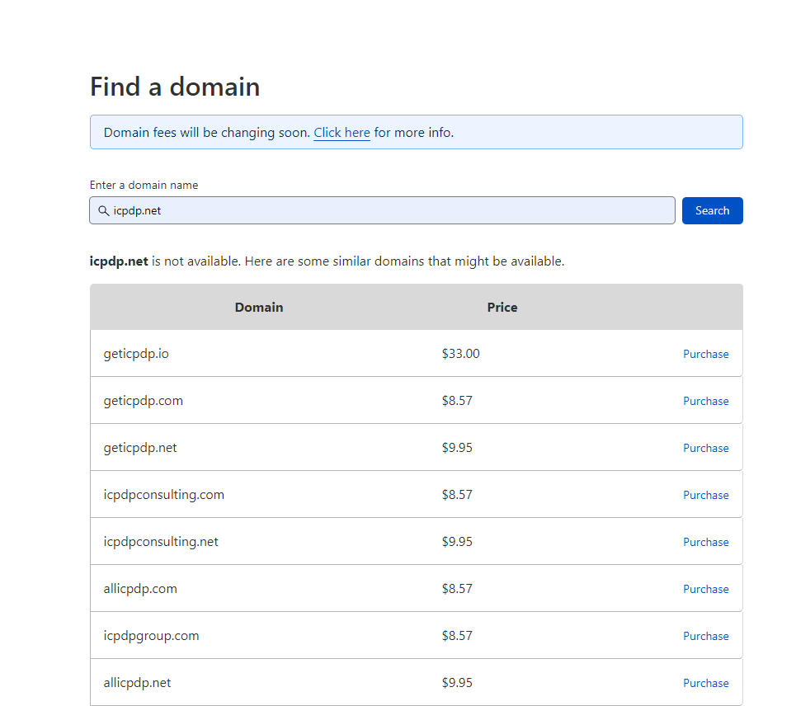

*Figure 180. CloudFlare add site screen*

* + Waiting for DNS confirmation for your domain. If your domain is verified, your CloudFlare dashboard will look like this. And then complete the payment procedure.

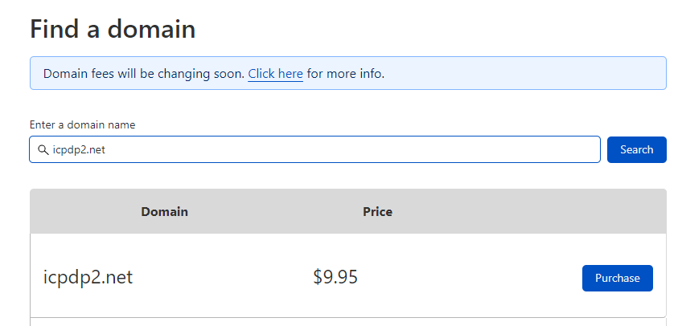

*Figure 181. CloudFlare overview dashboard*

* + Configure DNS
    - Then, depending on the purpose of use, create and manage your own sub domains. Currently, FCMS we are using 2 subdomains for the client and for the backend api, below is an illustration (covered sensitive information)

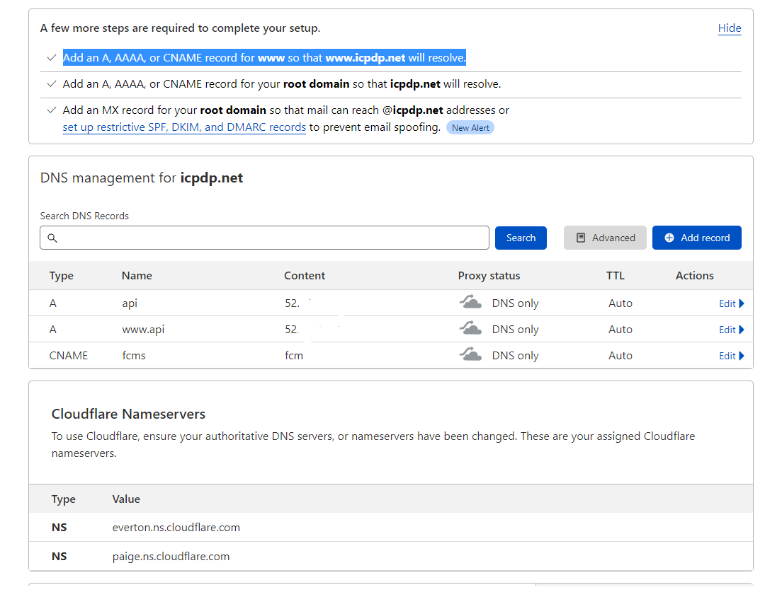

*Figure 182. CloudFlare configure DNS*

* + A record for ‘api’ will be pointed to public ip of the backend server on ec2
  + A record for ‘fcms’ will be pointed to CNAME of client side on Vercel

#### *1.2.9 Setup Firebase Cloud Messaging*

* **Register account at Firebase Cloud Messaging**
  + Go to https://firebase.google.com/ and click on “Sign In” to login with google account

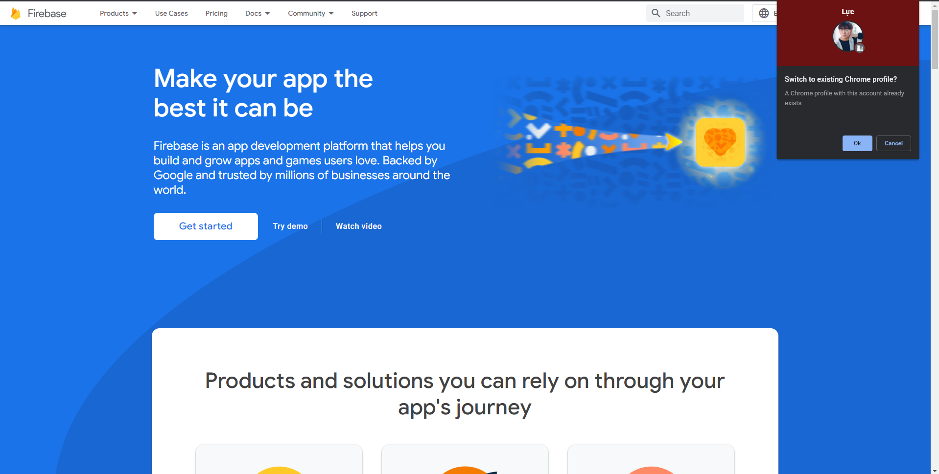

*Figure 183. Sign in account at Firebase Cloud Messaging*

* ***Configuration***
  + After Login success, Click “Product” in nav
  + Click “Get Started”
  + Click “Add Project”

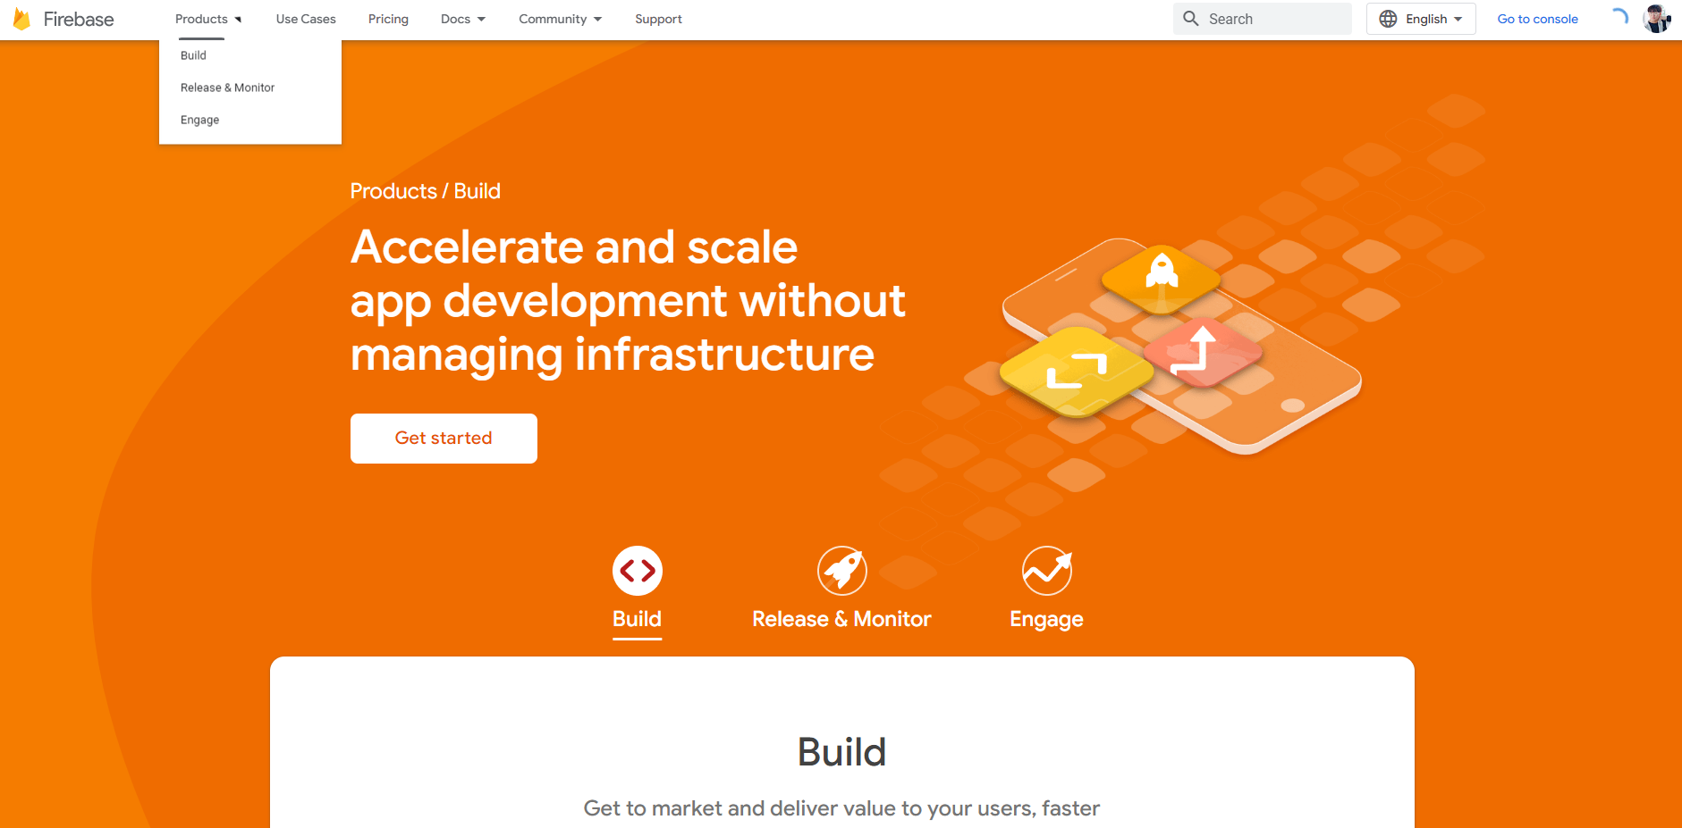

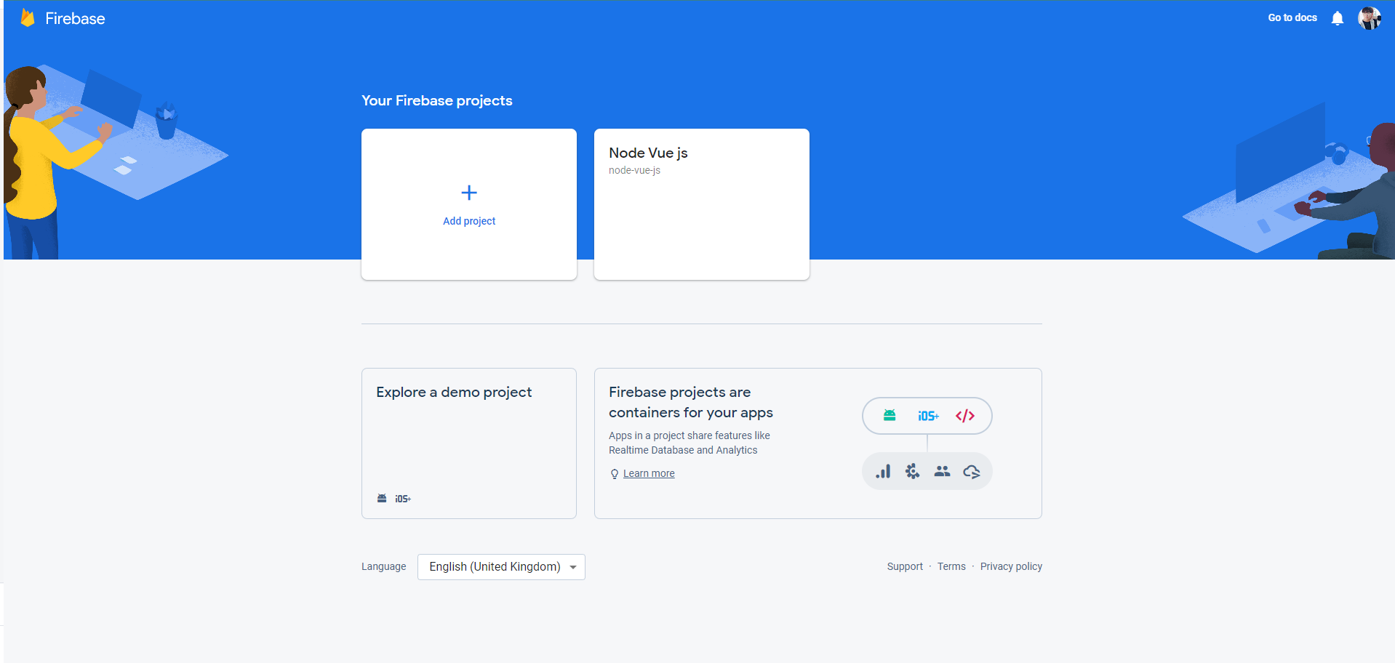

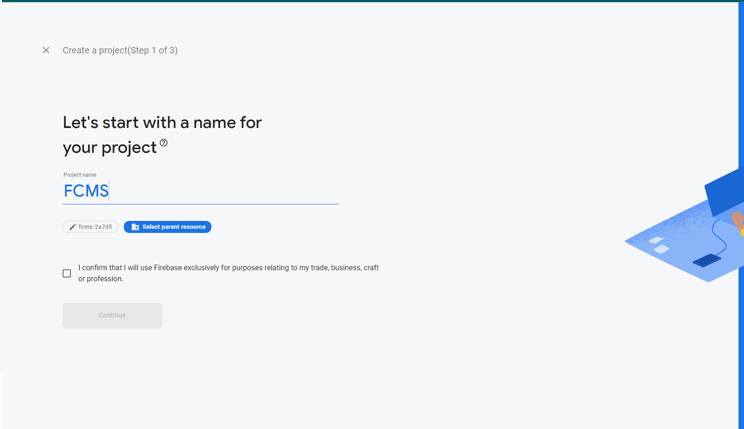

*Figure 184. Configure Firebase Cloud Messaging*

* + Follow the instructions on FCM to receive configuration push notifications like below. (You have to configure both client and server, remember let's learn how to store and erase device tokens!!)

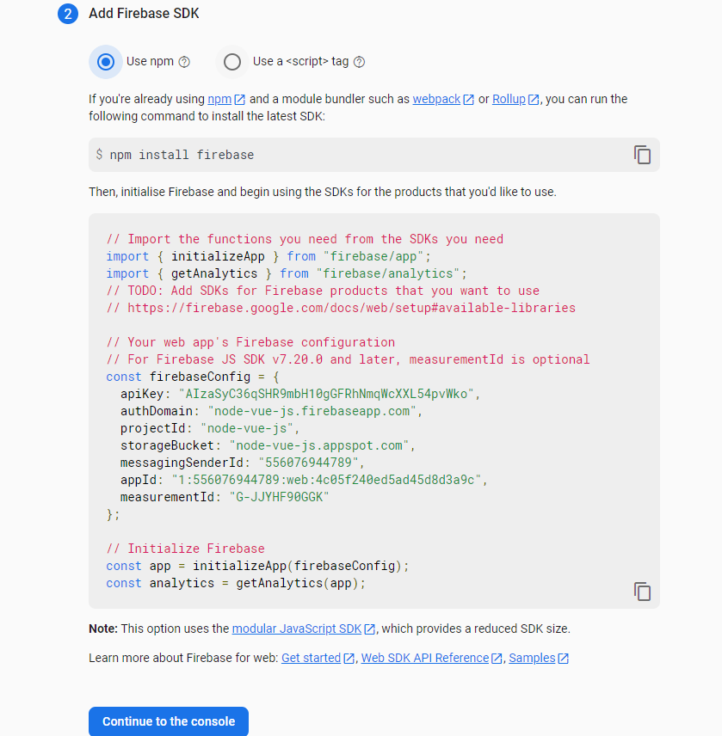

*Figure 185. Configure Firebase Cloud Messaging*

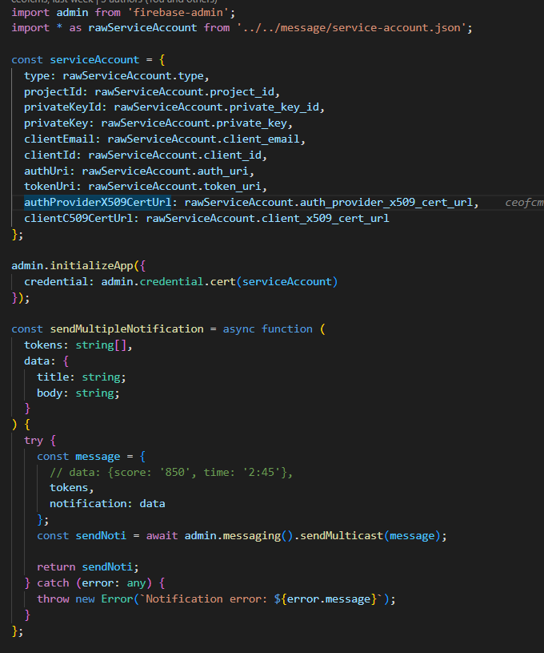

*Figure 186. Configure Firebase Cloud Messaging on Backend*

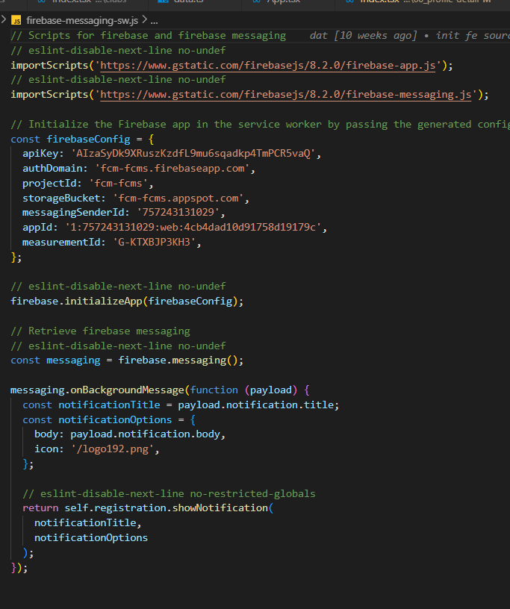

*Figure 187: Configure Firebase Cloud Messaging on Client*

#### *1.2.10 Setup SendGmail*

* ***Login your gmail***

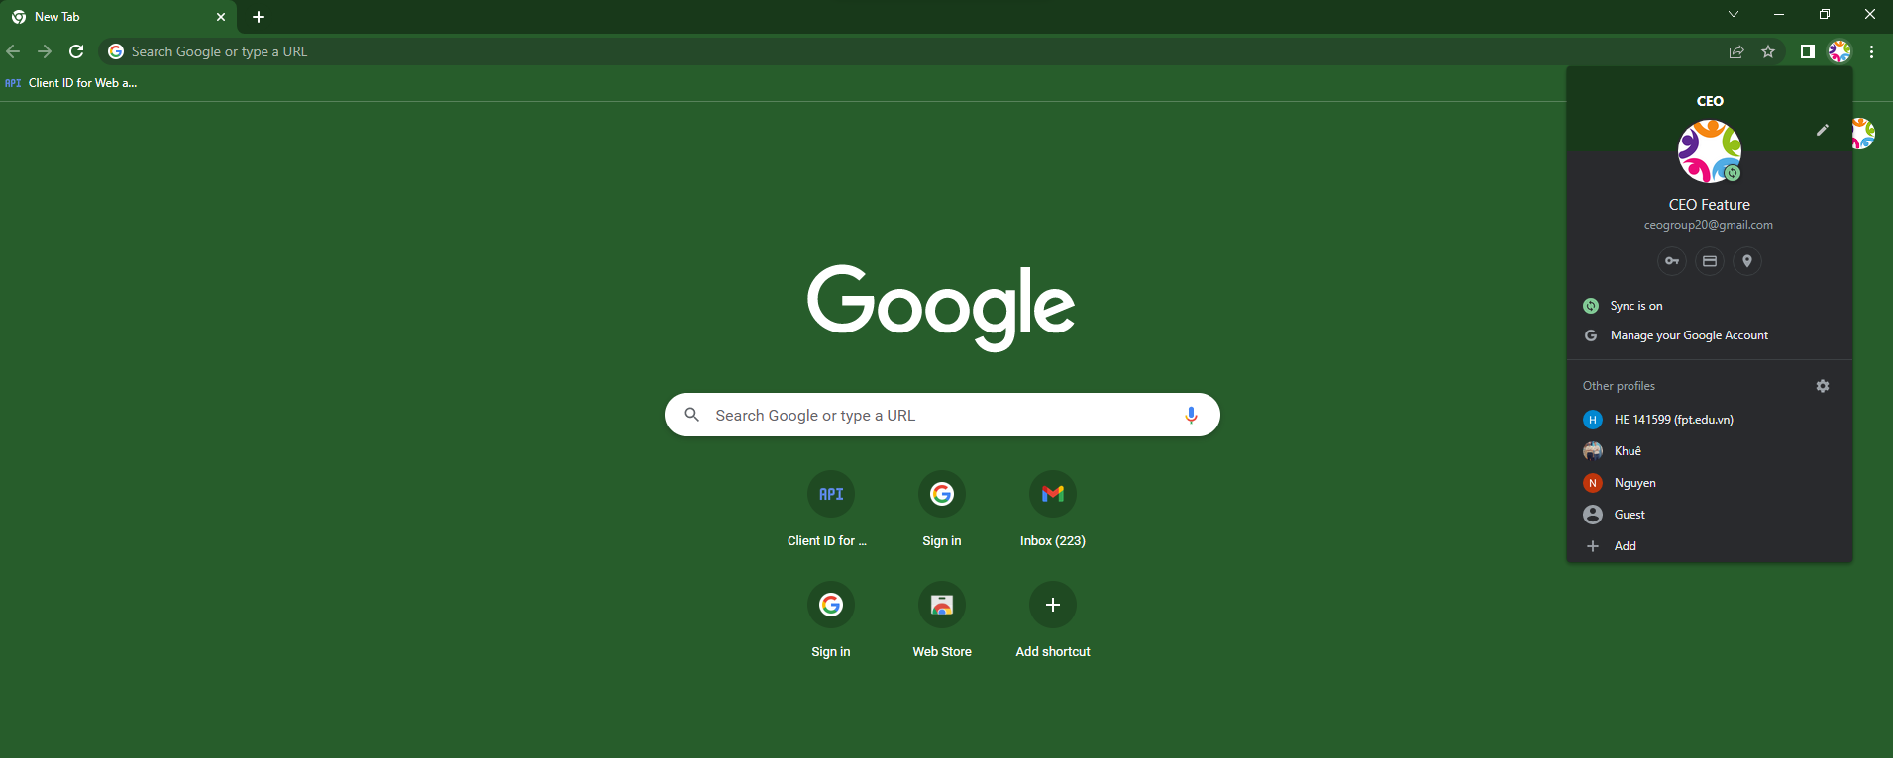

*Figure 188: Login gmail*

* ***Click manage your Google Account***

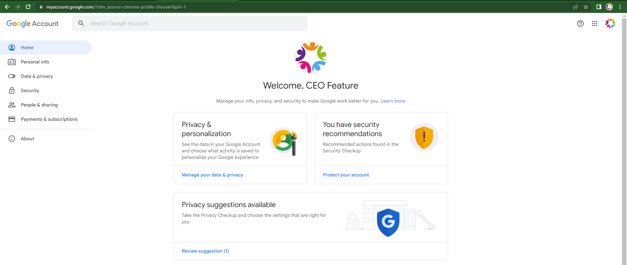

*Figure 189: Manage Google Account*

* **Click ‘Security’:**

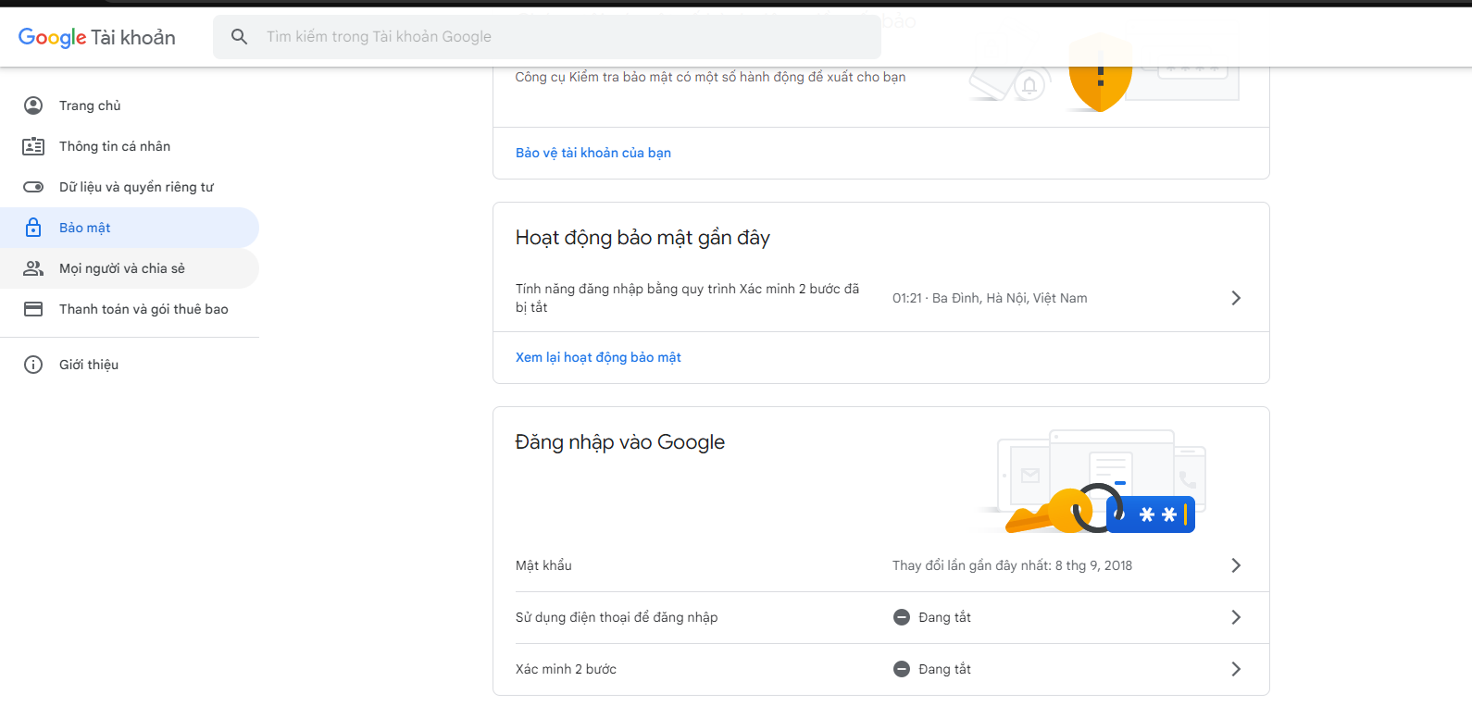

*Figure 190: Security*

* **Turn on 2 step verification**

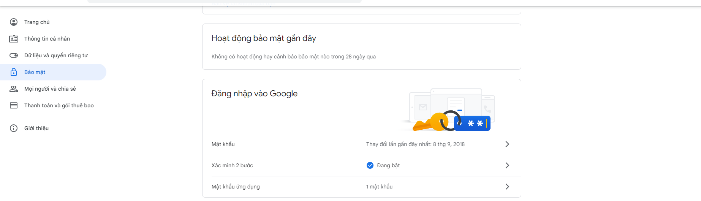

*Figure 191: Verification*

* **Click App passwords:**

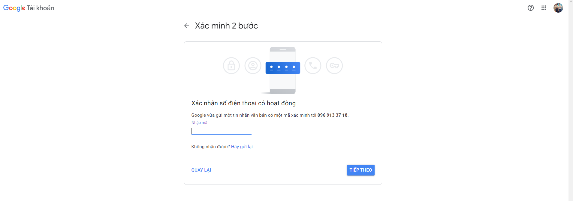

*Figure 192: Verification*

* **Successfully:**

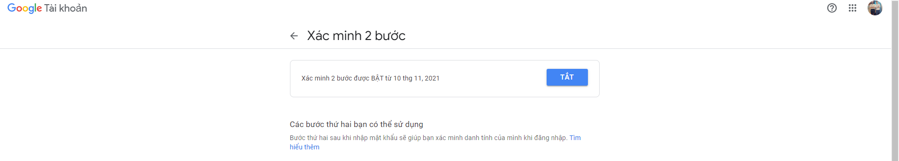

*Figure 193: Verify account successfully*

* **Click App passwords:**

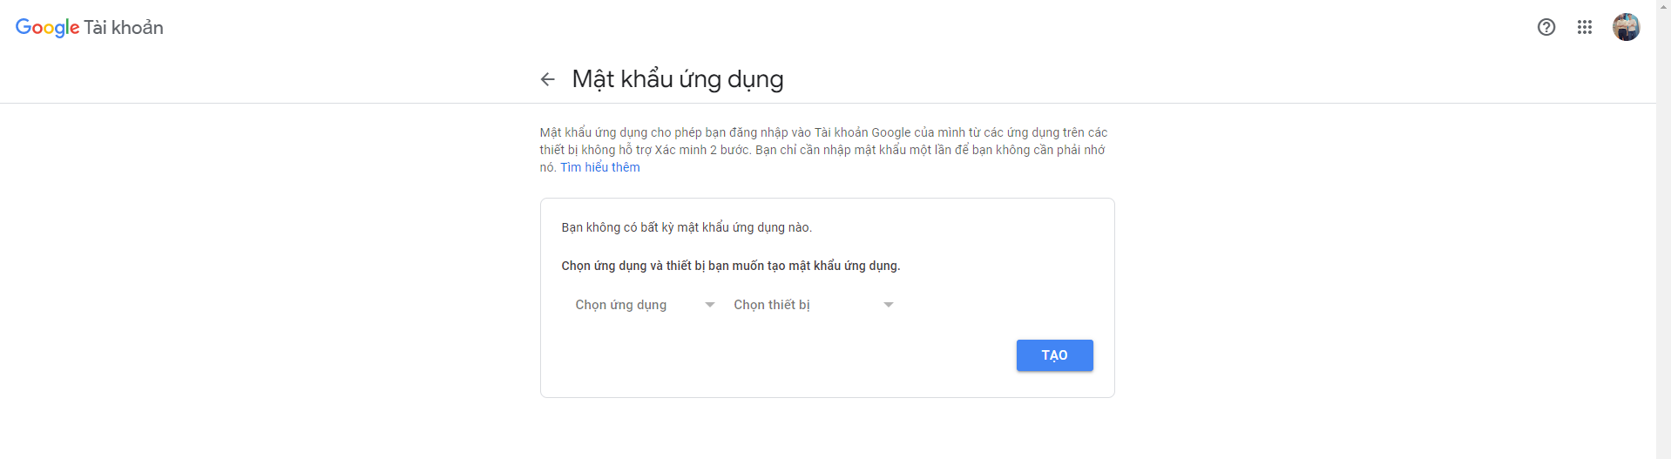

*Figure 194: App passwords*

* **Input your project name:**

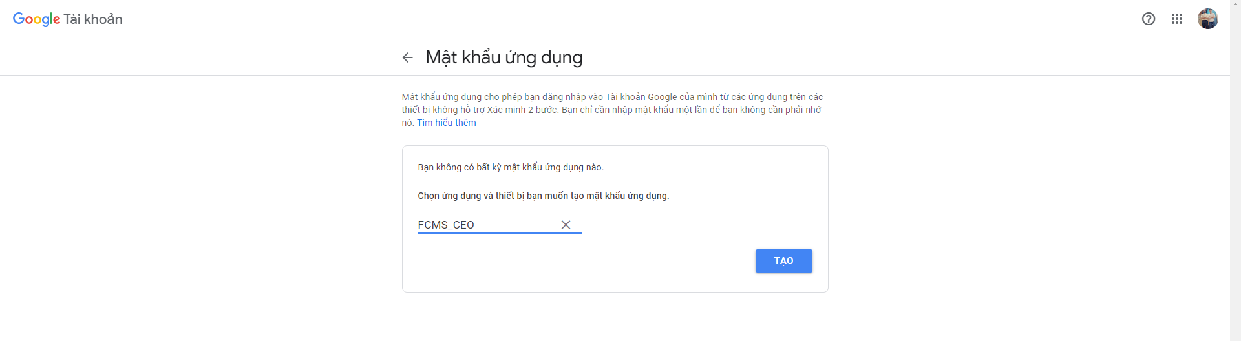

*Figure 195: App passwords*

* **Generate password successfully:**

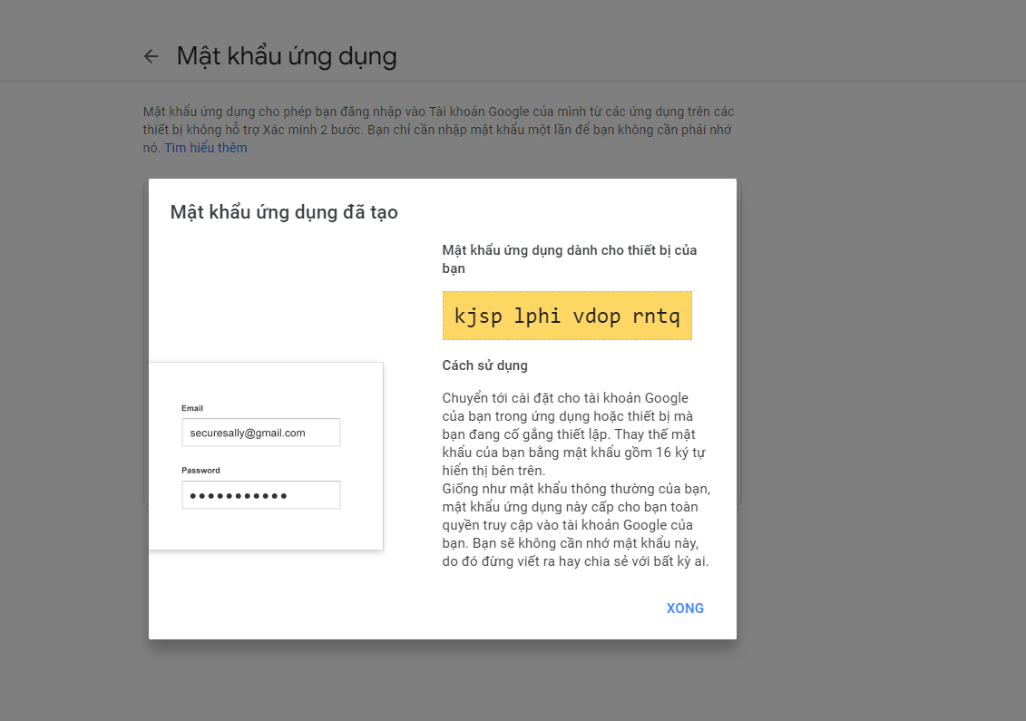

*Figure 196: Generate password successfully*

* **Code demo send gmail:**

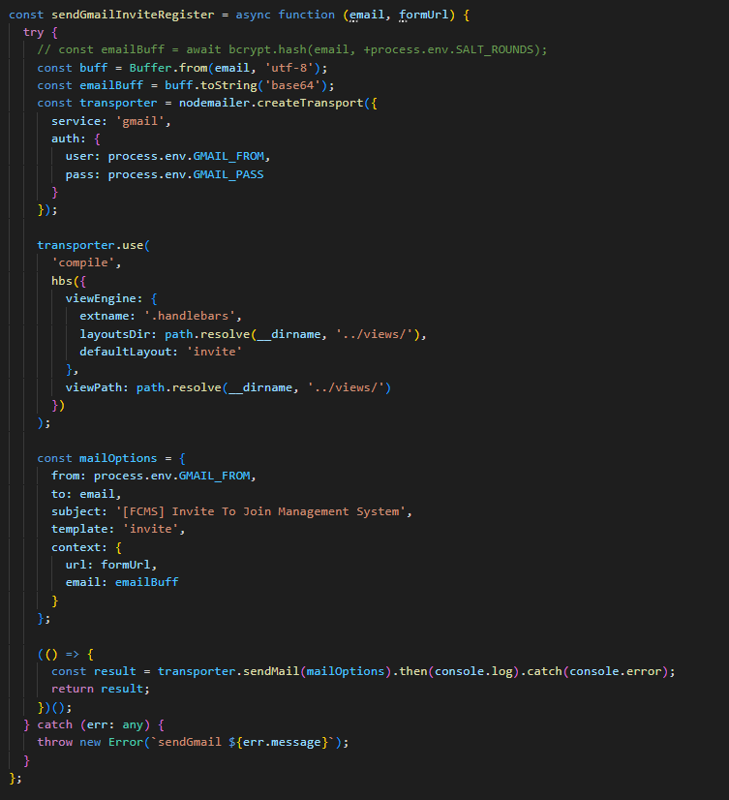

*Figure 197: Send gmail code demo*

* **Response send gmail successfully:**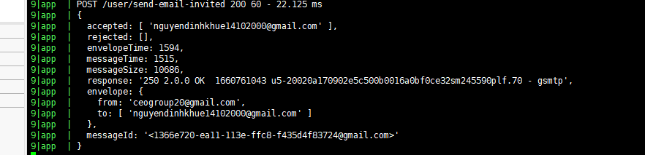

*Figure 198: Response send gmail successfully*

* **Gmail:**

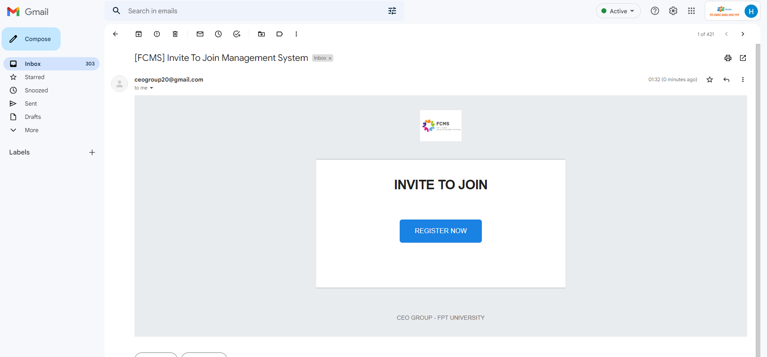

*Figure 199: Mail ‘Invite Join’ of FCMS*

## 2. User Manual

### 2.1 Form register account

#### *2.2.1 Admin*

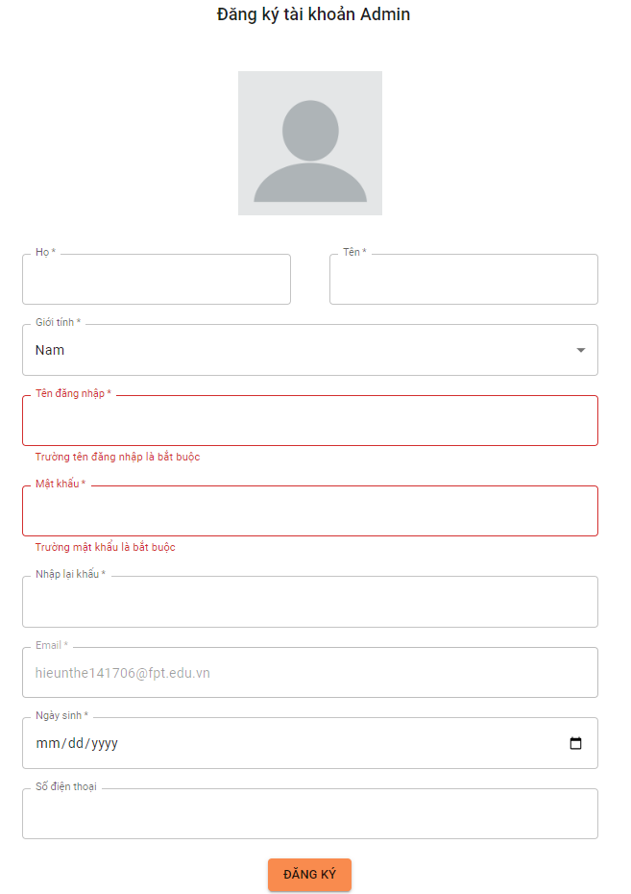

*Figure 200: Form register account of Admin*

#### *2.2.2 Collaborator*

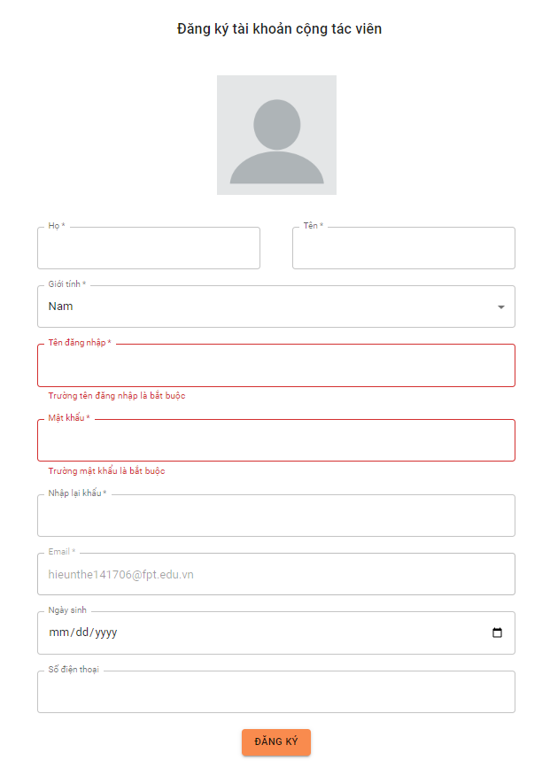

*Figure 201: Form register account of Collaborator*

#### *2.2.3 Club Manager*

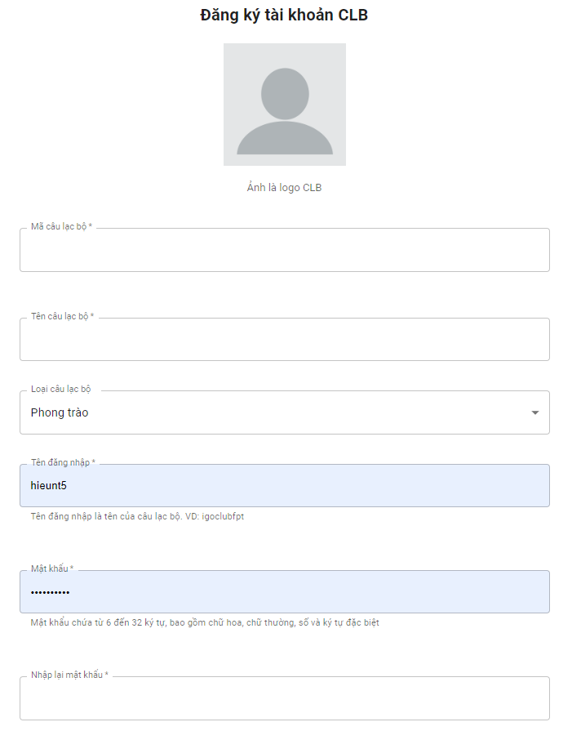

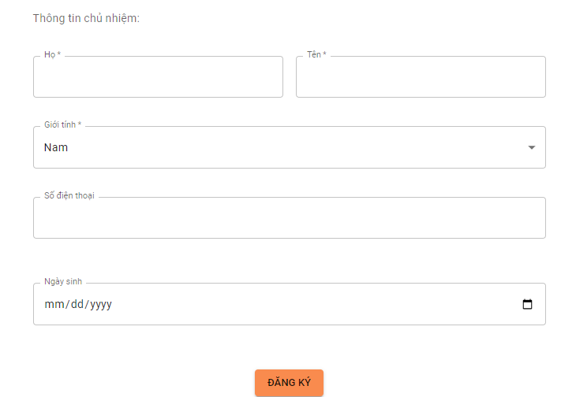

*Figure 202: Form register account of Club Manager*

### 2.2 User logs in

1. On the welcome page, the user clicks “Đăng nhập”.

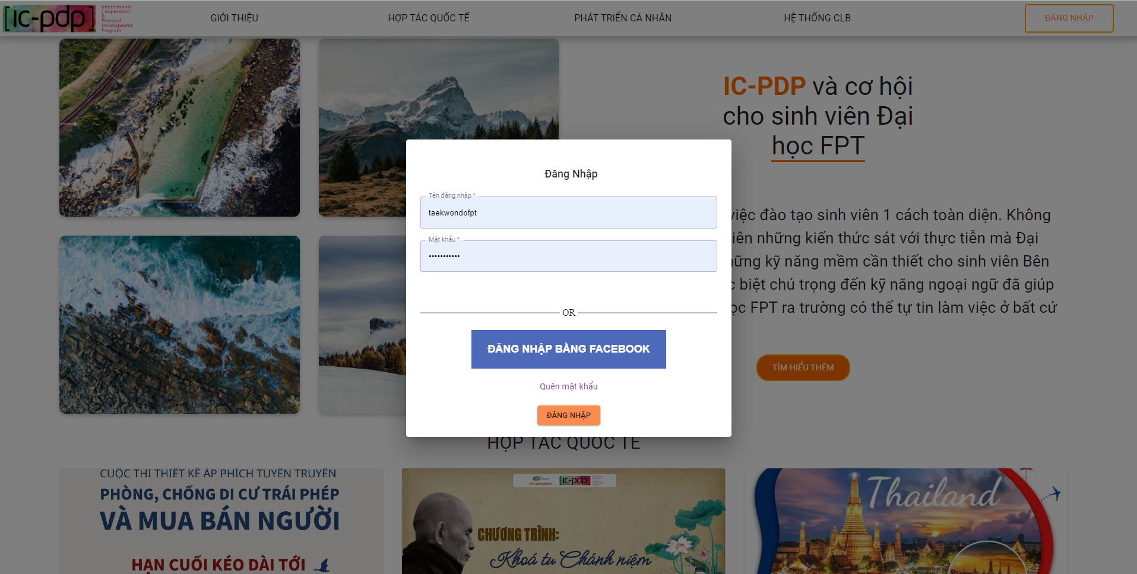

*Figure 203. Sign in Form*

1. System displays a Facebook sign in page.

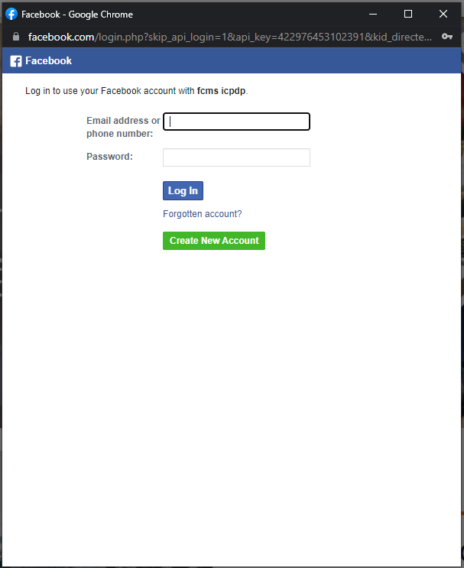

*Figure 204. Facebook login form*

1. SuperAdmin/Admin/Collaborator/Club manager login by account register in system.

3.1 Form

### 2.3 User view/edit profile

1. User clicks icon avatar

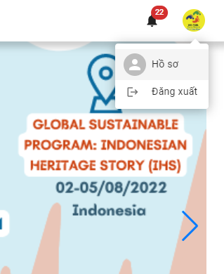

*Figure 205. User’s toolbar*

1. User view profile

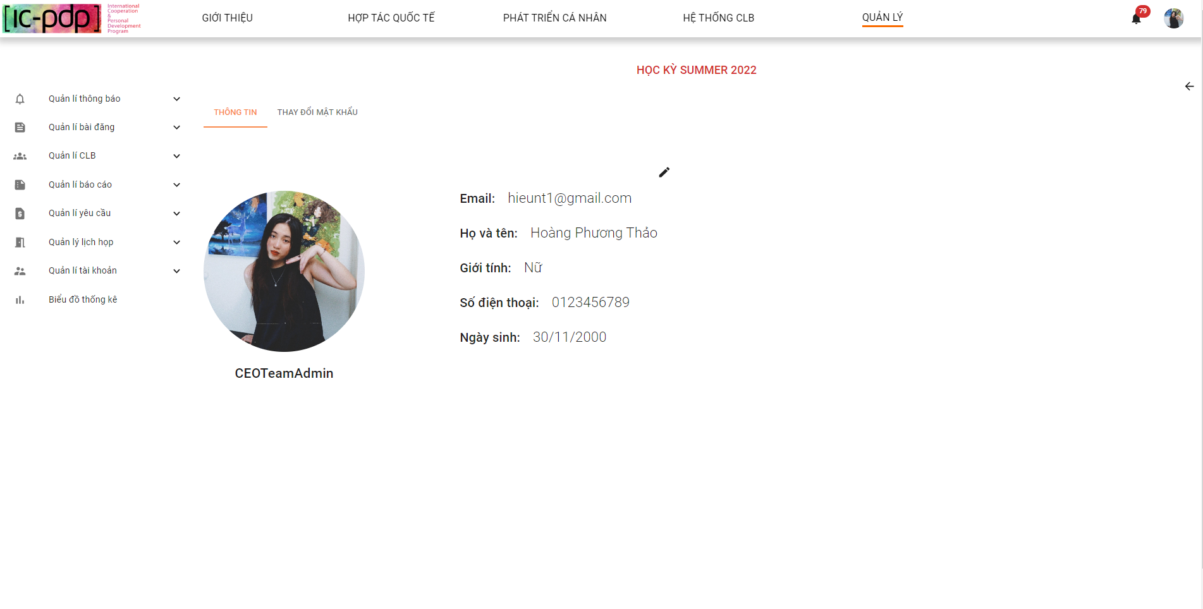

*Figure 206. User profile*

1. User clicks button edit profile

* Admin & Collaborator edit profile

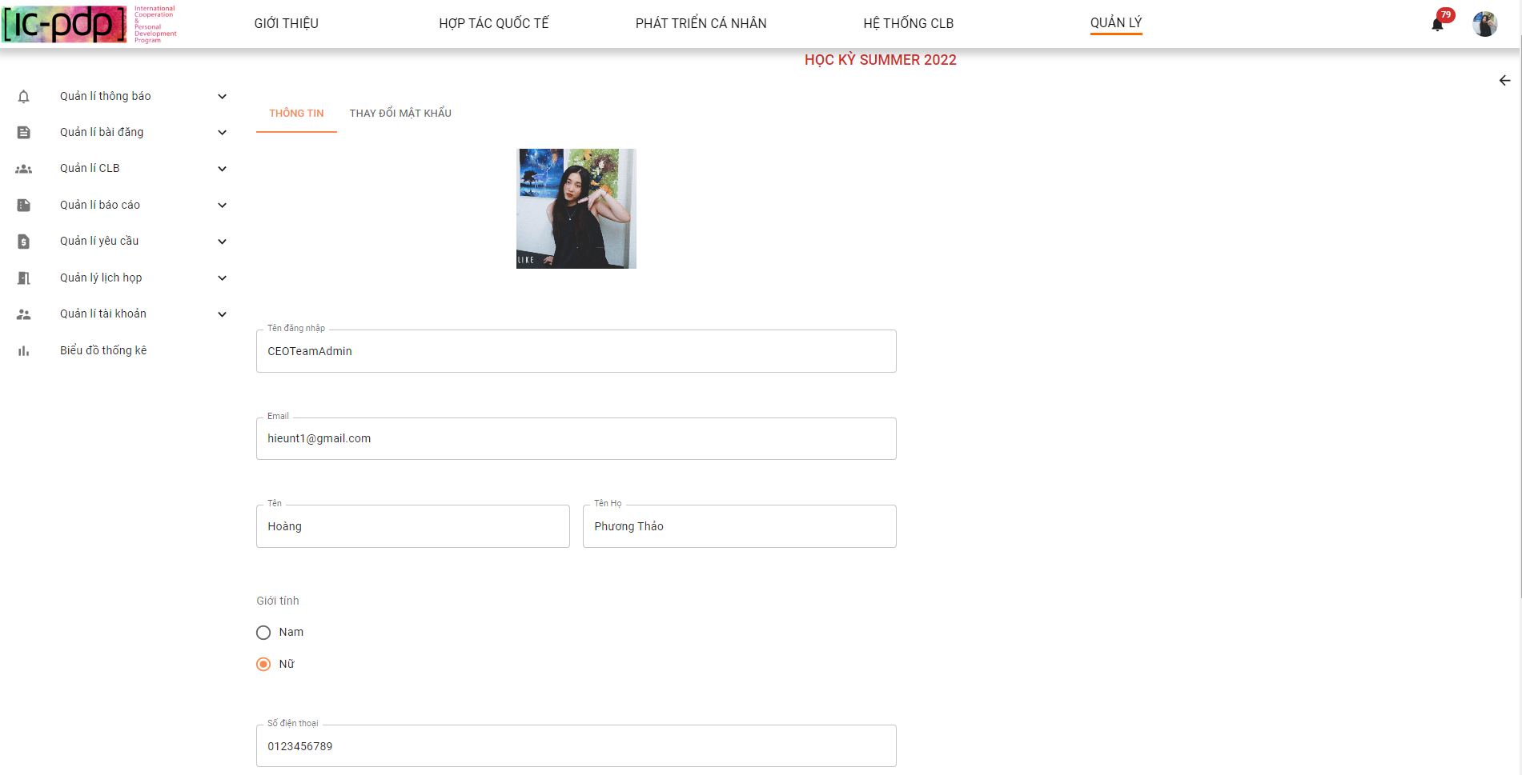

*Figure 207. Admin and Collaborator profile editing form*

* Club edit profile

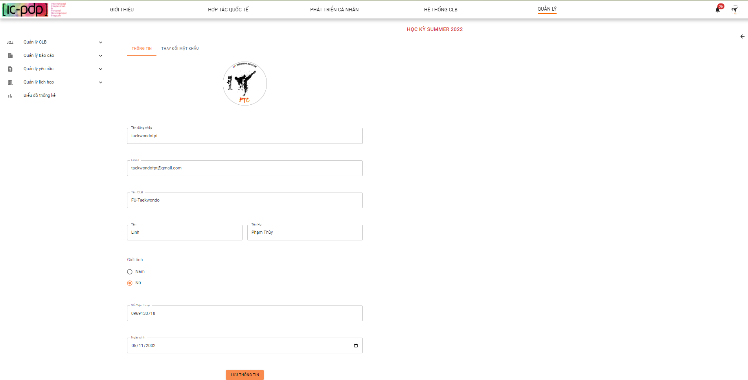

*Figure 208. Club Manager profile editing form*

1. User clicks “Thay đổi mật khẩu”

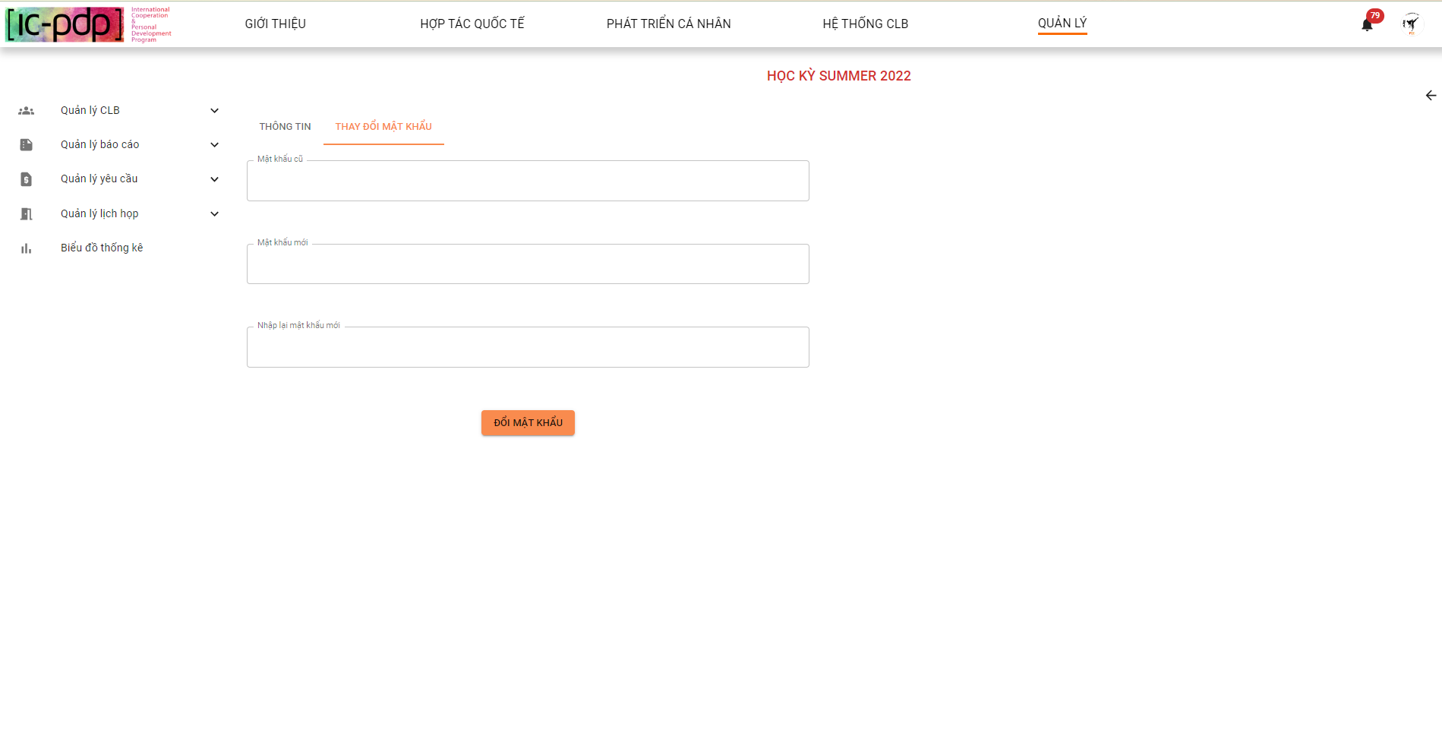

*Figure 209. Form change password*

### 2.4 User interface homepage

1. User clicks his/her name in the navigation bar.

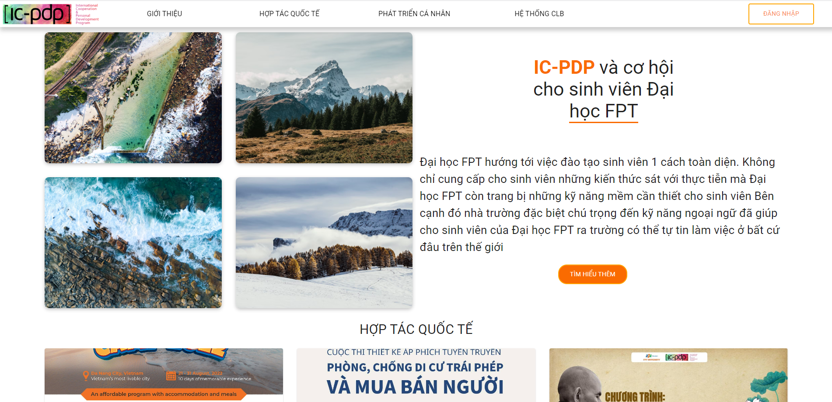

*Figure 210. Guest homepage*

1. User hover “Giới thiệu” on nav menu.

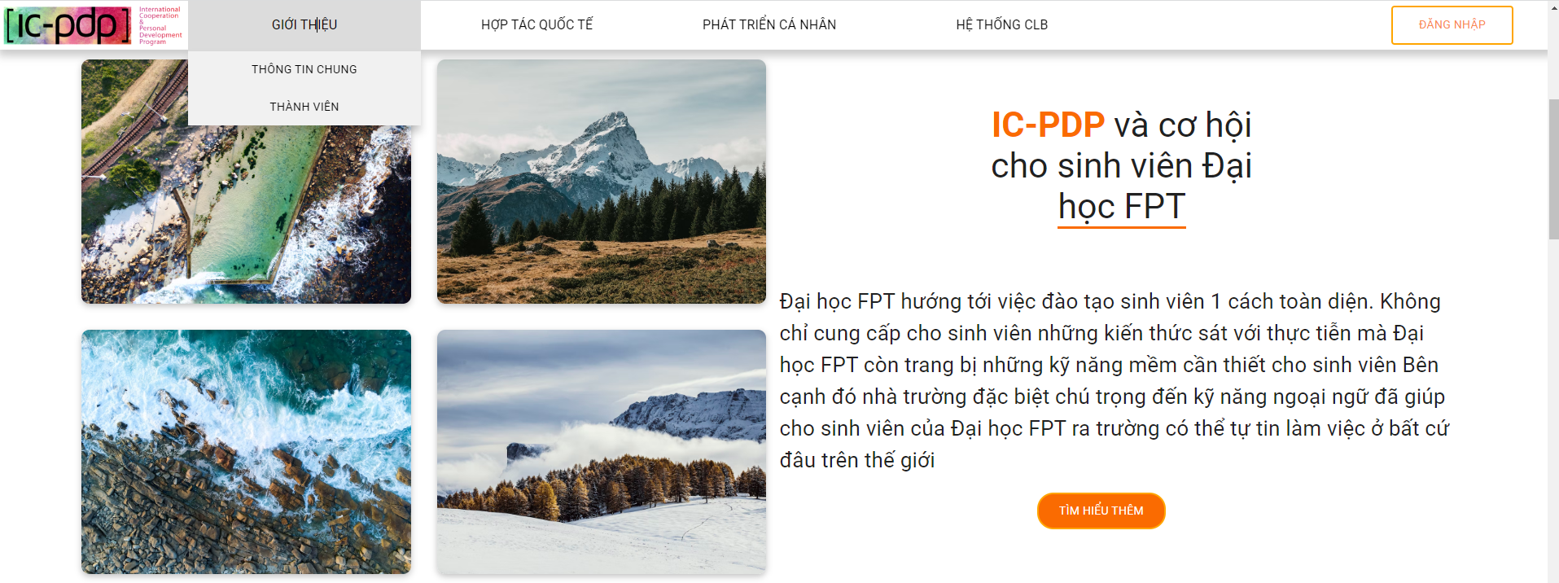

*Figure 211. Navigation bar dropdown menu*

1. User clicks “Thông tin chung”

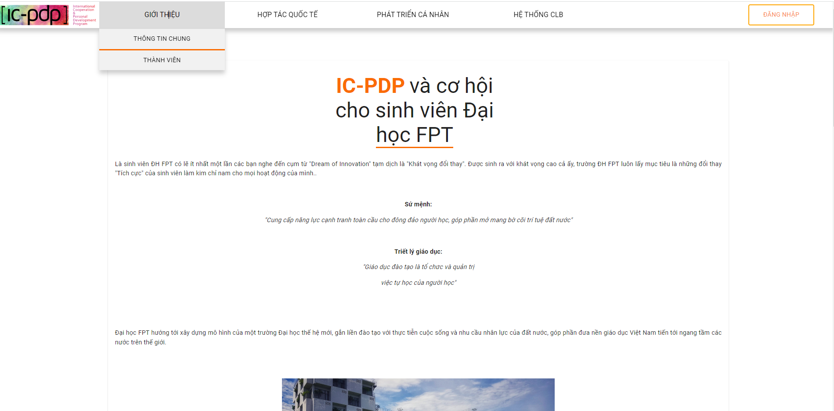.

*Figure 212. Information IC-PDP*

1. User clicks “Thành viên”

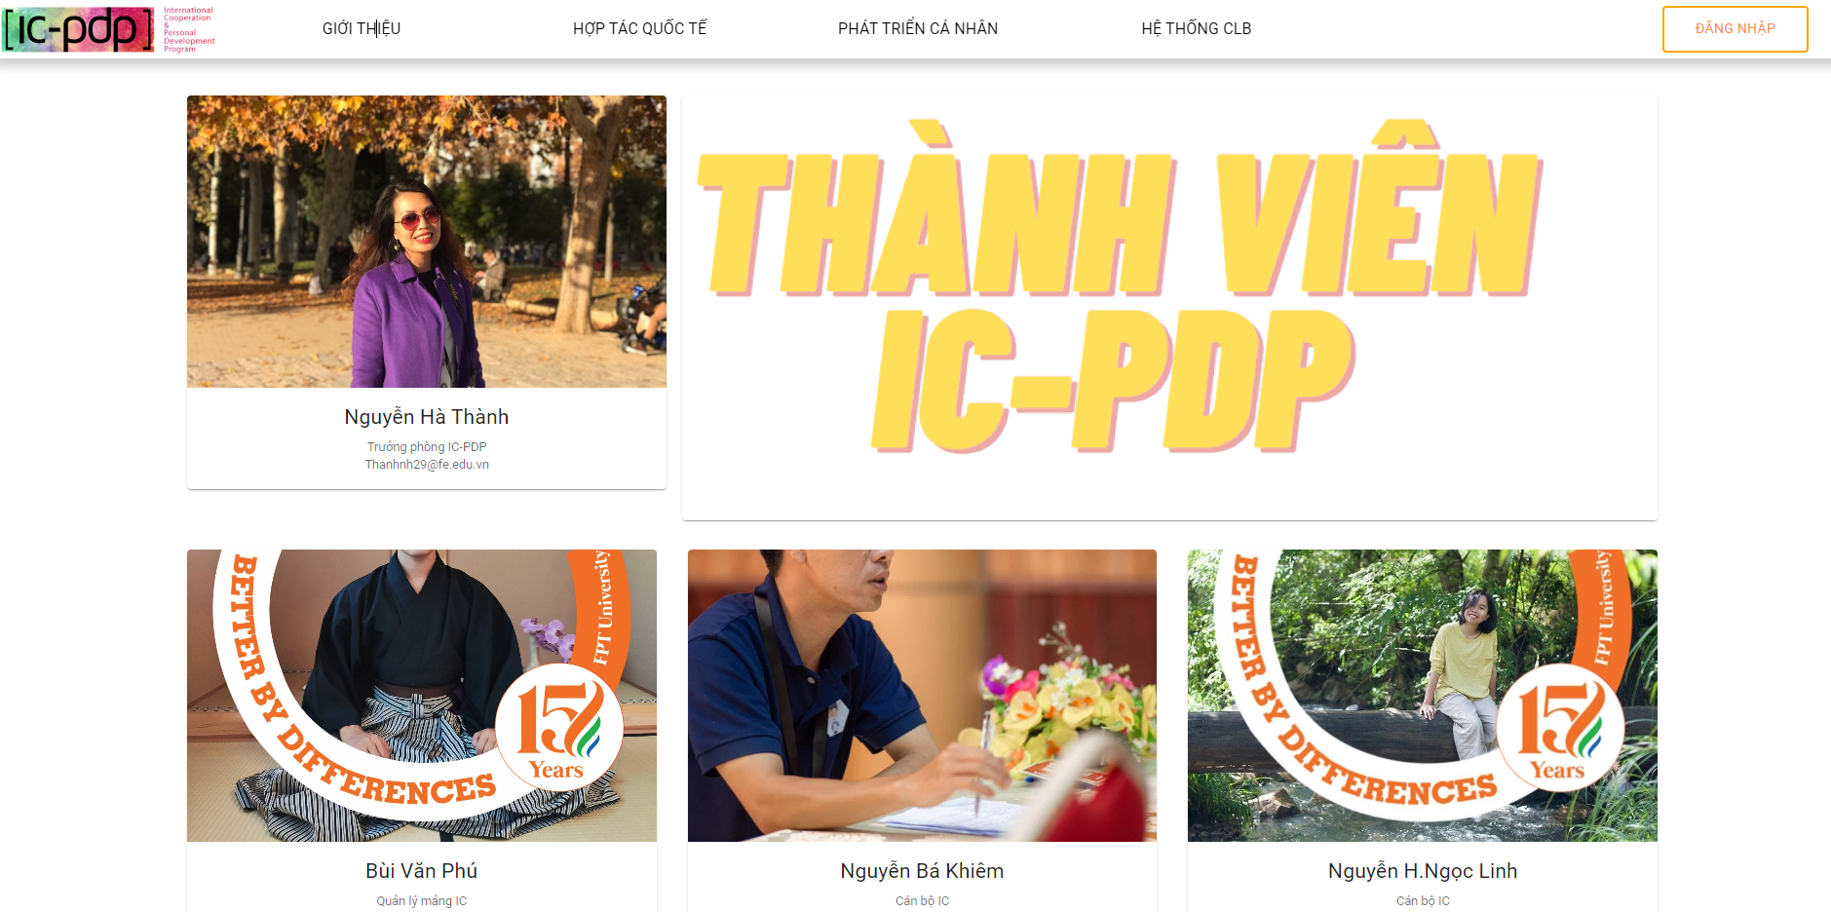

*Figure 213. IC-PDP’s Officer list*

1. User clicks image or information of “Thành viên IC-PDP”

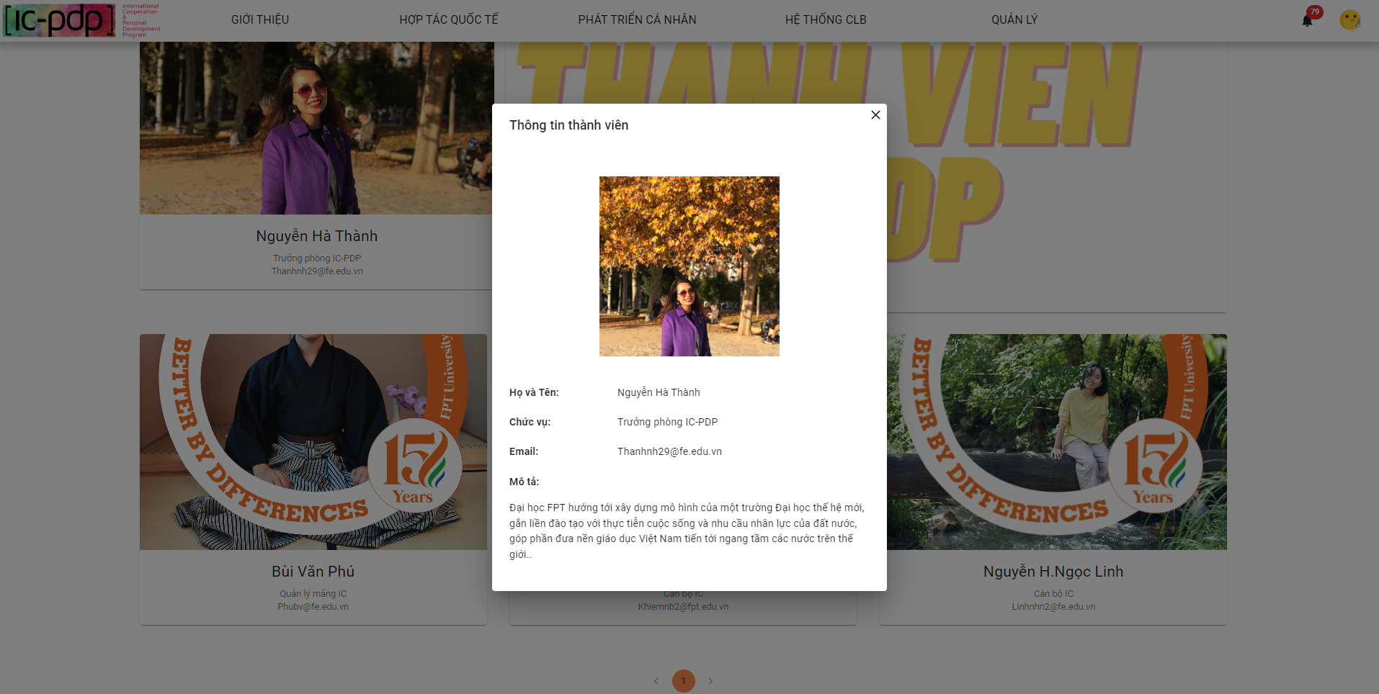

*Figure 214. Information of IC-PDP’s Officer*

1. User clicks “Hợp tác quốc tế”

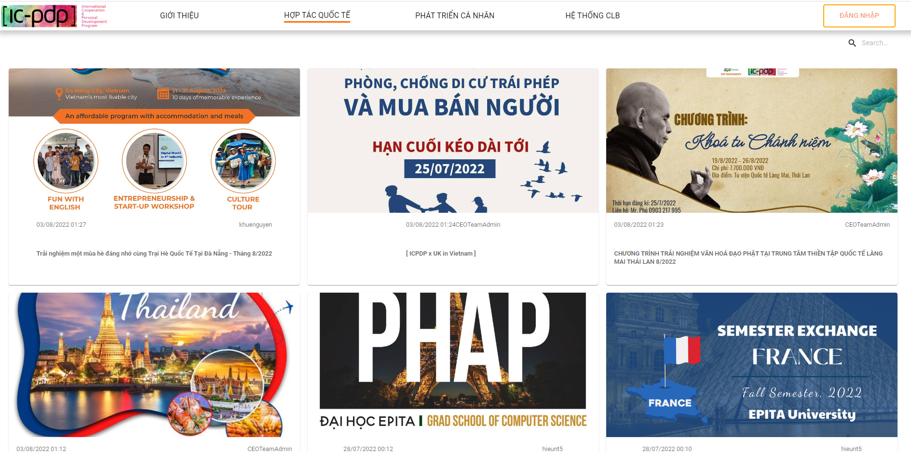

*Figure 215. “Hợp tác quốc tế” posts list*

1. User clicks search post

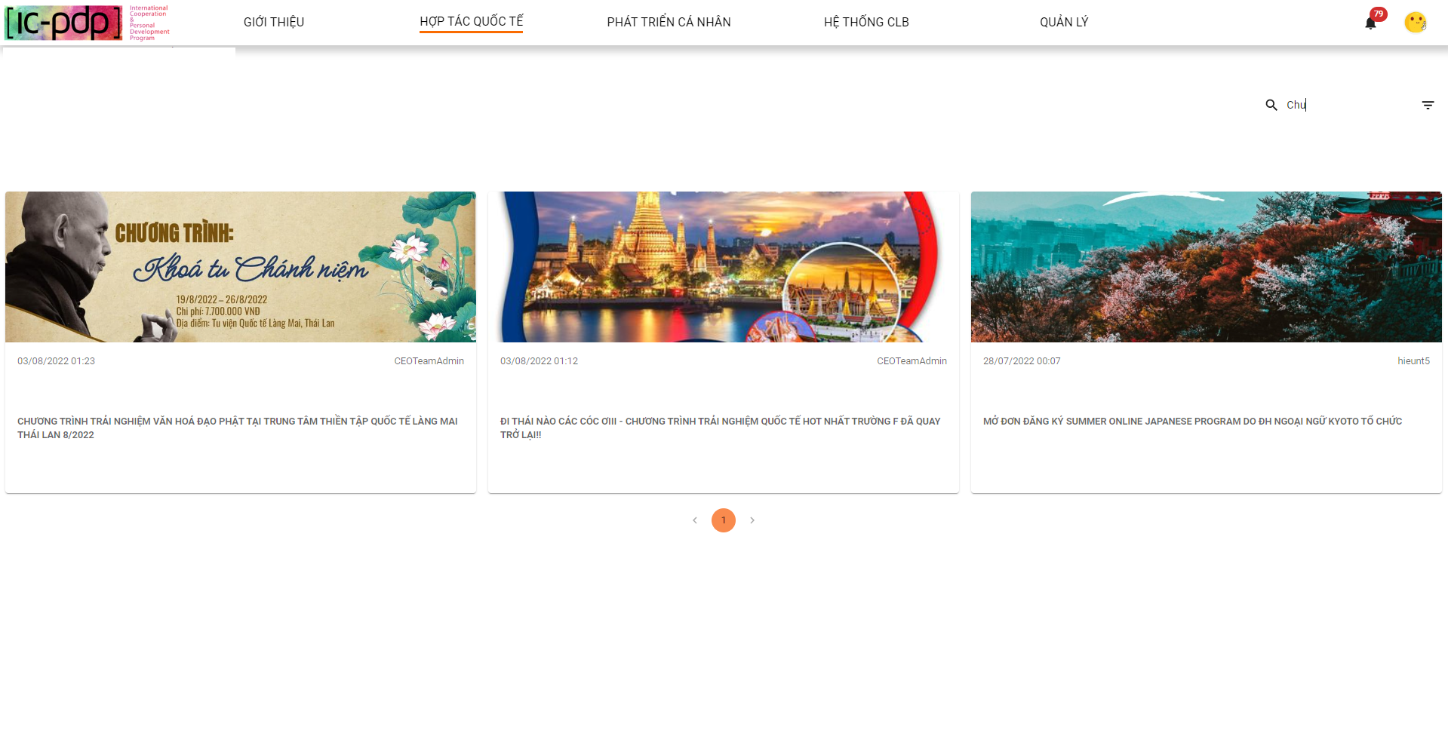

*Figure 216. Search posts of “Hợp tác quốc tế”*

1. User clicks view detail post in “Hợp tác quốc tế”

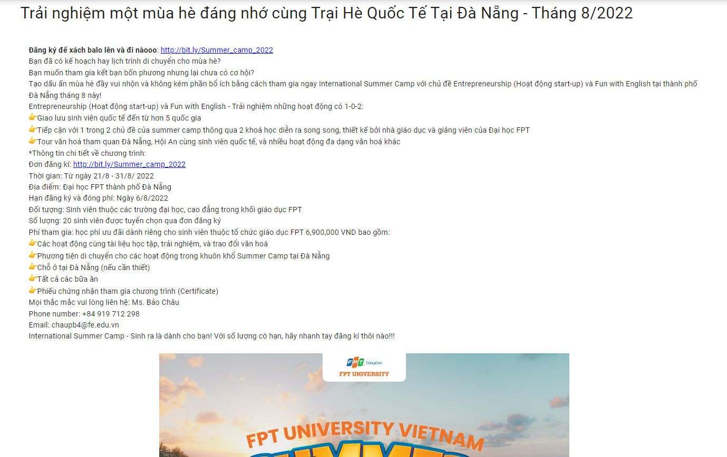

*Figure 217. Detail a post of “Hợp tác quốc tế”*

1. User clicks “Phát triển cá nhân”

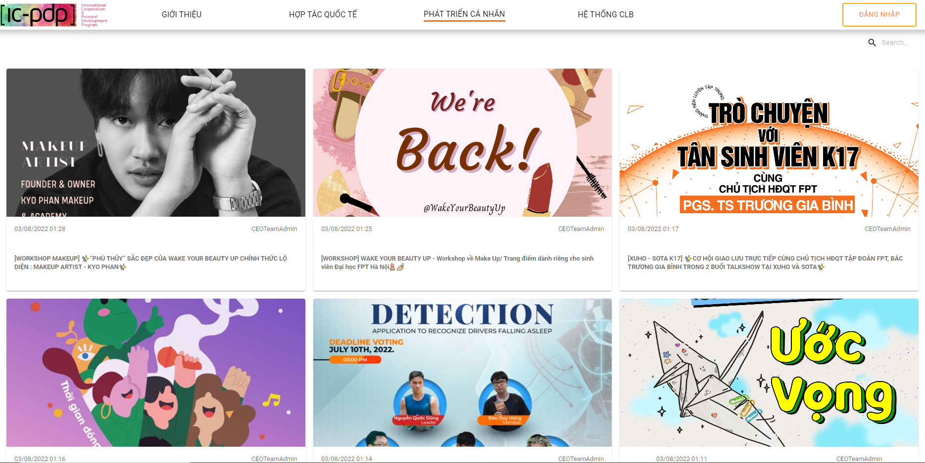

*Figure 218. “Phát triển cá nhân” posts list*

1. User clicks view detail post in “Phát triển cá nhân”

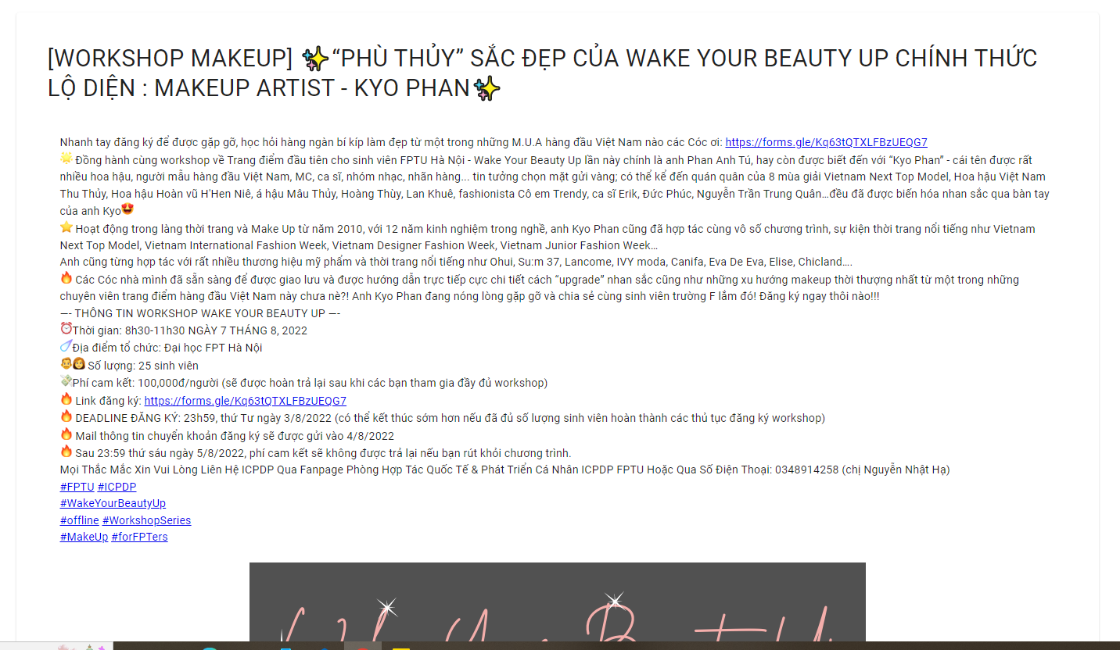

*Figure 219. Detail a post of “Phát triển cá nhân”*

1. User likes post in “Phát triển cá nhân”

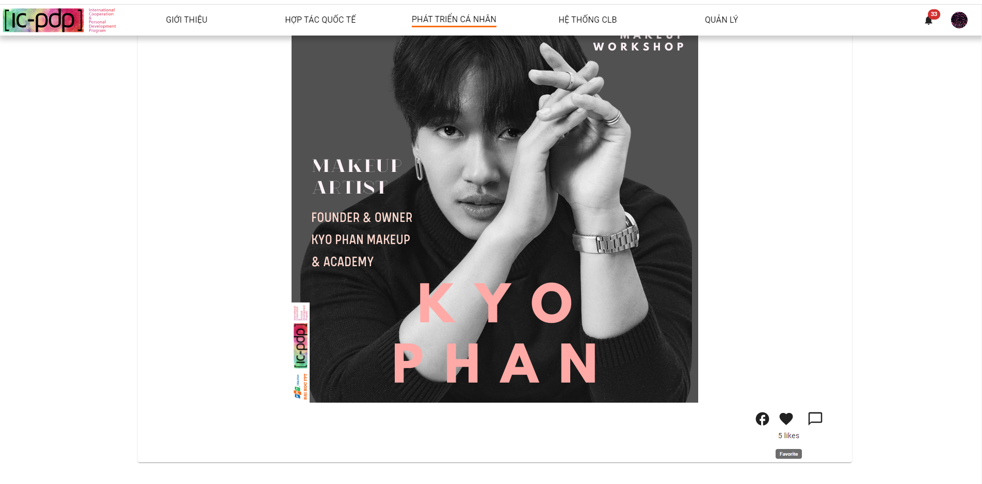

*Figure 219b. User likes a post in “Phát triển cá nhân”*

1. User shares post in “Phát triển cá nhân”

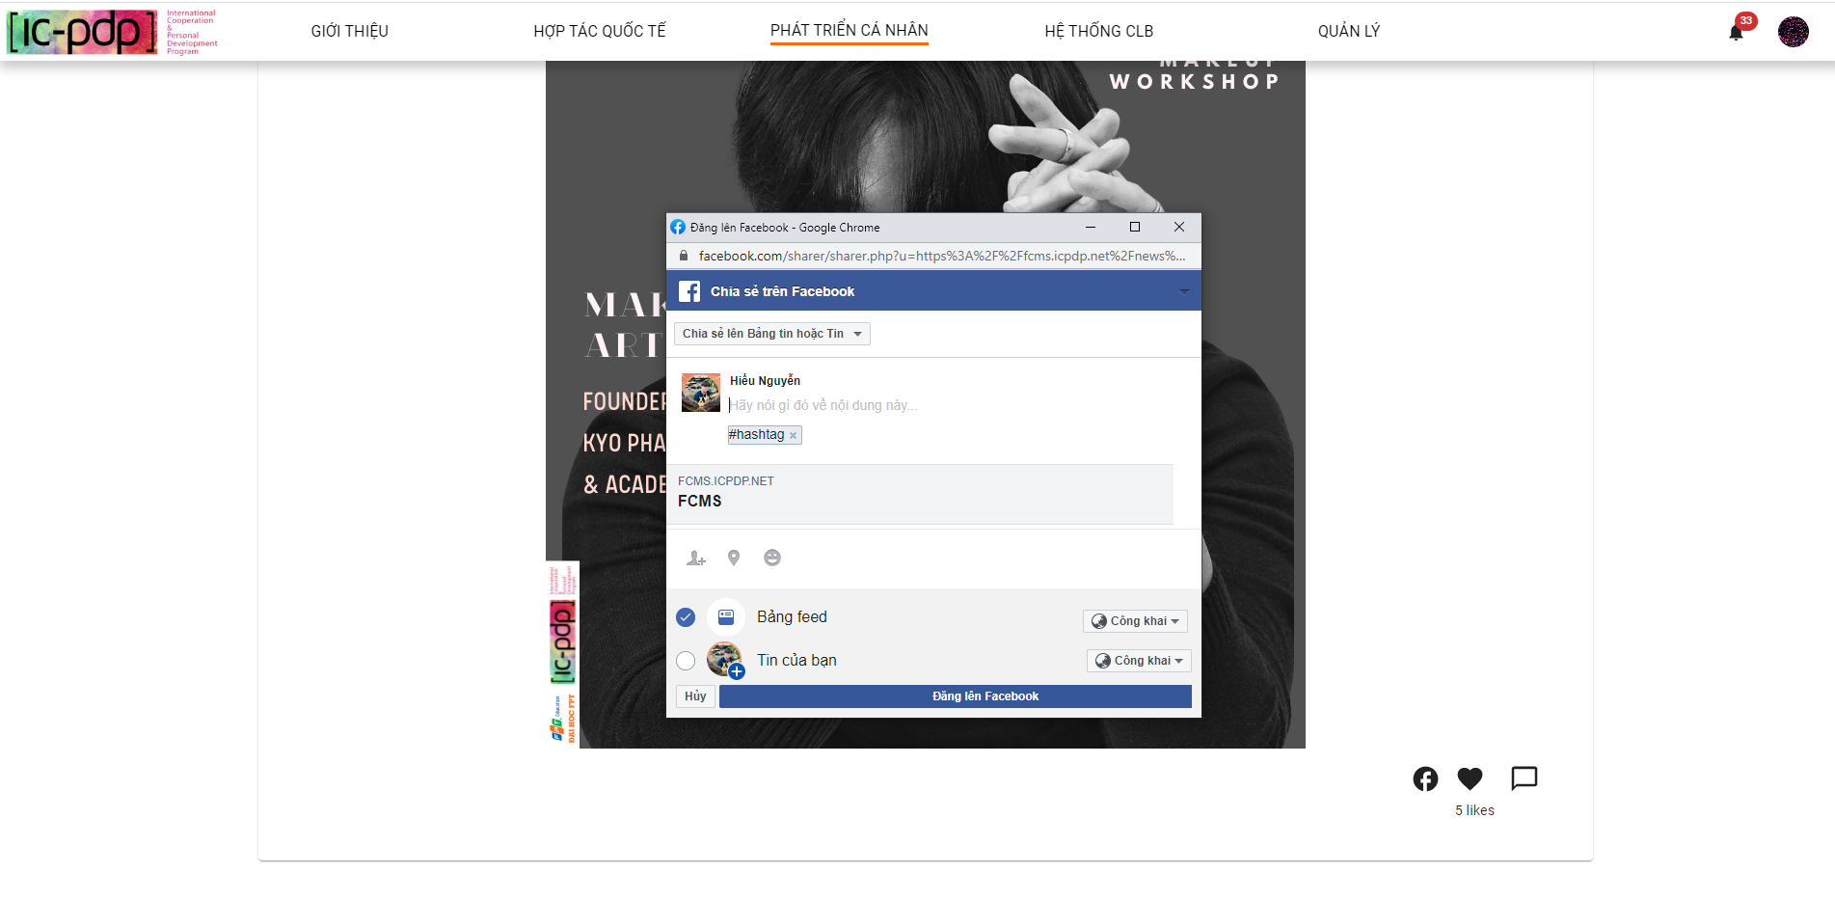

*Figure 219c. User shared a post in “Phát triển cá nhân”*

1. User clicks “Hệ thống CLB”

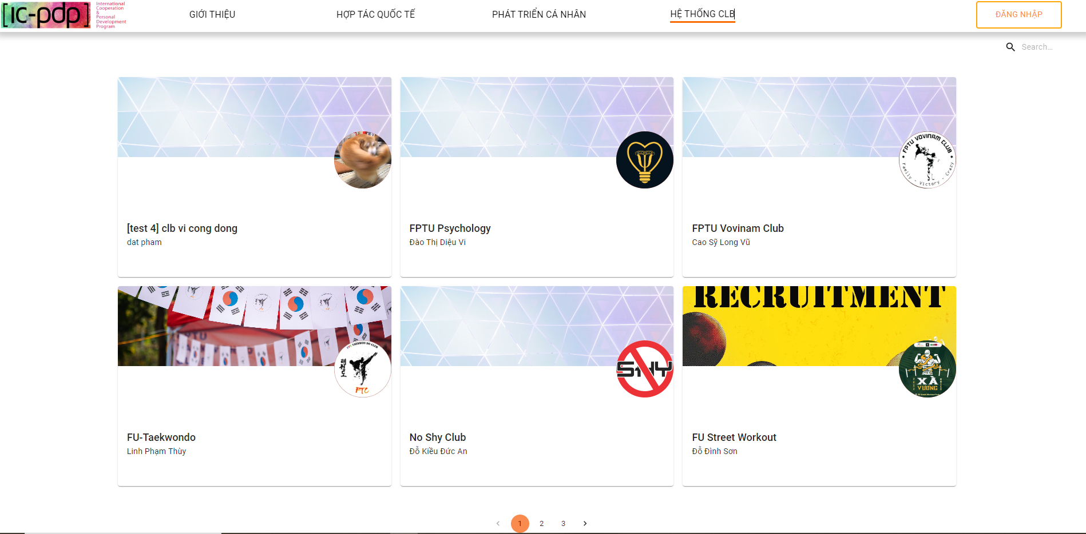

*Figure 220. Detail a post in “Phát triển cá nhân”*

1. User clicks view detail Club

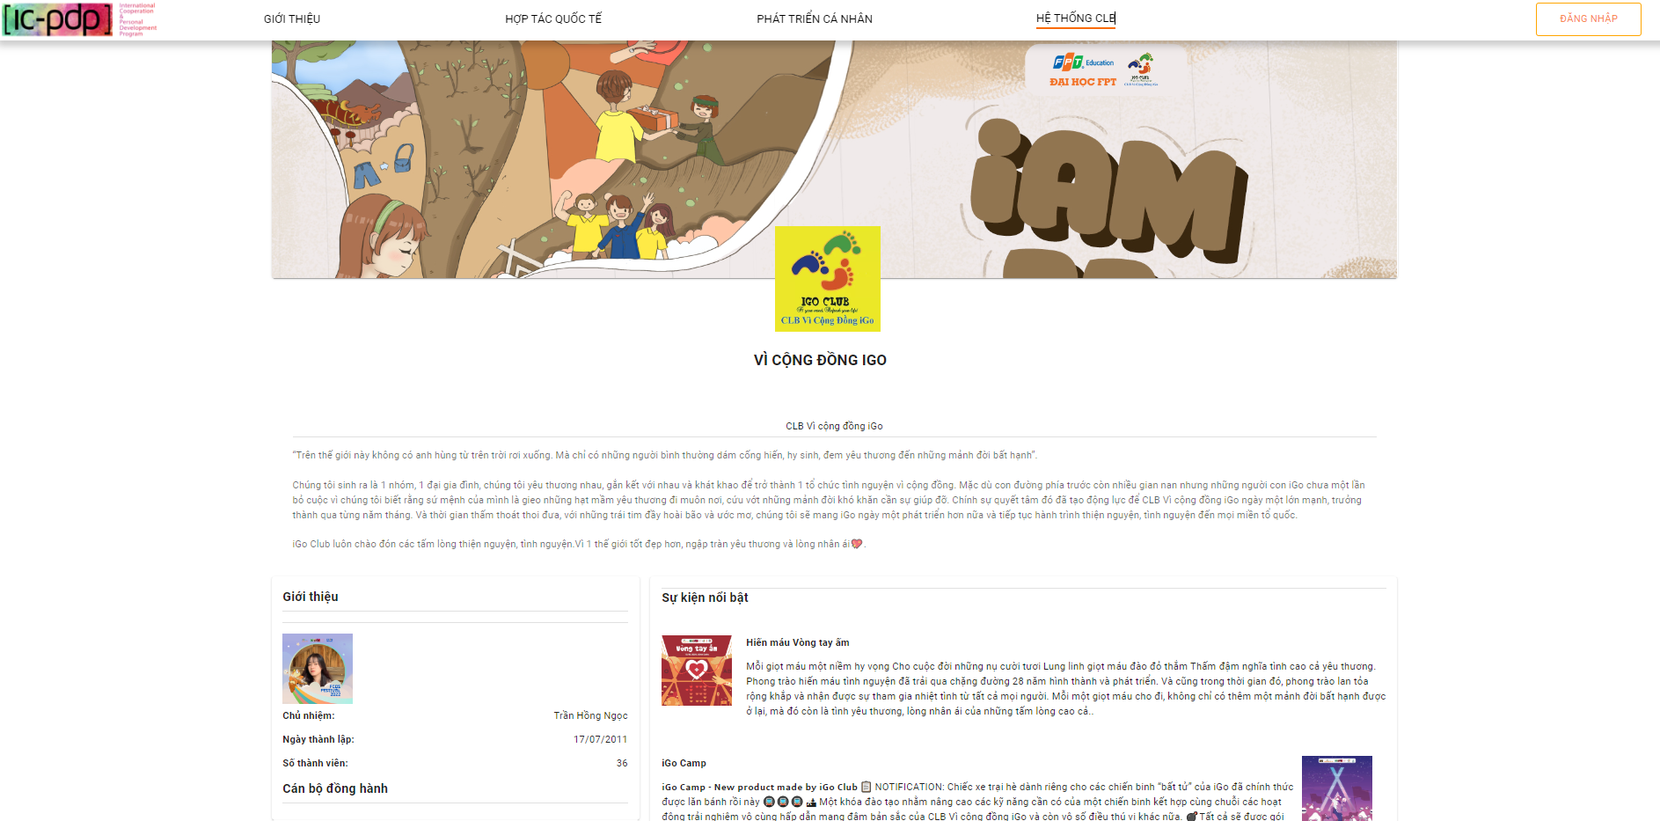

*Figure 221. Detail a club*

1. User view top 5 excellent clubs in Welcome page

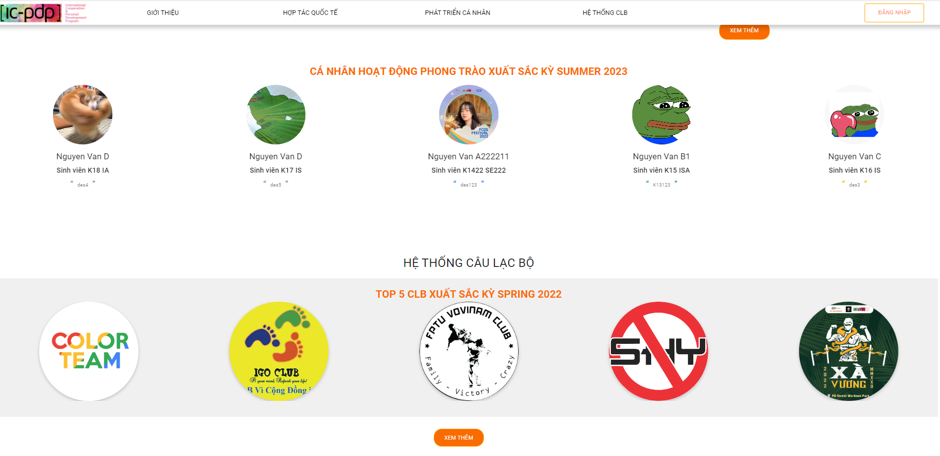

*Figure 222. Top 5 excellent clubs*

1. User view clicks icon logo to view information of club

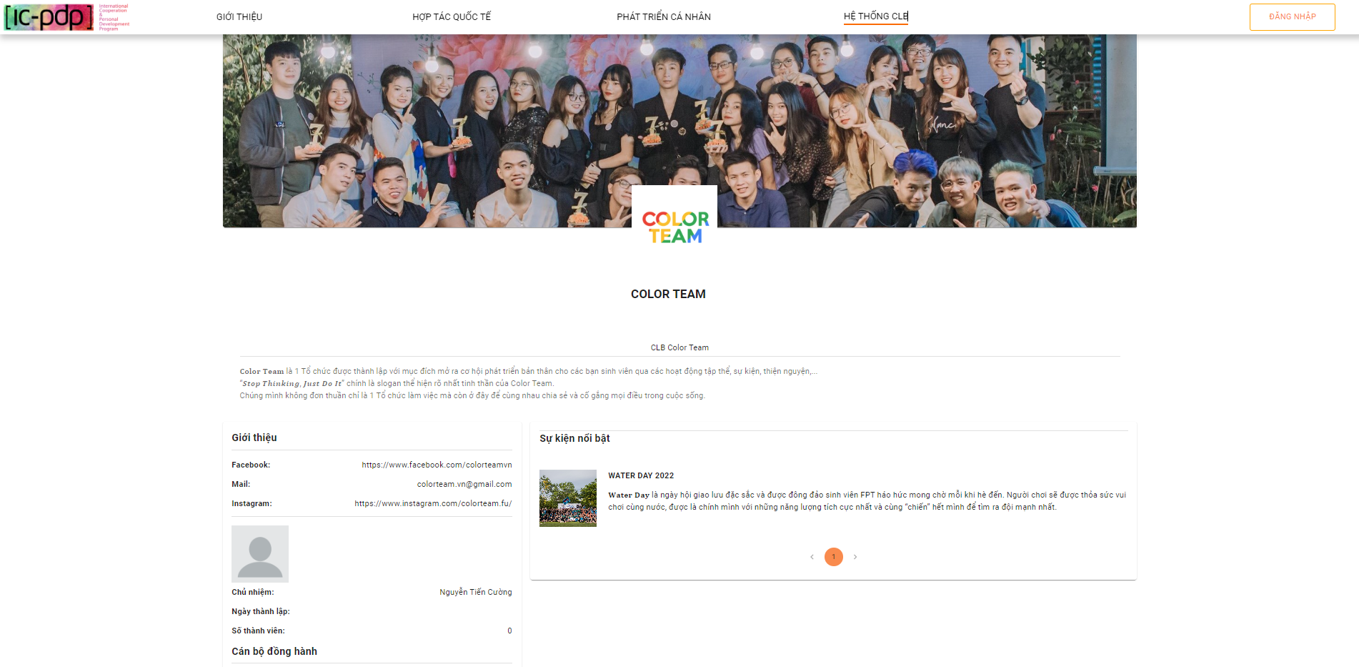

*Figure 223. Information of a club*

### 2.5 Super Admin

1. Super Admin clicks “Quản lý”

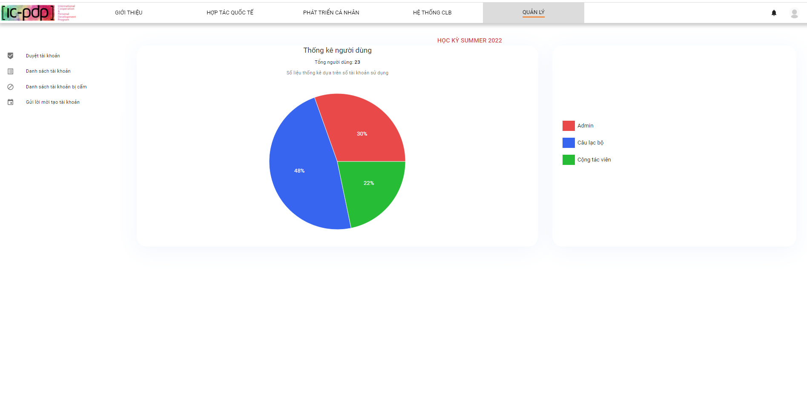

*Figure 224. Management page*

1. Super Admin clicks “Gửi lời mời tạo tài khoản”

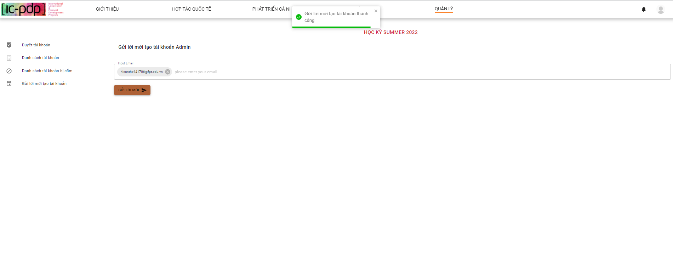

*Figure 225. Sending creating Admin account invitation screen*

1. Super Admin clicks “Duyệt tài khoản”

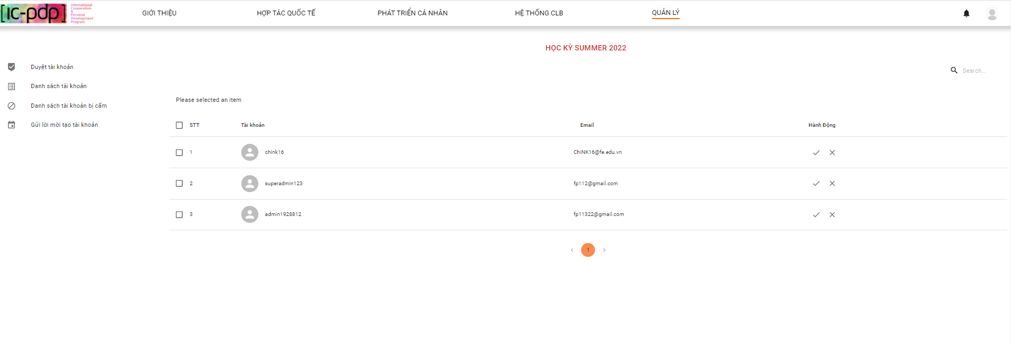

*Figure 226. Review account screen*

1. Super Admin select checkbox and click button V

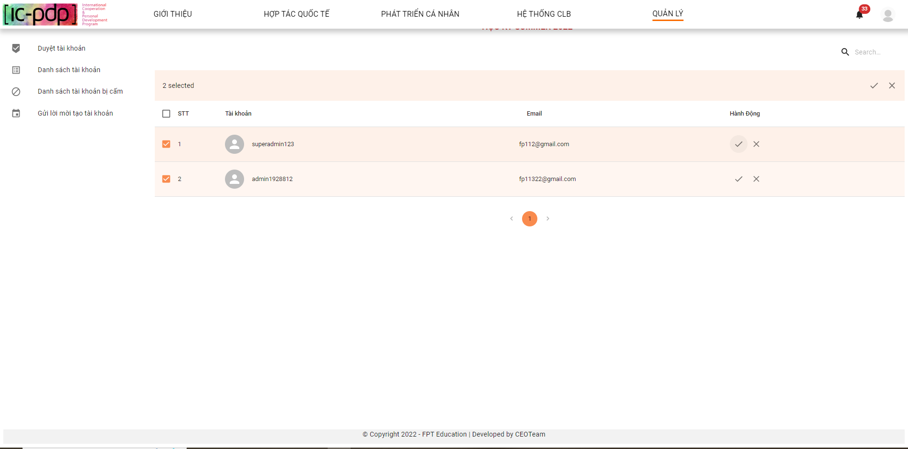

*Figure 227. Review account screen*

1. Super Admin approve successfully

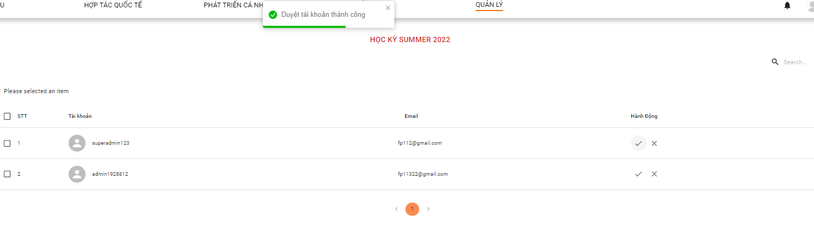

*Figure 228. Approve account screen*

1. Super Admin view list account Admin

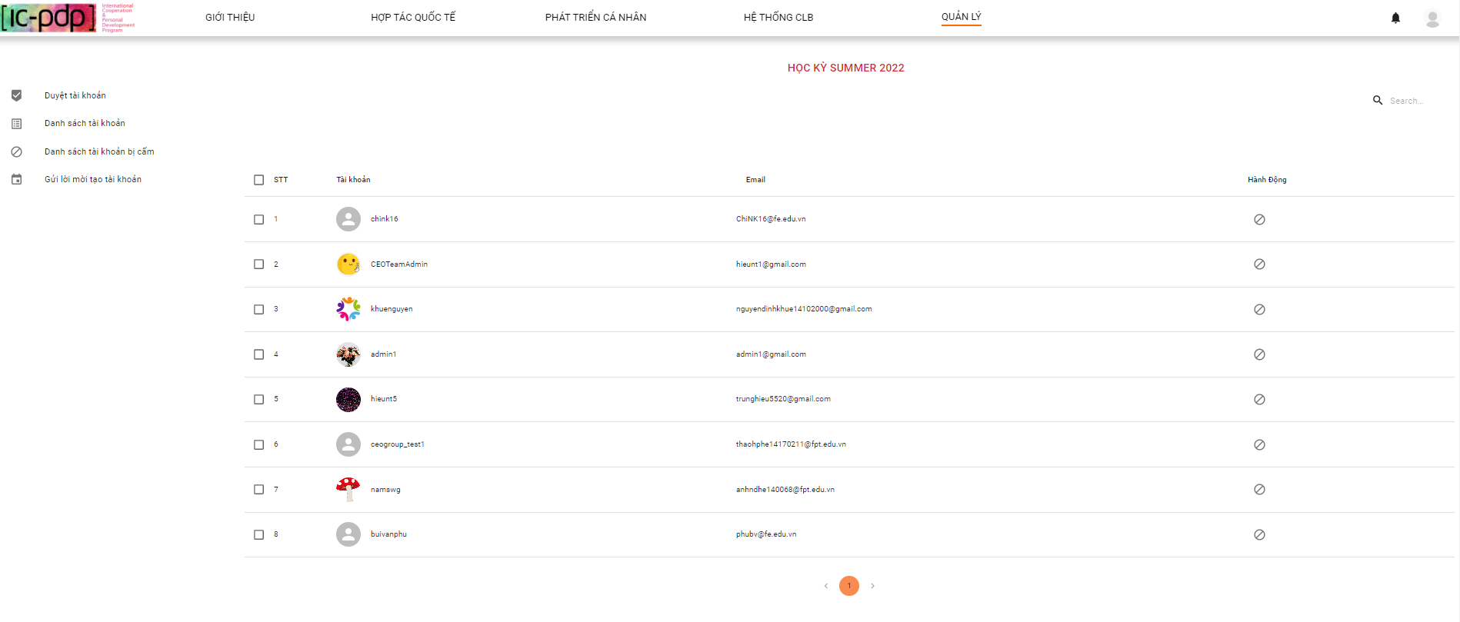

*Figure 229. List Admin account screen*

1. Super Admin ban account Admin

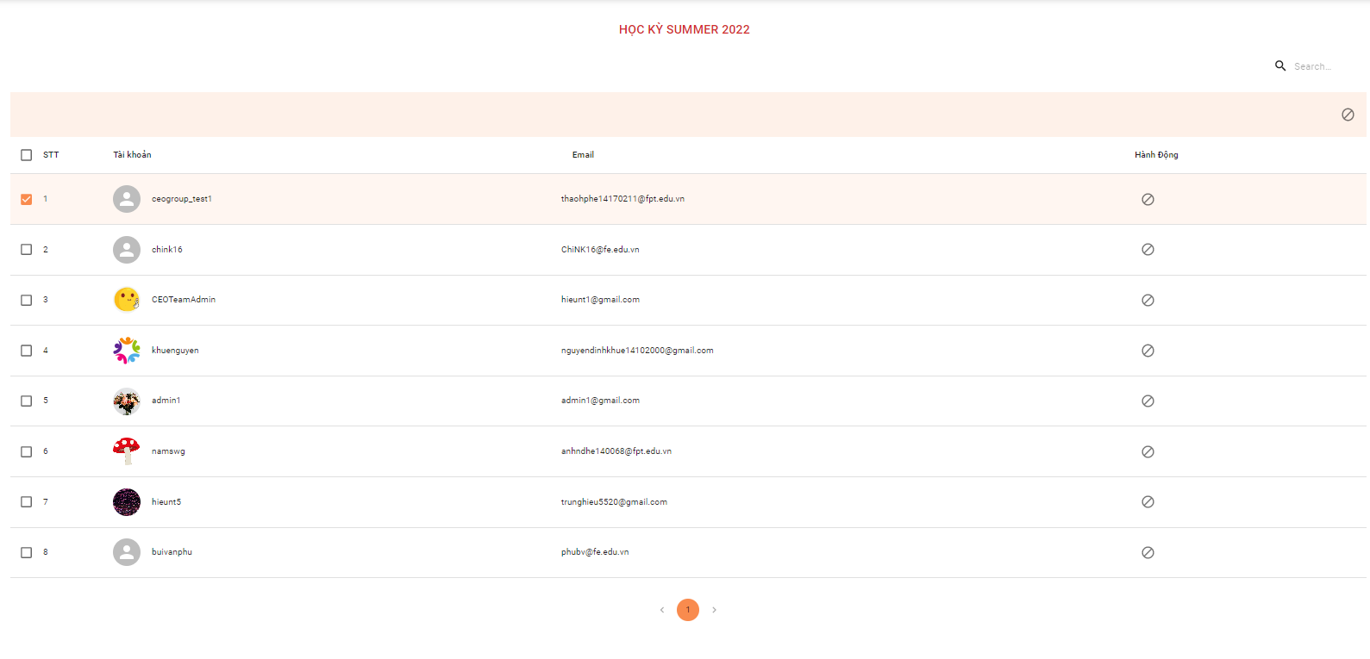

*Figure 230. Ban Admin account screen*

1. Super Admin view list account banned/ Super Admin unban account

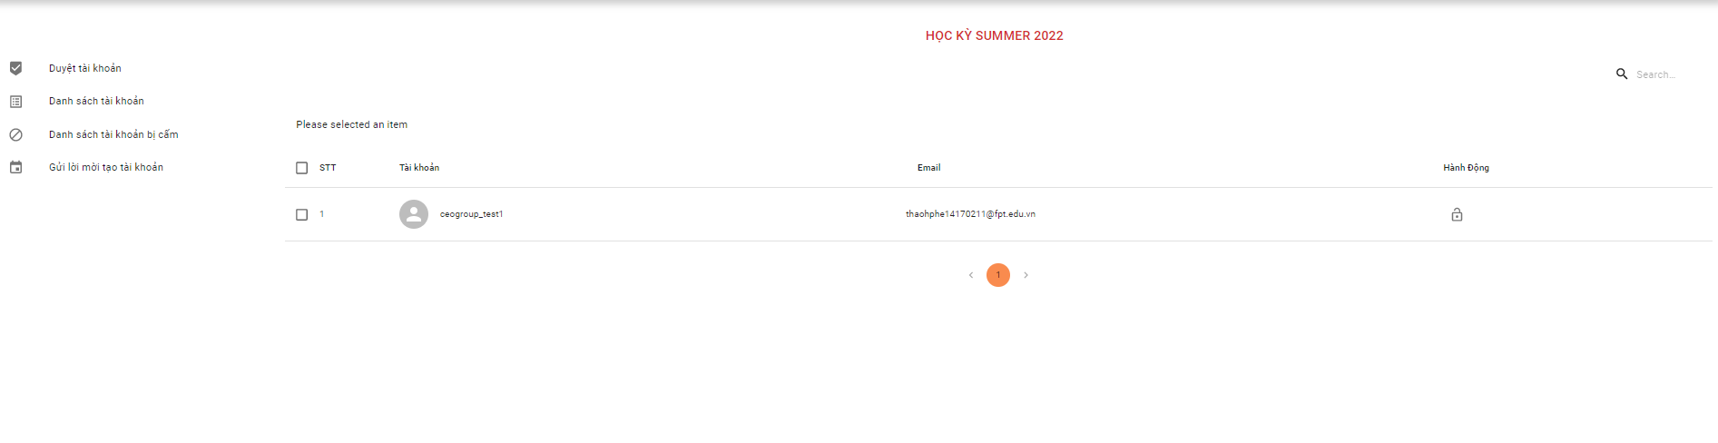

*Figure 231. List account banned screen*

*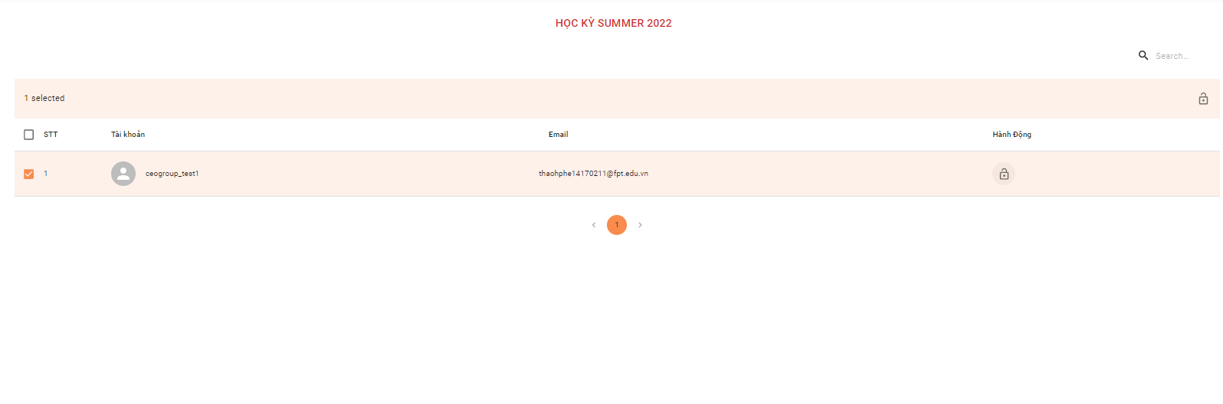Figure 232. Unban Admin account screen*

1. Super Admin search account

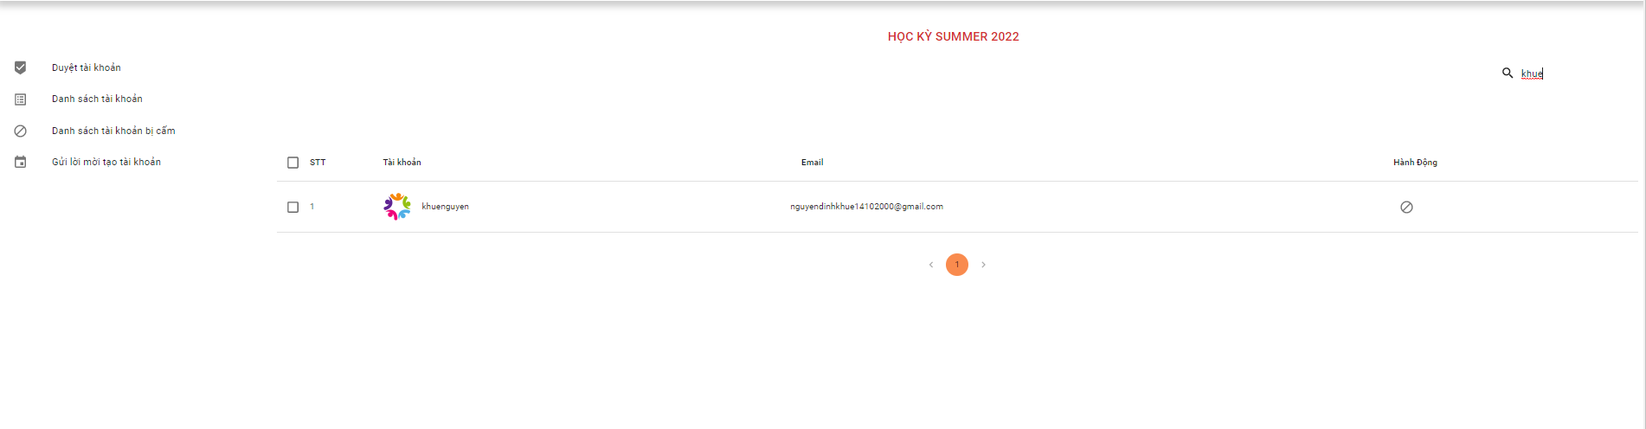

*Figure 233. Search Admin account screen*

### 2.6. Admin

#### 2.6.1 “Quản lý thông báo” screen

**1. Admin clicks “Danh sách thông báo”**

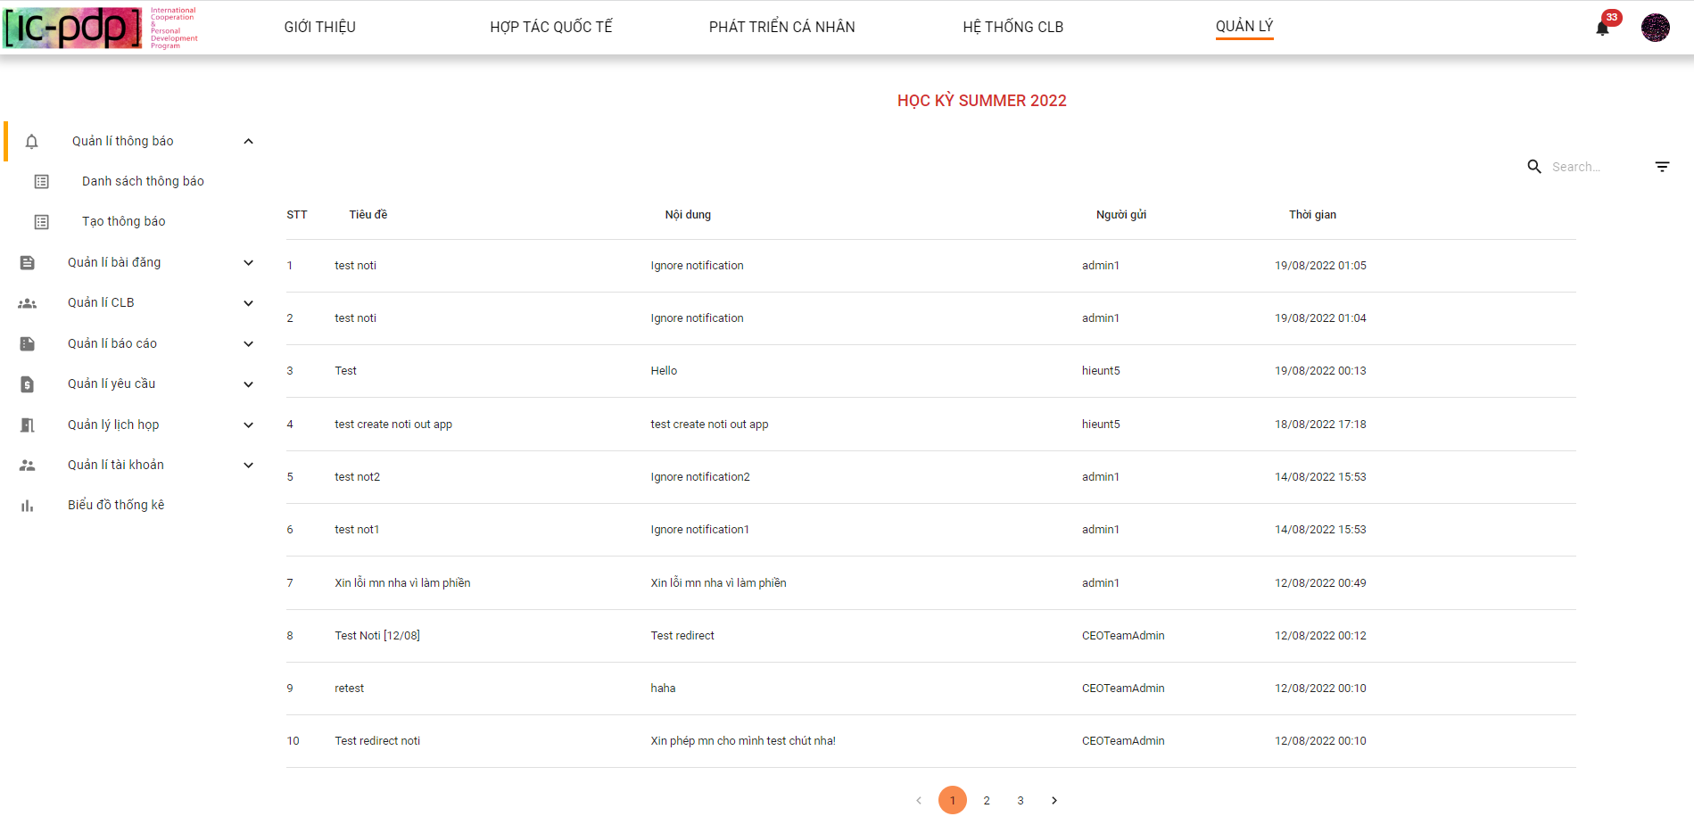

*Figure 234. List Admin notifications screen*

1.1 Admin clicks next page “Danh sách thông báo”



*Figure 235. List Admin notifications screen*

1.2 Admin clicks to search field

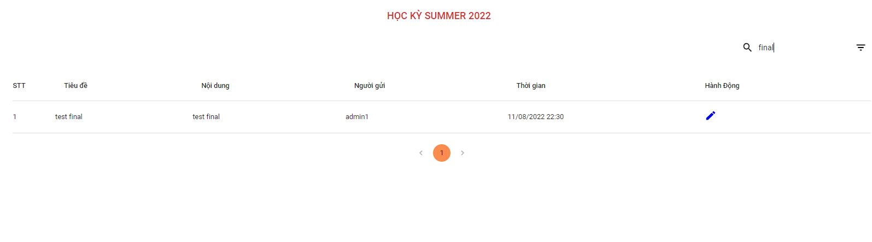

*Figure 236. Search Admin notifications screen*

1.3 Admin filter notification by “Người gửi”

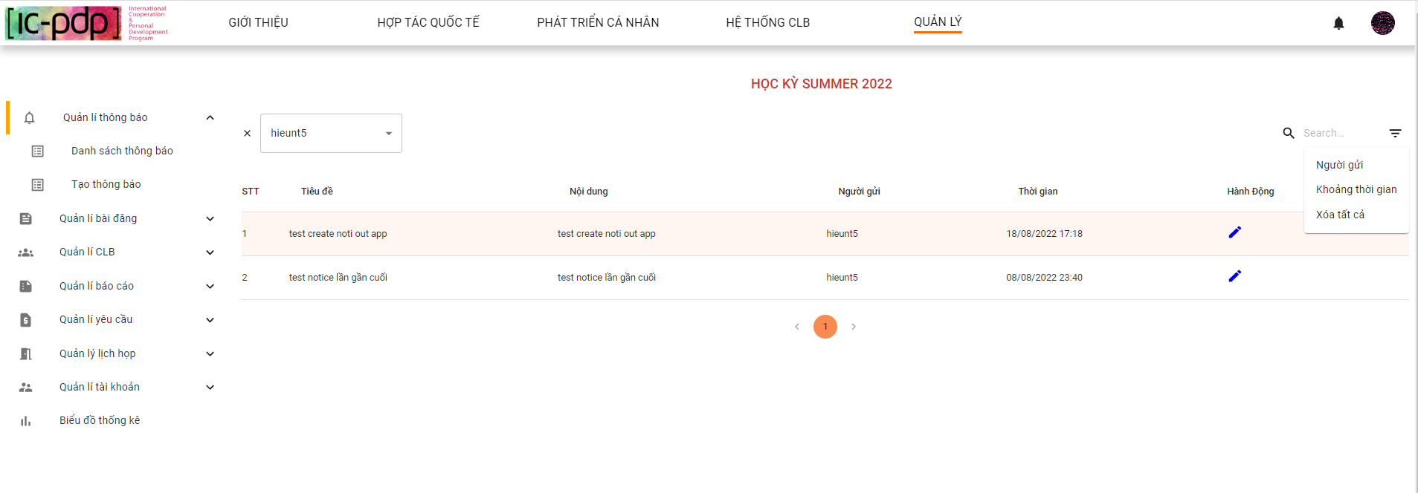

*Figure 237. Filter Admin notifications screen*

1.4 Admin filter notification by “Khoảng thời gian”

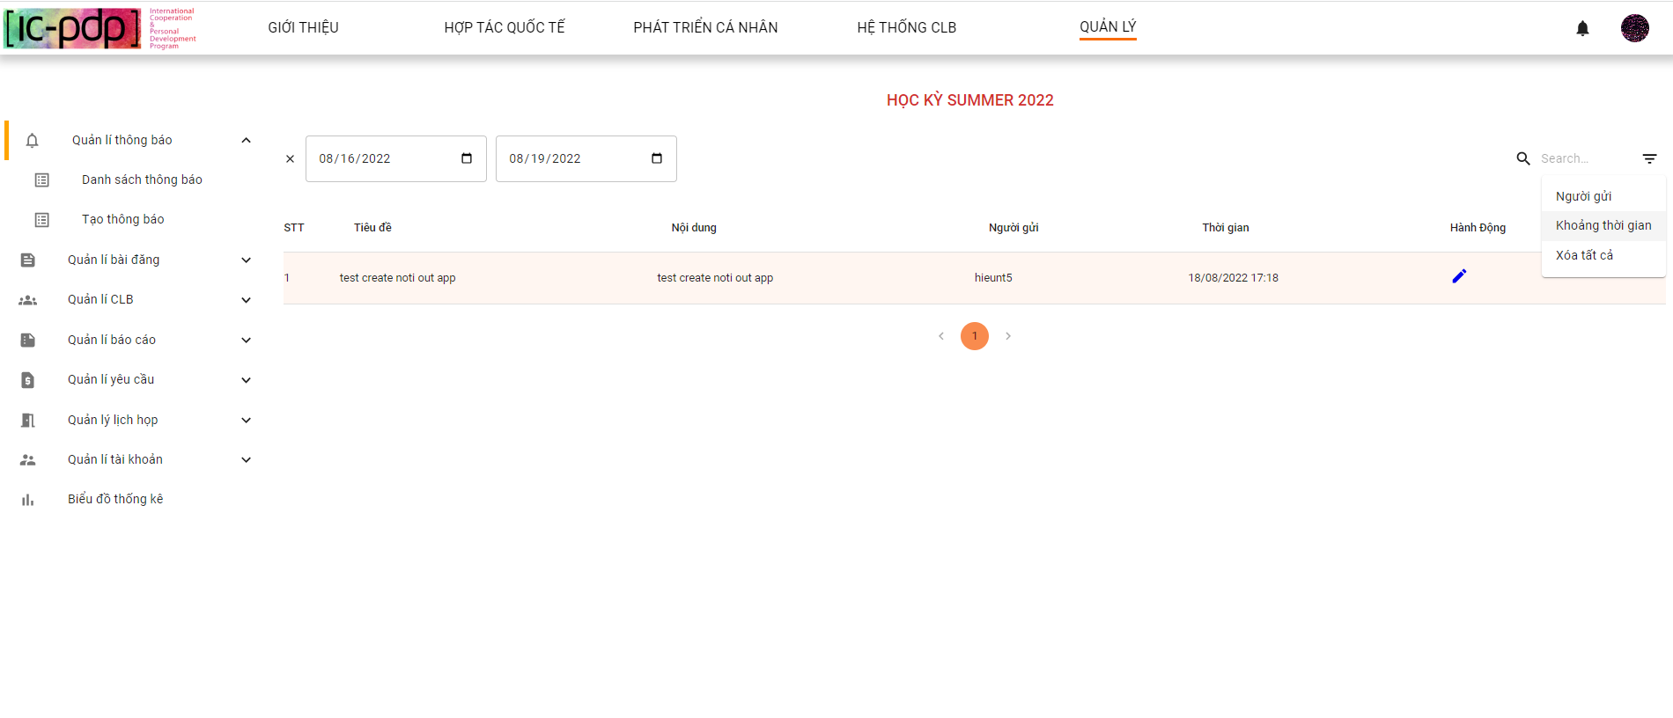

*Figure 238. Filter Admin notifications screen*

1.5 Admin close all filter

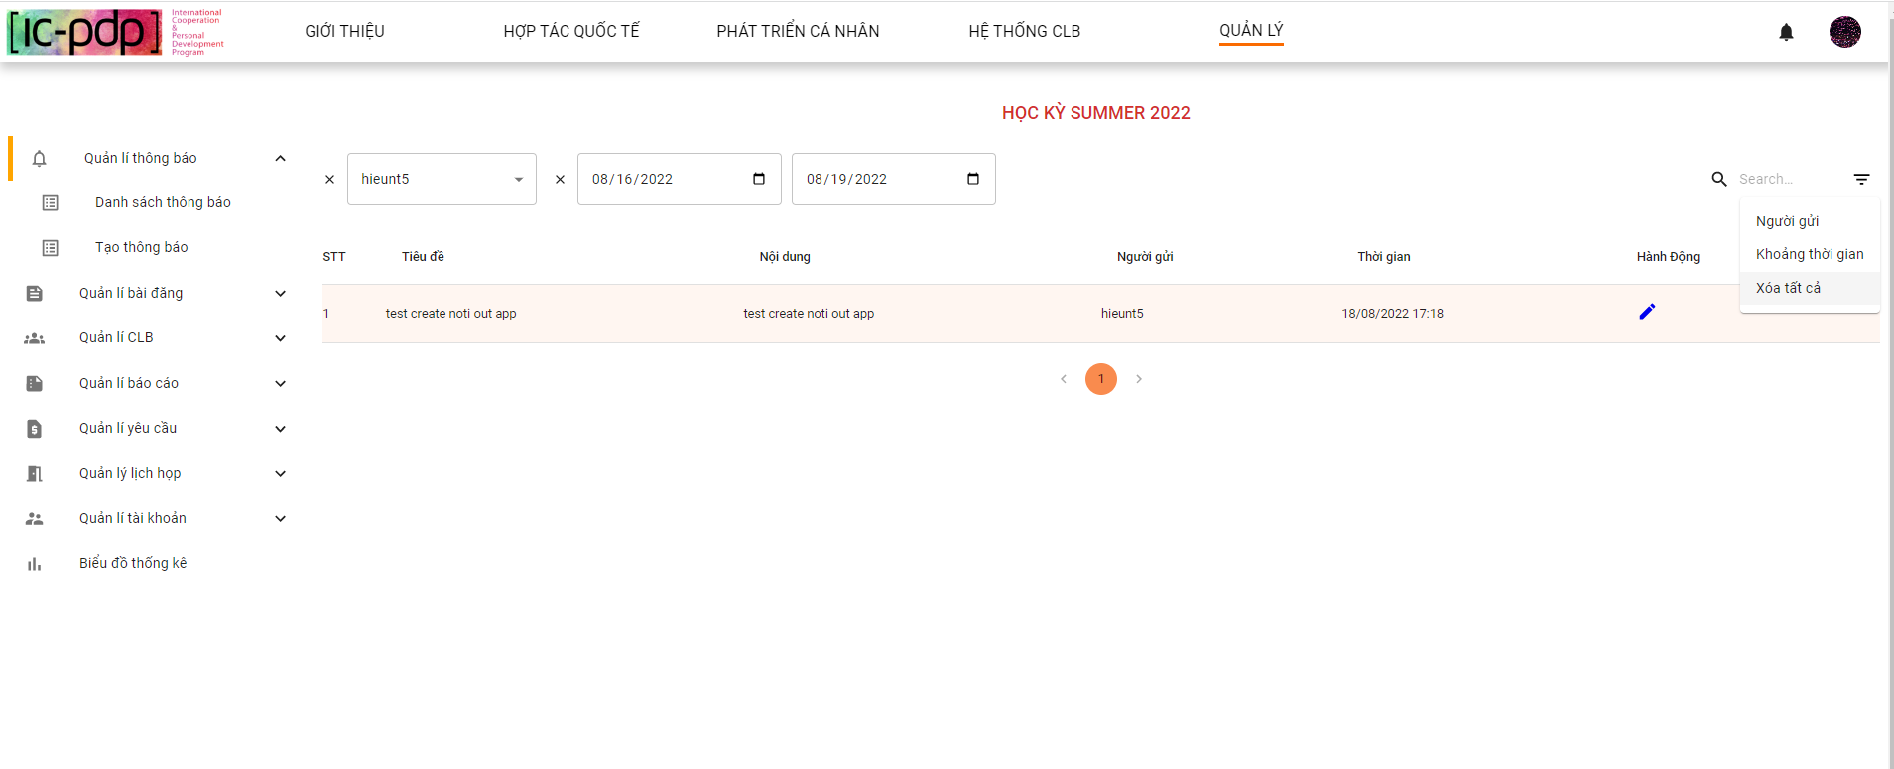

*Figure 239. Filter Admin notifications screen*

**2 Admin “Tạo thông báo”**

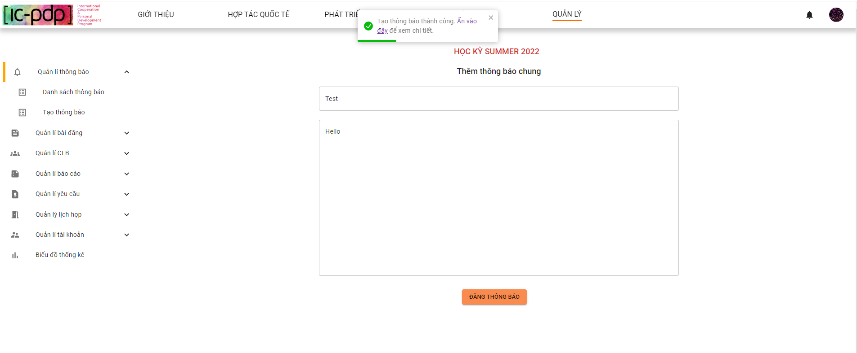

*Figure 240. Create Admin notification screen*

#### 2.6.2 “Quản lý bài đăng” screen

**1. Admin clicks “Danh sách bài đăng”**

1.1 Click “Danh sách bài đăng”- “ Hợp tác quốc tế”

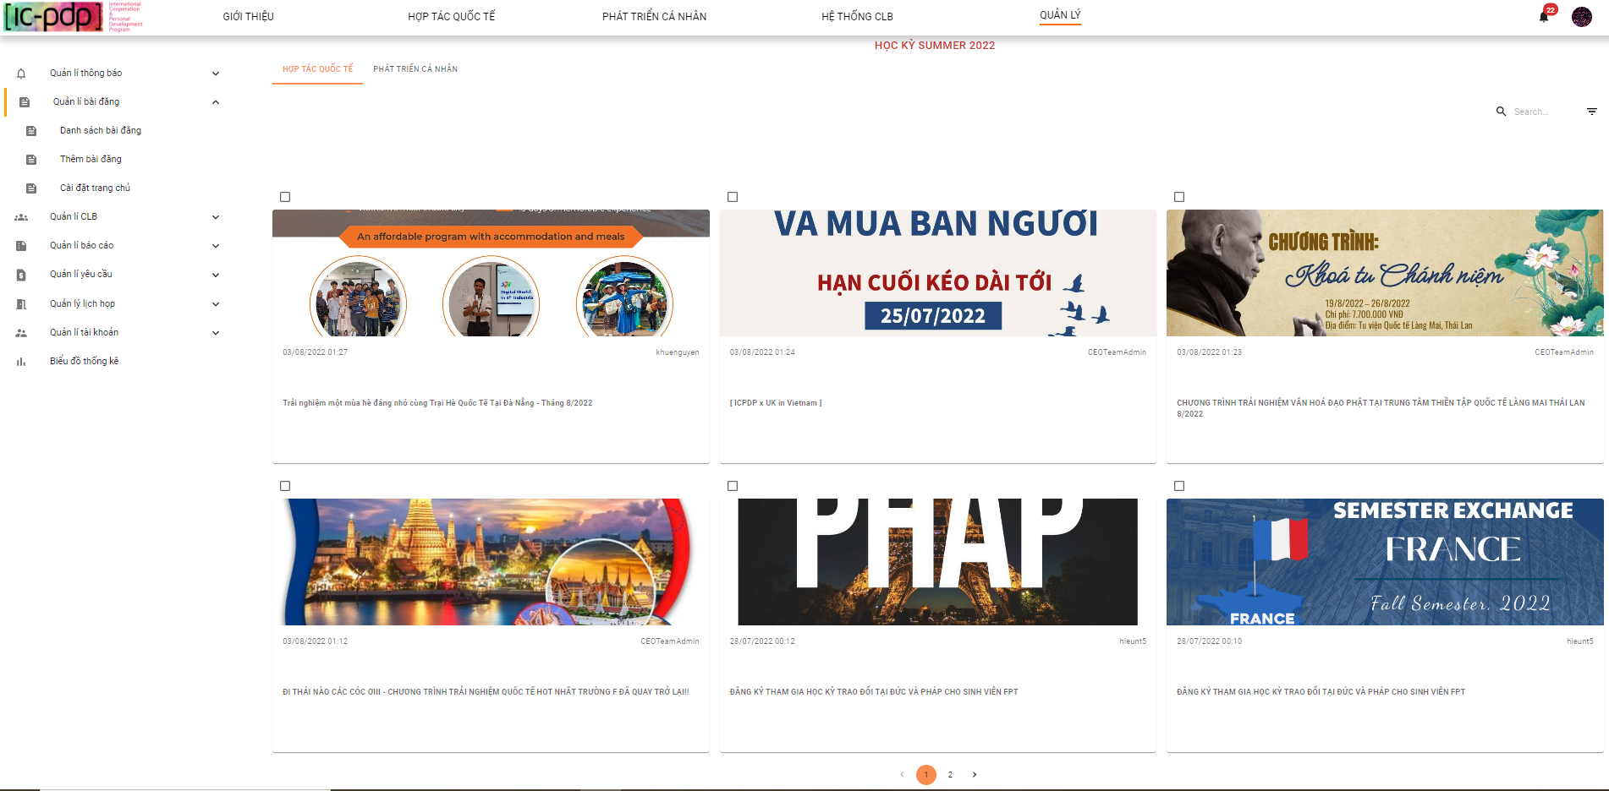

*Figure 241. List “Hợp tác quốc tế” posts screen*

1.2 Click “Danh sách bài đăng” - “Phát triển cá nhân”

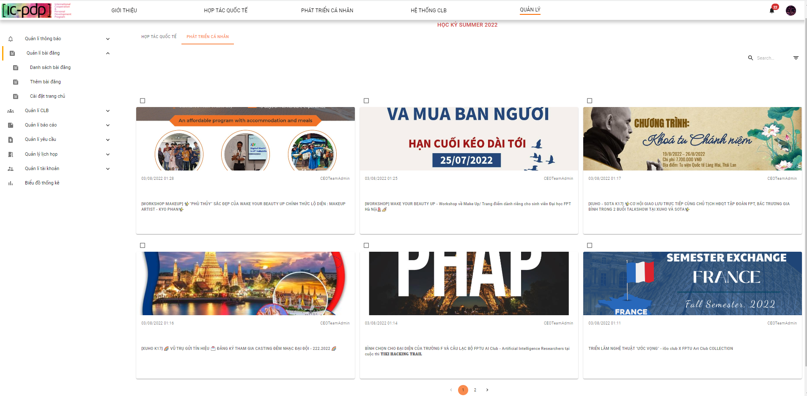

*Figure 242. List “Phát triển cá nhân” posts screen*

1.3 Admin clicks to search field

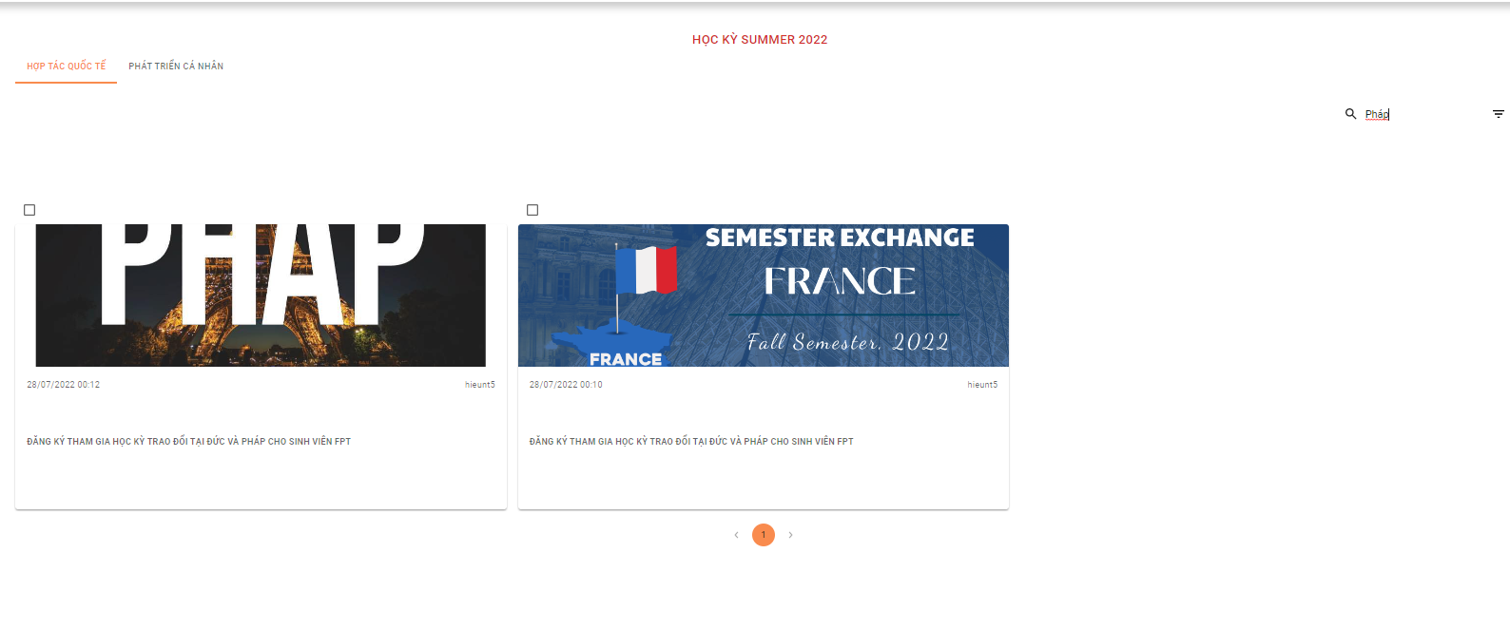

*Figure 243. Search “Hợp tác quốc tế” posts screen*

1.4 Admin filter post by “Người gửi”

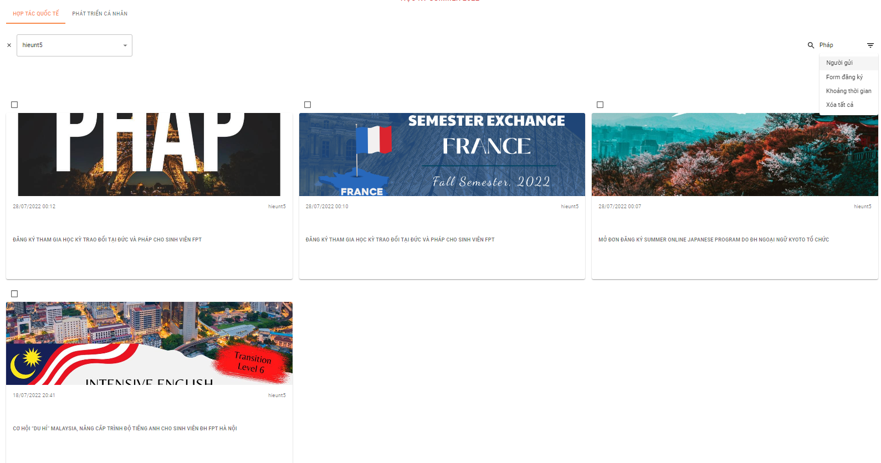

*Figure 244. Filter “Hợp tác quốc tế” posts screen*

1.5 Admin filter post by “Form đăng ký/ Không form đăng ký”

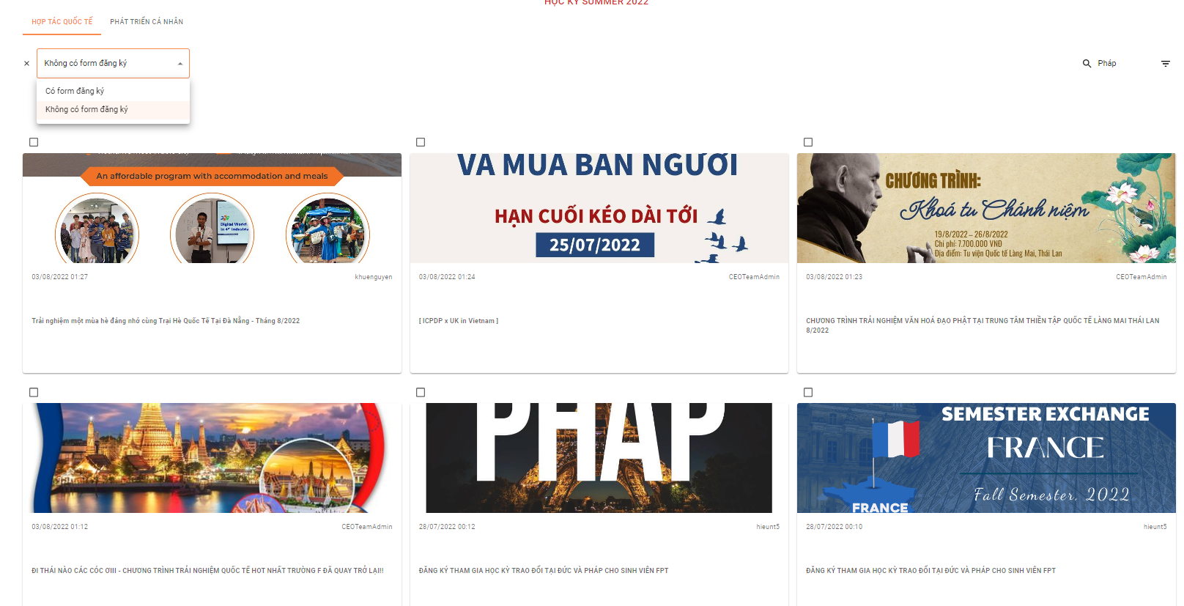

*Figure 245. Filter “Hợp tác quốc tế” posts screen*

1.6 Admin filter by “Khoảng thời gian”

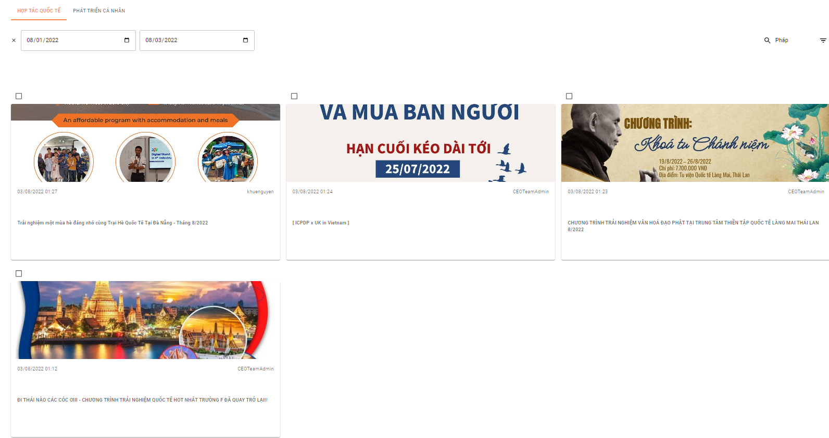

*Figure 246. Filter “Hợp tác quốc tế” posts screen*

1.7 Admin delete post

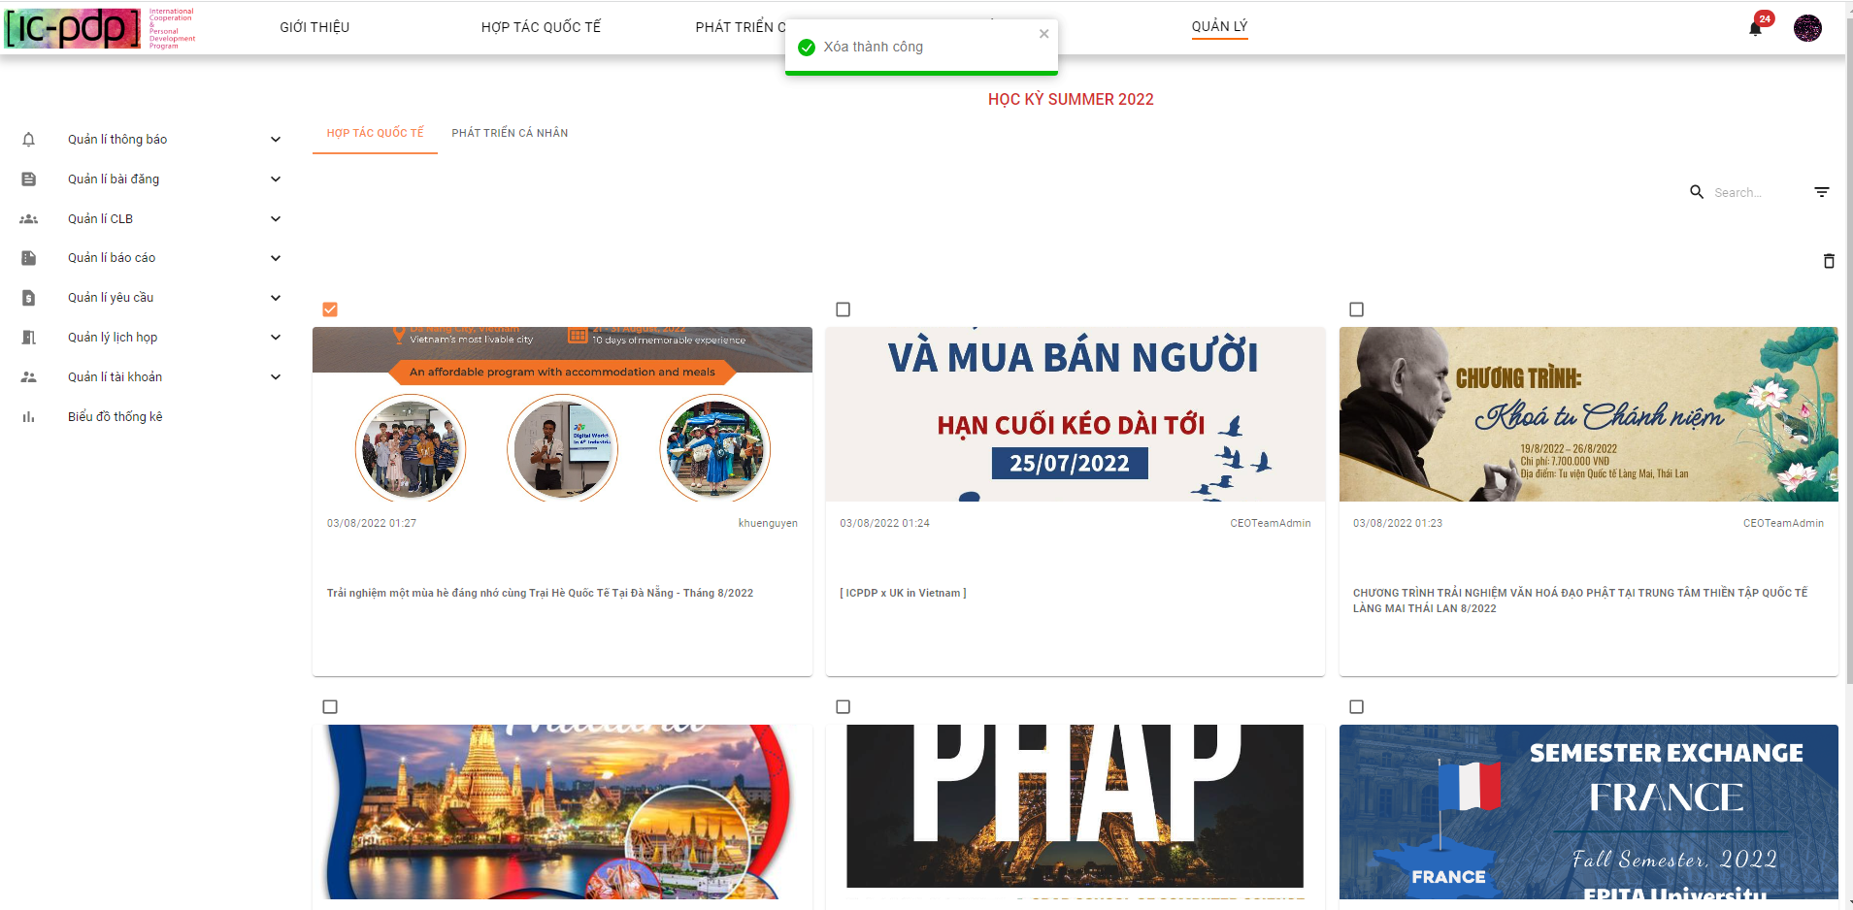

*Figure 247. Deleting posts screen*

1.8 Admin view detail post

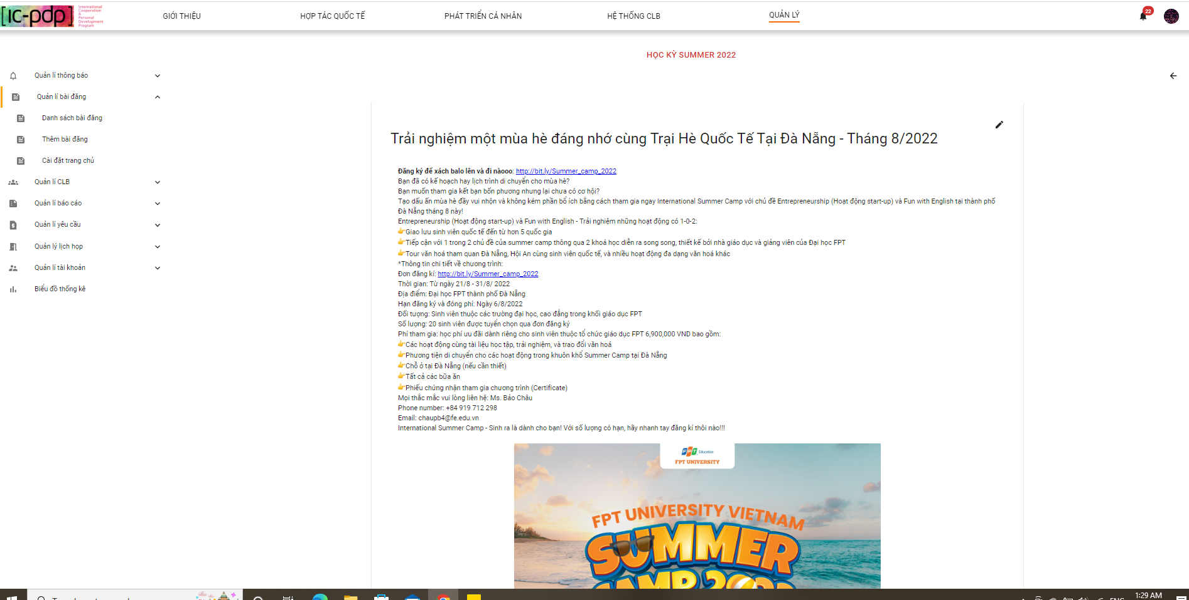

*Figure 248. Detail post screen*

1.9 Admin clicks button edit post

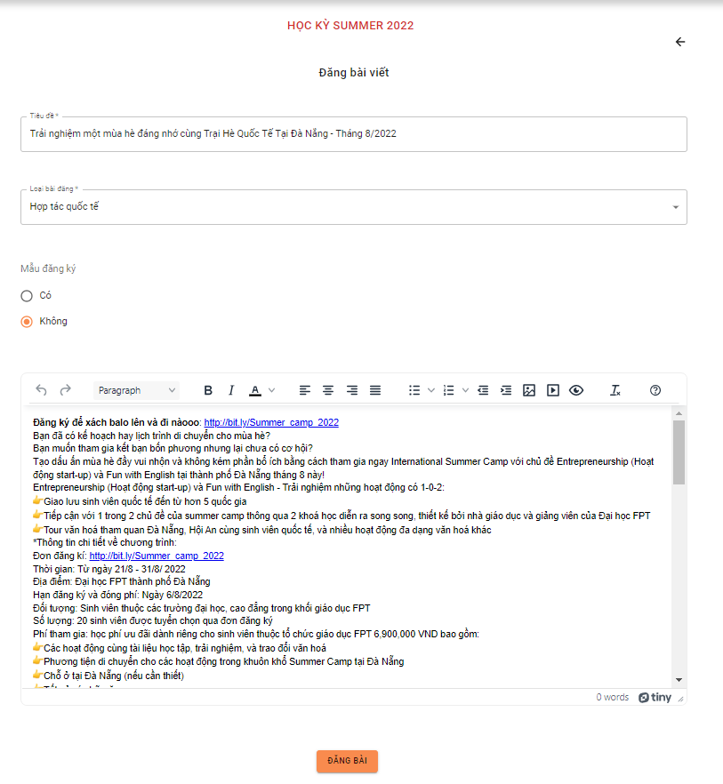

*Figure 249. Editing post screen*

**2. Admin clicks “Thêm bài đăng”**

2.1 “Không form đăng ký”

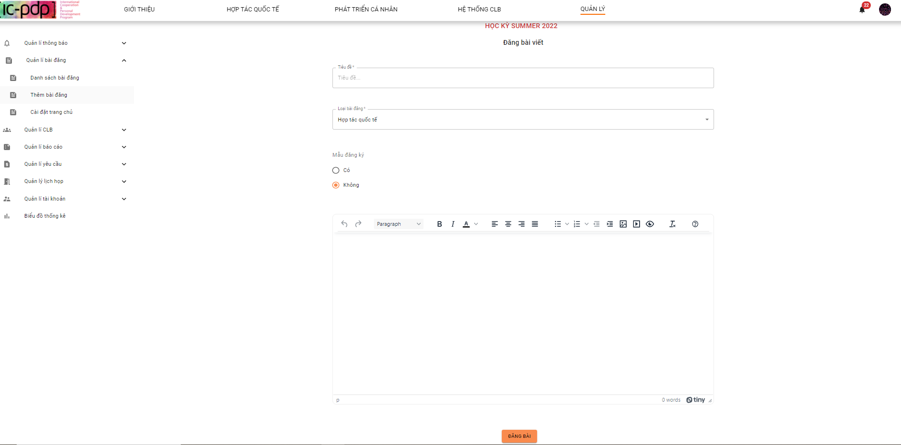

*Figure 250. Create post screen*

2.2 “Có form đăng ký”

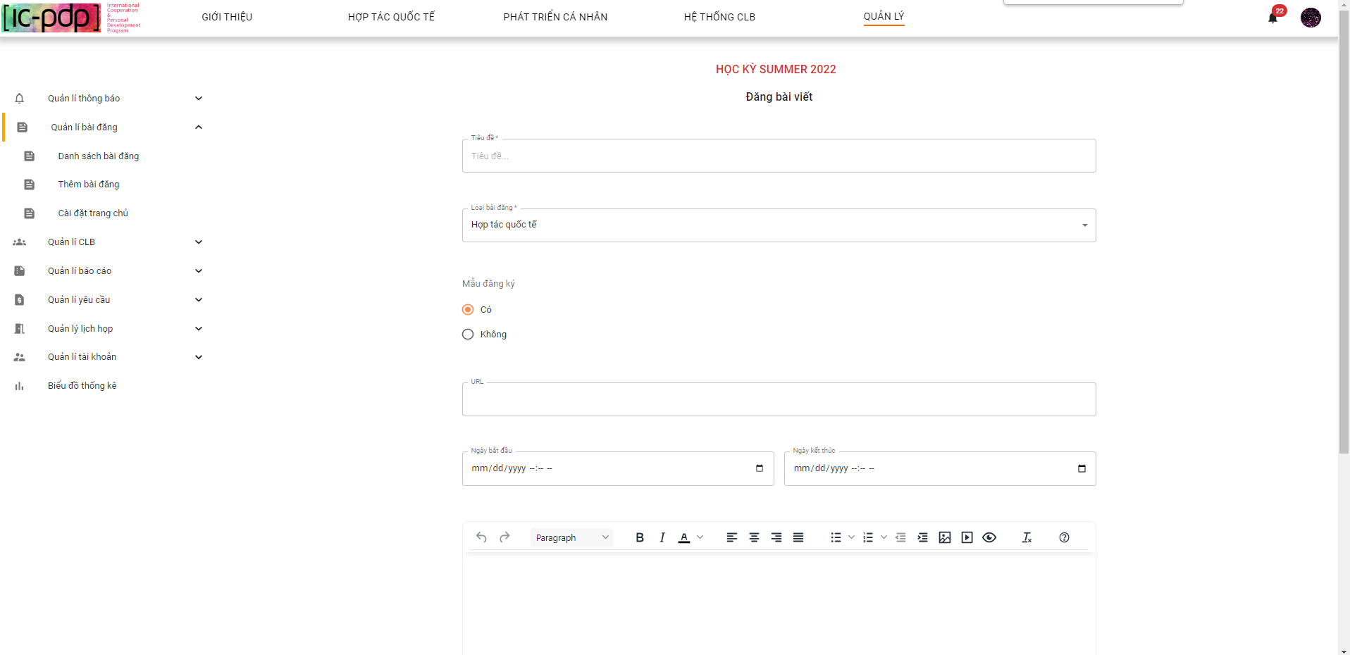

*Figure 251. Create post screen*

2.3 Admin clicks button “Đăng bài”

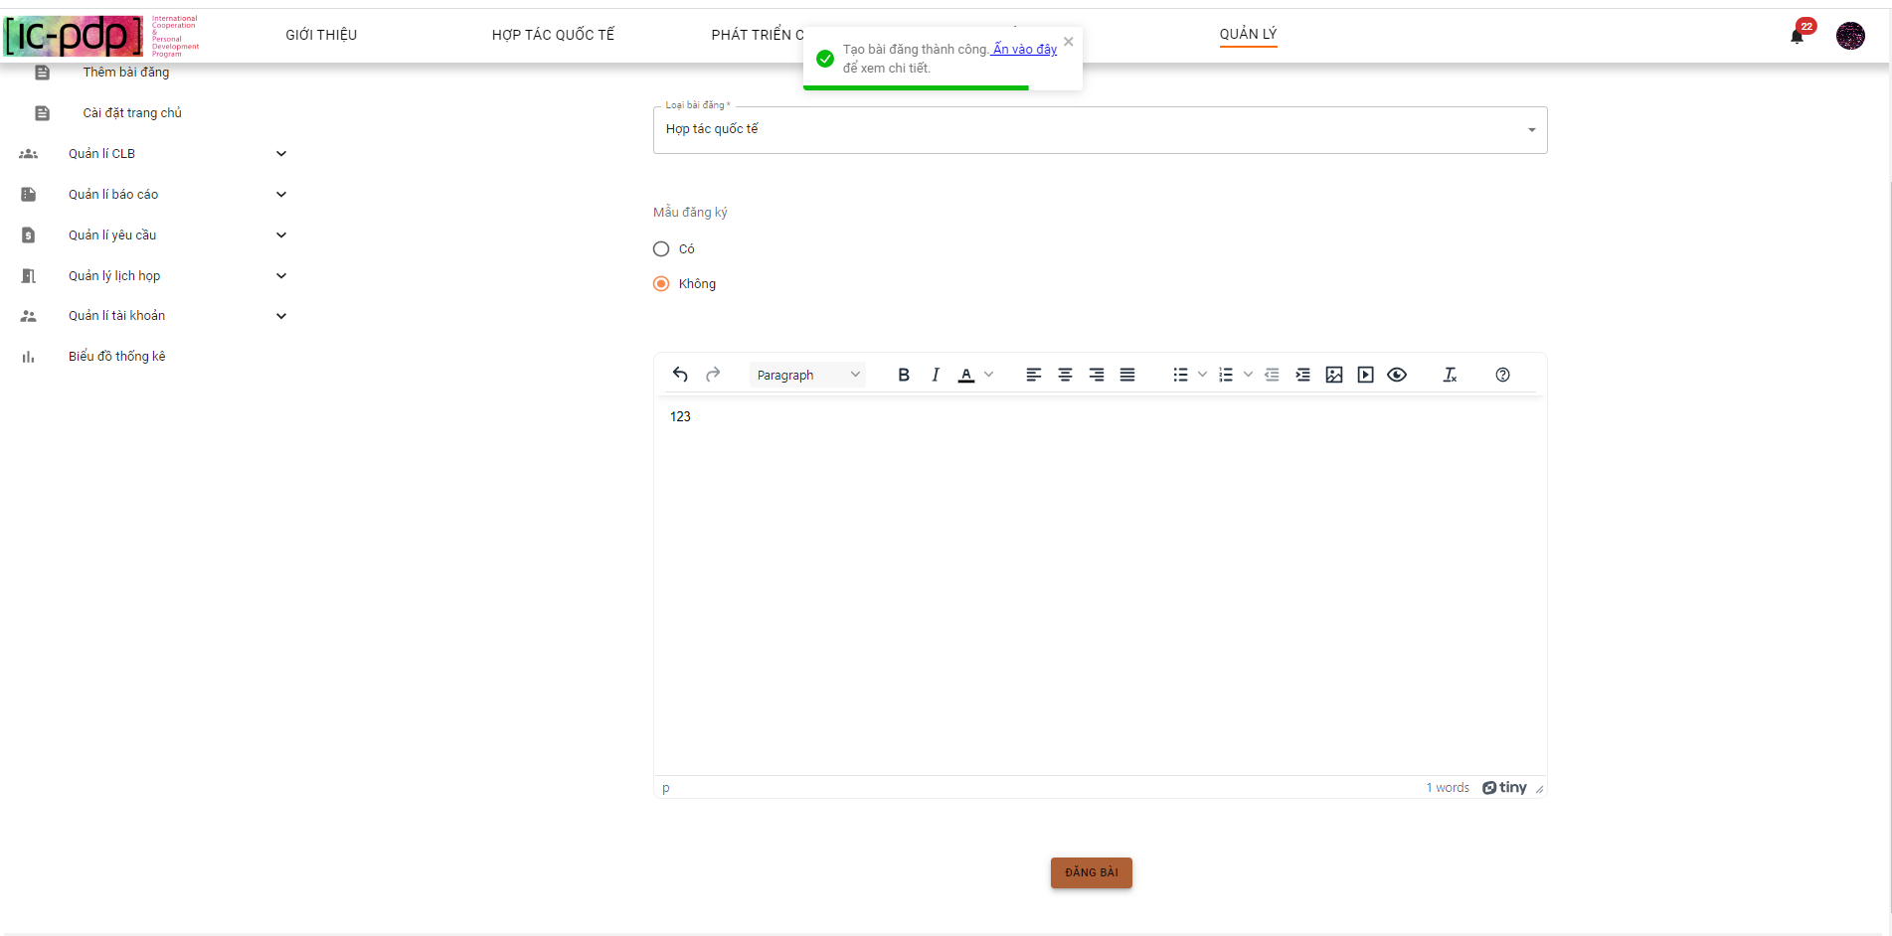

*Figure 252. Create post screen*

**3. Admin clicks “Cài đặt trang chủ”**

3.1 Admin view background in Home page

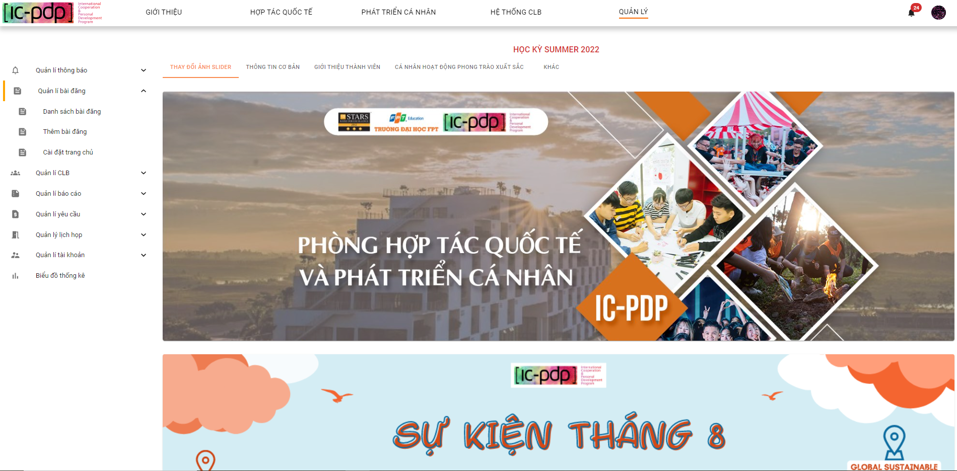

*Figure 253. Update Slider screen*

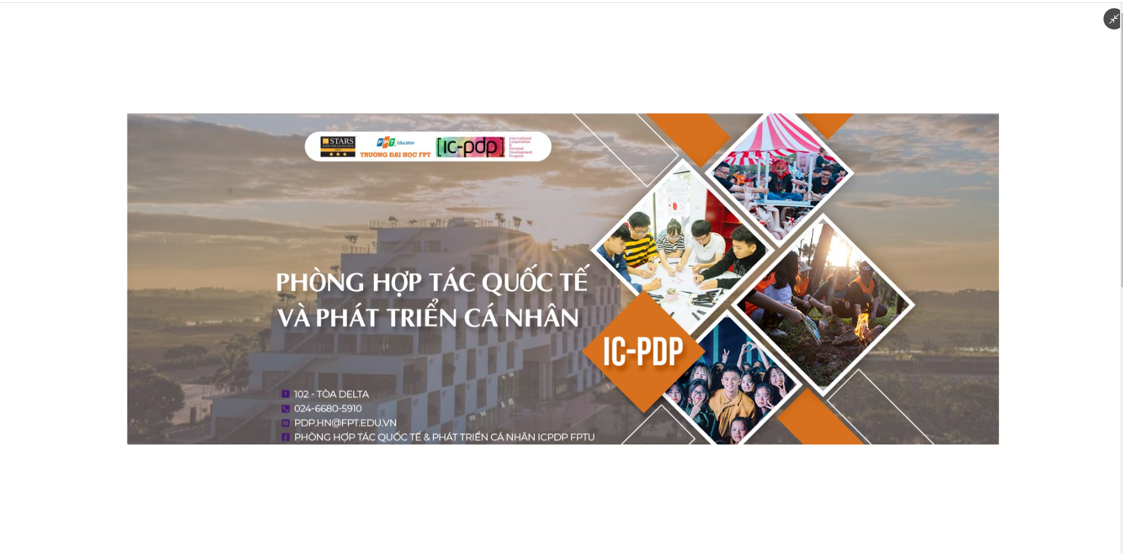

*Figure 254. View Slider Image*

3.2 Admin clicks button “edit ảnh slider”

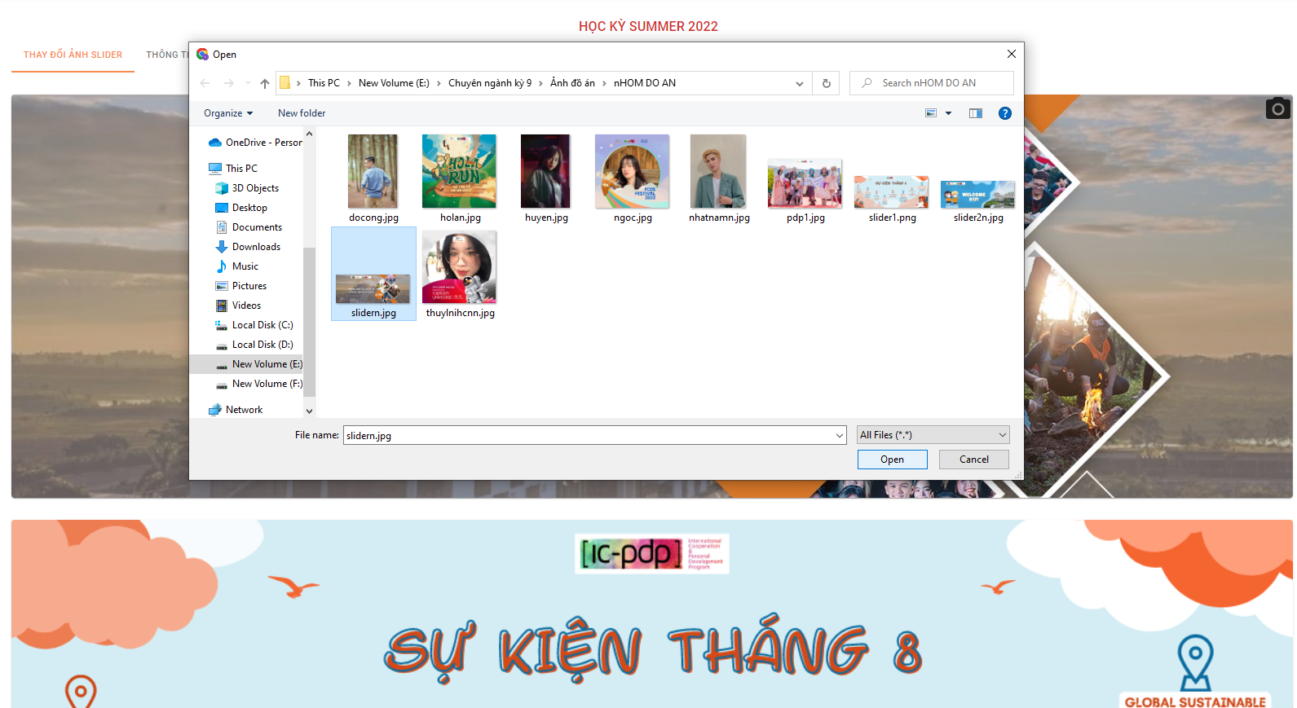

*Figure 255. Update Slider screen*

3.3 Admin view “Thông tin cơ bản”

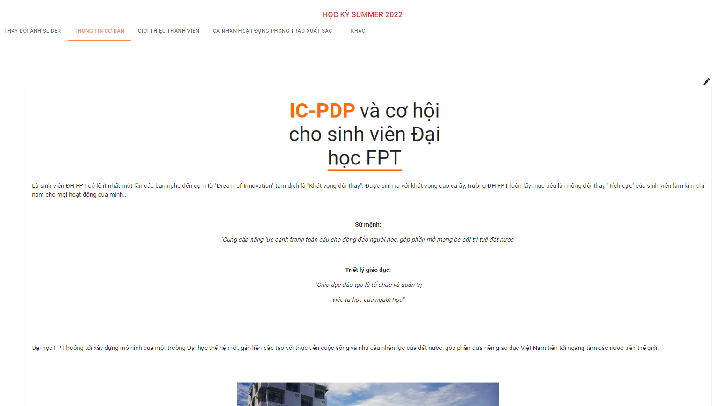

*Figure 256. IC-PDP’s introduction screen*

3.4 Admin clicks button “edit”

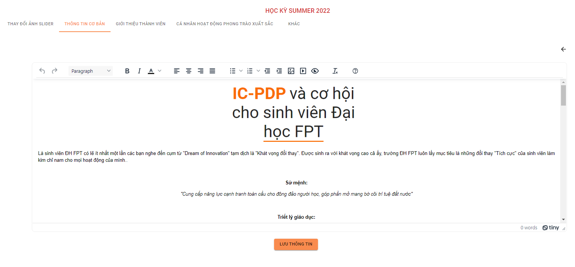

*Figure 257. Update IC-PDP’s introduction screen*

3.5 Admin clicks “Giới thiệu thành viên”

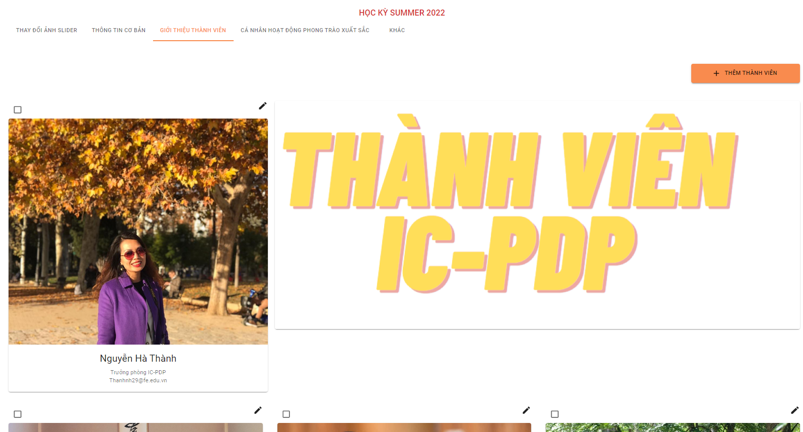

*Figure 258. View IC-PDP’s Officer list screen*

3.6 Admin clicks view detail member IC-PDP

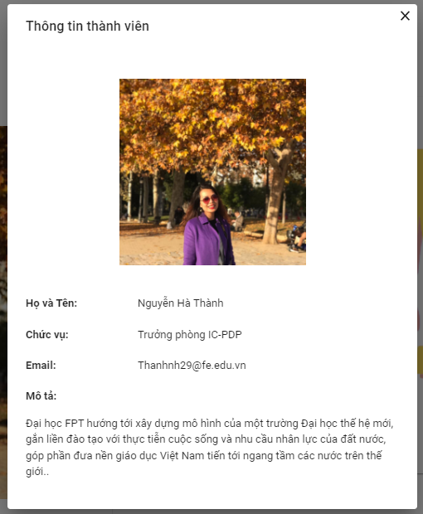

*Figure 259. IC-PDP’s Officer’s information screen*

3.7 Admin clicks edit “Thông tin thành viên”

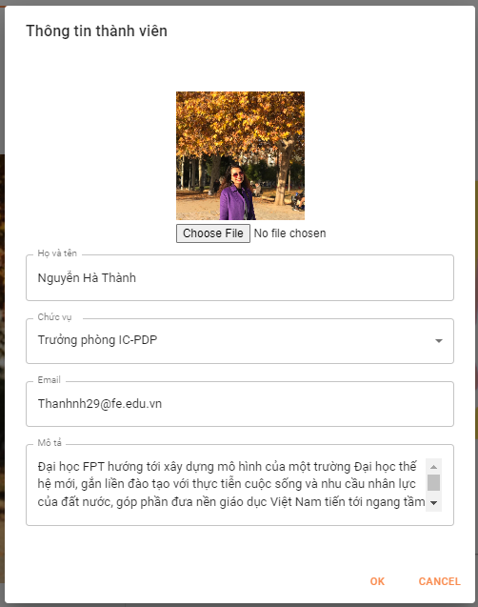

*Figure 260. Updating IC-PDP’s Officer’s information screen*

3.8 Admin clicks button “Thêm thành viên”

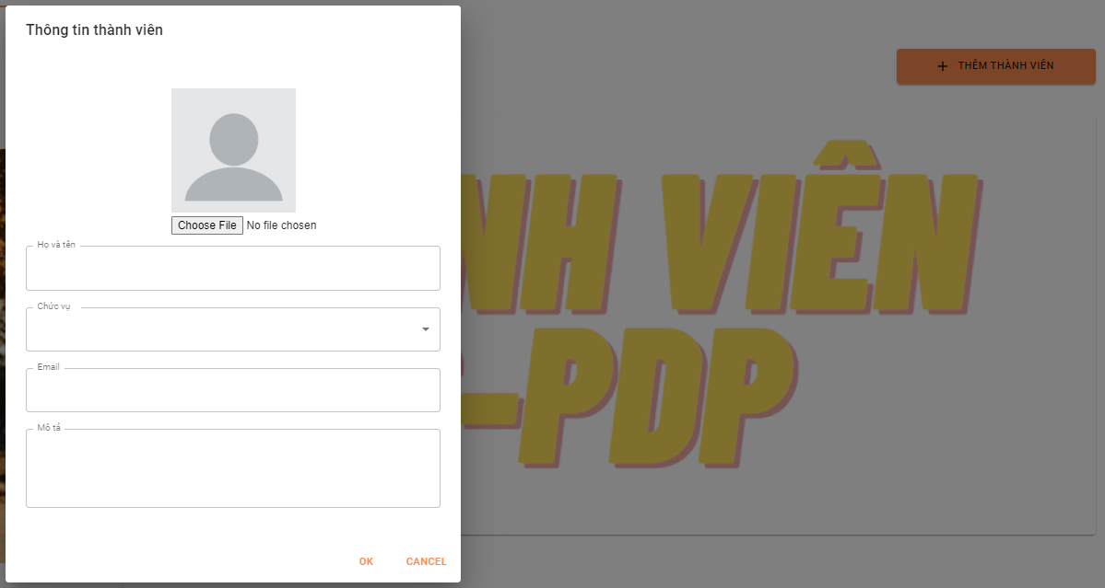

*Figure 261. Adding IC-PDP’s Officer’s information screen*

3.9 Admin clicks button “OK”

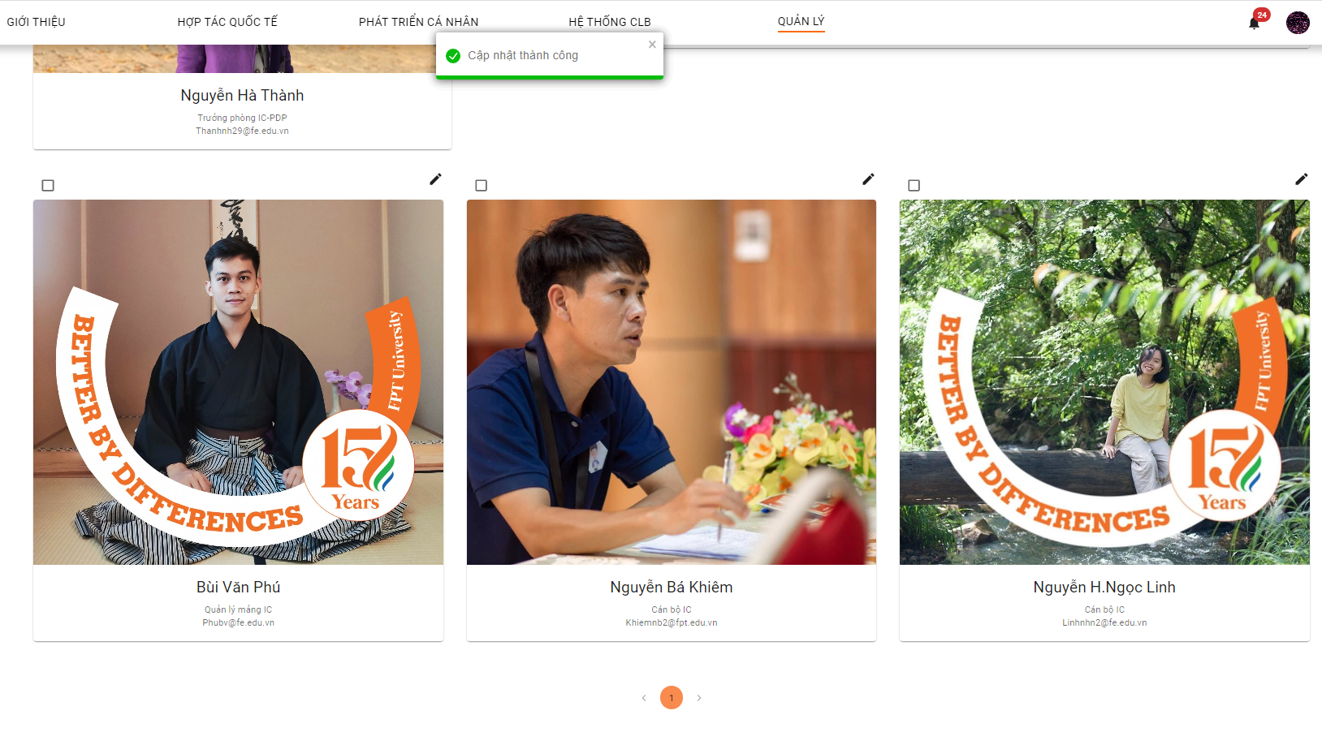

*Figure 262. Adding IC-PDP’s Officer’s information successfully screen*

**4. Admin clicks “Cá nhân hoạt động phong trào xuất sắc”**

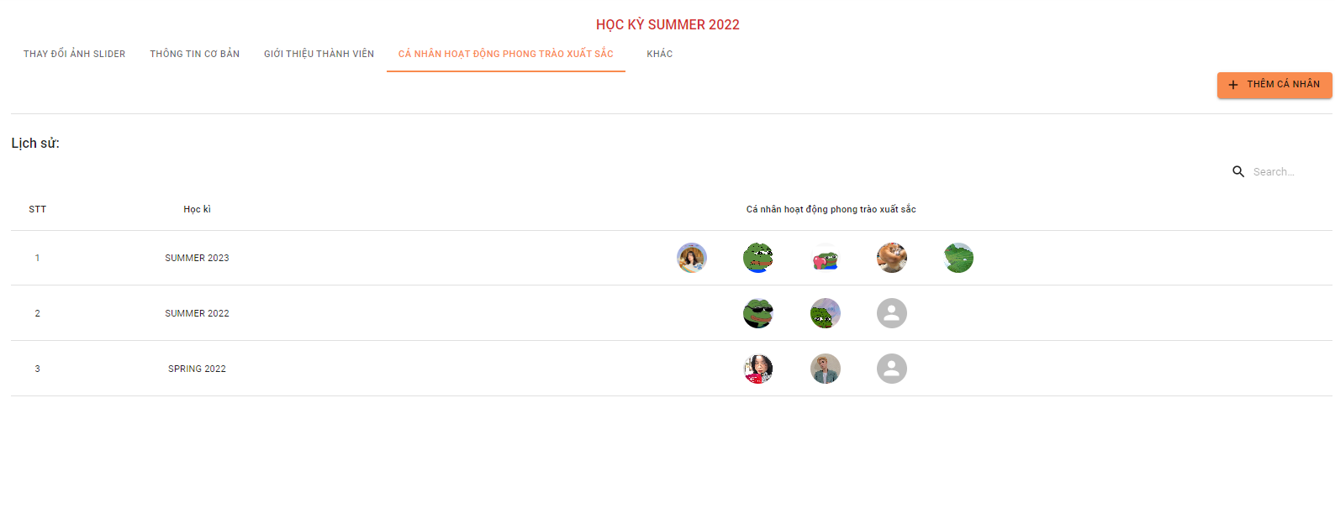

*Figure 263. Excellent individuals list screen*

4.1 Admin clicks view image

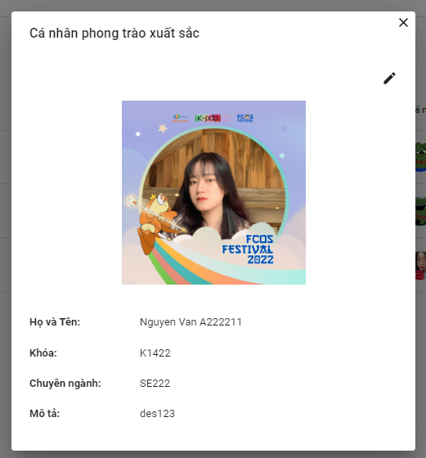

*Figure 264. Information of Excellent individual screen*

4.2 Admin clicks button edit

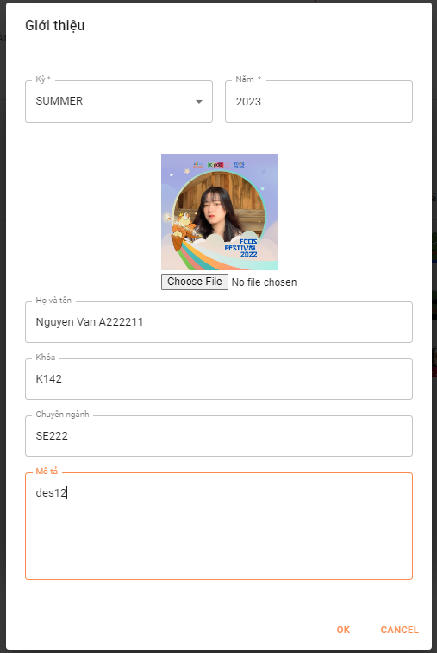

*Figure 265. Updating Information of Excellent individual screen*

4.3 Admin clicks button OK

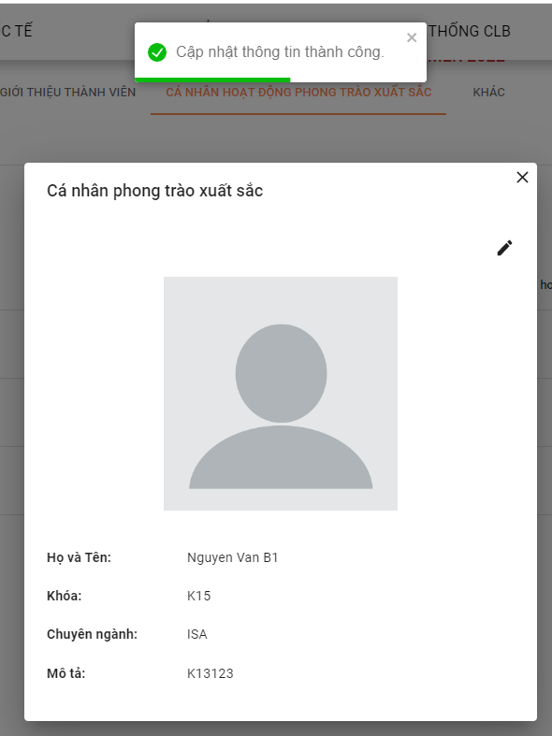

*Figure 266. Updating Information of Excellent individual successfully screen*

4.4 Admin clicks button “Thêm cá nhân”

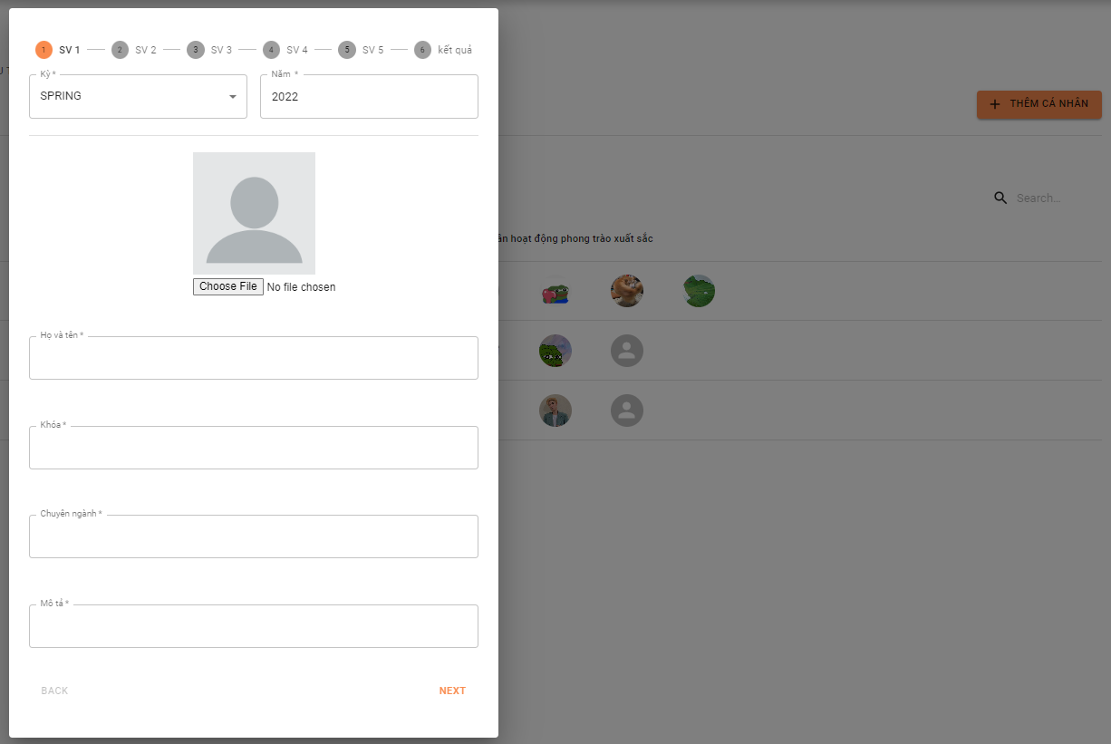

*Figure 267. Adding Information of Excellent individual screen*

4.5 Admin clicks button OK

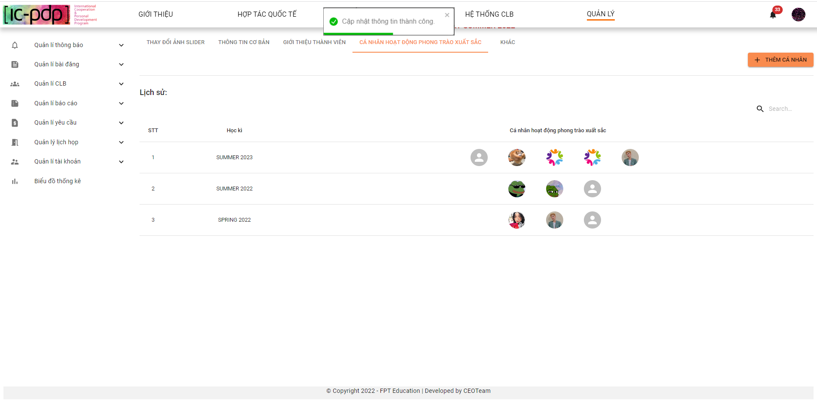

*Figure 268. Adding Information of Excellent individual successfully screen*

**5. Admin clicks “Khác”**

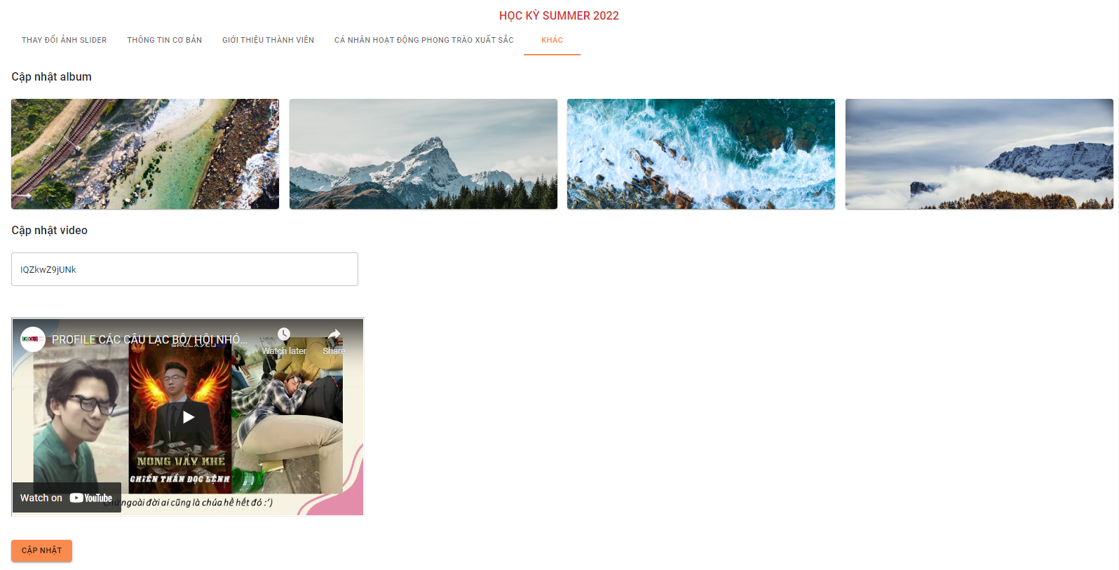

*Figure 269. Others screen*

5.1 Admin edit “Cập nhật video” and clicks button “Cập nhật”

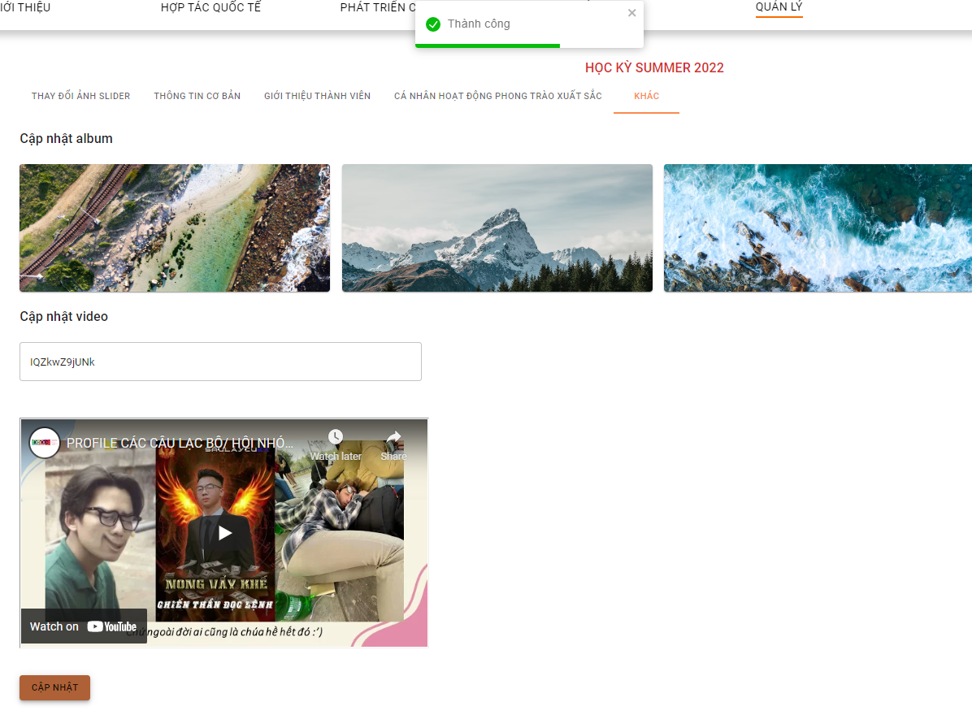

*Figure 270. Update image and video successfully screen*

#### 2.6.3 “Quản lý CLB” screen

1. **Admin “Danh sách CLB”**

1.1 Admin clicks “Danh sách CLB”

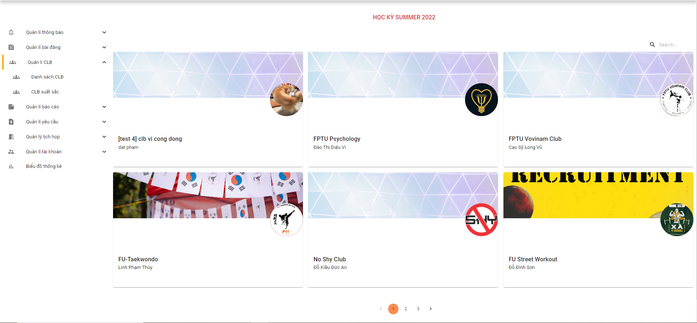

*Figure 271. List clubs screen*

1.2 Admin search CLB

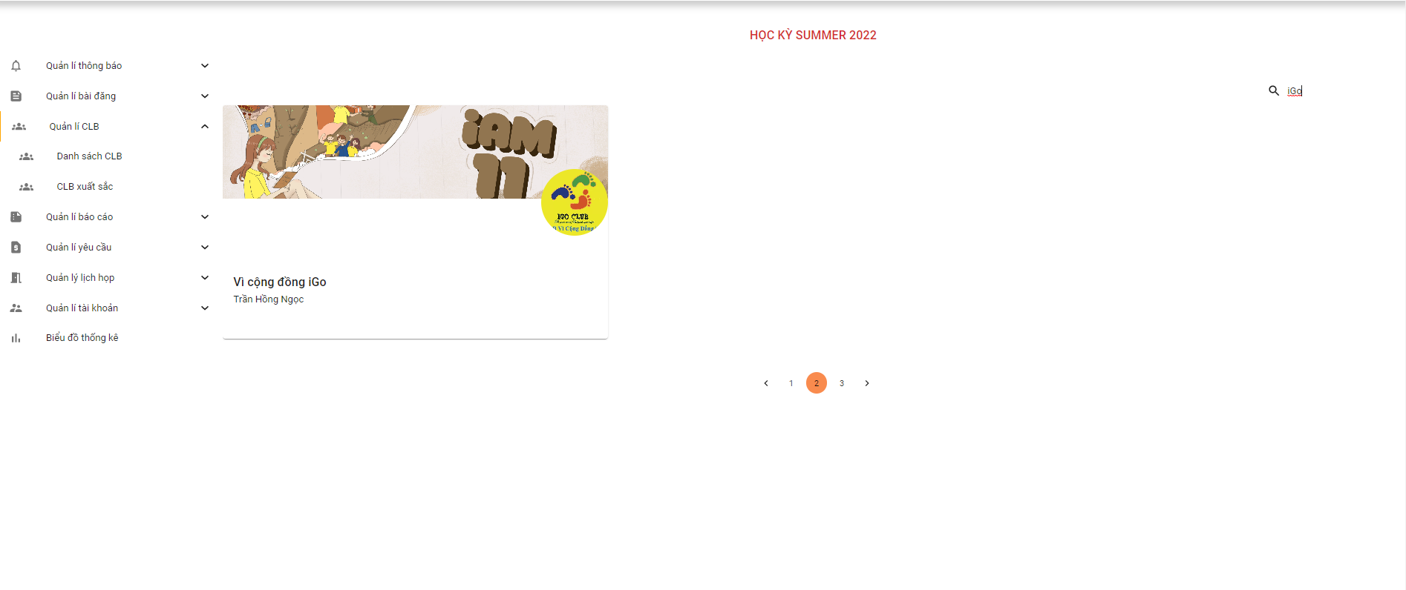

*Figure 272. Search clubs screen*

1.3 Admin view detail CLB

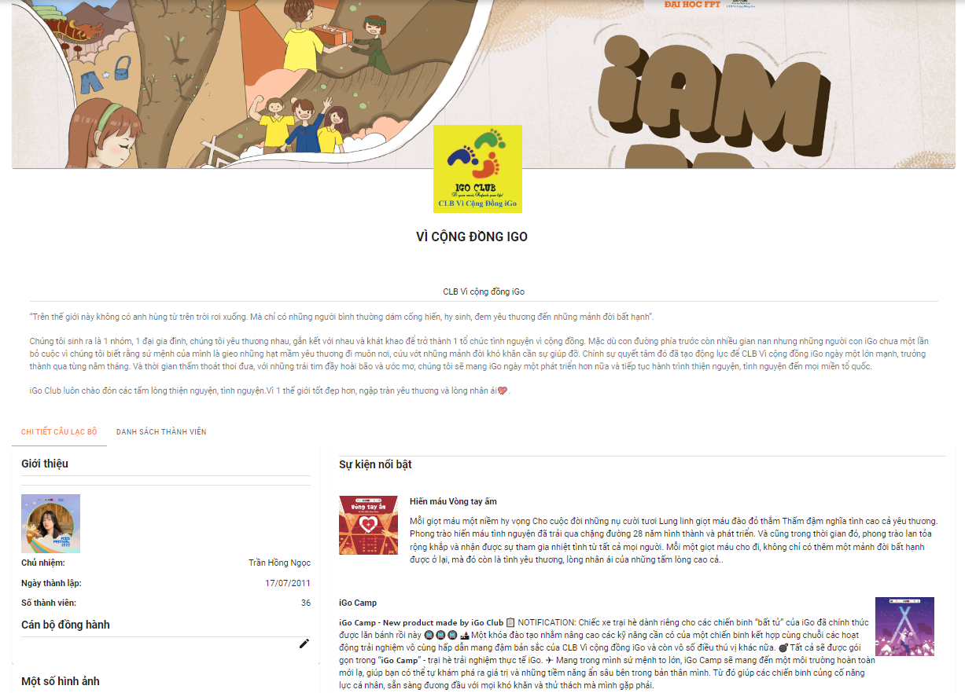

*Figure 273. Detail club screen*

1.4 Admin clicks buttons edit “Cán bộ đồng hành”

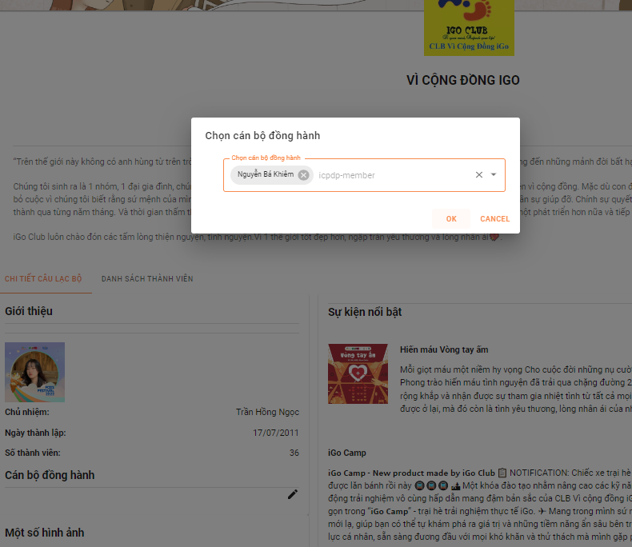

*Figure 274. Update club’s mentor screen*

1. **Admin clicks CLB Xuất sắc**

2.1 Admin clicks “CLB xuất sắc”

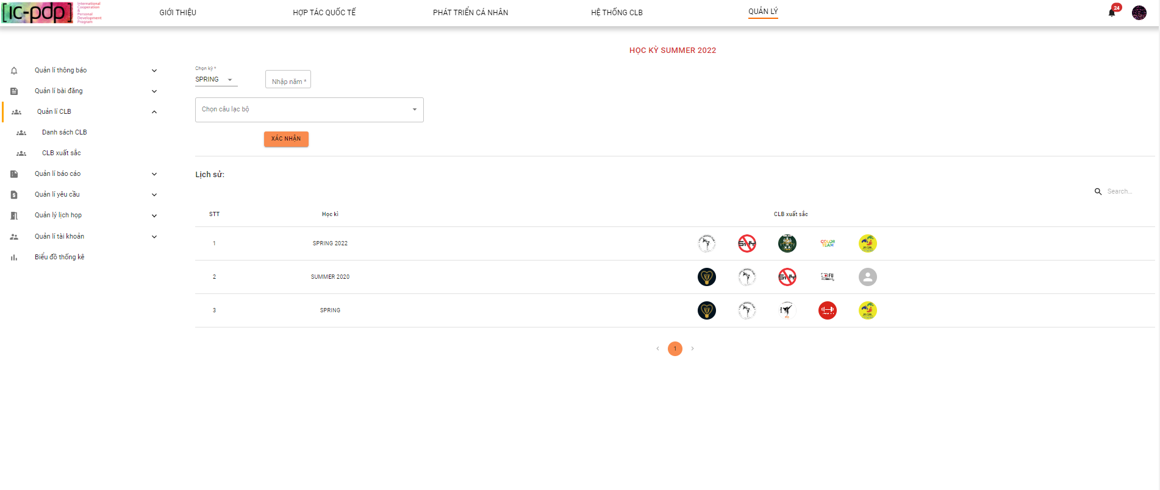

*Figure 275. Excellent clubs list screen*

2.2 Admin updates “CLB xuất sắc”

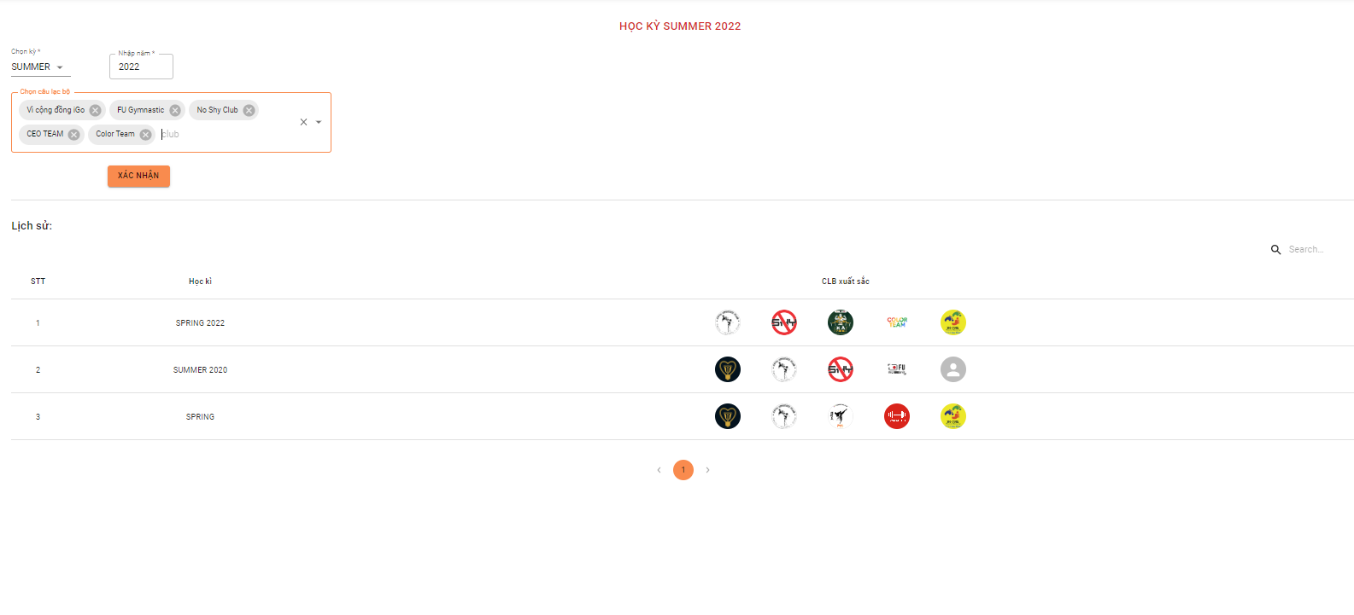

*Figure 276. Update Excellent clubs screen*

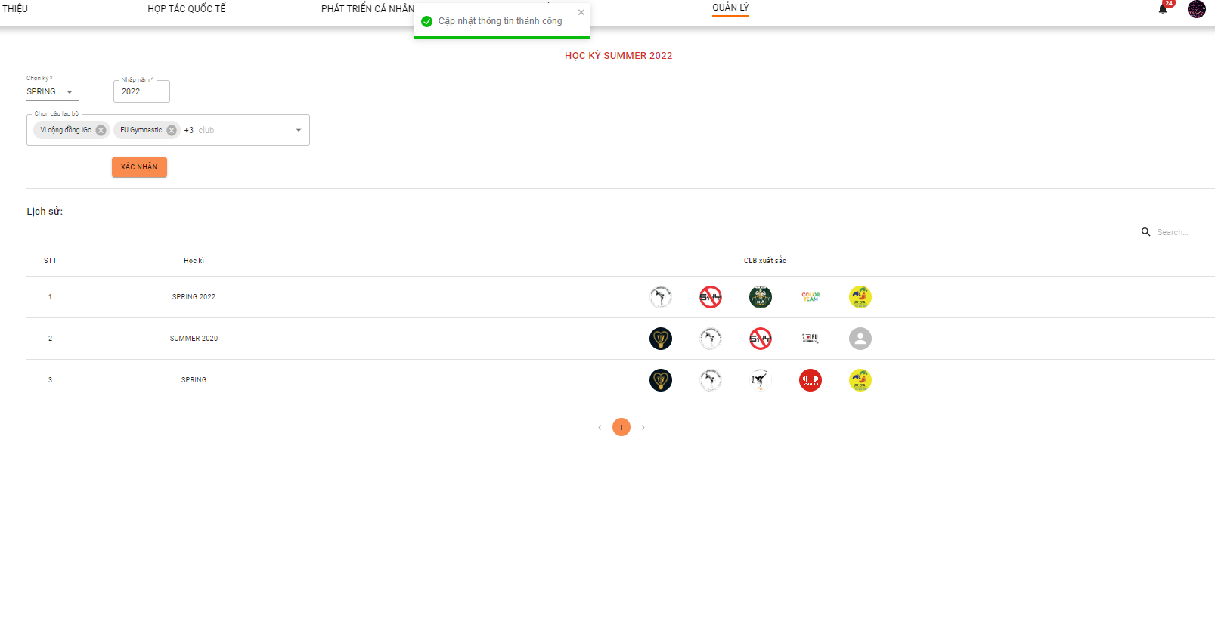

*Figure 277. Update Excellent clubs successfully screen*

#### 2.6.4 “Quản lý báo cáo” screen

1. **Admin clicks “Danh sách báo cáo”**

1.1 Admin clicks “Báo chưa xử lý”

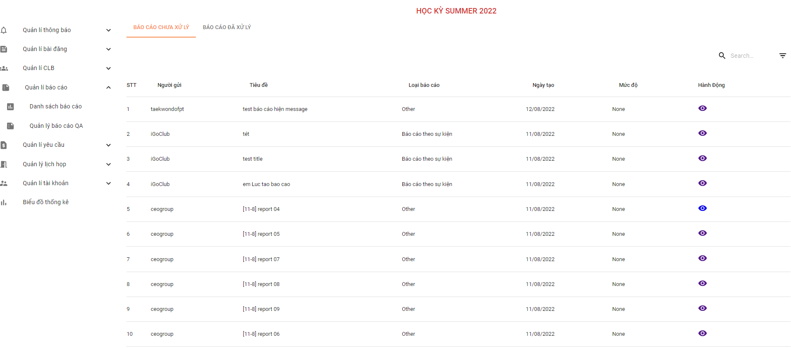

*Figure 278. Unprocessed reports list screen*

1.2 Admin clicks “Báo cáo đã xử lý”

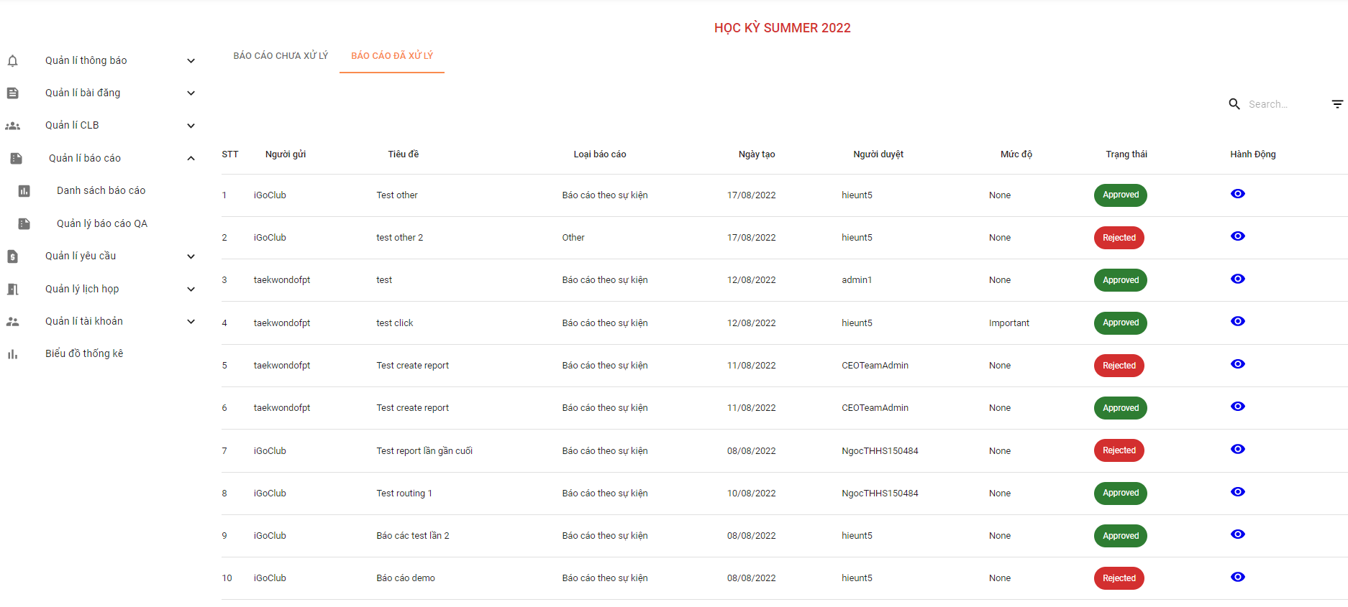

*Figure 279. Processed reports list screen*

1.3 Admin clicks search field

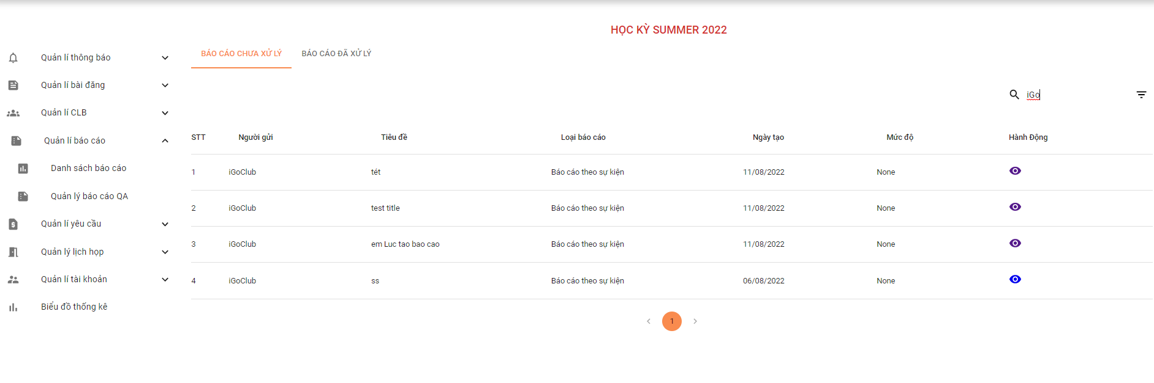

*Figure 280. Search reports screen*

1.4 Admin filters report by “Người gửi”

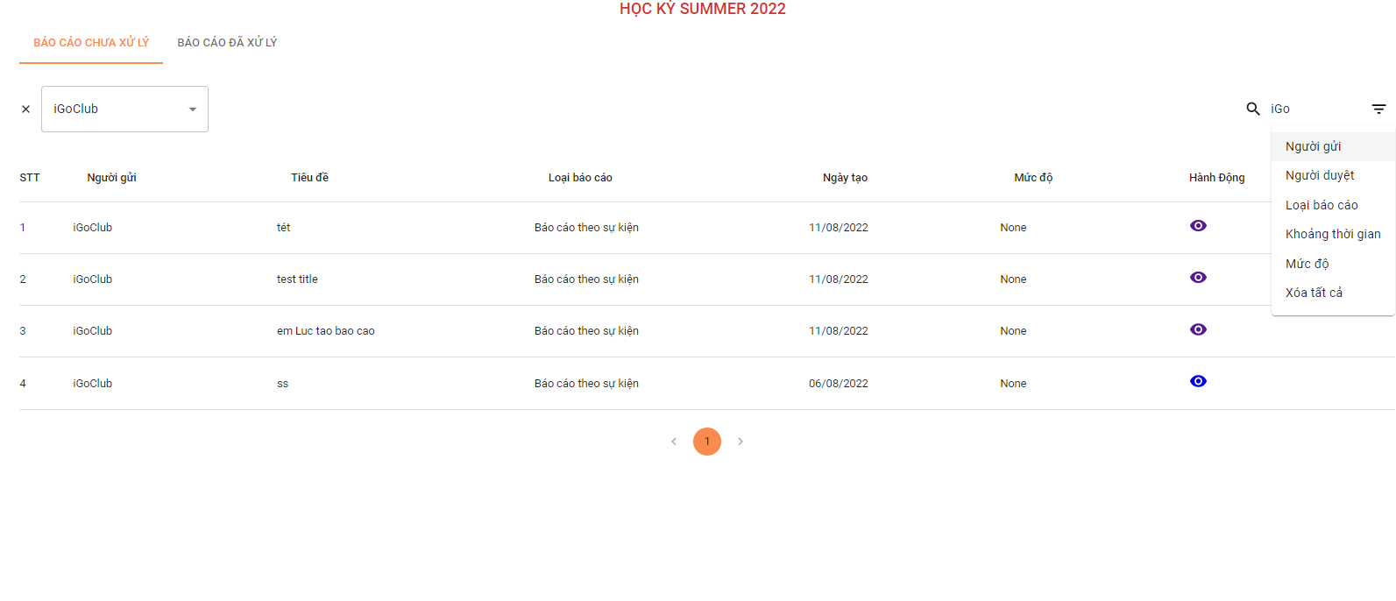

*Figure 281. Filter reports screen*

1.5 Admin filter report by “Người duyệt”

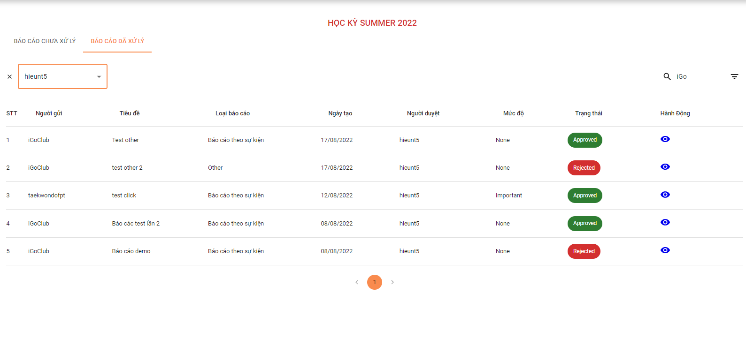

*Figure 282. Filter reports screen*

1.6 Admin filter report by “Loại báo cáo”

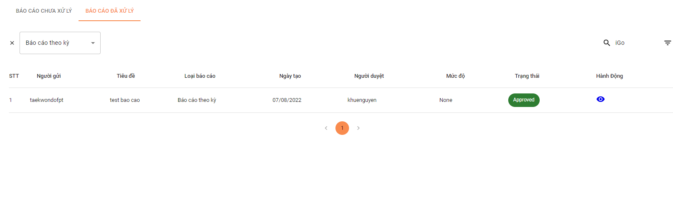

*Figure 283. Filter reports screen*

1.7 Admin filter report by “Khoảng thời gian”

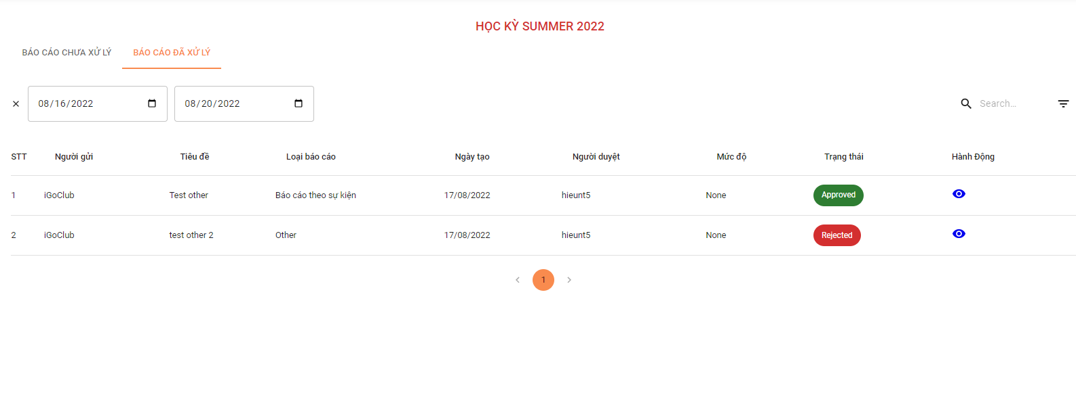

*Figure 284. Filter reports screen*

1.8 Admin filter report by “Mức độ”

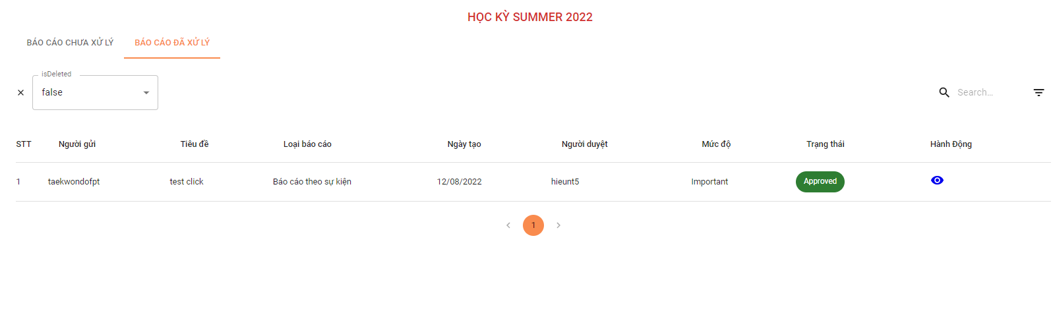

*Figure 285. Filter reports screen*

1.9 Admin clicks detail “Báo cáo chưa xử lý”

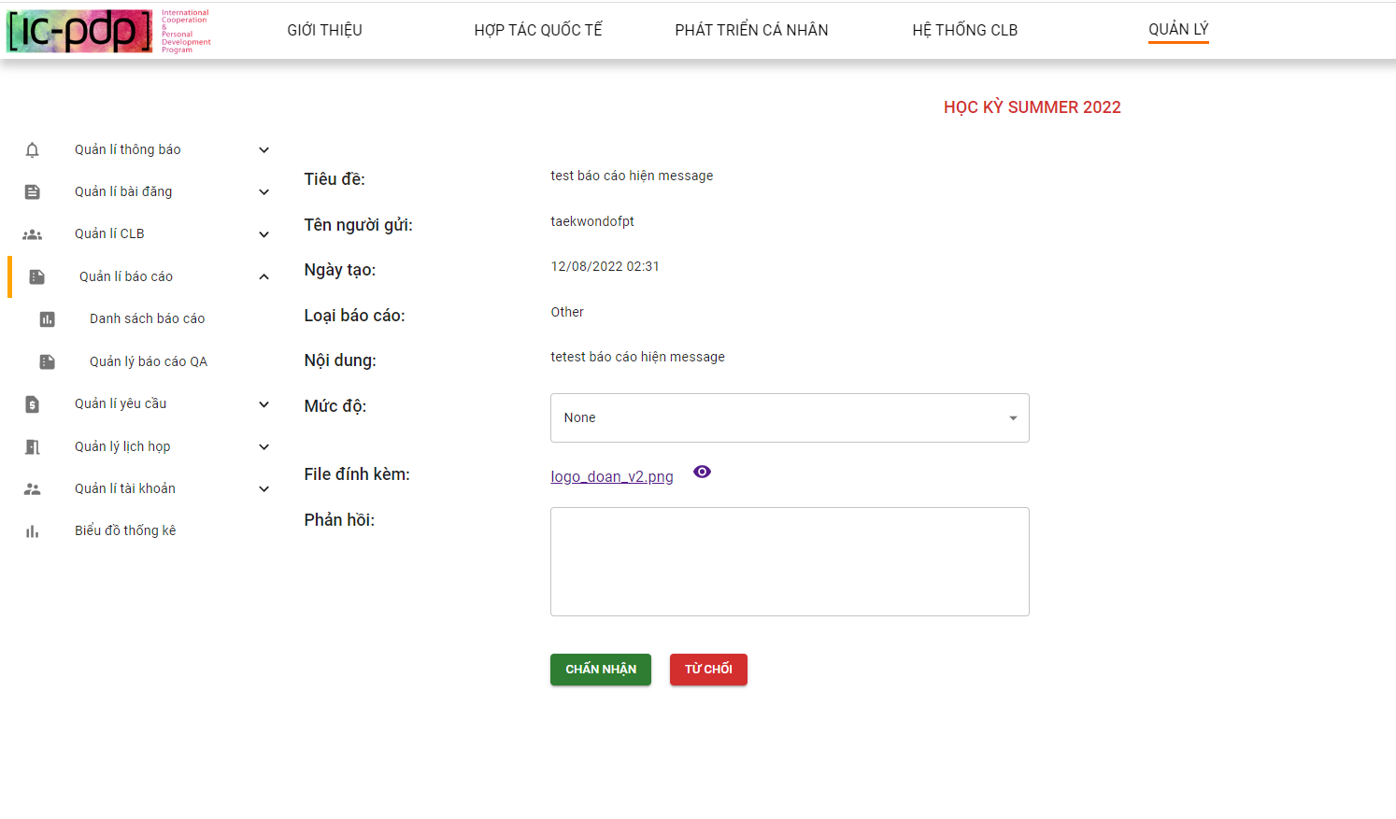

*Figure 286. Detail unprocessed reports screen*

1.10 Admin clicks button “Chấp nhận”

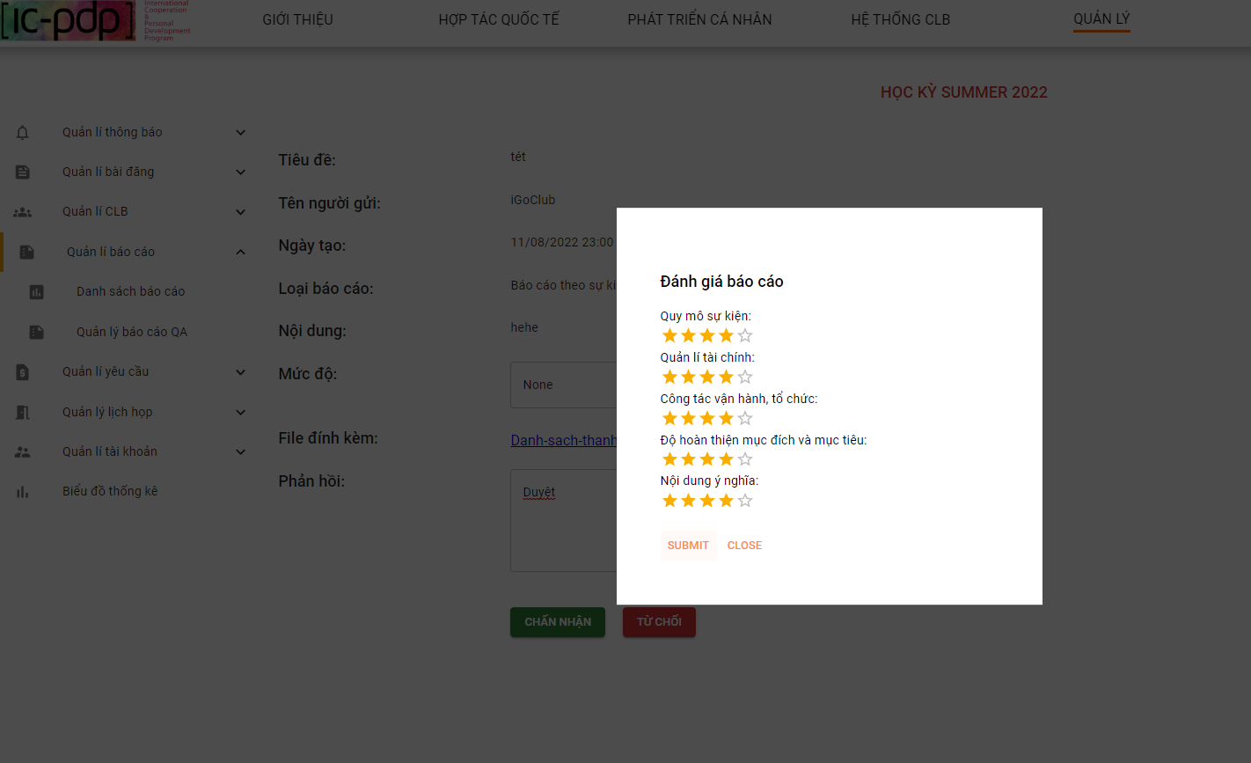

*Figure 287. Evaluation criteria “Báo cáo theo sự kiện” report screen*

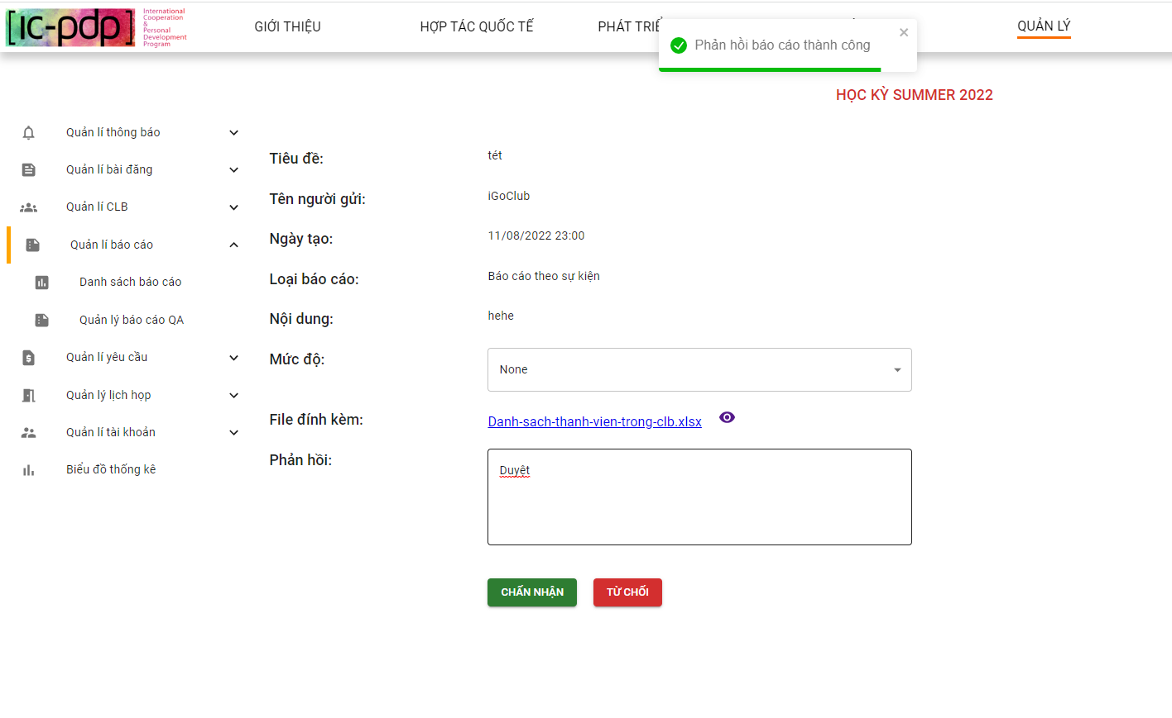

*Figure 288. Review report successfully screen*

1.11 Admin clicks button view detail “Báo cáo đã xử lý”

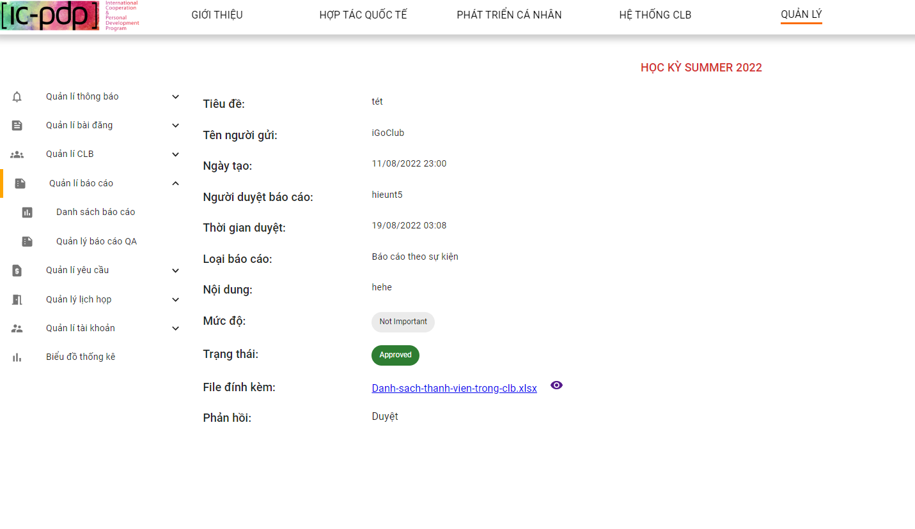

*Figure 289. Detail processed reports screen*

1.12 Admin clicks button view file online

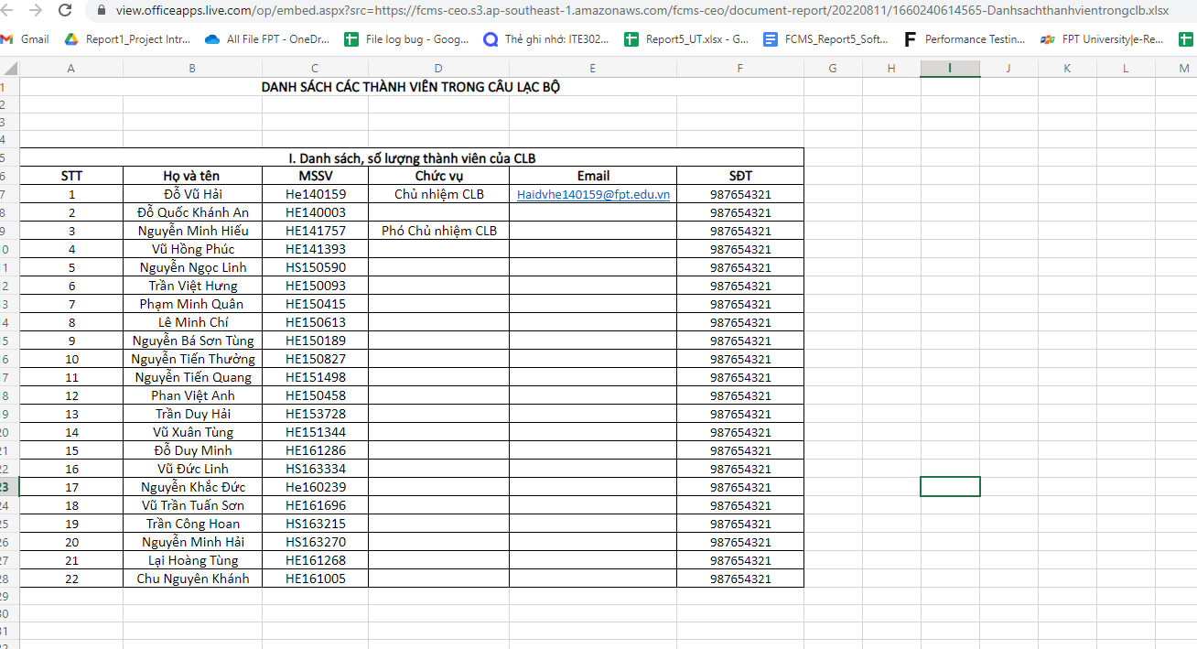

*Figure 290. View online attached file reports screen*

1.13 Admin clicks button download file

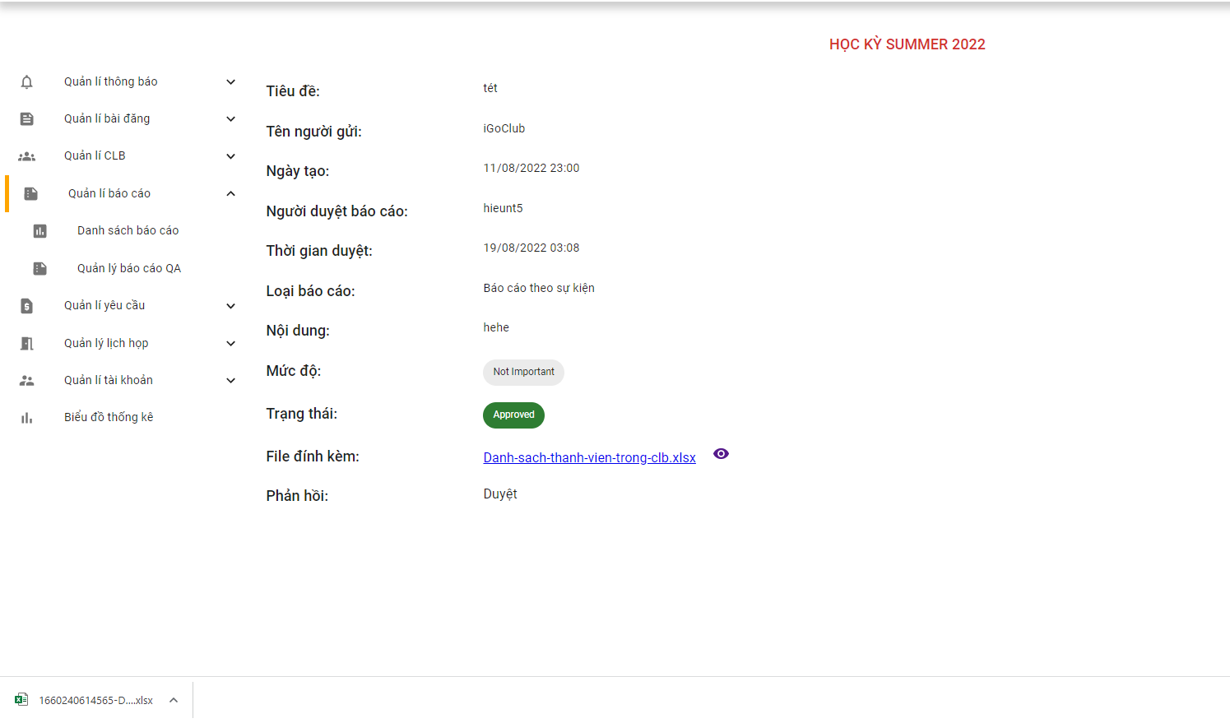

*Figure 291. Download attached file reports screen*

1. **Quản lý báo cáo QA**

2.1 Admin clicks “Quản lý báo cáo QA”

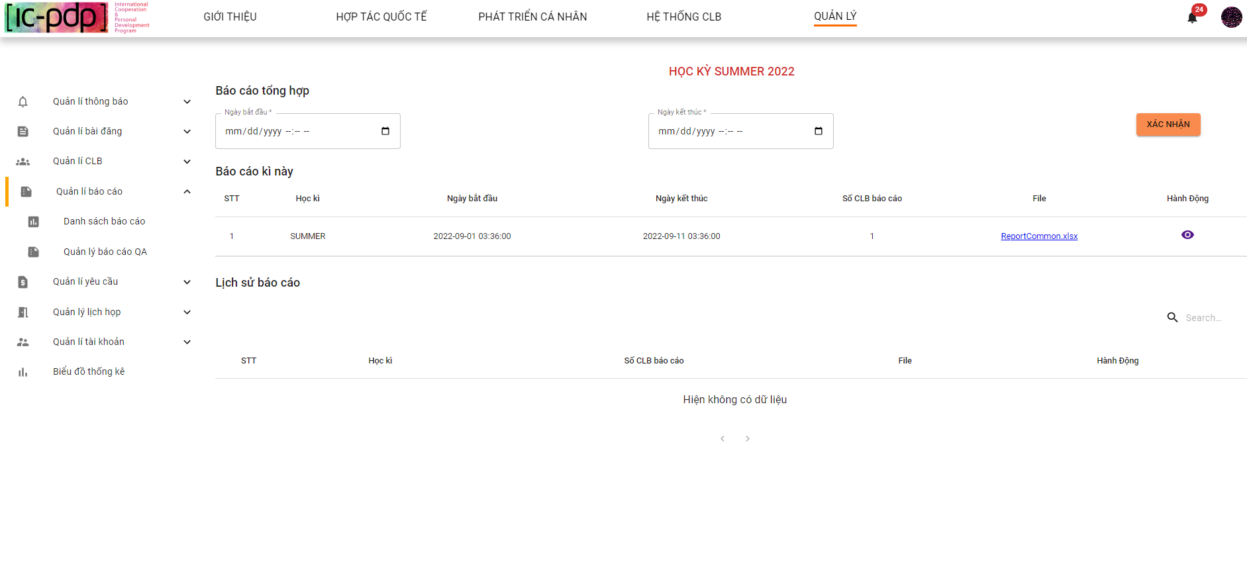

*Figure 292. View final reports semester list screen*

2.2 Admin create “Báo cáo QA” and clicks button “Xác nhận”

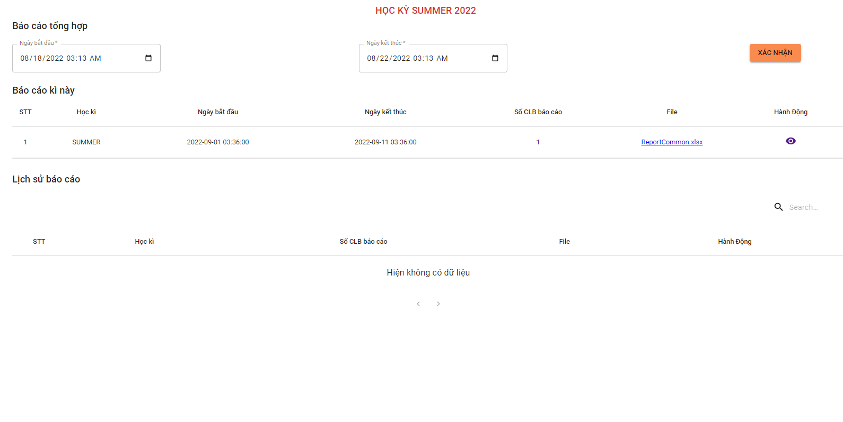

*Figure 293. Create final reports semester screen*

2.3 Admin clicks button view “Báo cáo QA” online

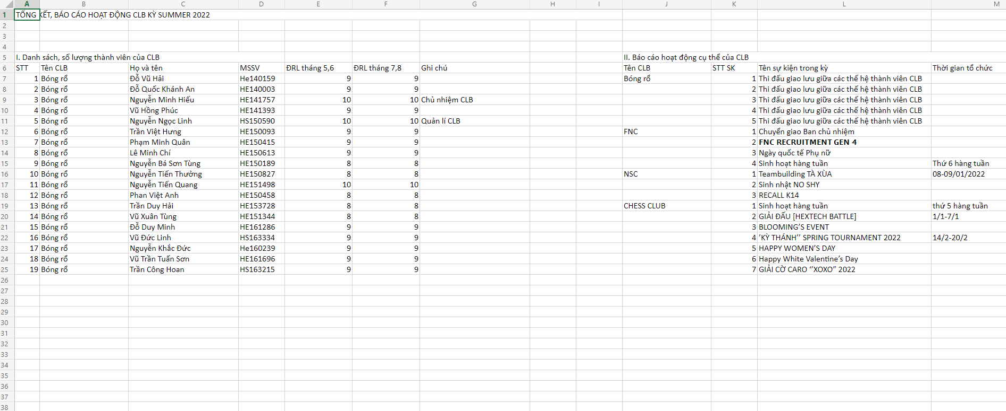

*Figure 294. View file reports semester screen*

2.4 Admin clicks button download “Báo cáo QA”

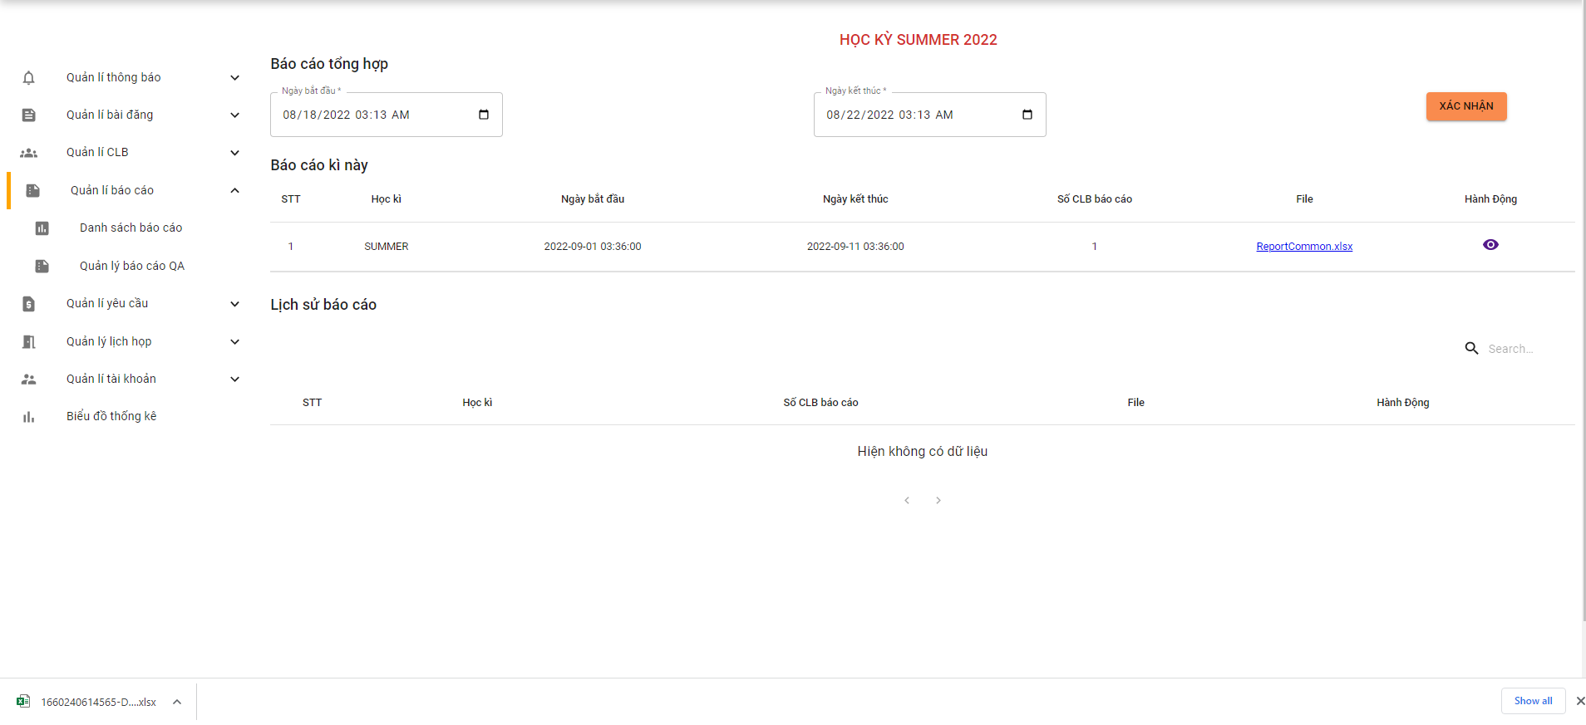

*Figure 295. Download file reports semester screen*

#### 2.6.6 “Quản lý yêu cầu” screen

1.Admn clicks “Danh sách yêu cầu” - “Yêu cầu chưa xử lý”

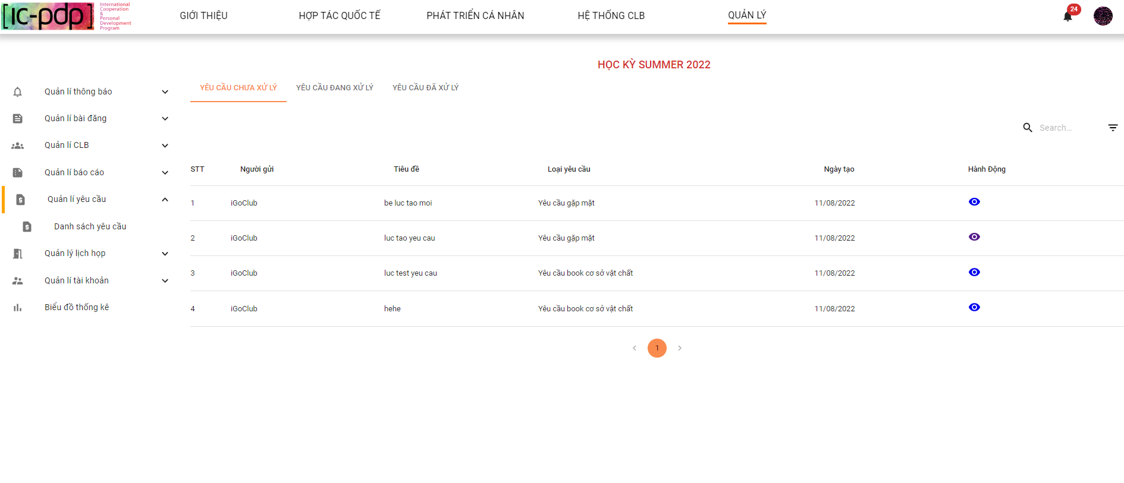

*Figure 296. Unprocessed requests list screen*

1.1 Admin search “Yêu cầu chư xử lý”

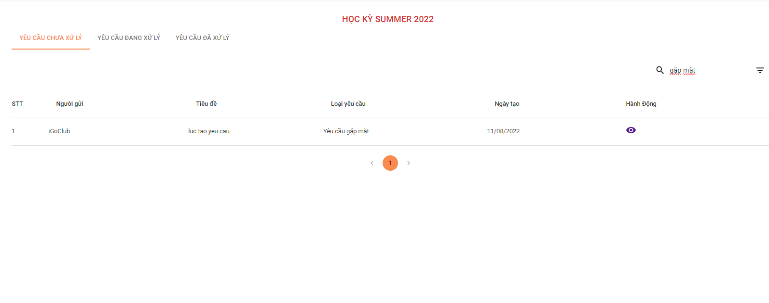

*Figure 297. Processed requests list screen*

1.2 Admin clicks view detail “Yêu cầu chưa duyệt” & clicks button “Duyệt”

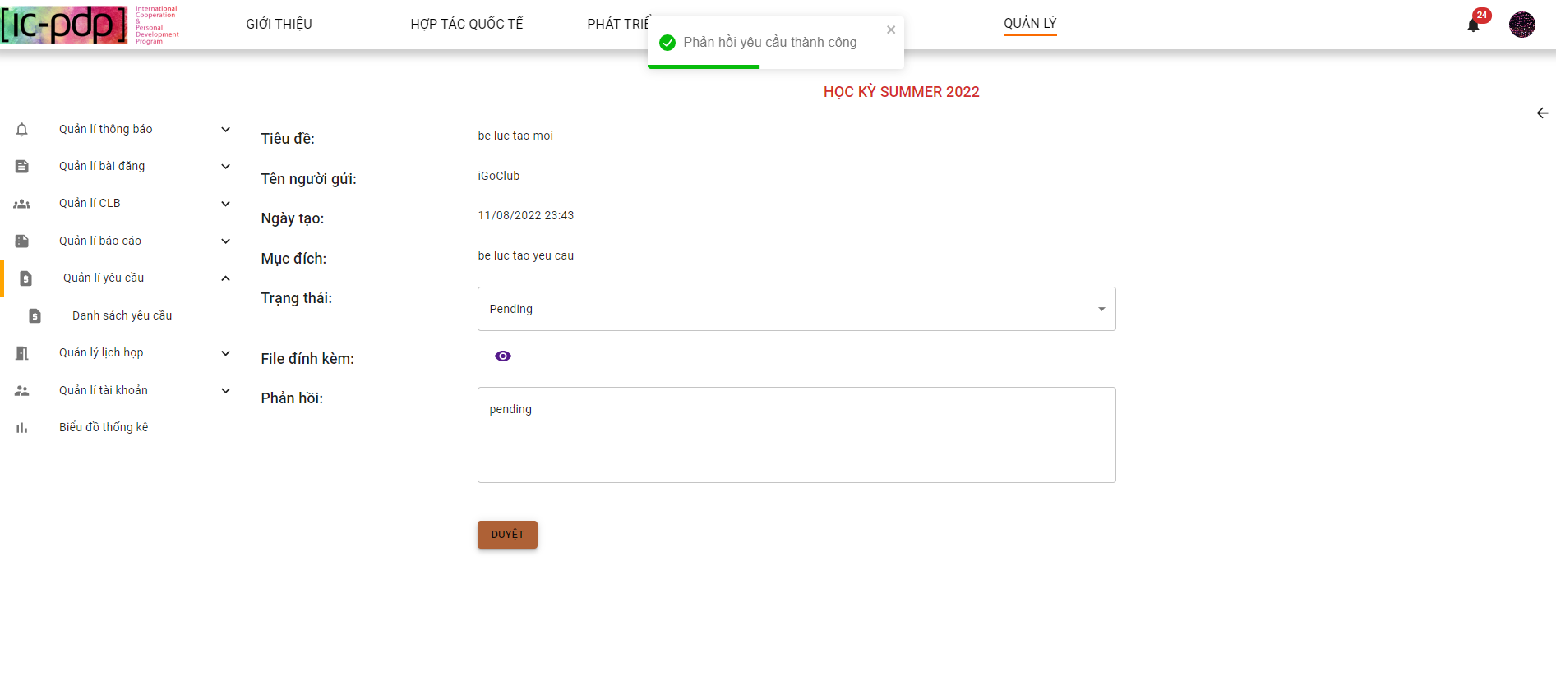

*Figure 298. Detail unprocessed request screen*

2.Admin clicks “Danh sách yêu cầu” - “Yêu cầu đang xử lý”

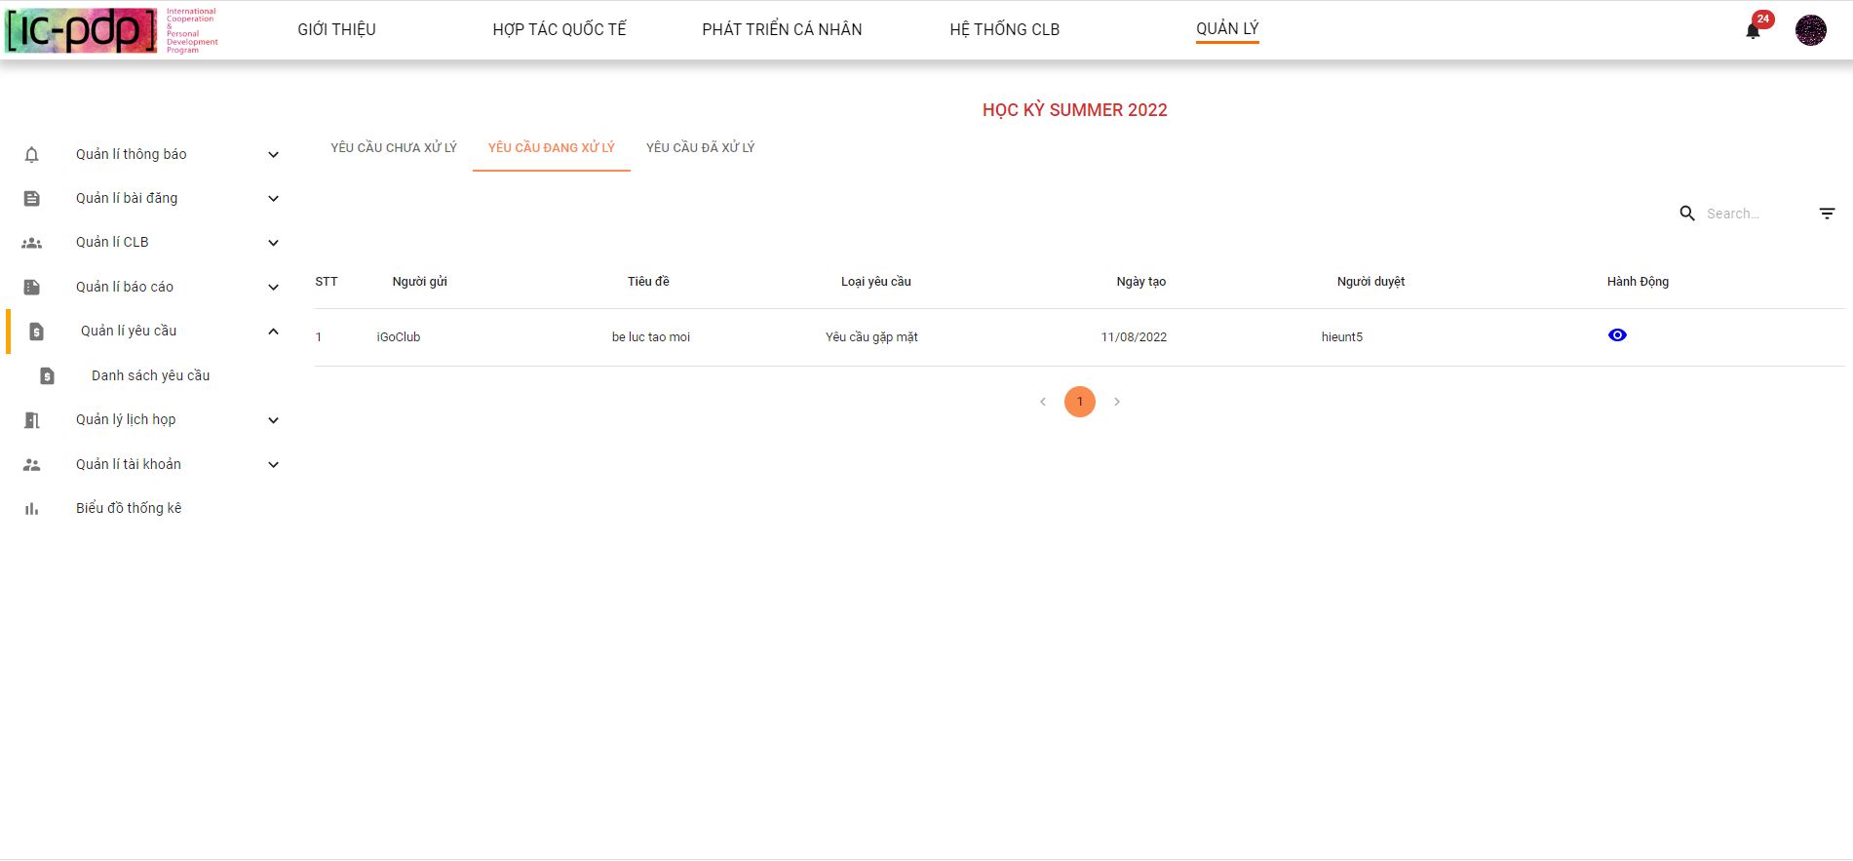

*Figure 299. Being processed requests list screen*

2.1 Admin search “Yêu cầu đang xử lý”

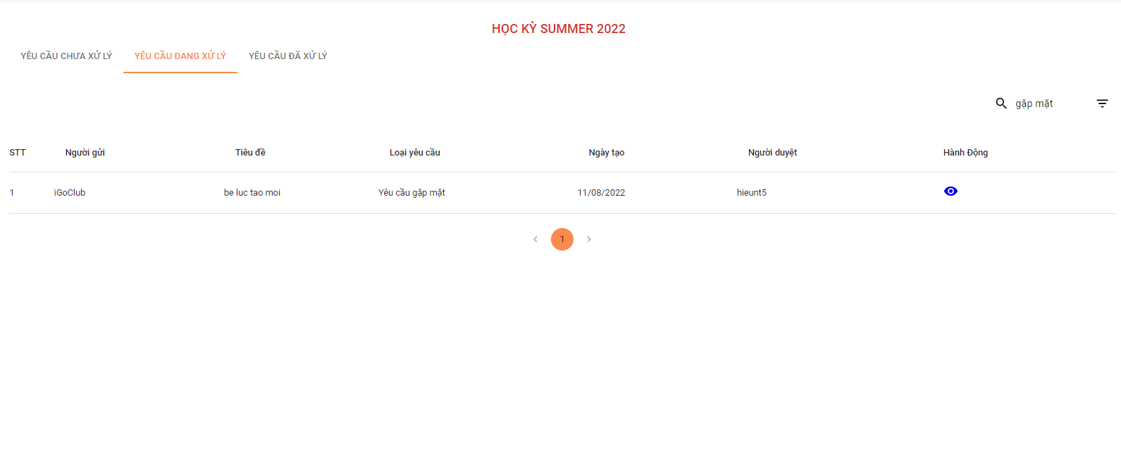

*Figure 300. Search being processed requests screen*

2.2 Admin clicks button view detail - “Yêu cầu đang xử lý”

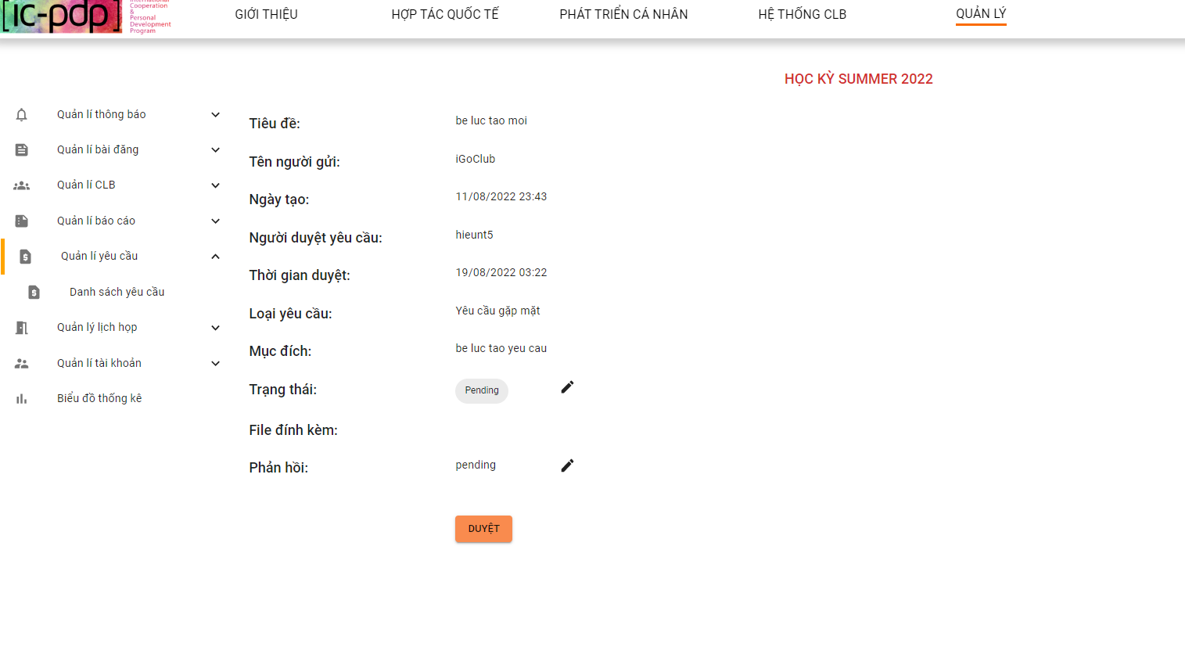

*Figure 301. Detail being processed request screen*

2.3 Admin clicks button edit “Trang thái” & button edit “Phải hồi”

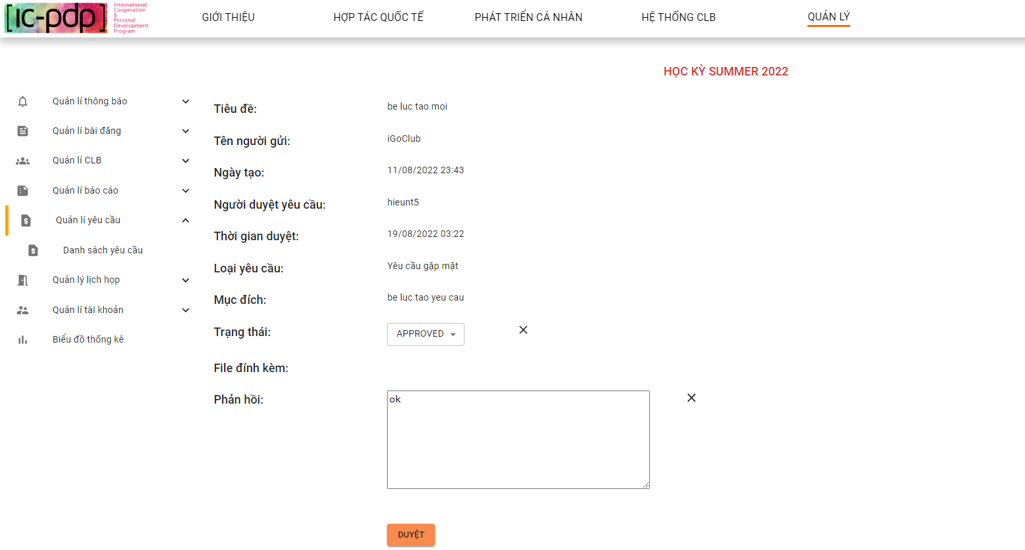

*Figure 302. Review being processed request screen*

2.4 Admin clicks button “Duyệt”

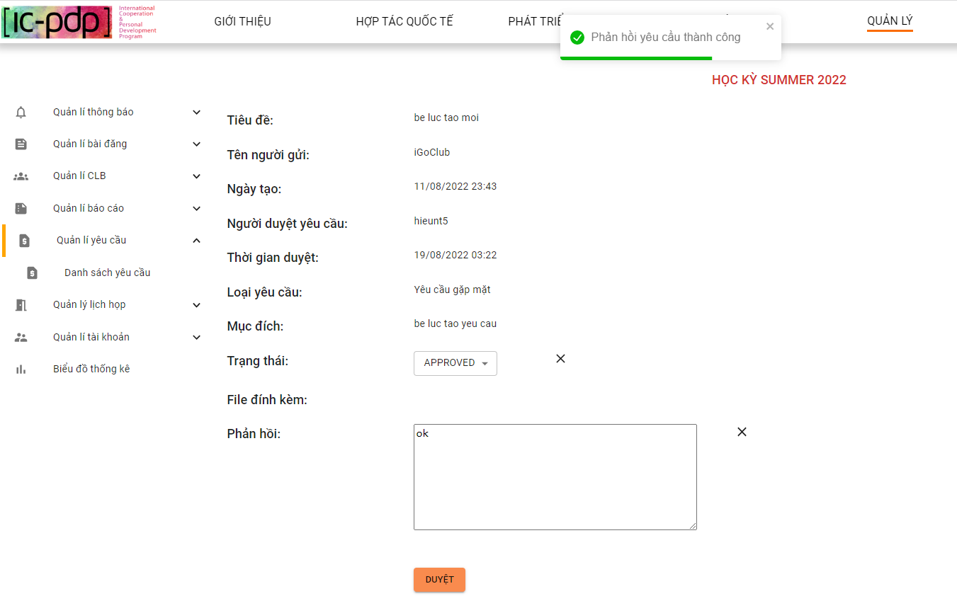

*Figure 303. Review being processed request successfully screen*

3.Admin clicks “Danh sách yêu cầu - yêu cầu đã xử lý”

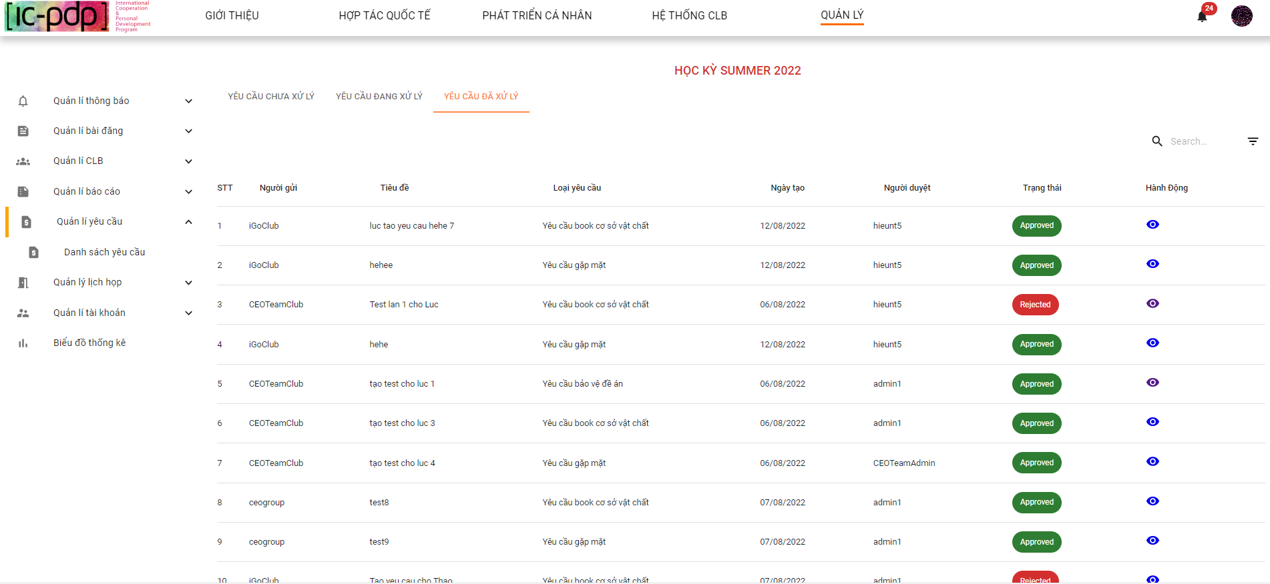

*Figure 304. Processed requests list screen*

3.1 Admin search “Yêu cầu đã xử lý”

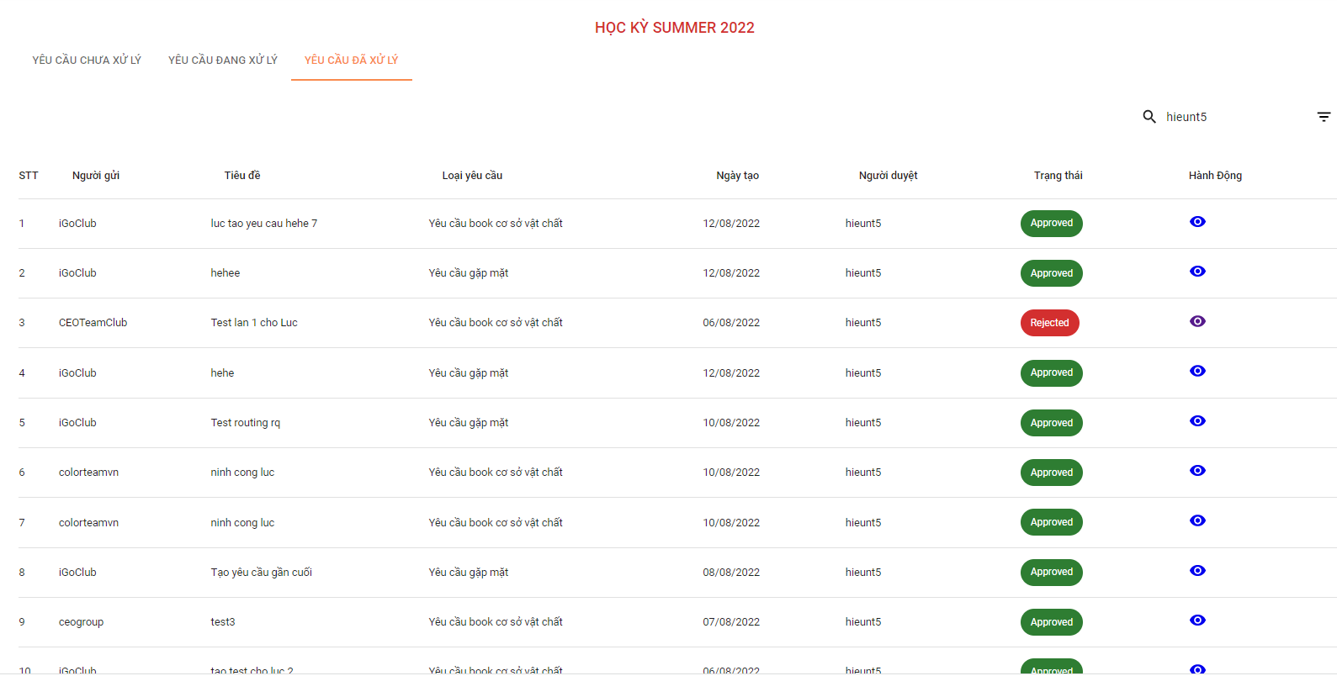

*Figure 305. Search processed requests list screen*

3.2 Admin clicks button view detail - “Yêu cầu đã xử lý”

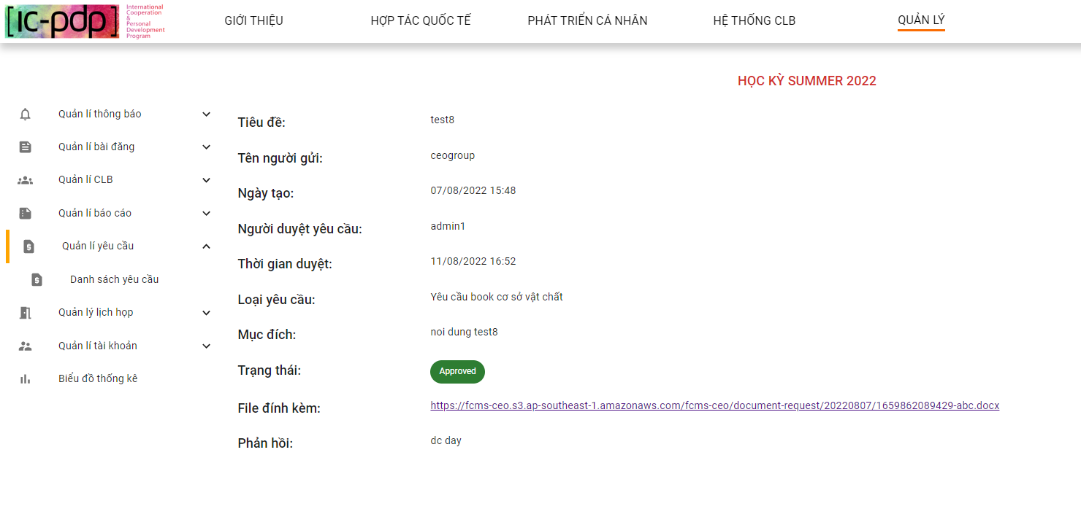

*Figure 306. Detail processed request screen*

3.3 Admin clicks download file “yêu cầu”

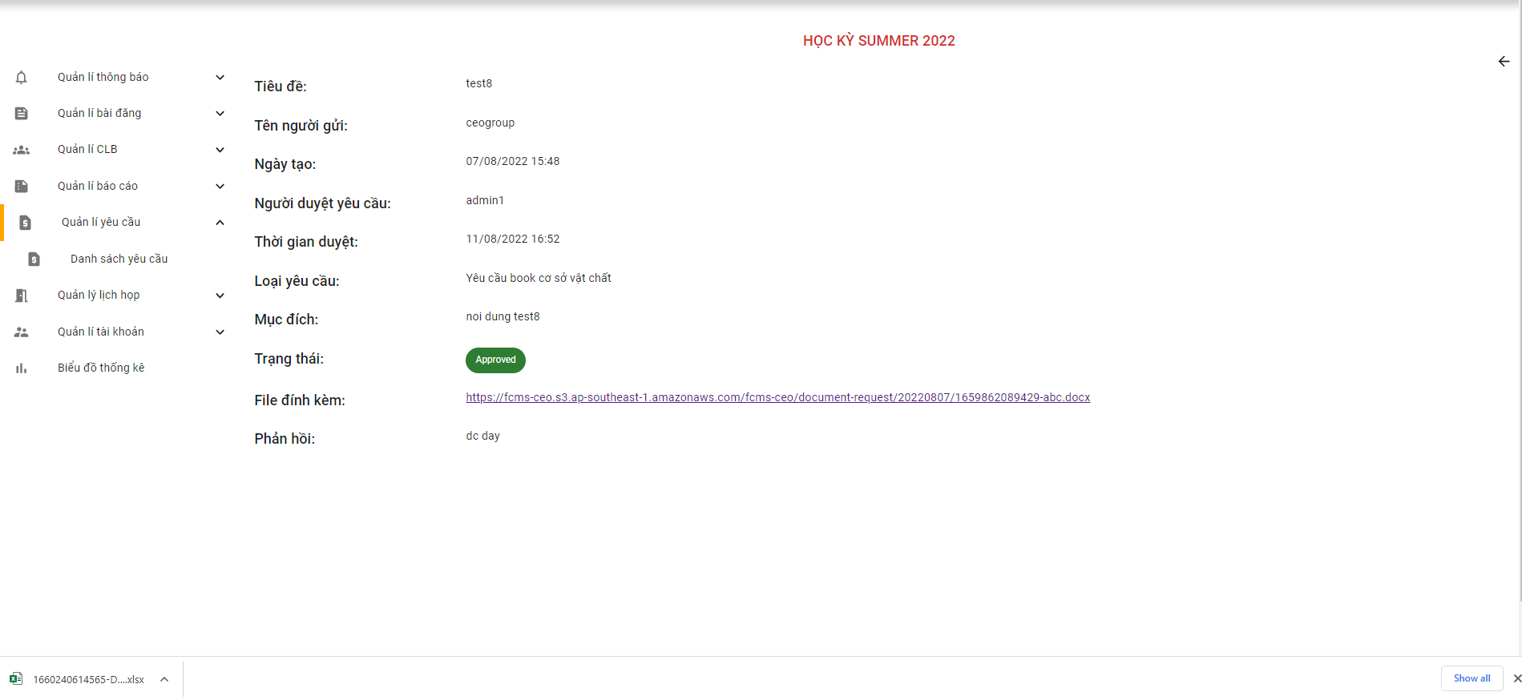

*Figure 307. Download attached file request screen*

3.4 Admin filter request by “yêu cầu gặp mặt”

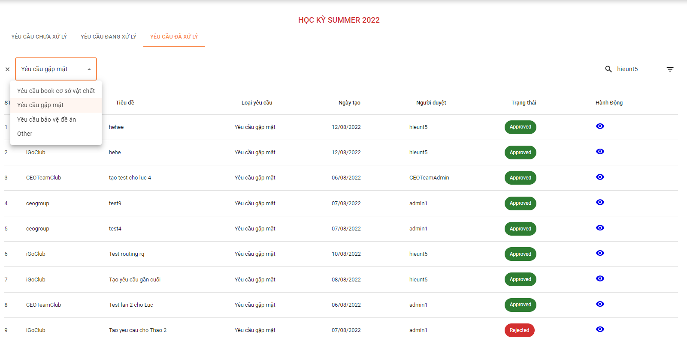

*Figure 308. Filter requests screen*

#### 2.6.7 “Quản lý lịch họp” screen

**1. Admin clicks “Tạo lịch họp”**

1.1 Admin create “Lịch họp”

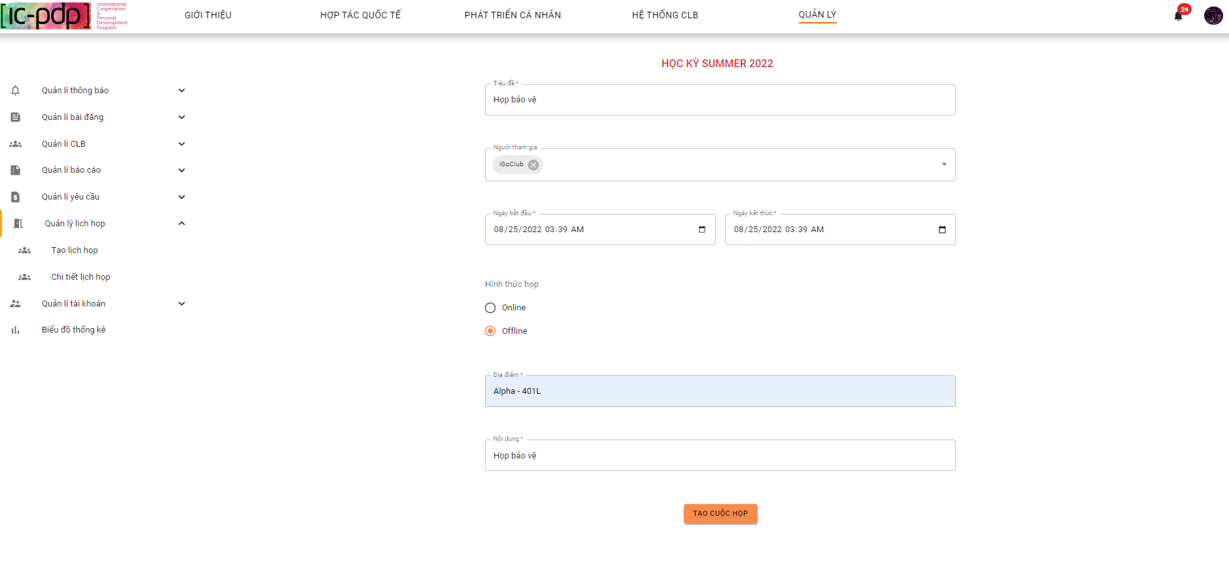

*Figure 309. Creating meeting screen*

1.2 Admin clicks button “Tạo lịch họp”

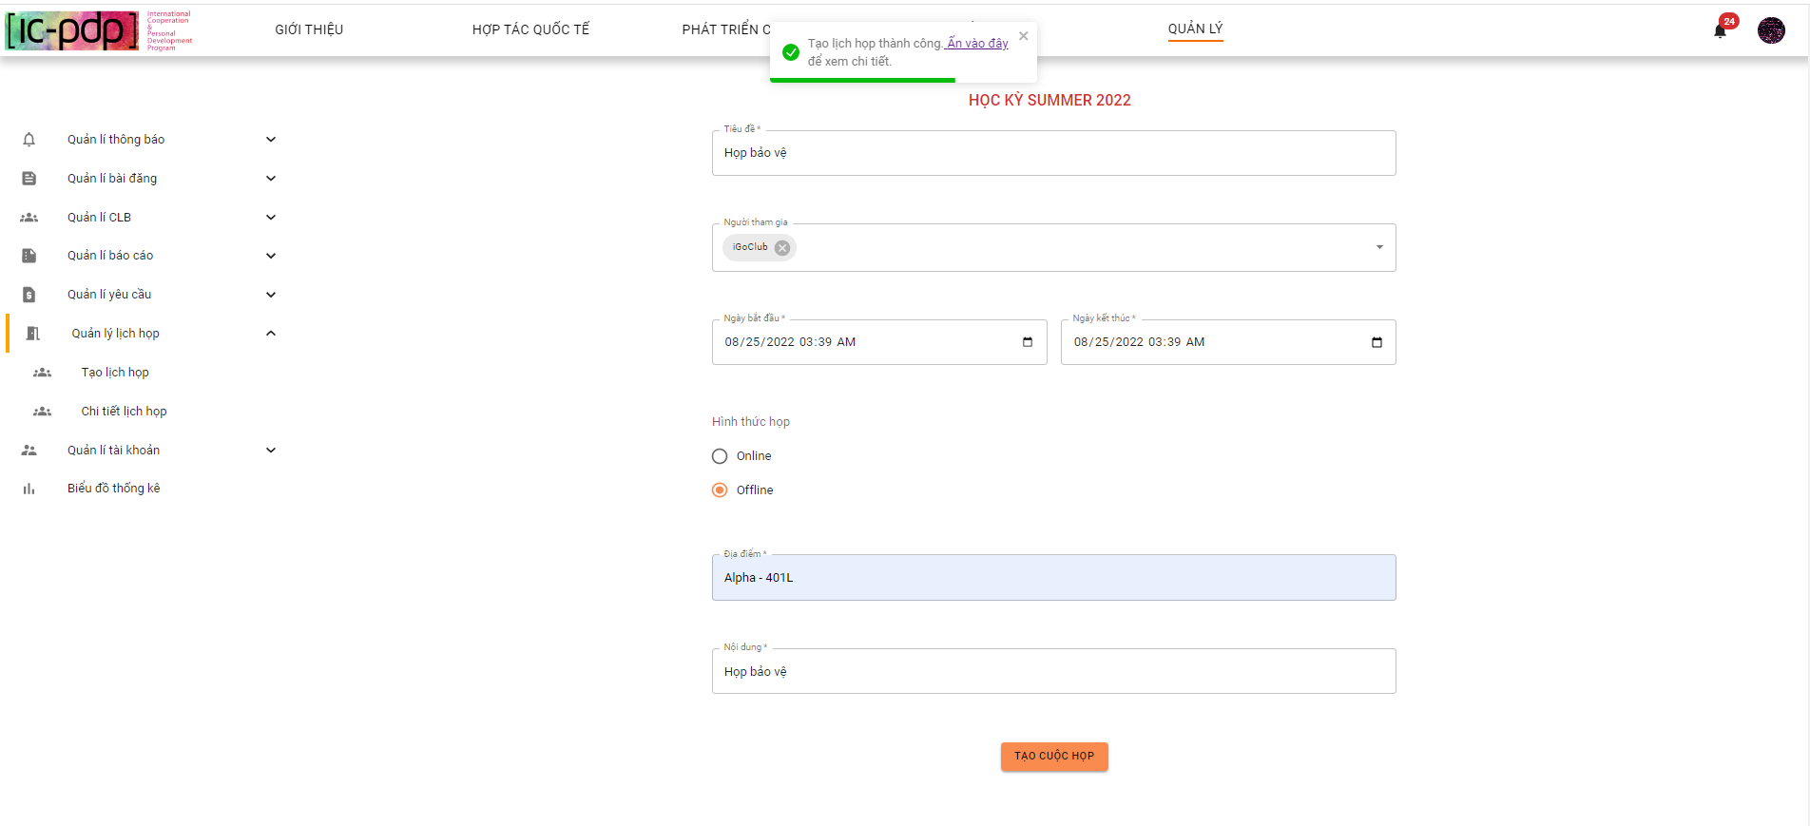

*Figure 310. Creating meeting successfully screen*

**2. Admin clicks “Chi tiết lịch họp”**

2.1 Admin view meeting

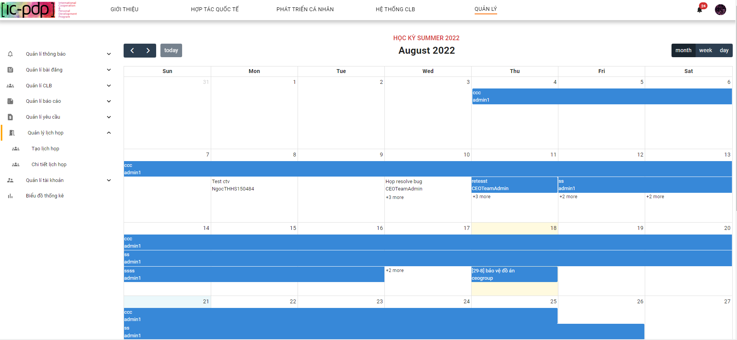

*Figure 311. Meeting calendar screen*

2.2 Admin clicks button “next”

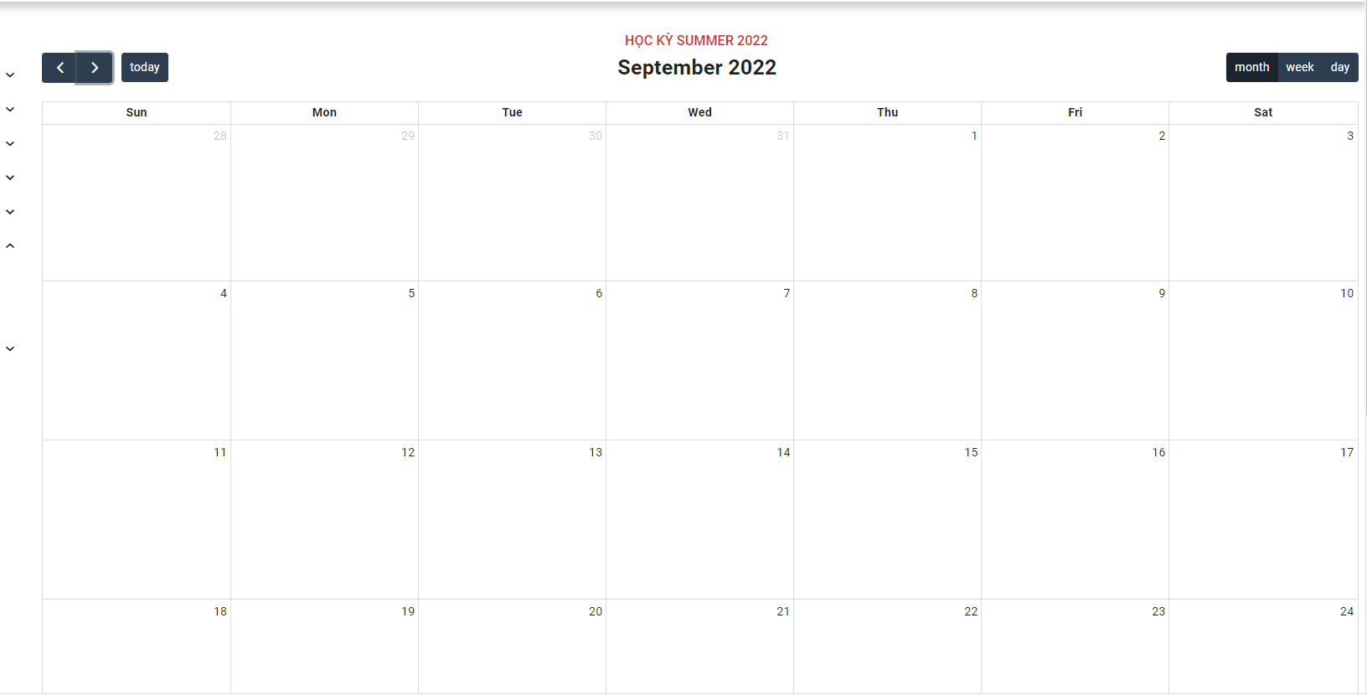

*Figure 312. Meeting calendar screen*

2.3 Admin hovers to view detail meeting

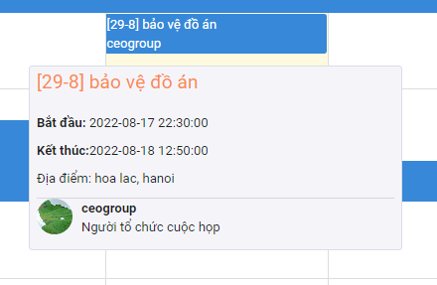

*Figure 313. Detail meeting screen*

2.3 Admin confirm/reject meeting

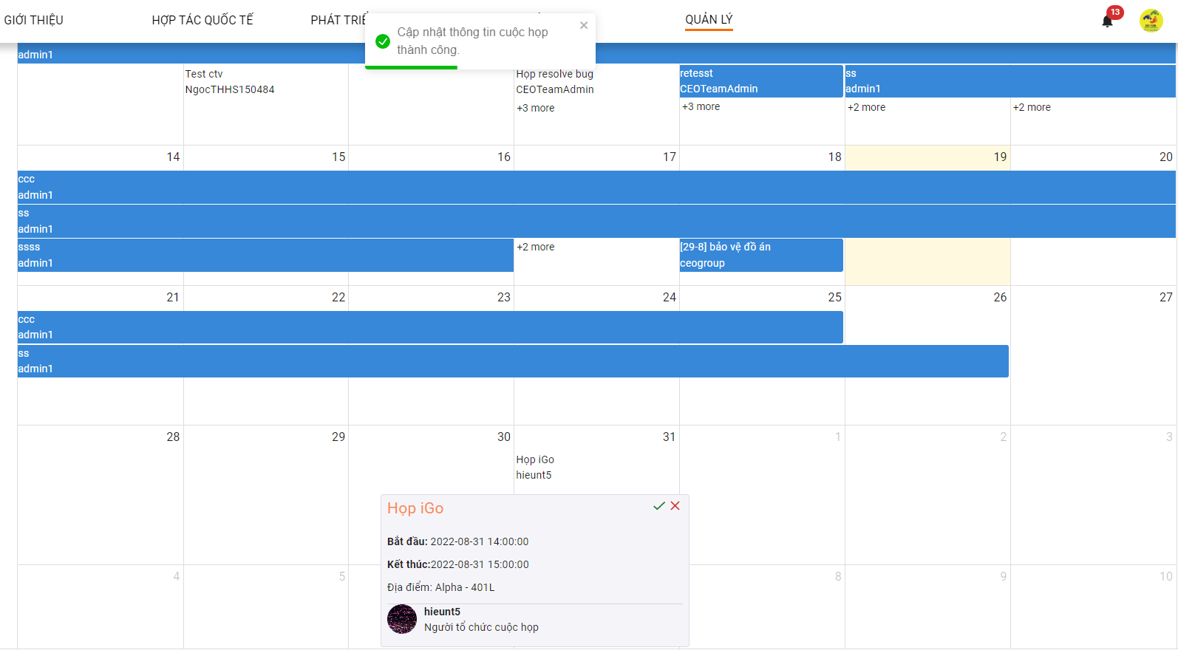

*Figure 314. Confirm/Reject meeting screen*

#### 2.6.8 “Quản lý tài khoản” screen

**1. Admin “Duyệt tài khoản”**

1.1 Admin clicks “Duyệt tài khoản” - “Câu lạc bộ”

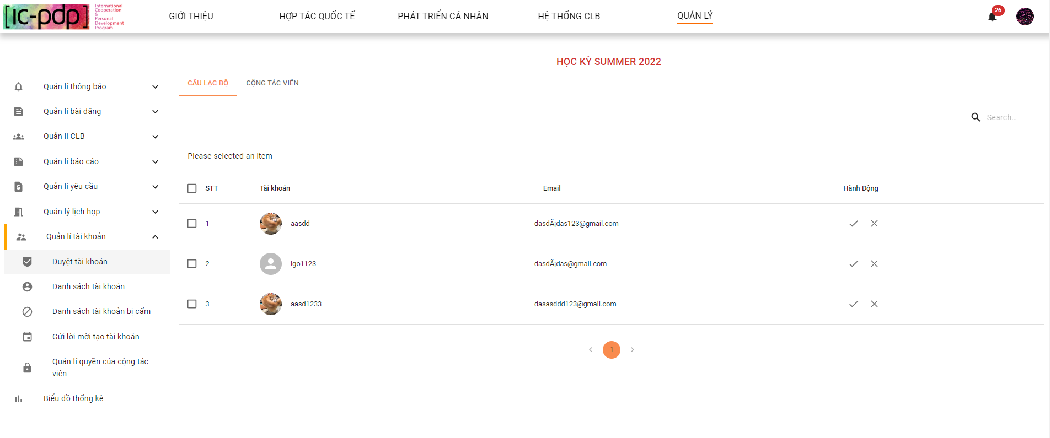

*Figure 315. Review Club Manager account screen*

1.2 Admin clicks “Duyệt tài khoản” - “Cộng tác viên”

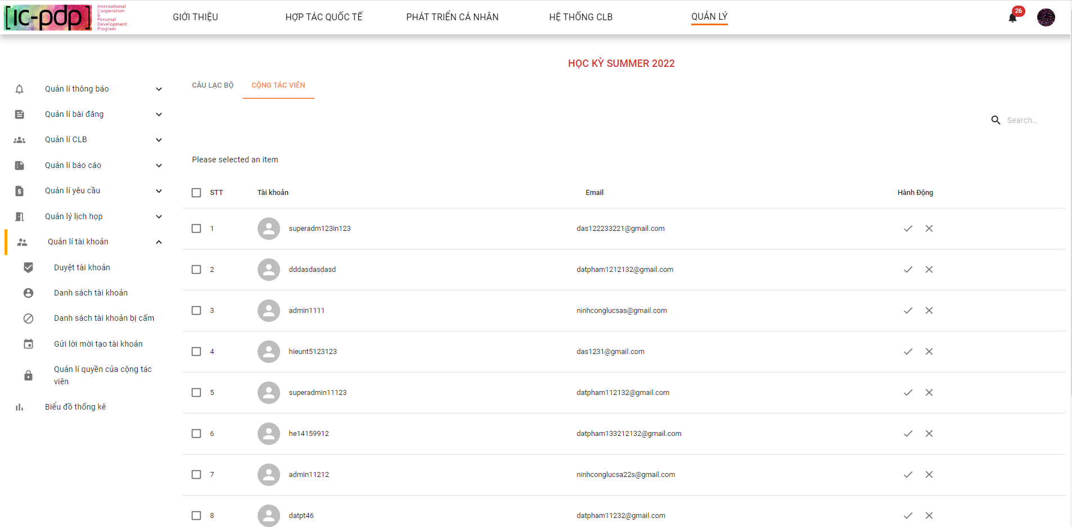

*Figure 316. View list account waiting for approval*

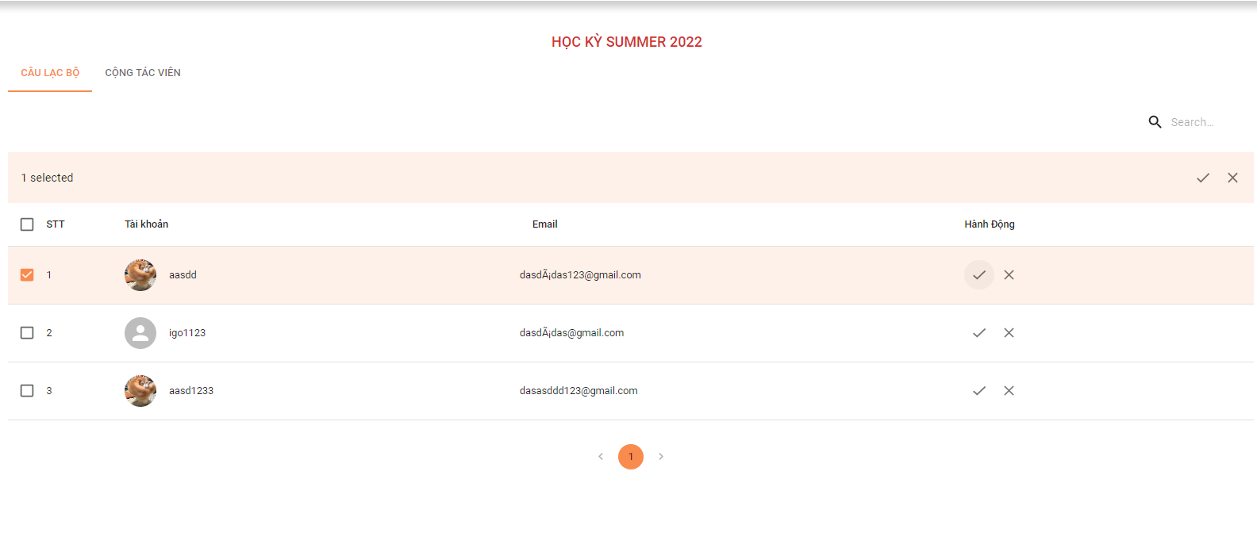

*Figure 317. Selecting account to approval*

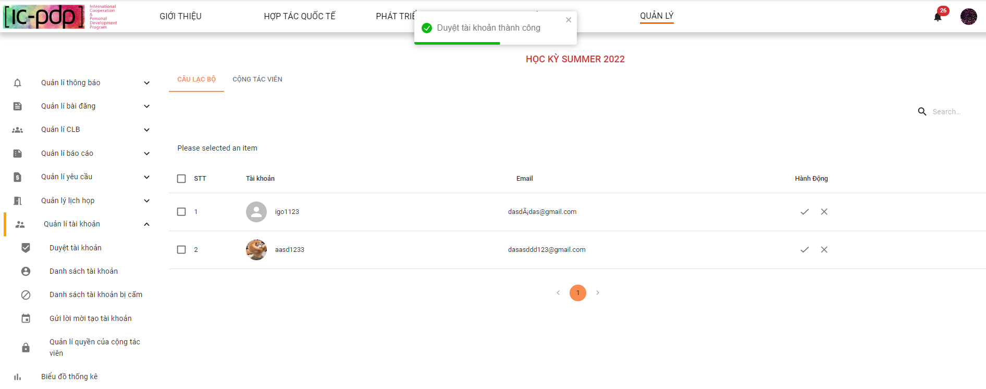

*Figure 318. Approval account result*

1.3 Admin clicks search field

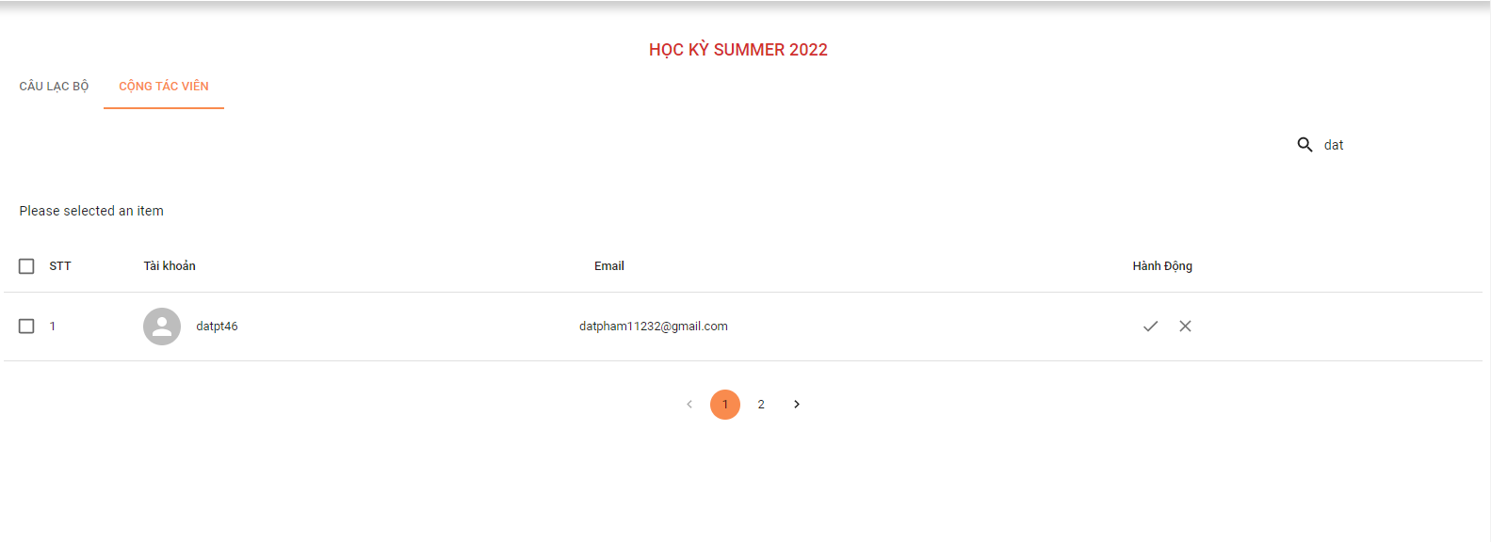

*Figure 319. Searching account*

**2. “Danh sách tài khoản”**

2.1 Admin clicks “Danh sách tài khoản”

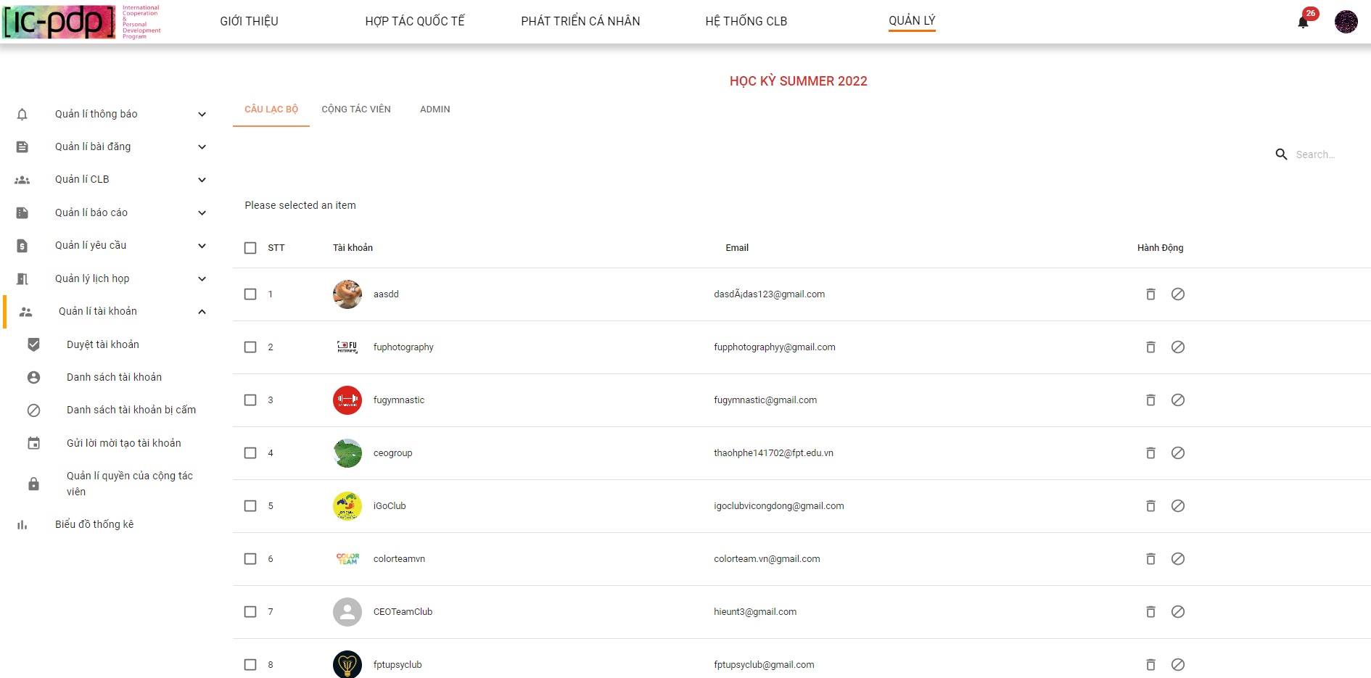

*Figure 320. View list accounts*

2.2 Admin clicks button “Xóa tài khoản”

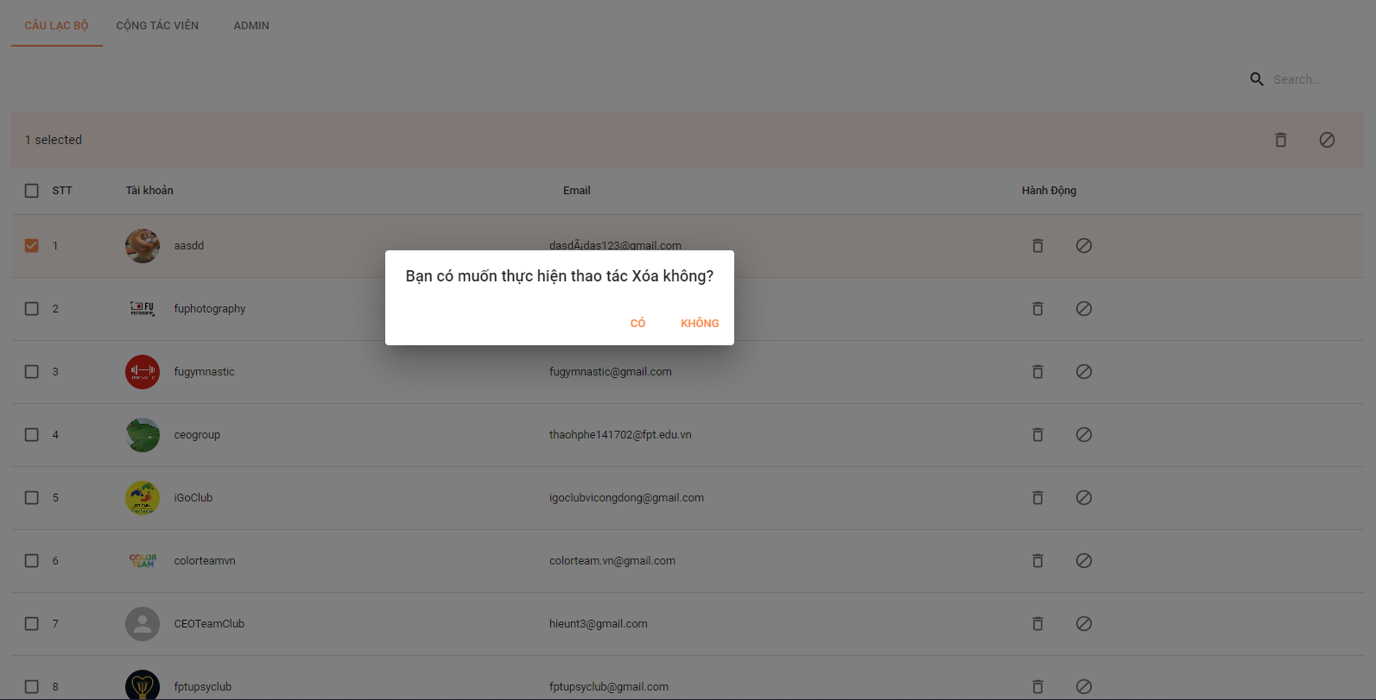

*Figure 321. Deleting account*

2.3 Admin clicks button “Cấm tài khoản”

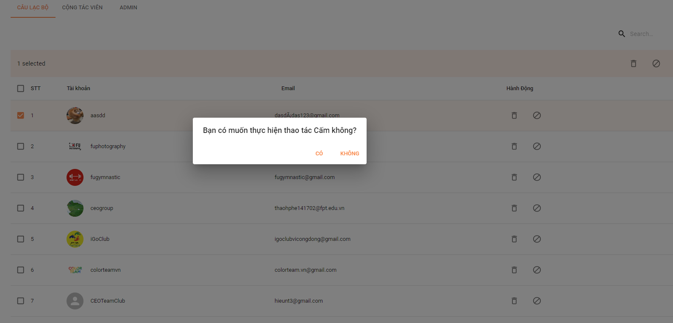

*Figure 322. Banning account*

**3. “Danh sách tài khoản bị cấm”**

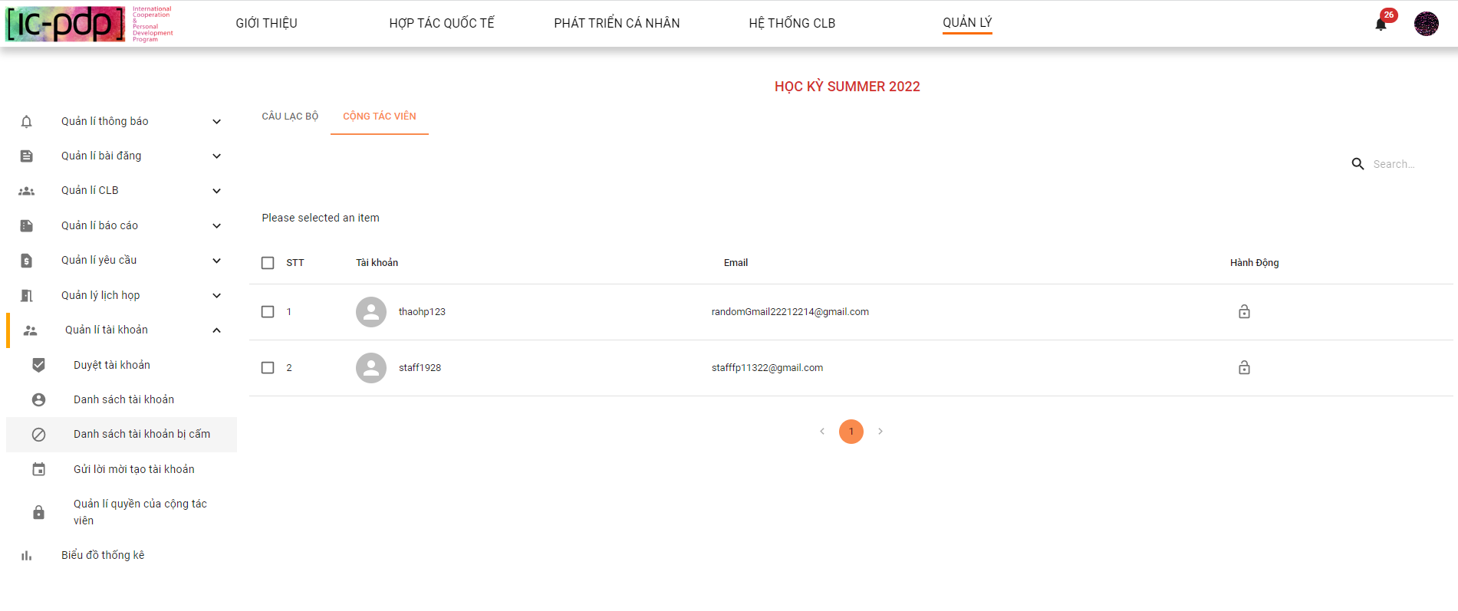

*Figure 323. List account is banned*

3.1 Admin clicks button “Gỡ cấm tài khoản”

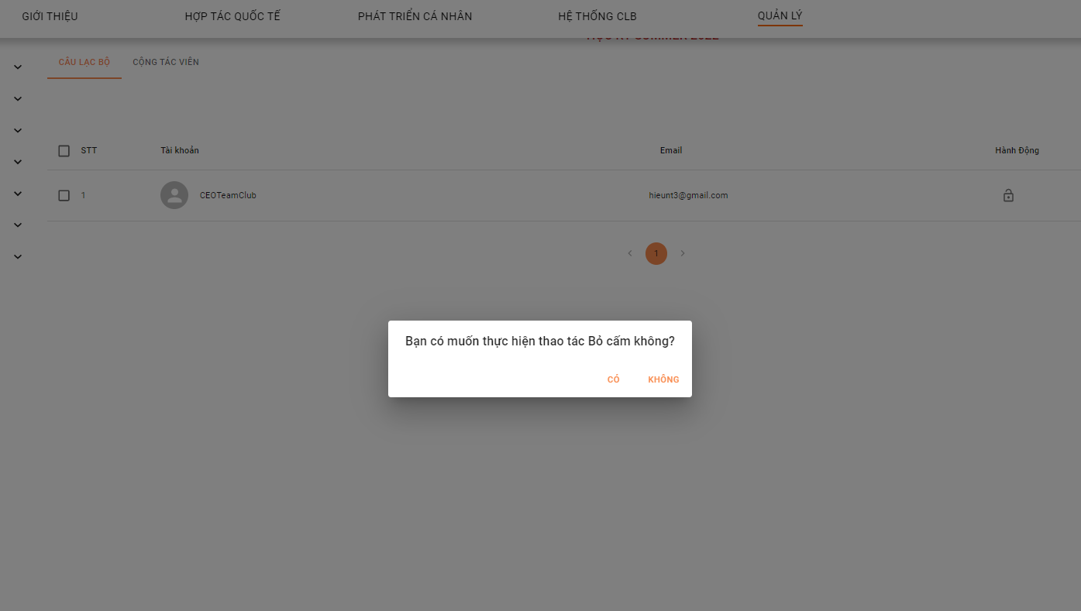

*Figure 324. Unban a account*

**4. “Gửi lời mời tạo tài khoản”**

4.1. Admin clicks button “Gửi lời mời” - “Tạo tài khoản Câu lạc bộ”

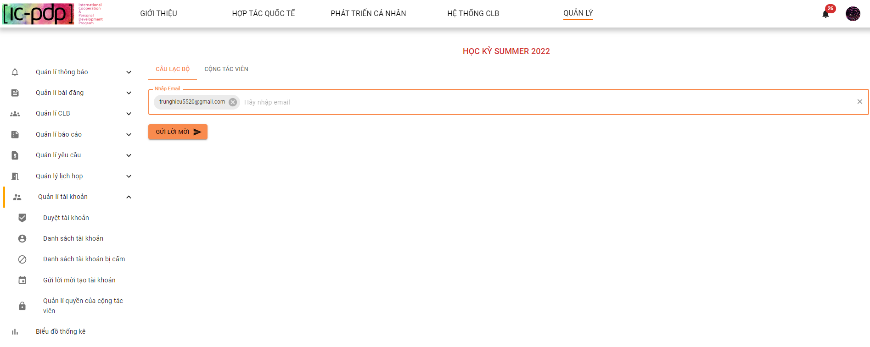

*Figure 325. Sending invitation to create account Club Manager*

4.2. Admin clicks button “Gửi lời mời” - “Tạo tài khoản Cộng tác viên”

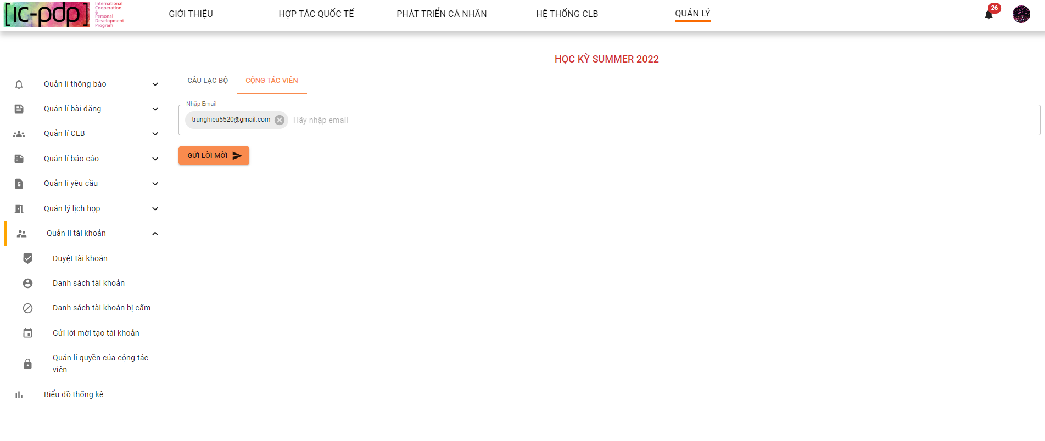

*Figure 326. Sending invitation to create account Collaborator*

**5. “Quản lý quyền cộng tác viên”**

5.1 Admin clicks button “Cài đặt quyền cộng tác viên”

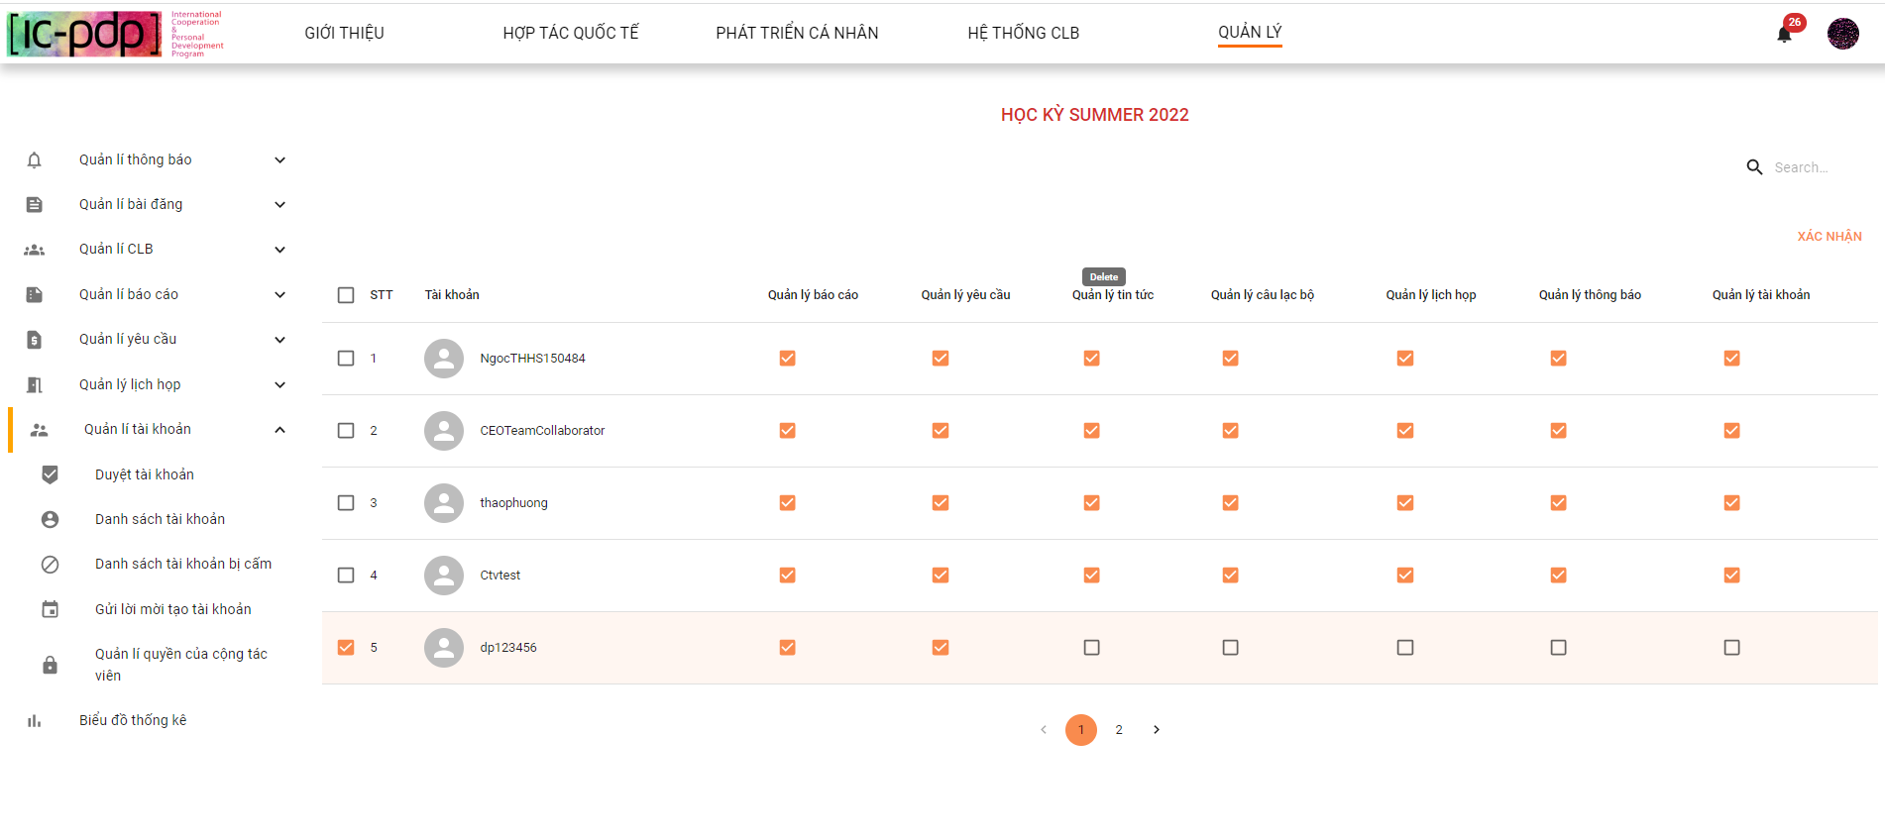

*Figure 327. Setting permissions collaborator result*

5.2 Admin clicks button “Xác nhận”

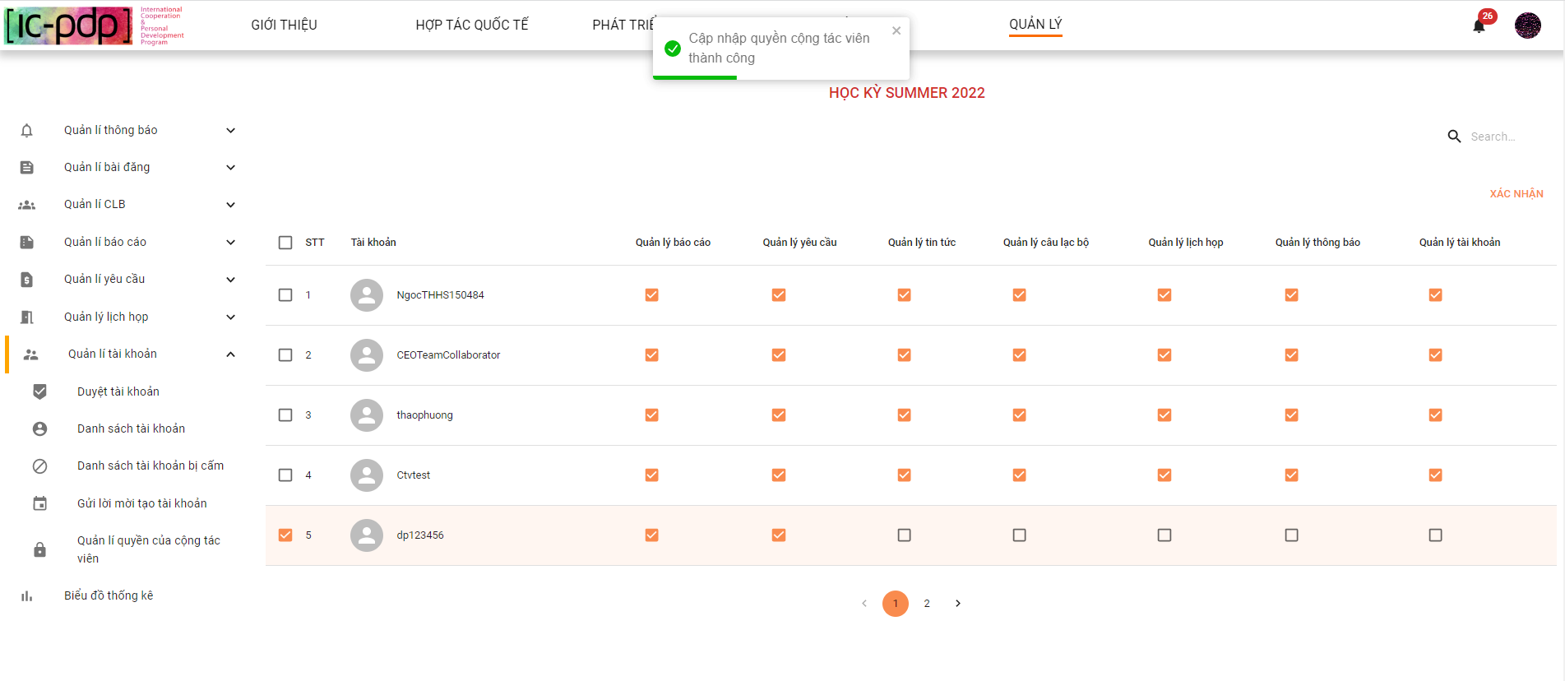

*Figure 328. Setting permissions collaborator result*

#### 2.6.9 “Biểu đồ thống kê” screen

2.6.9.1 “Thống kê người dùng (all role)”

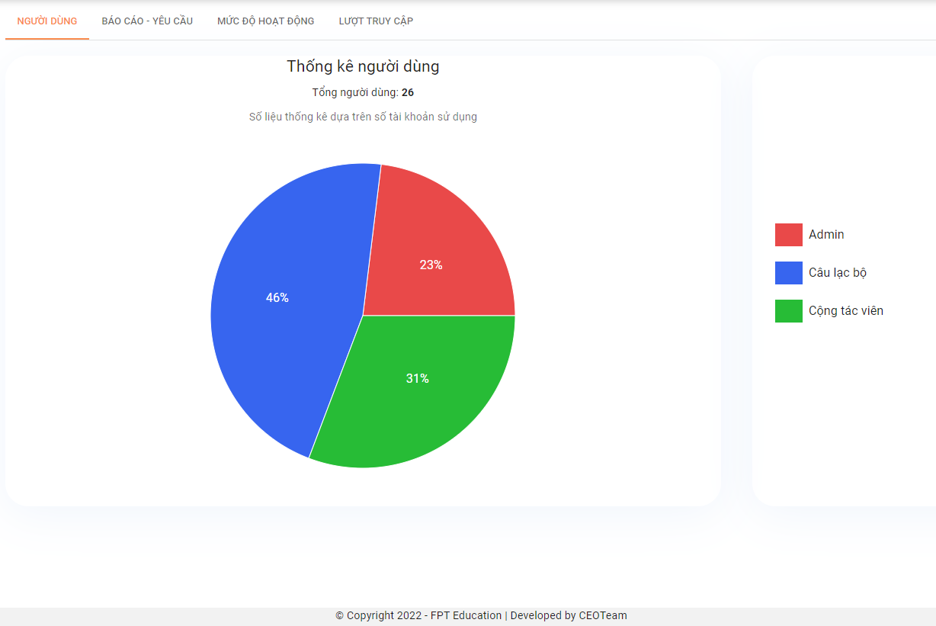

*Figure 329. Statistical number of user*

2.6.9.2 “Báo cáo - yêu cầu (Admin)”

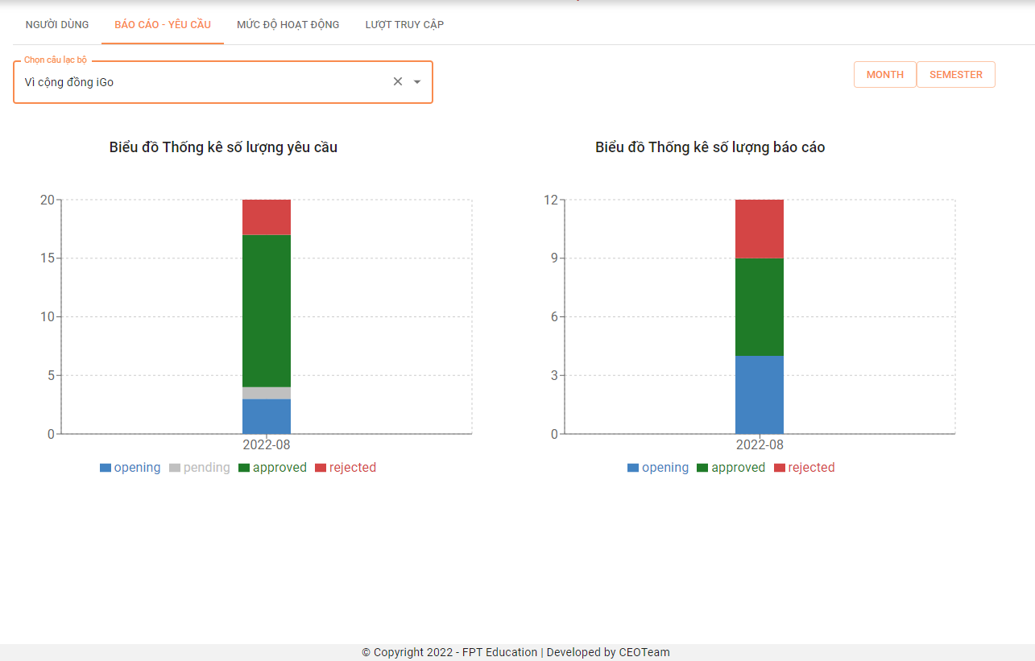

*Figure 330. Statistical report and request*

2.6.9.3 “Mức độ hoạt động”

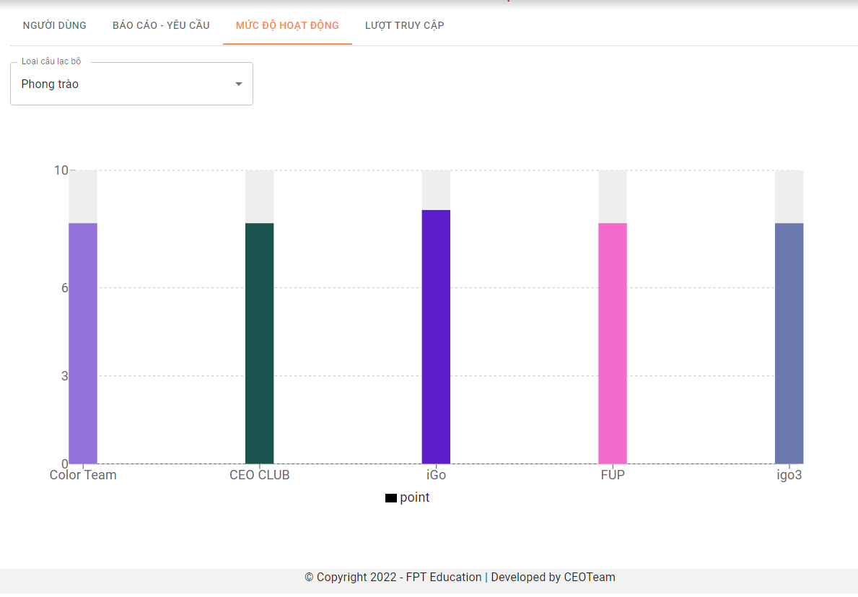

*Figure 321. Activity point of club*

2.6.9.4 “Lượt truy cập”

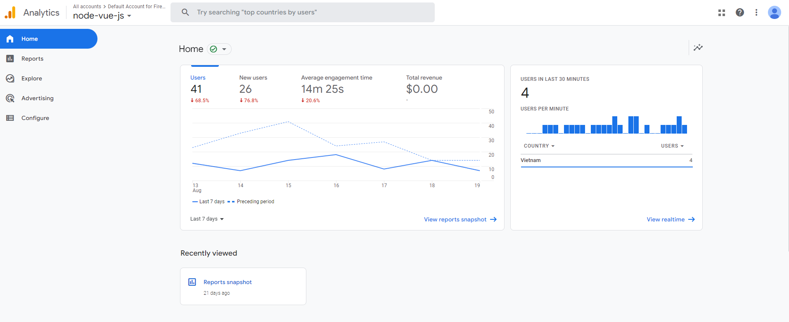

*Figure 322. Google Analytics Report*

### 2.7. Collaborator

Features of Collaborator are the same with Admin, except if Collaborator is limited some feature by admin

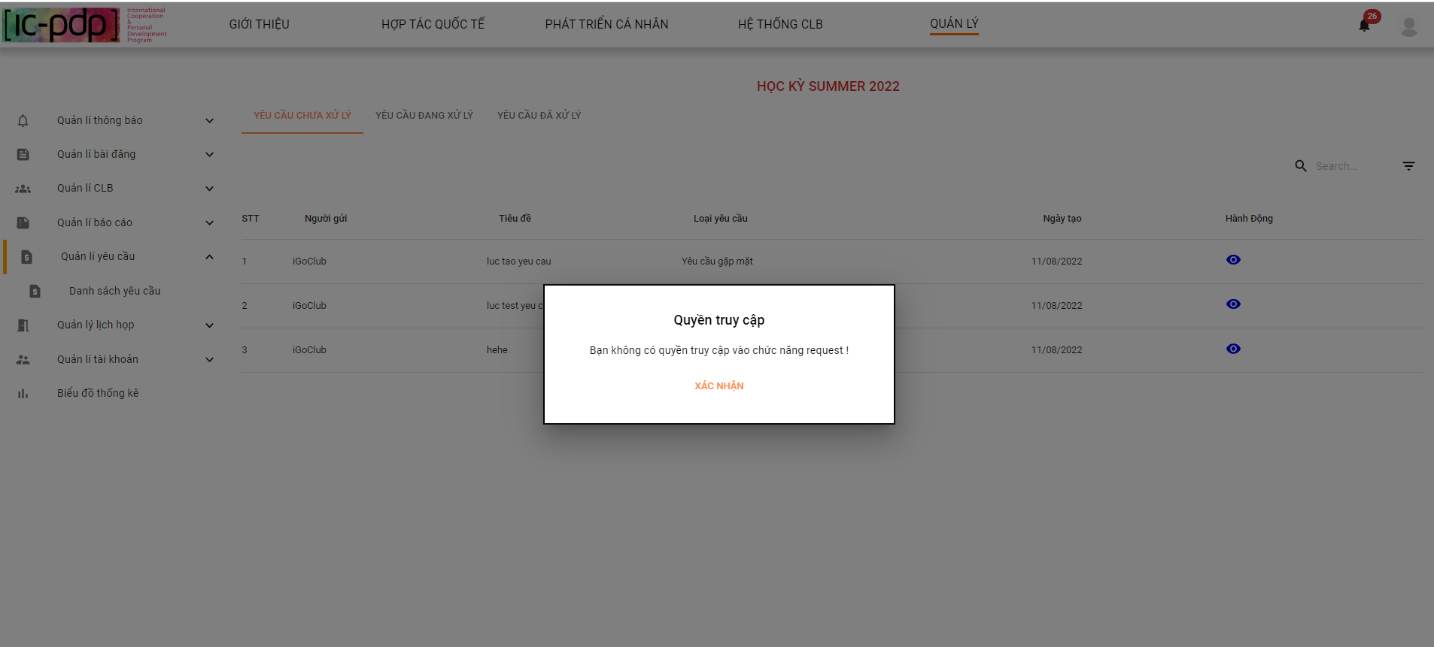

*Figure 323. Limit access permissions of Collaborator*

### 2.8. Club Manager

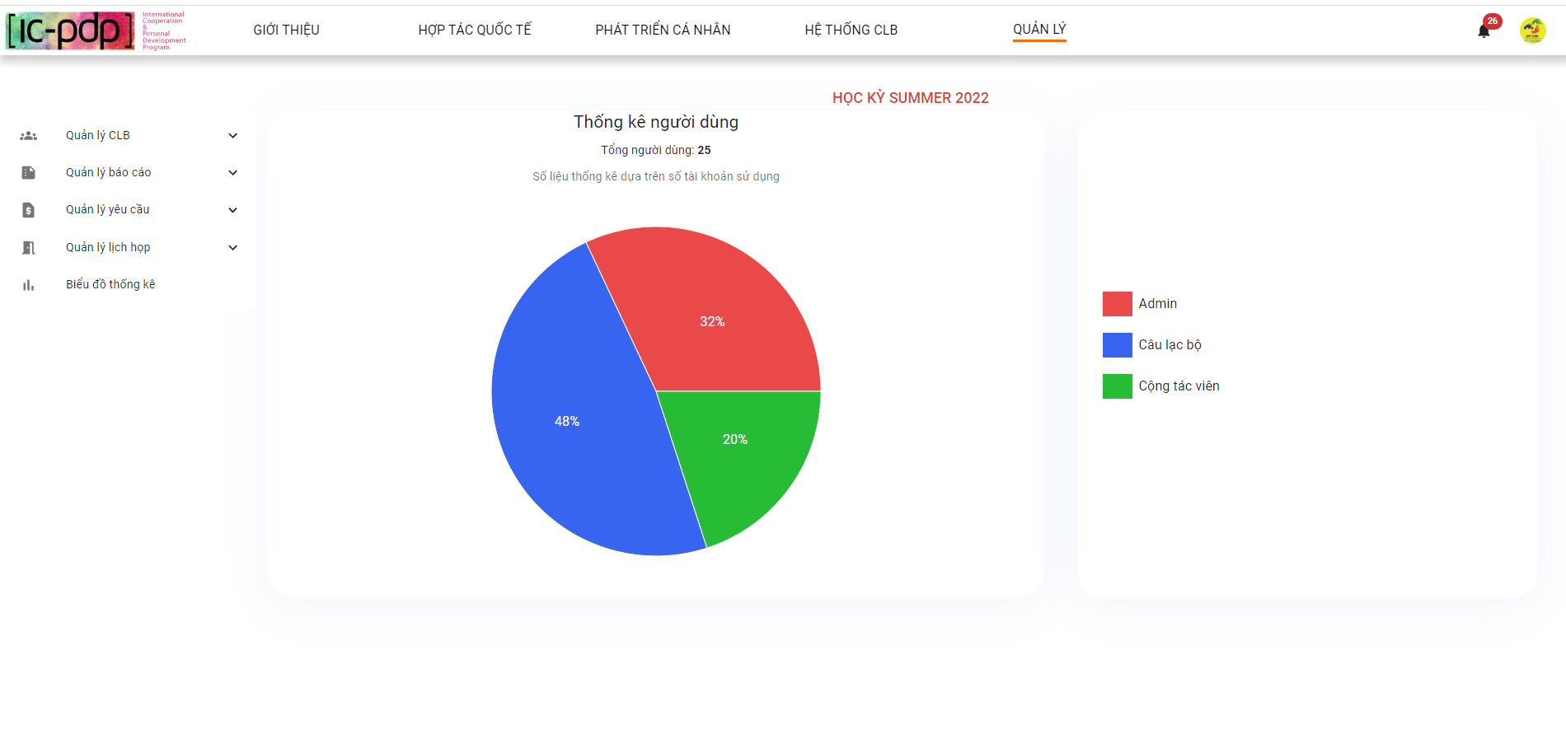

*Figure 324. Club manager interface*

#### 2.8.1 “Quản lý CLB” screen

**1. Thông tin CLB**

1.1 Club Manager clicks “Thông tin CLB”

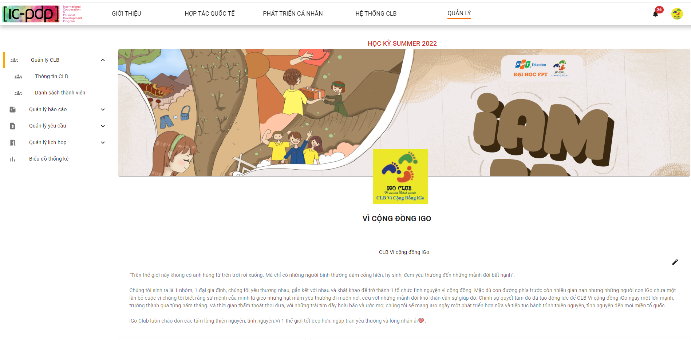

*Figure 325. View club information*

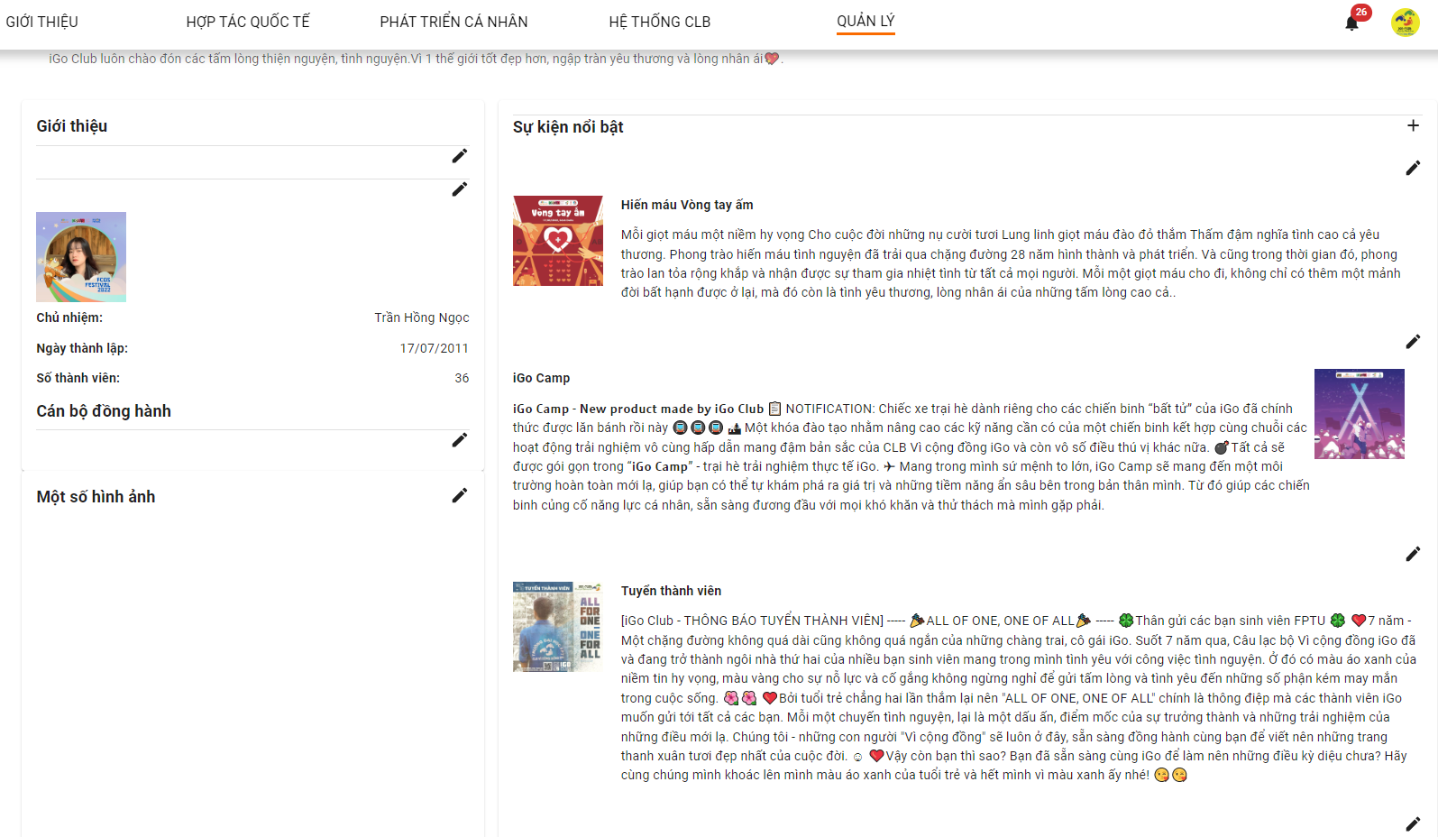

*Figure 326. View club information*

1.2 Club Manager clicks button edit “Mô tả CLB”

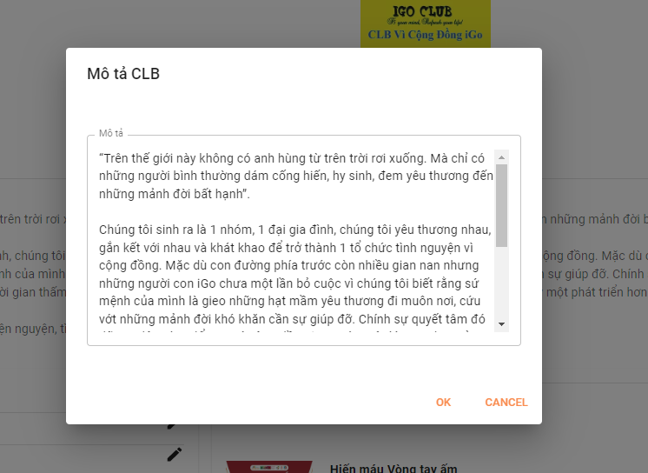

*Figure 327. Editing club description*

1.3 Club Manager clicks edit “Sự kiện nổi bật”

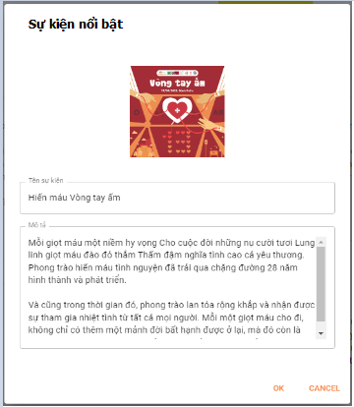

*Figure 328. Event in club*

1.4 Club Manager clicks edit “Giới thiệu”

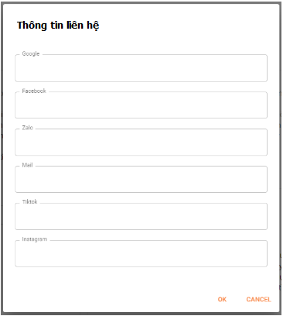

*Figure 329. Social media of club*

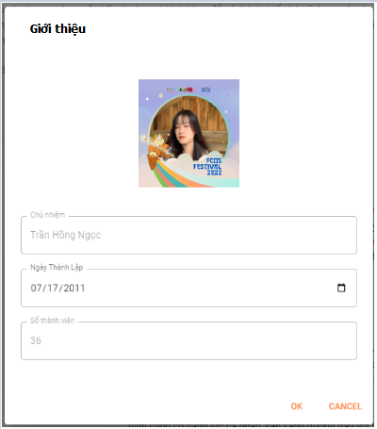

*Figure 330. Profile Club Manager*

1.5 Club Manager clicks button “OK” after edit something

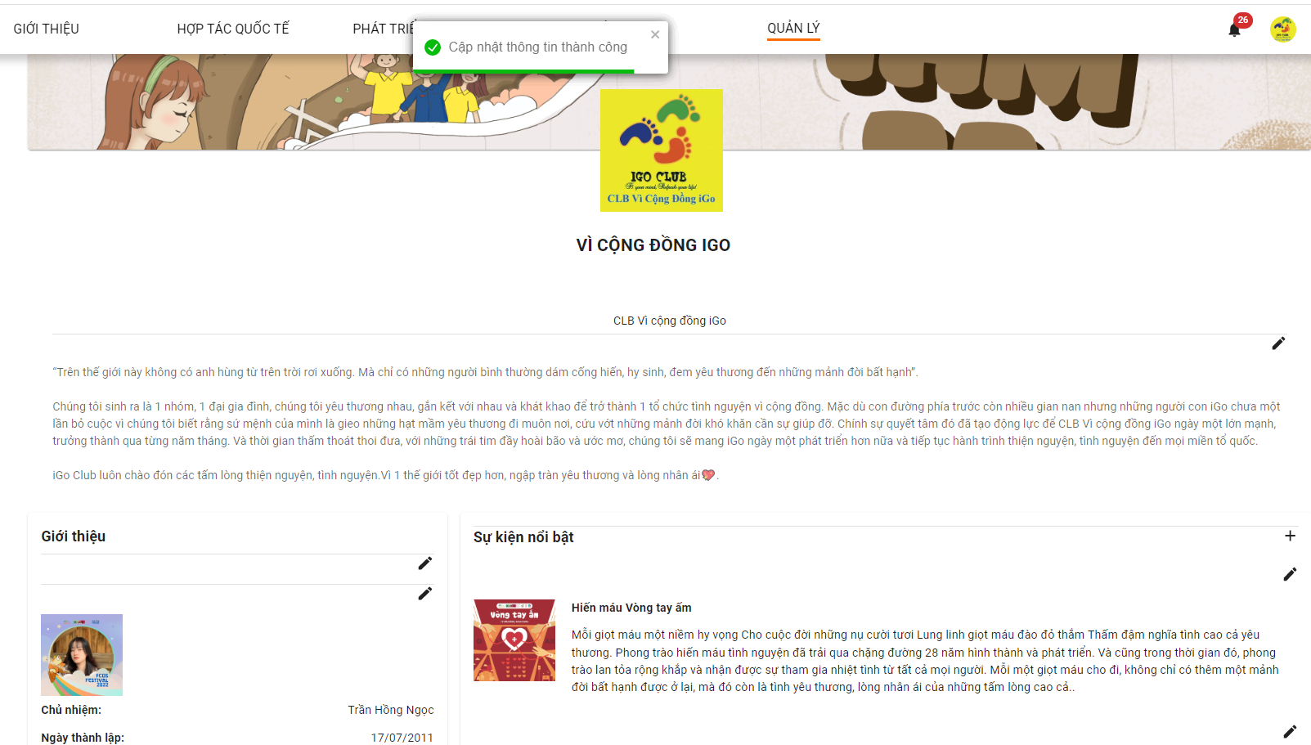

*Figure 331. Update information club result*

1.6 Club Manager adds image “Ảnh CLB”

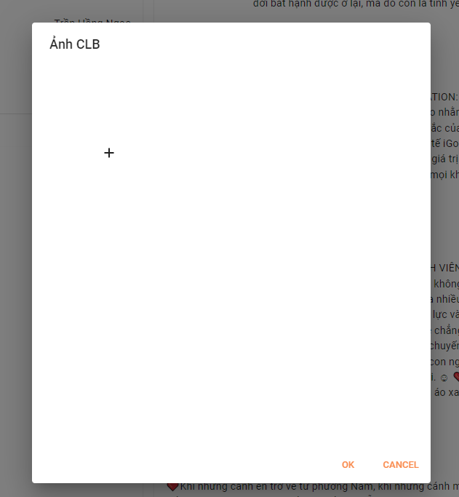

*Figure 332. Add image in club information*

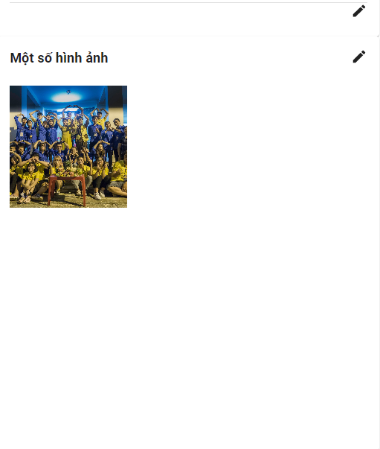

*Figure 333. Add image in club information result*

1.7 Club Manager clicks button edit “Ảnh bìa”

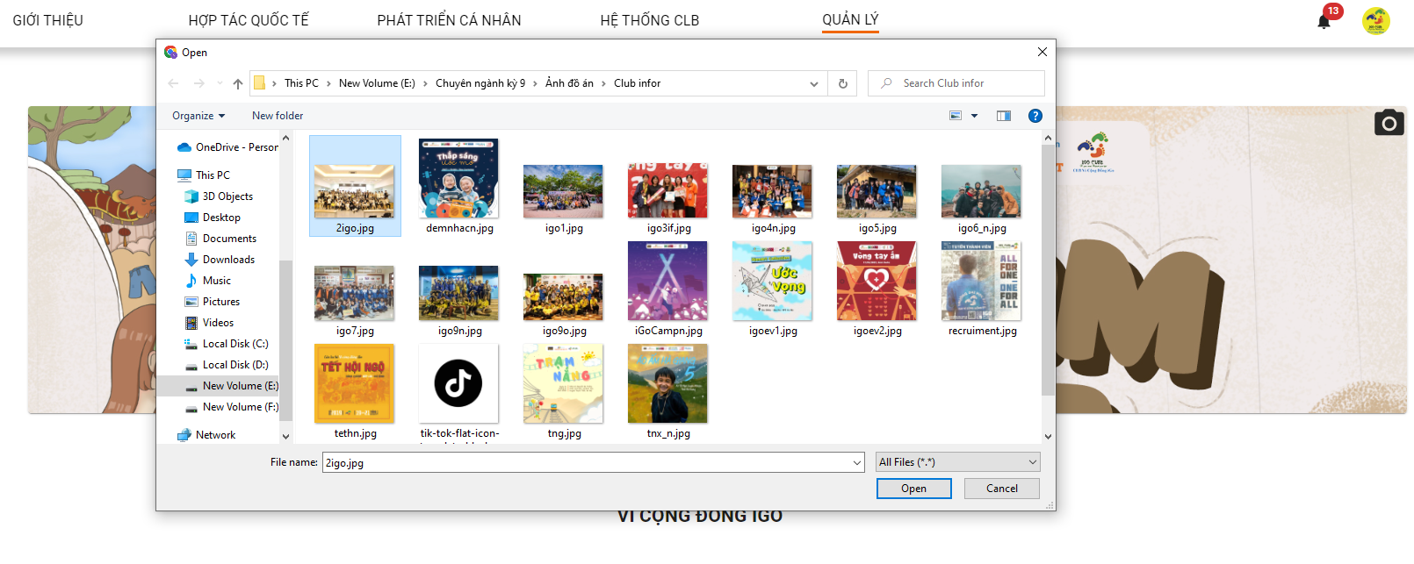

*Figure 334. Editing background image*

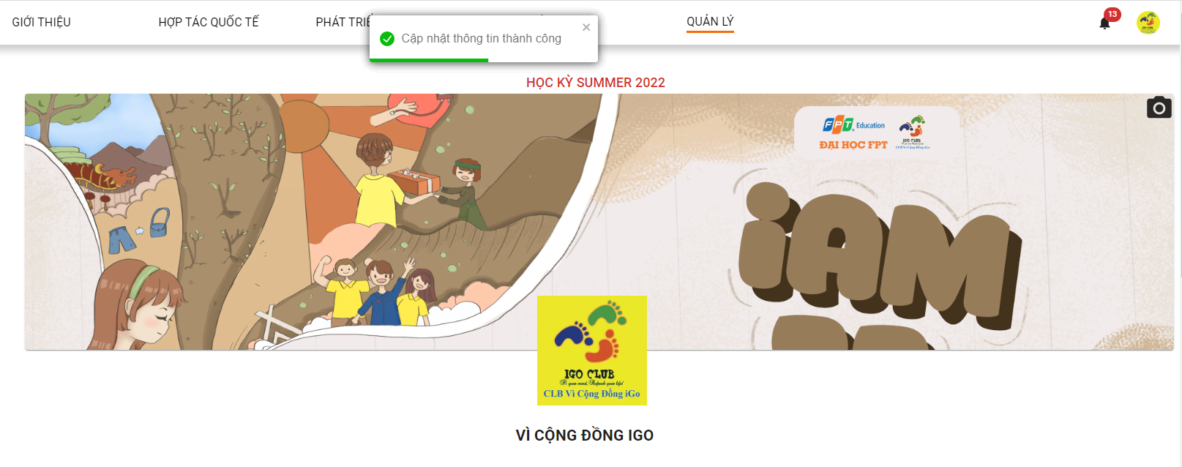

*Figure 335. Editing background image result*

**2. “Danh sách thành viên”**

2.1 Club Manager clicks “Danh sách thành viên”

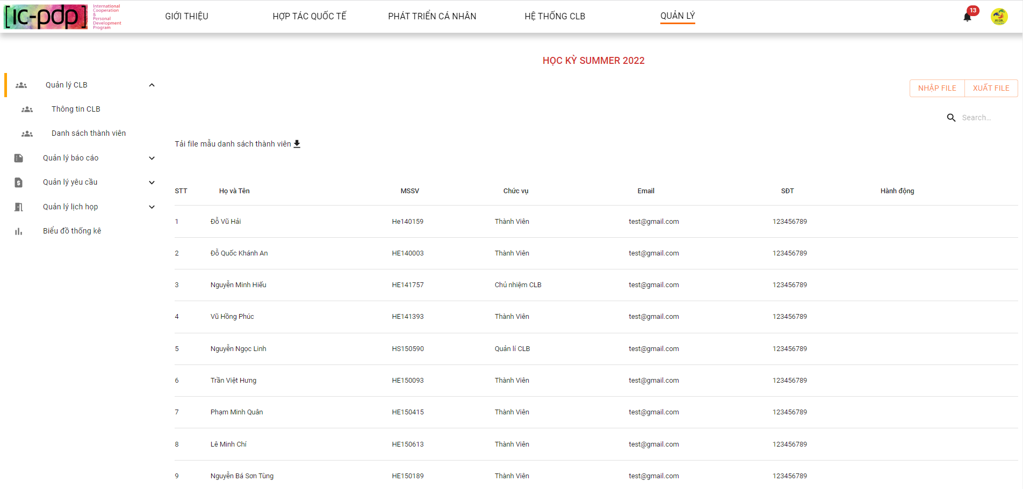

*Figure 336. View list members in club*

2.2 Club Manager clicks search field “danh sách thành viên”

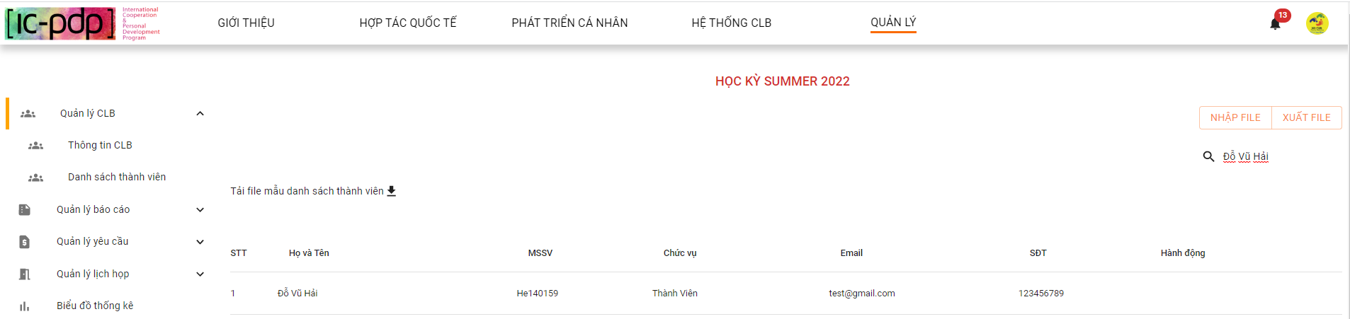

*Figure 337. Searching member in club*

2.3 Club Manager click button “Nhập file”

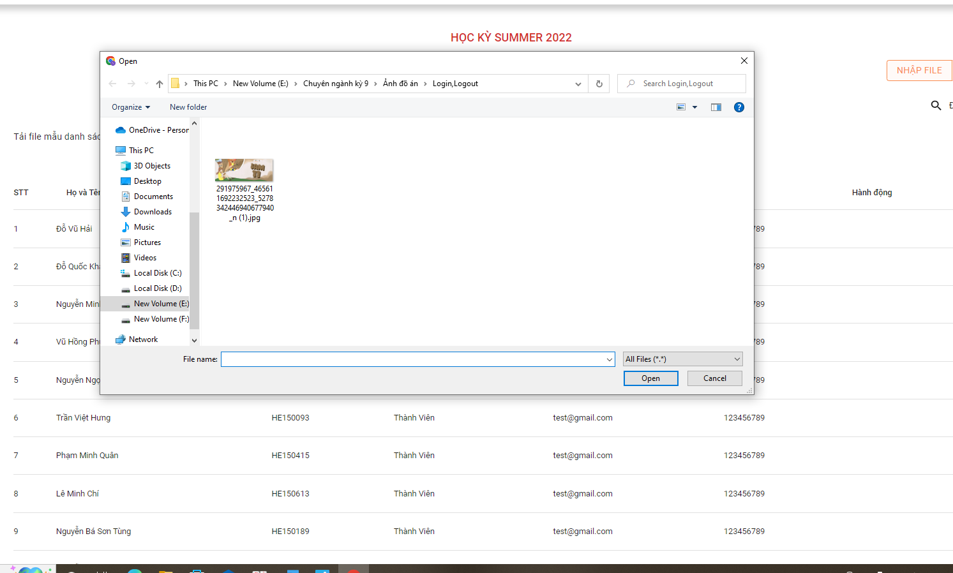

*Figure 338. Export file list members*

2.4 Club Manager clicks “Xuất file”

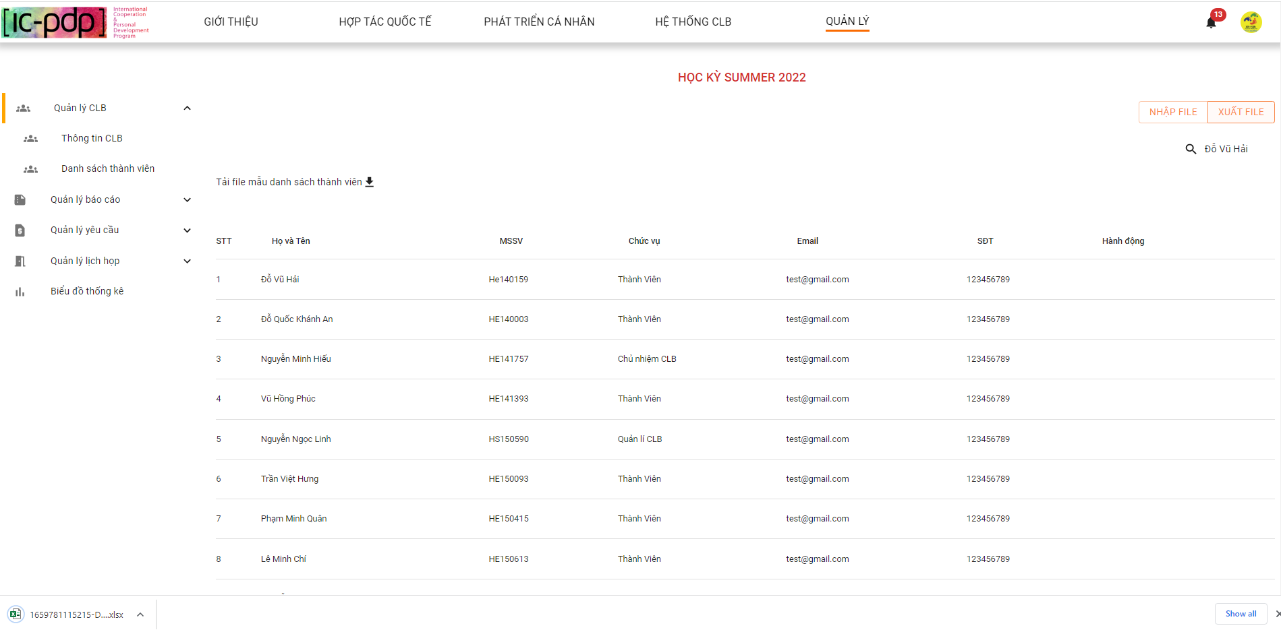

*Figure 339. Export file list members*

2.5 Club Manager clicks button “Tải file mẫu danh sách thành viên”

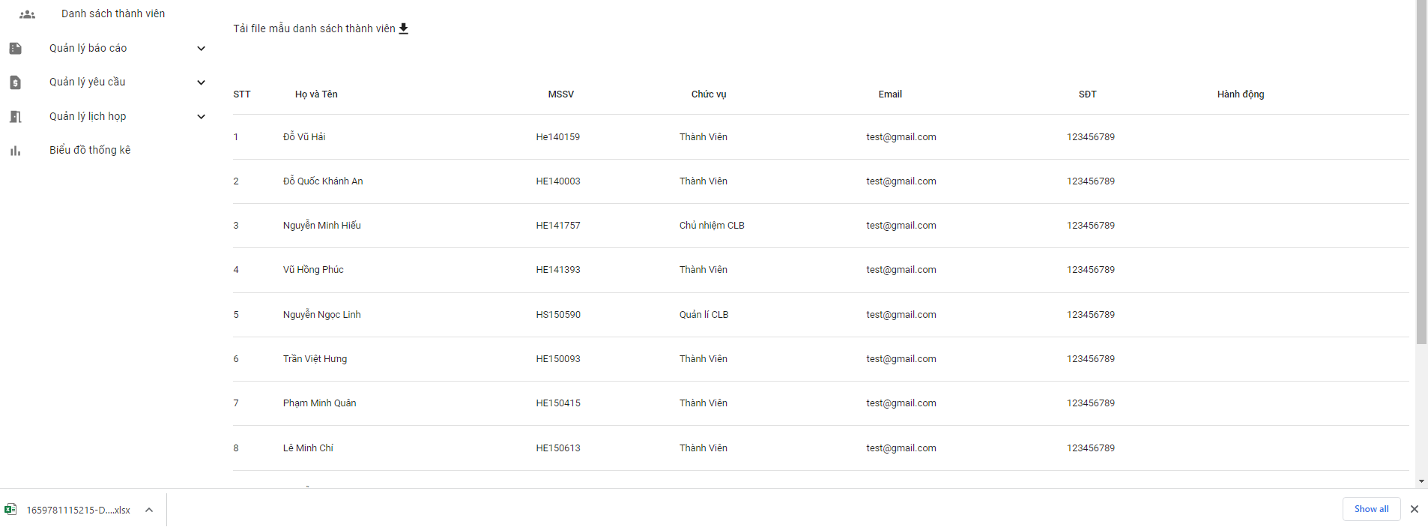

*Figure 340.Download file template list members*

#### 2.8.2 “Quản lý báo cáo” screen

**1. “Danh sách báo cáo”**

1.1 Club Manager clicks “Danh sách báo cáo”

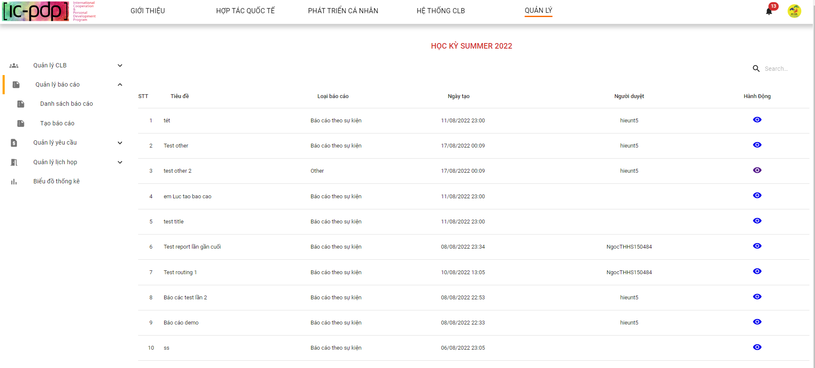

*Figure 341. View list reports*

1.2 Club Manager clicks view detail “báo cáo”

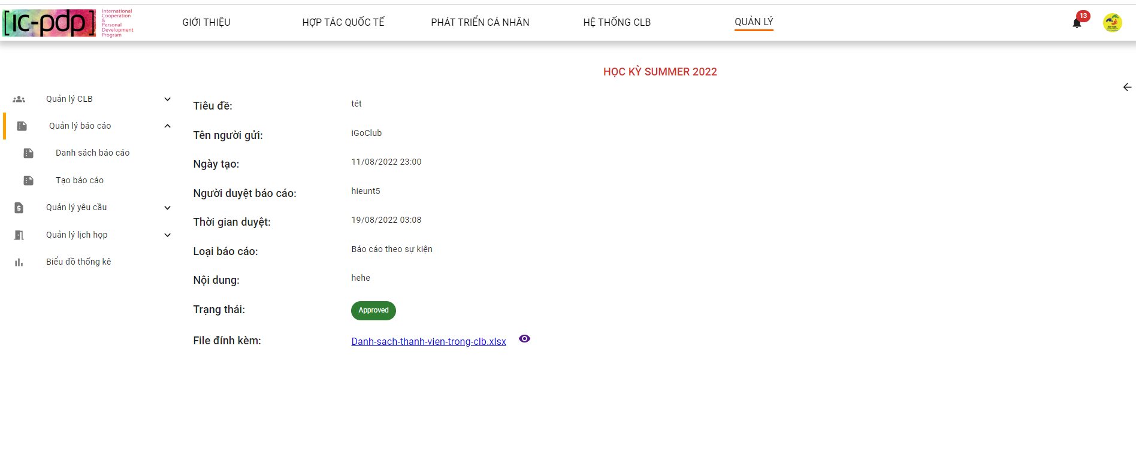

*Figure 342. View detail a report*

1.3 Club Manager clicks view online file

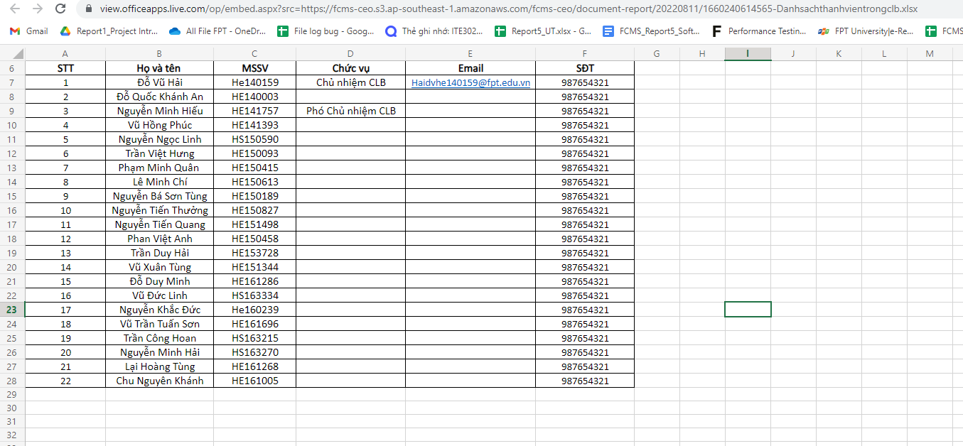

*Figure 343. View file attach online*

1.4 Club Manager clicks download file

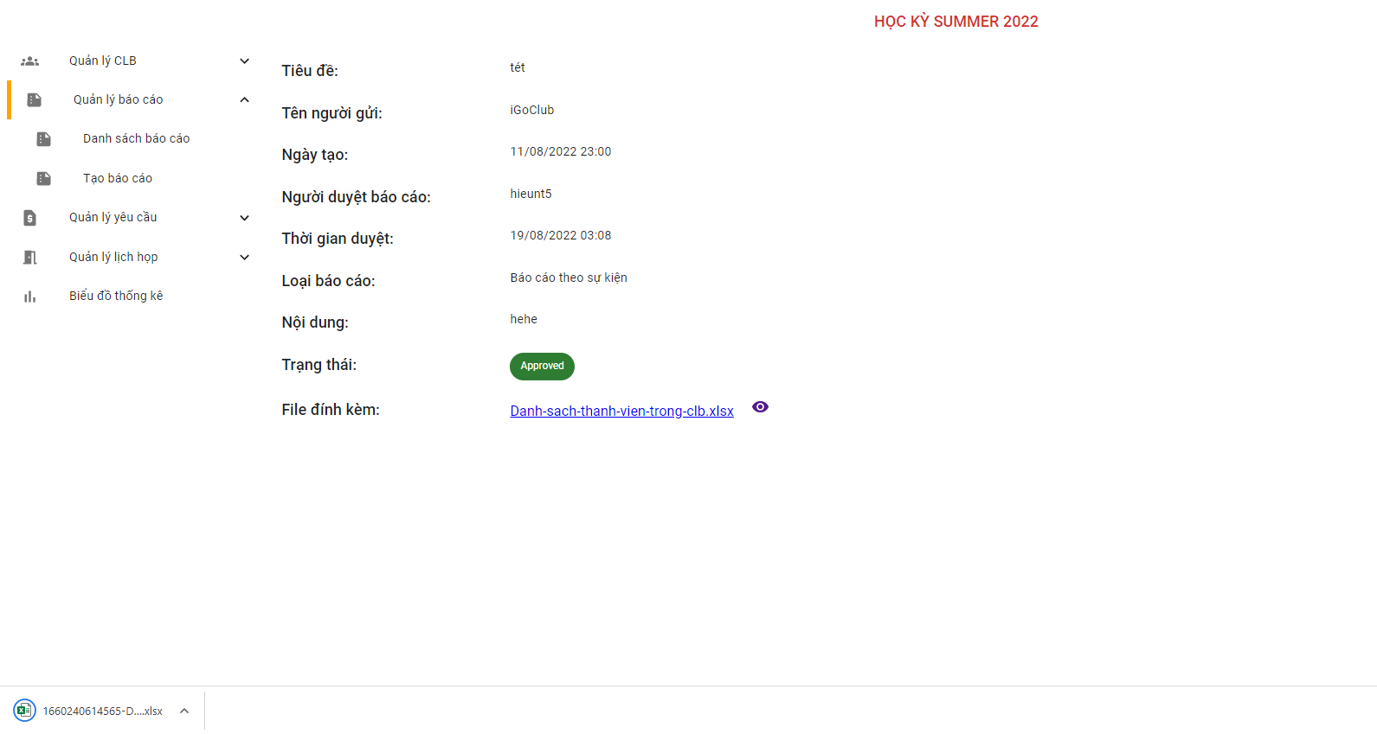

*Figure 344. Download file attach*

**2. Tạo báo cáo**

2.1 Club Manager clicks “Tạo báo cáo”

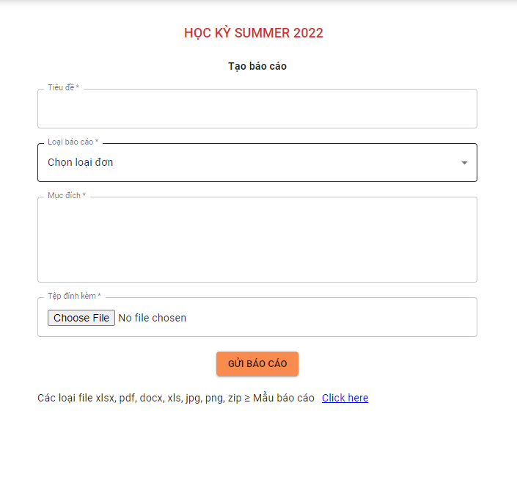

*Figure 345. Create a report*

2.2 Club Manager clicks button “Gửi báo cáo”

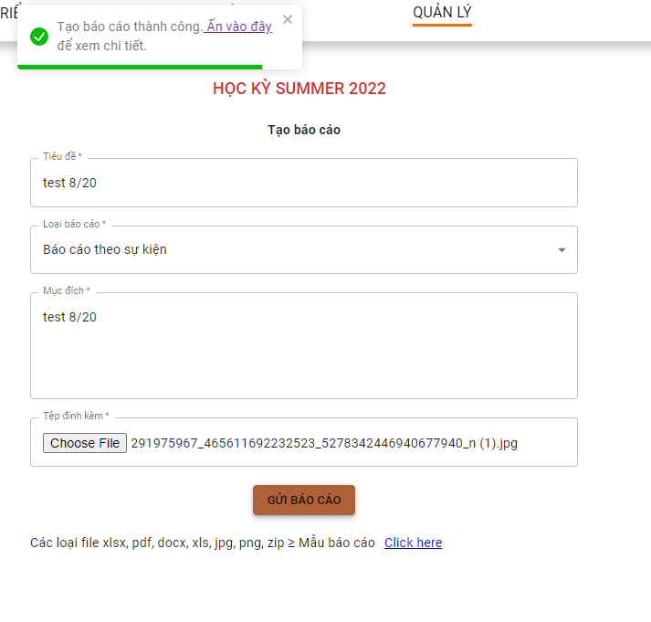

*Figure 346. Sending report result*

2.3 Club Manager clicks button download “Mẫu báo cáo”

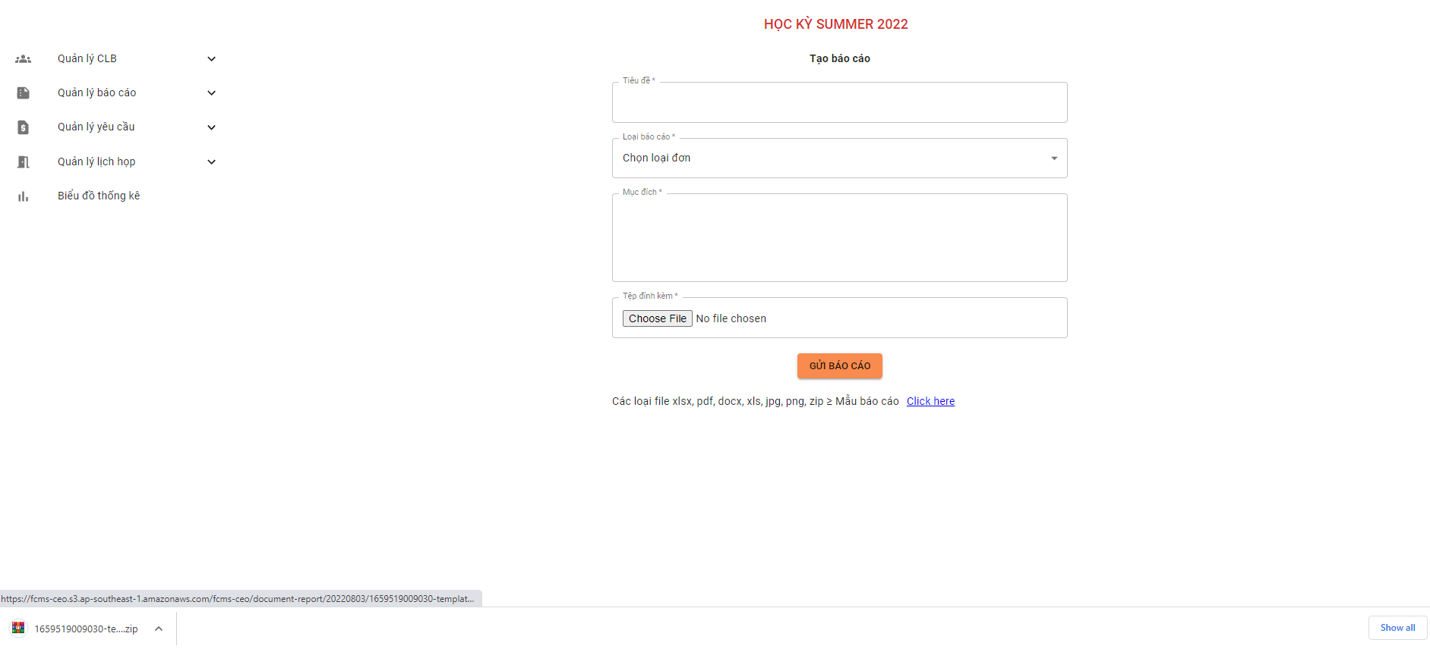

*Figure 347. Download file template report*

#### 2.8.3 “Quản lý yêu cầu” screen

1. **Danh sách yêu cầu**

1.1 Club Manager clicks “danh sách yêu cầu”

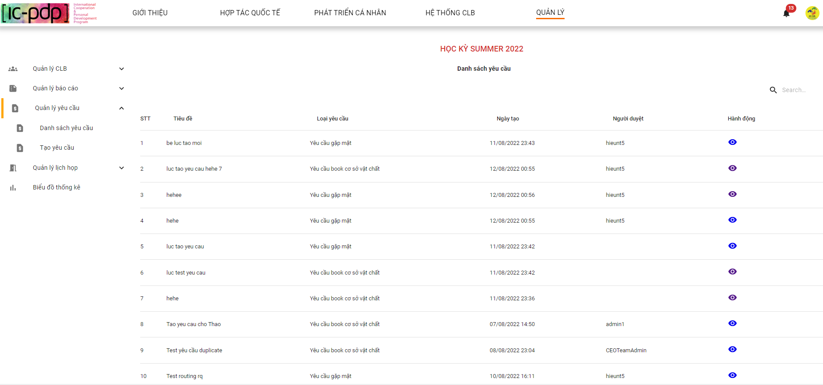

*Figure 348. View list requests*

1.2 Club Manager clicks button view detail “yêu cầu”

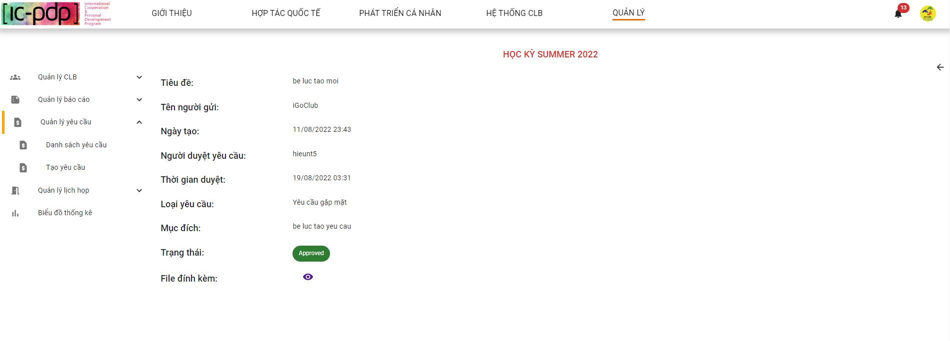

*Figure 349. View detail a request*

1.3 Club Manager clicks search field “yêu cầu”

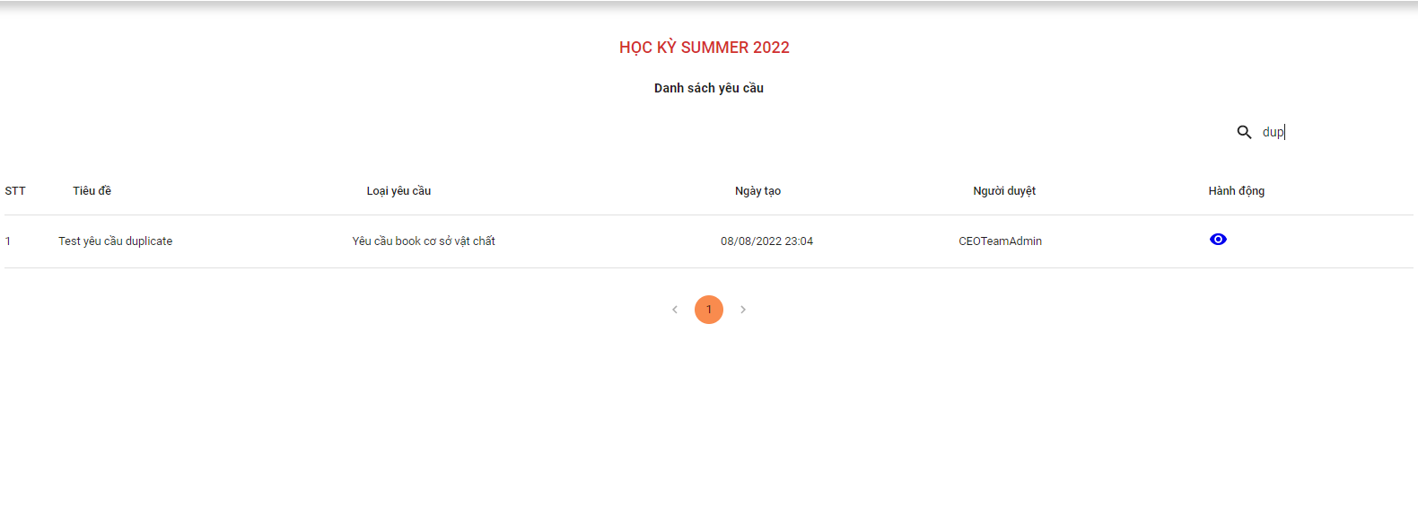

*Figure 350. Searching request result*

1. **“Tạo yêu cầu”**

2.1 Club Manager clicks “Tạo yêu cầu”

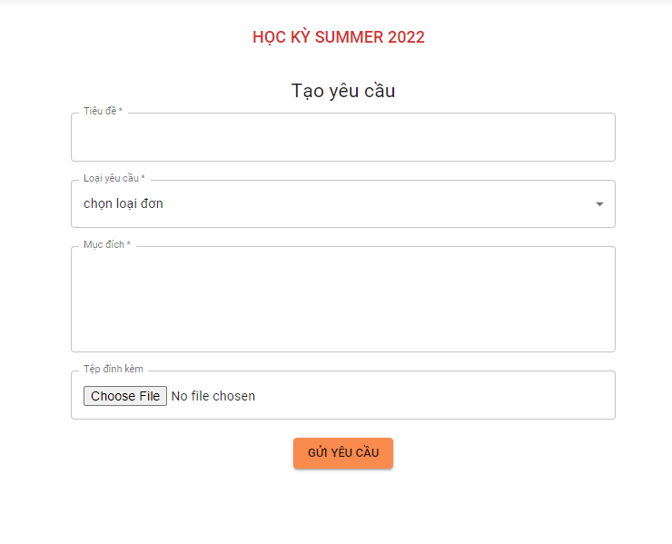

*Figure 351. Create a request*

2.2 Club Manager clicks button “Gửi yêu cầu”

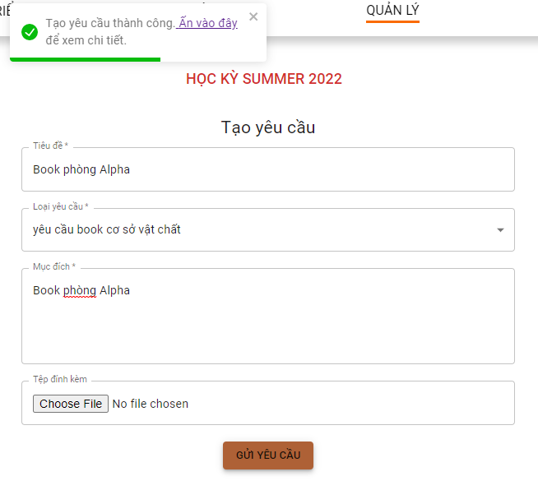

*Figure 352. Request created result*

#### 2.8.4 “Quản lý lịch họp” screen

**1. Tạo lịch họp**

1.1 Club Manager clicks “Tạo lịch họp”



*Figure 353. Create a new meeting*

1.2 Club Manager clicks button “Tạo cuộc họp”



*Figure 354. Popup after create meeting successfully*

**2. “Chi tiết lịch họp”**

2.1 Club Manager view meeting



*Figure 355. Club Manager clicks view meeting*

2.2 Club Manager clicks button next



*Figure 356. View meeting in next month*

2.2 Club Manager hovers to view detail meeting



*Figure 357. View detail meeting*

2.3 Club Manager confirm/reject meeting

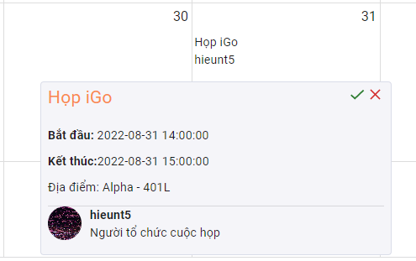

*Figure 358. Confirm/Reject meeting*



*Figure 359. Confirm/Reject meeting result*